An Examination and Critical Analysis of How the Early Help System is Communicated to Families via the Leicestershire County Council Website: A Comparative Study with Leeds City Council and Tower Hamlets Council

BSc Health and Social Care
BMHP5021: Protecting and Supporting Families in Health and Care
Component 2: Written Report Internal Verifier: Chloe Harries
Lecturer Name: Robert Nartowski
Student Name: Lilieana-Lavinia Victoria
Student ID: 2412370

Table of Contents
- Introduction 3
- The Early Help System in England 3
  - Definition and Purpose of Early Help 3
  - Legislative and Policy Framework 4
  - Thresholds and Intervention Levels 4
- Multi-Agency and Interdisciplinary Working 5
  - Importance of Partnership Working 5
  - Challenges in Multi-Agency Communication 6
- Evaluation of Local Authority Websites 6
  - Leicestershire County Council 6
  - Leeds City Council 7
  - Tower Hamlets Council 7
- Comparative Analysis: Strengths and Weaknesses 8
  - Accessibility and User-Friendliness 8
  - Clarity of Early Help Pathways 9
  - Multi-Agency Visibility and Family Support Range 9
- Conclusion and Recommendations 10
  - Overall Judgement 10
  - Recommendations for Improvement 10
References 11

Introduction
Early Help is one of the key elements of the architecture of safeguarding in England, aimed at ensuring that the need does not grow to the point at which statutory child protection intervention is needed. According to the Early Help System Guide, Early Help is the assistance offered within the first moment of a problem appearing at any stage of a child’s life to achieve better results by taking preventative measures in a coordinated way (NCB, 2021). Working Together to Safeguard Children, 2023, strengthens this preventative responsibility and obliges local authorities and other partner agencies to work together in identifying and progressing through the arising risks using proportionate multi-agency support (Durham, 2023). As an illustrative example, a parent in Leicester who faces housing instability and economic instability can be referred to family assistance services on a timely basis with the help of available website information about the early help (Edwards et al., 2021). This report critically reviews the way Early Help is conveyed on the websites of the Leicestershire County Council, Leeds City Council and Tower Hamlets Council and changes its clarity, access and adherence to statutory guidance to identify which of these three authorities best signposts families to preventative support.

The Early Help System in England

Definition and Purpose of Early Help
The Early Help model in England is an organised preventative system that tries to confront any upcoming challenges before legal protection limits are reached. According to the Early Help System Guide, Early Help could be the assistance offered immediately after the problem was located to improve the situation of children and families by coordinating intervention (Tollan et al., 2023). The need to identify early on in order to prevent the progression into Child in Need or Child Protection procedures is confirmed in Chapter 1 of Working Together to Safeguard Children (HM Government, 2023). Such a preventive approach is essential due to the fact that more than 400,000 children were found in need in England in 2023, which proves that statutory services are in demand on a large scale (Gov.uk, 2025). Practically, a family in Leicester with parental mental ill-health and school absenteeism can be assisted by Early Help coordination between education and health services, which will lead to the possibility of care proceedings being reduced. Early Help is thus a whole-family intervention that is strengths-based so that harm can be prevented before it escalates.

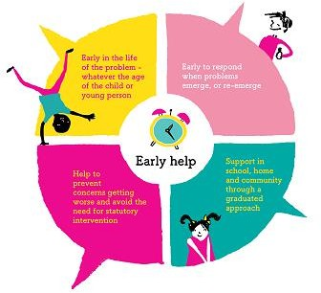

Figure 1: The Early Help Model in England
(Source: Leedsscp.org.uk, 2025)

Legislative and Policy Framework
The legal framework of the Early Help is ingrained in the Children Act 1989, which makes it the responsibility of the local authorities to protect and ensure the well-being of children living in their jurisdiction (Foster, 2024). The Children Act 2004 enhanced the requirements of multi-agency collaboration, which resulted in the development of the system of safeguarding partnerships and joint responsibility (Legislation.gov.uk, 2026). Working Together to Safeguard Children realises these responsibilities by mandating local jurisdictions to organise early intervention by means of strategic safeguarding alliances, where preventative services are systematically integrated into local services.

Thresholds and Intervention Levels
The Early Help model is applied on a need spectrum of universal provision like schools and health visiting, specific provision of emerging issues, and statutory Child in Need or Child Protection provision where the risk is severe (Ofsted, 2023). Thresholds need to be clearly stated; as an example, recurring domestic abuse can take a case out of targeted support and put it under Child Protection because of the potential of serious harm (Bekaert et al., 2021). The success of such a continuum using clear communication of thresholds to families is, in turn, a straightforward way to communicate the critical analysis of the presentation of Early Help pathways in local authority websites.

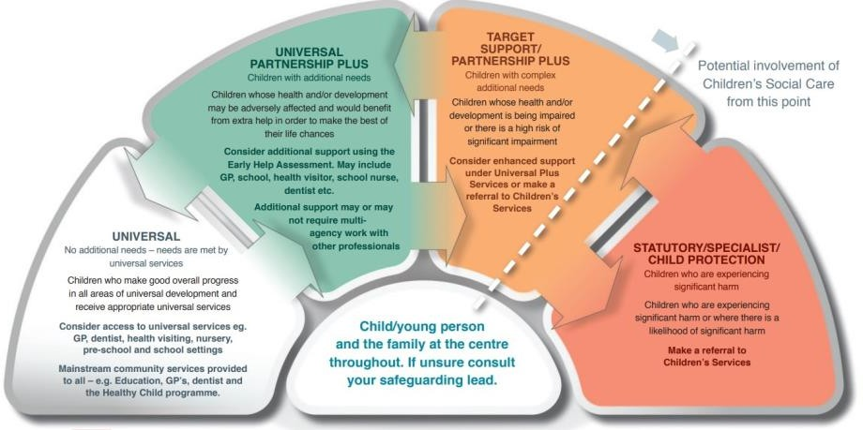

Figure 2: Early Help Continuum of Need
(Source: FYI, 2024)

Multi-Agency and Interdisciplinary Working

Importance of Partnership Working
Efficient Early Help provision requires multi-agency safeguarding partnerships, which combine education, health and social care to detect and address the arising risks. In Chapters 2 and 3, Working Together to Safeguard Children, local authorities, Integrated Care Boards and police are expected to work as statutory safeguarding partners sharing joint accountability and responsibilities (HM Government, 2023). Sharing of information amongst schools, GP and children's services is vital in early identification. As an example, frequent school non-attendance in Leeds and health visitor issues related to substance misuse in parents should prompt collaborative assessment and not a single intervention (Rainer, Le and Abdinasir, 2023). In the absence of organised partnering in working, Early Help will suffer a lack of protection and delay.

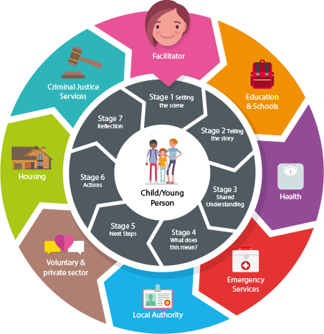

Figure 3: Multi-Agency Group Supervision
(Source: West Cheshire Children's Trust, 2022)

Challenges in Multi-Agency Communication
In spite of the statutory expectation, the inconsistency at the threshold and barriers to information exchange often weigh down on proper collaboration. The variations in professional judgement regarding risk, such as domestic abuse targeted support or Child Protection, can postpone intervention (Hale et al., 2024). The problem of accessibility on the internet also creates communication difficulties; ambiguous referral routes or inappropriately marked Early Help pages on council websites cannot allow families living in such regions as Tower Hamlets to self-refer at an early stage (Ryan et al., 2023). Failures by websites to effectively explain thresholds and routes to contact undermine the transparency that is needed to build effective public-facing safeguarding systems that also directly influence the utilisation and perception of Early Help.

Evaluation of Local Authority Websites

Leicestershire County Council
The Early Help route is made available to Leicestershire County Council through its children and families service pages on its site. The section Early Help has a succinct definition within the context of the principles of preventative intervention, and it also provides referral procedures to be used by professionals and families (Gov.uk, 2022). The contact information,

phone numbers, and online referral forms can be easily found, and downloadable Early Help assessment documentation can be accessed, which facilitates the transparency of the procedures (Ferreira et al., 2023). Since more than 400,000 children have been reported as Children in Need throughout the country in 2023, it is necessary to have a clear route of early intervention to prevent statutory escalation (Gov.uk, 2025). According to the site, the categories of support are those of mental health, SEND, domestic abuse and parenting programmes, which are multi-agency collaboration expectations in the context of Working Together (Dixon et al., 2022). Nevertheless, parts are composed mainly in professional language, like threshold guidance and assessment pathway, which might require the knowledge of the practitioner and not parental. Although structurally thorough, the communication strategy will not favour families who want early preventive measures, as they will be overshadowed by professional audiences.

Leeds City Council
The visibility of Early Help is high on the site of Leeds City Council: owners provide direct navigation in the home pages under the services offered to children in the children's menu, which minimises the obstacles of search by parents. The site uses relatively simple English explanations of Early Help that present it as assistance to families requiring additional help, instead of using terminology in statutes (House of Commons Education Committee, 2019). The use of icons, frequently asked questions, and hierarchical headings improves the overall readability and works in accordance with the concept of digital accessibility suggested to be applied to the use of public services (Ahmed, 2024). As Leeds indicated high rates of child poverty compared to the national data, the early support message is important in avoiding the situation of escalation of the crisis (Parliament.uk, 2020). Both self- and professional referrals are described as referral routes, which enhances the openness of thresholds (AlHarthy et al., 2024). Nevertheless, multi-agency safeguarding responsibilities is not as evident as procedural information, and this could restrain people in the context of understanding of the agencies' collaboration. The practise of Leeds is more family-centred linguistically, but it may enhance explicit threshold clarity to be in closer compliance with the statutory protection expectations.

Tower Hamlets Council
The website of the Tower Hamlets Council demonstrates an understanding of the diverse community profile, as it includes translation options and the use of culturally-conscious language throughout family support pages. The Early Help information is also interwoven with the family services (poverty support, housing advice and domestic abuse services), which is

contextually currently appropriate in the borough with a large percentage of socio-economic deprivation (Bennett et al., 2024). Combining financial hardship advice with structural risk factors that relate to safeguard concerns (Xu et al., 2021). There is clear guidance on the escalation of safeguarding information and directions on how to access children's social care directly (NHS, 2019). Nonetheless, Early Help content is not as strongly differentiated as that of statutory safeguarding content, which may confuse preventative and protective ways. Although culturally responsive and socially contextualised, the site might be enhanced in terms of structural clarity to help families be able to compare the universal and statutory intervention, which is the core of assessing the overall communication effectiveness.

Comparative Analysis: Strengths and Weaknesses

Accessibility and User-Friendliness
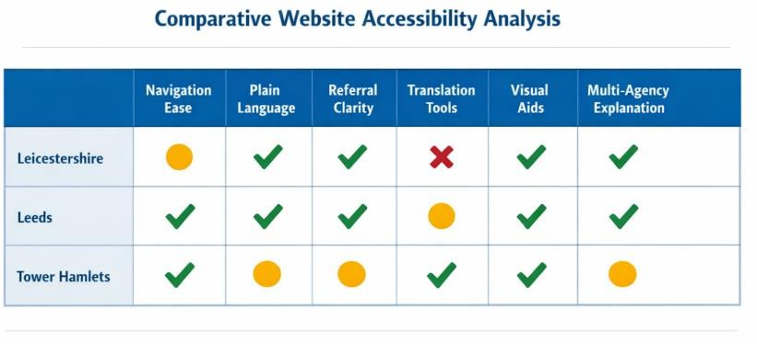

Figure 4: Comparison of Website Accessibility
(Source: Author)
The three authorities have a high level of contrast in how well they can be accessed in consideration of the ease of navigation, the readability and the digital inclusion criteria. The navigation structure of Leeds City Council is the most user-friendly, as the Early Help can be accessed on the homepage with two clicks and is written in plain English, which is not only easy to understand by non-experts (Leeds City Council, 2022). Tower Hamlets contributes to digital literacy by making its website accessible in other languages and design responsive to the needs of various communities (Tower Hamlets, 2025). Leicestershire, conversely, has been overburdened by terminology, so parents who do not understand how to protect language might not be able to do so (Leices.gov.uk, 2025). Generally speaking, Leeds is most effective at communicating with the non-technical families because it has a simplified structure and is framed towards readers.

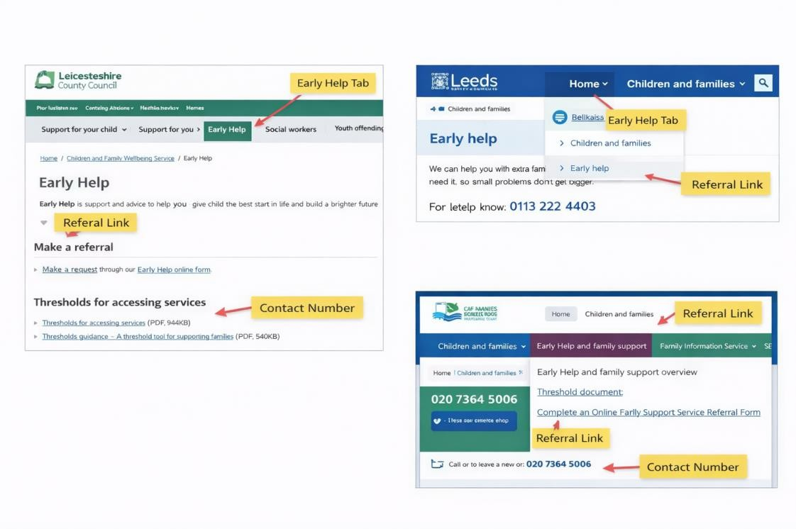

Figure 5: Early Help services across councils
(Source: Author)

Clarity of Early Help Pathways
With regards to referral transparency and explanation of threshold, Leicestershire is the most procedurally clear as it offers downloadable evaluation forms and pre-established contact channels (Leics.gov.uk, 2025). This is in line with Working Together to Safeguard Children 2023 that focuses on articulated local referral systems and sets thresholds (HM Government, 2023). Leeds presents self-referral routes in an effective manner but provides less specific threshold documentation, whereas Tower Hamlets incorporates escalation advice within the framework of wider safeguarding pages. Leicestershire thus combines the best statutory congruency, though its delivery can be streamlined to the parental levels.

Multi-Agency Visibility and Family Support Range
Tower Hamlets has been incorporating Early Help as part of extended socio-economic support, such as housing and financial legality, which indicates a sense of structural risk factors (Tower Hamlets, 2025). Leeds enumerates the vast array of family services but does not explain much about the protection of partner roles (Leeds City Council, 2022). Leicestershire mentions multi-agency collaboration explicitly, but it is introduced in rather professional language. Tower Hamlets provides the most contextualised service integration, Leicestershire demonstrates the presence of formal partnership structures more clearly, which is the source of tension between

the procedural clarity and the family-centred communication that forms the basis of this assessment.

Conclusion and Recommendations

Overall Judgement
Leeds City Council informs about Early Help most effectively when evaluated against the criteria of accessibility, clarity, transparency across agencies and presentation to the family. Its home page visibility, its plain English descriptions and structure in FAQ make it less hindrance to the non-specialist families who need to access support at an early stage. Leicestershire is more procedurally aligned with statutory guidance, Tower Hamlets is more sensitive to local conditions, readability and practicability, and Leeds demonstrates the most balanced combination of the two. The need for recognition and action before the statutory intervention is best facilitated by the model of communication among families. The basis of the comparative judgement is a predetermined application of systematic criteria, as opposed to preference, and weighing measurable indicators of digital accessibility, referral transparency and partnership visibility across the three authorities. It is based on this that Leeds has been chosen as it exhibits the greatest consistency between user-centred communication design and protection of accessibility in direct relation to the purpose of the assessment, which is to determine the effectiveness of Early Help communication.

Recommendations for Improvement
The three authorities would all be helped with better visual threshold infographics, one-click referral buttons and brief video explainers to elucidate Early Help pathways in accordance with the statutory demands of transparent local arrangements. As an example, in some councils around the country, interactive flowcharts and safeguarding video translations have been implemented in order to expand access to different communities (Unicef, 2023). Plaintext language, more straightforward escalation flowcharts and parent-oriented FAQ would also better fit websites with the concept of preventative by Early Help, enhancing digital security communication and facilitating equal access to early intervention services.

References
Ahmed, N. (2024) The Significance of Icons in Design: Enhancing User Experience and Accessibility, Medium. Available at: https://medium.com/@nasir-ahmed03/the-significance-of-icons-in-design-enhancing-user-experience-and-accessibility-62bac45348f5 (Accessed: 23
February 2026).
AlHarthy, S., Mansour AL-MoundhrI, Wisal Al-Mahmoodi, Ibrahim, R., Ayaad, O. and Khalid Al Baimani (2024) ‘Referral Process Enhancement: Innovative Approaches and Best Practices’, Asian Pacific Journal of Cancer Prevention, 25(5), pp. 1691–1698. Available at: https://doi.org/10.31557/apjcp.2024.25.5.1691.
Bekaert, S., Paavilainen, E., Schecke, H., Baldacchino, A., Jouet, E., Zabłocka – Żytka, L., Bachi, B., Bartoli, F., Carrà, G., Cioni, R.M., Crocamo, C. and Appleton, J.V. (2021) ‘Family Members’ Perspectives of Child Protection services, a metasynthesis of the literature’, Children and Youth Services Review, 128(128), p. 106094. Available at: https://doi.org/10.1016/j.childyouth.2021.106094.
Bennett, D.L., Wickham, S., Barr, B. and Taylor-Robinson, D. (2024) ‘Poverty and children entering care in England: A qualitative study of local authority policymakers’ perspectives of challenges in Children’s Services’, Children and Youth Services Review, 162, p. 107689. Available at: https://doi.org/10.1016/j.childyouth.2024.107689.
Dixon, S., Kendall, B., Driscoll, J. and Pope, C. (2022) ‘Supporting the “Multi” in Multi-agency working: Learning with and from Each Other Could Enable multi-agency Safeguarding’, British Journal of General Practice, 72(722), pp. 438–439. Available at: https://doi.org/10.3399/bjgp22x720617.
Durham (2023) Working Together to Safeguard Children 2023 -Summary of Changes. Available at: https://durham-scp.org.uk/wp-content/uploads/2024/05/WorkingTogetherSummaryOfChanges.pdf (Accessed: 23 February 2026).
Edwards, A., Gharbi, R., Berry, A. and Duschinsky, R. (2021) UNITED FOR DISABLED CHILDREN Supporting and Strengthening Families through Provision of Early Help a Rapid Review of Evidence. Available at: https://www.ncb.org.uk/sites/default/files/uploads/attachments/20210513_Rapid%20Review_ Full%20Report%20-%20FINAL.pdf (Accessed: 23 February 2026).
Ferreira, D.C., Vieira, I., Pedro, M.I., Caldas, P. and Varela, M. (2023) ‘Patient satisfaction
with healthcare services and the techniques used for its assessment: A systematic literature

review and a bibliometric analysis’, Healthcare, 11(5). Available at: https://doi.org/10.3390/healthcare11050639.
Foster, D. (2024) ‘An Overview of Child Protection Legislation in England’, commonslibrary.parliament.uk, 1(6787). Available at: https://commonslibrary.parliament.uk/research-briefings/sn06787/ (Accessed: 23 February 2026).
FYI (2024) Early Help Pathway | Bradford Families and Young Persons, Bradford.gov.uk. Available at: https://fyi.bradford.gov.uk/practitioners/prevention-and-early-help/early-help-pathway/ (Accessed: 23 February 2026).
Gov.uk (2022) What is early help? Concepts, policy directions and multi-agency perspectives. Available at:
https://assets.publishing.service.gov.uk/media/6203e0848fa8f5109c7f136e/Early_help_Resea rch_in_Practice_2022.pdf (Accessed: 23 February 2026).
Gov.uk (2025) Children in need, Reporting year 2025, Service.gov.uk. Available at: https://explore-education-statistics.service.gov.uk/find-statistics/children-in-need/2025 (Accessed: 23 February 2026).
Hale, H., Bracewell, K., Bellussi, L., Jenkins, R., Alexander, J., Devaney, J. and Callaghan, J. (2024) ‘The Child Protection Response to Domestic Violence and Abuse: a Scoping Review of Interagency Interventions, Models and Collaboration’, Journal of Family Violence [Preprint]. Available at: https://doi.org/10.1007/s10896-024-00681-4.
HM Government (2023) Working Together to Safeguard Children 2023. Available at: https://assets.publishing.service.gov.uk/media/6849a7b67cba25f610c7db3f/Working_togethe r_to_safeguard_children_2023_-_statutory_guidance.pdf (Accessed: 23 February 2026).
House Of Commons Education Committee (2019) Special educational needs and disabilities First Report of Session 2019 HC 20. Available at: https://publications.parliament.uk/pa/cm201919/cmselect/cmeduc/20/20.pdf (Accessed: 23
February 2026).
Leeds City Council (2022) One minute guide: Early help, Leeds.gov.uk. Available at: https://www.leeds.gov.uk/one-minute-guides/early-help (Accessed: 23 February 2026).
Leedsscp.org.uk (2025) Early Help | Leeds Safeguarding Children Partnership, www.leedsscp.org.uk. Available at: https://www.leedsscp.org.uk/practitioners/working-with-families/early-help (Accessed: 23 February 2026).
Legislation.gov.uk (2026) Children Act 2004, Legislation.gov.uk. Available at: https://www.legislation.gov.uk/ukpga/2004/31 (Accessed: 23 February 2026).

Leics.gov.uk (2025) Leicestershire & Rutland Safeguarding Children Partnership Yearly Report 2024-25. Available at: https://democracy.leics.gov.uk/documents/s191267/Appendix%20-
%20Leicestershire%20and%20Rutland%20Safeguarding%20Children%20Partnership%20Ye arly%20Report%202024-25.pdf (Accessed: 23 February 2026).
NCB (2021) Strengthening Early Help NCB’s response to the Independent Review of Children’s Social Care ‘Call for Ideas’. Available at: https://www.ncb.org.uk/sites/default/files/uploads/files/20210513_Call%20for%20Ideas%20-
%20v4.pdf (Accessed: 23 February 2026).
NHS (2019) Safeguarding Children, Young People and Adults at Risk in the NHS: Safeguarding Accountability and Assurance Framework NHS England and NHS Improvement. Available at: https://www.england.nhs.uk/wp-content/uploads/2015/07/safeguarding-children-young-people-adults-at-risk-saaf.pdf (Accessed: 23 February 2026).
Ofsted (2023) The multi-agency response to children and families who need help, GOV.UK. Available at: https://www.gov.uk/government/publications/the-multi-agency-response-to-children-and-families-who-need-help/the-multi-agency-response-to-children-and-families-who-need-help (Accessed: 23 February 2026).
Parliament.uk (2020) Children in crisis: the role of public services in overcoming child vulnerability. Available at: https://publications.parliament.uk/pa/ld5802/ldselect/pubserv/95/95.pdf (Accessed: 23
February 2026).
Rainer, C., Le, H. and Abdinasir, K. (2023) Behaviour and mental health in schools. Available at: https://cypmhc.org.uk/wp-content/uploads/2023/06/Behaviour-and-Mental-Health-in-Schools-Full-Report.pdf (Accessed: 23 February 2026).
Ryan, R., Silke, C., Parkhill, A., Virgona, A., Merner, B., Hurley, S., Walsh, L., Caroline de Moel-Mandel, Schonfeld, L., Edwards, A., Kaufman, J., Cooper, A., Kar, R., Solo, K., Hellard, M., Tanna, Pedrana, A., Saich, F. and Hill, S. (2023) ‘Communication to promote and support physical distancing for COVID-19 prevention and control’, Cochrane Database of Systematic Reviews, 2023(10). Available at: https://doi.org/10.1002/14651858.cd015144.
Tollan, K., Jezrawi, R., Underwood, K. and Janus, M. (2023) ‘A Review on Early Intervention Systems’, Current Developmental Disorders Reports, 10(2). Available at: https://doi.org/10.1007/s40474-023-00274-8.

Tower Hamlets (2025) Digital Inclusion Action Plan 2025-28. Available at: https://towerhamlets.moderngov.co.uk/mgConvert2PDF.aspx?ID=264006 (Accessed: 23
February 2026).
Unicef (2023) Gateways to Public Digital Learning | UNICEF Digital Education, www.unicef.org. Available at: https://www.unicef.org/digitaleducation/gateways-public-digital-learning (Accessed: 23 February 2026).
West Cheshire Children's Trust (2022) Multi Agency Group Supervision – West Cheshire Children’s Trust, West Cheshire Children’s Trust. Available at: https://westcheshirechildrenstrust.co.uk/our-way-of-working/multi-agency-group-supervision/ (Accessed: 23 February 2026).
Xu, Y., Jedwab, M., Soto-Ramírez, N., Levkoff, S.E. and Wu, Q. (2021) ‘Material hardship and child neglect risk amidst COVID-19 in grandparent-headed kinship families: The role of financial assistance’, Child Abuse & Neglect, 121, p. 105258. Available at: https://doi.org/10.1016/j.chiabu.2021.105258.

