Risk management Third Sector project
the entire idea of the project is to bring the data flow together connecting all devices together will be difficult and will require outside source to connect it. Also entire design contains most devices that will be needed. In quick calculations that will mean couple of thousands of pounds will be needed to be invested across the network. Without sponsors the network will not be able to Stand-up and be run properly. Without any doubt for a single company that is only starting the company investing at this network will be disastrous without involving 3rd party and sponsors will not have any affect.

Code of practice
Main issues of the project that are there a limited people that are designing it. I only done the design and prototype. To make it test there is needed financial support from different companies to make it run. After designing and connecting manually entire project need time to progress. The third party might not accept this idea because it will not guarantee profit back however. If more people would involve to that project and more testers. There is a chance to make that project run with third parties. Another point that needed to be covered out-come countries might not be interested in buying that network because of the Brexit. The design will cost a lot because it was designed to UK environment. If someone in EU would like to use that design. They will need to describe what type of network need. Then what is happening project team is gathering all information needed to produce rework of project and entire plan – connection between computers. That will cost time and effort to redesign entire network again. So following by points and procedures that were arranged in team or by single person the (designer) with Third Parties what type of network and how the project will be used. Another point there will be needed a conformation from a company that will allow to expose the network to third parties. However to gain that permission is to produce the network design and how it will be working with covering all topics. Then all meetings will be arranged to agree when the design of the network need to be produced. Good website that will be used an example and producing the first design would be used as (practical and demonstrate type)
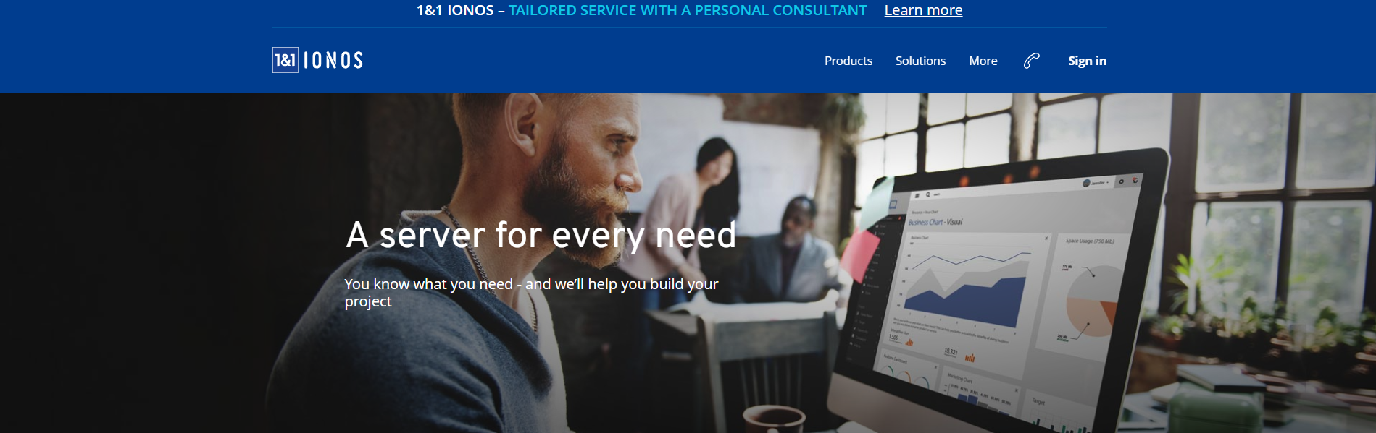
By using this website the company would have access to limited data that would be shared with the third parties that will see how the work is done. If IEEE would accept the policy of investigating project outside the UK with 3rd parties EU.
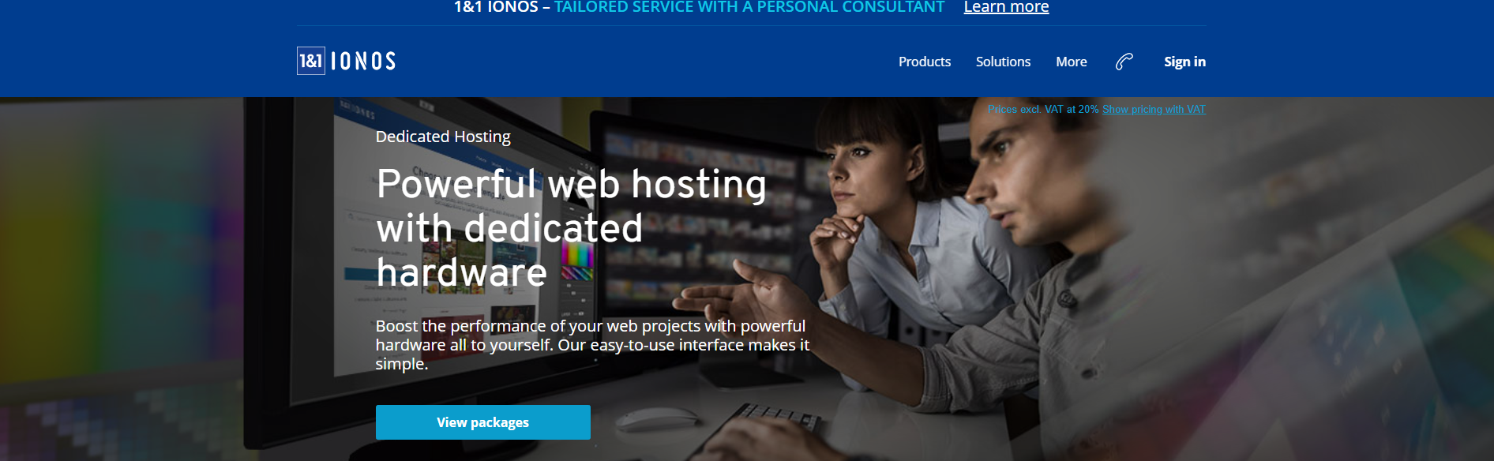
(10%)
Quality Assurance
There is no ever guarantee that project will work in all metrics. The third party might ask for the changes in last second. That will cost the designers to rush the work to make sure the deadline is met. If the changes are appearing in last minute that will cost errors mistakes and will cause to the network a leak. Or security will be corrupted by the mistakes that are caused by the third parties changes. Making sure third party have limited access to a project. Because that will cause leak of data. And the third party might use that network as they own.

A References section.
The references that would be used after the project will appear on the report.
As the good references will be used CISCO. Network the larges connector designers. That produce software’s for many network that will have access to different locations.
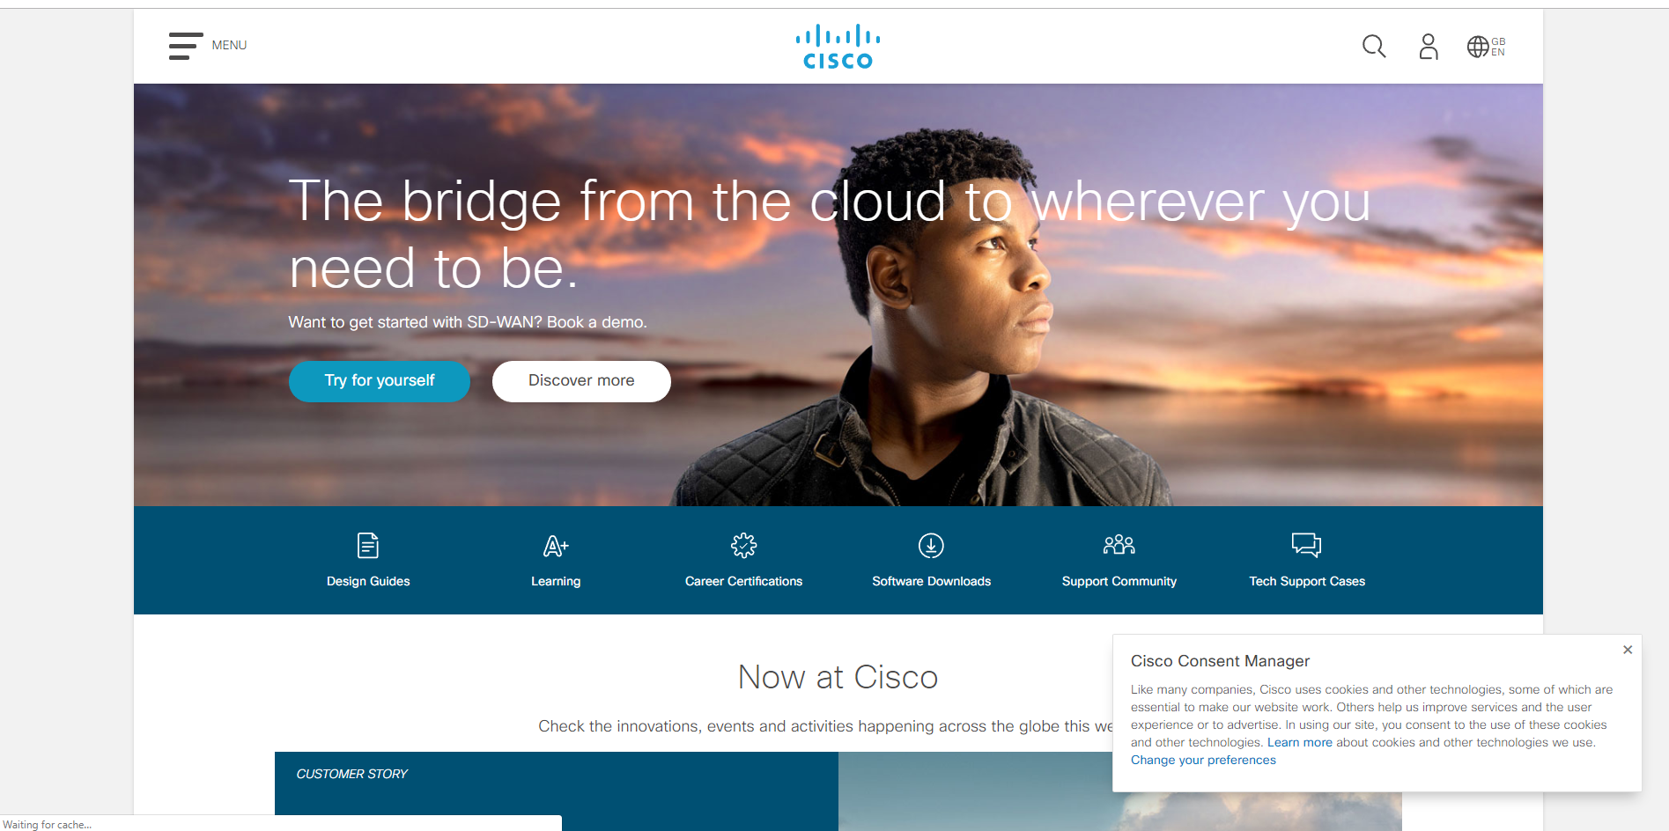
Cisco is a good example when cisco become largest network designer. Two people have design the cisco company however the name cisco become from coding. However back to a point two people design it without guarantee that the company will expand on larger scale. Now is the most powerful designer and provider.

