Student Name: Daniela Paveliuc
Student ID: 2330355
Module: Project Management
Module Code: LCLM5003
Assessment Title: Project Management Portfolio
Lecturer: Dr. Seyed Navid Nasirpourosgoei

Table of Contents
Part A- Project proposal poster 4
Part B – Reflection on Tutor and Peer Feedback 5
1. Introduction 5
2. What Went Well 5
3. What Could Be Improved 5
4. What I Learned 6
5. How I Will Improve the Final Project Plan 6
6. Conclusion 6
7. References 6
Part C- Project Management Plan 7
1. Introduction 7
1.1 Background 7
1.2 Purpose of the Report 7
2. Project Description 8
2.1 Overview of the Project 8
2.2 Project Activities 8
2.3 Project Constraints and Assumptions 8
2.4 Expected Outcomes 8
3. Scope 9
3.1 Defining Project Scope 9
3.2 In-Scope Activities 9
3.3 Out-of-Scope Activities 9
3.4 Scope Baseline and Change Control 9
4. Work Breakdown Structure 9
4.1 Purpose of the WBS 9
4.2 Project Stages 10
5. Quad Chart 10
5.1 Aim and Objectives 11
5.2 Stakeholders 11
5.3 Critical Success Factors 11
5.4 Measures of Success 12
6. Gantt Chart 12
6.1 Project Timeline 13
6.3 Schedule Control 13
7. Stakeholders’ Involvement 14
8. Allocation of Resources 14
8.1 Human Resources 14
8.2 Material Resources 14
8.3 Equipment Resources 14
8.4 Financial Resources 15
9. Risk Analysis 15
9.1 Importance of Risk Management 15
9.2 Major Risks 15
9.3 Mitigation Measures 15
10. Conclusion 15
11. References 17

Part A- Project proposal poster

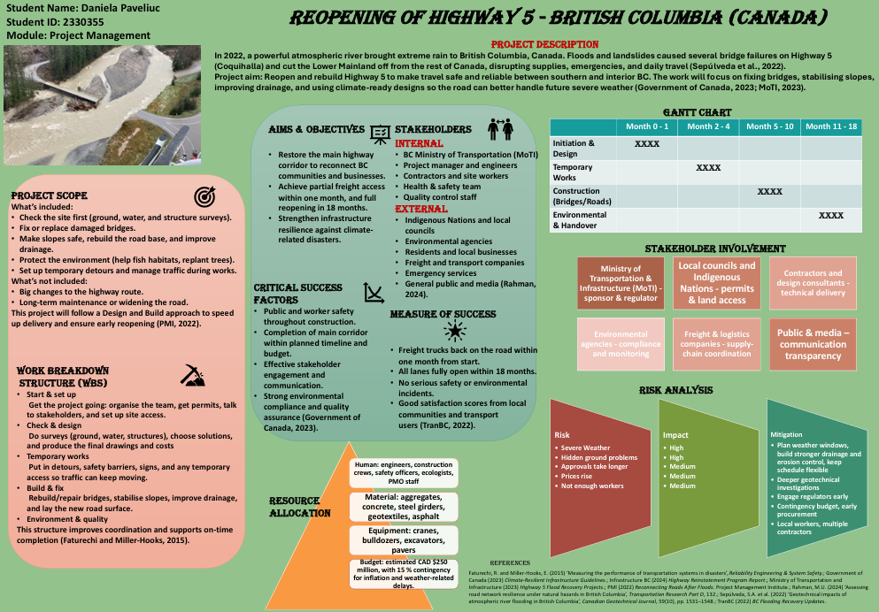

Part B – Reflection on Tutor and Peer Feedback

1. Introduction
Reflecting on feedback is an important part of developing academic and professional skills, as it helps improve future work and encourages critical thinking. According to Moon (2013), reflection supports deeper learning by helping students understand what worked well and what needs further improvement. The feedback received from my tutor and peers on my project poster for the Highway 5 reconstruction was mostly positive and highlighted both strengths and clear areas for development. This reflection discusses what I did well, what could be improved, what I learned and how I will use the feedback to strengthen the final Project Management Plan.

2. What Went Well
One of the key strengths identified in the feedback was my use of appropriate project management tools. The poster included a clearly defined project scope, a well-structured Work Breakdown Structure (WBS), a concise Quad Chart and a logical Gantt Chart. My tutor noted that these tools were not only correctly used, but also well aligned with standard project management practices. This matches Kerzner’s (2022) view that tools such as WBS and scope statements provide structure and improve communication. Peers also commented that the information on the poster was easy to follow and logically organised, suggesting the layout supported a strong understanding of the project. The Quad Chart was highlighted as a clear summary of aims, stakeholders and success factors, consistent with Forsberg, Mooz and Cotterman’s (2005) description of the Quad Chart as an effective visual tool for presenting complex project information.

3. What Could Be Improved
Although the overall structure was strong, feedback highlighted the need for improvements in numbering and formatting. Some sections of the poster lacked consistent numbering, which affected the clarity and the reader’s ability to follow the flow. My tutor pointed out that clearer ordering of sections would improve the visual and logical progression across the poster. Additionally, peers suggested that spacing and alignment between sections could be more consistent. Lock (2020) explains that presentation quality influences how information is perceived, so improving formatting will help produce a more professional final report.

4. What I Learned
The feedback helped me understand the importance of not only using the right project management tools but also presenting them in a coherent and polished way. I learned that effective communication in project management is not just about content but also about layout, consistency and readability. Feedback also made me more aware of how audiences engage with structured information, especially in visual formats like posters.

5. How I Will Improve the Final Project Plan
For the final Project Management Plan, I will apply the suggestions by first ensuring that all sections follow a clear and consistent numbering system. This will help create a stronger flow and make the report easier to navigate. I will also improve spacing, alignment and formatting to maintain a professional appearance. Additionally, based on the comments, I will expand some sections-such as stakeholder involvement and risk analysis-to demonstrate deeper understanding and critical engagement.

6. Conclusion
Overall, the feedback process was constructive and helped me recognise both strengths and areas for improvement. By applying the suggestions related to structure, numbering and clarity, I will be able to produce a more polished and academically sound final project plan.

7. References
Forsberg, K., Mooz, H. and Cotterman, H. (2005) Visualizing Project Management. 3rd ed. New York: Wiley.
Kerzner, H. (2022) Project Management: A Systems Approach to Planning, Scheduling and Controlling. 13th ed. Hoboken, NJ: Wiley.
Lock, D. (2020) Project Management. 11th ed. London: Routledge.
Moon, J. (2013) Reflection and Employability: Reflection on Learning and Employability. York: Higher Education Academy.

Part C- Project Management Plan

Reopening of Highway 5 – British Columbia (Canada)

1. Introduction

1.1 Background
In November 2022, British Columbia experienced a major natural disaster when an atmospheric river brought unprecedented levels of rainfall across the region. The extreme weather caused landslides, flooding and significant infrastructure failures. Highway 5, widely known as the Coquihalla Highway, was one of the most severely impacted routes. Several bridges collapsed, long sections of pavement were washed away, and multiple slopes became unstable, causing the highway to be closed indefinitely. According to Sepúlveda et al. (2022), the scale of geotechnical damage in this event was among the largest ever recorded in Canadian transport infrastructure.
The damage disrupted the movement of goods, delayed emergency response efforts and caused substantial economic losses. Communities that rely on Highway 5 were temporarily cut off, highlighting the vulnerability of critical transportation corridors to extreme weather events. The incident demonstrated a clear need for a structured and carefully managed project to restore the highway safely and efficiently. Restoring Highway 5 is therefore not just a construction effort but a major recovery initiative with long-term implications for economic resilience and connectivity.

1.2 Purpose of the Report
The purpose of this Project Management Plan is to outline a structured and comprehensive approach for reopening Highway 5 after the 2022 flood damage. The plan describes the project’s objectives, scope, work breakdown structure, schedule, stakeholder involvement, resource allocation and risk management. It provides clear guidance on how the reconstruction will be organised and delivered in a safe, efficient and environmentally responsible manner.

2. Project Description

2.1 Overview of the Project
The reopening of Highway 5 represents a large-scale infrastructure recovery project designed to restore a major transportation corridor in British Columbia. The highway is a critical route used by freight operators, local commuters and emergency services. It connects the Lower Mainland to the Interior and supports national supply chains. The closure of the corridor significantly disrupted commercial activities, increased shipping times and limited regional mobility. The Ministry of Transportation and Infrastructure (2023) states that Highway 5 carries nearly one-third of the province’s freight traffic, demonstrating its strategic importance.

2.2 Project Activities
The project includes a combination of assessment, design, construction and environmental restoration tasks. These activities involve the reconstruction of collapsed bridges, stabilisation of slopes, replacement of pavement, installation of improved drainage systems and restoration of damaged natural areas. The project also includes the development of temporary access routes to allow limited freight and emergency vehicles to move through the region during reconstruction. The purpose of the project is not only to rebuild what was lost but also to enhance the road’s resilience to future extreme weather events.

2.3 Project Constraints and Assumptions
Key constraints include the mountainous terrain, unpredictable weather conditions and the need to minimise disruptions to local communities. There is also a fixed estimated budget of CAD $250 million. The project assumes that materials, labour and equipment will remain available throughout the reconstruction period. It also assumes that stakeholders will collaborate and provide timely necessary approvals.

2.4 Expected Outcomes
Expected outcomes include the full reopening of Highway 5 within eighteen months, improved structural resilience, restored transportation connectivity and enhanced safety for road users. The project also aims to support long-term sustainability by integrating climate-resilient infrastructure features (Government of Canada, 2023).

3. Scope

3.1 Defining Project Scope
Project scope refers to all the work required to deliver the final project outcome. PMI (2022) emphasises that clear scope definition prevents misunderstandings, sets deliverable expectations and reduces the risk of unnecessary work. Kerzner (2022) notes that the scope also influences time, cost and quality planning.

3.2 In-Scope Activities
The project scope includes all engineering, construction and environmental activities necessary to restore Highway 5. These activities include geotechnical assessments, hydrological studies, engineering design, slope reinforcement, road reconstruction, drainage improvements and environmental restoration. Temporary access roads are also included as they enable limited transportation during construction. All reconstruction activities must meet safety, environmental and engineering standards.

3.3 Out-of-Scope Activities
The project does not include widening of lanes, major redesigns of the existing route, additional ramps or long-term maintenance activities beyond handover. Activities such as private property repairs or unrelated infrastructure upgrades are also excluded.

3.4 Scope Baseline and Change Control
The project will establish a scope baseline that includes the final scope statement, the Work Breakdown Structure and the agreed deliverables. If any changes are suggested later in the project, they must go through a structured change-control process to check how they might affect the project’s cost, schedule or quality (Meredith and Shafer, 2021). This approach helps keep all decisions clear and ensures the project stays aligned with its main objectives.

4. Work Breakdown Structure

4.1 Purpose of the WBS
The Work Breakdown Structure (WBS) divides the project into manageable sections that support planning, monitoring and control. Lock (2020) explains that breaking large projects into smaller components helps teams understand responsibilities and improves coordination.

4.2 Project Stages

4.2.1 Initiation and Mobilisation (Start & Set-up)
This stage focuses on setting up everything needed before construction can begin. It includes organising the project structure, preparing the work area, obtaining the required permits and putting initial safety and environmental measures in place. Mobilisation also involves transporting equipment and staff to the site and making sure that all communication systems are ready so the project team can coordinate effectively.

4.2.2 Assessment and Design (Check & Design)
Technical teams complete detailed geotechnical and hydrological studies to understand the full extent of the damage and determine the most suitable engineering solutions. After analysing these results, the design phase begins, where engineers prepare the necessary structural plans, drawings and technical specifications.

4.2.3 Temporary Works
Temporary access routes and short-term structural supports are constructed during this stage. They allow limited freight and emergency movement through the corridor while reconstruction progresses.

4.2.4 Main Construction (Build & Fix)
This is the most extensive stage of the project. It includes reconstructing bridges, stabilising slopes, restoring pavement and installing upgraded drainage systems. These activities are resource-intensive and require strict coordination and safety management.

4.2.5 Environmental and Quality Closure
This final stage focuses on environmental restoration, final inspections, quality assurance and project handover. All works are evaluated to ensure compliance with engineering standards and regulatory requirements.

5. Quad Chart
A Quad Chart is a project-communication tool that summarises the essential elements of a project in four concise sections, often displayed on a single page. Its purpose is to provide stakeholders with a quick, clear overview of the project’s aims, stakeholders, success factors and performance measures. According to Forsberg, Mooz and Cotterman (2005), Quad Charts support decision-making by presenting complex project information in a simple, structured format that improves clarity and alignment during project planning and review processes. In this project, the Quad Chart helps maintain a clear focus on strategic priorities and ensures that all parties share a consistent understanding of project expectations.

5.1 Aim and Objectives
The main aim of the project is to fully restore Highway 5 following the severe flood damage experienced in 2022. This requires rebuilding destroyed and weakened sections of infrastructure while also improving resilience to future extreme weather events. The objectives extend beyond simple reconstruction. They include reopening the highway within the planned eighteen-month timeframe, achieving compliance with regulatory and environmental standards, ensuring safe working conditions throughout the project lifecycle and restoring reliable mobility for freight, emergency services and the public. The objectives also seek to integrate long-term improvements, such as enhanced drainage and slope protection, so that the highway is better prepared for future climatic challenges.

5.2 Stakeholders
Stakeholders represent individuals, groups or organisations affected by the project or capable of influencing its progress. The Highway 5 reconstruction includes a wide range of stakeholders, reflecting the project’s regional significance. Internal stakeholders include engineers, construction teams, project controllers and safety personnel. External stakeholders include local communities, Indigenous Nations, environmental agencies, freight operators, local councils and regulatory authorities. Stakeholder involvement is essential because it ensures that diverse interests and concerns are considered during decision-making. As Bourne (2016) argues, effective stakeholder engagement strengthens cooperation, reduces conflict and increases project acceptance. In this context, meaningful communication with Indigenous Nations ensures respect for cultural and land-use considerations, while dialogue with freight companies and residents helps minimise disruption during construction.

5.3 Critical Success Factors
Critical success factors are the essential elements that must be achieved for the project to succeed. In the case of Highway 5, strong communication across project teams is vital because the reconstruction involves multiple disciplines and tight scheduling. Effective scheduling and coordination are equally important, as delays in one activity can affect the entire timeline. Safety is another crucial factor due to the hazardous nature of construction in mountainous areas and post-disaster conditions. Environmental compliance also plays a significant role, as the project must meet regulatory expectations regarding drainage, slope stability and habitat restoration. Finally, accurate engineering assessments with all structural decisions, ensure that reconstructed elements can withstand future extreme weather, and the project progresses efficiently, safely and to the required standards.

5.4 Measures of Success
Measures of success provide a way to evaluate whether the project has met its objectives. For the reopening of Highway 5, one key measure is the timely restoration of partial freight access, followed by full reopening within the planned eighteen-month period. Safety performance is another essential measure, with success defined as the absence of major incidents or injuries throughout construction. Environmental measures of success include meeting all regulatory requirements and completing habitat restoration without compliance issues. Stakeholder satisfaction will also serve as an important indicator, assessed through feedback from local communities, Indigenous groups, freight operators and regulatory agencies. All demonstrates that the project has restored highway functionality, deliver long-term resilience, maintaining trust with affected groups.

6. Gantt Chart
A Gantt chart is a time-based scheduling tool that illustrates the duration and sequence of project activities across a timeline. Lock (2020) states that Gantt charts are widely used because they clearly visualise task dependencies, overlaps and progress, supporting effective project coordination.
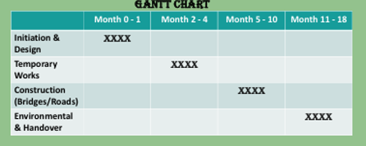

6.1 Project Timeline

6.1.1 Initiation and Design
During the first two months, the project team establishes governance arrangements, communication structures and safety procedures. Early site inspections are carried out to understand the condition of damaged areas and confirm where detailed investigations should be focused. Basic design activities also begin at this stage, including reviewing existing infrastructure drawings and preparing initial engineering concepts.

6.1.2 Temporary Works
These works include temporary detours, signage, short-term drainage solutions and basic slope-support measures. This stage also allows freight operators and emergency services to regain controlled access to the corridor. Alongside this, more detailed geotechnical and hydrological investigations continue so that the final construction plans can be completed with accurate data.

6.1.3 Main Construction
Work includes rebuilding damaged bridges, stabilising slopes, reconstructing road surfaces and installing improved drainage infrastructure. The activities in this stage require close coordination between different engineering and construction teams to ensure that all structures meet safety and quality standards. Environmental considerations are also incorporated throughout this phase to ensure compliance with provincial requirements.

6.1.4 Environmental and Handover
The final stage runs from month eleven to month eighteen and focuses on environmental restoration, quality inspections and regulatory clearance. Restoration work includes vegetation repair, erosion control and rehabilitation of natural areas affected by construction. Quality and safety inspections are completed to confirm that the reconstructed highway meets required standards. Once all documentation, inspections and regulatory approvals are finalised, the highway is prepared for reopening and long-term operation.

6.3 Schedule Control
Effective schedule control is essential to ensure that the project stays within the planned eighteen-month timeframe. Progress is monitored through regular milestone reviews, performance reports and comparisons between planned and actual progress.
Coordination meetings are held frequently to support communication between engineers, contractors and environmental specialists. These meetings help identify emerging issues quickly and allow the team to respond before delays escalate. Maintaining strong schedule control ensures that the project remains on course and that disruptions to freight operators, local communities and emergency services are minimised.

7. Stakeholders’ Involvement
Stakeholder involvement is critical in ensuring that reconstruction meets community needs, regulatory requirements and technical expectations. Freeman (1984) emphasises that stakeholders influence project success and must be considered in decision-making.
Internal stakeholders include engineers, construction crews, project managers, safety officers and administrative staff. They contribute directly to planning and execution.
External stakeholders include local communities, Indigenous Nations, environmental organisations, freight companies, government authorities and emergency services. Their input helps ensure that reconstruction activities consider environmental and social impacts.
Engagement will be supported through regular updates, consultation meetings, public notices and transparent communication channels. Walker (2019) argues that structured communication reduces conflict and improves project acceptance.

8. Allocation of Resources

8.1 Human Resources
The project requires skilled engineers, construction personnel, environmental specialists, geotechnical experts and project managers. Workforce planning ensures that personnel are deployed efficiently during peak activity periods.

8.2 Material Resources
Key materials include concrete, steel, aggregate, drainage pipes and erosion-control systems. Heavy machinery such as excavators, cranes and pavers is required for major construction tasks. Procurement planning helps prevent delays.

8.3 Equipment Resources
The project requires a wide range of equipment resources to support major construction activities along Highway 5. These include heavy machinery such as cranes, bulldozers, excavators, pavers, articulated trucks and compaction equipment. Access to reliable machinery is essential for bridge reconstruction, slope stabilisation, road resurfacing and drainage installation. Effective equipment planning ensures that machinery is available when needed, reduces downtime and helps maintain progress during peak construction periods.

8.4 Financial Resources
The CAD $250 million budget covers design, construction, environmental work and contingency costs. Continuous financial monitoring ensures spending aligns with forecasts (OGC, 2009).

9. Risk Analysis

9.1 Importance of Risk Management
Risk analysis is essential in post-disaster reconstruction because of unpredictable environmental conditions and technical uncertainties. Hillson and Murray-Webster (2017) emphasise that early risk identification supports more effective mitigation.

9.2 Major Risks
Major risks include severe weather, ground instability, supply-chain delays, inflation, labour shortages, environmental non-compliance and safety incidents. These risks can significantly affect the schedule and budget.

9.3 Mitigation Measures
Weather risks will be mitigated through flexible scheduling and monitoring systems. Geotechnical assessments and reinforcement address slope instability. Supply disruptions will be managed through early procurement and multiple suppliers. Safety protocols and regular inspections will reduce accident risks. Vose (2019) suggests that quantitative analysis can further support decision-making by estimating the likelihood of delays.

10. Conclusion
The reopening of Highway 5 is essential for restoring connectivity, supporting economic stability and improving community resilience after the 2022 floods. This Project Management Plan outlines the structured approach needed to restore the highway safely, efficiently and sustainably.
By integrating effective planning, stakeholder engagement, strong resource management and proactive risk control, the project aims to deliver a resilient and fully operational transportation corridor. Once completed, the reconstructed Highway 5 will provide long-term benefits to the province and its communities.

11. References
- Bourne, L. (2016) Stakeholder Relationship Management: A Maturity Model for Organisational Implementation. 2nd ed. London: Routledge.
- Faturechi, R. and Miller-Hooks, E. (2015) ‘Measuring the performance of transportation systems in disasters’, Reliability Engineering & System Safety, 156, pp. 89–102.
- Fleming, Q.W. and Koppelman, J.M. (2016) Earned Value Project Management. 4th ed. New York: PMI.
- Freeman, R.E. (1984) Strategic Management: A Stakeholder Approach. Boston: Pitman.
- Forsberg, K., Mooz, H. and Cotterman, H. (2005) Visualizing Project Management. 3rd ed. New York: Wiley.
- Government of Canada (2023) Climate-Resilient Infrastructure Guidelines. Available at: https://www.infrastructure.gc.ca
- Hillson, D. and Murray-Webster, R. (2017) Understanding and Managing Risk Attitude. 3rd ed. London: Routledge.
- Kerzner, H. (2022) Project Management: A Systems Approach to Planning, Scheduling and Controlling. 13th ed. Hoboken, NJ: Wiley.
- Lock, D. (2020) Project Management. 11th ed. London: Routledge.
- Meredith, J.R. and Shafer, S.M. (2021) Project Management: A Strategic Managerial Approach. 12th ed. Hoboken, NJ: Wiley.
- Ministry of Transportation and Infrastructure (2023) Highway 5 Flood Recovery Projects. Available at: https://www2.gov.bc.ca
- OGC (Office of Government Commerce) (2009) Managing Successful Projects with PRINCE2. 5th ed. London: TSO.
- PMI (Project Management Institute) (2022) PMBOK Guide – Seventh Edition. Newtown Square, PA: PMI.
- Sepúlveda, S.A. et al. (2022) ‘Geotechnical impacts of atmospheric-river flooding in British Columbia’, Canadian Geotechnical Journal, 59(10), pp. 1531–1548.
- Turner, J.R. (2020) Handbook of Project Management. 5th ed. London: Routledge.
United Nations (2022) Sustainable Development Goals Report 2022. New York: UN.
- Vose, D. (2019) Risk Analysis: A Quantitative Guide. 4th ed. Chichester: Wiley.
- Walker, D. (2019) Project Management Leadership: Building Creative Teams. 2nd ed. Oxford: Wiley-Blackwell.

