ASSIGNMENT TITLE: REFLECTION ON MY LEARNING IN THIS MODULE
NAME: RAMONA DORELIA STEFAN
STUDENT ID :2022359
LECTURER: RITA UKACHI - LOIS
MODULE CODE: BMSW 4001
MODULE NAME: ACADEMIC AND EMPLOYABILITY SKILLS
LEVEL 4: CERTIFICATE IN HIGHER EDUCATION: HEALTH AND SOCIAL CARE, APRIL 2020

TABLE OF CONTENTS
INTRODUCTION 2
TASK 2 3
TIME MANAGEMENT 5
REFERENCING 7
ACADEMIC WRITING 8
PUBLIC SPEAKING AND GIVING PRESENTATIONS 9
CONCLUSION 11
REFERENCE 12

INTRODUCTION
The module 'Employability and Academic skills' has helped me realise the importance of skills that I require in order to maximise efficiency. In this report, I will use two reflective models namely Gibbs and Kolb's reflective cycle. In this report, I will reflect on my experiences on four skills that were taught to me in the module, and they are time management, referencing, academic writing and public speaking.

TASK 2
In this reflection, I have used two reflective models. They are Gibbs reflective cycle (1988) and Kolb reflective cycle (1984). These models will help me in writing this reflection more effectively.
GIBBS REFLECTIVE CYCLE
According to Sekarwinahyu et al., (2019), Gibbs reflective cycle is one of the most widely recognised Reflective model and consist of six stages for evaluating a particular skill or situation. I have decided to use Gibbs Reflective cycle because it is easy to understand and effective for beginners in reflective writing.
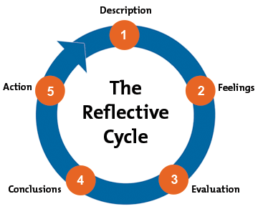
Figure 1: Gibbs Reflective Cycle
Source: (Sekarwinahyu et al., 2019).

KOLB’S REFLECTIVE CYCLE
According to Konak, Clark and Nasereddin (2014), Kolb’s model is also widely recognised as ‘experimental learning’ and consist of three stages. I have decided to use this model because it is more ‘flexible’ and helps to meet the requirements of a particular situation. Upon completing this model, I will be able to use that skill practically too.
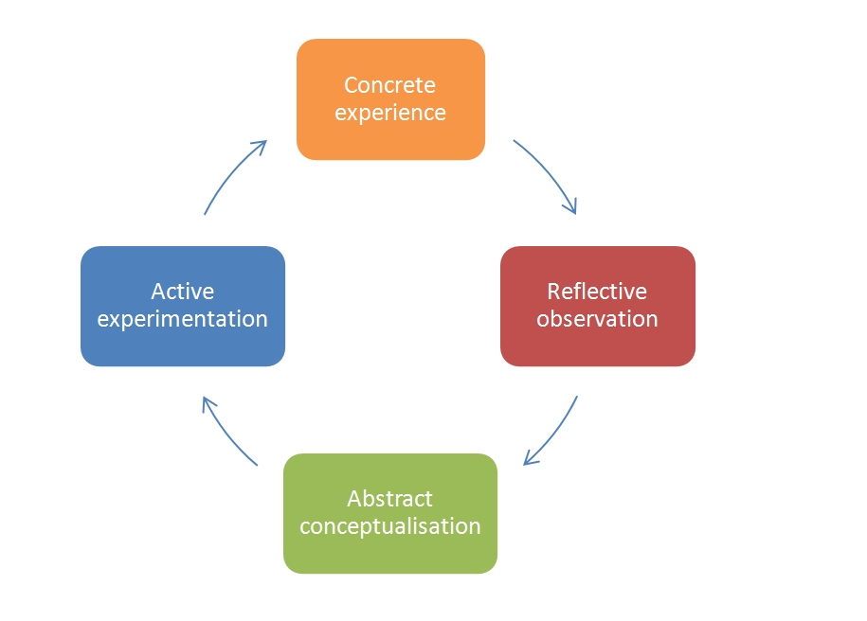
Figure 2: Kolb's Reflective cycle
Source: (Clark and Nasereddin, 2014).

TIME MANAGEMENT
According to Sainz, Ferrero and Ugidos, (2019), time management is important for both academic and professional life. I have recognised if I don’t manage my time efficiently, I will academically and professionally.
Description: While studying this module, I was asked to submit my report by the end of the week. I have also enrolled myself in the sports club. I had to dedicate my time to that club too. Initially, for the first two days, I wasted my time and wasn't able to start writing my report. After attending the class related to time management of this module, I was able to realise how important time management is. Since I have lost a significant amount of time for making the report, I decided to schedule my activities for the day and follow it. Due to my effective management of time I was able to submit my report just before the deadline.
Feelings: Initially when after losing two days, I was not sure if I will be able to complete my report. After attending the classes related to time management skills I was inspired to schedule my day. I am happy that I managed to submit my report before the deadline. I wish that I have realised the importance of time management earlier, since I lost two days, I was not able to proofread my documents. The work I submitted was not the best I have done to date.
Evaluation: this experience had several good and bad aspects. Due to this experience, I have realised that time management is important to make effective use of my time. Another good thing about this experience is that I managed to submit my report before the deadline. The bad aspect was that I realised the importance of time management after losing two days and I was not able to proofread my documents, which will result in me losing marks for the assignment.
Analysis: I think that the reason I lost my two days due to my overconfidence that I am sure I will not be able to submit the assignment. I have discovered that I did not look into the solutions and just assumed that I will not be able to complete my assignment from the first day.
Since I concluded that there is no way I will be able to complete my work, I did not start writing it. After I attended the class related to time management, I realised that I haven’t lost much time and can still work on it. From the class, I understood that if I make a to-do list and schedule my day by allocating particular time to each activity, I will be able to manage my time. After I searched on Literature I realised that according to Sainz et al., (2019), time management is essential for maximising the productivity of one’s day. Therefore, I made to-do lists for scheduling my day.
Conclusion: I have learned that overconfidence and quickly giving up will not help me in my life. I also realised that when I receive an assignment, it is important for me to allocate the days I will be dedicated to a particular section of the report. I will continue to schedule my day by to-do lists so that I can maximise my productivity. Lastly, I learned that I will face difficulties but instead of giving up, I should look for the situations.
Action plan: Whenever I will be assigned an assignment, firstly I will analyse how much time a particular section will require then divide the time accordingly. I will also save one day, where I will proofread my document. I will also try to schedule my days so that I don't miss any deadline. I can also use the 'Eisenhower matrix' to schedule task according to their urgency.

REFERENCING
Referencing is necessary Santini, (2018), referencing is necessary to make the paper more credible. It is also crucial to respect as well as acknowledge the author, whose ideas are using in one's paper. I have used Kolb's reflective cycle for this part.
Concrete Experience: When I received my assignment, which was graded by the teacher, I realised that there are several parts of the referencing in which I was scored good marks and, in some part, there were some mistakes. I think that I have basic knowledge of referencing, and I need to work on the skill.
Reflective observation: After analysing and observing my assignment, I realised that in the parts where I mentioned journals and books, I have lost marks and wherever I have mentioned and referenced the website, I have scored good marks. This situation originated because I have referred to several online articles about website referencing, but didn’t pay much attention to the journal and book’s referencing.
Abstract Conceptualisation: This situation wouldn’t have originated if I have paid attention to the book and journal references. I can improve by reading literature about the correct way of doing referencing books and journal. According to Neville (2010), while referencing a journal and article it is important to mention the page number from where the idea was referenced. I realised that although I remember the title of the book, I didn't remember the page number. Therefore, I will write the edition, title and page number of the book and journal.
Active experimentation: After the assignment, when I received a new assignment, I started writing down the page numbers, edition and tile of the book and journal which I was referencing. I also took help from my senior who proofread my referencing and told me about the mistakes. This strategy was very helpful for me since I was able to score better marks in the referencing parameter.

ACADEMIC WRITING
I am quite efficient with academic writing. It is also an important part of my academic life and it will contribute to my grades too. I have used Kolb’s reflective cycle for this part.
Concrete experience: I realised that I am good at academic writing and I should reflect upon it after I received my graded assignment. I have scored good marks on the assignment I submitted. The teacher positively commented on the amount of research I have done before writing my assignment. The teacher also mentioned that my style of writing was also appropriate.
Reflective observation: From the experience, I realised that I am efficient in academic writing and if I submit my assignment well before the deadline, I can upgrade my grades with the help of my assignments. From the teacher's comment, it can also be observed that the teacher evaluates the amount of research I have done in the assignment. Therefore, before writing an assignment, I will make sure that I put lots of efforts into the research.
Abstract Conceptualisation: Even though I scored good marks in academic writing, I realised that I have made several grammatical mistakes and to rectify it I study literature about English grammar. I can also use an application like Grammarly which will help e rectify my errors.
Abstract Conceptualisation: Whenever I will get the next assignment, I will start doing it as soon as I receive it. This will provide me with enough time to research it. I will also apply the knowledge of grammar that I have acquired by studying kinds of literature. I will also ask someone to point out my grammatical mistakes.

PUBLIC SPEAKING AND GIVING PRESENTATIONS
Public speaking is also crucial since, in business operations, one is required to speak before several people (Beebe and Beebe, 2010). From this module, I have also realised that I don’t possess public speaking skills. I have used Gibbs reflective cycle to reflect upon my experience.
Description: As a part of the public speaking assignment, I was asked to present a topic on a topic. We were sorted into groups, and we had to present a particular part of the presentation. I was asked to start the presentation. I accepted it although I wanted to deny it, I couldn't do it since I am an introvert. My group decided that there is no need to practice together, instead, we should just practice our part and present it on the day of the presentation. I did not perform well because I was nervous and since I had the introductory part, it severely affected my group's presentation too.
Feelings: I was really disappointed that because of me, my team wasn't able to perform well. I was also motivated to work rigorously on my public speaking skills. I was frustrated with myself too because I was not able to put my opinion in front of my teammates about my inability to present the introductory part.
Evaluation: There were good and bad parts to this experience. The bad part was that due to my public speaking skills, I ruined the flow of the presentation. Another bad part was that I wasn't able to talk to colleagues about my inability to do the introductory part. The good part about this experience was that I am now motivated to work on public speaking skills. Another thing that went well was that my colleagues approached me and told me that they will help me whenever we will be grouped together for a presentation.
Analysis: After the analysis of the literature, I have understood that every team member can be categorised according to Belbin's team roles. This categorisation is based on one's strengths and weaknesses (Belbin, 2012). We should have used these roles to delegate responsibilities according to individual strengths and weaknesses. Another theory that was relevant to our situation was 'groupthink'. According to Hahn Judd and Park, (2010), this happened when group member doesn’t feel they belong to the group and doesn’t present their opinion since they think they are ‘outsider’. Along with me, few members of our group felt like an outsider.
Conclusion: From this experience, I have realised that I am not good at public speaking skills and giving a presentation. I have also realised that it is important for me to put my opinion even if I am uncomfortable because if I don't I will end up in situations like these. It can also be concluded that in group activities, tasks should be delegated according to the strengths.
Action plan: I have decided that I need to put a lot of efforts into my public speaking. Therefore, I have decided to enrol myself in the public speaking club. These clubs will organise events where I will get the opportunity to speak in front of people. From this and lots of practice, I will get better in public speaking skills.

CONCLUSION
From this report, it can be concluded that there are several skills which I possess and there are several skills which I need to work on. In this report, I have reflected upon four skills namely, time management, academic writing, public speaking and referencing by using two models of reflection, they are, Gibbs and Kolb’s reflective cycle.

REFERENCE
Beebe, S.A. and Beebe, S.J., 2010. Public speaking handbook. Allyn & Bacon.
Belbin, R.M., 2012. Team roles at work. Routledge.
Hahn, A., Judd, C.M. and Park, B., 2010. Thinking about group differences: Ideologies and national identities. Psychological Inquiry, 21(2), pp.120-126.
Konak, A., Clark, T.K. and Nasereddin, M., 2014. Using Kolb's Experiential Learning Cycle to improve student learning in virtual computer laboratories. Computers & Education, 72, pp.11-22.
Neville, C., 2010. The complete guide to referencing and avoiding plagiarism. McGraw-Hill Education (UK).
Sainz, M.A., Ferrero, A.M. and Ugidos, A., 2019. Time management: skills to learn and put into practice. Education+ Training.
Santini, A., 2018. The importance of referencing. The Journal of Critical Care Medicine, 4(1), pp.3-4.
Sekarwinahyu, M., Rustaman, N.Y., Widodo, A. and Riandi, R., 2019, February. Development of problem based learning for online tutorial program in plant development using Gibbs’ reflective cycle and e-portfolio to enhance reflective thinking skills. In Journal of Physics: Conference Series (Vol. 1157, No. 2, p. 022099). IOP Publishing.

