Managing Projects In The Organisation
Vintners Antiques
Muminur Rahman
1711386
Lecturer/ Mr Ernest Ovia

Table of Contents
Table of Contents 2
Introduction 3
Description of the organisation associated with the undertaken project 4
Critical Assessment of the risk factors associated with the project 4
Description of the project management tools and techniques being used for the new project 6
Communication with the stakeholders of the project 9
Personal reflection on managing the entire project with future recommendation and self- development plan to improve own performance. 10
Conclusion 12
References 13
Appendix 14

Introduction
Project management play a major role in the business and management. It is important for each and every business organisation to use the proper methods and techniques of project management in order to handle the project. It is the responsibility of the management of the business organisation to ensure the profitability as well as effectivity and efficiency of the project before starting it. This is why in any business organisation project management play a major role. With the help of project management, the management of the business organisation can ensure the profitability of the project. Also, the project management can help the business organisation in ensuring the smooth running of the project from the starting to completion. In this document we will discuss regarding a particular project of introducing the antique products in the market. The shop we have used for example in this project is named as Vintners Antique Shop. In this document we will discuss various tools techniques and methods which we have used in the project of introduction of the antique products in the market from the Vintners Antique Shop. Also, different other aspect of project management location with the stakeholders as well as recommendation and plan for self-improvement has been discussed in this report.

Description of the organisation associated with the undertaken project
The project is being developed for an antique shop named Vintners Antique. As the name suggests, the organisation deals in selling antiques to end users. The business mainly targets the people interested in collecting antiques, especially the tourist groups. Vintners Antique shop stocks up several antique pieces that such as vintage clocks, vases, coins, dolls, toys, antique furniture, artistic works and several types of crafts. These antique products are generally collected from different country shops, antique centres, antique stalls, auctions, fairs, age- old mansions and such other places. These collected antiques are then sold at the shops and even online. The business procures these antique prices from across different countries and sells them to the consumers. The collection of antiques at the Vintners is unique, historical, quirky as well as artistic. There are different types of objects to choose from. The warehouse of Vintners Antiques is located at Sparkhill and the warehouse is fully stocked up with antiques of different kinds.
The project is about moving the warehouse of Vintners Antiques from Sparkhill to the city centre of Birmingham or Central Birmingham. The business has planned to move into a larger and more spacious warehouse in the city centre of Birmingham wherein the antiques can be stored in a proper and organised manner. This will reduce the risk of breaking any of the antique pieces or any other type of destruction or damage of stock. Hence, the project that has been undertaken is associated with the moving of Vintners Antiques’ warehouse from Stratford road Birmingham to the Birmingham city centre.

Critical Assessment of the risk factors associated with the project
In project management, risks are inherent. Risks can be defined as the uncertain events that may occur during the project and may negatively impact the project as well (Pielichaty et al., 2017). There are several risks involved in moving the warehouse of the considered business, Vintners Antiques. As it has been mentioned, the warehouse will be moved from Stratford road to the city centre of Birmingham which is the central place for business and is surrounded by business places. The project, thus, involves different risks that may be incurred during the project. These risks have been assessed below:
Operational risks- The operational risks are those which occur during the Operations of the project. These risks often obstruct the activities of the project and may delay the project delivery or completion.
Financial risks- The financial risks are the risks associated with the finances or funds of the project. These risks are required to be control so as to ensure that the financial resources are properly used in the project.
Safety and security risks- The safety and security risks are the ones associated with the safety of the people involved in the project or the project team (Meredith et al., 2017).
Below, few of the identified risks associated with the present project of Vintners Antiques have been assessed.
Risks | Likelihood | Impact | Mitigating actions
New competitors or high competition | High | Medium | - Prior strategic planning to launch in Birmingham city  - Planning the structuring and organisation of store  - Creating awareness among the consumers, especially tourists
Non- compliance to legislations | Medium | Medium | - Research and study of legislations related to the operating of a business  - Planning business activities in accordance with the legislations (Cleden, 2017)
Formalities and legalities (like permit from council) | Low | Medium | - Establish healthy relations with authoritative bodies  - Following ethical ways of doing business  - Planning the communication with council to approve the permit for the business
Shortage of funds | Low | Medium | - Implementing budget from the initial stage  - Implementation of cost control methods (Kliem and Ludin, 2019)
Hazards in transportation of stock | High | High | - Planning and communicating with transportation services company  - Guiding them with the route  - Tracking the vehicle
Damage of stock | High | High | - Loading the stock carefully into vehicles  - Packaging the stock effectively and efficiently
Security issues | Medium | Medium | - Monitoring the stock through CCTV cameras  - Implementation of inventory management system (Kliem and Ludin, 2019)
Equipment defect or failure | Low | Medium | - Keeping a backup ready  - Hiring a team of repairs and maintenance work
Safety of employees | Medium | High | - Providing employees with helmets, gloves etc.  - Arrangement of first aid (Qazi et al., 2016)

These are few identified risks associated with the project and it is necessary to develop a proper risk management system so as to ensure that these risks do not adversely impact the project.

Description of the project management tools and techniques being used for the new project
In project management, there are different tools used by project managers to ensure that the activities of the project take place effectively and that the project objectives are achieved. The tools that have been used for this project have been discussed below:
Iron triangle – The iron triangle shows the different key factors of the project. It is a model that is used by project management that shows the constraints of project management. These key factors as shown in the iron triangle determine the overall success of the project and its delivery as well.
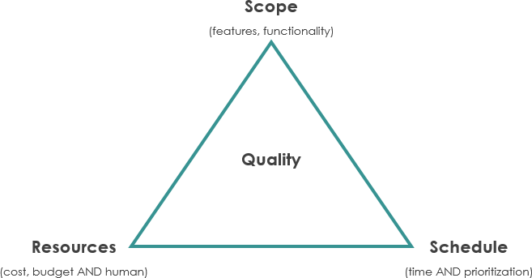
Iron Triangle
Source: www.visual-paradigm.com
There are three main aspects that the iron triangle presents:
- Resources- The key resources are the funds or cot of the project and the human resources
- Scope of the project- This is referred to as the total amount of work or activities involved in the project.
- Schedule- The project schedule is the time estimation or allocation to each project activity and delivery
These key factors of the iron triangle determine the overall quality of the project. In other words, the proper and effective management of the resources, project scope and schedule ensures that a high-quality project is delivered and this increases the satisfaction of stakeholders (Locke, 2007).
User stories- The project management tool of user stories is basically a natural and informal description of the product or software development from the viewpoint of an end-user. This tool describes what the user wants and why as well as the type of user. These user stories can be written by various stakeholders of the project such as managers, team members, users and such others (Berteig, 2019).
Steering group – A steering group in project management is basically formed to oversee the project or monitor the overall activities of the project. The main responsibility of the steering group is to oversee whether or not the protocols are being followed, what errors are there as well as the group provides advice and troubleshoot wherever necessary (Rew et al., 2020).
Sponsor- The sponsor is basically the person or group who owns the project and provides it with the necessary resources and support in order for the project to be successful. The project sponsor acts as the link between the project, the users and the other decision-making groups.
Chevron (MoSCoW)- The MoSCoW technique or method that is used for prioritisation in projects. This prioritisation is made easier through the use of this MoSCoW method.
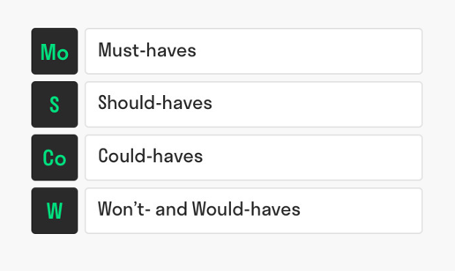
MoSCoW
Source: www.toolshero.com
- Must-haves are minimal requirements that are determined in advance to achieve the end-result of the project. In this project, the human resources, financial resources are the must-haves.
- Should-haves are the additional requirements that are much desired and are of high priority. Here, steering group is an example of should-haves.
- Could-haves are the requirements that can be considered when there is additional time left. In this project, additional could-haves can be a separate packaging team.
- Won’t haves are the wishes that are often not possible due to cost or time. In this project, the wont haves will be additional cars to move stock in smaller numbers (Heagney and Lewis, 2016).
Gantt chart- A Gantt chart is basically a schedule that shows the estimated time required for each activity of the project and the total time required to complete the project (Eskerod and Jepsen, 2016). A basic Gantt chart looks like the following:
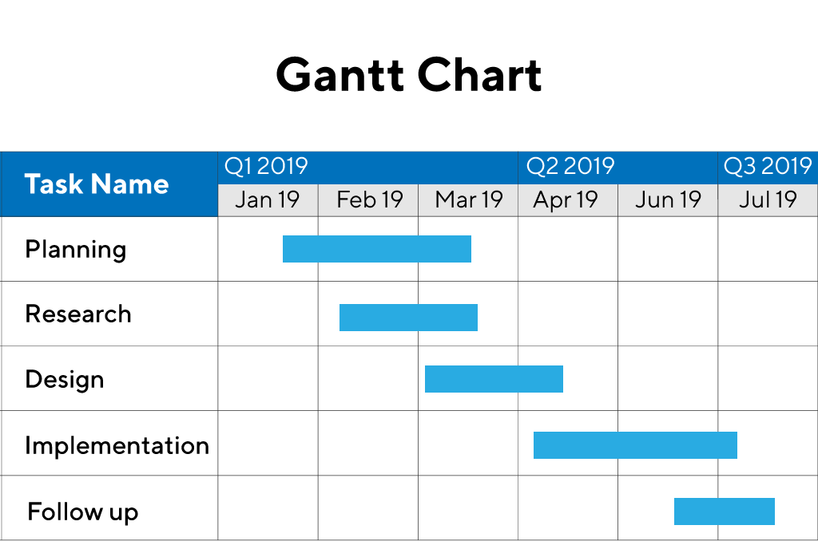
Gantt Chart
Source: www.productplan.com

Communication with the stakeholders of the project
The communication strategy with each of the project stakeholders have been provided in the table below:
Stakeholders | Communication
Vintners Antiques | The communication with Vintners Antiques will take place through meetings mostly. These would be stand- up meetings where the update of the project can be communicated to the stakeholder. Further, skype calls, video chats, phone calls, texts messages and emails will be used whenever necessary.
Project team members | The project team members are required to coordinate in a proper and effective manner and in order to do so informal meetings will be conducted on a weekly basis, besides the daily interactions (Eskerod and Jepsen, 2016). Further, skype calls will also be used and in order to communicate any details or information of the project formal emails will be used. The communication will often take place through steering group and sponsor as well.
Project Manager | The project manager can be communicated through meetings that will take place on a weekly basis, though daily interactions, phone calls and skype calls (Meredith et al., 2017).

These communication strategies have been planned in order to communicate with the project stakeholders. It is necessary to ensure that the communication channels are well- planned and established so as to ensure that the communication between the stakeholders are proper and the project progresses with thorough coordination and cooperation (Medredith et al., 2017).

Personal reflection on managing the entire project with future recommendation and self- development plan to improve own performance.
In the considered project of Vintners Antiques, it is important for me to reflect on my own performance throughout the completion of the project and to analyse the work I have done. To work in a team has its own advantages and disadvantages and throughout the project I realised what needs to be improved in me and what I can do to perform better in future. The project team had been formed in a proper manner and I was a team member. Initially, it had been difficult to adjust and agree to the opinions of others which often led to conflicts among the team members. I understood that I have to develop the skills of listening patiently and trying to understand what the other person wants to communicate. I also need to develop the skill of decision- making as well. However, I realised that I have developed the skills of planning and organising throughout this project and this project has given me the opportunity to develop these skills as I helped in planning and allocation of responsibilities.
Below, a self- improvement plan has been developed which will help me to perform better and in a more effective manner in the future.
Skills I need to develop or improve? | What resources are required to improve? | How will I measure my improvement? | How long will I take to make this improvement?
Listening | - I will need to practice listening daily  - Participate in more team activities  - Listening to friends and family members | - Take feedback from friends, family and supervisors  - Assess my performance in other team activities | Through regular practice, I will be able to improve my listening skills within one month.
Decision- making | - Practice decision making in daily life  - Lead team activities  - Undertake group work and make decisions for the group | - Take feedback from family and friends  - Evaluate the outcomes of the decisions taken  - Reflect on the daily decisions | One month to two months
Conflict management | - Understand what others try to communicate  - Practice looking at positive aspects of the conflicts  - Undertake team work | - Evaluate the outcomes of team work  - Reflect on the activities of the group work  - Self-evaluation | One month (through frequent practice)
Communication | - Listen to public speakers  - Practice communication at home and with friends  - Practice communicating ideas clearly  - Read books and podcasts | - Take feedback from friends  - Self- evaluation through recording communications | Two months (after thorough practice)

Conclusion
In the conclusion of this document we can say that it is important for each and every project manager to ensure the profitability as well as the successful completion of the project. This is why it is important for the project manager to use the proper strategies method and planning tools in order to prepare the planning for the successful completion of the project. In this case scenario it is the responsibility of the project manager to complete the project successfully as well as help the business in running smoothly by providing highest quality of product to the customers of the business organisation. Also it is the responsibility of the project manager to minimise the risk of the project. Also from the above discussion we can easily understand that there are different kind of tools and techniques are available which will help the project manager analysis and evaluation of the scenario of the project. In this way it will be easier for the project manager to ensure both of the profitability and successful completion of the project. Also as a team member it is important for myself to evaluate and analyse my performance and the strategies prepared by me for the completion of the project. With the help of self-improvement it will be easier for me to continue the project and improve the performance of both of the project and myself.
Below is a original copy of the Gantt chart.

References
Berteig, M. 2019. User Stories and Story Splitting - Agile Advice. [online] Agile Advice. Available at: http://www.agileadvice.com/2014/03/06/referenceinformation/user-stories-and-story-splitting/ [Accessed 29 Dec. 2019].
Cleden, D., 2017. Managing project uncertainty. Routledge.
Eskerod, P. and Jepsen, A.L., 2016. Project stakeholder management. Routledge.
Heagney, J. and Lewis, J. 2016. Fundamentals of project management. New York: Amacom, American Management Association.Kahneman, D. and Egan, P. (2011).
Kliem, R.L. and Ludin, I.S., 2019. Reducing project risk. Routledge.
Locke, D. 2007. Project Management. 9th ed. Aldershot:Gower Publishing Limited, p.21.
Meredith, J.R., Mantel Jr, S.J. and Shafer, S.M., 2017. Project management: a managerial approach. John Wiley & Sons.
Pielichaty, H., Els, G., Reed, I. and Mawer, V., 2016. Events project management. Routledge.
Qazi, A., Quigley, J., Dickson, A. and Kirytopoulos, K., 2016. Project Complexity and Risk Management (ProCRiM): Towards modelling project complexity driven risk paths in construction projects. International journal of project management, 34(7), pp.1183-1198.
Rew, L., Cauvin, S., Cengiz, A., Pretorius, K. and Johnson, K., 2020. Application of project management tools and techniques to support nursing intervention research. Nursing Outlook.

Appendix

