Synthesize a Solution to a Potential Real-Life Scenario
Networks and Cyber-Security Essentials
Noah John (2502346)

Contents
1.0 Introduction 2
2.0 Identification of Modern Threats 2
2.1 Ransomware-as-a-Service (RaaS) 2
2.2 AI-Powered Social Engineering (Vishing) 2
2.3 Supply Chain Vulnerabilities 2
2.4 Cloud and Hybrid Work Risks 2
3.0 Modern Security Policies 3
3.1 Policy 1: Identity-First Authentication 3
3.2 Policy 2: Principle of Least Privilege (PoLP) 3
3.3 Policy 3: Device Compliance 3
4.0 Technical Mitigation Measures 3
5.0 Proactive Monitoring and Incident Response 4
6.0 Continuous Training and Awareness 4
6.1 Role-Specific Simulations 4
6.2 Just-in-Time Training 4
6.3 Incentivised Reporting 4
7.0 Conclusion 5
8.0 Reference List 5

1.0 Introduction
As technological landscape grows in complexity year over year, the potential threats to companies only become more sophisticated. According to Picus [1], financial service firms are up to 300 times more susceptible to said threats. This poses operational and reputational danger due to the vast amount of valuable sensitive data contained in company systems. Vigilant Trust & Asset Management (VTAM) has experienced the reality of these statistics in recent months, narrowly avoiding exposure via advanced phishing and ransomware attacks leaving the company vulnerable to more attacks soon. It’s essential moving forward that the company implements a thorough Zero Trust framework to modernise their security posture. This report synthesises a solution that identifies modern threats, proposes NIST CSF, ISO 27001, MFA and SIEM aligned policies and mitigation measures, continuous monitoring and response plans in addition to awareness training for company employees.

2.0 Identification of Modern Threats

2.1 Ransomware-as-a-Service (RaaS)
RaaS is the commercialisation of ransomware that’s main intention is to infiltrate a system, disable security controls, locate sensitive data and hold it ransom behind encrypted paywalls. RaaS companies work through operators (developers) leasing or selling ransomware infrastructure (code) and support services, to affiliates (customers). Affiliates then handle the execution of attacks, which includes target selection and infection [2]. Initial Access Brokers (IABs) breach networks and sell access to the affiliates creating a more streamlined attack service. Examples of RaaS companies include LockBit, RansomHub, and Akira. For firms like VTAM this means you’re no longer worried about solo hackers, but a coordinated team.

2.2 AI-Powered Social Engineering (Vishing)
AI social engineering such as voice fishing (vishing) targets humans as the weakest link in a company’s system. AI social engineering techniques act as the delivery vector for an affiliate attempting to compromise a system. AI can clone an executive voice to create convincing scenarios to trick employees into downloading malicious files or disclosing credentials to allow deeper system access [3].

2.3 Supply Chain Vulnerabilities
In addition to direct person attacks, VTAM could see potential danger from attackers targeting third-party vendors. These attackers target vendors directly affiliated with financial companies (software, payroll, cloud providers) to gain access through their service delivery as a conduit to compromise numerous targets simultaneously. In 2023 the CL0P ransomware group exploited a zero-day vulnerability to steal data from thousands of organisations now named the MOVEit Transfer Breach [4]. Highlighting that VTAM is only as secure as its weakest vendor.

2.4 Cloud and Hybrid Work Risks
"The shift to hybrid work environments has rendered traditional perimeter firewalls largely redundant, as employees operate outside the corporate IP domain and subnet. This transition of a network shifts responsibility on the end-user. This can lead to software as a service (SaaS) misconfiguration which leaks data due to employees leaving network configurations as public. Additionally, the use of “shadow IT” (unapproved apps) such as Dropbox or AI apps used in conjunction with company information can pose significant vulnerabilities. IBM outlines that 40% of all data breaches involve hybrid work environments [5].

3.0 Modern Security Policies
To adapt to the evolving threat landscape, it’s imperative VTAM adopt a Zero Trust Architecture which aligns with NIST CSF and ISO 27001 policies. With the aim of this shift being to move away from a network-centric system to one that focuses on individual users, assets and resources.

3.1 Policy 1: Identity-First Authentication
To directly mitigate the potential damage caused by RaaS and AI-vishing, a policy which does not determine trust based on location will be implemented. Mapping to NIST CSF (PR.AA) [6] and ISO 27001 (A.9) [7], and as illustrated in figure 1, each access request must be verified explicitly using Context-Aware Multi-Factor Authentication (MFA). Subsequently requiring information on the user’s identity, device health and geographic location before permitting access. Ensuring that more than just a password is needed for system entry.

3.2 Policy 2: Principle of Least Privilege (PoLP)
VTAM will enforce a policy of Least Privilege to align with ISO 27001 (A.8.2) [8], access control. Users are provided with the bare minimum level of system access to carry out their, job function. To do so, Role-Based Control (RBAC) is implemented which allows VTAM to prevent “lateral movement”, a tactic that allows ransomware to scale from low-level accounts to sensitive financial databases. Establishing that even if a lower-level breach occurs it cannot scale to a critical network segment.

3.3 Policy 3: Device Compliance
In coordination with NIST CSF (ID.AM) [9], asset management, to mitigate potential damage caused by supply chain and hybrid work vulnerabilities VTAM will require continuous health checks on each device connecting to the company network. This entails downloading specific security patches and encryption to ensure infected devices cannot act as “Patient Zero” for VTAM’s cloud services.
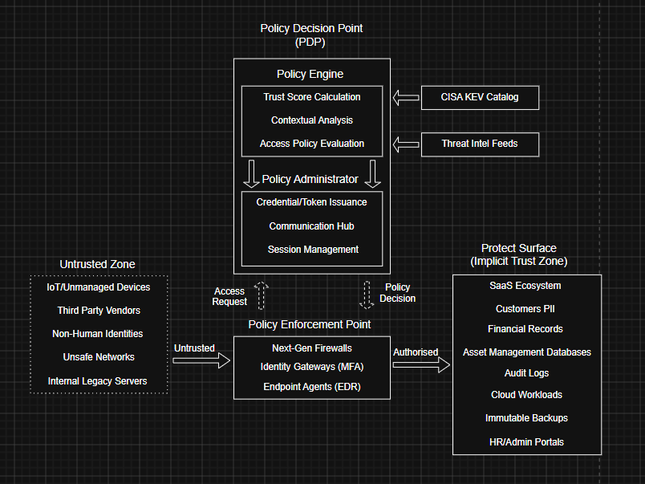
Figure 1: Zero Trust Architecture (ZTA) based on NIST SP 800-207, illustrating the Policy Decision Point (PDP) and Enforcement Point (PEP) for VTAM.

4.0 Technical Mitigation Measures
To actualise Zero Trust policies, a varied suite of modern technical controls will need to be implemented. These are designed to automate protection and provide intrinsic visibility across hybrid environments.
- Multi-Factor Authentication (MFA)
  - Directly counters AI-vishing and other credential threat.
  - VTAM will deploy FIDO2 [10] compliant MFA.
  - Removes reliance on vulnerable SMS/OTP codes.
  - Requires hardware security keys/ biometrics to verify identity.
- Cloud Security Posture Management (CSPM)
  - Addresses SaaS misconfigurations.
  - Continuously audits VTAM’s cloud environment.
  - Provides automated remediation for public data leaks and “Shadow IT” apps.
- Immutable Backups
  - Negates RaaS threats.
  - Stored in “write-once-read-many” (WORM) state [11].
  - No matter the level of access, attackers cannot encrypt or delete backup data.
- Vulnerability Management
  - Following CISA Known Exploited Vulnerabilities (KEV) catalogue [12].
  - Prioritise patching vulnerabilities being exploited.
  - Closes critical gaps before exposure.

5.0 Proactive Monitoring and Incident Response
To provide 24/7 monitoring and protection VTAM will implement a Security Operations Center (SOC) for “always-on” visibility. This consists of two parts, Security Information and Event Management (SIEM) and Security Orchestration, Automation, and Response (SOAR) [13]. SIEM is the centralised hub for log aggregation, collecting data from the cloud, office and remote devices. Enabling real-time analysis of alerts, while tracking patterns to detect when anomalies, such as RaaS, could be infiltrating the system.
As demonstrated in figure 2, SOAR acts on SIEM detection by utilising “automation playbooks” to react instantly to threats. For example, if it detects a device is attempting to encrypt thousands of files at once, the device will be automatically isolated by disabling internet connections, revoking session tokens and alert network administrators. Significantly improving Mean Time to Respond (MTTR), reducing reliance on manual intervention to provide instantaneous action.
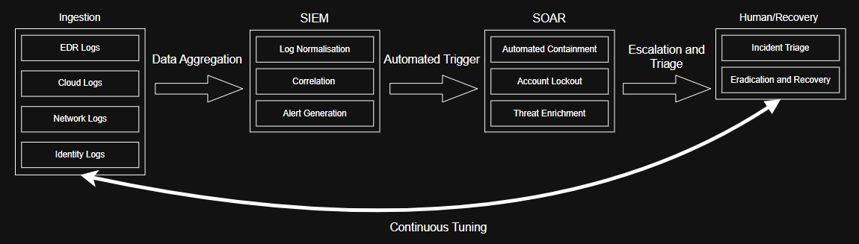
Figure 2: Modern Incident Response Lifecycle utilizing SIEM for anomaly detection and SOAR for automated threat containment.

6.0 Continuous Training and Awareness
As digital threats become increasingly complex and refined the need for continuous education to heighten awareness is imperative. A report from Fortinet [14] indicates that proper training can reduce cyber incidents, intrusions, and breaches by up to 67%.

6.1 Role-Specific Simulations
Training should be specific to job-roles. For example, the finance and customer support teams who are more likely to directly engage with customers over the phone should have a more in depth and specific tests on AI-vishing. Or the accountancy team should be provided extra training on supply chain phishing by engaging with simulations mimicking trusted payroll notifications.

6.2 Just-in-Time Training
Measures should be taken that send tests out anonymously to company employees, such as fake phishing links in emails. If employees engage with these tests, then they’ll have to watch a short and immediate training video reminding them of the risk and how to suspect the threat next time.

6.3 Incentivised Reporting
Employees that successfully report real or simulated threats to the SOC team will receive rewards. These include badges visible on company portals for the top 10 staff members who report the most threats in addition to companywide shout-outs to build reputation. Additionally, gift cards should be given out to employees who identify highly sophisticated threats before they infiltrate the system. This re-enforces good behaviour for those that come forward early, reducing time-to-containment significantly.

7.0 Conclusion
With the steps outlined within this report implemented, VTAM can move passed its out-dated, vulnerable, perimeter-based model to a durable, Zero-Trust architecture that proactively combats the increasingly hostile cyber landscape. By combining technical automation with security awareness, this new framework protects the confidentiality, integrity and availability of VTAM’s assets. Forming a strategic investment in the company’s growing future and reputation.

8.0 Reference List
[1]
S. Ozarslan, “Key Threats and Cyber Risks Facing Financial Services and Banking Firms in 2022,” www.picussecurity.com, Mar. 24, 2022. https://www.picussecurity.com/key-threats-and-cyber-risks-facing-financial-services-and-banking-firms-in-2022
[2]
A. S. Gillis, K. Yasar, and S. Kerner, “What is ransomware as a service (RaaS)?,” WhatIs.com, Jun. 11, 2025. https://www.techtarget.com/whatis/definition/ransomware-as-a-service-RaaS
[3]
ENISA, “ENISA Threat Landscape 2024,” ENISA, Oct. 2024. https://www.enisa.europa.eu/publications/enisa-threat-landscape-2024
[4]
National Cyber Security Centre, “MOVEit vulnerability and data extortion incident,” www.ncsc.gov.uk, Jun. 07, 2023. https://www.ncsc.gov.uk/information/moveit-vulnerability
[5]
J. Gregory, “2024 cloud threat landscape report how does cloud security fail,” Ibm.com, Jan. 22, 2025. https://www.ibm.com/think/insights/2024-cloud-threat-landscape-report-how-does-cloud-security-fail
[6]
“PR.AA: Identity Management, Authentication, And Access Control - CSF Tools,” csf.tools, Mar. 01, 2024. https://csf.tools/reference/nist-cybersecurity-framework/v2-0/pr/pr-aa/
[7]
M. G, “ISO 27001 Annex A.9 – Access Control Explained,” ISO Templates and Documents Download, Dec. 27, 2023. https://iso-docs.com/blogs/iso-27001-standard/iso-27001-annex-a-9-access-control?srsltid=AfmBOorZQk94uPHbxcgI0zeBYVrnKd6is2L5BWCDToRkdpiMIie0k6jL (accessed Apr. 29, 2026).
[8]
J. Whiting, “ISO 27001:2022 Annex A Control 8.2 Explained - ISMS.online,” ISMS.online, 2022. https://www.isms.online/iso-27001/annex-a-2022/8-2-use-of-privileged-access-rights-2022/
[9]
“ID.AM: Asset Management - CSF Tools,” csf.tools, Aug. 13, 2020. https://csf.tools/reference/nist-cybersecurity-framework/v1-1/id/id-am/
[10]
“FIDO2 Passwordless Authentication | YubiKey,” Yubico. https://www.yubico.com/authentication-standards/fido2/
[11]
R. Sheldon, “What is WORM (write once, read many)?,” SearchStorage, Jan. 25, 2022. https://www.techtarget.com/searchstorage/definition/WORM-write-once-read-many
[12]
Cybersecurity and Infrastructure Security Agency, “Known Exploited Vulnerabilities Catalog | CISA,” www.cisa.gov, 2023. https://www.cisa.gov/known-exploited-vulnerabilities-catalog
[13]
“What is SOAR? Technology and Solutions | Microsoft Security,” www.microsoft.com. https://www.microsoft.com/en-gb/security/business/security-101/what-is-soar
[14]
“2025 Security Awareness and Training Global Research Report Contents.” Available: https://www.fortinet.com/content/dam/fortinet/assets/reports/report-2025-security-awareness-and-training.pdf

