Title: Critically evaluate the different approaches to leadership and their effectiveness within the hotel industry
Student name:Andreea Catalina Mecic
Student Number: 2215573
Lecturer: Maggie Lan Zang
Module Code: BMIH5004
Module: Management and Organisational Behaviour
Programme: BA International Hotel Management

Table of Contents
1 Introduction 3
2 Compare and contrast theories 3
3 Pros and cons of different approaches of leadership in hotel industry 6
4 Managerial styles within the hospitality industry 7
5 Effectiveness of leadership approaches to managerial leadership 8
6 Conclusion 9
7 References 10

Introduction
Effective leadership in the hotel industry varies on numerous components which include organizational culture, norms, values, guest satisfaction, maintaining the quality of standards, employees' satisfaction and preferences, etc. However, Leaders face barriers hurdles, and challenges that alter to evolving changes and foster durable connections among clients or stakeholders. This assessment focuses on different leadership theories such as Blake and Mouton or McGregor's X and Y etc. Furthermore, this assessment emphasizes effective leadership and real-life examples of leaders in the hospitality sector.

Compare and contrast theories
A leadership theory has a crucial impact on the hotel industry. However, McGregor’s Theory X indicates the management style's conflicting assumptions about human nature and workplace behavior (Mills, et al., 2020). However, assuming that employees are naturally lazy, do not have interest in the work, and must be rigorously monitored and pressured to meet organizational objectives. Theory Y believes that individuals are self-driven, appreciate their jobs, need responsibilities, and can be expected to perform successfully under minimal oversight (Simha, 2022). Additionally, Theory X promotes a more centralized management trend, which highlights rigor and discipline, whereas Theory Y advocates for a participative style of leadership, focusing on development and employee engagement. Nevertheless, McGregor's theory emphasizes the need to match leadership style to beliefs regarding staff inspiration and behavior (Alyafei, 2023).
ACL focuses on accomplishing responsibilities, controlling staff behavior, and relationships, and improving particular group participants equally. The model includes three key aspects namely, accomplishing the task, creating, and forming by managing the team members while growing individuals (Ackah, 2019).
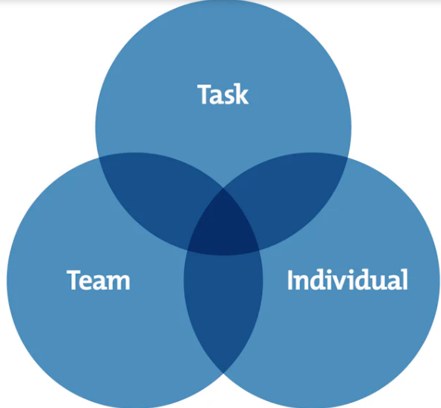
Figure# 1: ACL Model
Source: (Adair, et al., 2023)
In this model of ACL, the highlighted or shaded part indicates that each element team, individual, and task is interlinked with each other in achieving the organizational goals (Bashir, et al., 2022). In the hotel industry different departments for instance, housekeeping, front desk officer, and food and beverage department must interlinked and connected to enhance their performance and productivity in the workplace (Folarin, 2021). However, leaders are responsible for creating a relaxed environment in the hotel industry so that the workers can easily accomplish their assigned goals. However, to ensure that a work is finished successfully, efficient managers concentrate on creating specific objectives, developing strategies, and evaluating the performance (Srivastava, et al., 2022). They prioritize achieving objectives while taking into account the available resources and limits. Building and Maintaining the Team in which Leaders create positive team surroundings by encouraging honest debate, collaboration, and constructive dispute resolution (Senarathne, 2020). They want to build cohesive, motivated teams that work around shared objectives. Individual Team Members develop in team dynamics, and leaders invest in the personal growth and development of their staff colleagues (Elramalli, 2020). They offer guidance, supervision, and training programs to help everyone reach their maximum potential and succeed in their careers (Touma, 2021).
The Blake and Mouton Theory was developed in the year 1960, further, this theory broadly emphasizes two main demissions namely concern for production and other is a concern for people (Cai, et al., 2019). This identifies that in the hotel industry, the leader or the manager must be concerned about their employees as well as concerned with the outcome and production of the hotel industry. The grid reflects the country club management in which the manager or the leaders show high concern for the people with low concern with the production (Mindapa, 2022). This demonstrates the strong relationship of leaders with their employees but the result is not up to mark. However, the other dimension reflects team management which has a high concern for people as well as for production and results (Shafiu et al., 2019). The leader focuses on employee’s well-being as well as concern with the outcomes this is a team management asset. In the hotel industry, the leader follows such strategies to gain both the employee's trust and satisfaction with profit-generating. Furthermore, the third factor represents Impoverished Management in which there is low concern for the employee or people and low concern for the production as well. This shows the manager or leader having no interest in their particular sector (Ibrahim and AlOmari, 2020). However, in the middle of road management indicates that there is high concern for the production and results whereas, low concern for the people. This is a kind of selfish leader who has only an interest in the outcomes rather than concentrating on their main assets which are their employees. This low motivation, satisfaction, and encouragement can lead to low productivity of the employees (Stanley, 2022).
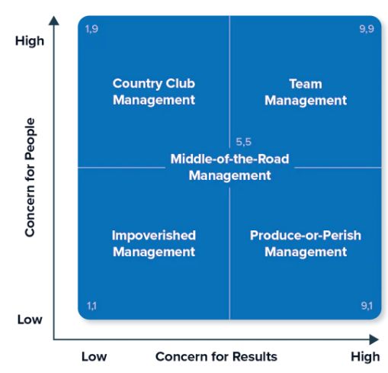
Figure# 2
Source: (Cai, et al., 2019)
Blake Grid emphasizes on certain ratio of work, while ACL emphasizes completing tasks, team interactions, and personal growth (Adair, et al., 2023). Managerial Grid classifies methods of leadership based on two criteria (results and people), although ACL and Theory X and Y focus on fundamental assumptions regarding human behavior. ACL takes a broader perspective on leadership, including task, team, and person aspects, while Managerial Grid and Theory X and Y concentrate on particular aspects of leadership behavior or beliefs (Marshall and Kay, 2019).

Pros and cons of different approaches of leadership in hotel industry
In social life the leadership in the hotel industry plays an important part. Because every society needs someone who can direct that society. Initially, the leader who is directing the society come forward with its characteristics but afterwards the most important part would be the behavior or attitude of the leader. Basically there are two problems which arisen in the behavioral leadership which are the first one is that the leader puts the person in front and the second one is that the leader puts the business in front (Elkhwesky, et al., 2022). Or it can be said as in Blake and Mouton study that the leader is productive and oriented towards interpersonal relations.
In the approach of transitional leadership the advantage of it is that leader control all the tasks and expectations therefore all the confusion and guessing of work is eliminated while due to the rigidity of the environment the innovation and the creativity of the people suffocated. In the transformational leadership where leaders find all the better ways and findings to make things better by their own this create the level of trust between leaders and employees and can able to share them their goals and aims. This can also create aggressiveness among some people to change things in the environment according to only leader’s perspective (Maccoby, 2017).

Managerial styles within the hospitality industry
Leaders of prosperous and fast growing business know that innovation is the engine of growth and that innovation is produced by amazing individuals who share a persistent growth mindset, a love for solving problems and bringing ideas to life (Ashton, 2018). Many researches have concluded that only through leadership a climate and culture to change the organization is adapted. The hospitality sector has special culture as compare to other industries, it is the sector where recurrent interaction between employees and customers are taken place and there frontline staff plays an important role in service delivery. For the success in the hotel sector effectual leadership is necessary. Adapting the approaches by the leaders help to face the challenges and complexity of the work. The choice of leadership style has a big impact on establishment’s overall success in the hospitality industry, where teamwork and visitor happiness are crucial (Huertas-Valdivia et al., 2019).
One of the leadership style is authoritative leadership style in which the leader provides the clear picture and providing direction and motivation. This style is used when there is crisis or when to take final actions in the hotel industry. In order to avoid any stifling innovation and teamwork, an authoritative approach is useful (Denizci Guillet et al., 2019). Another leadership style which can be applied to hospitality sector is the transformational leader. In this leader inspire and motivate their team through common vision. They prioritize each team member’s development, promote creativity and cultivate happy work atmosphere. As in the hospitality sector where creativity and flexibility are important there transformational leadership provide continuous improvement (Sarhan et al., 2020). The growth and welfare of the team member is managed by the servant leadership style. This style is based on the dedication to helping others and humility. Servant leadership style has the potential to establish the culture of care and quality in the hospitality industry, where the satisfaction of guests and employees are closely linked (Boukis et al., 2020). While making decision the input and ideas of the team members are put forward and valued by the democratic leaders. In hotel industry this strategy help to enhance the team work develop the sense of shared responsibility. However the situations which are sensitive to time needs a balance between democratic input and decisive action (Rabiul et al., 2023)

Effectiveness of leadership approaches to managerial leadership
The attitude and the behavior of the leaders play a very important role in the combination of the followers with the organization. The positive discernment of the leaders with their followers and the behavior of the leaders are necessary for any commitment of the organization and their productivity. Behavior of the leaders must be adjusted according to their maturity this would encourage to meet flexibility and the assessment of the team by the leaders. Leadership effectiveness is necessary which promotes understanding and adaptation to fulfill any demand and to receive good result (Razak et al., 2018). Innovation approach in the leadership encourages the innovation, creativity and provide unity in the team. If the followers are supported by their leaders, it promote the empathy, active listening and leadership modesty. The proper hierarchal structure in the leadership management help to establish clear chain of command but it has the limit of collaborative decision making (Gil et al., 2018).
Leadership encourages input and collaboration from all level of organization which fosters the democratic, inclusive and empowering decision making process. Focus on the leaders actions and behaviors promotes a balanced and practical leadership style, which is responsive to different situations. Leadership effectiveness is the function of leader’s personality and the situation which advocates for the flexible leadership which is adjusted to situational demand. Leadership emphasizes flexibility, adaptability and collaboration and requires continuous improvement which help in the support and to create responsive decision making in various environment. Whichever type of leadership is adopted it is expected by the followers that the leaders must be loyal to his employees, to be truthful, to build trust in his workers and to motivate and strengthen them. However, they expect that their leaders must inclusive, tolerant, humble, not arrogant, sharing and instructive. For full filing these expectations the leaders must do individual accounting, act inclusively and make decisions by identifying their workers (Lemoine et al., 2019). Leadership is complex and dynamic process which need deep understanding of various styles, approaches and theories. A good understanding of these concepts help the leaders to utilize tools to adapt their leadership which is based on the unique demand of contexts and need of their employees.

Conclusion
This assessment is based on the reflection on different leadership theories that help and assist the leaders and managers in the hotel industry. Adapting the approaches by the leaders helps to face the challenges and complexity of the work. The choice of leadership style has a big impact on the establishment's overall success in the hospitality industry, where teamwork and visitor happiness are crucial. However, Adair's ACL Model highlights the value of accomplishing chores, creating successful groups, and cultivating teammates at the same time. Hotels can profit from this technique by guaranteeing that duties are carried out successfully, groups operate effectively, and staff members have encouragement in their career development. Blake and Mouton's Managerial Grid provides an outline to determine managerial styles that incorporate concern for people and concern for production and outcomes. Furthermore, there are significant advantages and disadvantages of these theories, further, this assessment involved effective leadership and some real-life examples of leaders who become idle for the leaders to enhance their capabilities and to handle the overall team. In the hospitality sector where creativity and flexibility are important there transformational leadership provides continuous improvement.

References
Ackah, D., 2019. Models of Leadership and Teamwork: Adairs Action-Centred Leadership Model (1973). Worldwide Journal of Multidisciplinary Studies, 1(5), pp.01-06.
Adair, K.C., Levoy, E., Tawfik, D.S., Palassof, S., Profit, J., Frankel, A., Leonard, M., Proulx, J. and Sexton, J.B., 2023. Assessing leadership behavior in health care: Introducing the local leadership scale of the SCORE survey. The Joint Commission Journal on Quality and Patient Safety, 49(3), pp.166-173.
Alyafei, O., 2023. Analysis of Leadership Style: A Case of One Leader. Journal of Human Resource and Sustainability Studies, 11(3), pp.511-520.
Ashton, A.S., 2018. How human resources management best practice influence employee satisfaction and job retention in the Thai hotel industry. Journal of Human Resources in Hospitality & Tourism, 17(2), pp.175-199.
Bashir, I., Rana, R.A., Naseem, A., Ghafoor, A. and Mumtaz, B., 2022. A Comparative Analysis of Situational and Style Leadership Theories. Competitive Education Research Journal, 3(1), pp.127-134.
Boukis, A., Koritos, C., Daunt, K.L. and Papastathopoulos, A., 2020. Effects of customer incivility on frontline employees and the moderating role of supervisor leadership style. Tourism Management, 77, p.103997.
Cai, D.A., Fink, E.L. and Walker, C.B., 2019. Robert R. Blake, With Recognition of Jane S. Mouton. Negotiation and Conflict Management Research.
Denizci Guillet, B., Pavesi, A., Hsu, C.H. and Weber, K., 2019. Is there such a thing as feminine leadership? Being a leader and not a man in the hospitality industry. International Journal of Contemporary Hospitality Management, 31(7), pp.2970-2993.
Elkhwesky, Z., Salem, I.E., Ramkissoon, H. and Castañeda-García, J.A., 2022. A systematic and critical review of leadership styles in contemporary hospitality: a roadmap and a call for future research. International Journal of Contemporary Hospitality Management, 34(5), pp.1925-1958.
Elramalli, O.M., 2020. Leadership Theories and its Styles: A Review Study. In Econder 2020 3rd. International Economics, Business and Social Sciences Congress (p. 290).
Folarin, K., 2021. Leadership Styles, Organizational Performance and Effectiveness among Sub-Saharan African Employees. American Journal of Leadership and Governance, 6(1), pp.24-36.
Gil, A.J., Rodrigo-Moya, B. and Morcillo-Bellido, J., 2018. The effect of leadership in the development of innovation capacity: A learning organization perspective. Leadership & Organization Development Journal, 39(6), pp.694-711.
Huertas-Valdivia, I., Gallego-Burín, A.R. and Lloréns-Montes, F.J., 2019. Effects of different leadership styles on hospitality workers. Tourism management, 71, pp.402-420.
Ibrahim, R. and AlOmari, G., 2020. The effect of talent management on innovation: Evidence from Jordanian Banks. Management Science Letters, 10(6), pp.1295-1306.
Lemoine, G.J., Hartnell, C.A. and Leroy, H., 2019. Taking stock of moral approaches to leadership: An integrative review of ethical, authentic, and servant leadership. Academy of Management Annals, 13(1), pp.148-187.
Maccoby, M., 2017. Narcissistic leaders: The incredible pros, the inevitable cons. In Leadership perspectives (pp. 31-39). Routledge.
Marshall, J.E. and Kay, L., 2019. Leadership and Management in. Myles Professional Studies for midwifery education and practice: Concepts and challenges, p.211.
Mills, B.R. and Mene, C.T., 2020. Conflict and Its Management in an Organisation: A Theoretical Review. Int. J. Sci. Res. Publ, 10, pp.540-545.
Mindapa, A.K., 2022. Critical Evaluation of Blake And Mouton’s Managerial Grid and Its Application To Baze University Library. Library Philosophy & Practice, pp.1-14.
Rabiul, M.K., Shamsudin, F.M., Yean, T.F. and Patwary, A.K., 2023. Linking leadership styles to communication competency and work engagement: evidence from the hotel industry. Journal of Hospitality and Tourism Insights, 6(2), pp.425-446.
Razak, A., Sarpan, S. and Ramlan, R., 2018. Effect of leadership style, motivation and work discipline on employee performance in PT. ABC Makassar. International Review of Management and Marketing, 8(6), p.67.
Sarhan, N., Harb, A., Shrafat, F. and Alhusban, M., 2020. The effect of organizational culture on the organizational commitment: Evidence from hotel industry. Management Science Letters, 10(1), pp.183-196.
Senarathne, C.W., 2020. The optimal capital structure under the conditions of employment: An application of theory X and theory Y. Zagreb International Review of Economics & Business, 23(1), pp.51-69.
Shafiu, A.M., Manaf, H.A. and Muslim, S., 2019. The Impact Of Effective Leadership On Employee’s Performance In Local Government Of Kaduna State, 2013-2019. The International Journal of Engineering and Science (IJES), 8(11), pp.60-65.
Simha, A., 2022. Behavioral and Style Approaches to Leadership. In Leadership Insights for Wizards and Witches (pp. 27-32). Emerald Publishing Limited.
Srivastava, N., Srivastava, N. and Srivastava, H.K., 2022. Critical evaluation of Blake and Mouton's managerial grid: a study of employees of IT sector in India. International Journal of Social Entrepreneurship and Innovation, 6(2), pp.145-158.
Stanley, D., 2022. Leadership theories and styles. Clinical Leadership in Nursing and Healthcare, pp.31-60.
Touma, J., 2021. Theories X and Y in combination for effective change during economic crisis. Journal of Human Resource and Sustainability Studies, 9(01), p.20.

