Context Diagram
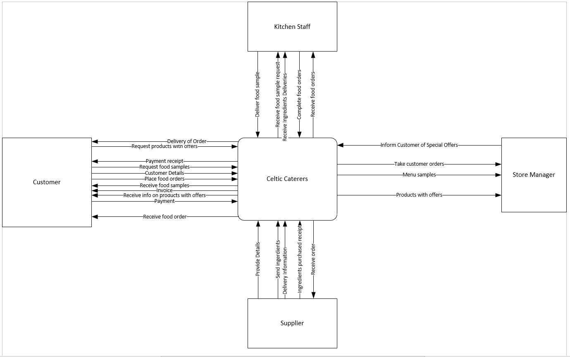
This context diagram shows the scope of the entire new Celtic Caterers system. It shows the major information flows between the entity and the system.

Level 0 Data Flow Diagram

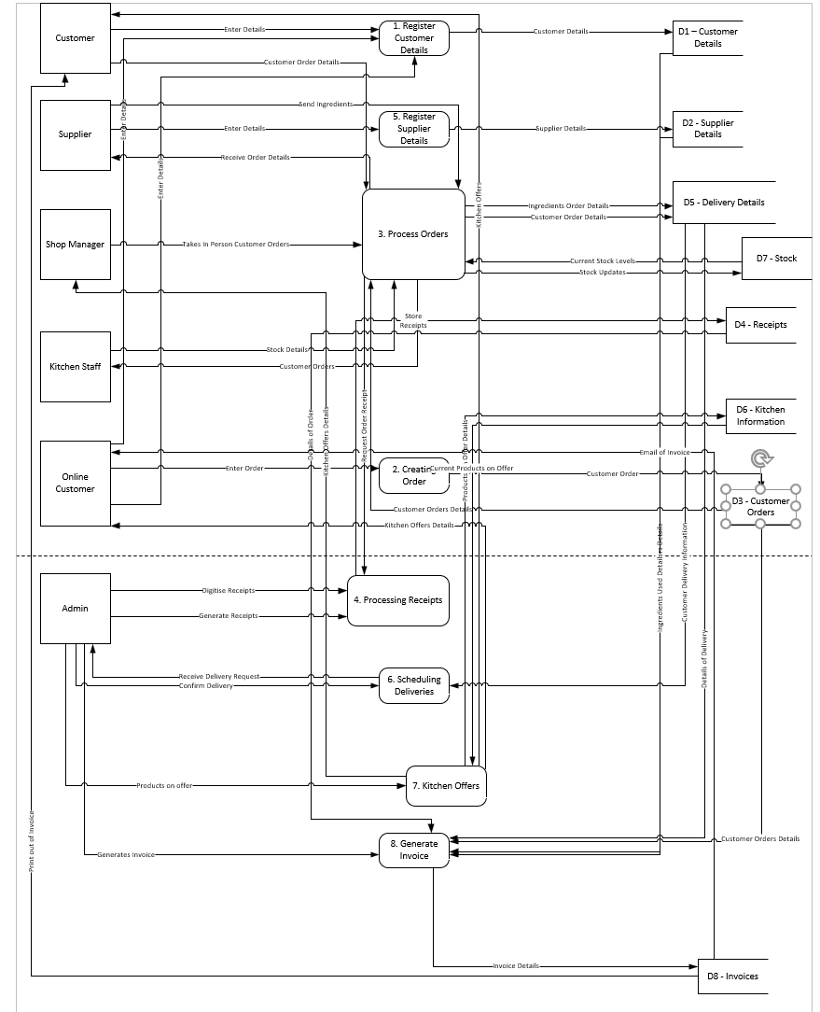
The level 0 data flow diagram illustrates the movement of data within the Celtic Caterers new system.

Level 1 Data Flow Diagram
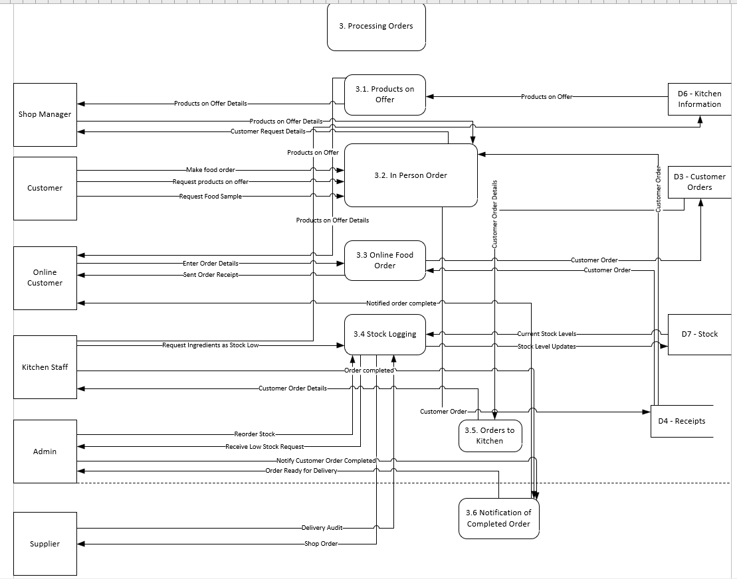
This level 1 data flow diagram notates the main sub process of the Processing Orders process from the level 0 data flow diagram.

Entity Relationship Diagram
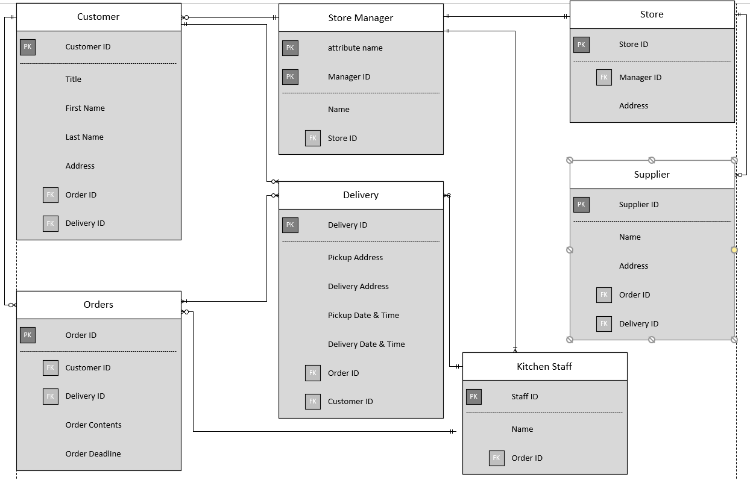
This Entity Relationship Diagram is a design of the database which represents the information requirements of the system.

