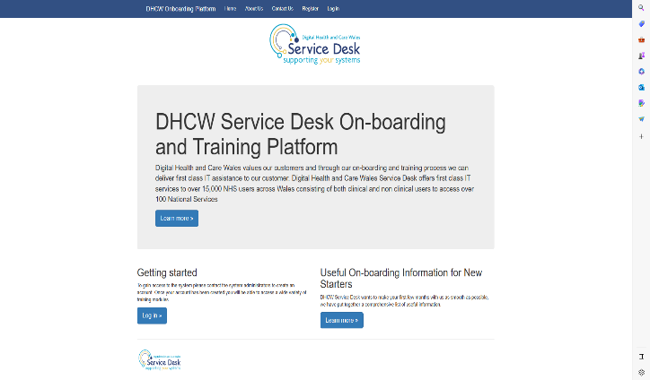
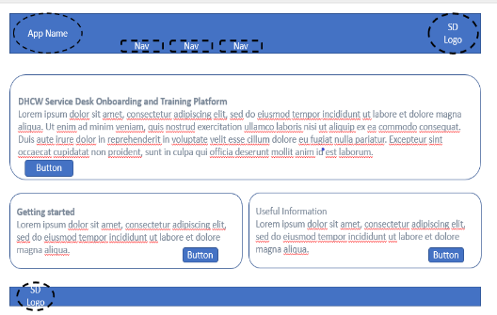
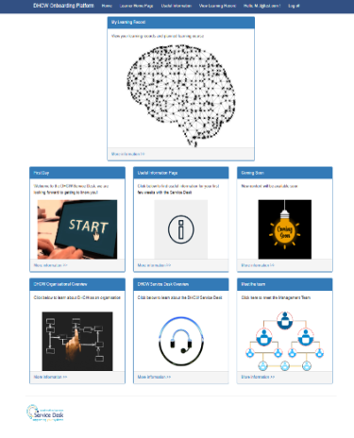


Fig 2 Onboarding Home page
Results
Iteration one
Users identified that the application should have a standardised design throughout to improve usability. Users identified that a useful information section for new employees would be useful.
Iteration two
Developer testing demonstrated several unhandled errors which needed to be addressed and communicated to the user. These features were positively received during the end user testing.
Iteration three
The addition of an admin role was implemented successfully, and the accessibility of the navigation bar was addressed. During this iteration the visual appearance was improved using graphics and prompts.
Introduction
The purpose of this project was to conduct a comprehensive case study review of the current Digital Health and Care Wales Onboarding and Training Process. Which would then lead to the development of a prototype application. In order to assess the validity of a new onboarding application, it would need to meet the end users requirements and usability criteria.
Aims
- To create a training and onboarding application for use by DHCW Service Desk during the onboarding and training of new starters.
Objectives
- To critically analyse the current DHCW training and onboarding process.
- To compare other learning management systems, training platforms currently in use.
- Identify a suitable development methodology for the project.
- Identify a suitable software suite in which to develop the project.
- Identify a suitable language in which to develop the project.
- Develop the platform.
- Test the platform and gain feedback from peers and end users.

Conclusion
The overall aim of the project was met, by creating a single platform which DHCW Service Desk could use to carry out training and onboarding tasks. The prototype application will require further development to address all the system requirements identified by the end users.
Agile methodology has proven to be exceptionally useful due to its iterative and incremental develop, test and release nature. This approach has enabled the project to remain flexible and adapt to the stakeholders needs.
Focus Group
The aim of a focus group meeting is to gain feedback before, during, or after a product is developed and
is a useful tool that can be used at every stage of the application development [1].
This meeting was used to establish the current process used by DHCW for onboarding and training as well as to discuss some of the end users pain points with the current process. From this focus group meeting, system requirements were established which led to the development of user stories. These user stories were then used to evaluate the success of the application.
End User Testing
End user testing was conducted in the form of users attempting to complete tasks within the application such as account registration, course creation and content updates. The end user testing was used alongside system usability scales to capture the systems usability score.
[1] U. Government, “Focus group study: qualitative studies,” 2020. https://www.gov.uk/guidance/.

Design and Implementation
During the design and implementation process the prototype application went through several design iterations in line with the choosen Agile Development Methodology.
Iteration one focused on the appearance of the application (Fig1) that were presented to the end user in the form of wireframes. The feedback from the end user was used to form the basis of the application appearance and user stories.
Iteration two focused on the initial development namely the registration and log in features and the implementation of role-based access for areas of the application. Additionally, this iteration saw the development of the site master page.
Iteration three saw adjustments made to the application as a result of the feedback received from the SUS and end user tests.
Literature Review
The case study review identified several end user pain points, which were given further consideration during the requirements and implementation phase of this project. The comparative component of the case study also highlighted that the proposed application would benefit from a student dashboard which allows the student to track their progress through there onboarding process and therefore gain a deeper understanding of the training program.
The literature review also highlighted that there are several suitable development frameworks and programming languages which offer many of the same features and functionalities. Choosing between these comes down to developer preference or project constraints.

Fig 1 Iteration 1 Wireframes
Fig3 Student Home Page

A Case Study Review of DHCW

Onboarding and Training

Samantha J john 2115880, 2115880@student.uwtsd.ac.uk
BSc Computing Software Development, School of Applied Computing, UWTSD

