

MASTERS OF BUSINESS ADMINISTRATION
STRATEGIC MANAGEMENT
MODULE CODE – LCBM7003
LECTURER – EJIKE UDEOGU (BRIMINGHAM)
Assessment component - Individual report
___________________________
SUBMITTED
BY
STUDENT NAME:- NEEL MANISHBHAI KORAT
STUDENT ID – 2523741
TABLE OF CONTENTS
1. Organisational Context and Overview 3
2. External and Internal Analysis 5
2.1. PESTEL, political and economic factors. 5
2.2. PESTEL, social and technological factors. 7
2.3. PESTEL, environmental and legal factors. 9
2.4. VRIO, brand and innovation resources. 10
2.5. VRIO, marketplace and organisational capability. 11
2.6. VRIO, structural weaknesses and eroding rarity. 13
2.7. SWOT Analysis 14
3. Comprehensive and Holistic View of Nike 17
3.1. CSR Strategy and Strategic Alignment 17
3.2. Financial Perspective 18
3.3. Customer Perspective 19
3.4. Internal Business-Process Perspective 20
3.5. Learning and Growth Perspective 21
4. Strategic Choices and Implementation 22
4.1. Business-level Choice 22
4.2. Ansoff Validation 23
4.3. SAFe evaluation 25
4.4. Implementation Challenges and Mitigation 26
Section 2: Reflective Account Using Kolb’s Experiential Learning Cycle 28
Concrete Experience 28
Reflective Observation 30
Abstract Conceptualisation 31
Active Experimentation 32
References 33

1. Organisational Context and Overview
Nike was originally established as Blue Ribbon Sports in 1964 and evolved into a worldwide athletic brand defined by footwear innovation, athlete endorsements, and cultural relevance (EBSCO, 2025). Its mission is to “bring inspiration and innovation to every athlete in the world”, while its wider purpose-led vision is to “move the world forward through the power of sport” (NIKE, 2026a). The business model featured product design, development, brand marketing, consumer engagement, and outsourced manufacturing. Nearly all products are made by independent contractors, and sales are made through wholesale partners, owned stores and NIKE Brand Digital platforms (SEC, 2025). The hybrid model continues to be a strategic priority, as FY2026 revenue grew to $46.4 billion, with a 6% increase in wholesale revenue and a 6% drop in NIKE Direct revenue to $17.7 billion. Digital revenue declined 12%, revealing an unmet channel-balance challenge in the turnaround (NIKE, 2026b).
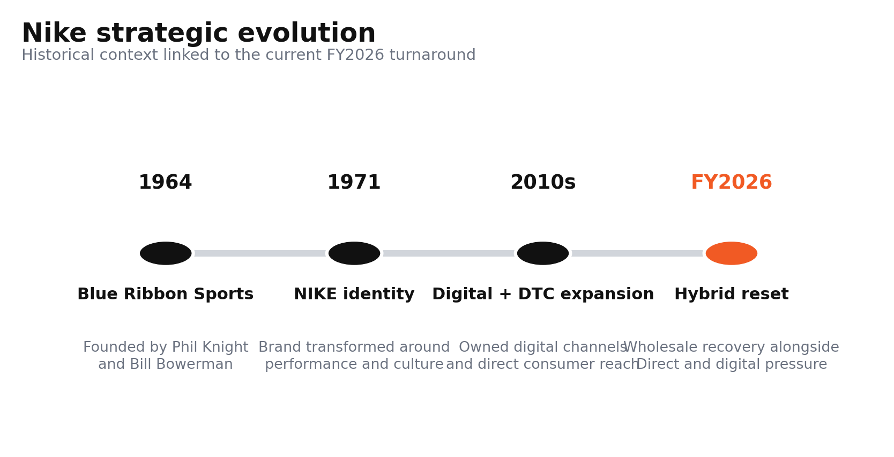
Figure 1. Nike strategic evolution from founding to the FY2026 hybrid-channel reset.
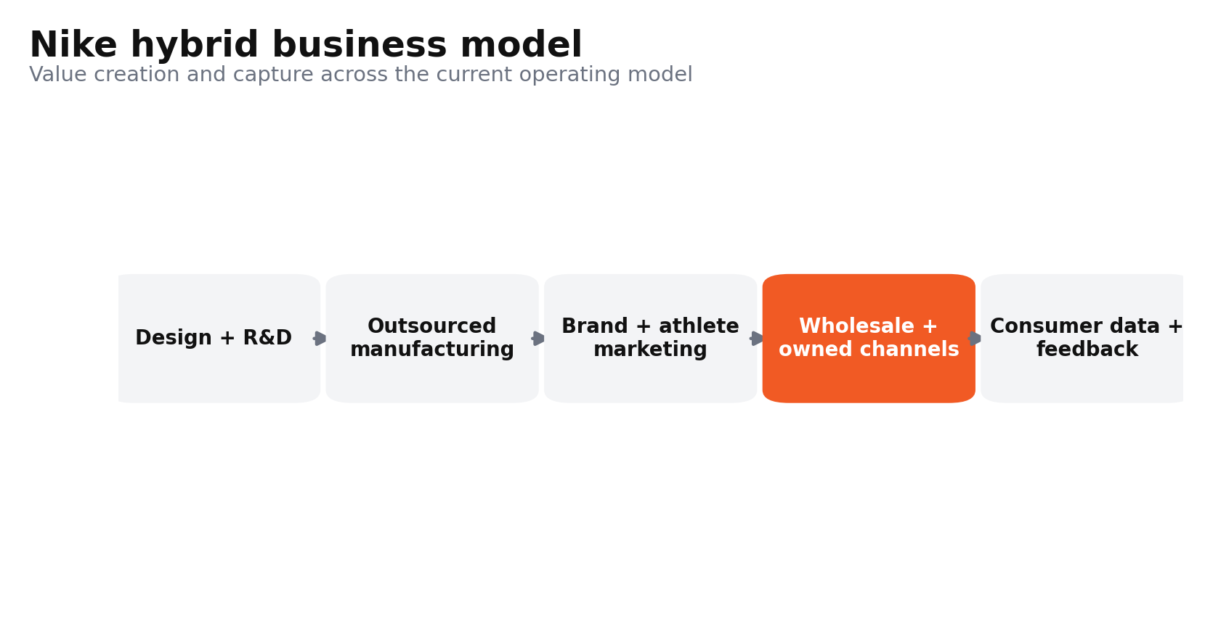
Figure 2. Nike’s hybrid value creation and revenue model.
Nike operates in the highly contested athletic footwear, apparel and sporting goods industry, where product innovation and brand relevance increasingly determine growth. In 2025, sports-related apparel and footwear in North America were estimated at $173 billion and are estimated to reach $209 billion by 2029 (McKinsey and WFSGI, 2025). Nike has also maintained significant scale, with revenue in FY2026 North America rising by 5% to $20.5 billion, and footwear revenue climbing to $13.3 billion, making North America its largest geographic market (NIKE, 2026c). But market dominance is challenged by Adidas, New Balance, On and Hoka, as challenger brands surged in recent revenue growth and market-share gains (McKinsey & Company, 2025). Competitive pressure was seen in 2026 as Adidas recorded 47% more store visits than Nike in the first week of the World Cup, while Nike's US World Cup merchandise sell-out rate was 28% compared with Adidas's 7% (Reuters, 2026d). Thus, Nike remains a scale leader, but its strategic position is increasingly contested by faster-growing specialists and a resurgent Adidas.
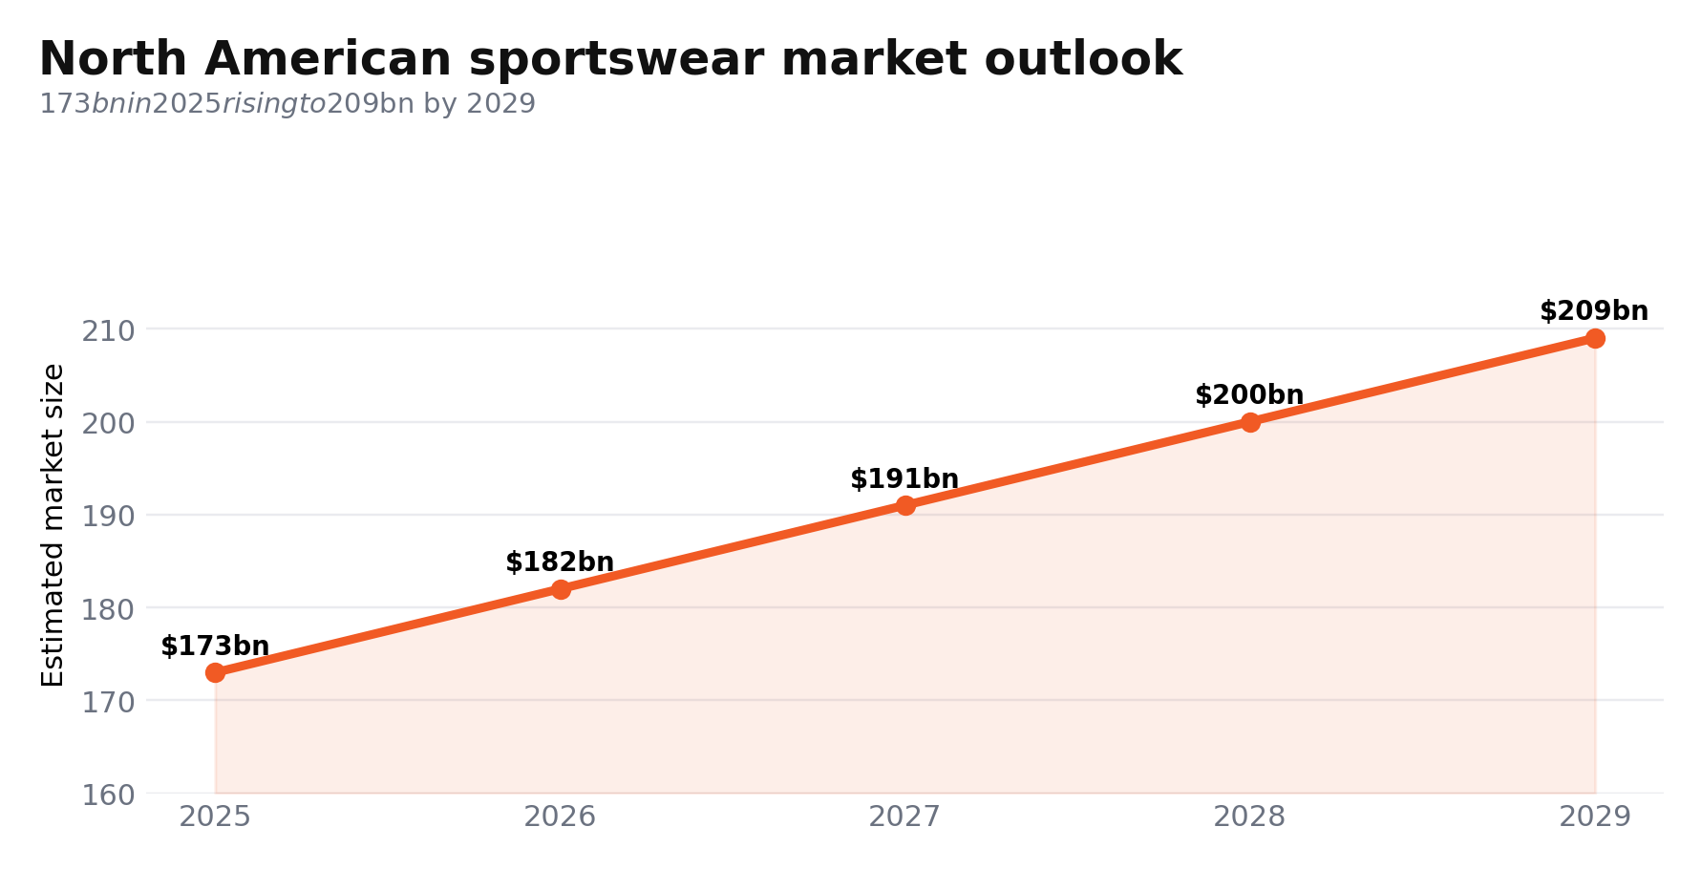
Figure 3. North American sports-related apparel and footwear market outlook.
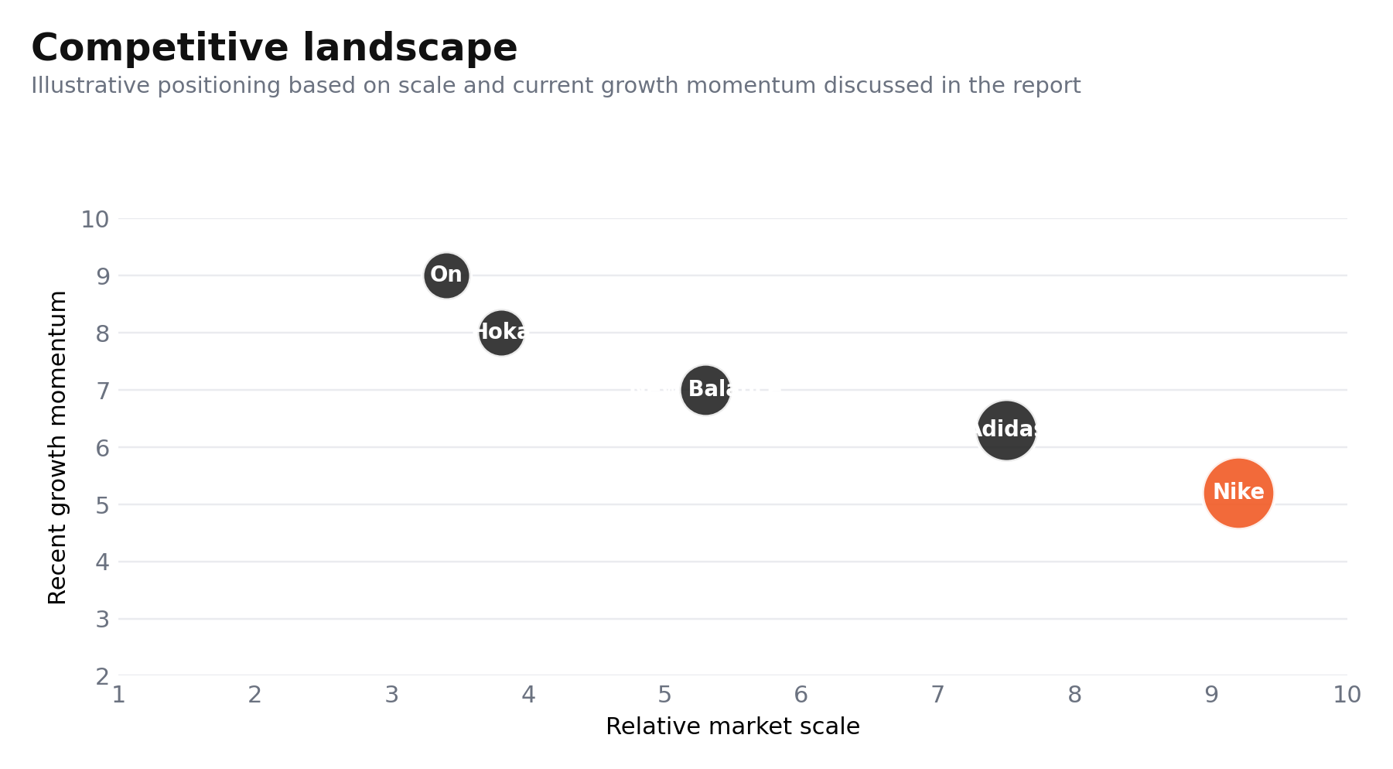
Figure 4. Competitive landscape showing Nike’s scale advantage and challenger momentum.

2. External and Internal Analysis

2.1. PESTEL, political and economic factors.
The biggest material political risk for Nike North America is the return of the US tariff regime, which explicitly targets Asian sourcing. The gross margin in Q3 FY2026 dropped by 130 basis points to 40.2%, driven largely by increased tariffs in the North American market (Nike, 2026a). The exposure is ongoing and not short-term because the US-Vietnam framework will have a transitional tariff schedule of 20% that will remain in place for Vietnamese imports for a limited period of time (USTR, 2025a). This is important strategically because Nike will be unable to pass cost inflation through to the consumer without eroding price-value perceptions in a turnaround. But not everything is bad in the demand arena. US non-store retail sales are up 12.2% year-on-year in May 2026, offering a chance to push back ecommerce ahead of a retreat (US Census Bureau, 2026). Labour conditions are not recessionary, but somewhat softer, with a 4.2% unemployment rate in June (BLS, 2026), which makes spending more comfortable, but also more selective. Thus, the pressure from tariffs is the more significant threat, and the growth from digital retail is the more evident opportunity. Nike needs to defend its premium product from blanket discounting and employ channel-specific assortment to counter landed-cost inflation.
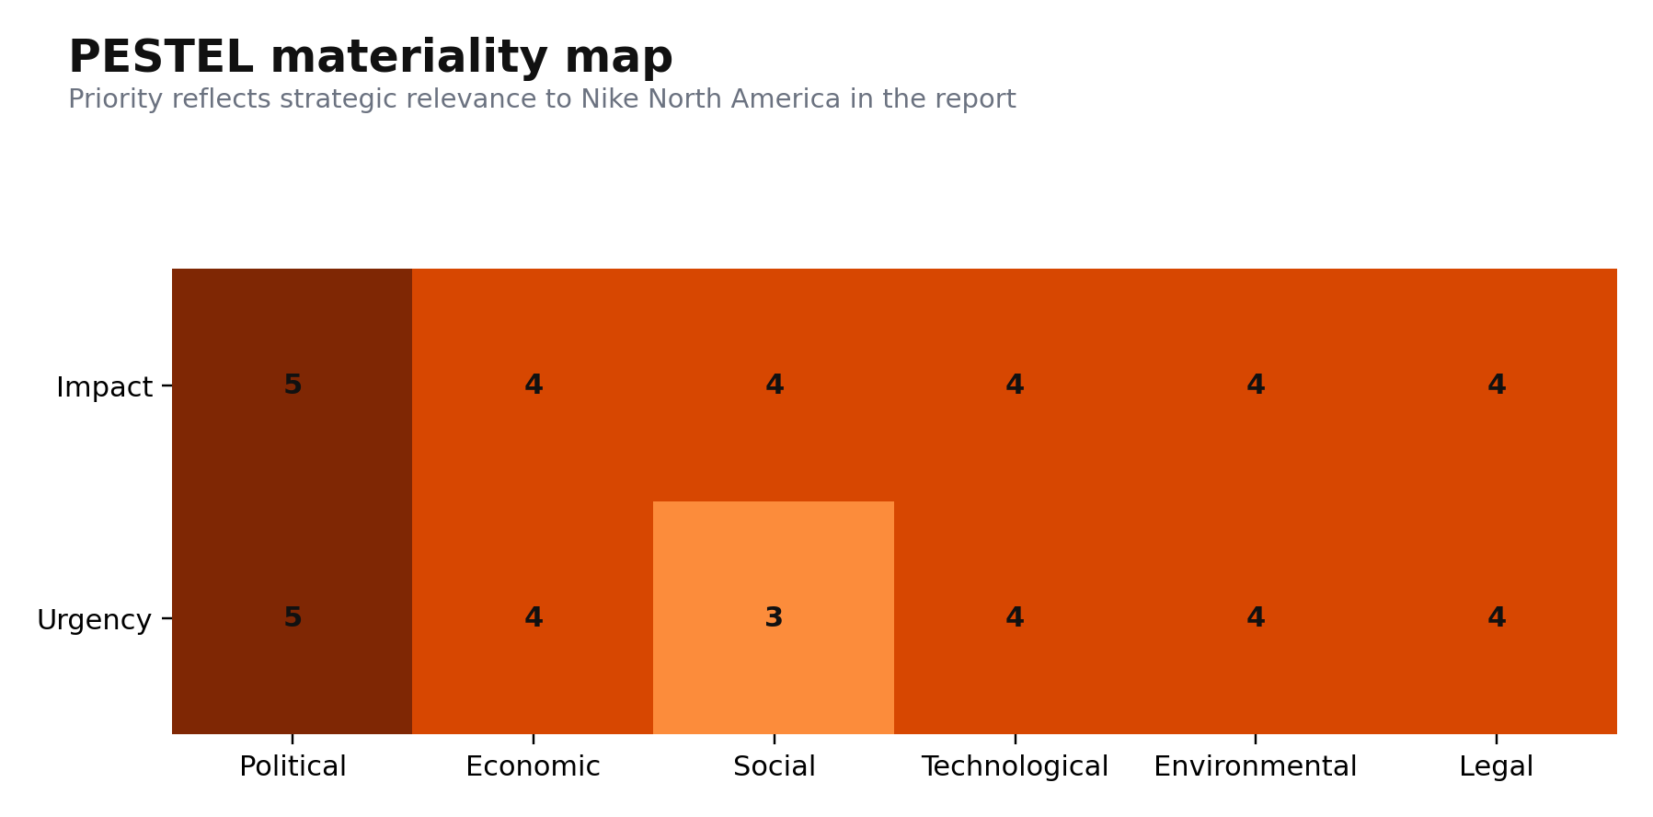
Figure 5. PESTEL materiality map prioritising the most strategically relevant external forces.
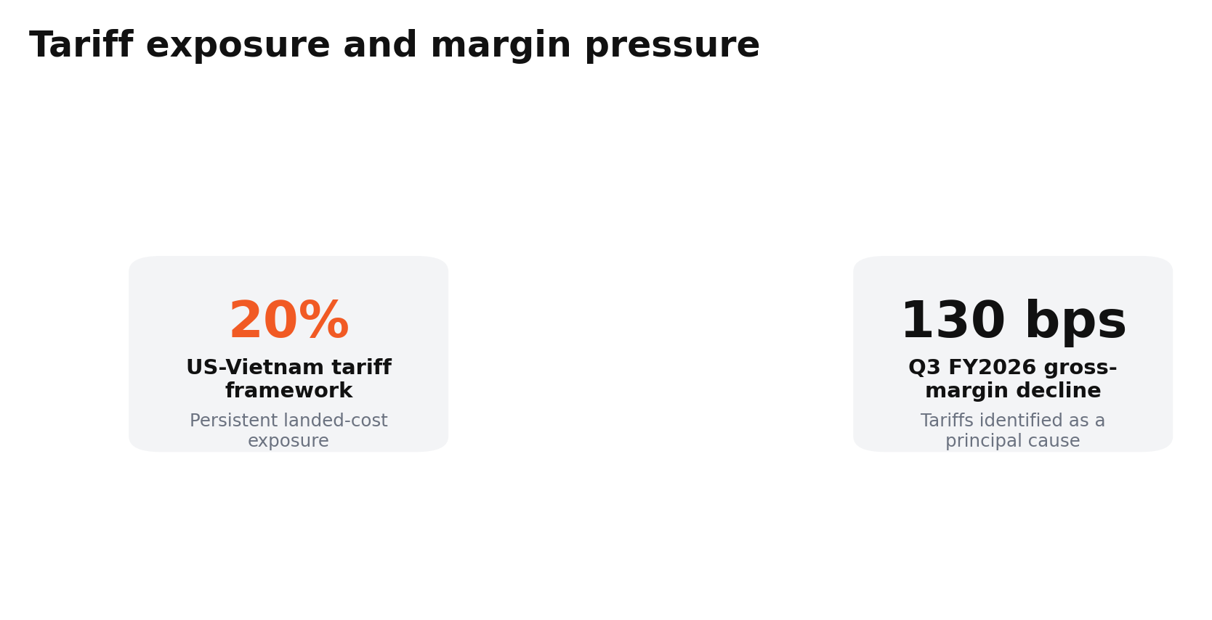
Figure 6. Tariff exposure and associated margin pressure.
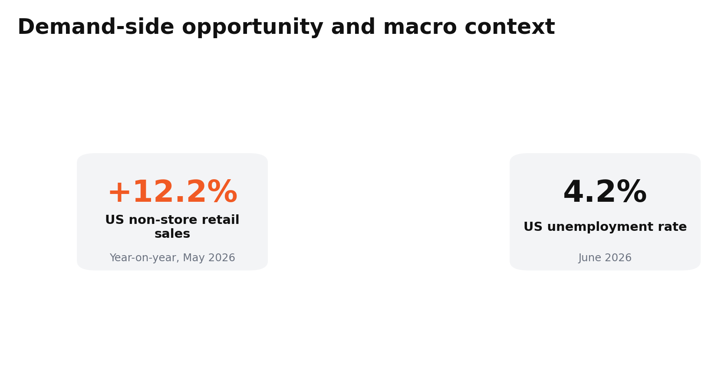
Figure 7. Digital retail growth alongside a selective consumer environment.

2.2. PESTEL, social and technological factors.
Social demand is moving towards communities based on participation, favouring Nike's running, training and women's products, while reducing dependence on wide lifestyle brands. In 2025, Strava discovered that Gen Z was 75% more likely than Gen X to feel that race or event was the primary motivation for their exercise (Strava, 2025). This affords avenues for a local run-club ecosystem, race-linked performance credibility and launches. However, BCG projects activewear growth to be moderate to roughly 3% to 5% annually through 2029, implying that share capture will matter more than category expansion (BCG, 2025). Consumer loyalty is also shifting to become conditional. According to Deloitte's 2025 survey, price, value and quality continued to be the primary drivers of loyalty, followed closely by loyalty programmes (Deloitte, 2026a). Hence, for Nike, scale isn't an adequate replacement for product desirability. From the technical perspective, cross-channel data can enhance the relevance of recommendations, but recent studies indicate that integration of online and offline preferences involves channel-specific modelling instead of simple data pooling (Choi et al., 2024). Therefore, Nike should develop an intelligent omnichannel membership system that combines store, membership and digital data to improve personalisation and demand forecasting. The risk is strategic inertia from Nike continuing to drive web traffic through owned platforms without reinvigorating differentiated product demand.
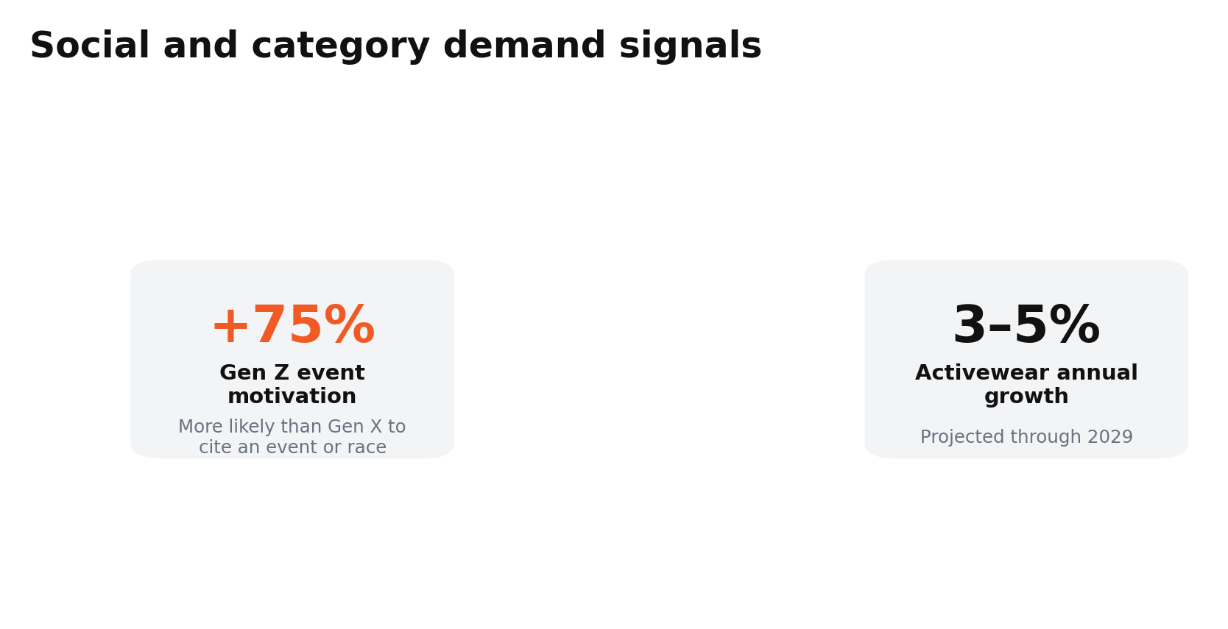
Figure 8. Participation-led social demand and moderating category growth.
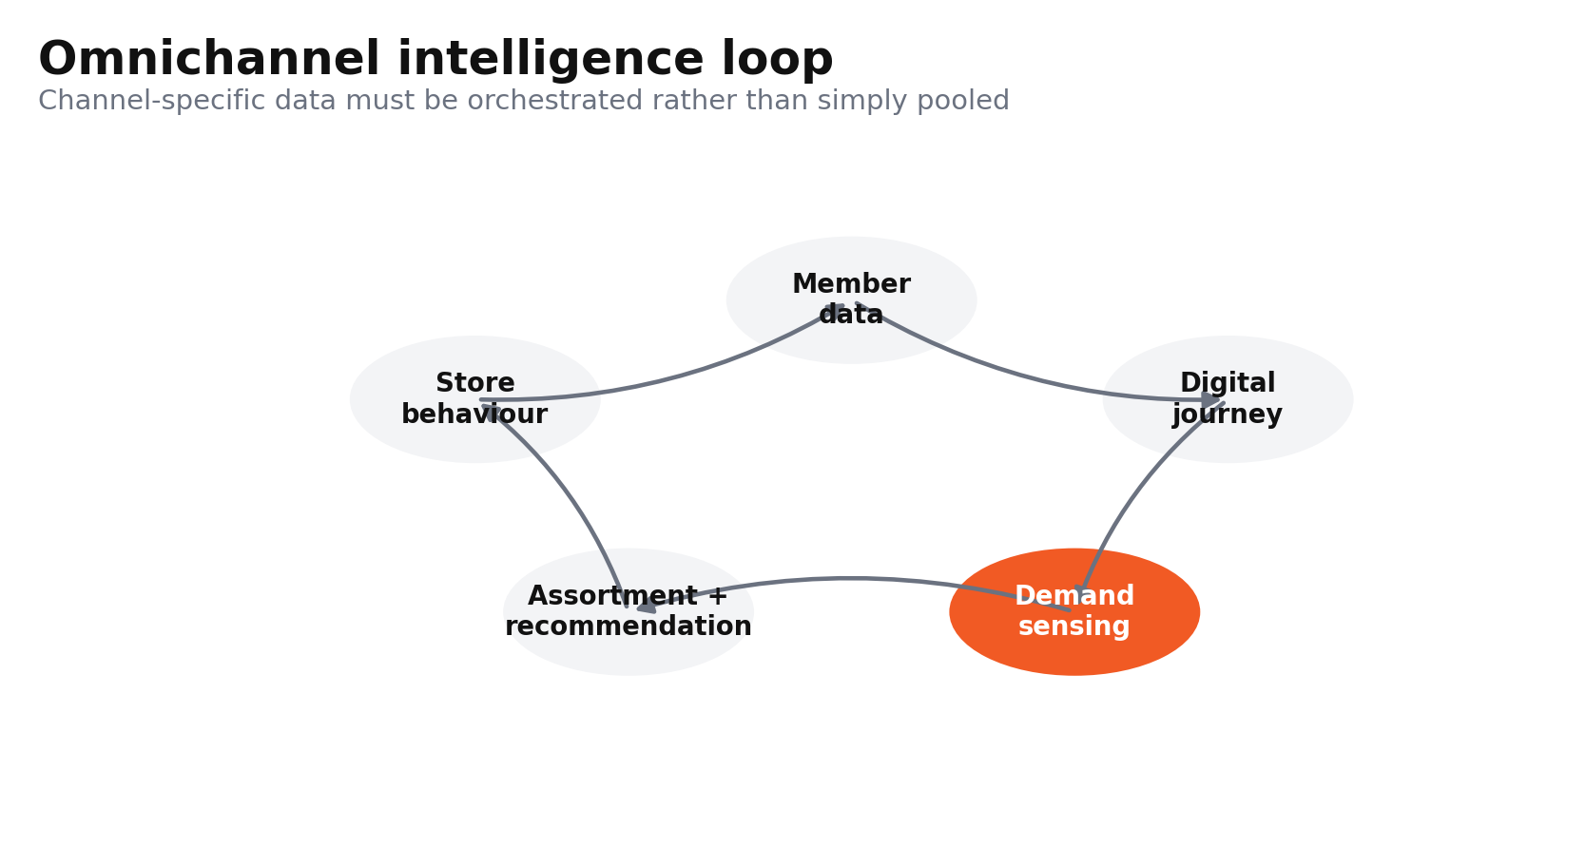
Figure 9. Omnichannel intelligence loop linking stores, membership and digital behaviour.

2.3. PESTEL, environmental and legal factors.
Regulation is turning sustainability from a reputation management exercise into a tangible operating necessity. California's climate disclosure regime extends emissions disclosure to businesses with annual revenues exceeding $1 billion and climate-risk disclosure to those with annual revenues exceeding $500 million, thus clearly exposing Nike through its California operations and market presence (CARB, 2026). This increases compliance costs, but it can also benefit companies with well-developed supplier data. In addition, Marketing claims are subject to parallel evaluation as the FTC's Green Guides review explicitly applies to claims like “recyclable” and “recycled content”, adding to the risk of greenwashing in product communications (FTC, 2022). The commercial opportunity remains, but it is conditional. According to the 2025 sportswear study that included 400 respondents, functionality and sustainability have a combined influence on purchase intent: if one of the factors is poor, the other cannot make up for it (Lee et al., 2025). There is also a threat of legal action for counterfeiting. The USTR also notes that it has identified open sales of counterfeit goods in clothing, sports footwear and accessories in markets with weak enforcement, which weakens brand equity and may continue to flow into digital marketplaces (USTR, 2025b). The highest value environmental opportunity is therefore verified low-carbon product innovation, and the main legal threat is the growing weight of substantiation, traceability and IP enforcement throughout the global value chain.
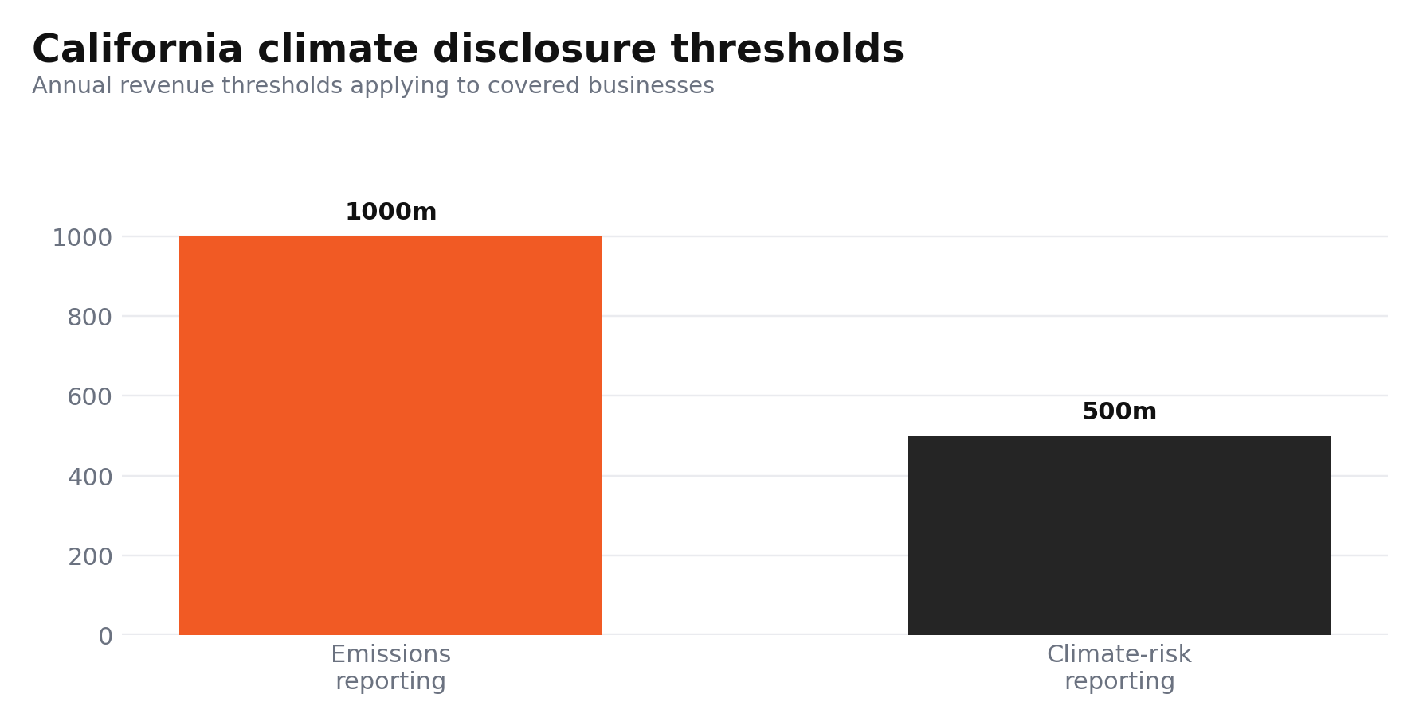
Figure 10. California climate-disclosure revenue thresholds.
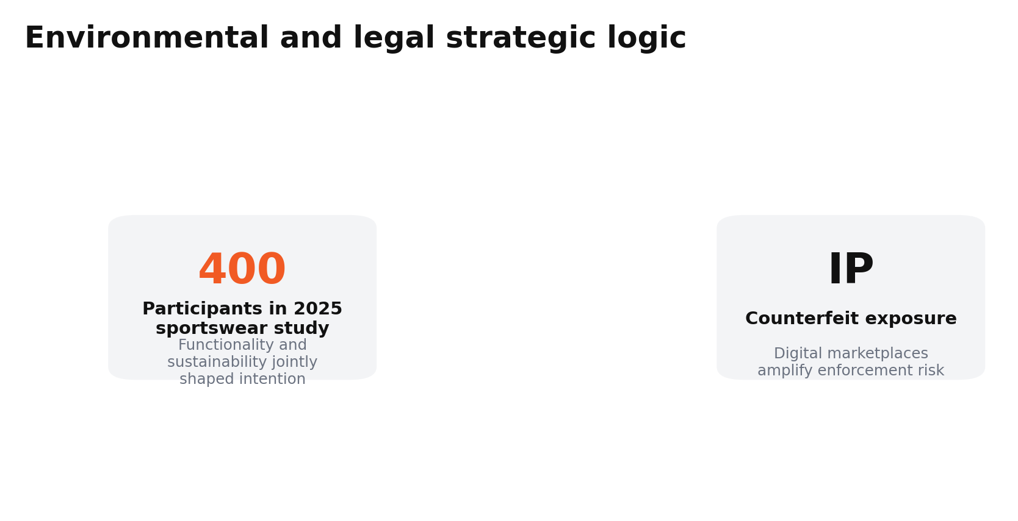
Figure 11. Sustainability opportunity is conditional on performance and credible substantiation.

2.4. VRIO, brand and innovation resources.
Nike's most valuable internal resource is brand equity, which is valuable, rare and difficult to imitate at an equally significant cultural level. In 2025, Nike received a score of 94.7 out of 100 for brand strength and was ranked the world's strongest apparel brand (Brand Finance, 2025). This is not a perfectly inimitable resource in that rivals can buy endorsements and mimic design elements, but path dependence is built up from athlete affiliations, iconic brands, and cultural memory. Innovation capability also meets several elements of the VRIO test. The Nike 2025 innovation engine launched Project Amplify, a powered footwear system for running and walking, and new ideas for thermoregulation (NIKE, 2025a). These capabilities are valuable and technically complex, yet sustained advantage depends on commercial cadence rather than laboratory novelty. The NikeSKIMS initiative brings a complementary resource together as Nike's sport science team combines with SKIMS' expertise in fit and female consumer expertise (NIKE, 2025b). The research suggests that the pursuit of premium positioning can enhance brand knowledge, which helps in the monetisation of differentiated innovation (Dwivedi et al., 2025). Therefore, Nike's brand equity and athlete network provide sustained competitive advantages. Its sport-science innovation capability currently provides a temporary competitive advantage because commercial conversion is not yet fully organised.
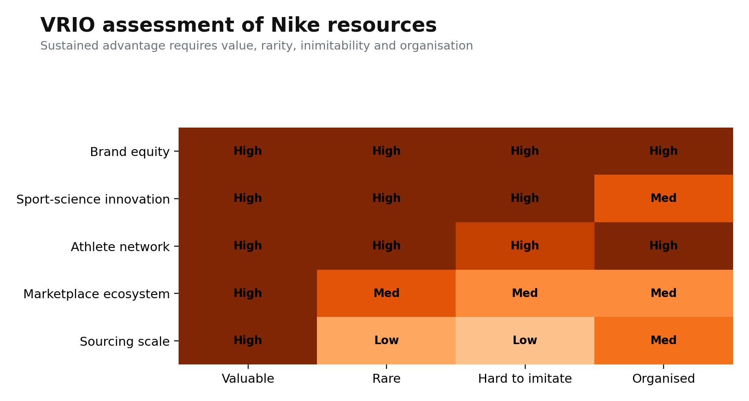
Figure 12. VRIO assessment of Nike’s key strategic resources.
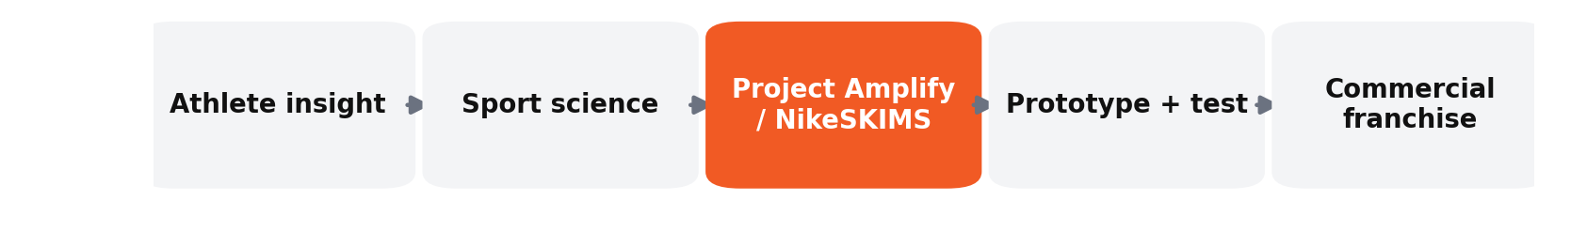
Figure 13. Innovation conversion pathway from insight to commercial franchise.

2.5. VRIO, marketplace and organisational capability.
The Nike integrated marketplace is useful as it brings a mix of wholesale reach and owned stores, apps and membership data, but evidence from FY2026 indicates this resource is not yet fully organised for value capture. NIKE Brand wholesale revenue grew 7.9% to $7.5 billion, compared to $6.9 billion in Q2 FY2026, with digital traffic contributing mainly to this increase (NIKE, 2025c). This gap indicates that channel width is positive, while the past channel-heavy DTC setup reduced channel complementarity with retail channels. Key capabilities identified in research as important for omnichannel transformation are sensing, seizing and resource reconfiguration, with the focus on organisational adaptation instead of channel ownership (Solem et al., 2023). Deloitte recently found, in its survey of 99 apparel, footwear and accessories brands, that the performance of the supply chain is also dependent on cross-functional visibility and capability development (Deloitte, 2025a). Recent logistics research further finds that internal and external omnichannel integration must be strategically orchestrated to improve market power (Li et al., 2026). In VRIO, Nike's distribution system has a high value and is comparatively rare, but not inimitable. Its current weakness is the “O” condition: Nike lacks consistent orchestration of digital demand, wholesale partnerships and inventory. Therefore, Nike's marketplace ecosystem provides a temporary competitive advantage because it is valuable and comparatively rare, but imitable and not fully organised for value capture.
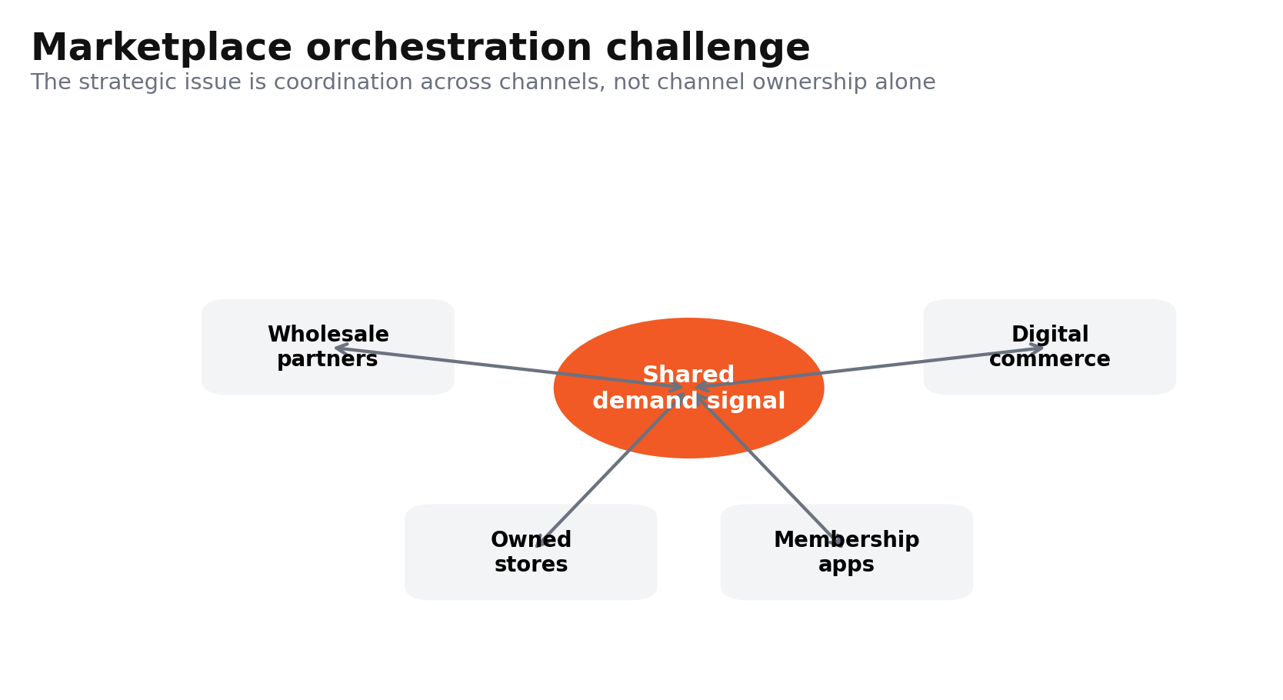
Figure 14. Marketplace orchestration across wholesale, stores, membership and digital commerce.
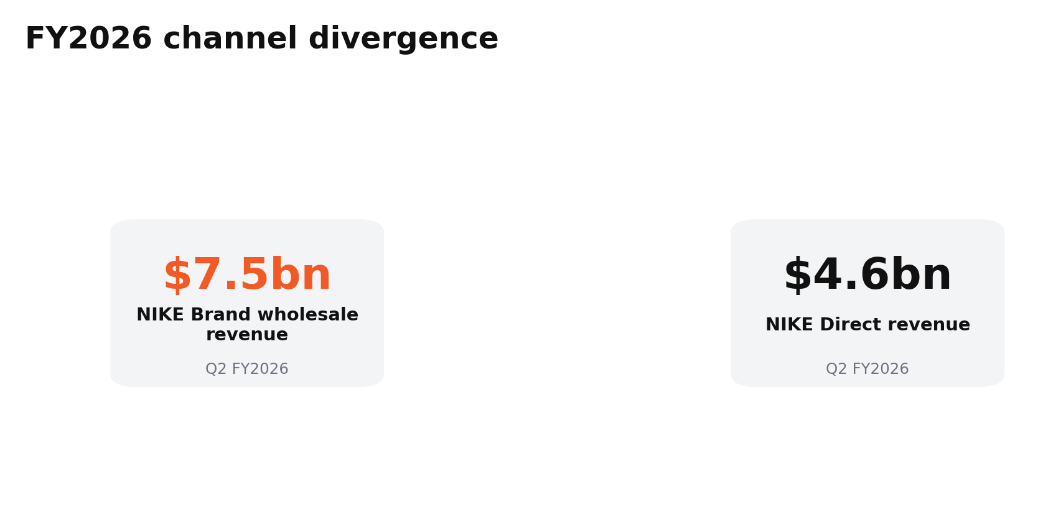
Figure 15. Channel divergence reinforcing the need for coordinated hybrid distribution.

2.6. VRIO, structural weaknesses and eroding rarity.
Nike's resource base is limited by the fact that it compounds the fragility of its margins, and it centralises its sourcing. Q1 FY2026 gross margin was down 320 basis points due to lower average selling prices, discounting, channel mix and tariffs (NIKE, 2025d). This indicates that Nike is not fully converting its brand equity into stronger inventory productivity and consumer traffic. The risk is intensified by sourcing concentration, as industry estimates quoted by Reuters showed that sports-footwear manufacturing in Vietnam was 50%, in Indonesia 27%, and in China 18% (Reuters, 2025a). This scale can provide bargaining power, but it is not uncommon and exposes Nike to trade shocks. Nike's innovation edge is becoming less rare as competitors improve. On reported 26.4% currency-adjusted sales growth in Q1 2026, driven by younger and female consumers (Reuters, 2026b). Continued specialist momentum was evident in Hoka's latest 14.5% increase in quarterly sales (Reuters, 2026c). In addition, Adidas has narrowed its operating-profit margin gap with Nike to its smallest level in about 25 years (FT, 2026). Thus, the primary failing of Nike is not a lack of resources. It is slower to translate brand, insight and R&D into differentiated products that can command full prices from targeted challengers. Therefore, Nike's sourcing scale provides competitive parity rather than competitive advantage because it is valuable but neither rare nor difficult to imitate.
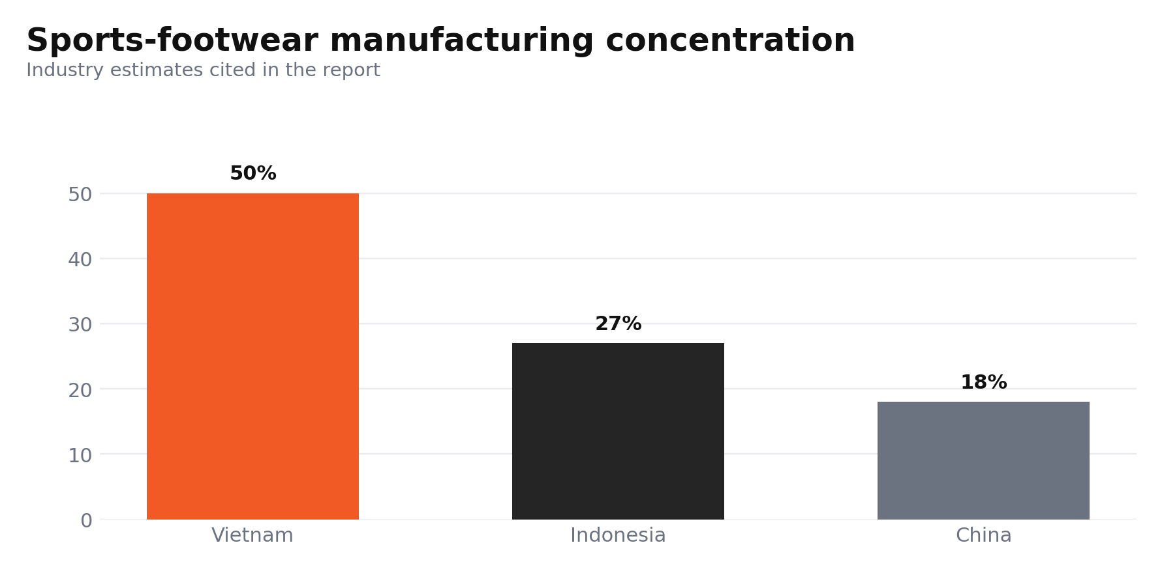
Figure 16. Manufacturing concentration increases exposure to trade and logistics shocks.
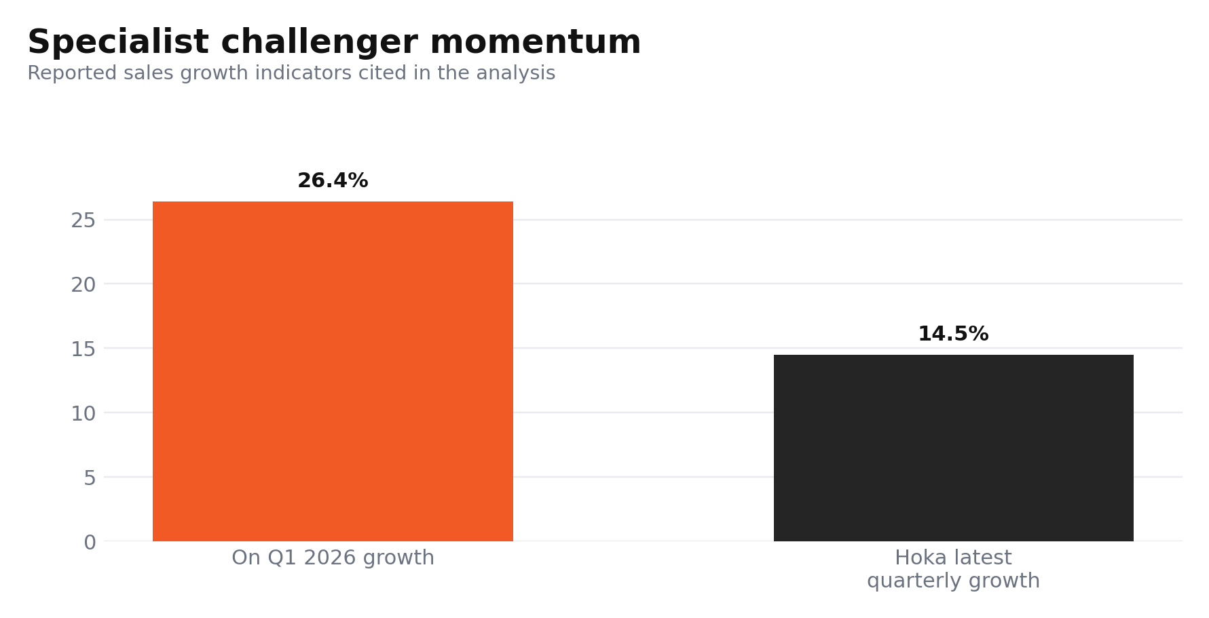
Figure 17. Challenger growth demonstrates erosion of Nike’s resource rarity.

2.7. SWOT Analysis
Nike’s principal strengths are exceptional brand salience, sport-science capability, athlete credibility and broad distribution. Furthermore, its sustainability operating base is not solely a marketing message; Nike is reporting absolute decreases of 69% in Scope 1 & 2 emissions from 2015 to 2025, along with a drop of 36% in specified Scope 3 manufacturing & transportation emissions when compared to its stated baselines (NIKE, 2025e). In addition, the company has dedicated design and performance areas designed for athlete innovation, testing and prototyping, in effect reinforcing tacit knowledge that competitors cannot easily acquire (NIKE, 2025f). Women's fitness, performance running, community-based participation and selective digital reactivation are the most appealing opportunities. According to Reuters, women accounted for roughly 40% of Nike's customer base during the announcement of NikeSKIMS, meaning there is significant potential for further growth if the partnership can translate attention into repeat demand (Reuters, 2025b). This is a growth strategy that should be approached as a related growth, not for the sake of brand extension. Research findings about sustainable competitive advantage highlight the need to constantly match market sensing with resource deployment (Majeed et al., 2025). Nike should thus invest its best resources in marketing into less penetrated demand pockets rather than maximise undifferentiated SKU volume.
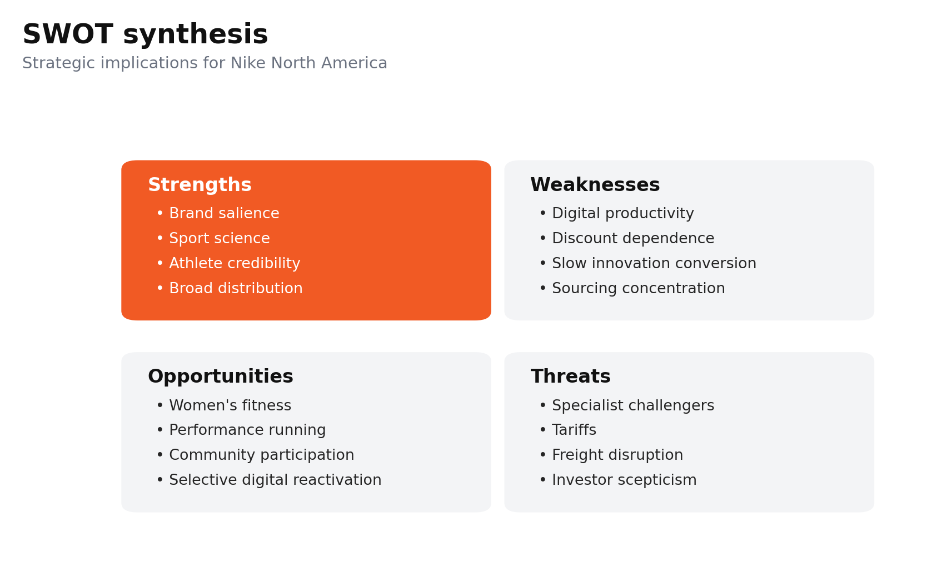
Figure 18. SWOT synthesis of Nike North America.
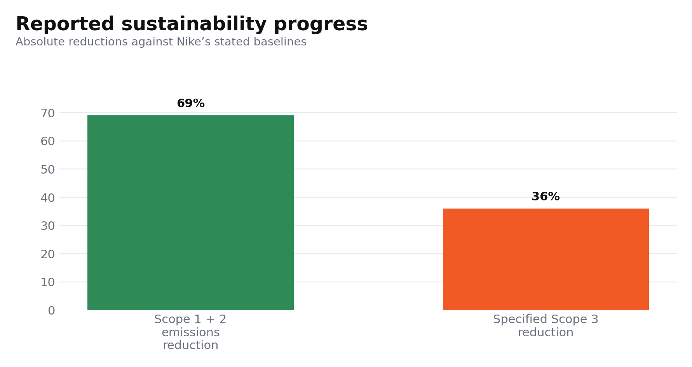
Figure 19. Sustainability progress strengthens resilience but does not remove social-governance gaps.
Critical weaknesses include declining digital productivity, discount dependence, channel imbalance, slow innovation conversion and Asian manufacturing concentration. These vulnerabilities compound into growing threats. The investor short interest in Nike surged in 2026, reflecting doubts about how fast the company could turn around, as Adidas gained 12.2% market share in 2025 compared to 11.7% in 2024 (Reuters, 2026a). Nike's shares ended 35% lower on Tuesday, and analysts were forecasting that sales of its biggest brands would not recover before fiscal 2028 (Reuters, 2026f). Tariff uncertainty also compromises execution, with 2025 supply-chain evidence revealing that international procurement purchases by US buyers slowed significantly, highlighting the risk of over-optimistic sourcing and forecasting (QIMA, 2025). This indicates that supply-chain volatility is persistent rather than episodic. Fashion-sector evidence from 2026 also shows geopolitical disruption continuing to raise freight costs, delay deliveries and push brands towards diversification and better inventory visibility (Vogue Business, 2026). Nike should avoid any aggressive growth until the execution is sorted out. The best strategic response is to integrate fewer, more differentiated performance franchises, partner-driven reach, discipline in inventory and supplier diversification, and verified sustainability. This turns brand strength into resilience and diminishes the risks that already pose threats to margin and strategic credibility.

3. Comprehensive and Holistic View of Nike

3.1. CSR Strategy and Strategic Alignment
Nike's CSR structure is relevant because it connects decarbonisation, supplier capability and inclusion with cost resilience, product credibility and brand trust, instead of CSR as philanthropy. Nike reported that 96% of the electricity used in its owned or operated facilities came from renewable sources in FY2024, helping to reduce energy risk and support Move to Zero (NIKE, 2025a). Progress in the supply chain, with 75% of strategic supplier facilities measuring and working to improve worker engagement and 67% having gender equity, was found to be a material gap (NIKE, 2025b). The 2026 academic study of Nike's reporting showed decent reporting on the environment but inconsistent on labour rights, living wages and supply-chain transparency (Soltanisehat et al., 2026). The strategic alignment of CSR should not be restricted to reputational statements but should also be linked to operational accountability (Chehimi et al., 2024). Therefore, Nike must incorporate verified worker-welfare, traceability and circular-product metrics into its executive scorecards. The contemporary SBSC research calls for such integration, but highlights that the choice of indicators and resistance from organisations can limit implementation (Silva et al., 2025). Measurement of social value is not as well developed as environmental reporting, which is linked to the CSR's innovation and resilience goals.
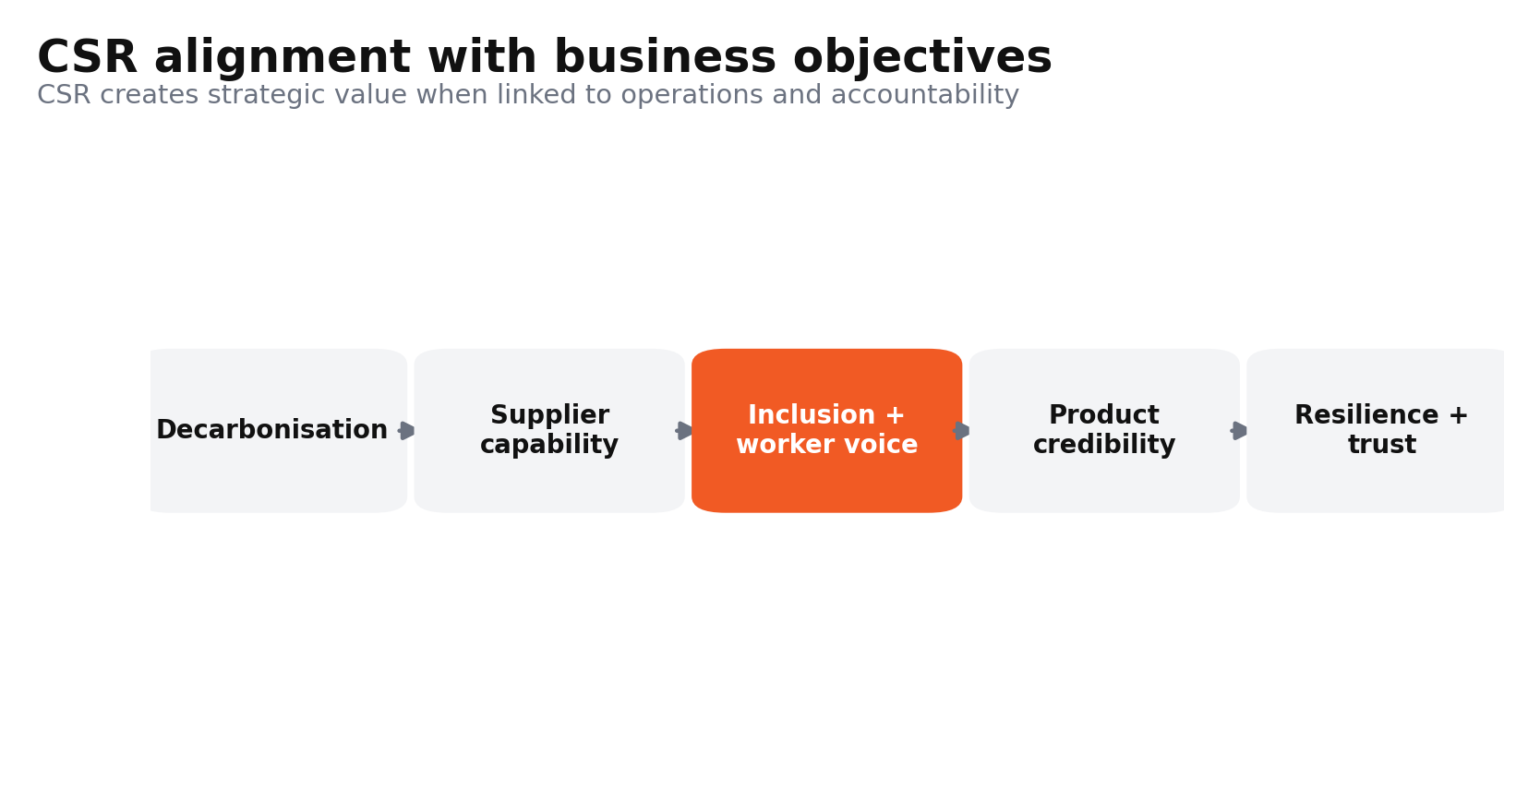
Figure 20. CSR alignment chain linking stakeholder outcomes to competitive resilience.
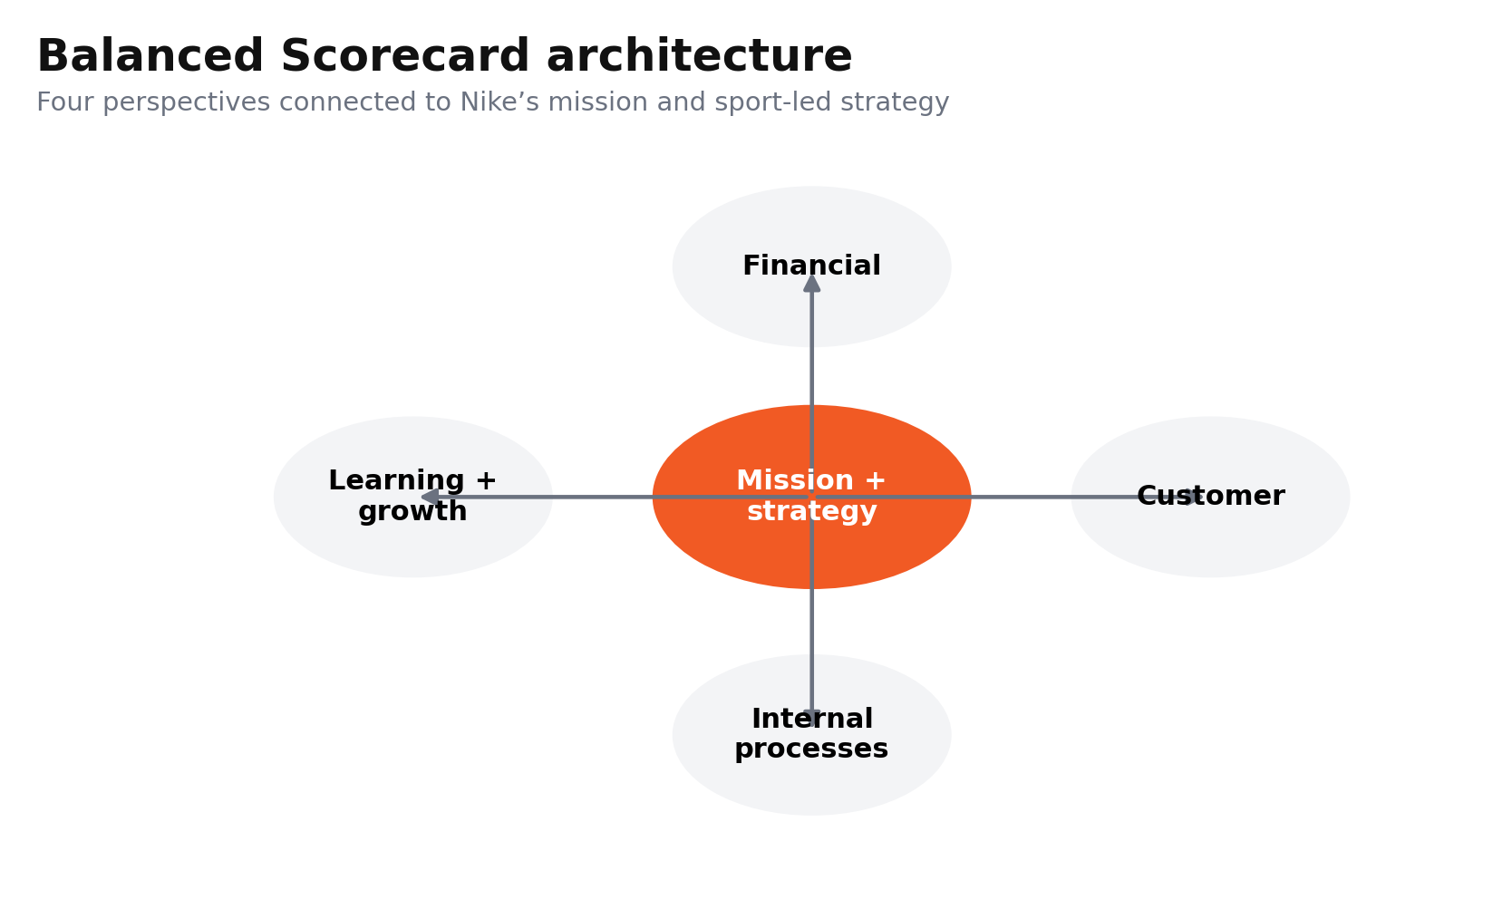
Figure 21. Balanced Scorecard perspectives aligned with Nike’s mission and strategy.

3.2. Financial Perspective
The goal should be to regain healthy North American growth without relying on discount intensity as a volume tool. KPIs are North America revenue growth, full-price sell-through, gross margin, inventory turns and net-income margin. The net income in FY2026 was $3.108 billion, a decrease of 3 percent, and the year-end inventory was $7.501 billion, indicating that there has not been sufficient momentum generated by stabilisation (SEC, 2026). The $986 million tariff-recovery benefit in Q4 was a one-off benefit and should not be treated as structural recovery (Reuters, 2026e). FY27 goals include at least a 5% revenue increase in North America, a gross margin greater than 43% and a 15% decline in markdown rate and inventory growth while sales grow. Sport-led franchise renewal, strict open-to-buy controls and regional demand sensing and selective wholesale expansion are all part of the initiatives. Madsen (2025) emphasises that BSC KPIs should relate profitability results to the drivers of the business. Hristov et al. (2024) demonstrate the need for causal connections between lead and lag indicators. Nike’s Board should track full-price sell-through and inventory ageing monthly because these reveal whether desirability is improving before earnings confirm it.
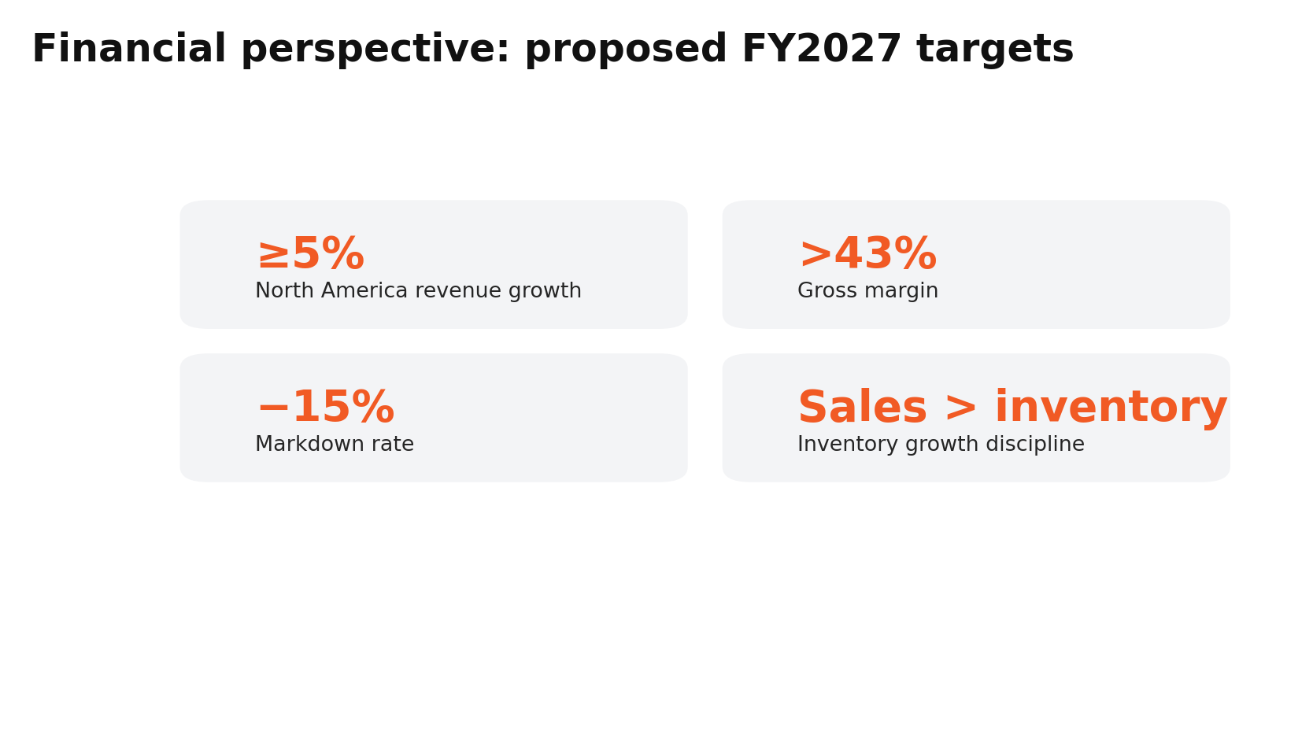
Figure 22. Proposed financial scorecard targets for the turnaround.

3.3. Customer Perspective
The goal should be to restore preference and perceived value while maintaining Nike's premium differentiation. US brand consideration, satisfaction, repeat purchase, member activity, full price conversion and category share should be included in the KPIs. Nike's appeal to the US was higher with Gen Z at 55.4% than with Gen X at 39.1%, revealing an age imbalance (YouGov, 2026a). BrandIndex had Nike's global Index score at 34.5 compared with 35.3 for Adidas, with Nike outperforming in quality perception in the U.S. (YouGov, 2026b). L.E.K.’s 2026 study still ranked Nike first overall in women’s athletic footwear, but Hoka and On followed closely, with On tying for first among Gen Z women (L.E.K. Consulting, 2026). Proposed FY28 targets are to raise Gen X consideration to 45, improve US value perception by five points, maintain a top-two position in athletic-footwear brand heat and increase active-member repeat purchase by 10%. Initiatives should bring together local run communities, women-specific ecosystems, partner-linked membership and less generic promotions. Digital-marketing research suggests that engagement quality, rather than quantity, builds brand loyalty when channel execution reinforces brand relevance (Chen, 2024).
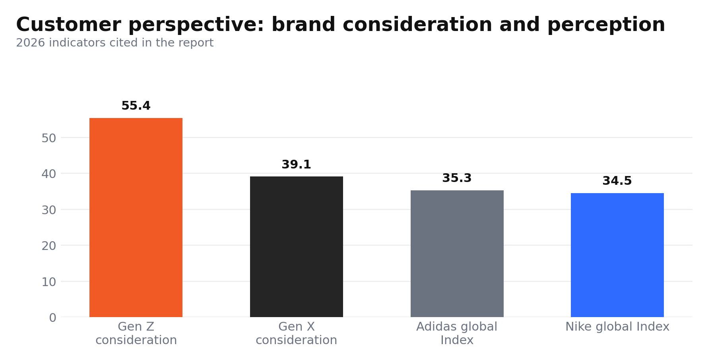
Figure 23. Customer metrics reveal age-segment imbalance and close brand competition.

3.4. Internal Business-Process Perspective
The goal should be to reduce insight-to-market time and improve ethical performance, availability and inventory accuracy throughout the supply chain. KPIs should include concept to launch time, forecast error, on-time in full delivery, aged inventory, remediation closure, and traceability beyond Tier 1. Nike's FY24 gender-equity programme involved targeted capability-building with suppliers in Vietnam and Cambodia, demonstrating that improvement can be done upstream of the audits (NIKE, 2025c). Indirect-tier visibility is also strategically material, however, as seen in investigations of Taiwanese fashion supply chains with migrant workers' recruitment fees reported at $6,000 in 2025 (Webb, 2025). Digitalisation, resilience and diversification are also identified as interrelated needs when it comes to research on fashion supply-chain shocks (Al-Amin et al., 2025). Proposed FY2028 targets are to cut forecast error by 20%, reduce concept-to-market time by 25%, achieve 95% on-time in-full delivery and close 90% of severe supplier-remediation cases within 90 days. AI-assisted demand sensing, SKU rationalisation, supplier digital twins and worker-voice escalation should all be part of initiatives. Data-governance research acknowledges that these three KPI clusters are interdependent and ultimately form a single control architecture, rather than separate dashboards (Vyhmeister et al., 2025).
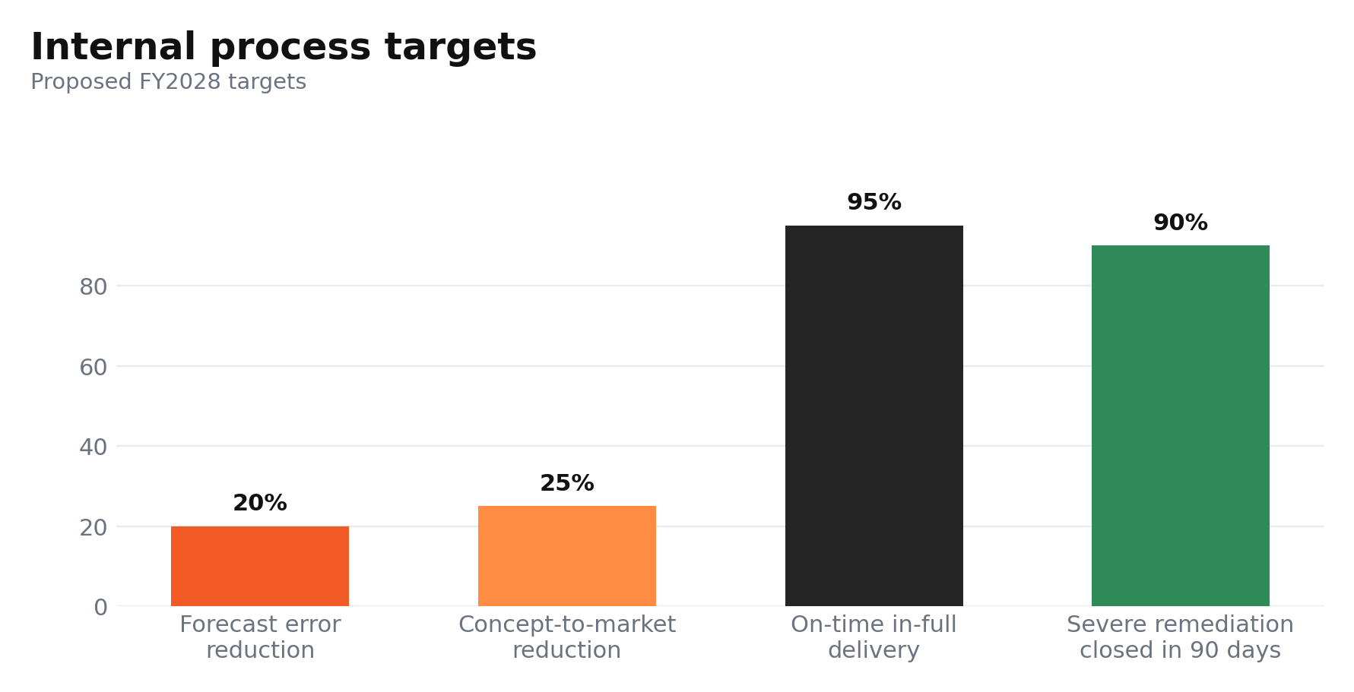
Figure 24. Proposed internal process targets for speed, reliability and remediation.

3.5. Learning and Growth Perspective
The goal should be to strengthen sport expertise, innovation speed and digital capability while preserving organisational memory. Critical skill coverage, internal mobility, employee engagement, training completion, regretted attrition, and patent-to-launch conversion should be included in KPIs. Nike reported about 1,400 more job cuts across the globe in 2026, mainly in technology, as it looks to deploy technologies quickly and upskill (Cho, 2026). While the agility gains may be achieved through cost simplification, the loss of capabilities may reduce the innovation engine required to get back on track. Systems-based BSC research sees learning capacity as a means of operational and financial results, not merely a secondary HR measure (Yawson et al., 2023). Another review of 1294 BSC studies also reveals that the themes of innovation, customer orientation and strategic performance management are interrelated (Kumar et al., 2024). Nike should target 90% completion of role-specific AI and analytics training, 60% internal fill for critical vacancies, regretted attrition below 8% and a 20% improvement in patent-to-commercial-launch conversion by FY2028. Sport category academies, protected innovation squads, retailer secondments and leadership incentives based on capability depth are all essential to initiatives. Research into human-centred scorecards can help investigate the dimension of employee capabilities beyond culture, enhancing the accuracy of diagnosis (Vokony et al., 2026).
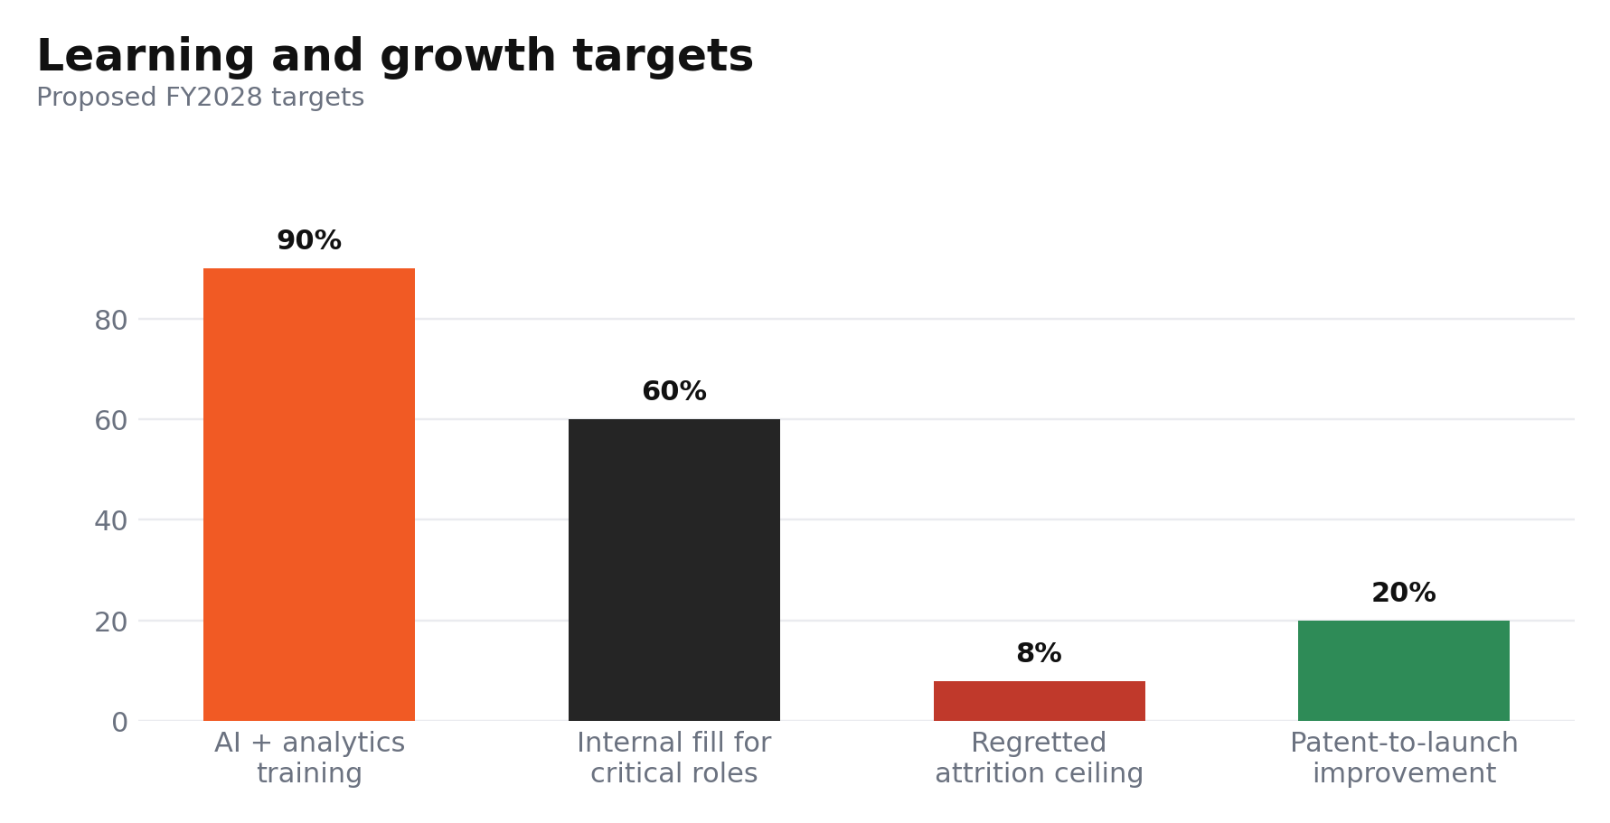
Figure 25. Proposed learning and growth targets for capability renewal.

4. Strategic Choices and Implementation

4.1. Business-level Choice
Nike North America should not adopt a low-price strategy, as doing so would dilute the premium rents that are generated by athlete credibility, design and performance innovation. A narrow focus strategy is also unsuitable, since Nike has a broad range of interests, such as running, basketball, football training, and lifestyle, because the scale would be lost otherwise. The better solution is sport-led broad differentiation and selective cost discipline, and not price competition. This aligns with the finding that the differentiation can boost innovation performance when firms convert market knowledge into unique value offers (Rubio-Andrés et al., 2024). Also, product differentiation is more effective when management matches resources to competitive pressure (Baird et al., 2024), and innovation can help buffer the link between strategy and competitive advantage (Farida et al., 2022). The market case is strong: According to Circana, US performance footwear sales grew 5% in Q1 2026, with running seeing double-digit dollar and unit growth. On's forecast of at least 23% constant-currency sales growth and a 63% gross margin in 2026 further indicates that targeted innovation can support premium economics (Reid et al., 2026). Nike should compete directly by differentiating performance systems, building fewer but stronger franchise teams, and supporting sport communities that are relevant to local markets.
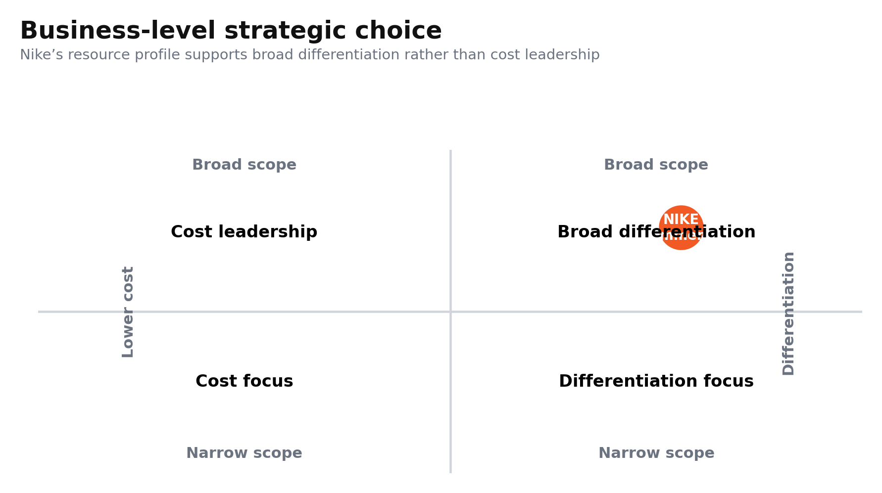
Figure 26. Business-level strategy comparison highlighting broad differentiation.
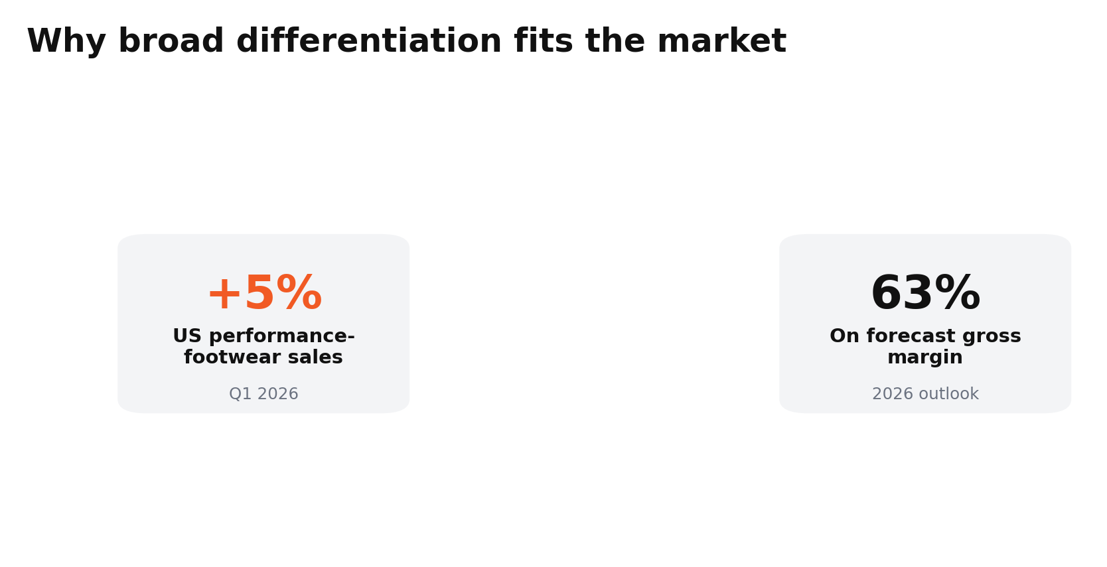
Figure 27. Performance-market growth and challenger economics support differentiated competition.

4.2. Ansoff Validation
The main growth strategy should be product development in the present North American market, supplemented by market penetration as a secondary strategy. New and materially enhanced products for current customers are preferred by Ansoff logic, as Nike has distribution reach and knowledge of the sports industry. In large companies, disciplined governance positively affects the transformation of ideas into business results (López Fernández et al., 2025) and dynamic capabilities influence firms' ability to sense opportunities and reconfigure resources for digital innovation (de la Torre et al., 2025). This sequencing is confirmed by channel evidence. In Q3 FY2026, North American wholesale revenue grew by 11% in currency-neutral terms, and footwear revenue increased by 6% to demonstrate that partner reach can drive a reinvigorated product demand without re-establishing DTC exclusivity (SEC, 2026). Product uniqueness, sophisticated distribution and product innovation (Sipos et al., 2025) are other advantages of marketing innovation. The Nike “Rip the Script” World Cup campaign reached over 1.5 billion views, demonstrating the power of culturally relevant activation to drive penetration around sports moments (Danziger, 2026). Nike should thus start fewer sport-led platforms in running, training and football for women, and then scale them with differentiated wholesale assortments, membership and community activation. Some market development and unrelated diversification should be postponed, as both would fragment management focus during the turnaround.
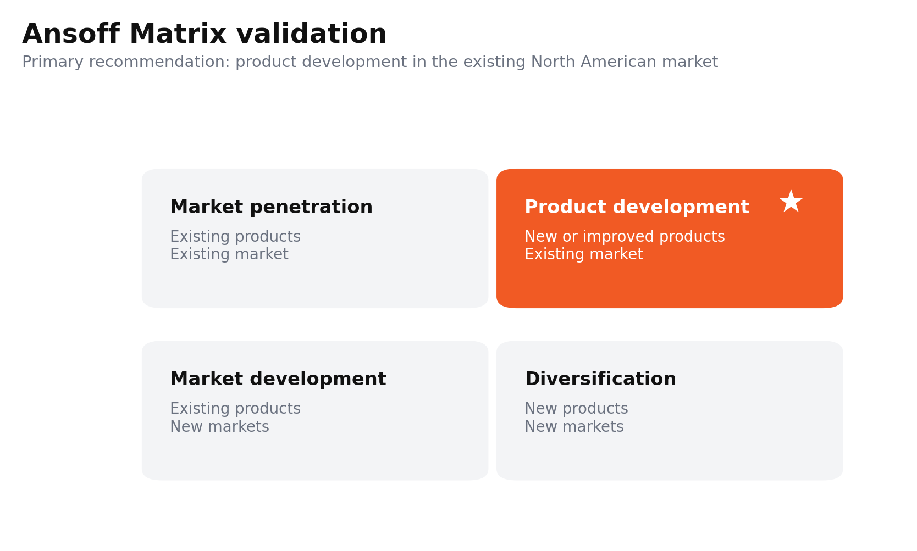
Figure 28. Ansoff Matrix highlighting product development as the primary growth path.
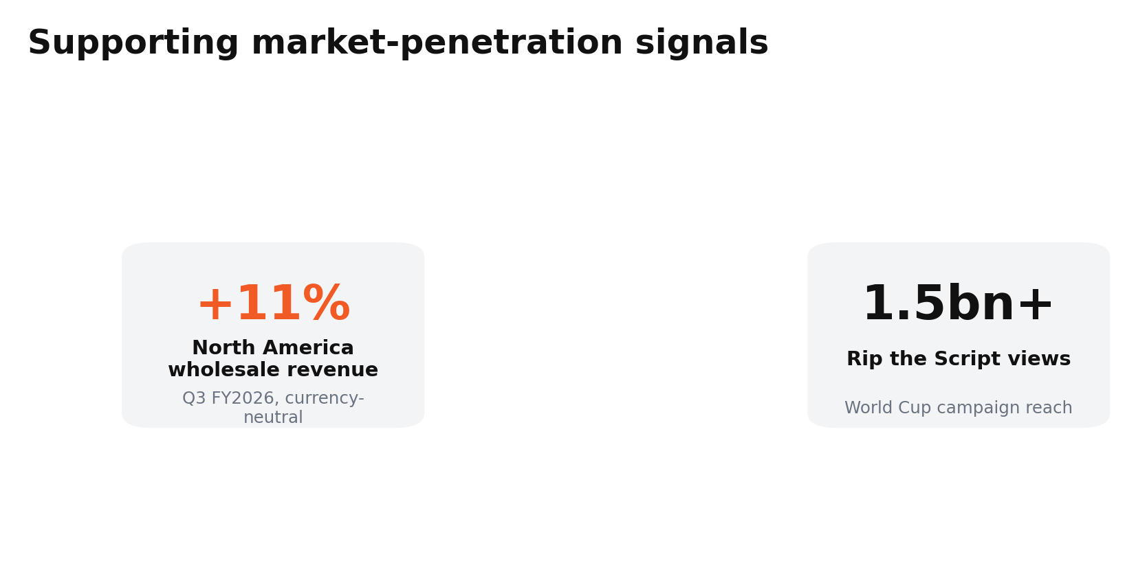
Figure 29. Wholesale reach and culturally relevant activation can support penetration.

4.3. SAFe evaluation
The recommendation is suitable because it addresses declining product desirability, challenger growth and channel imbalance while using Nike's brand, athlete network and R&D capabilities. SAFe requires explicit testing of suitability, feasibility and acceptability rather than managerial intuition (Hashemkhani Zolfani et al., 2022). It is acceptable because premium product development can improve consumer relevance without permanent markdowns. The integration of responsibility into strategy, as opposed to compliance, can enhance future innovation performance through ESG-linked innovation (Cabaleiro-Cerviño et al., 2024). It is feasible because Nike already possesses design, sport science and marketplace capabilities, although innovation must be linked to organisational learning (Dukhaykh et al., 2026). Orchestrating resources can reinforce innovation (Tajeddini et al., 2024). Innovation capability positively influences performance when firms face disruptions and reconfigure their operations, and digital transformation relies on dynamic capabilities and strategic decision-making (Garrido-Moreno et al., 2024; Abu Alrub et al., 2025). The proposed targets include a 20% reduction in concept-to-launch time, 25% of North American footwear sales from products launched in under 24 months and full-price sell-through of 8 percentage points by FY2029. These steps would support faster innovation renewal, stronger pricing power and lower inventory risk.
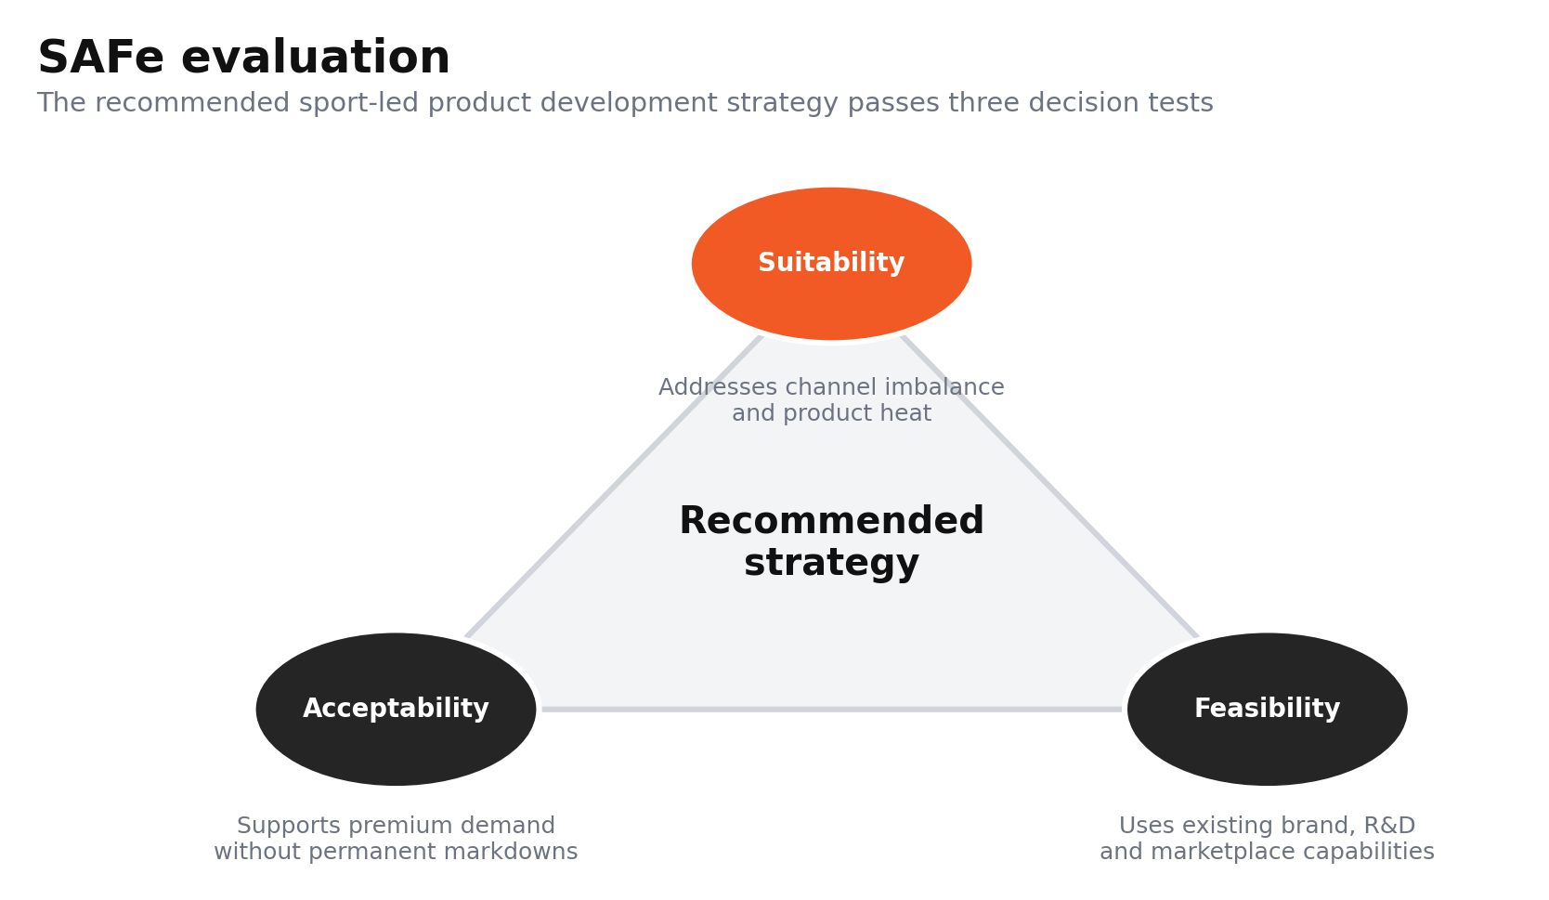
Figure 30. SAFe evaluation of the recommended sport-led product development strategy.
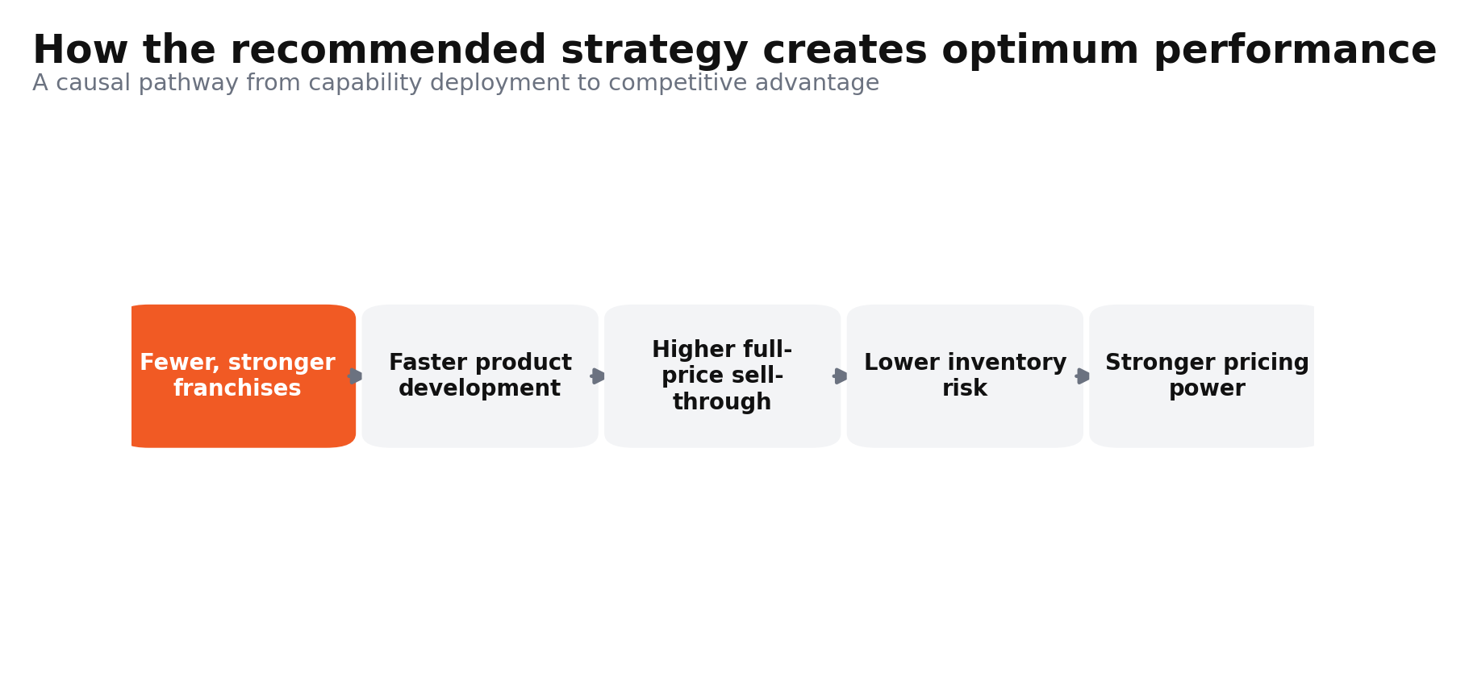
Figure 31. Causal pathway from focused innovation to stronger competitive performance.

4.4. Implementation Challenges and Mitigation
The main implementation risks include SKU proliferation, retailer conflict, forecast errors, and a lack of innovation leadership and incentives that focus on short-term volume instead of franchise health. Nike should exploit successful franchises while also exploring new growth opportunities. Ambidexterity is effective in enhancing strategic flexibility if both activities are coordinated (Kafetzopoulos et al., 2023), but evidence cautions against the benefits of ambidexterity in all organisational contexts (Hu et al., 2023). Nike should establish cross-functional sport squads with category P&L ownership, kill-or-scale decisions every quarter, and stage-gate funding. Conflict at the wholesale level can be reduced by using joint account plans, differentiated assortments and shared demand signals, while DTC should serve as a testing and membership channel rather than the default sales channel. Middle-manager leadership and coordination are key to implementation (Tawse et al., 2024), and incentives should be tied to shared full-price sell-through, launch speed, and repeat-purchase metrics and outcomes. For organisations with cascading objectives, OKRs can create a stronger integrative implementation (Wowerath, 2026). Leadership continuity is material as Nike's latest change was its third innovation chief departure in under three years (Pacheco, 2026). Restructuring should be complemented by protected technical career paths, succession plans and retained category knowledge so that valuable capabilities are not lost in the turnaround.
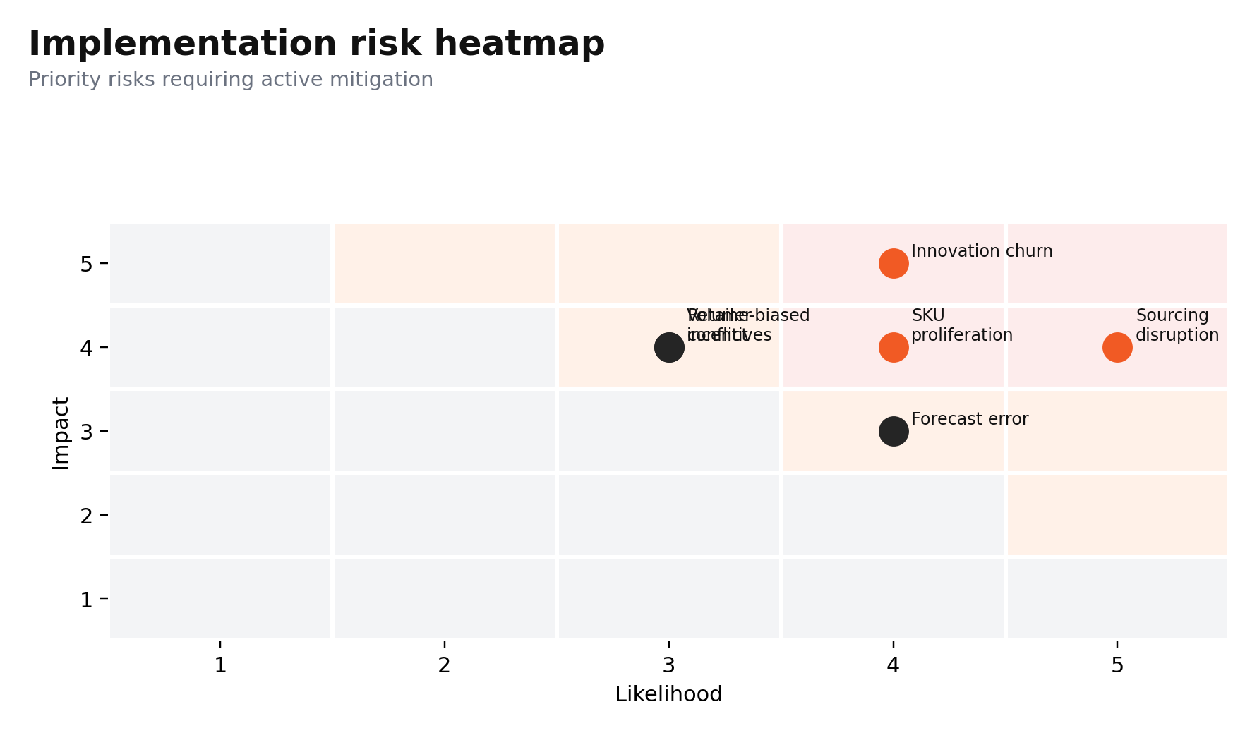
Figure 32. Implementation risks prioritised by likelihood and impact.
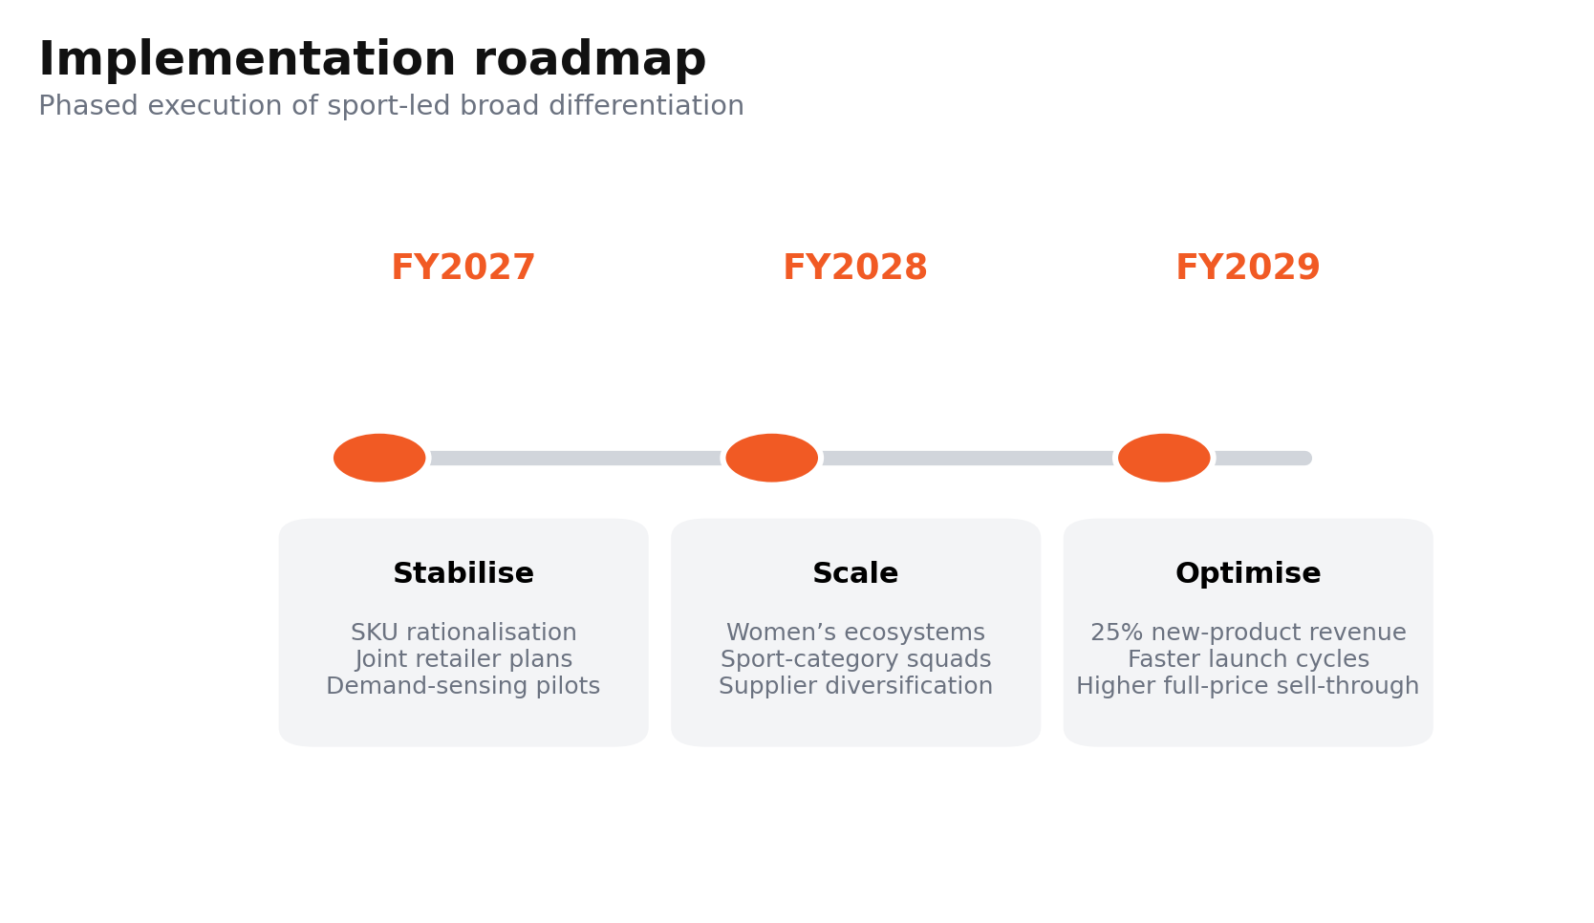
Figure 33. Three-phase implementation roadmap for FY2027 to FY2029.

Section 2: Reflective Account Using Kolb’s Experiential Learning Cycle

Concrete Experience
The process of researching, analysing and preparing the strategic management assessment on Nike in the North American athletic footwear and apparel market required me to move beyond simple description and adopt a consultant-oriented approach. My starting point was to define the organisational scope carefully because Nike operates globally across several product categories and markets. For this reason, I took North America as my focus and investigated Nike's strategic positioning in terms of external analysis, internal analysis, CSR evaluation, the Balanced Scorecard and the strategic-choice frameworks. The most challenging aspect was finding suitable, recent, and reliable evidence, without relying on unsupported claims. I studied company disclosures, regulatory filings, reputable media articles, academic journal articles and market evidence to analyse Nike's position in 2026. I also had to manage statistics carefully to avoid unnecessary repetition across sections.
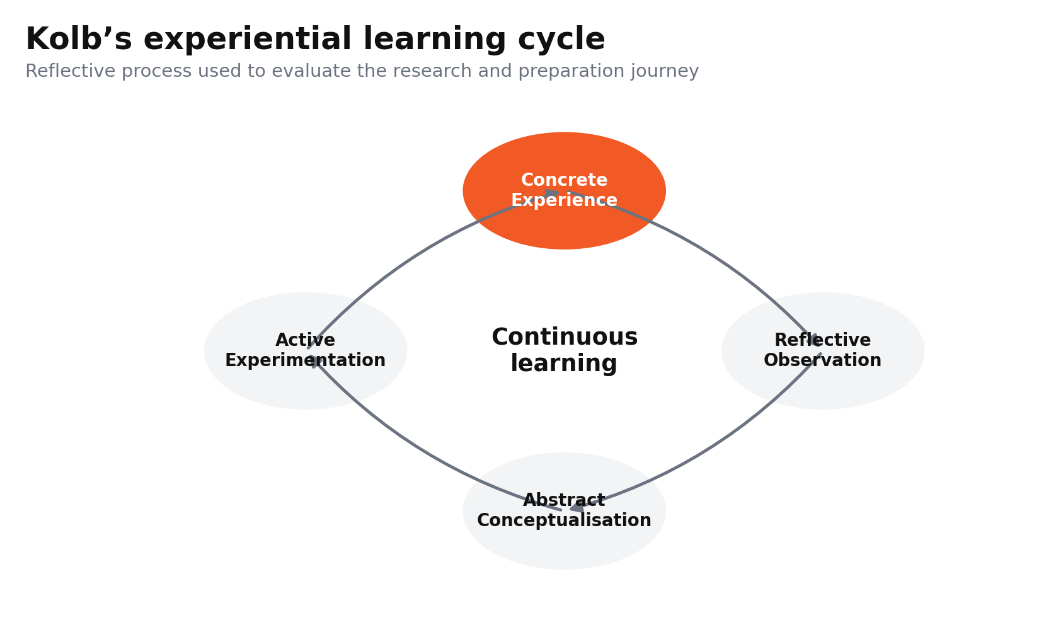
Figure 34. Kolb’s experiential learning cycle used for the reflective account.
In the course of the analysis, I used the tools PESTEL, VRIO, SWOT, Ansoff and SAFe to evaluate external pressures, strategic resources, strategic synthesis and future strategic decisions, respectively. The process illustrated that strategic analysis is not simply the sum of its constituent parts. Each model needed to make a contribution to an integrated argument concerning Nike's competitive advantage, channel imbalance, innovation capacity, tariff exposure, digital weaknesses and growth opportunities. This experience was insightful for me in terms of understanding how strategic management frameworks could have the potential of being analytical tools if they are put together around a clear business problem.
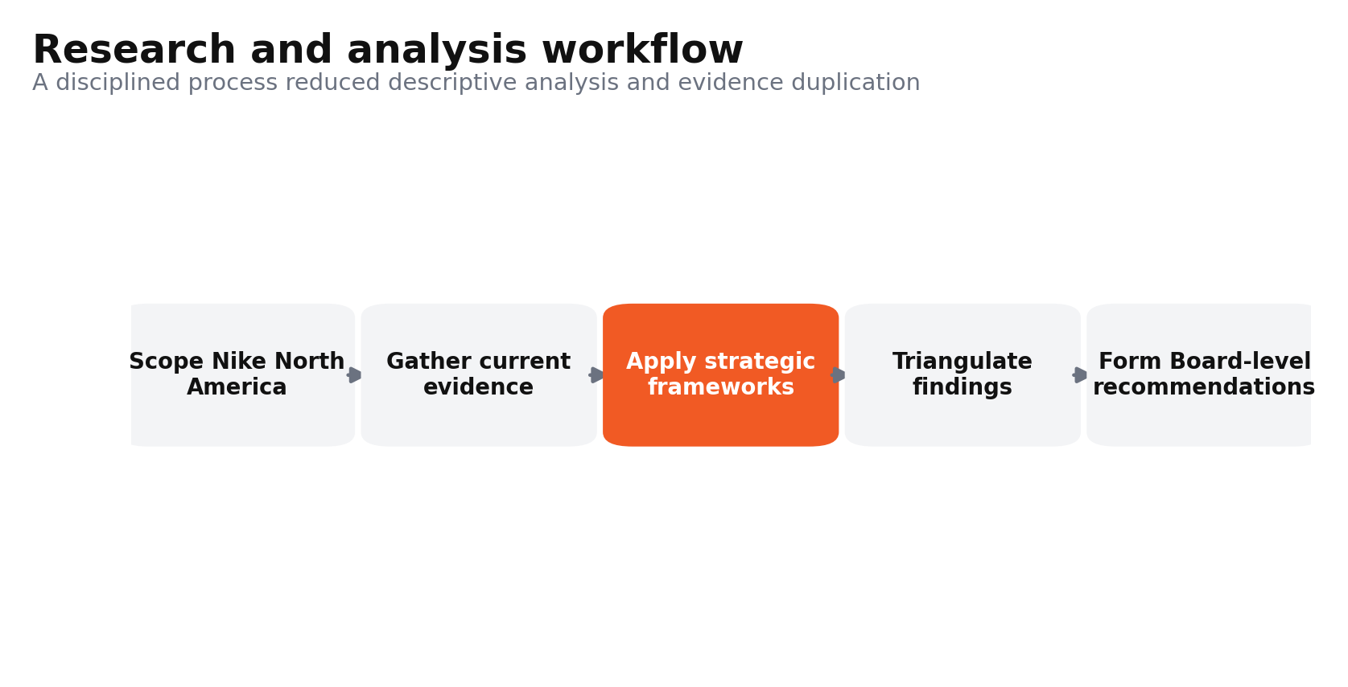
Figure 35. Research and analysis workflow used to prepare the strategic assessment.

Reflective Observation
Reflecting on the experience, I identified several strengths and weaknesses in my approach. One of the key strengths was that I chose to focus on existing evidence and strategic materiality. Rather than examining all the PESTEL elements equally, I focused on the ones that directly impact Nike's performance in the North American market: Tariffs, digital retail growth, sustainability regulation and changing consumer preferences. This enhanced the relevance as analysis was based on factors which might have an impact on competitive advantage. I also learned the benefit of critically evaluating the strengths of companies. At first, I thought Nike's brand, innovation, and ability to go directly to consumers were sure to give them sustainable advantages. However, the VRIO analysis forced me to question whether these resources were genuinely rare, difficult to imitate and fully supported by the organisation. With evidence of digital weakness, margin pressure and escalating competition from On, Hoka and Adidas, the result was that superior resources didn't always lead to superior outcomes.
A weakness in my process was the risk of collecting too much information. In some instances, descriptive writing was encouraged by the vast amount of information about the market and the companies. I had to repeatedly remove general information and retain only evidence connected to the strategic issue. I also learned that frameworks can have negative side effects by causing artificial separation. For instance, in PESTEL, tariff pressure was present, but also internal factors such as sourcing weaknesses, financial results and the feasibility of strategy. This showed me that strategic issues cut across analytical categories and should not be treated in isolation.

Abstract Conceptualisation
The research process has changed my understanding of the use of theory in Strategic Management. Previously, I considered frameworks like PESTEL, SWOT and Ansoff as tools for information structuring. This assessment gave me a deeper understanding of frameworks as tools that support causal thinking and strategic judgement rather than simple information organisation. For instance, tariff exposure was a political and economic risk identified in the PESTEL analysis, but the bigger strategic risk was that of Nike's sourcing focus and limited ability to pass on any cost pressures without cannibalising its premium positioning. Likewise, the VRIO analysis identified that brand equity itself does not provide a sustained advantage unless a company is organisationally able to turn brand equity into products, full-price sales and preference.
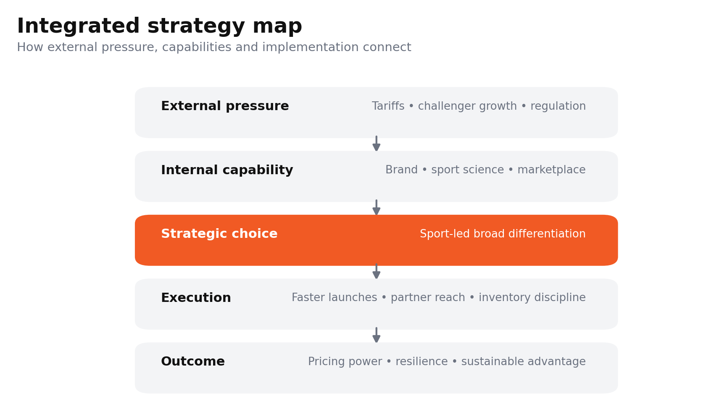
Figure 36. Integrated strategy map connecting external pressures to competitive outcomes.
The Balanced Scorecard also enabled me to appreciate the linkage between financial and non-financial performance. The ability to recover financially can't be divorced from customer relevance, innovation speed, workforce capability or supply-chain effectiveness. This prompted me to rethink Nike's problem as a problem of resource orchestration, not a sales problem. I also learned that strategic recommendations need theoretical consistency. Cost leadership was not suitable due to Nike's brand architecture and innovation resources. The product development strategy, backed by the selective market penetration, was more coherent with Ansoff's Matrix and the company's capacities. Then, SAFe offered an organised way to test if this recommendation was appropriate, acceptable and feasible. This stage reinforced my capacity to tie theory to evidence, instead of forcing models in mechanically.

Active Experimentation
Based on these reflections, I would improve my future strategic research process in several ways. First, I would lay out an evidence map and connect each statistic, source, and theoretical concept to an analytical purpose. This will eliminate duplication and over-collection of data. Second, I would create a strategy map as part of the assignment. This would indicate how the external threats affect the internal resources, customer outcomes, and financial performance and provide a stronger conclusion. Third, I would evaluate suggestions for specific alternatives sooner. A significant amount of analysis in this evaluation led to a final decision on sport-led broad differentiation. I would begin with a systematic comparison of cost leadership, focus and differentiation in future, applying strategic fit criteria.
Fourth, I would enhance stakeholder analysis of how actions recommended will impact employees, retail partners, suppliers, investors and customers, as well as competitive performance. I would further employ scenario analysis in cases of uncertain externalities like tariffs, consumer spending and supply-chain disruption. This would help to build resilience for implementation planning. Lastly, I would keep a structured reflective journal during the research process rather than reflecting primarily after drafting. Continuous application of Kolb's cycle would enable me to recognise weaknesses earlier and adjust my research approach and analytical judgement during the research process. Overall, the assessment has enhanced my research skills, as well as my capacity to critically assess and interpret evidence, and then to develop recommendations which are theoretically sound, commercially viable and within the organisation's capabilities.

References
Al-Amin, M., Tahir, M., Talukder, A., Al Mamun, A., Hossain, T., and Sultana, N. (2025). Unraveling Global Threads: Pandemic, Geopolitical Conflict, and Resilience in Fashion and Textile Supply Chain. Ekonomi İşletme ve Yönetim Dergisi, 9(1), 158-222.
Alrub, Y. A., and Sánchez-Cañizares, S. M. (2025). Dynamic capabilities and digital transformation: Toward strategic planning in the digital age—Evidence from palestine. Administrative Sciences, 15(1), 21.
Baird, K., Nuhu, N., and Jiao, L. (2024). The effect of Porter’s competitive forces on competitive advantage and organisational performance and the moderating role of management accounting practices. Journal of Management Control, 35(2), 303-332.
BCG (2025) Walk, Lounge, Sweat: How the Generations Are Redefining Activewear. Boston Consulting Group. Available at: https://web-assets.bcg.com/e9/55/28d5934b44c6a18e83554c7d0d1a/bcg-activewear-trends-report.pdf (Accessed: 9 July 2026).
BLS (2026) The Employment Situation, June 2026. U.S. Bureau of Labor Statistics. Available at: https://www.bls.gov/news.release/empsit.nr0.htm (Accessed: 9 July 2026).
Brand Finance (2025) ‘Nike is strongest apparel brand globally in 2025; Chanel is most valuable’, 28 August. Available at: https://brandfinance.com/press-releases/nike-is-strongest-apparel-brand-globally-in-2025-chanel-is-most-valuable (Accessed: 9 July 2026).
Cabaleiro-Cerviño, G., and Mendi, P. (2024). ESG-driven innovation strategy and firm performance. Eurasian Business Review, 14(1), 137-185.
CARB (2026) ‘CARB approves climate transparency regulation for entities doing business in California’, 26 February. California Air Resources Board. Available at: https://ww2.arb.ca.gov/news/carb-approves-climate-transparency-regulation-entities-doing-business-california (Accessed: 9 July 2026).
Chehimi, M., and Naro, G. (2024). Balanced Scorecards and sustainability Balanced Scorecards for corporate social responsibility strategic alignment: A systematic literature review. Journal of Environmental Management, 367, 122000.
Chen, T. (2024). A study on Nike’s digital marketing strategy based on the 4Ps theory and analysis of competitiveness maintenance methods. In SHS Web of Conferences (Vol. 207, p. 01007). EDP Sciences.
Cho, J.H. (2026) ‘Nike cutting 1,400 more jobs. The stock is rising’, Barron’s, 23 April. Available at: https://www.barrons.com/articles/nike-cutting-jobs-stock-eca8d61a (Accessed: 9 July 2026).
Choi, Y., Shin, J., and Lim, C. (2024). Cross-channel Recommendation for Multi-channel Retail. arXiv preprint arXiv:2404.00972.
Circana (2026) ‘US footwear industry delivers modest first-quarter growth driven by price increases and strength in performance segment’, 4 May. Available at: https://www.circana.com/post/us-footwear-industry-delivers-modest-first-quarter-growth-driven-by-price-increases-and-strength-in (Accessed: 9 July 2026).
Danziger, P.N. (2026) ‘Nike’s Sport Offense reignites momentum as “Rip the Script” breaks 1.5 billion views’, Forbes, 3 July. Available at: https://www.forbes.com/sites/pamdanziger/2026/07/03/nikes-sport-offense-reignites-momentum-as-rip-the-script-breaks-15-billion-views/ (Accessed: 9 July 2026).
de la Torre, A., and De la Vega, I. (2025). Dynamic capabilities and digital innovation: pathways to competitive advantage through responsible innovation. Journal of Responsible Innovation, 12(1), 2500154.
Deloitte (2025a) Apparel and Footwear Supply Chain Dynamics. Available at: https://www.deloitte.com/us/en/services/consulting/articles/apparel-and-footwear-supply-chain.html (Accessed: 9 July 2026).
Deloitte (2026a) ‘Reshaping loyalty programs in an era of value seeking’, 12 January. Available at: https://www.deloitte.com/us/en/insights/industry/retail-distribution/reshaping-customer-loyalty-programs.html (Accessed: 9 July 2026).
Dukhaykh, S., and Alangri, N. (2026). Dynamic Capabilities and Sustainable Competitive Advantage in SMEs: The Roles of Innovation and Organizational Learning. Sustainability, 18(3), 1320.
Dwivedi, A., and McDonald, B. (2025). A model of brand price premiumness and its marketing outcomes. Journal of Marketing Theory and Practice, 1-22.
EBSCO (2025) Nike, Inc. Business and Management Research Starters. Available at: https://www.ebsco.com/research-starters/business-and-management/nike-inc (Accessed: 9 July 2026).
Farida, I., and Setiawan, D. (2022). Business strategies and competitive advantage: the role of performance and innovation. Journal of open innovation: Technology, market, and complexity, 8(3), 163.
Financial Times (2026) ‘Adidas is outplaying Nike in the global sportswear competition’, 4 July. Available at: https://www.ft.com/content/cc431354-dced-4e9f-bfdb-0cbf0e6bb083 (Accessed: 9 July 2026).
FTC (2022) ‘FTC Environmental Marketing Guides: Is it time for a change of green-ery?’, 28 December. Federal Trade Commission. Available at: https://www.ftc.gov/business-guidance/blog/2022/12/ftc-environmental-marketing-guides-it-time-change-green-ery (Accessed: 9 July 2026).
Garrido-Moreno, A., Martín-Rojas, R., and García-Morales, V. J. (2024). The key role of innovation and organizational resilience in improving business performance: A mixed-methods approach. International Journal of Information Management, 77, 102777.
Hashemkhani Zolfani, S., Bazrafshan, R., Ecer, F., and Karamaşa, Ç. (2022). The suitability-feasibility-acceptability strategy integrated with Bayesian BWM-MARCOS methods to determine the optimal lithium battery plant located in South America. Mathematics, 10(14), 2401.
Hristov, I., Cristofaro, M., Camilli, R., and Leoni, L. (2024). A system dynamics approach to the balanced scorecard: a review and dynamic strategy map for operations management. Journal of manufacturing technology management, 35(4), 705-743.
Hu, M., Dou, J., and You, X. (2023). Is organizational ambidexterity always beneficial to family-managed SMEs? Evidence from China. Journal of Business Research, 167, 114184.
Kafetzopoulos, P., Psomas, E., and Katou, A. A. (2023). Promoting strategic flexibility and business performance through organizational ambidexterity. Sustainability, 15(17), 12997.
Kumar, S., Lim, W. M., Sureka, R., Jabbour, C. J. C., and Bamel, U. (2024). Balanced scorecard: trends, developments, and future directions. Review of managerial science, 18(8), 2397-2439.
L.E.K. Consulting (2026) 2026 US Footwear, Apparel and Accessories Brand Heat Index. Available at: https://www.lek.com/sites/default/files/insights/pdf-attachments/2026-footwear-apparel-accessories-brand-heat-index-special-report.pdf (Accessed: 9 July 2026).
Lee, J., Son, J., and Lim, S. (2025). Consumer’s contradictory needs: functionality and sustainability on purchase intentions for sportswear. Journal of Global Fashion Marketing, 16(2), 173-195.
Li, Y., and Zhang, K. (2026). The effect of omnichannel supply chain integration on market power: the moderating role of environmental uncertainty. The International Journal of Logistics Management, 1-26.
López Fernández, D. and Oliver, M. (2025). Methodology, strategies, and factors for business innovation in large companies, International Journal of Innovation Studies, 9(2), pp. 91-115.
Madsen, D. Ø. (2025). Balanced scorecard: History, implementation, and impact. Encyclopedia, 5(1), 39.
Majeed, M., Tijani, A., Ofori, K. S., Abubakari, A., and Ampong, G. O. A. (2025). Impact of strategic orientation on sustainable competitive advantage: the mediating role of organizational capabilities. Cogent Social Sciences, 11(1), 2457230.
McKinsey and Company (2025) Sporting goods industry trends 2025. Available at: https://www.mckinsey.com/industries/retail/our-insights/sporting-goods-industry-trends (Accessed: 9 July 2026).
McKinsey and WFSGI (2025) Sporting Goods 2025: The New Balancing Act. Available at: https://www.mckinsey.com/~/media/mckinsey/industries/retail/our%20insights/sporting%20goods%20industry%20trends/2025/sporting-goods-2025-the-new-balancing-act-turning-uncertainty-into-opportunity-v3.pdf (Accessed: 9 July 2026).
NIKE (2025a) ‘Nike creates new innovation engine to power athletes and sport’, 23 October. Available at: https://about.nike.com/en/newsroom/releases/nike-new-innovation-engine-announcement (Accessed: 9 July 2026).
NIKE (2025a) FY24 NIKE, Inc. Sustainability Data. Available at: https://media.about.nike.com/files/460d3198-9609-4f5b-b18c-d4e7aa570bff/FY24_NIKE%2C-Inc.-Sustainability-Data.pdf (Accessed: 9 July 2026).
NIKE (2025b) ‘NIKE, Inc. and SKIMS introduce new brand for women’, 18 February. Available at: https://about.nike.com/en/newsroom/releases/nikeskims-official-announcement (Accessed: 9 July 2026).
NIKE (2025b) Responsible Supply Chain. Available at: https://about.nike.com/en/mission/focus-areas/responsible-supply-chain (Accessed: 9 July 2026).
NIKE (2025c) Gender Equity. Available at: https://about.nike.com/en/mission/initiatives/supply-chain-gender-equity (Accessed: 9 July 2026).
NIKE (2025c) NIKE, Inc. Reports Fiscal 2026 Second Quarter Results, 18 December. Available at: https://investors.nike.com/investors/news-events-and-reports/investor-news/investor-news-details/2025/NIKE-Inc--Reports-Fiscal-2026-Second-Quarter-Results/default.aspx (Accessed: 9 July 2026).
NIKE (2025d) NIKE, Inc. Reports Fiscal 2026 First Quarter Results, 30 September. Available at: https://investors.nike.com/investors/news-events-and-reports/investor-news/investor-news-details/2025/NIKE-Inc--Reports-Fiscal-2026-First-Quarter-Results/default.aspx (Accessed: 9 July 2026).
NIKE (2025e) Sustainability. Available at: https://about.nike.com/en/mission/focus-areas/sustainability (Accessed: 9 July 2026).
NIKE (2025f) ‘The spaces where Nike creates the future of sport’, 24 January. Available at: https://about.nike.com/magazine/nike-spaces-sports-design-innovation-performance (Accessed: 9 July 2026).
NIKE (2026a) Explore Nike’s Purpose and Read Our Mission Statement. Available at: https://about.nike.com/en/mission (Accessed: 9 July 2026).
NIKE (2026a) NIKE, Inc. Reports Fiscal 2026 Third Quarter Results, 31 March. Available at: https://investors.nike.com/investors/news-events-and-reports/investor-news/investor-news-details/2026/NIKE-Inc--Reports-Fiscal-2026-Third-Quarter-Results/default.aspx (Accessed: 9 July 2026).
NIKE (2026b) NIKE, Inc. Reports Fiscal 2026 Fourth Quarter and Full Year Results. Available at: https://investors.nike.com/investors/news-events-and-reports/investor-news/investor-news-details/2026/NIKE-Inc--Reports-Fiscal-2026-Fourth-Quarter-and-Full-Year-Results/default.aspx (Accessed: 9 July 2026).
NIKE (2026c) Fiscal 2026 Divisional Revenues. Available within NIKE’s FY2026 fourth-quarter and full-year results. Available at: https://investors.nike.com/investors/news-events-and-reports/investor-news/investor-news-details/2026/NIKE-Inc--Reports-Fiscal-2026-Fourth-Quarter-and-Full-Year-Results/default.aspx (Accessed: 9 July 2026).
Pacheco, I. (2026) ‘Nike switches up its innovation leadership’, The Wall Street Journal, 10 April. Available at: https://www.wsj.com/business/retail/nike-switches-up-its-innovation-leadership-0add24ab (Accessed: 9 July 2026).
QIMA (2025) ‘U.S. tariffs propel global supply chains into uncharted territory’, 14 August. Available at: https://www.qima.com/newsroom/news/news-q3-2025-supply-chain-signals-report (Accessed: 9 July 2026).
Reid, H. and Kanatt, N.J. (2026) ‘Sportswear brand On sees possible boost from lower US tariff rate’, Reuters, 3 March. Available at: https://www.reuters.com/business/retail-consumer/sportswear-brand-sees-possible-boost-lower-us-tariff-rate-2026-03-03/ (Accessed: 9 July 2026).
Reuters (2025a) ‘Retailers’ exposure to tariffs on Asian countries’, 8 July. Available at: https://www.reuters.com/business/retail-consumer/retailers-exposure-tariffs-asian-countries-2025-07-08/ (Accessed: 9 July 2026).
Reuters (2025b) ‘Nike to launch new women’s fitness brand with Kim Kardashian’s Skims’, 18 February. Available at: https://www.reuters.com/business/retail-consumer/nike-launch-new-womens-fitness-brand-with-kim-kardashians-skims-2025-02-18/ (Accessed: 9 July 2026).
Reuters (2026a) ‘Bets surge against Nike, heaping pressure on CEO Hill’, 5 May. Available at: https://www.reuters.com/business/bets-surge-against-nike-heaping-pressure-ceo-hill-2026-05-05/ (Accessed: 9 July 2026).
Reuters (2026b) ‘Zendaya effect helps sportswear maker On lift 2026 profit outlook’, 12 May. Available at: https://www.reuters.com/business/sportswear-brand-expects-higher-2026-profit-it-attracts-younger-female-customers-2026-05-12/ (Accessed: 9 July 2026).
Reuters (2026c) ‘Hoka-owner Deckers provides upbeat annual outlook on resilient demand’, 21 May. Available at: https://www.reuters.com/business/retail-consumer/hoka-owner-deckers-provides-upbeat-annual-outlook-resilient-demand-2026-05-21/ (Accessed: 9 July 2026).
Reuters (2026d) ‘Adidas edging Nike in World Cup sales boost, data show’, 25 June. Available at: https://www.reuters.com/sports/soccer/adidas-edging-nike-world-cup-sales-boost-data-show-2026-06-24/ (Accessed: 9 July 2026).
Reuters (2026e) ‘Nike flags prolonged turnaround as China slump, weak outlook eclipse quarterly beat’, 30 June. Available at: https://www.reuters.com/legal/transactional/nike-edges-past-quarterly-revenue-estimates-2026-06-30/ (Accessed: 9 July 2026).
Reuters (2026f) ‘Nike gains despite China slump as investors eye slow turnaround’, 1 July. Available at: https://www.reuters.com/business/retail-consumer/nike-stumbles-china-woes-cautious-outlook-temper-turnaround-hopes-2026-07-01/ (Accessed: 9 July 2026).
Rubio-Andrés, M., Linuesa-Langreo, J., Gutiérrez-Broncano, S., and Sastre-Castillo, M. Á. (2024). How to improve market performance through competitive strategy and innovation in entrepreneurial SMEs. International Entrepreneurship and Management Journal, 20(3), 1677-1706.
SEC (2025) NIKE, Inc. Form 10-K for the fiscal year ended 31 May 2025. U.S. Securities and Exchange Commission. Available at: https://www.sec.gov/Archives/edgar/data/320187/000032018725000047/nke-20250531.htm (Accessed: 9 July 2026).
SEC (2026) NIKE, Inc. Fiscal 2026 Fourth Quarter and Full Year Results, Exhibit 99.1. U.S. Securities and Exchange Commission. Available at: https://www.sec.gov/Archives/edgar/data/320187/000032018726000076/q4fy26exhibit991er.htm (Accessed: 9 July 2026).
SEC (2026) NIKE, Inc. Form 10-Q for the quarterly period ended 28 February 2026. U.S. Securities and Exchange Commission. Available at: https://www.sec.gov/Archives/edgar/data/320187/000032018726000037/nke-20260228.htm (Accessed: 9 July 2026).
Silva, A., Maldonado, I., da Silva, M., and Cepeda, C. (2025). Sustainability balanced scorecard: systematic literature review. Journal of Risk and Financial Management, 18(6), 324.
Sipos, N., Rideg, A., Al Najjar, A. S., and Lukovszki, L. (2025). Resource-based view of marketing innovation in SMEs: a multi-country empirical analysis based on the global competitiveness project. Journal of Innovation and Entrepreneurship, 14(1), 94.
Solem, B. A. A., Fredriksen, J. I., and Sørebø, Ø. (2023). Dynamic capabilities in the realisation of omnichannel retailing. International Journal of Retail and Distribution Management, 51(1), 21-38.
Soltanisehat, M., and Jestratijevic, I. (2026). Sustainability Reporting in the Spotlight: Exploring Evidence from Nike’s Corporate Reports. Accounting and Auditing, 2(1), 3.
Strava (2025) ‘Strava releases 12th annual Year in Sport Trend Report’, 2 December. Available at: https://press.strava.com/articles/strava-releases-12th-annual-year-in-sport-trend-report-2025 (Accessed: 9 July 2026).
Tajeddini, K., Hussain, M., Gamage, T. C., and Papastathopoulos, A. (2024). Effects of resource orchestration, strategic information exchange capabilities, and digital orientation on innovation and performance of hotel supply chains. International Journal of Hospitality Management, 117, 103645.
Tawse, A., Atwater, L., Vera, D., and Werner, S. (2024). Strategy implementation: the role of middle manager leadership and coordination. Journal of strategy and management, 17(1), 59-77.
US Census Bureau (2026) Monthly Retail Trade: Sales Report, 17 June. Available at: https://www.census.gov/retail/sales.html (Accessed: 9 July 2026).
USTR (2025a) ‘Fact Sheet: The United States and Viet Nam reach framework for an agreement on reciprocal, fair, and balanced trade’, October. Available at: https://ustr.gov/about/policy-offices/press-office/fact-sheets/2025/october/fact-sheet-united-states-and-viet-nam-reach-framework-agreement-reciprocal-fair-and-balanced-trade (Accessed: 9 July 2026).
USTR (2025b) 2025 Special 301 Report. Office of the United States Trade Representative. Available at: https://ustr.gov/sites/default/files/files/Issue_Areas/Enforcement/2025%20Special%20301%20Report%20%28final%29.pdf (Accessed: 9 July 2026).
Vogue Business (2026) ‘Fashion’s big supply chain stress test’, 7 July. Available at: https://www.vogue.com/article/fashions-big-supply-chain-stress-test (Accessed: 9 July 2026).
Vokony, I., and Csete, M. S. (2026). A design-oriented sustainable balanced scorecard framework for the energy sector. Journal of Sustainability Research, 8(1).
Vyhmeister, E., Pietropaoli, B., Molina, A. M., Gonzalez-Ferreiro, M., Gonzalez-Castane, G., Aroca, J. A., and Visentin, A. (2025). Metrics, KPIs, and Taxonomy for Data Valuation and Monetisation--Internal Processes Perspective. arXiv preprint arXiv:2512.10622.
Webb, B. (2025) ‘What happens after a brand is called out for worker exploitation?’, Vogue Business, 10 April. Available at: https://www.vogue.com/article/what-happens-after-a-brand-is-called-out-for-worker-exploitation-patagonia (Accessed: 9 July 2026).
Wowerath, C. (2026). Engaging the entire organization: how OKRs enhance integrative strategy implementation. Journal of Business Strategy, 47(1), 52-70.
Yawson, R. M., and Paros, A. K. (2023). Systems perspective of the use of the balanced scorecard for organization development and change. Sage Open, 13(4), 21582440231218064.
YouGov (2026a) ‘Nike leads US fashion brand consideration as Skechers gains ground’, 20 March. Available at: https://yougov.com/en-us/articles/54374-nike-leads-us-fashion-brand-consideration-as-skechers-gains-ground (Accessed: 9 July 2026).
YouGov (2026b) ‘Adidas vs Nike: A close race in global brand perception’, 5 February. Available at: https://yougov.com/articles/54038-adidas-vs-nike-a-close-race-in-global-brand-perception (Accessed: 9 July 2026).

