An Analysis into
the Problem at Asda

Verginica Caracas
190679

Executive summary

Asda is the third retail supermarket in the UK.
However, given that nowadays there is a fierce competition in this industry. Asda has to act according to the changing business environment.
This report provides an analysis of the problems Asda is currently facing. Due to the new discounters Aldi and Lidl, Asda has lost approximately 4% of the market share. The relevant theories like SWOT analysis and PESTLE analysis were applied to Asda to explain the current business environment of the organisation and to identify the causes that led to the appearance of the problems.
Based on these analyses several options have been configured. The main option for helping Asda to regain the market share is narrowing the product range and increasing the amount of selected products.
In addition the Action plan shows how this decision will be monitoring, reviewing and communicating.

Contents Page
Contents
Executive summary 2
Contents Page 3
1.0 Introduction 4
2.0 Findings 5
2.1 Overview of ASDA 5
2.2 Nature, Scope and Impact 6
2.3 SWOT 6
2.4 PESTLE 6
3.0 Conclusion 6
4.0 Options 6
5.0 Action Plan 6
6.0 Appendices 6
7.0 Acknowledgements 6
8.0 Reference List 6

- Introduction
On 20th January Laura James has requested a concise report about the current problems faced by ASDA. The report will be compiled by Verginica Caracas until the deadline, on 27th of March.
The purpose of this report is to identify the causes of the current problems faced by ASDA and to provide solutions describing the process of communicating , implementing and monitoring them. A SWOT analysis provides information about the internal factors: strengths, weaknesses, opportunities and threats related to business.
On the other hand a PESTLE analysis describes a framework of external marketing environment factors that have an important impact on ASDA.
These are analytical tools, which help to draw a conclusion and suggest solutions for improvement at ASDA.
Information about the company can be gathered from various research methods such as: reading journal articles, reading online BBC News, accessing ASDA website and ASDA TV programme. All academic sources are available to be accessed.

- Findings
  - Overview of ASDA

The story of how two families joined forces to create something new in the world of retail is how the well-known supermarket chain ASDA was created.
It all started in West Yorkshire about 100 years ago with the Asquith family; W.R. Asquith owned a butcher’s shop in Knottingly. The butcher’s shop was later expanded to seven different shops, given that Mr. Asquith’s sons were also involved in running the family business. They went on to become co-founders of Asda.
Simultaneously the Stockdale family was involved in establishing Hindell’s Dairy Farmers Ltd together with a group of dairy farmers, and by 1949 a new company was formed with Arthur Stockdale as Managing Director.
In the late of 1950’s, Asquith brothers visited Piggly Wiggly, the world‘s first supermarket, in the USA and they discovered the concept of food discounting.
It was during the early ‘60s that Noel Stockdale sat down with the Asquith brothers only to become later on co-founder of the future Asda.
Speculating that cars would impact the way people shop, Peter Asquith built his first supermarket in 1965 from the ground up next to a car park. It was around the same time that he was searching for another company to purchase his in-store butchery operation. He contacted Peter Asquith and this is how a great partnership, by the name of Asda, was born.
The AS in Asda stand for ASquith and the DA for DAiries. (retreat from h
Asda has always had the client needs as main focus, and has been supplying customers with a vast range of products for the best price. One of Asda core principles is offering good value for money.

Asda has created a network of shops including super-centres, supermarkets, petrol filling stations and depots all over the UK.

Customer service is also of great importance in Asda philosophy; hence, dedicated employees work everyday to meet customer needs in nothing but a satisfactory way.
Timeline of ASDA ( Appendices, page 25)
2.2 Nature, Scope and Impact
Asda, the third retailer supermarket in the UK has had a continuous development in business , with a total profit and number of customers always on the rise . However, today Asda is facing two new competitors, these being Aldi and Lidl. Over the past 100 years Asda has faced many crises but nowadays this struggle with the new discounters is really tough . Statistics show that in the last ten years the market share for Asda has been decreasing slightly every year, from 17.2% in 2012, to 14,9% in 2019. (Statista , 2020)
Nature
-A big problem for the supermarket chain is the fact that Asda cannot compete with the new discounters Aldi and Lidl which offer best value for money among all supermarket chains like Tesco, Sainsbury’s and Asda respectively . This happened because Asda took no action, while Aldi and Lidl have chosen simple strategies in order to gain customers. They offered consumers the right range of products, as opposed to Asda, which simply opted for selling a variety of products.
-This caused many other problems for Asda: sales have dropped, and now Asda has to cut costs, thus 2832 jobs are put at risk. Asda has started a negotiation process with employees with back-office jobs and forced them to sign a controversial new contract with more flexible hours. This situation has created a heated debate with GMB trade union .( Wood , 2020)
In 2019 Walmart tried a merger between Asda and Sainsbury’s, but unfortunately Competition and Markets Authority (CMA) blocked this transaction. ( CMA blocks merger between Sainsbury’s and Asda, 2019)
Scope
-The problem became really wide affecting thousands of back-office employees, who have two options:
- to sign a controversial new contract , “shameful exploitation” as it was described by Jeremy Corbin ( Parson,2019)
- to leave the company
-The customers are affected, they will seek quality products for low prices.
-Looking deeper this situation, it will affect many others: suppliers, Asda stores and employees roles need to be rethought, the families of the dismissed employees will have to live on a lower income .
Impact
- Asda need time for implementing and monitoring new solutions for recover and regain its market.
-The purchasing power for families of the dismissed employees will decrease significantly.
-The brand ASDA will be affected along this situation. If until now Asda has the logo “Save money. Live better” at this moment the logo is not longer true because there are other retailers like Aldi and Lidl, which have better offers for the customers.
-The communities from many cities will be affected because the unemployability rate will go up.
-The customers will be unhappy to be attended by employees who are not respected and treated well in their jobs.
-Walmart is affected because it loses money after CMA blocked the merger between Asda and Sainsbury’s.

SWOT Analysis
A good start in resolving this problem faced by Asda is identifying the strengths, weaknesses, opportunities and threats that can help or hinder the organisation.
Strengths
- A strong popular brand with a smart logo.
- More than 18 million customers.
- Built a reliable supply chain by integrating small firms through acquisition and mergers.
- Has created a strong partnership distributor & dealers and together are training the sales team and promoting the products.
- Very trained and highly skilled workforce.
- Owns a number of intellectual property rights for patents and trademarks.
- A very attractive Portfolio: a large range of quality products, even a number of unique products, various services for customers, petrol filling stations, Click & Collect, Online & Mobile, George, Asda Living.
- Asda has a policy to meet customers’ needs at the local level.
- Asda has won several awards, the recently one is Retail of the year at the Quality Food Award 2019. ( Kaul, 2019).

Weaknesses
- Asda lost market shares because it could not cope with the new competitors.
- Most stores operate in rented spaces, which has led to increased costs for the organisation.
- The profitability rate is lower than the industry average.
- It does not invest in Research and Development enough to be at the same level with their competitors.
- Need more investment in new technologies.
- Critics about the quality of the products and the “horse meat scandal” represent a weakness for Asda. (Felsted, 2013).
Opportunities
- A cash flow stable that could be used to invest in other product categories so as to revitalise sales and keep their customers interested in buying products from Asda stores.
- The free trade agreement of the UK government could be an opportunity for Asda to introduce a new emerging market.
- By gathering information about the customer behaviour Asda could foresee the new trend and consequently take advantage.
Thus, after a ‘test and learn’ approach, Asda started implementing a new alternative ‘ food for now ‘ first in 35 stores By the end of the year it will be implemented in 150 stores. Also to increase efficiency Asda closed 400 of its traditional meat and fish counters and introduced more pre-packed meat and fish options. (Valentine, 2020).
- Another great opportunity to secure market share is done through the Online Market platform.
- Asda can become a provider in the government green drive, as a federal government contractor.
Threats
- Asda operates in several countries with different laws and it is exposed to various responsibilities claims.
- The price competition with other supermarkets is a threat for Asda. Trying to cut costs and have the lower prices on the market there is the risk to reach in an other crisis.
- An immense threat for any business is the continuous change of government policies.
- The existence of other autonomous online retailers is also a threat for Asda.
Based on SWOT analysis Asda have to create a mechanism for asking feedback directly from sales team.
Also following the new regulations, after Brexit, Asda could have meetings with the suppliers, distributors & dealers and discuss a new price policy for products . In this way Asda could regain the market shares.

PESTLE Analysis
In the macro-environment there are many factors that affect any business. PESTLE is a model that can provide more information about macro-environment to help the managers of the any organisation taking the right decisions.

    - Political factor
UK government policies establish what goods and services must be produced. The government also passes on changes in employment law as well as in taxation law and in trade policies.
The government controls the consumer rights and any other regulation.
All these regulations and directives affect business organisations.
In 2016 the UK voted to leave the European Union and this fact could have serious consequences for Asda, like the rise in costs for imported products from abroad.
    - Economical factor
Economic factors have an important role in the success or failure of Asda because these factors can not be controlled by the organisations but they affect all business. They have a significant impact on the pricing strategies of every organisation. These factors are: interest rates , inflation, exchange rates, energy prices, fuel prices, salaries, labour supply and demand, etc.
However fuel prices have risen slowly in the last few years. This leads to higher prices for products, or a decrease in profit.
So have the salaries that are rising every year.
Given that Asda has a large number of workers this will seriously affect the company expenses and will reduce overall profit.

    - Social factors
These factors represent the changes in customers’ behaviour and they refer to their beliefs and in general to the change of people‘s lifestyle.
In the 21st Century the customers have turned to healthy products. Adapting to customers’ demands represents an imperative obligation for long -term success.
By knowing the trends of the buyers Asda can ensure the right range of products . Understanding social needs helps Asda to introduce new products, services in the market and to develop its segmentation strategy.

    - Technological factors
New technology means an important investment for the business but also a reduction of costs. At this moment it has become paramount for Asda to reduce its costs.
Asda has to embrace the right technological innovations like online retail and e-marketing in order to be successful.
Nowadays many people have developed a new habit: order the products they need from home . It is a new trend in shopping just like consuming healthy food and Asda has to satisfy customers’ demands.
    - Legal factors
These are all rules and regulations about employment, consumer, competition, health and safety. These are laws that must be respected by any organisation. More than that Asda must know and abide by the rules and laws of all countries where it operates. At the moment Asda is in the process of negotiating with GMB union regarding 2832 jobs and on the controversial contact proposed to the employees.
Due to Brexit changes in UK legislation will be important this year and organisations will have to comply. New taxation policy can represent an opportunity for Asda to increase profitability rate.
    - Environmental factors
Environmental factors mean: green economy, pollution, carbon footprint, hazardous waste, organic food , etc. Every organisation works in a particular environment having the obligation and the responsibility to protect this environment.
Asda more than other companies make the effort to protect the environment and have done several steps:
- Reducing the wastage,
- Using recycled paper,
- Creating campaigns for awareness about protecting the environment.
Therefore Asda demonstrates that it is an environmentally friendly company.
Recently had been an accident about polluting a river in County Antrim and it was fined £7500 at Belfast Magistrates’ Court. Asda agreed to what happened, explaining it was an isolated incident, they apologised for any inconvenience and immediately took the measures that were required.( Macauley, 2019).
Asda will need to find new ways to become more environmentally friendly and seriously think of reducing the damage caused by their accidental operations.
PESTLE shows that Asda has to deal with fierce competition, political uncertainty and a continue rise in fuel costs along with increased wages. Moreover, Asda must take into account customer expectations regarding healthy products and the promise of an eco-friendly environment.

Conclusion
In conclusion, all the aspects presented above: the weaknesses and the threats of the company, as well as the external factors of the organisation are important for management to configure a new sales strategy. Also tax changes, trade barriers or opportunities to enter new markets can impact Asda operations.
Thus, taking into consideration possible changes that may occur, managers can predict and evaluate the impact on the company.
Therefore SWOT/PESTLE analysis is vital to the development and the success of Asda stores, as well as for their daily management.

Options
The information that was provided by the SWOT and PESTLE analyses help underline the main problem in the case of Asda, namely the fierce competition from the discounters Aldi and Lidl. The fact that Asda failed to counteract the two competitors created other problems for Asda that is on the verge of putting more than 2800 employees at the risk of being made redundant. Asda is now in the situation of cutting costs by 10%.
For a powerful strategy that leads to resolving the problem , connecting more measures will certainly have real changes of success.
Considering the component elements of the price of a product it is possible to identify which of them can be reduced in order to obtain a lower price:
- Suppliers’ cost can be negotiable
- Staff cost minimum wage law-regulated
- Packaging can be reduced
- Utilities ( energy, water, gas, communication services, etc ) government-regulated
- Taxes, licenses, etc law-regulated
- Administration cost
- Transportation cost
- Provisional cost
- Profit rate
In addition to the measures recently implemented:
- Introduction of the new ‘food for now’
- Closure of traditional meat and fish counters
The measures proposed are the following:
- Renegotiation with each supplier in order to obtain a lower price and an involvement of the supplier in promotional campaigns .
- Cheaper packaging.
- Narrowing the product range and increasing the quantities for the products kept in the range. This will be a higher requirement for suppliers and they will be able to lower the cost of the product.

Action Plan
Decision implemented :
Narrowing the product range and increasing the quantities for the products kept in the range. This will be a higher requirement for suppliers and they will be able to lower the cost of the product.
5.1 Monitoring the decision:
Resources:
-A performance sales team,
-Feedback from the customers,
-The management involved in implementation .
Key indicators:
-Number of products selected to remain for each range ,
Which products were selected,
-Which are the suppliers ,
- Schedule for negotiations with suppliers .
Targets:
- The end of March ,
- Steps for each ‘key indicators’ with deadlines ,
- Customers will be happy to buy their favourite products

Data sources :
- Existing feedback from customers ,
- New questionnaire for customers online and asking in stores,

5.2 Reviewing the decision:
The leader appointed for this task will gather information from the sales team members daily.
As the number of products in each range is prefigured the leader will draw up the list with the chosen suppliers and write down the program for negotiations with them. During this time he/she will inform the general manager.
- Evaluated the effectiveness of the strategy
- How the objectives have been met ?
- How efficient was the strategy ?
- Has the decision impacted any other areas of the organisation ?
- Has the problem been resolved?
- Is there any further action to be taken?
- How it can be done better next time?

5.3 Communicating the decision:
The first who will be informed is CEO of the organisation.
Afterwards the internal stakeholders will be informed and employees through a meeting.
The external stakeholders : suppliers, customers, shareholders will be informed by electronic communication ( emails) and the representatives of government, civil society will be informed through an official statement.

Appendices
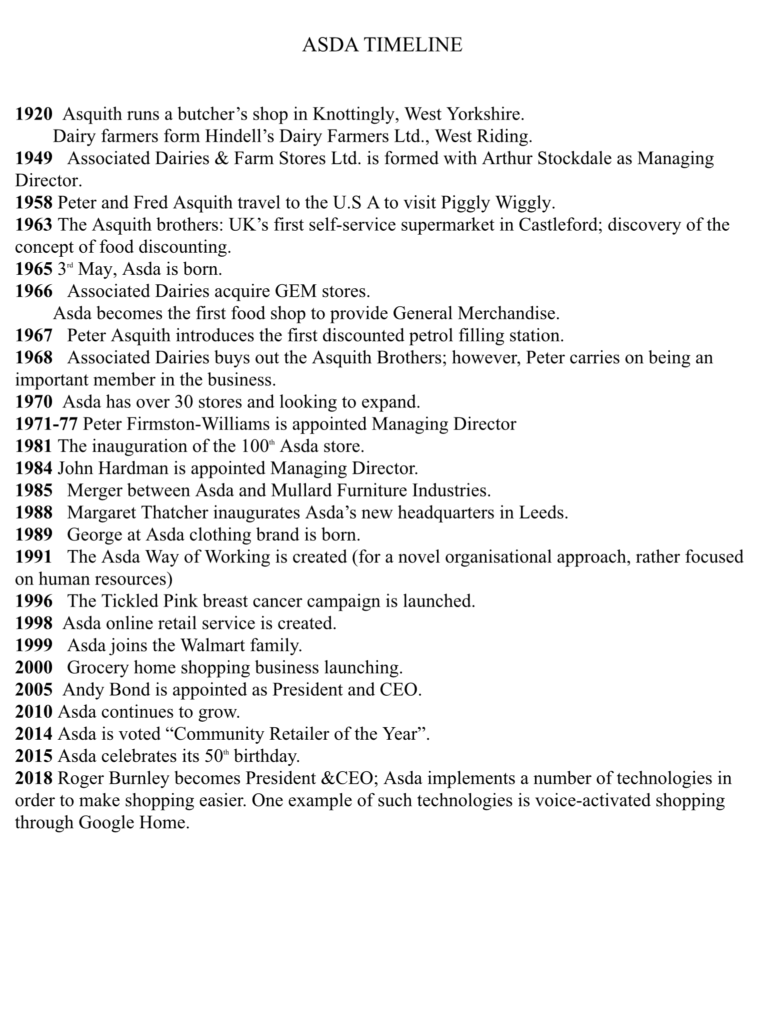

Acknowledgements

For the preparation of this report I had support of Professor Laura James and of people from Study Support. I express my appreciation for their assistance and co-operation given to me. On this way I thank for suggestions and directions they have given to me and for explanation about how to paraphrase . All suggestions were really useful.

Reference List

- Maund A., Schriek M. and Tickler P. (2017) Certificate in Higher Education: Skills for the Workplace Student Yearbook, London: Sage
- Morgan P., (2017) The Business Student’s Guide to Study and Employability , London: Sage

Reports
- Statista (2020) Grocery market share in Great Britain 2015-2020 ( Accessed: 28 February 2029)

Electronic newspapers
Felsted, A. (2013) Asda in pledge after horse meat scandal, Financial Times, 21th February 2013, ( Accessed: 20th March 2020)
Wood, Z. (2016) Cost-cutting at Asda supermarket chain puts 2832 jobs at risk, The Guardian, 9th January 2020, ( Accessed : 12 January 2020)

Government publications
CMA blocks merger between Sainsbury’s and Asda, 2019. Available at www.gov.uk.news, ( Accessed: 22th March 2020)

www.asda.com
www.bbc.co.uk/news
www.theindependent.com
www.retailanalysis.igd.com
www.essentialretail.com/news
my5.tv/inside-asda

