Name - Halima Miah
Student No – 1712451
My Gmail/Password – Halima1712451@gmail.com / dob09.04.92
Group Members - Halima Miah, Taslima Begum, Stephanie Jones, Kamil Sloboda, Malgorzata Szpila.
Name of business – Tiny Tots Nursery
Group Email/Password – kamil712240@gmail.com dob11.03.91
Brief contribution audit – We created a website and a questionnaire as a team for our nursery. I was responsible for the ‘our team’ page for the website, Taslima did the ‘about’ page, Gosia did the ‘service’ page and ‘contact’ page, Kamil did the ‘Home’ page and Steph did the ‘facilities’ page.

Questionnaires

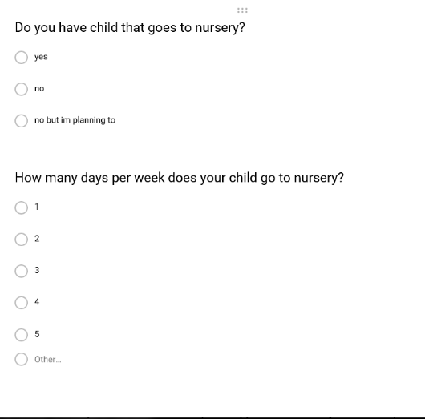

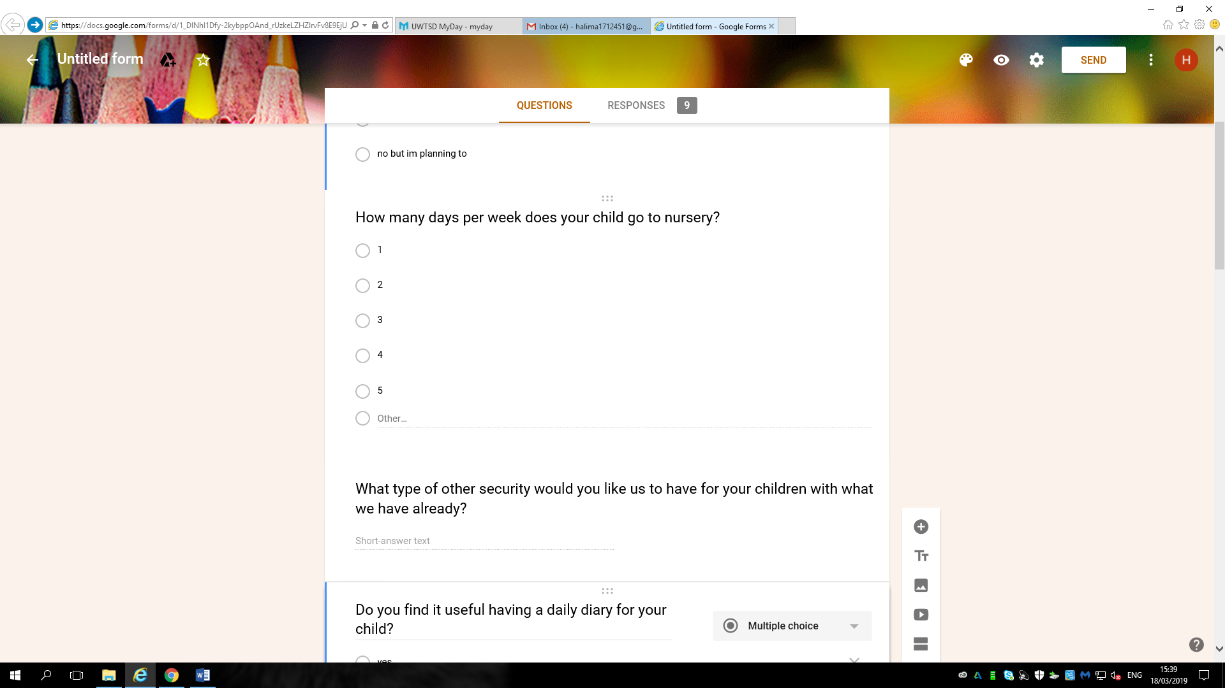
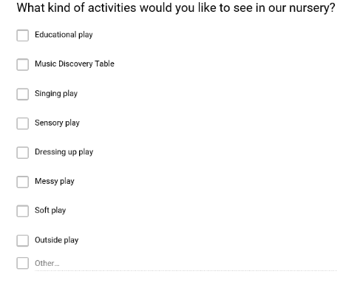

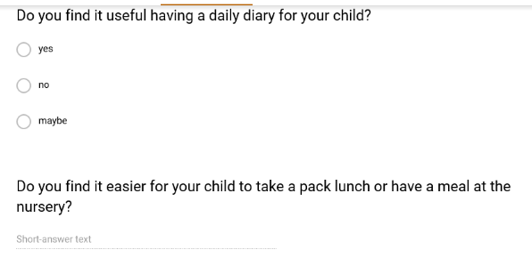

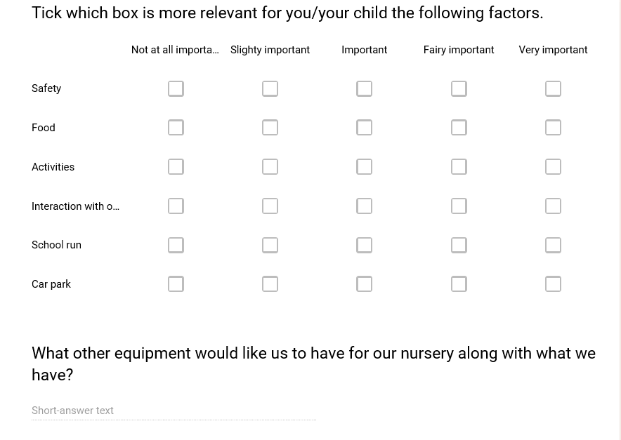

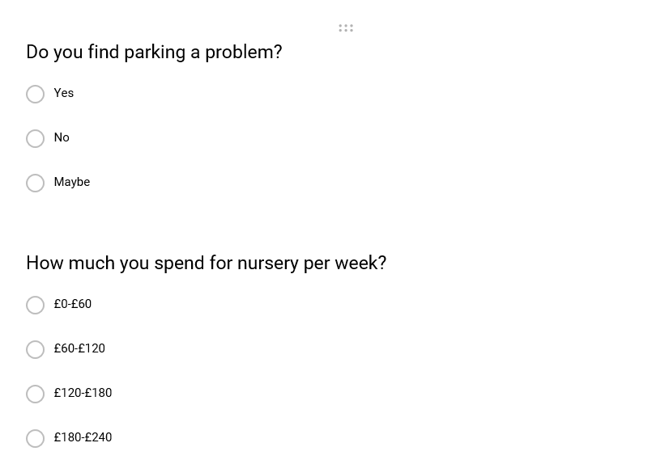

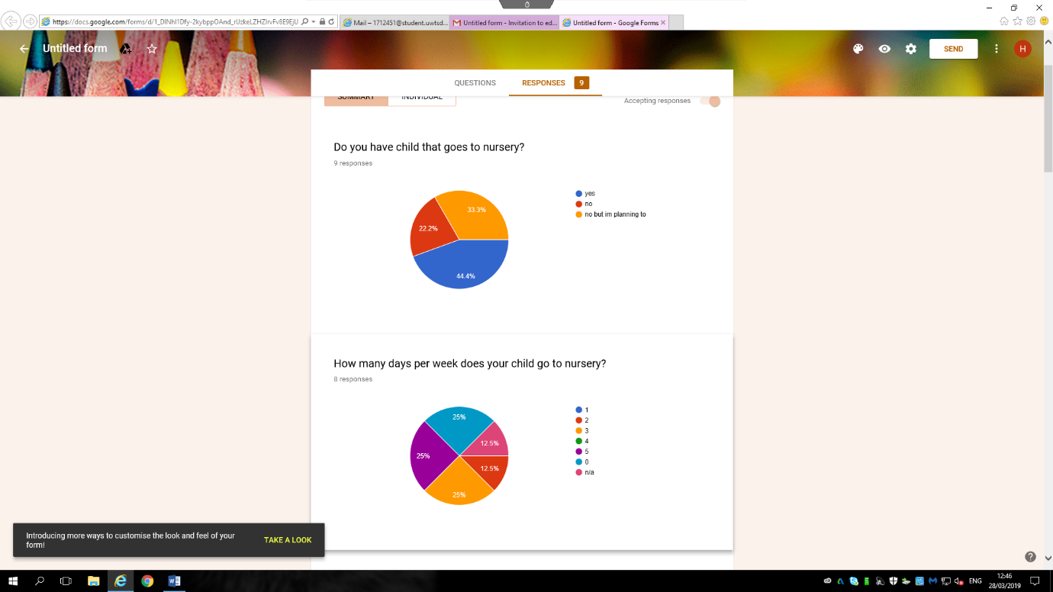

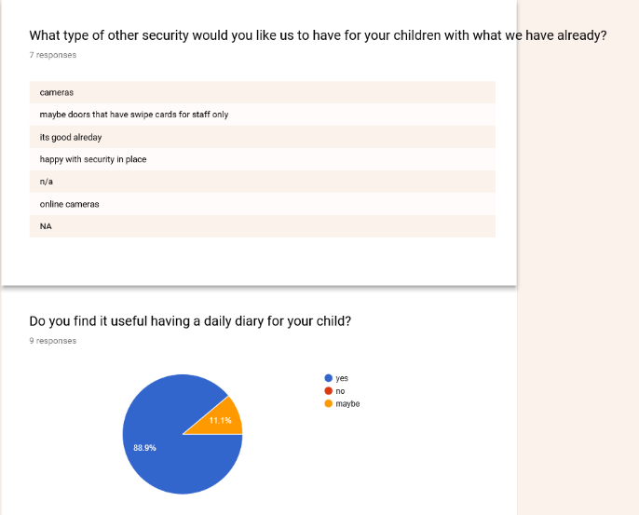

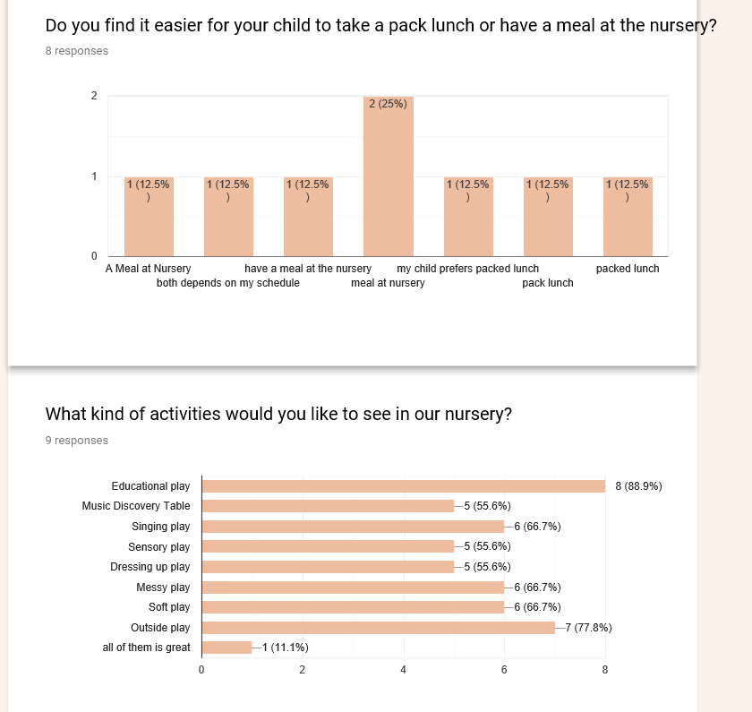

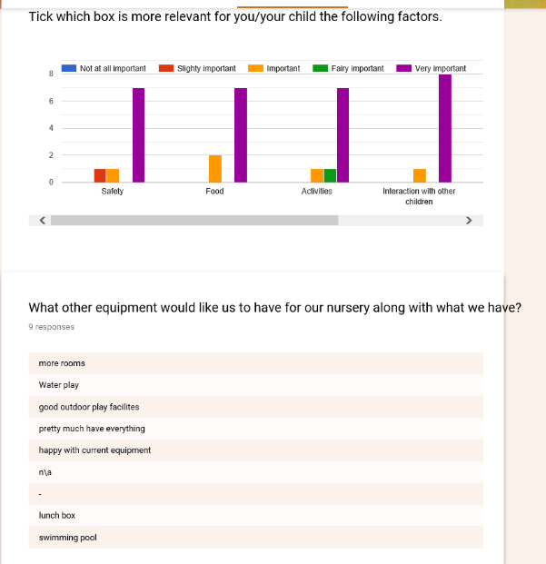

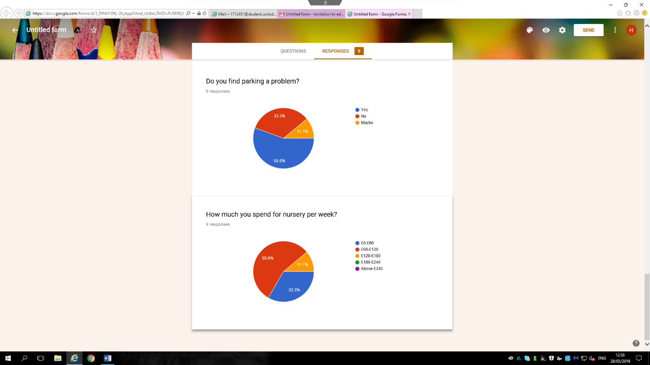

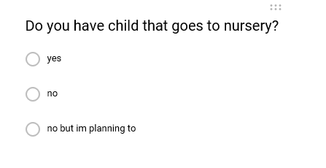
My Questions -

The reason I have chosen the question above is because it is important for us as a business to know how many parents/carers send their child to nursery. This is important because if a high percentage of parents/carers send their child to a nursery this would benefit our business allowing it to grow, have customers and make profit. However, if the percentage was low this would affect our business leading us to make low profits and in the worst-case scenario leaving us to close down the business.
By researching this we can act on the findings. As you can see from our results 44.4% of parents/carers already give their child to a nursery and 33.3% are planning to. This is an advantage for our business as we could cater for the 33.3% and have them coming to our nursery.

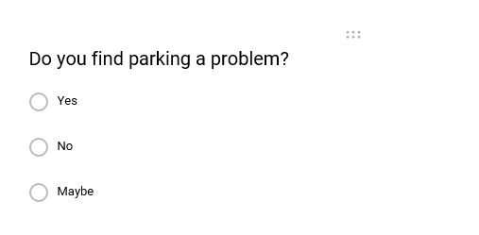

‘Do you find parking a problem?’ I feel this is an important question to be asked as parking is a major problem for most businesses and in our business. We have no parking on site leaving only drop of bays in front of the building. Parents/carers would need suitable designated parking as dropping of children should not be rushed, it is dangerous on the side of the road. Parents should be allocated safe areas to park and drop their child.
Looking at the results above 55.6% of parents/carers find parking a problem, we as a business will prioritise this and look into converting the back of our building into a car park once we have made enough profit.

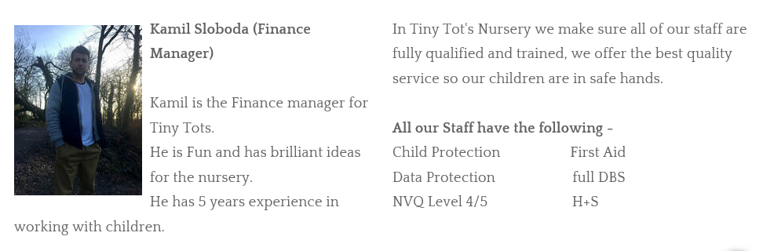
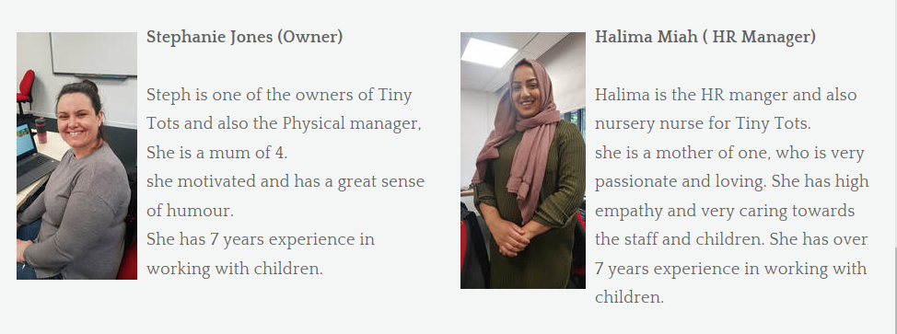
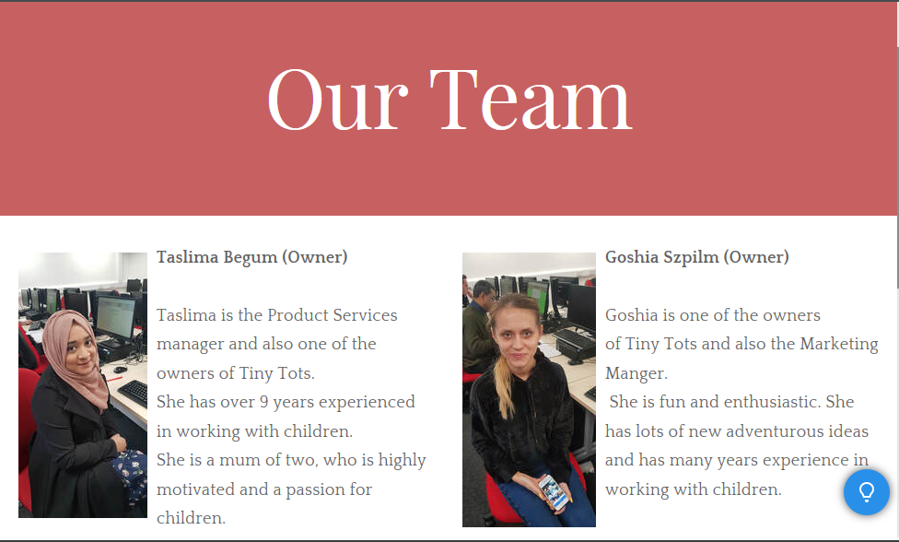
Website

I was responsible for creating ‘Our Staff’ page. I feel it is important for parents/carers or anyone who has interest in our nursery to know who the staff are. I felt it was necessary for parents/carers to know a little bit about our staff before sending their child to us. I have uploaded individual photos of staff. Knowing the staffs faces puts an image in their minds and familiarise themselves with us, so when they come to our nursery, they will know who is who. Also knowing our experiences and a little bit of our background will give them some ease. As for some parents giving their child to a nursery is a massive experience and sometimes daunting. therefore, by having a friendly face on our website and introducing our staff should comfort our parents.
I have also added a section where I have discussed about training and qualifications. The reason behind this is I wanted our parents/carers to feel confident knowing that the staff in Tiny Tots have the best qualifications and are fully trained, therefore parents/carers know that their child are in the safest hands. I have also mentioned a few of the qualifications Staff must obtained in our nursery, such as NVQ Level 4/5, Safe Guarding, Data Protection, First Aid etc. the reason I have done this is so Parents/Carers know that in Tiny Tots nursery we have all the specific qualifications needed to work with children, and that we are constantly training to develop ourselves so we offer the best service to their children.

