University of Wales Trinity Saint Davids
Wales Institute of Science and art


Engine Performance Characteristics
Motorsport Technology. ACHA4004

Cody Surridge
2304028
17.03.2024
Table of Contents
1 Introduction 2
2 Methodology 3
2.1 Equipment Used. 3
2.2 What Was Done-Manual Test 3
2.3 How The Data Was Gathered-Sweep Test. 3
3 Results and Analysis 4
4 Conclusion 7
4.1 Summary 7
4.2 Evaluation 7
5 References 8

Figure 1- 1.6litre Honda CRX engine. 3
Figure 2-Eddy-Current Dynamometer W230 3
Figure 3- 815.776mm Radius Arm 3
Figure 4- Engine Load and RPM Control Centre 3
Figure 5- Graph of Brake Power Vs Engine Speed 4
Figure 6- Graph of Torque Vs Engine Speed 5
Figure 7- Graph of SFC vs Engine Speed 6

Introduction
In this report there will be a description of how to preform a dyno test of a Honda engine where the aim, equipment and methodology will be stated and discussed. This report will then be discussing the results of the dyno test by presenting the raw data as well as the calculations of power, torque, BMEP, SFC and overall thermal efficiency. This then leads onto graphs that will compare SFC against engine speed, Torque against engine speed and brake power against engine speed, to then show how SFC, Torque and Engine Speed vary against engine speed. Finally, the report will be containing a conclusion based on the results that have been found as well as a self-evaluation on what could be improved and therefore could be done differently.

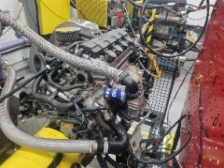
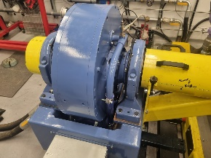
Methodology
Figure 1- 1.6litre Honda CRX engine.

Equipment Used.
- Eddy-current dynamometer W230
- 1.6 litre Honda CRX engine
- 815.776mm Radius Arm
Figure 2-Eddy-Current Dynamometer W230
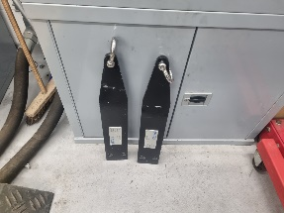
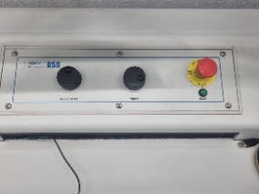
- Dials controlling both Engine Load and rpm.
Figure 3- 815.776mm Radius Arm
Figure 4- Engine Load and RPM Control Centre

What Was Done-Manual Test
Start by ensuring that the engine isn’t on idle. If it is turn off idle. Then using the control centre which contains the dials for both engine load of the dyno and engine speed begin to slowly raise the rpm of the engine. Additionally, as the engine speed increases the engine load needs to be adjusted so that the engine doesn’t stall as this means that the engine hasn’t been able to sustain itself under the applied load meaning results over time may be disrupted and not fully accurate. This is then continued and repeated until the desired rpm is achieved. For this test it was attempting to keep the RPM at 1500 by increasing the load applied to the engine by the dyno while managing the engine load to keep the RPM constant. Meanwhile, ensuring that the engine doesn’t stall due to the load being too high or low so that the engine can’t sustain itself.

How The Data Was Gathered-Sweep Test.
In the Dyno Program The starting RPM is set to 1000 and the final RPM is set to 5500, while the rpm is also recorded in intervals of 50. Additionally, the Ramp and Hold time is set to 1 second this allows the program to instantly record the data and then move onto the next values for the rpm. Then put 100 throttles into the throttle controller and then begin the test. The wait for the System to perform the test until it reaches 5500RPM therefore finishing the sweep test.

Results and Analysis
The equations that have been used include:
- Torque (Nm)= engine load(N)*radius at which the load acts(m) T=WR
- Power(W)= (2π*Engine Speed(rpm)* Torque (Nm))/60 $P=\frac{2πNT}{60}$
- BMEP= Power(W)/Cylinder Displacement(M^3) *Dyno Speed (RPM)/120 = $\frac{P}{D*(\frac{N}{120})}$
- SFC= Power (KW)/Fuel Flow Rate (Kg/h) or SFC= (Volume of Fuel being measured*0.75*3600)/(time*1000*Power) = $P/V$ or $\frac{V*0.75*3600}{t*1000*P}$
- Mechanical Energy/ hour = Power*3600 =$P*3600$
- Fuel Flow Rate (Kg/h) *(43391*10^3.) = $V*\$3391*10^3$
- Overall Thermal efficiency = (Mechanical energy/hour) / (energy/second)

Figure 5- Graph of Brake Power Vs Engine Speed
Brake power varies with engine speed because the power was calculated by $P=\frac{2πNT}{60}$ where N is the engine speed. Therefore, as the engine speed increases the power does as well. This is then shown in the initial linear relation between brake power and engine speed which shows that for some time they are directly proportional. As “Brake power is the measure of an engine's total power output, engine speed is the rate at which the engine's crankshaft rotates, and BMEP (brake mean effective pressure) is the average pressure exerted on the piston during the power stroke. These three factors work together to determine the amount of power an engine can produce.” (PhysicsForums,2015). As a result, this means that brake power and engine power a directly related and as result, once the engine reaches a speed of around 4000 RPM more power is needed to increase the RPM. As a result of being unable to sustain itself the power has begun to decrease to keep the engine running at the required RPM.

Figure 6- Graph of Torque Vs Engine Speed

Torque varies with Engine Speed as when the engine’s Speed begins to increase more load is applied to the engine meaning that the torque will increase as Torque= Engine load*radius. However, this then changes at about 2700 where the is less force required to make engine move because as the velocity increases less force is required to keep the engine moving at the same speed due to resistive forces becoming negligible this then means that the torque will decrease. As a result of torque being The “force that determines whether a car accelerates, maintains its speed, or slows down” (Chudzinski, 2023). When a load is applied to the engine is increased the engine can become unable to sustain the force meaning that the force required would decrease and therefore begins to lower to maintain the same spped on the engine.

Figure 7- Graph of SFC vs Engine Speed
Specific Fuel Consumption (SFC) varies with Engine Speed as SFC is Power/Fuel Consumption. This means that as the Dyno begins to work the fuel required is less. Whereas, as the speed begins to increase the fuel required increases as the fuel required for the engine to be held at a faster speed is increased. This is because “The more rotation of the crankshaft per minute , the more fuel/air flow(BSFC) is required to feed the beast.” This is then shown on the graph as the fuel needed has increased as the rpm has risen.

Conclusion

Summary
To conclude, from the graphs it has shown that Brake power and Engine speed are directly related due to the Power equation, but additionally as they are a result of torque applied. This is shown when the torque graph begins to decrease at the same point as the power showing that the engine hasn’t been able to sustain itself at the RPM of around 4000 due to the load being applied being too large for the engine to handle. This is then shown in the SFC vs RPM where the fuel consumption increases as the engine gets faster, showing that the faster the engine is the more reliant it is on combustion to get the engine faster rather than external loads.

Evaluation
During the test things that went well were that there were no issues with the engine. This includes the engine not stalling so that there were no interruptions between changes in rpm and the test can run smoothly. Some things that could’ve been done differently, include using smaller intervals of rpm such in 25s or 10s. This would allow for more accurate data meaning that it would be more comparable to other data. Additionally, you could repeat the test with different fuels to compare the SFCs of fuels to one another.

References
- Motorsport Trend (2023) What Is Torque? Why It’s Important for Cars and How It Works [online] Matthew Chudzinski Available at: https://www.motortrend.com/features/what-is-torque-in-cars/ (Accessed 14 March 2024)
- Physics Forums (2015) Brake Power, Engine Speed and BMEP Relationship [online] Physics Forums Available at :https://www.physicsforums.com/threads/brake-power-engine-speed-and-bmep-relationship.843810/ (Accessed 12 March 2024)
- Physics Forums (2015) Relation between SFC vs RPM in diesel engine?
[online] Physics Forums Available at: https://www.physicsforums.com/threads/relation-between-sfc-vs-rpm-in-diesel-engine.750380/ (Accessed 12 March 2024)

