PDP Presentation
Name: Sêren Williams
Student ID: 2501567
Module Name: Academic and Professional Development
Lecturer: Jenni Steen
Date: 07/01/2026
Contents
Task 1 - Self Evaluation 2
Task 2 – PDP 3
Task 3 – Work Summary 4
Task 4 – Video Presentation 5

Task 1 - Self Evaluation
Screenshots Of Self Evaluation
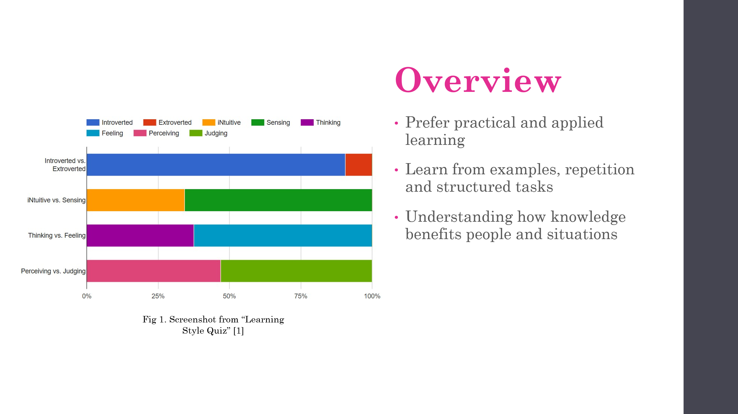
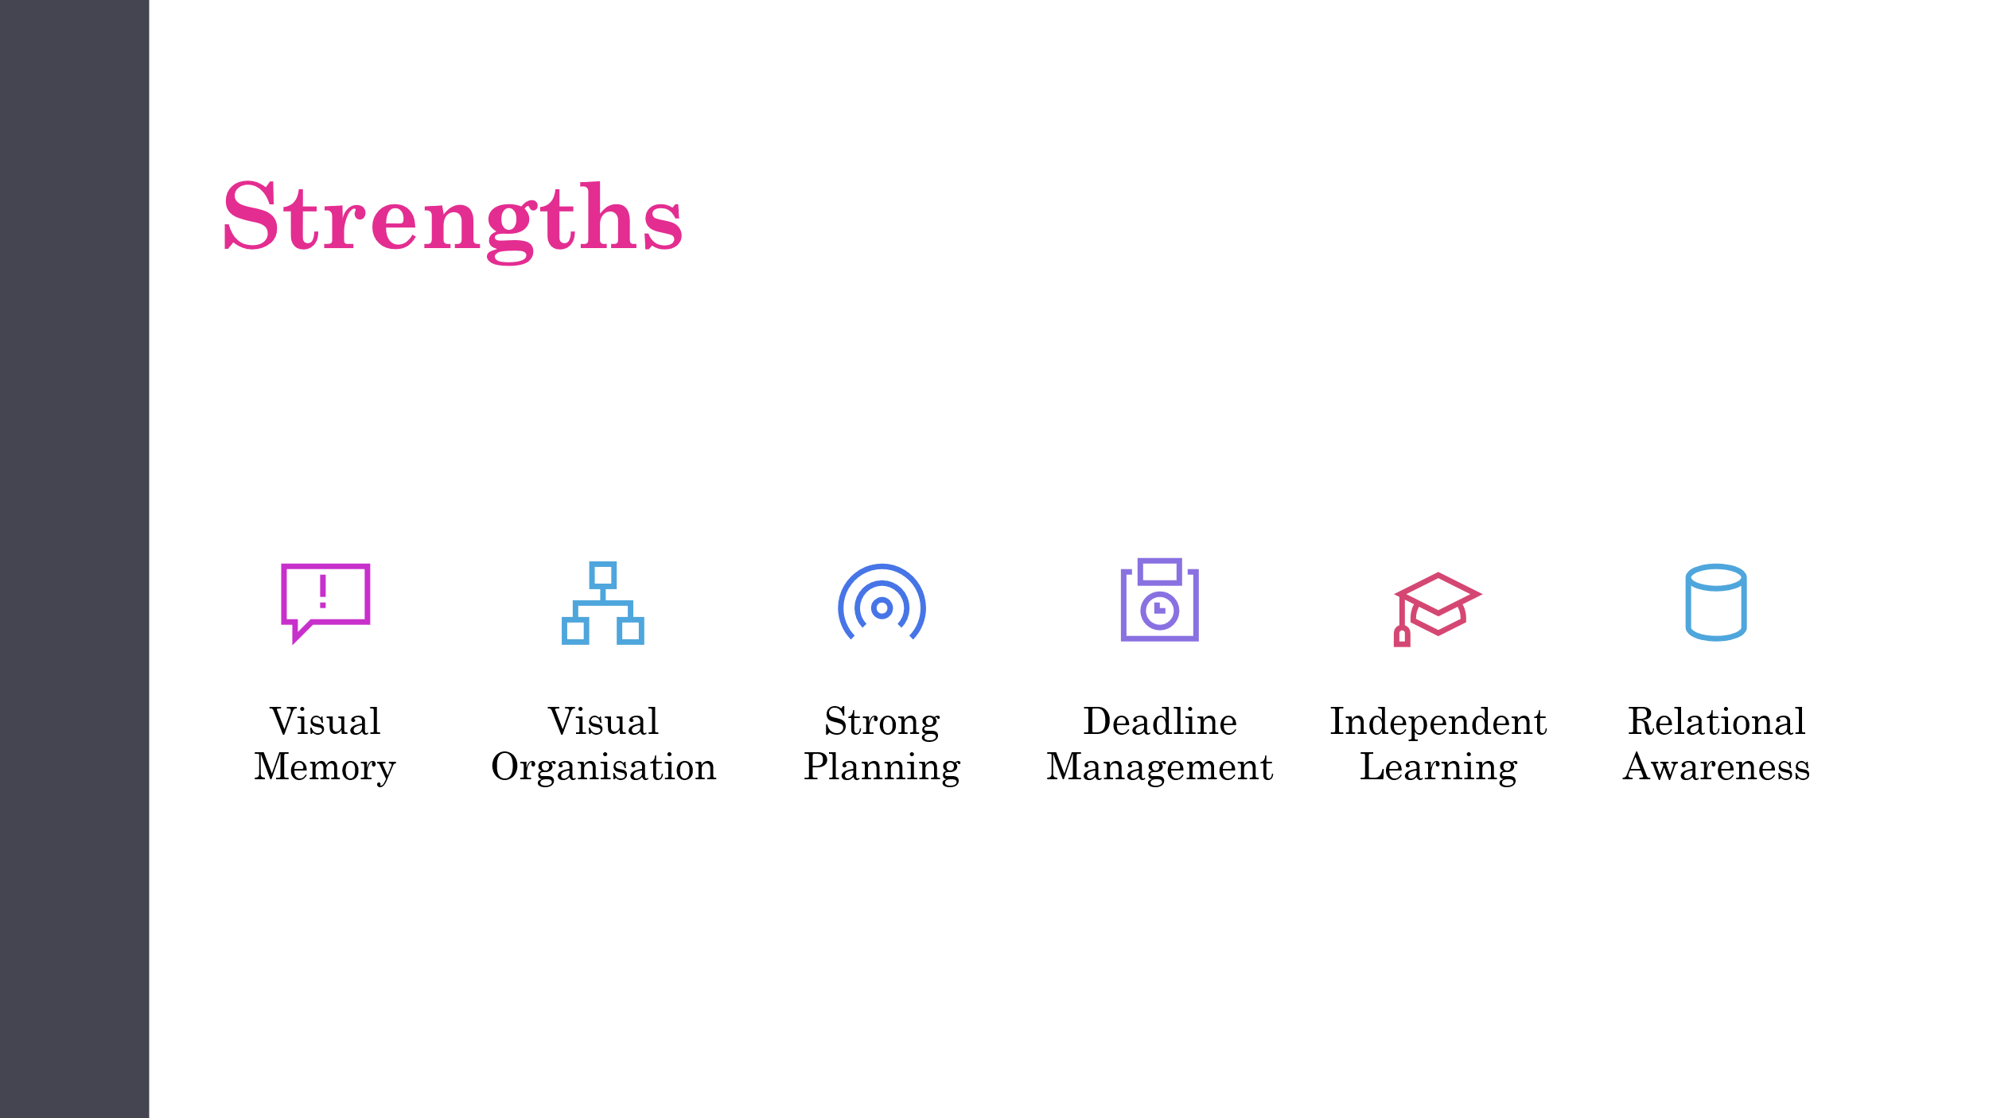
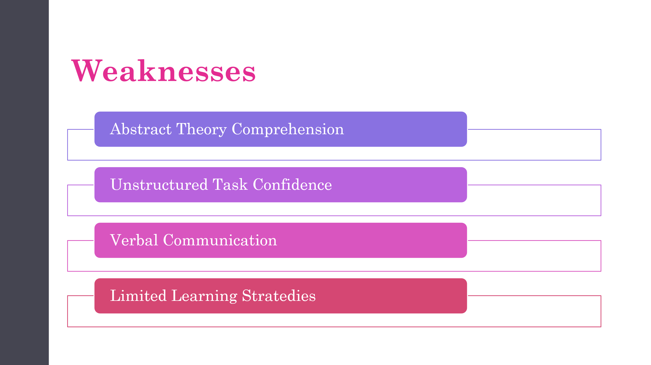

Task 2 – PDP
Link to view PDP
PDP Document.pdf
Screenshots of PDP and SMART Goal Application
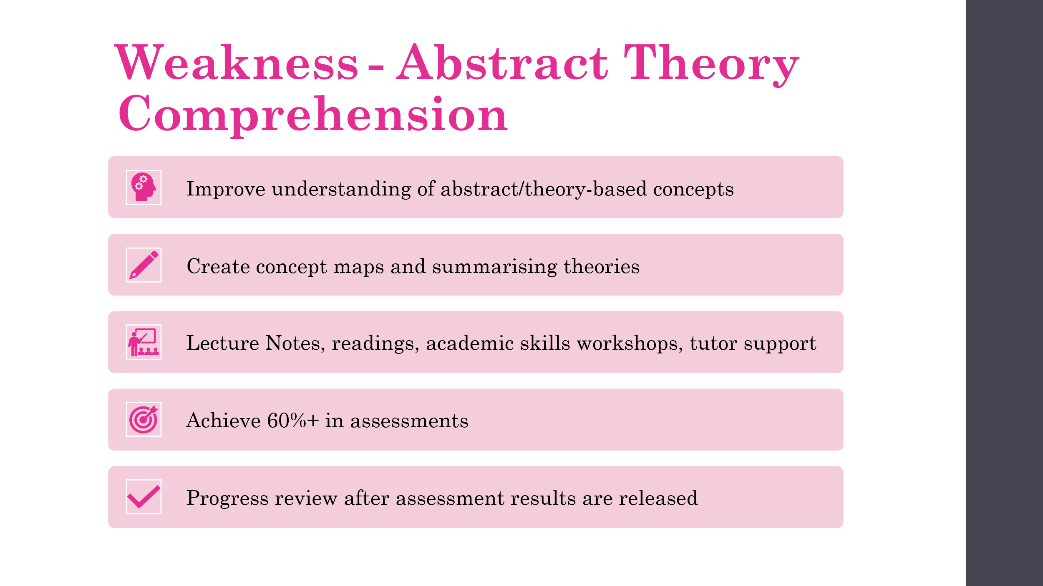
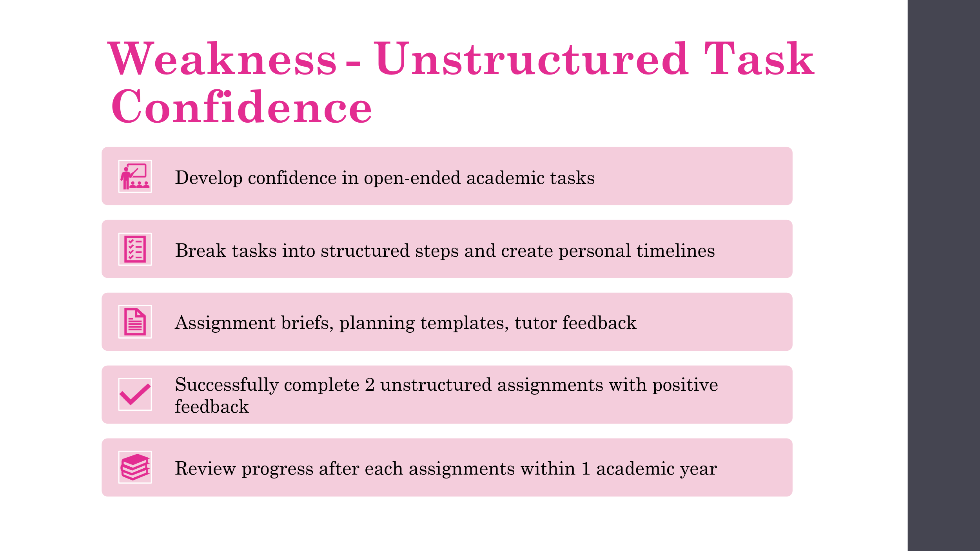
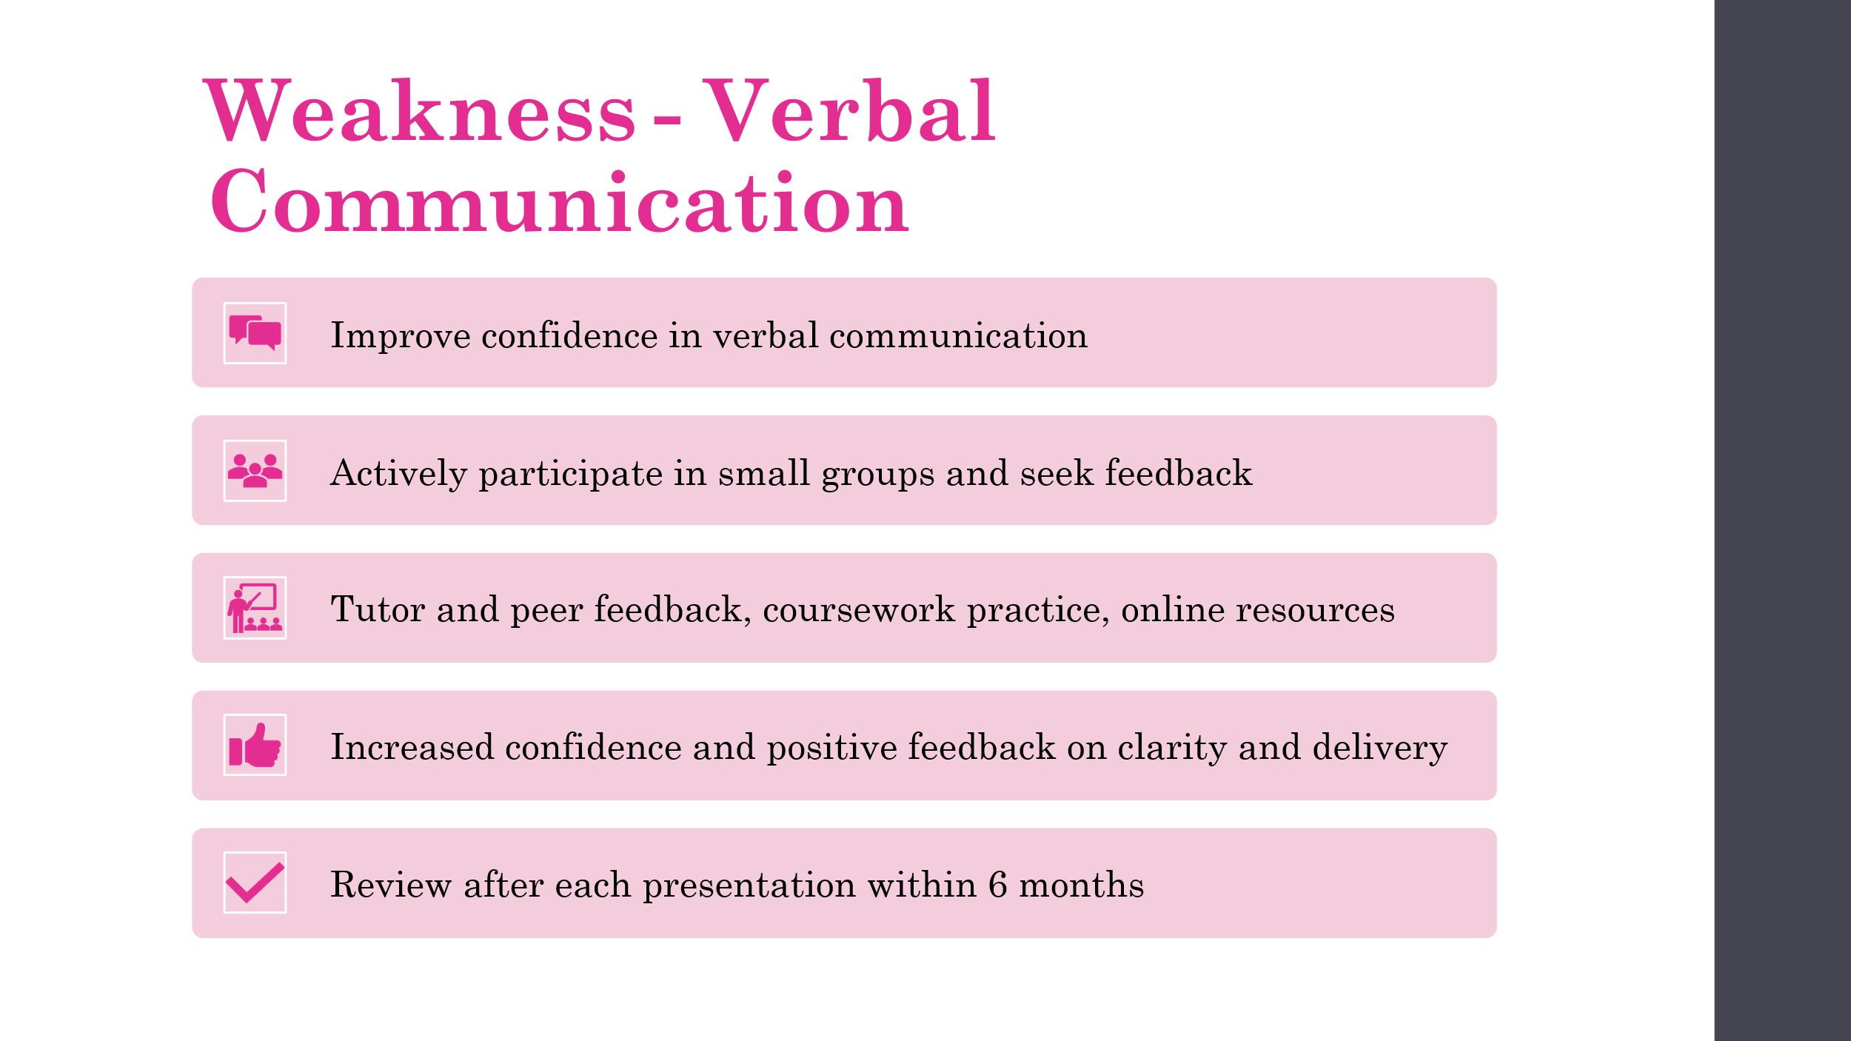
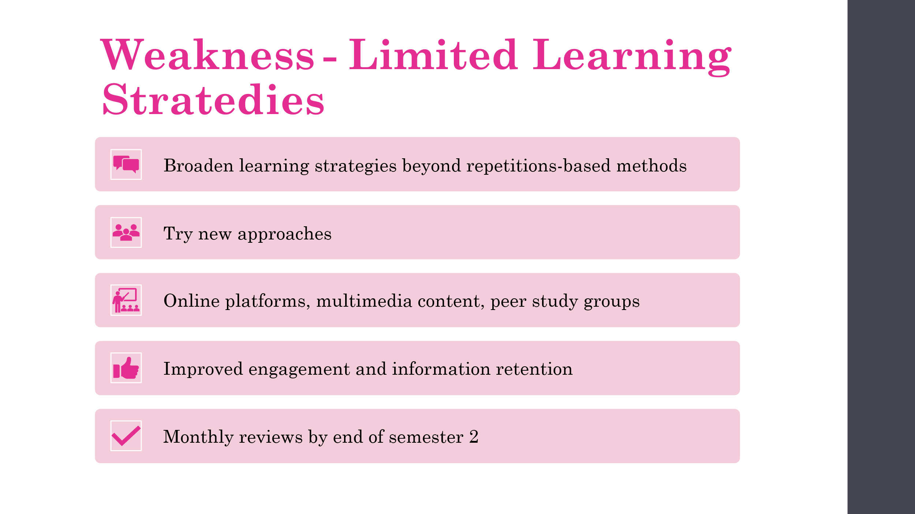

Task 3 – Work Summary
Screenshot of Work Summary
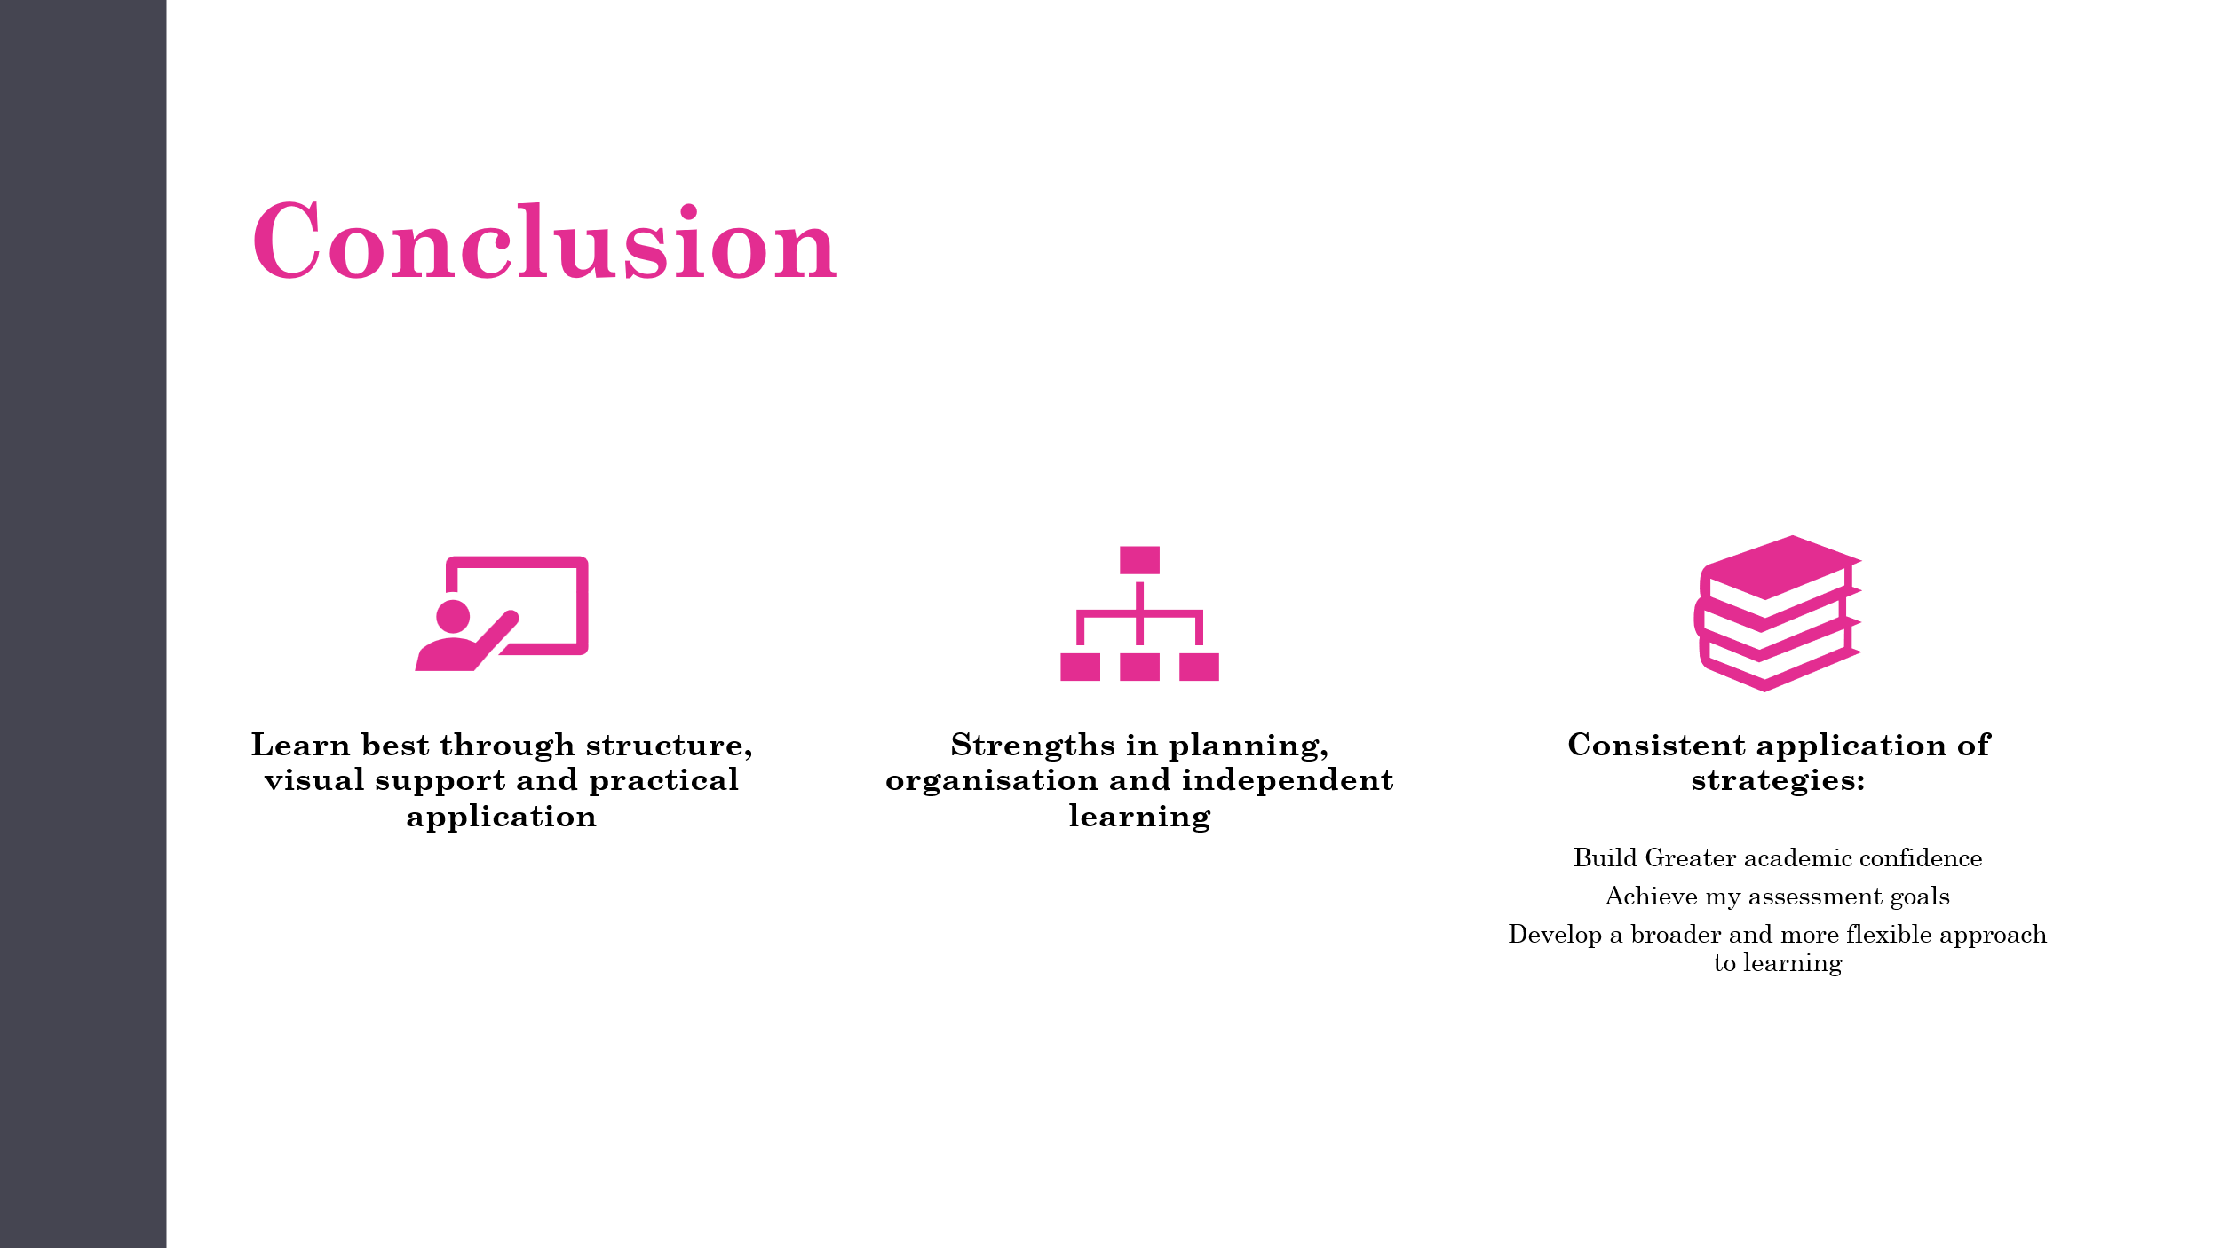

Task 4 – Video Presentation
LINK TO VID ON YT
Personal and Professional Development Presentation
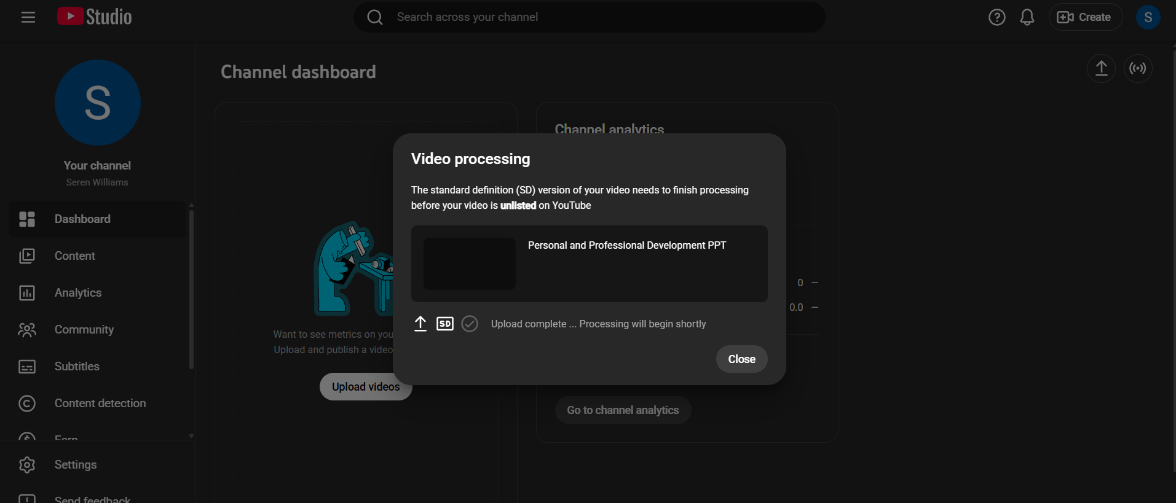

Link to Download Video File
Personal and Professional Development PPT.mp4

