Self-Reflection of Practice 2021- My time at Pricewaterhouse and Cooper.

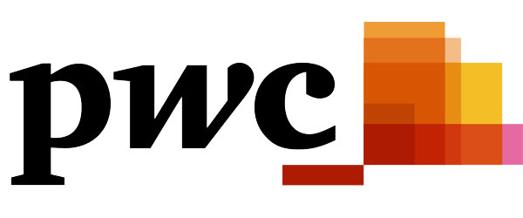

May 2020

MODULE NAME: Independent Project (BMBM6020)
Name: kATE oLIVER
Student Number: 1702582

Table of Contents
1. Introduction 3
1.1 My Placement 3
2. Main Body 3
2.1 Communication 4
2.2 Teamwork 7
3. Conclusion 8
4. References 10

List of Figures
Figure 1 - Gibb's Reflective Cycle 4
Figure 2 - The Shannon-Weaver communication model 6

Introduction
Self-reflection can be defined as the action of considering one’s feelings and behaviour and the reasons for them (Cambridge Dictionary, 2021). The ability to reflect is considered essential when it comes to being professionally competent (Wald & Reis, 2010). By possessing the skill to self - reflect an individual can recognise their strengths, identify gaps in their knowledge and abilities, and from there decide the best path to grow and improve (Wald, 2015). This report will reflect upon the time I spent at Pricewaterhouse and Cooper (PwC) focussing specifically on how it has developed key employability skills. It will concentrate on my communication and teamwork skills; the Shannon Weaver and Tuckman models will be utilised to gain further analysis. The aim is to identify how the placement has facilitated my development of key employability skills.

My Placement
My placement was with Pricewaterhouse and Cooper also known as PwC. I started my 11-month placement after completing my first two years studying business management; it began on the 5th of August 2019 and finished on the 3rd July 2020. PwC has offices in 155 countries and over 284,000 employees worldwide. They are among the leading professional services networks in the world. They help organisations and individuals create the value they are looking for, this is done by delivering quality in Assurance, Tax and Advisory services (PwC Global, 2021). My role was to be the personal placement assigned to the management team of compliance testing mainly with the Centre of Excellence (CoE) and Tech Risk departments. My main role was to be available to the management team to help with any task they needed. A lot of my work was ad hoc, helping to pull data and run analysis for management. However, I did have weekly tasks such as the Weekly MI, Taskbook checks as well as the weekly newsletter that was distributed on Fridays.

Main Body
Employability skills are the skills that are essential for getting, keeping, and performing well in a job. Employers would prefer to employ individuals that are already trained and could fit in with those already working, however they are willing to spend the time and money on getting individuals trained especially if they possess the key employability traits (Robinson, 2000). The World Economic Forum (2020) published the estimate top 15 skills to possess for 2025, analytical thinking and innovation are at the top due to the fact the norms of the business world are shifting, and the expectation of work life is evolving. It also mentions the ability to work with others as well as the ability to reason and problem solve to ensure that even without training, they possess the traits that mean with the right training they can reach their goals effectively and efficiently.
Reflective practice is bound to analytical thinking (Potter, 2015). To reflect and analyse my experience, Gibb’s reflective model will be used. Gibb’s reflective cycle divides the reflection into 6 stages to look at the scenario from different perspectives as shown from Fig 1 below.
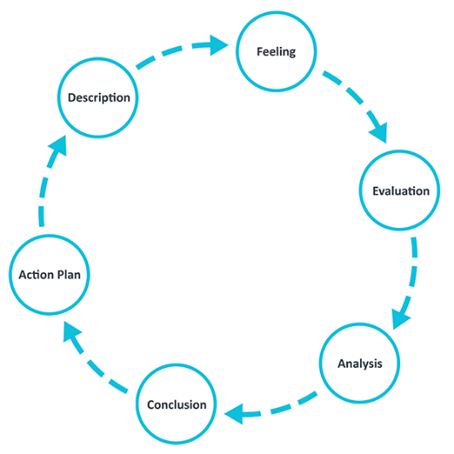
Figure 1 - Gibb's Reflective Cycle
( Source: https://www.ed.ac.uk/reflection/reflectors-toolkit/reflecting-on-experience/gibbs-reflective-cycle )
First there is a description of the experience, next the feelings the experience invoked, from there its an evaluation of the benefits and drawbacks to the experience which progresses to an analysis of what the individual has learnt from the experience. Finally, there is the conclusion which describes what could be done differently in the future. For those using the model on recurring, next there is the action plan for how it would be tackled it if faced again (The University of Edinburgh, 2020). This model was selected for this report due to its easy to follow structure and it takes into consideration bot and feelings when reflecting (Lawrence, 2008).

Communication
Communication is an interaction through signals and or messages, it is considered a basic form of social behaviour, even though 80% of communication is non-verbal and can be recognised through body language, facial expressions, and tone (Chandler & Munday, 2020; Mullins & Christy, 2017). Effective communication is vital to a business’s success; it is a key ability that businesses look for in potential employees (Johnson, et al., 2019). With a business of PwC’s size, communication is even more of an essential skill. In my placement, I operated within two forms of communication, face to face and electronical correspondence. I participated weekly in three management meetings, where my role was to take minutes and record the actions. These meetings consisted of four to thirteen members of management, ranging from Director of Compliance Testing to senior and departmental managers. Furthermore, I communicated with my colleagues for a range of purposes such as, wellbeing check-ins, informal follow ups for taskbooks and gathering feedback. Next, there was communication through electronic means such as email, instant messages, and video calls. For inward communication, I was emailed instructions as well as any requests or queries from staff. In addition, I distributed trackers, weekly MI and compliance reports, plus reminders regarding the weekly newsletter outward via email. Before my placement, I considered myself a very well-articulated individual and felt comfortable communicating with others from different generations and ranging authority levels. However, as I progressed with my placement, I realised I had little to no understanding of how to utilise email as a main form of communication, plus my face-to-face interactions needed to be improved. Initially I struggled with email as I have avoided it in the past wherever possible; I preferred to communicate in person or over the phone as I found it easier to clearly articulate my points verbally due to my dyslexia and dyspraxia. Yet, when I entered the workplace, I realised that rapid clear communication is essential to a business’ long-term success due to its ever-evolving nature. Above all else, when I returned to university at the end of my placement, I was unaware of how my written communication had developed. Due to COVID 19 face to face interactions were no longer an option, online communication quickly became my only means of engaging with my lecturers and group members. I recognised that my ability had grown as I felt confident emailing lecturers with queries and requests as well as organising meetings and monitoring progress within my team. In evaluation, my communication skills were evident from the increase in compliance regarding taskbooks in the CoE. Initially I was given the task of recording non-compliance in individual’s taskbooks and report them weekly. The records had not been updated since May 2019, within a week I learnt the task, contacted all 93 members of the CoE staff with a reminder, and ensured that they corrected the errors in a timely manner. Each week I examined every taskbook, non-compliant staff were sent a reminder and progress was communicated to my senior manager. Taskbook non-compliance reached 75% in August 2019, by January 2020 there was 0% non-compliance which did not exceed 17% until July 2020. Furthermore, by using distribution groups I sent out an email to the entire Compliance Testing department announcing the release of the Weekly Comms with a link which increased readership across the three subdepartments. However, there were deficiencies. For example, the Weekly MI when completed is emailed to the management team, yet, due to similarities in titles I accidently distributed the management report to the department email address. Additionally, I set up automatic emails to gather information and save time, but when I took annual leave there were occasions when I failed to remove the automation, meaning information was sent to me rather than a colleague. Finally, when it came to my face-to-face communication, I struggled to maintain a professional volume due to my confidence and clear dialect. So, my voice carried which I had not considered the impact this would have in a working environment. Using the Shannon Weaver Model shown in Fig 2 below, I was able to determine why these errors were made.
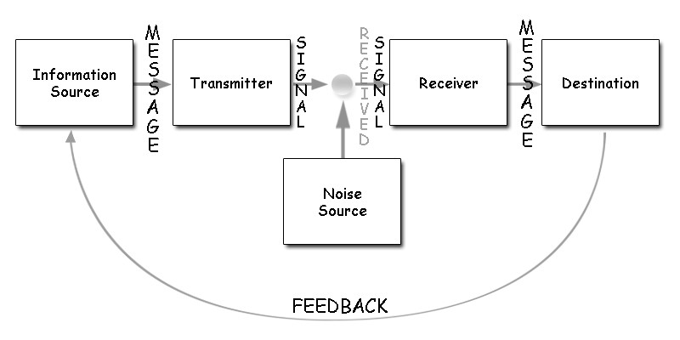
Figure 2 - The Shannon-Weaver communication model
(Source: https://www.open.edu/openlearn/ocw/mod/oucontent/view.php?id=85957&extra=thumbnailfigure_idm45805627631328)
It highlights that whether you are successful in communicating depends on how others interrupt your message especially when you take into consideration the ‘noise’, which refers to any obstacles or interference with the message (Al-Fedaghi, 2012; Pierce, 2019). In this scenario the ‘noise’ was the constant stream of emails being circulated throughout the business. Stich, et al (2019) identified that the higher an individual’s email load, the higher their stress level. This can lead to human error as well as misinterpretations of online communications. Although I have used email, it was on a lower scale than PwC, I was receiving more than excess of 40 emails a day and my colleagues were receiving over 75 emails a day. However, the results I mentioned previously regarding increased readership and a decrease in non-compliance highlights that when my messages made it through the ‘noise’ it had the desired results which also continued to improve indicating my communication skills have evolved regarding online communicating and can be just as effective as conveying a message in person.
Overall, I learnt the importance of various communication skills when it comes to employability (Victoria University of Wellington, 2015). I also identified that in business I need to be skilled in communicating my message but also understanding that it must be interpreted by someone else on the receiving end. During my placement, my ability to use email as a form of communication steadily improved with minimal errors occurring which enhanced my focus and organisational skills to ensure they did not reoccur. I also recognised how electronic communication is the most efficient way to communicate whilst in the workplace and when managed correctly can become a time saver and in some cases boost interactions with optional materials such as newsletters and bulletins.

Teamwork
In the basic sense teamwork refers to the combined action of a group of individuals (Cambridge Dictionary, 2021). Harmonious teamwork can lead to increased morale and performance; it is a necessity in business, it leads to greater creativity and time management than someone who is working alone (Mullins & Christy, 2017). My role meant that I worked individually for the majority of the time and I was not part of one particular team. I became part of whichever team I was working with for the period that I was helping them. My top priority was the Compliance Testing management team. My role within this team was to relieve pressure, improve efficiency and analyse data to then summarise it for their review. A further example of teamwork during my placement was when I identified the time lost sending daily/weekly/biweekly/monthly emails. I recognised an opportunity for automation, but as I was unaware as to how I could implement this, I approached two team members who had experience with scriptwriting. They taught me how to build a script, test it and then refine it to ensure its efficiency. Before my placement I understood teamwork was going to be an essential skill in the workplace. I felt apprehensive due to the fact I was still at university and had little experience compared to those I could be working with. During my placement when I was part of a team, I felt energized and motivated, I gained strength from working with others as it provided me with a sounding board to come up with a plan. However, due to the nature of my role within Compliance Testing most of my time was spent working alone, which became quite isolating, especially when we went into COVID 19 lockdown. Now I have finished my placement, I feel confident in my team working abilities and better understand myself and the environment I need to obtain my best performance. It was evident that the time spent working with David May and Adam Wilkinson to automate emails was an effective use of teamwork, as we were able to automate three of my weekly emails. Additionally, we ensured it was duplicable so it could be rolled out to others across the team. Alternatively, there was not clear communication as to who I was reporting to daily, as members of the management team from different departments would ask for their task to take high priority. It was thus unclear as to who I had to make aware of these change in plans, and how to approach having two high priority tasks needed for different departments. This caused a disconnect as well as time lost trying to confirm which task to continue with. When analysing my teamwork skills with the use of Tuckman’s Model I learnt that we had grown into an efficient team. Tuckman’s Model is based off the theory that no team comes into existence fully formed; there is a process all teams go through and it is made of 5 stages of development. The first stage is forming, where the group is initially formed. In my case this was done when David and Adam agreed to help me with the automation. Next, there is storming, which is considered a conflict stage, in bigger groups it is where they identify each individuals goals and require guidance by a leader as to the role of each person in the team. In my experience our storming was in the mould of figuring out how each of us processes information as we all learnt in different styles. From there its norming where the group find their rhythm as to how best work together and achieve the common goal (Natvig & Stark, 2016). When working with David and Adam, once we had figured out how best to communicate ideas to one another we were able to start writing the script, each of us working on a different section saving time in the long run. In Tuckman’s model the next stage is performing, where a team is working cohesively and moving closer to getting the task completed. We tested the automation to make sure there was no errors or miscalculations we then entered the specific emails we wished to automate and presented into to our senior manager for implementation. The final stage is adjourning where the group disbands after reaching their goal. For David, Adam, and I we resumed our day-to-day work and would gather when we needed support from one another (Hall, et al., 2008). On the other hand, regarding my teamwork experience with management the problems began due to the fact we had not reached the norming stage where the rules and guidance is clearly set out and everyone involved is on the same page. Due to this miscommunication within the team, it caused me to second guess myself as well as time and energy being lost trying to identify how to manage the task. To conclude over my time at PwC I learnt the value of good team working skills and the difference it can make to your time at work when working in a team. I learnt the strength I gain from working in a team as I benefit from having someone to bounce ideas off of. I also recognise there are a variety of places problems can arise whilst working in a team, as a group of individuals are trying to work cohesively. For a business to operate successfully its employees must possess a level of team working capabilities.

Conclusion
To summarise, I spent 11 months working in the Compliance Testing department at PwC Belfast. In this report we reflected on my time spent with PwC and how the opportunity developed key employability skills. With the use of Gibb’s reflective cycle, I reviewed my communication and team working abilities. I recognised I lacked understanding at the importance of communication in business, specifically, electronically. Whilst on my placement I was able to develop my capability regarding email communication and deal with any potential obstacles. In reflection it was also identified I had not been aware of my personal development until I returned to university and applied the new found skills. When reviewing my team work abilities, it was clear I had minimal exposure to team work but on the occasions I did, I worked effectively and efficiently. It was also identified that when working in a team my motivation increased. However as part of the Compliance Testing management team, due to a disconnect in communication, my role and who I reported to was unclear which lead to obstacles and issues when it came to multiple high priority tasks. My findings showed that the placement developed both of communication and team working abilities, learning about new areas of the skill. Additionally, with team work I gained experience at working in different teams and with the use of Tuckman’s model I determined that when a stage is missed it can affect the teams cohesivity.

References

Al-Fedaghi, S., 2012. A conceptual foundation for the Shannon-Weaver model of communication. International journal of soft computing, 7(1), pp. 12-19.
Cambridge Dictionary, 2021. Meaning of Self Reflection. [Online]
Available at: https://dictionary.cambridge.org/dictionary/english/self-reflection
[Accessed 14 May 2021].
Cambridge Dictionary, 2021. Meaning of Teamwork. [Online]
Available at: https://dictionary.cambridge.org/dictionary/english/teamwork
[Accessed 14 May 2021].
Chandler, D. & Munday, R., 2020. A Dictionary of Media and Communication. 3rd ed. Oxford: Oxford University Press.
Hall, D., Jones, R., Raffo, C. & Anderton, A., 2008. Business Studies. 4th ed. Harlow: Pearson Education.
Johnson, C. S., Dunn-Jensen, L. M. & Wells, P. M., 2019. Sketchy communication: An experimential exercise for learning about communication in business.. Innovative Instructional Classroom Projects/Best Practices, 94(1), pp. 46-56.
Lawrence, P., 2008. Reflecting on events. Emergency Nurse, 15(9), pp. 16-18.
Mullins, L. J. & Christy, G., 2017. Management and Organisational Behaviour. 10th ed. India: Pearson.
Natvig, D. & Stark, N. L., 2016. A Project Team Analysis Using Tuckman's Model of Small-Group Development. Journal of Nursing Education, 55(12), pp. 675-681.
Pierce, T., 2019. The Evolution of Human Communication: From Theory to Practice. 2nd ed. Ontario: Etre Press.
Potter, C., 2015. Leadership development: an applied comparison of Gibbs’ Reflective Cycle and Scharmer’s Theory U. Industrial and Commercial Training, 47(6), pp. 336-342.
PwC Global, 2021. About Us. [Online]
Available at: https://www.pwc.com/gx/en/about.html#:~:text=With%20offices%20in%20155%20countries,Assurance%2C%20Tax%20and%20Advisory%20services.
[Accessed 14 May 2021].
Robinson, J. P., 2000. What are employability skills. The Workplace, 1(3), pp. 1-3.
Stich, J.-F., Tarafdar, M., Stacey, P. & Cooper, C. L., 2019. E-mail load, workload stress and desired e-mail load: a cybernetic approach. Information Technology & People, 32(2), pp. 420-452.
The University of Edinburgh, 2020. Gibbs' Reflective Cycle. [Online]
Available at: https://www.ed.ac.uk/reflection/reflectors-toolkit/reflecting-on-experience/gibbs-reflective-cycle
[Accessed 14 May 2021].
Victoria University of Wellington, 2015. Employability skills survey. [Online]
Available at: https://www.wgtn.ac.nz/careers/resources/employability-skills-survey
[Accessed 12 May 2021].
Wald, H. S., 2015. Refining a definition of reflection for the being. Medical Teacher, 37(7), pp. 696-699.
Wald, H. S. & Reis, S. P., 2010. Beyond the Margins: Reflective Writing and Development of Reflective Capacity in Medical Education. Journal of Generic Internal Medicine, 25(7), pp. 746-749.
World Economic Forum, 2020. The Future of Jobs report. [Online]
Available at: http://www3.weforum.org/docs/WEF_Future_of_Jobs_2020.pdf
[Accessed 14 May 2021].

