Generative AI: Impactful Considerations to Responsible Data Practices in Business Execution

Tea Osmëni ^{[0000-0003-3207-6539]}
Risk Advisory
Deloitte
Tirana, Albania
tosmeni20@epoka.edu.al
Maaruf Ali [0000-0001-9906-5004]
Department of Computer Science
Universiteti Metropolitan Tirana
Tirana, Albania
Maaruf@ieee.org

Abstract—AI is shaping our society and changing what it means to be human. The future is getting active since the adoption of Generative AI (GenAI) in our everyday life. Humanity is slowly transcending from a society of consumers to creators. We first began with Siri and Alexa; now it is ChatGPT, DALL-E, Stable diffusion and other several tools powered by Artificial Intelligence and machine learning. Audi as well has started the use of Generative Adversarial Networks (GANs) to get inspiration on wheel design. This paper will focus on the advantages the social and cultural impact GenAI opposes, use cases on how GenAI can enhance innovation and drive business value from the technical prospect, the potential risks that might arise if abused with it, and to conclude how technology teams alongside the C-Suite and Board of Directors shall take action. These risks include deepfakes, legal confusion, hiring biases and inaccurate chatbots. AI is in the service of humanity and it is a responsibility of ours to treat it with dignity and fairness.
Keywords—bias, chatbots, deepfakes, GANs, GenAI

Introduction (Heading 1)
What exactly is Generative AI? The start of Generative AI (GenAI) can be likened to the invention of photography and celluloid film. The main objective to use GenAI is to drive creation of our intentions.
GenAI functionalities rely on concise information, generated text, designing custom products, producing music, speech, visual effects, 3D assets or sound effects. This is done by using algorithms trained on already existing data. By training on large data sets, we can reduce the burden of repetitive tasks and complex computations, enabling us to focus on more creative and strategic activities [1].
Providers and services have expanded, and so has the quality of technology. But how is GenAI different from other types of Artificial Intelligence (AI)? AI is an umbrella term that encompasses several different subcategories for various tasks like: Reactive Machines, Limited Memory AI, Theory of Mind, Narrow AI, Supervised Learning, Unsupervised Learning and Reinforcement Learning. GenAI falls into a lot of these categories and is specifically designed to generate new content as its primary output (image generation, video synthesis, language generation, music composition). Fig.1 shows a brief representation of GenAI [2].
In this paper we will be discussing about the audience of GenAI, ethics and responsibilities related to moral and executive skill set required to work with GenAI, how the board of directors shall manage risk and opportunity in AI, how ethical decisions shall be made and more.
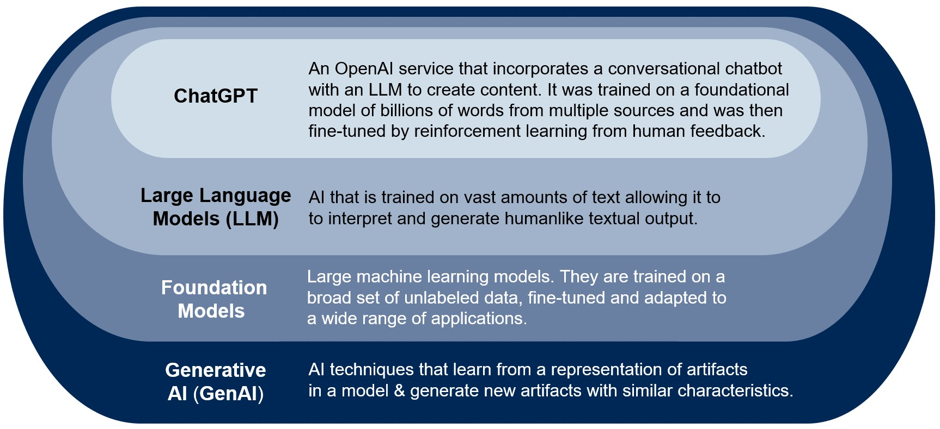
- GenAI falls in various categories of AI [2].

Social and Cultural Impact of GenAI
IT leaders must recognize the profound impact of GenAI on our society, as well as how society will impact the adoption of generative AI. This note highlights several plausible impacts of GenAI from a social and cultural perspective [3], [1]:

Academic Integrity
The potential to accelerate academic research and improve education. Anyhow, concerns related to academic integrity and policies arise.

Hiring Biases
GenAI can enhance creativity and productivity but cannot replace human judgment. Challenges concerning biases, impersonaliation and distrust arise. These are the same biases that the humans were expressing when training the dataset.

Deepfakes
GenAI will enable hyper-personalization, automate content creation and foster deeper user engagement. However, ethical considerations, algorithmic bias, filter bubbles and privacy concerns will arise. Tools that might create a persona/avatar that’s pretending to be a trusted person, delivering fraudulent information, or even advise them to take dangerous and potentially risky courses of action.

Inaccurate Chatbots
GenAI will revolutionize collaboration, play a vital role in the creation of digital human assistants and enhance work outcomes. Concerns about bias, security, privacy, dependency and integration difficulties will arise. Without an ethical design in place, chatbots might provide false advice.

Societal Division
GenAI can deepen societal divisions, reinforce biases and widen wealth disparities. Job displacement may affect certain groups more negatively.

Energy Consumption
By 2030, Gartner has predicted that AI may consume up to 3.5% of the world’s electricity [2].

Use of GenAI in Fraud and Anomaly Detection
In this section we will be showing how organizations can benefit from GenAI. Organizations and technology teams might use GenAI when dealing with fraudulent classifications of data or in terms of anomaly detection.

GANs [Generative Adversarial Networks]
Versatility is the greatest power of a GAN. GAN models work together to improve the generator’s ability to create realistic data. In this way, GANs improve the generator’s ability to create realistic data and over time the generator becomes better and better. GAN's generator samples from a relatively low dimensional random variable and produces an image. Then the discriminator takes that image and predicts whether the image belongs to a target distribution or not [4]. In this way we have an adequate transitional quality of inputted and outputted data.
In the context of financial fraud detection, GAN models can be used to generate synthetic versions of fraudulent transactions, which can then be used to train a fraud detection model. Existing approaches to identifying financial fraud and money laundering rely on databases of human-engineered rules that match suspicious patterns in financial transactions. As new schemes are identified, new rules are added to the rules base [4].

VAE [Variational Autoencoders]
VAEs are a type of neural network architecture that is used for generative modelling. VAEs are used for anomaly detection by training the model on a dataset of normal data and then using the trained model to identify instances that deviate from the normal data.
VAE is used in financial fraud, manufacturing flaws [5] and network security breaches. Once trained, the autoencoder can be used to reconstruct new data samples. If a new data sample is significantly different from the normal data that the autoencoder was trained on, it may be reconstructed poorly, indicating that it is potentially anomalous.
One of the key features of VAEs is that they are designed to be able to learn a probabilistic model of the data, which means that they can be used to generate new samples that are similar to the training data, but not necessarily identical [6].

Organising Data with Ethics in Mind
All models are built on top of data. There are three goals in effective and ethical data organization [1]:

Prioritising Privacy
Any new technology is only as ethical as the underlying data that it is trained on. An organization shall conduct a privacy audit to build a comprehensive understanding of what data it has, how it was collected, how it is stored and how it is administered.

Reducing Bias in Data Collection and in Data Use
Are we asking the right questions when collecting data? Each of us has to be curious about who the data serves. As well as consider who interpreted the data, to reduce the risk of potential bias. Any new tool should begin with a focused statement of intention of the organization’s goals and identification of the population we’re trying to serve. Understating the bias in the data helps us minimize the negative impacts of bias in the algorithm.

Promoting Transparency
We want to be able to explain to all stakeholders, customers, employees, suppliers, regulators etc., how this data is collected and used. We might consider publishing a data governance framework. Consider how transparent the recommendations of the tool are and how traceable those outcomes are. This allows for human auditing of ethical accountability.

Conclusions
“We shape our tools, and thereafter our tools shape us.” – John Culkin, Professor of Communication. We can conclude from this paper that GenAI, can serve special business purposes like anomaly detection, fraudulent transactions detection, enhanced creativity etc. But, anyhow, there are more implications impacting humanity if not used adequately. Fig 2. Shows the main drivers and barriers GenAI is built on:
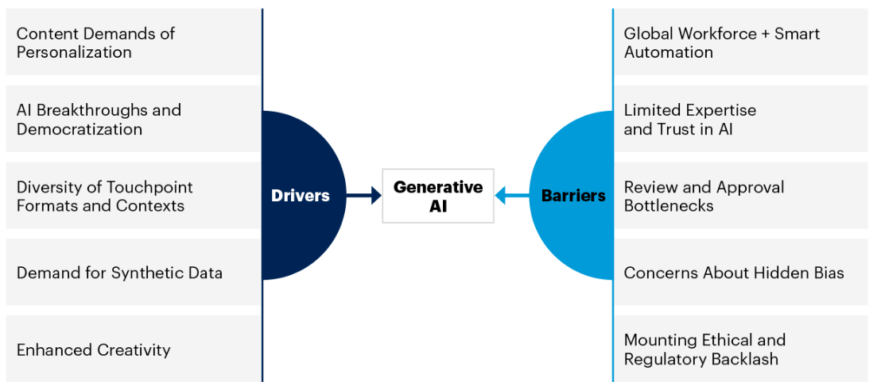
- GenAI falls in various categories of AI [2].
Thus, when deciding to implement GenAI in organizations, ethical analysis need to be intertwined with the initial design and at every phase of deployment. Since, for e.g., when a chatbot is making inappropriate responses to customers, it is not only a product issue, but also a problem to be grounded in ethical decision making. The best solution to have GenAI implications in control is by dividing two main groups with crucial responsibilities:

Technology Team
Technology teams shall be prepared to make ethical decisions. They shall:
- Possess specific skills and expertise
- Work under tight deadlines
- Be subject to specific regulatory requirements (GDPR and other European laws)
- Have a strong internal ethical culture along with external oversight and accountability
Ethical decisions that technology teams might face include the following:
- Deciding how to ensure security and privacy of data collection, storage, use and reuse
- Deciding how to audit algorithms to ensure they are free from bias
- Deciding how to reduce their environmental impact

CEOs and C-Suite
CEOs and C-Suite play a critical role in building cultures of responsible AI. C-Suite should make sure there is a responsible AI Policy and Governance Framework in place which should be able to describe how to make ethical decisions, how to protect privacy and how to eliminate/reduce bias.
They should:
- provide and mandate responsible AI training to employees
- insist on building ethical AI elements into all their technologies and conduct regular audits
- create regular reporting mechanisms to AI practices
- identify specific metrics
- hire a Chief of AI ethics Officer

The Board of Directors shall be prepared to manage risk and opportunity in AI by:
- ensuring policies and procedures exist for ethical concerns, designated to mitigate risks including bias, privacy and security.
- ensure necessary resources and expertise to manage the ethical risk posed by AI effectively.
- ensuring alignment with regulatory requirements.
- establishing a dedicated AI committee to oversee ethical AI practices within the organization.

References
- Pinar Seyhan Demirdag, “Career Essentials in Generative AI by Microsoft and LinkedIn”, LinkedIn, March 2023.
- Frank Buytendijk, Pieter den Hamer, Frances Karamouzis, “Generative AI: The Basics”, Gartner, 12 June 2023.
- Issa Kerremans, Jay Wilson, Bart Willemsen, Samantha Searle, Ankita Khilare, “9 Social and Cultural Implications of Generative AI”, Gartner, August 2023.
- Mehrdad Mamaghani, Nima Ghorbani, Jim Dowling, Davit Bzhalava, Prabhu Ramamoorthy and Mark J. Bennett, “Detecting Financial Fraud Using GANs at Swedbank with Hopsworks and NVIDIA GPUs”, March 2021.
- Tea Osmëni, Maaruf Ali, “Contemporary Generation: Artificial Intelligence Contribution to Manufacturing”, 2022 International Conference on Computing, Networking, Telecommunications & Engineering Sciences Applications (CoNTESA).
- Alon Agmon, “Hands-on Anomaly Detection with Variational Autoencoders” , Towards Data Science, July 2021.
- Nicole Greene, Andrew Frank, “Use Generative AI to Enhance Content and Customer Experience”, July 2022.

