Task 1
A parallel circuit is an electronic device that can be found in various home appliances such as switches and plugs. It can run in two or more paths and passes through the same direction, which makes it a parallel circuit. The total current that the circuit has is always divided by the voltage of the paths it goes through. The potential difference between the two values is used to show the changes that occur in the circuit.

Task 2
- The voltage being measured across the resistor
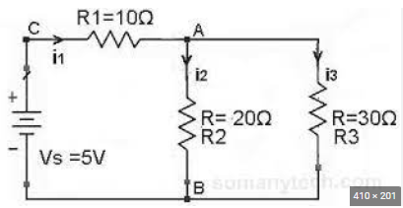
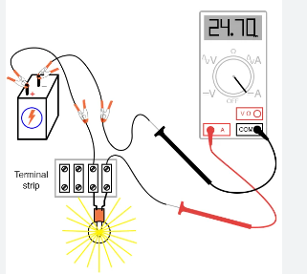
- To measure current in a circuit is to break the circuit open and insert an “ammeter” in series with the circuit. This is connecting to a battery which helps get the readings accurate

- This method will determine the overall resistance of a group of individual resistor. The total resistance will be calculated by taking into account the individual resistances.
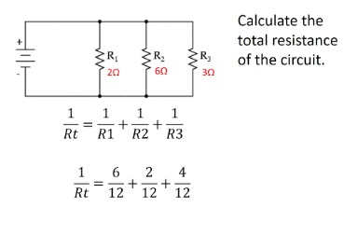

Task 3
The unit's power output can be calculated by multiplying its hours of use by the number of hours. For instance, if you use a 120v television for two hours every day, you can multiply its hours of use by 240 to get a total of 240 Watt-hours.
Task 4
Electric circuit theorems are always beneficial to help find voltage and currents in multi-loop circuits. These theorems use fundamental rules or formulas and basic equations of mathematics to analyse basic components of electrical or electronics parameters such as voltages, currents, and resistance.

