
Aidan Chappell-Smith

P151655

ACBA5012

Energy Efficiency and sustainable materials

Lecturer: Juan A Ferriz-Papi
Contexts:
0.0 …………………………………………………………………………. Introduction
- …………………………………………………………………………… Orientation
1.1 …………………………………………………………………………………. Shading
1.2 ……………………………………………………………….. Natural Ventilation
1.3 …………………………………. Foundation, floor and cavity wall detail
2.0 …………………………………………………………………… Roof Detailing
- ………………………………………………………………… Thermal Bridging

0.0 Introduction
In this assignment I will be constructing a detached house as shown in the assignment brief, considering I have seen the design before construction I will be making suggestions to improve the energy efficiency of the building using passive and active solutions. I will be amending the orientation, shading, natural ventilation, openings, partitions and considerations about envelope shape.
I will design the Facades, roof and area in contact with the ground whilst defining the corresponding cross sections of layers, materials and thickness to comply with building regulations part L.
Finally, I will identify possible thermal bridges and solutions I would implement to avoid.
1.0 Orientation.
The best way to optimise solar gains is to have the building facing south. As the sun rises in the east and sets in the west between the times of 9am and 4 pm the sun will be generally facing south. During the summer the sun is a lot higher than it will be in the winter, with this information it allows us to build to maximise the heat the building will receive in the winter and deflect it in the summer. (Anon., 2019) (Hall, 2008) (Crown, 2006) (Sun-Direction.com, 2020)
I will maximise the size of the windows from the south and minimise the north side this will generate more natural light and minimise artificial light to reduce energy consumption and the use of electricity. (McGee, 2013)
The living spaces such as lounge, kitchen etc will be constructed at the front of the south façade as these are more open areas which need light, the bedrooms will be constructed to the north side of the building as they are used less and don’t need as much light as they are predominantly for sleeping. (Green Building Press, 2003) (Nicholls, 2003)
Please see technical drawing for the new layout of the building where the building will be orientated correctly and the pool moved and orientated to not be shaded by the building and maximise heat from the sun.
1.1 Shading.
When constructing the over hang of the building and the eaves this should be calculated so that the sun will hit the roof and not the building in the summer when the sun is at its highest keeping the building cooler, then in the winter the sun will hit the building/window directly as the sun is lower to heat the building. (see Technical Drawing)
1.2 Solutions for natural ventilation.
The windows should be able to open fully to maximise cross ventilation in the building and trickle vents will be incorporated into every window to allow constant airflow, you can also choose when to open and close these vents. A solar chimney will be incorporated as it is an inexpensive solution to heat and ventilate the dwelling this will be constructed on the south facing wall to maximise its potential in a dark colour the minimise reflection of heat.
(Cedar Lake Ventures, Inc, 2016) (Jordan Hanania, Kailyn Stenhouse, Brodie Yyelland, Jason Donev, 2020) (Green Building Press, 2003) (Nicholls, 2003) (Green Building Press, n.d.)

1.3 Foundation, floor and cavity wall detail.
With a strip foundation of approximately 225mm deep the cavity wall will have an internal structure of 100mm width Thermalite Aircrete Turbo block work (0.11 K Value) an external structure of dense concrete block work until the ground floor starts where it will change to single leaf brick work of 102.5mm (k value of 0.77 W/mk). 200mm rigid polyurethane foam with waterproof coating floor insulation (0.021 W/mk) will be used and a damp-proof membrane will run from beneath the floor insulation around to the internal block work and up to the ground floor level and back across the block work, with a reinforced concrete aerated slab of 200mm (0.16 W/mk) on top of the insulation. (DIY Doctor Ltd 2020, 2020) (Forterra Building, 2020) (Ibstock brick limited, 2015) (React-ite.eu, 2013)
Where the cavity is still part of the substructure it should be filled with reinforced concrete to deal with the pressure of the ground acting against it to stop any bending moments or cracking in the structure, this should be designed by a specialised engineer. (2020 Building regs 4 plans, 2020)
A Multi-coat Render Tanking system will be implemented by professionals on the internal surface to keep water and moisture at bay especially in the basement. (DIY Doctor Ltd 2020, 2020) (NCC Limited 2014, 2014)
Above ground floor level the cavity will continue with 12mm internal plasterboard internal Thermalite Aircrete Turbo block work 100mm thick (0.11 K Value) 100mm celotex cavity wall insulation ( 0.022 W/mK) attached to the internal face of the cavity, and brick work on the exterior, there will be a minimum air gap of 50mm in the cavity. A cavity tray will run from the top of the DPM down the weep vent to disperse of moisture build up. TeploTie wall ties will be used as they are 20 times less thermally conductive than stainless steel, the wall ties will join the internal and external structure as detailed in the technical drawing. (Green Building, 2020) (Forterra Building, 2020) (Modern Masonry, 2018) (Nicholls, 2003) (Green Building Press, 2003) (MD Insurance Services Ltd, 2020) (Future Publishing Limited, 2020)
On top of the hardcore infill there will be a sand blinding (to prevent piercing of the dpm) with a dpm on top and 200mm polyurethane insulation. A 200mm aerated reinforced concrete slab will be constructed on top to comply with the minimum 150mm that building regulations state. (Future Publishing Limited, 2020) (Green Building, 2020)
Floor U Value for this design will be - 0.09 W/m2K which complies with building regulations part L1A new dwellings and exceeds the 0.25 W/m2K expectation. (Crown copyright, 2010)
Cavity wall U Value will be – 0.17 W/m2K This complies will Building regulations part L1A and exceeds the 0.3 W/m2K expectation (Crown copyright, 2010)
(see Technical Drawings)
- Roof Detailing
The roof will be constructed of 12mm plasterboard,47x25mm battens, airtightness barrier, 12.5mm fire acoustic board, a metal web pitched rafter with the void being filled with 100mm ecobeads, a joist ,18mm OSB board, 70mm Kingspan insulation, breather membrane, 47x25mm counter batten, 47x25mm batten on top and natural slate tile finish.
0.15 W/m2K which succeeds the compliance expectations of 0.25 W/m2K in the building regulations part L1A.
(Insulation shop Ltd, 2020) (Springvale EPS Ltd, 2020) (Beattie Passive Buils System Limited, 2020) (Viirtual Maths, n.d.) (GreenSpec, 2020)
Thermal bridging
Thermal bridging with in the windows is a massive issue. A air barrier will be installed at the perimeter of the window system and will integrate with the wall system. The thermal breaks within the window should be aligned with the insulating glass unit and at least 12mm wide. The window should be triple glazed with low E glass and warm edge technology incorporated and compression seals all to minimise thermal bridging. (C.C. Sullivan, Barbara Horwitz-Bennett, 2014)
The opening for doors and windows will have Cavalok cavity technology implemented to tightly seal the openings along with being super energy efficient. BigBlok Cavity Closer Formers, this will suit a cavity between 125mm and 300mm. It is perfect for new builds and the cavity closer is assembled into the window/ door template. This technology is super insulating and specially designed to meet the needs of zero carbon, this product is easy to install and use standard plastic ties to fix into coursework as you build. (Cavalok Building Products, n.d.) (RIBA enterprise Ltd, n.d.) (Eurocell 2020, 2020)

Appendix –
The Rsi and Rso is standard for each element and all U values comply with Part L1A of the building regulations.

Floor U Value Calculations
Rsi – inside surface = 0.14 m2k/W
Polyurethane 0.2(M) / 0.021W/mK = 9.52 m2 K/W
Aerated slab 0.2 (M)/ 0.16 W/mK= 1.25 m2 K/W
Rso – outside surface = 0.04
1/ (0.04 + 0.14 + 9.524 + 1.250) = 0.092 W/m2K
Cavity wall U Value Calculations
Rsi = 0.12 m2k/W
Plaster board 0.012(M)/0.016 W/mk =0.075 m2 K/W
Block work 0.1(M) / 0.11 W/mK = 0.909 m2 K/W
Celotex insulation 0.1(M)/ 0.022 W/mK = 4.545 m2 K/W
Brickwork 0.102(M)/0.77 W/mK = 0.132 m2 K/W
Rso = 0.06 m2 K/W
1/ (0.06 + 0.12 + 0.909 +4.545 +0.132+0.075) = 0.17 W/m2k
Roof U value calculations
Rsi = 0.10 M2K/W
Plaster board 0.012(M)/0.16 =0.075 m2 K/W
Fire Acoustic Board 0.0125(M)/0.25 W/mk =0.050 m2 K/W
eco beaded insulation 0.100(M)/0.033 W/mk = 3.030 m2 K/W
Kingspan insulation 0.07(M)/0.021 W/mK = 3.333 m2k/W
Natural slate tiles 0.005(M)/2.5 W/mK = 0.002 m2k/W
1/(0.10+0.075+0.050+3.030+3.333+0.002) = 0.15 W/m2K

Figure 1 Shading.
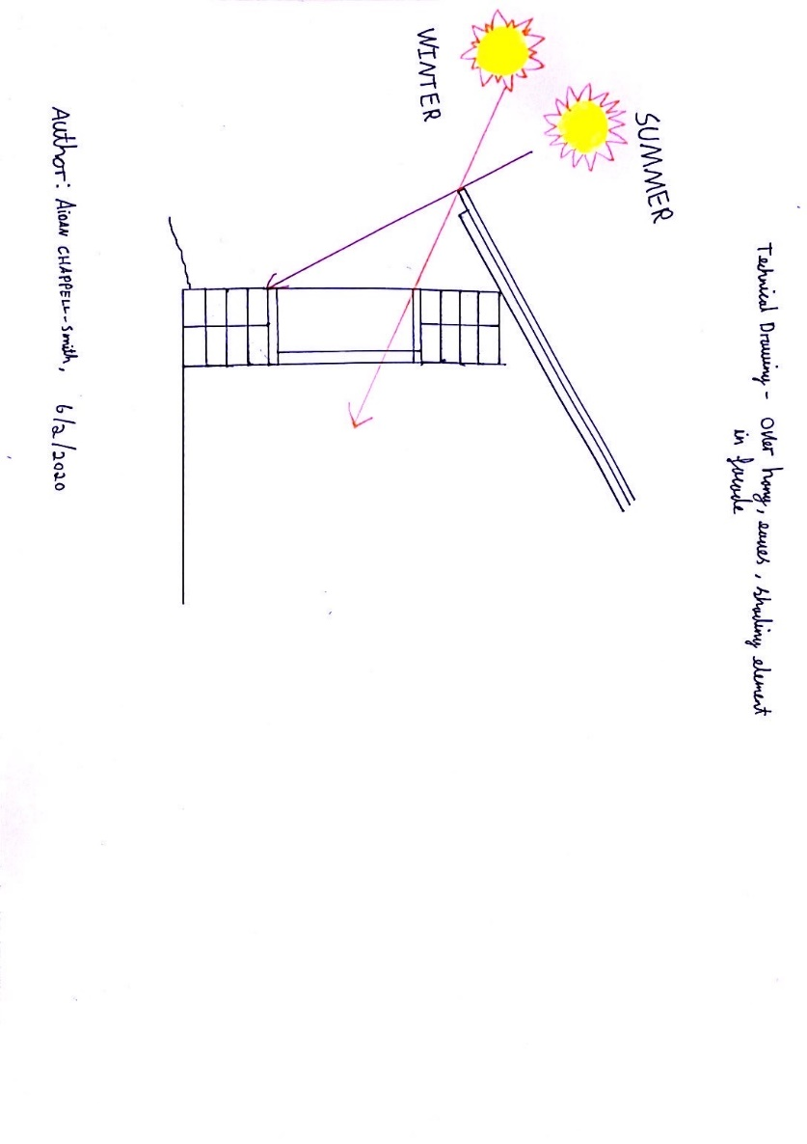

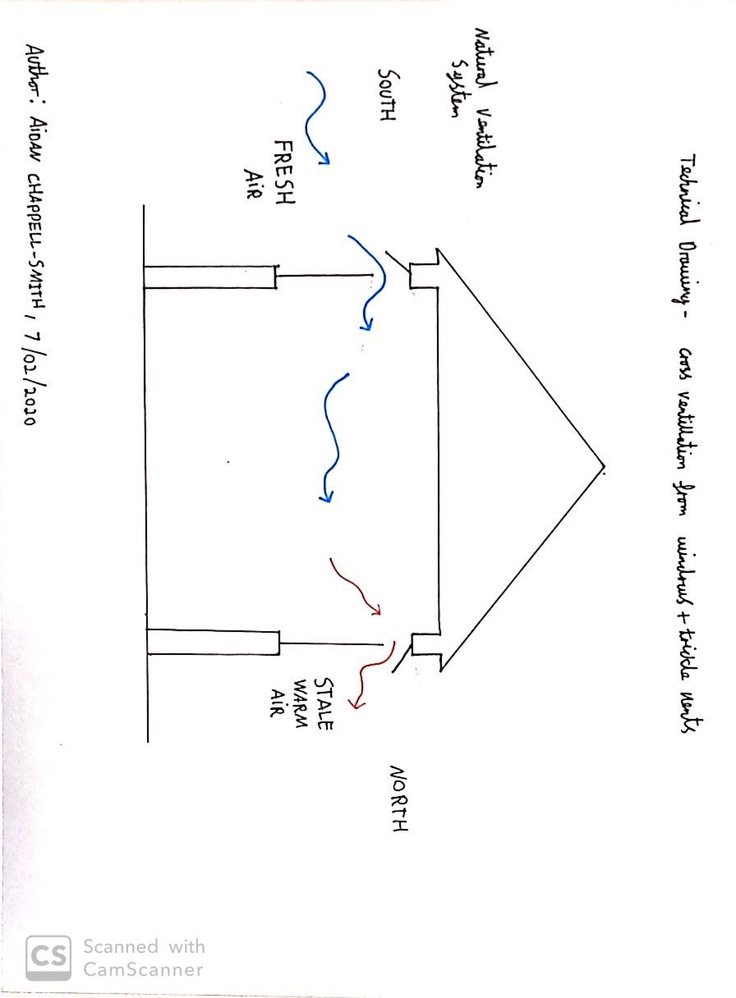

Figure 2 cross ventilation.

Figure 3 Solar Chimney.
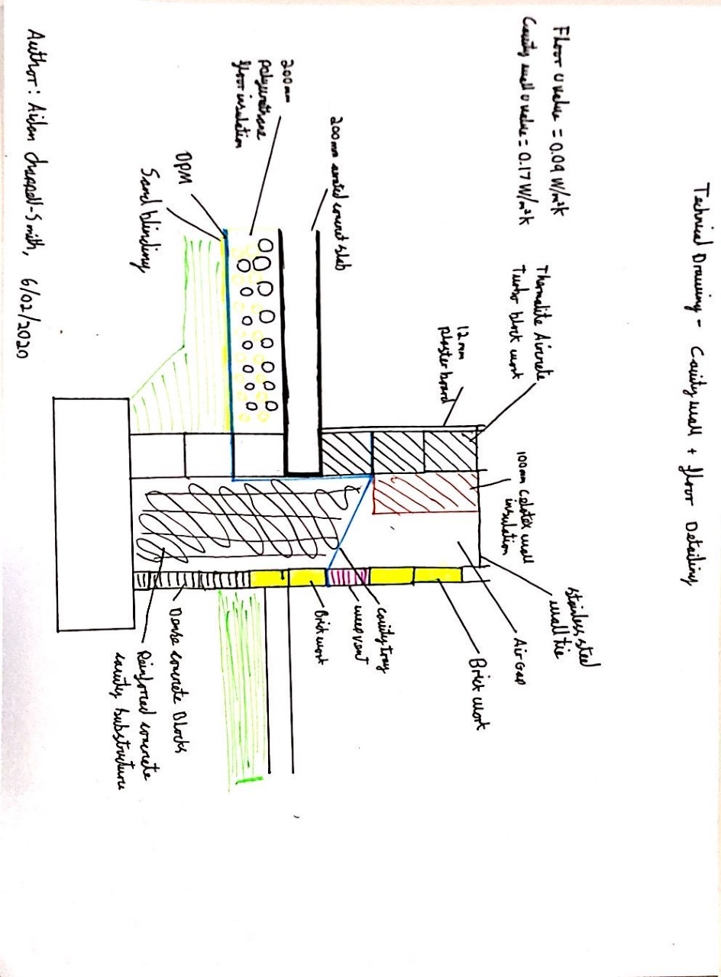
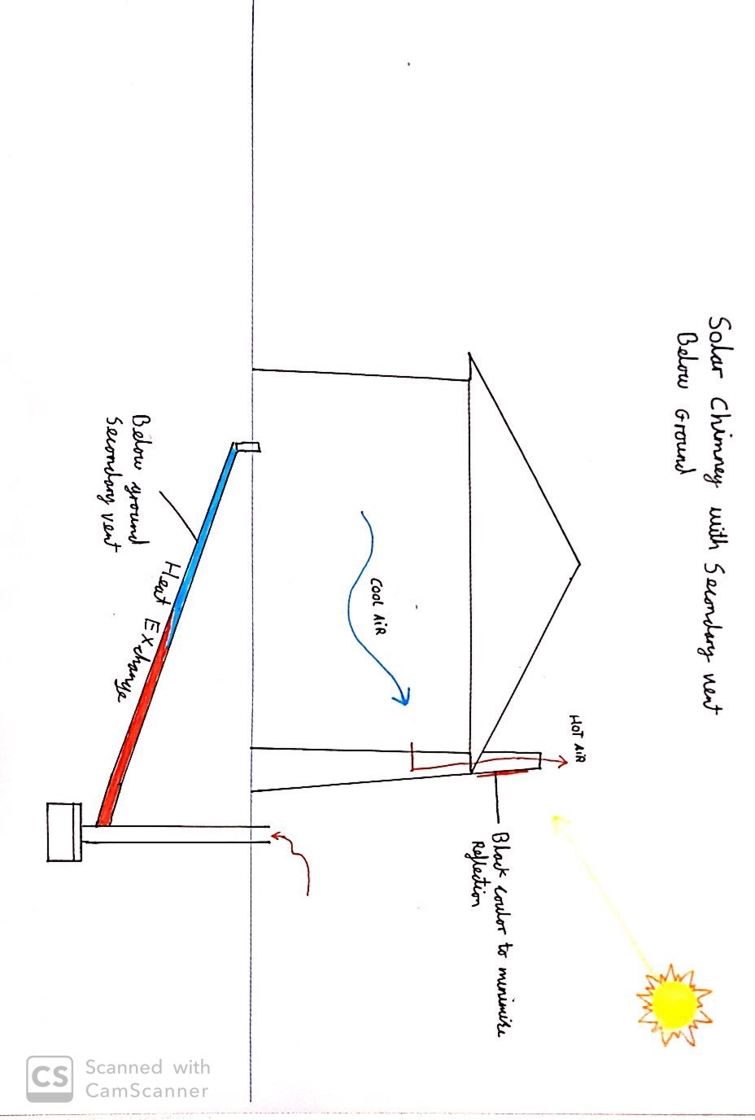
Figure 4 technical detailing of foundation, floor and cavity wall.

Figure 5 roof detail.

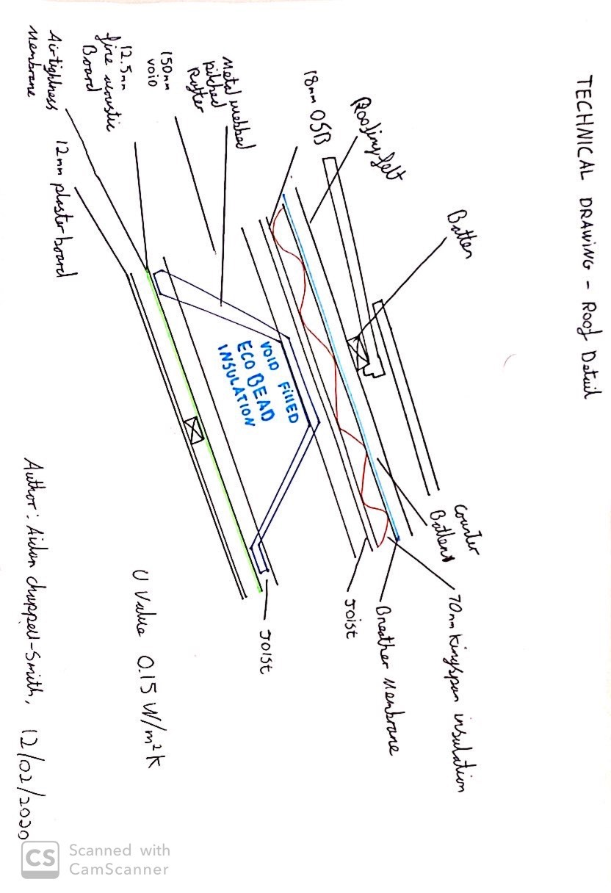

References

Bibliography
2020 Building regs 4 plans, 2020. Buildingregs4plans. [Online]
Available at: https://www.buildingregs4plans.co.uk/foundation_floor_wall_3d_detail.php
[Accessed 10 January 2020].
Anon., 2019. gharpedia. [Online]
Available at: https://gharpedia.com/blog/importance-of-building-orientation-in-architecture/
Beattie Passive Buils System Limited, 2020. Beattiepassive.com. [Online]
Available at: http://www.beattiepassive.com/technical.php
[Accessed 7 January 2020].
C.C. Sullivan, Barbara Horwitz-Bennett, 2014. bdcnetwork.com. [Online]
Available at: https://www.bdcnetwork.com/8-tips-avoiding-thermal-bridges-window-applications
[Accessed 15 January 2020].
Cavalok Building Products, n.d. Eurocell. [Online]
Available at: file:///C:/Users/p151655/Downloads/eurocell%20cavalok%20brochure_lr.pdf
[Accessed 18 January 2020].
Cedar Lake Ventures, Inc, 2016. Weather Spark. [Online]
Available at: https://weatherspark.com/y/41923/Average-Weather-in-Wales-United-Kingdom-Year-Round
[Accessed 10 January 2020].
Crown copyright, 2010. assets.publishing.service.gov.uk. [Online]
Available at: https://assets.publishing.service.gov.uk/government/uploads/system/uploads/attachment_data/file/697629/L1B_secure-1.pdf
[Accessed 15 January 2020].
Crown, 2006. Astronomical Information Sheet, Somerset: HM Nautical Almanac Office.
DIY Doctor Ltd 2020, 2020. diydoctor.org.uk. [Online]
Available at: https://www.diydoctor.org.uk/projects/strip-foundation.htm
[Accessed 10 January 2020].
Eurocell 2020, 2020. Eurocell.co.uk. [Online]
Available at: https://www.eurocell.co.uk/specifiers/cavity-closers
[Accessed 17 January 2020].
Forterra Building, 2020. Forterra.co.uk. [Online]
Available at: https://www.forterra.co.uk/thermalite-and-aggregrate-blocks/thermalite-aircrete-block-detail/thermalite-aircrete-shield
[Accessed 09 January 2020].
Future Publishing Limited, 2020. Homebuilding and renovating. [Online]
Available at: https://www.homebuilding.co.uk/cold-bridging/
[Accessed 17 January 2020].
Future Publishing Limited, 2020. Homebuilding.co.uk. [Online]
Available at: https://www.homebuilding.co.uk/floor-structure-guide/
[Accessed 09 January 2020].
Green Building Press, 2003. The Green Building bible volume 1. In: K. Hall, ed. The Green Building bible volume 1. s.l.:Keith Hall, p. 482.
Green Building Press, n.d. The green building bible volume 1 third edition. In: K. Hall, ed. The green building bible volume 1 third edition. s.l.:Keith Hall, p. 466.
Green Building, 2020. Greenbuildingstore.co.uk. [Online]
Available at: https://www.greenbuildingstore.co.uk/golcar-passivhaus-ground-floor-foundations/
[Accessed thursday January 2020].
GreenSpec, 2020. Greenspec.co.uk. [Online]
Available at: http://www.greenspec.co.uk/building-design/pitched-roof-coverings-1/#slate
[Accessed 7 Feburary 2020].
Hall, K., 2008. The Green Building Bible volume 1. In: The Green Building Bible volume 1. s.l.:Green Building Press, p. 482.
Ibstock brick limited, 2015. ibstockbrick.co.uk. [Online]
Available at: https://ibstockbrick.co.uk/wp-content/uploads/2015/08/Ibstock-TIS-A9-UNDERSTANDING-THERMAL-CONDUCTIVITY-k-VALUES-.pdf
[Accessed 10 January 2020].
Insulation shop Ltd, 2020. Insulation shop. [Online]
Available at: https://www.insulationshop.co/12.5mm_gyproc_soundbloc_high_density_acoustic_board_1200x2400.html
[Accessed 6 Feburary 2020].
Jordan Hanania, Kailyn Stenhouse, Brodie Yyelland, Jason Donev, 2020. Energy education. [Online]
Available at: https://energyeducation.ca/encyclopedia/Solar_chimney
[Accessed 15 January 2020].
McGee, C., 2013. Yourhome. [Online]
Available at: http://www.yourhome.gov.au/passive-design/orientation
MD Insurance Services Ltd, 2020. labcwarranty. [Online]
Available at: https://www.labcwarranty.co.uk/blog/minimise-heat-loss-with-our-cavity-wall-insulation-guide/
[Accessed 15 January 2020].
Modern Masonry, 2018. Modernmasonry.co.uk. [Online]
Available at: https://www.modernmasonry.co.uk/Precast/media/BPMediaLibrary/Publications/MMA_EasyGuide_CavityWalls.pdf
[Accessed 09 January 2020].
NCC Limited 2014, 2014. Basementwaterproofing site.co.uk. [Online]
Available at: http://www.basementwaterproofingsite.co.uk/TankingSystems.html?gclid=EAIaIQobChMIr7f04qXH5wIVRbTtCh3kbQS7EAAYASAAEgLV__D_BwE
[Accessed 10 January 2020].
Nicholls, R., 2003. The green building bible volume 2. In: K. Hall, ed. The green building bible volume 2. s.l.:Green Building Press, p. 295.
React-ite.eu, 2013. React-ite.eu. [Online]
Available at: http://www.react-ite.eu/uploads/tx_mddownloadbox/PP02_Thermal_insulation_materials_-_PP02_20130715.pdf
[Accessed 10 January 2020].
RIBA enterprise Ltd, n.d. Ribaproductselector.com. [Online]
Available at: https://www.ribaproductselector.com/cavalok-building-products-ltd/20857/overview.aspx
[Accessed 17 January 2020].
Springvale EPS Ltd, 2020. Springvale.com. [Online]
Available at: https://springvale.com/ecobead/
[Accessed 6 Feburary 2020].
Sun-Direction.com, 2020. Sun-direction.com. [Online]
Available at: http://www.sun-direction.com/city/64412,swansea/
[Accessed 10 January 2020].
Viirtual Maths, n.d. Virtualmaths.org. [Online]
Available at: http://www.virtualmaths.org/activities/topic_data-handling/heatloss/resources/thermal-conductivity-of-building-materials.pdf
[Accessed 7 Feburary 2020].

