Worksheet 4 – Network Resources

Dominik Tomasz Kania
Computing (Computer Networks and Cybersecurity)
University of Wales Trinity Saint David
Swansea, Wales
1702026@student.uwtsd.ac.uk

Table of Contents
Abstract 3
Introduction 3
Worksheet 4 – Practical Tasks 4
Task 1: Utilising ARP and Routing Tables 4
Task 2: Deploying Core Services (FTP Server) 8
Task 3: Configuring the Routing and Remote Access Service 16
Task 4: IP Packet Filtering 32
Worksheet 4 – Observational Tasks 43
Task 3: Router Operation 43
Task 5: Failover Clustering 44
High Availability Failover Clusters 47
Continuous Availability Failover Clusters 48
Concepts Pertaining to the Failover Clustering 49
Task 6: Network Structure 50
DTK’s Network Policy 50
Network Design 55
Network Access 55
Security Team 56
Enforcement of Policies 57
Risk Analysis 57
Security Operations Monitoring and Breach Mitigation 58
High Availability and Security Best Practises 59
Network Security Best Practices 60
High Availability Best Practices 61
Conclusion 63
References 64

Abstract
Network administration is the method of managing and maintaining a computer network to guarantee that all of the resources, including hardware and applications, are in good working order and are being used constructively. This procedure is supervised by a network engineer, security administrator, or Managed Service Provider (MSP), who uses mechanisms, programmes, operating systems, and devices to guarantee the network can meet market expectations and customer needs. The complexity in network security is that systems are becoming increasingly complicated. There are more computers to handle on infrastructure than ever before, and they are not all made identical. Similarly, related network equipment, such as switches, can be vastly distinct if made by various manufacturers. Network administration is a massive burden. To get a greater understanding of this sector, it is best to divide it into the five main fields covered by the FCAPS acronym: fault, configuration, accounting, performance, and security management.

Introduction
Network security and administration of the ICT infrastructure is referred to as the capacity to preserve the integrity of an organisation’s network, data, and internal ecosystem. The numerous technologies and purposes to which systems are placed are increasing with each day, and as a result, they are becoming increasingly complicated and problematic to handle. Computers are used in every industry, including finance, healthcare, education, employment, manufacturing, and so on. In a worldwide scale, the pervasive use of these technologies contributes to illegal activities and chaos. Furthermore, the Internet's enormous advantages have accelerated the spread of cyber-crime and uncertainty. Besides that, ICT has rapidly become a distinguishing factor for corporation representatives because it provides reliable and easy means of contact with one another around the world. This increase in the number of companies relying on ICT for business activities has resulted in an increment in the number of threats and vulnerabilities on inappropriately controlled and protected networks, with the intention of stealing private information, especially financial data, and passwords. As a result, this paper suggests some recommendations and policies that system administrators in organisations can adopt in order to guarantee efficient network maintenance and the protection of ICT resources and records.

Worksheet 4 – Practical Tasks

Task 1: Utilising ARP and Routing Tables
The Internet Protocol determines how to transfer data packets to their destinations based on routing information. If the device has more than one functional IP interface or is linked to more than one IP gateway, the standard routing information may not be enough for IP to decide where to send data packets. The Routes window allows users to connect and delete routes used by IP to determine where to transfer packets of data. To identify a path, the list of endpoint IP addresses that may use this route ("Destination"), as well as where they should be delivered ("Gateway"), must be determined.
ARP is an abbreviation for Address Resolution Protocol, which specifies how IP addresses are transferred to the physical hardware addresses used to transport data to explicitly connected computers. When a host must determine the hardware address for an IP address, it issues an ARP request to establish which device has this IP address. Any computer the identifies that IP address as one of its own returns the matching hardware address. To minimize the number of queries, hosts keep an ARP cache, which is a table of newly found addresses.
Figure 1 shows the use of the "arp -a" command, with all addresses available. There was an attempt to update this information by issuing the ping command, as seen in Figure 2, but since the ping command was used in previous assignments, the table was already up to date, and no modifications were made, as seen in Figure 3.
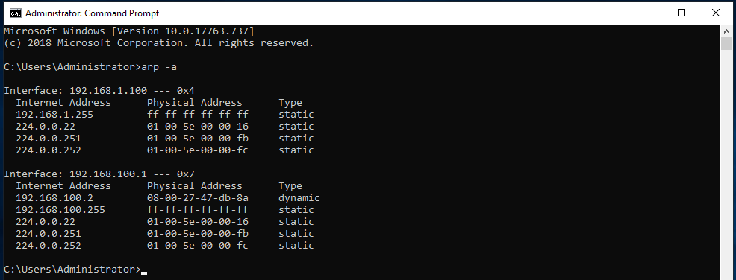
- Information received by using “arp -a” command.
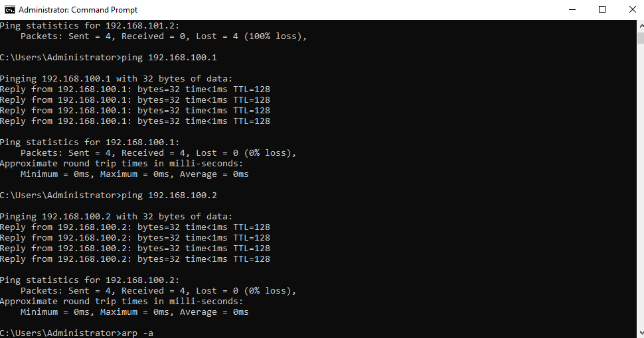
- Using “ping” command to connect more servers.
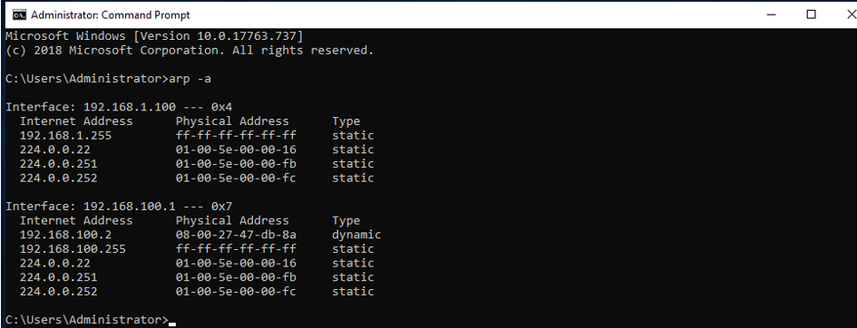
- Information received by using “arp -a” command.

The "route print" command from a Windows administrative command prompt contains a large amount of valuable information, and it can be used on the operating system to print out the routing table information to check which networks the host is connected to. This command was issued on Server 1, as seen in Figure 4, to review the results and see how the data is clustered, as well as to comprehend its logic.
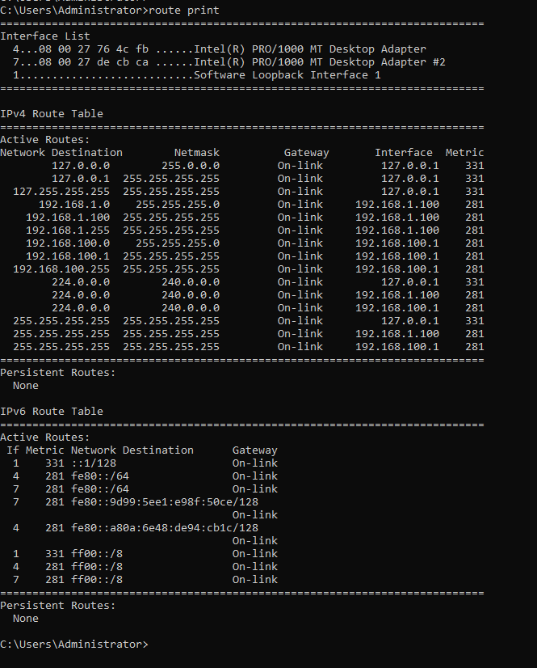
- Information received by using the “route print” command.

Task 2: Deploying Core Services (FTP Server)
The File Transfer Protocol (FTP) is one of the oldest protocols that is still in use today. Its origins can be traced back to 1971 when it was distributed as RFC 114. It is still used nowadays to transmit data over IPv4 and IPv6 networks, regardless of the infrastructure, environment, or system software of either the transmitting or collecting entity. Since the FTP is similar to web servers in its applications today, Microsoft has provided the FTP server role under the Internet Information Services (IIS) server role. Figures 5–8 demonstrate the successful deployment of the FTP server role on Server 2, as well as all configurations that were set during the installation phase.
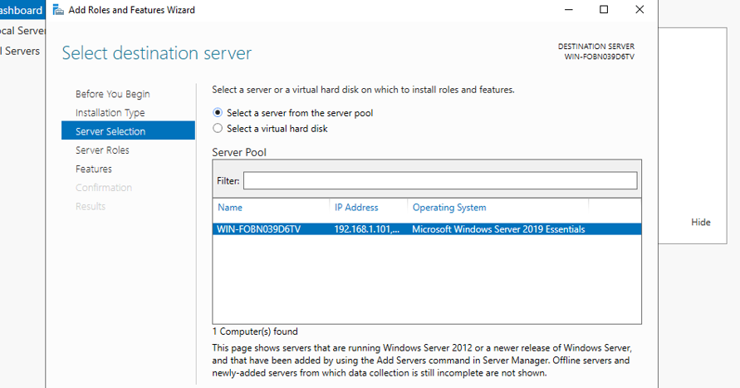
- Destination server selection.

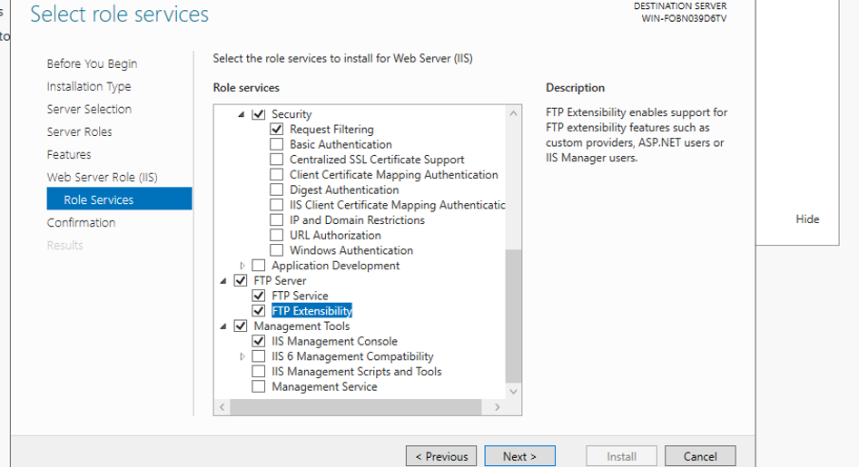
- Role services selection.
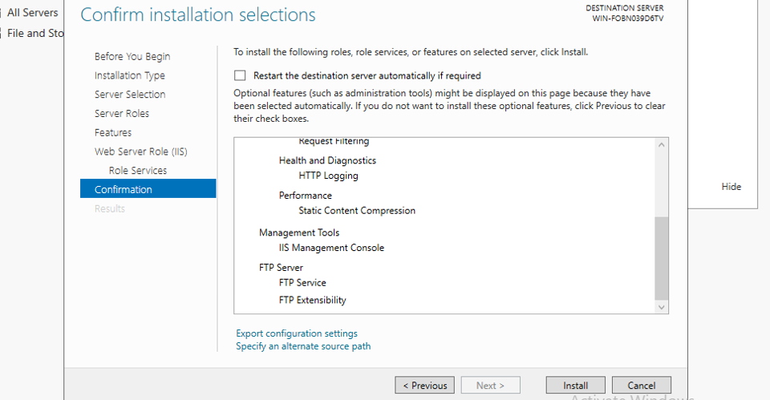
- Results and confirmation.

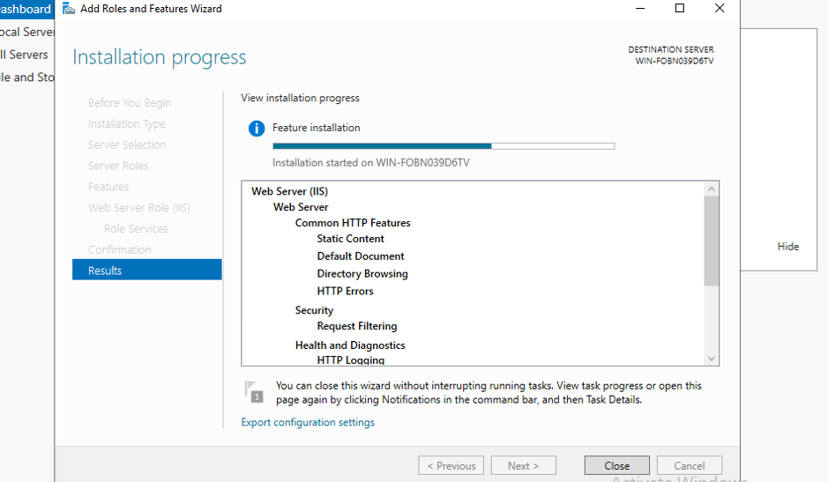
- Results of installation.

Figure 9 shows how to create a user account that is authorised to use the FTP server role. To access the FTP server role, the option to change the user's password at the next logon should be disabled, and the user should be named accordingly.
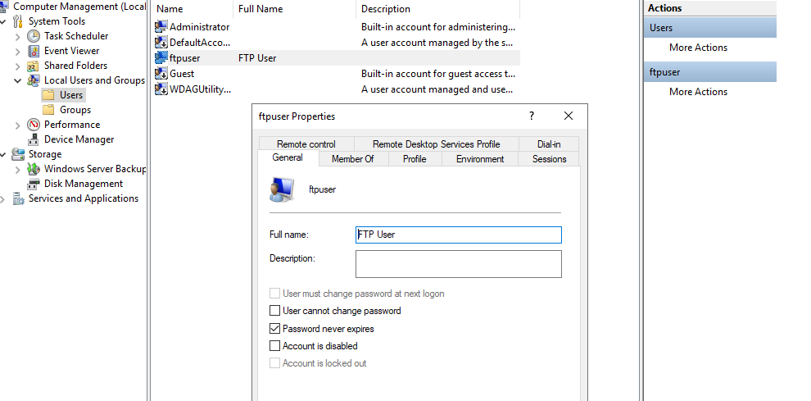
- FTP user creation.

Figures 10-14 show how to customise the FTP site. It is important to add the correct site name and physical path, as seen in Figure 10. As shown in Figures 11 and 12, SSL should be disabled and permissions for specified users enabled. Finally, if the setup was successful, as shown in Figure 13, the FTP site should be available, and banner text should be inserted, as shown in Figure 14, for the users who will be connecting to this server.
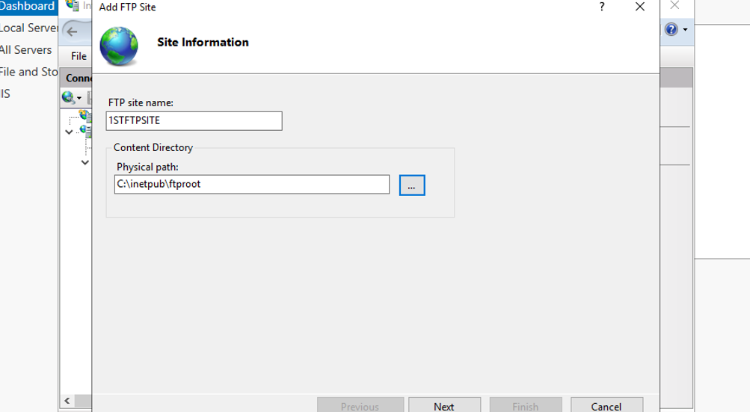
- FTP site information.
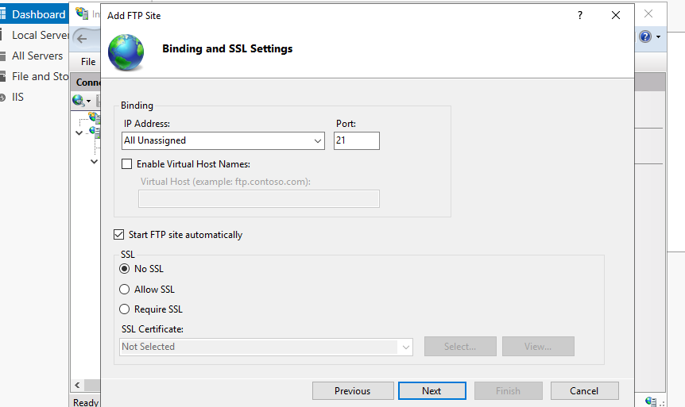
- Binding and SSL settings.
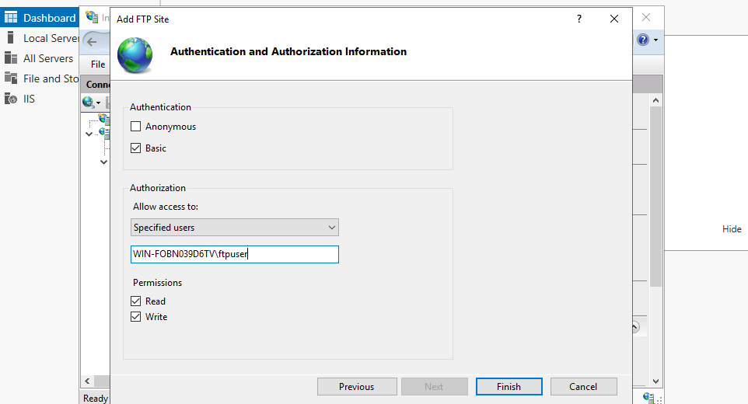
- Authorization information.
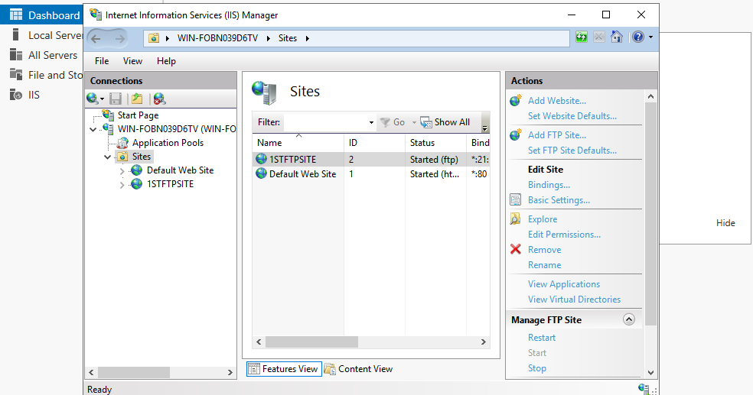
- FTP site added successfully.
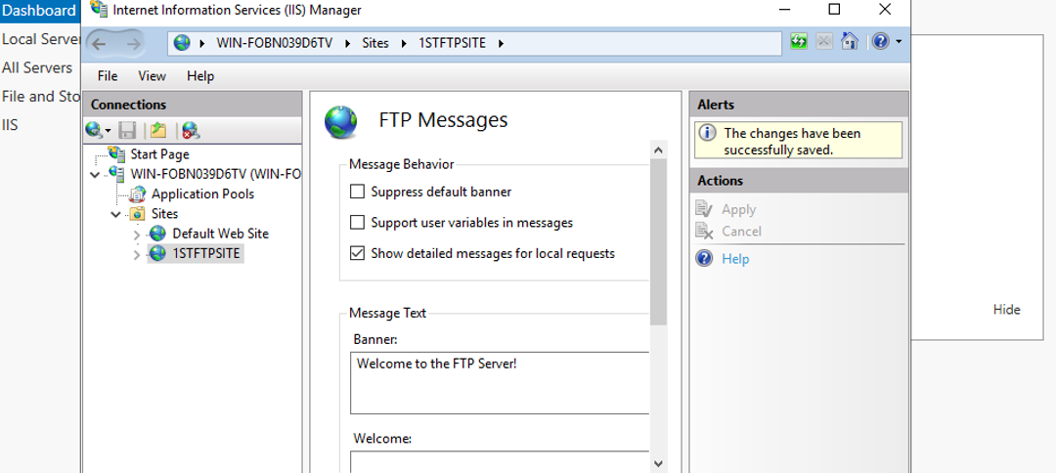
- Banner message for the FTP site.

In order to transfer files, an FTP user must be added to the FTP root folder and configured to have full access, as seen in Figure 15. It is also critical to disable firewalls, as shown in Figure 16, since they can jeopardise the communication between the user and the FTP server.
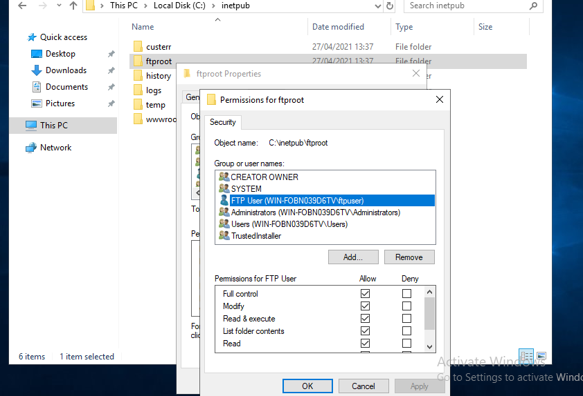
- FTP user with full control.
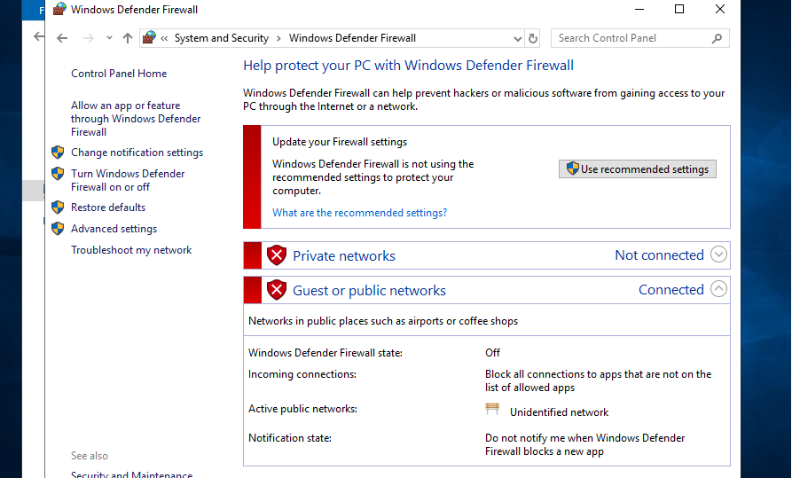
- Firewall settings.

To send a file to an FTP server, it must first be generated, as shown in Figure 17, and a connection must be established between the user and the server using the "ftp" command, as shown in Figure 18. Following that, the file can be transferred to the server using the appropriate commands, as seen in Figure 19. If the file was successfully transferred, information about it will be visible in the command prompt, and the file itself will be visible in the server, as seen in Figure 20.
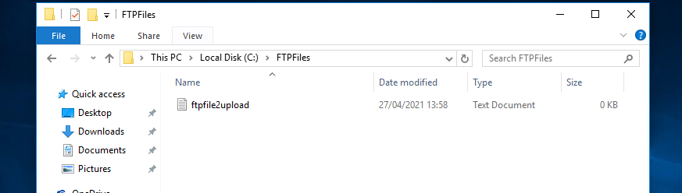
- New file created for FTP transfer.
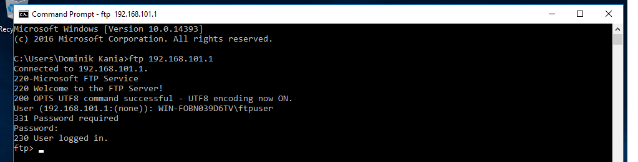
- Successful connection to the FTP server.
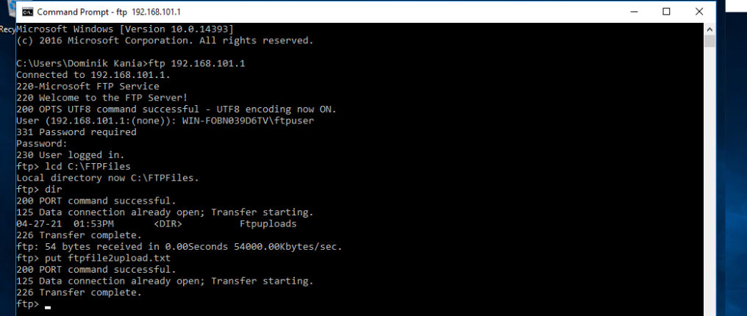
- Successful transfer of the file to the FTP server.
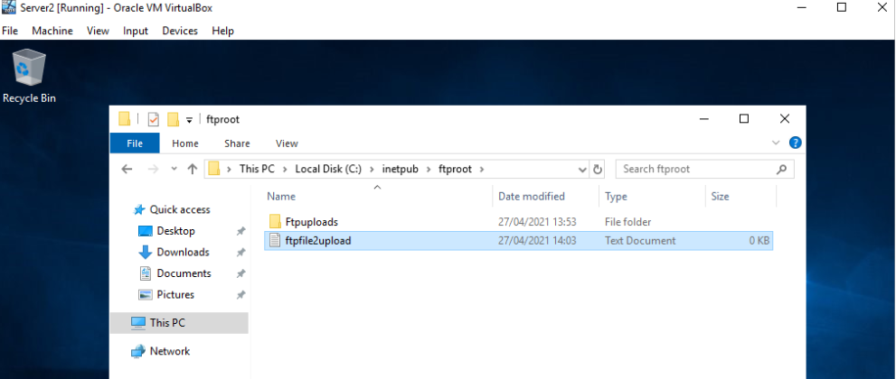
- Evidence of a successful file transfer.

Task 3: Configuring the Routing and Remote Access Service
Routing and remote access service (RRAS) is a collection of network services included with Windows Server that allows a server to execute the functions of a traditional router. RRAS provides an Application Programming Interface (API) that allows for the implementation of software and procedures for managing a variety of network resources.
That being said, two remotely linked local area networks were created for this task. The steps taken to construct these networks are detailed below. To begin, server roles must be configured with the appropriate server and roles, as seen in Figures 21-25. Among the steps are choosing Server 1 as the machine and RAS as the role service. Confirmation of chosen settings, as well as the installation phase, are also shown.
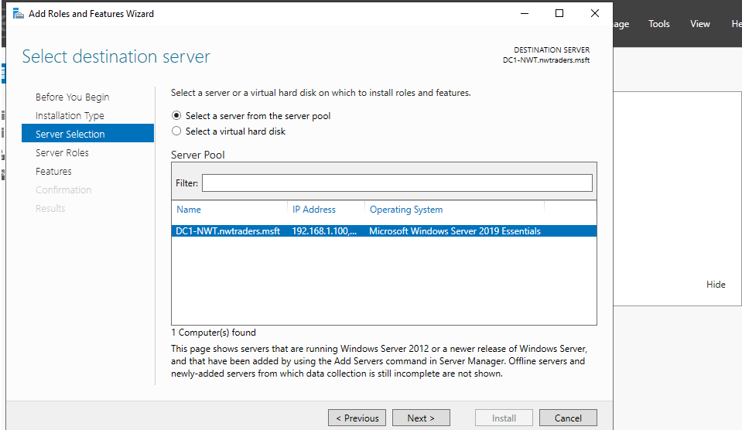
- Server selection.
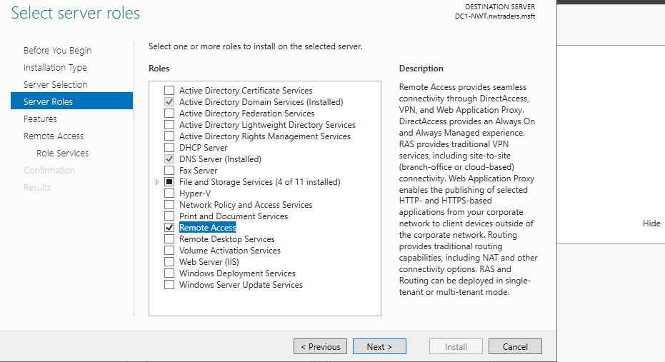
- Role selection.
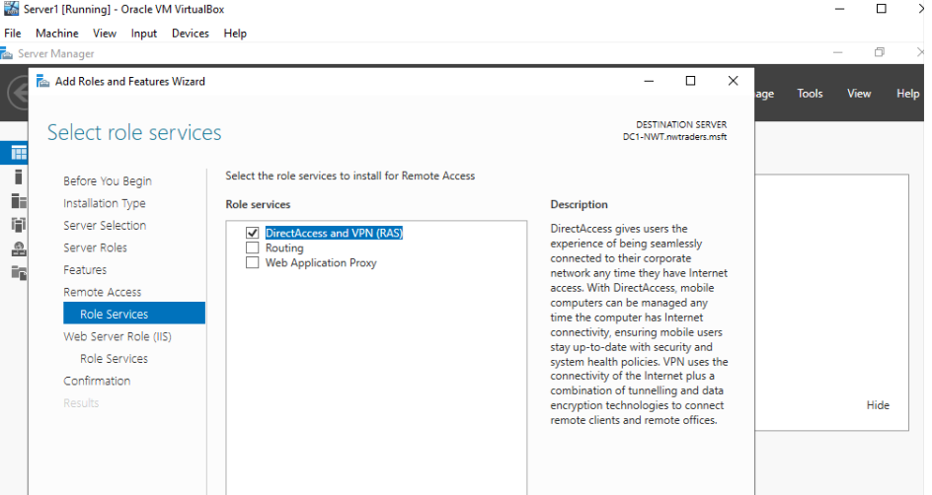
- RAS selection.
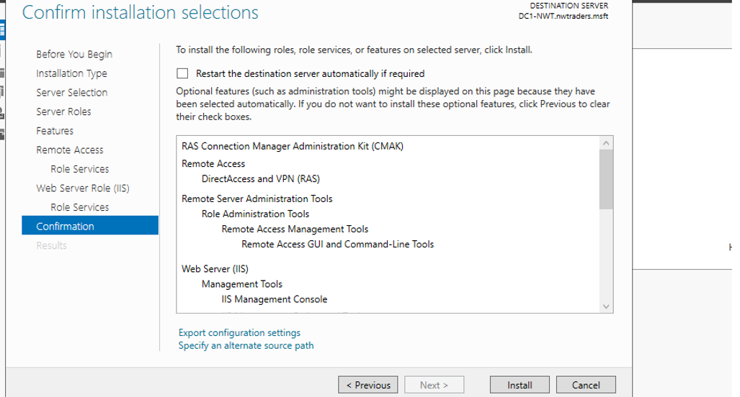
- Settings confirmation.
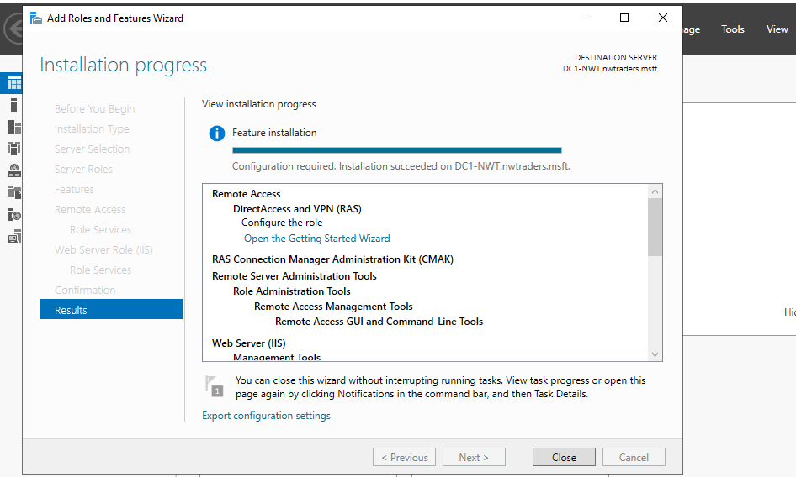
- Installation phase.

After completing the preceding tasks, users must configure remote access using the server setup wizard, as seen in Figures 26-28. These measures include allowing LAN routing and configuring routing and remote access, which can be checked by looking at the green arrow next to it.
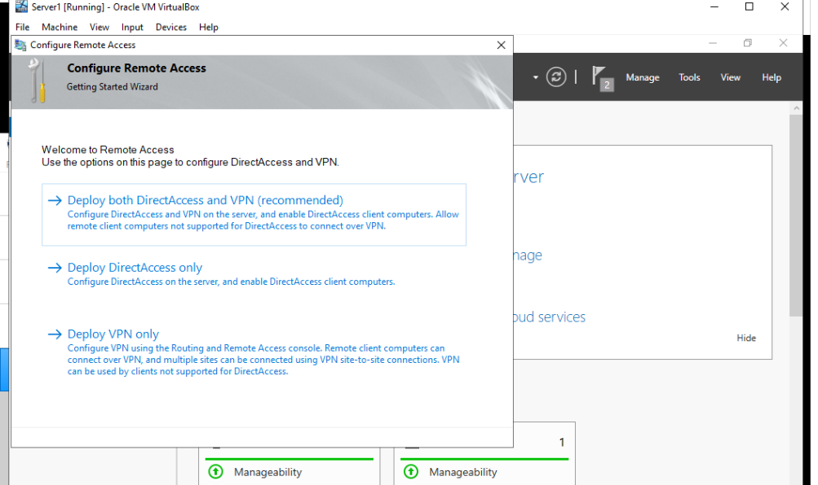
- Deploying VPN only.
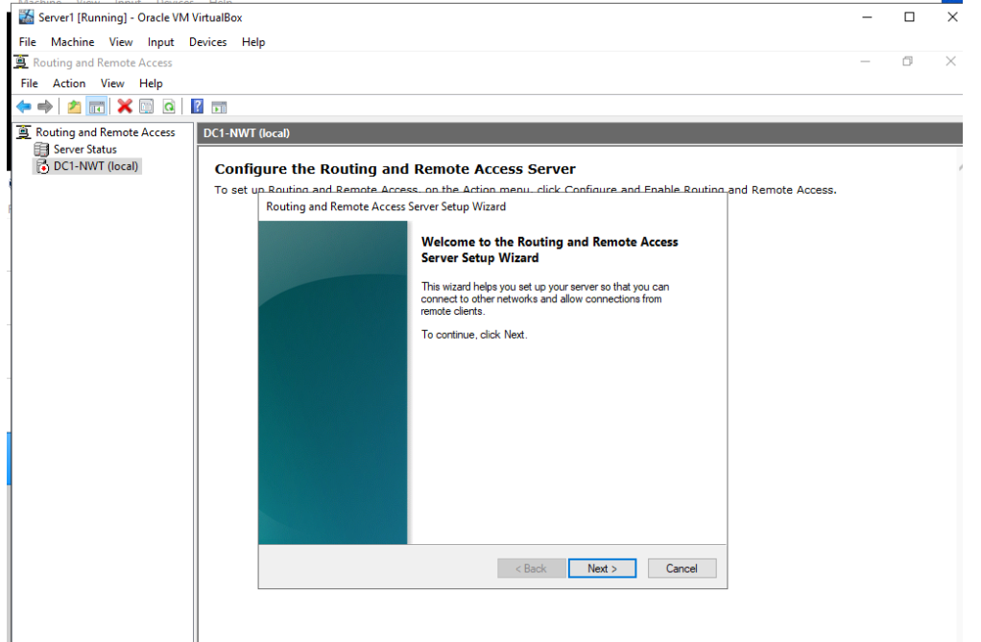
- Server setup wizard.
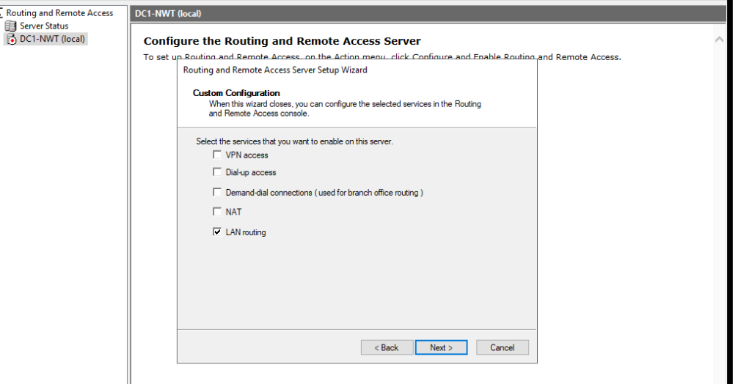
- LAN routing.
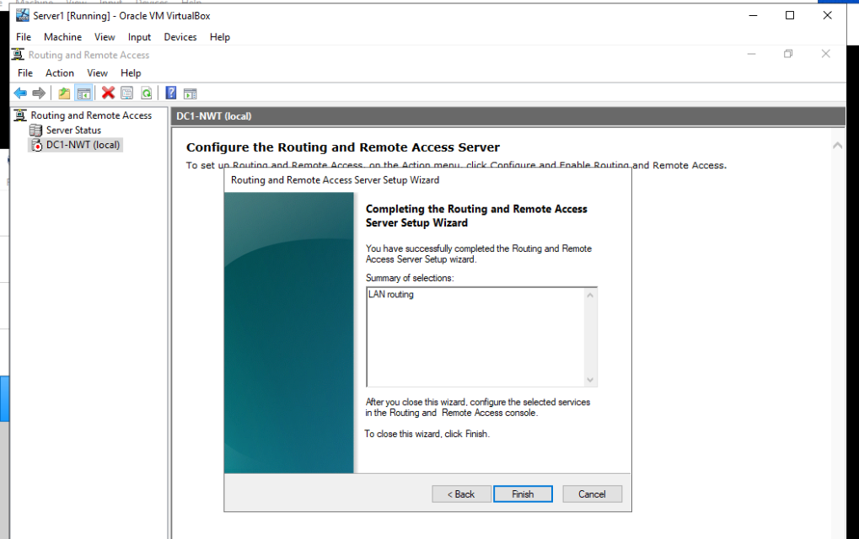
- Confirmation window.
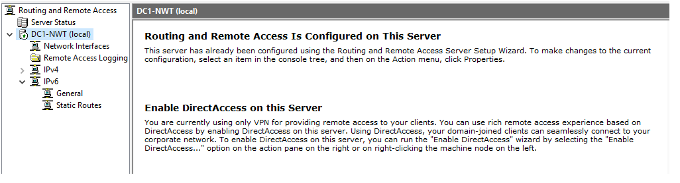
- Successfully deployed routing and remote access.

Following that, routing protocols on the network interfaces of these two networks must be implemented so that the systems in these networks can acquire knowledge about new networks. RIP version 2 for Internet Protocol must be added to the IPv4 configurations, as seen in Figures 31 and 32, and routing protocols must also be added to the network interfaces, as seen in Figure 33.
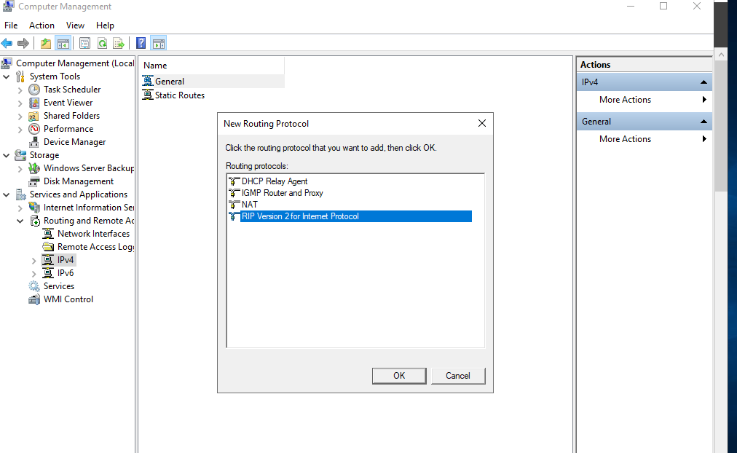
- Enabling RIP.
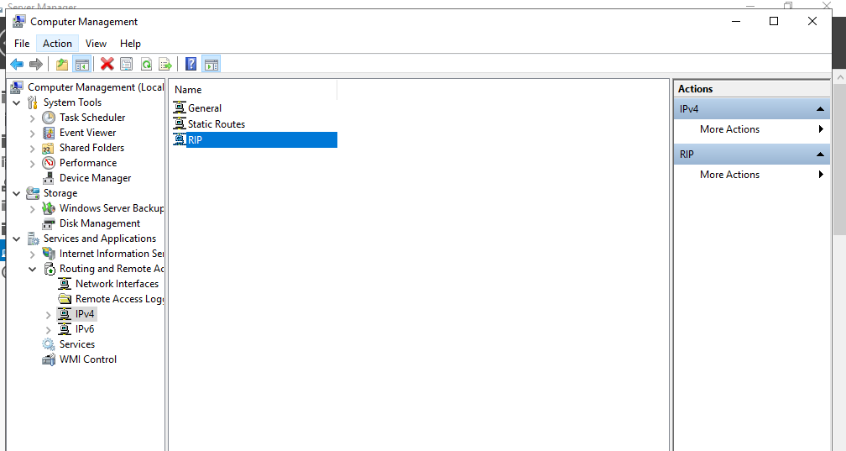
- RIP enabled correctly.
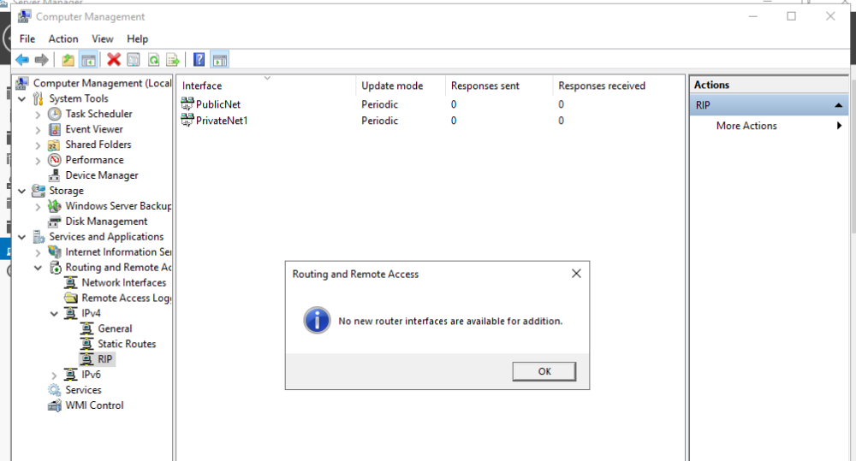
- Routing protocols added to the network interfaces.

To successfully accomplish this task, the steps depicted in Figures 21-33 must be implemented on another server. Figures 34-46 represent this implementation, and since these measures were previously outlined, there is no need to describe each picture in detail. However, illustrations are presented to demonstrate that this setup was also enforced on server 2.
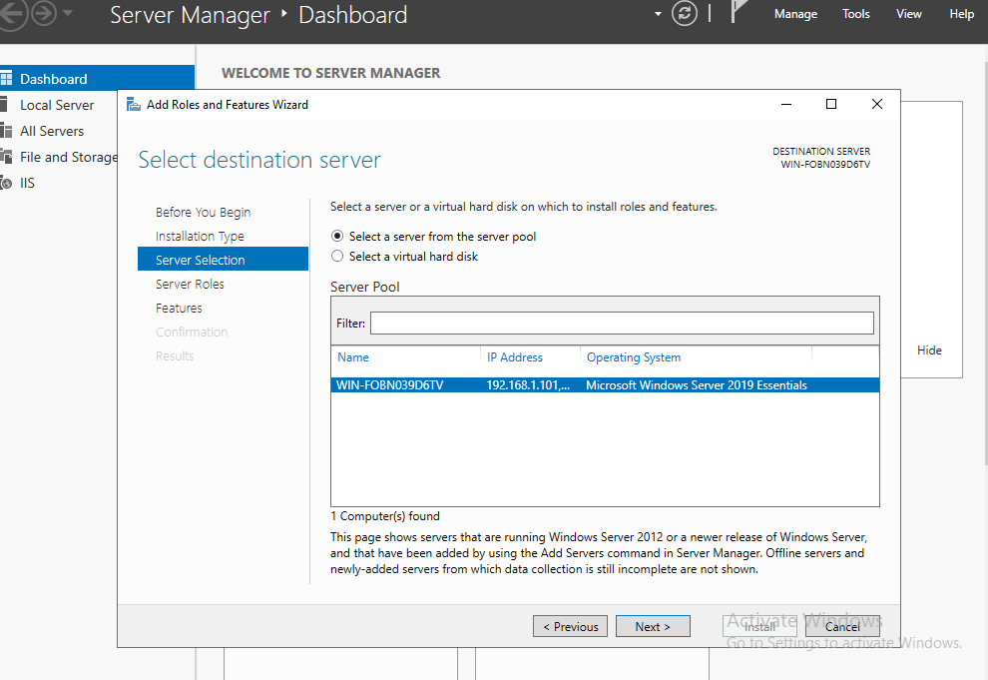
- Server selection.
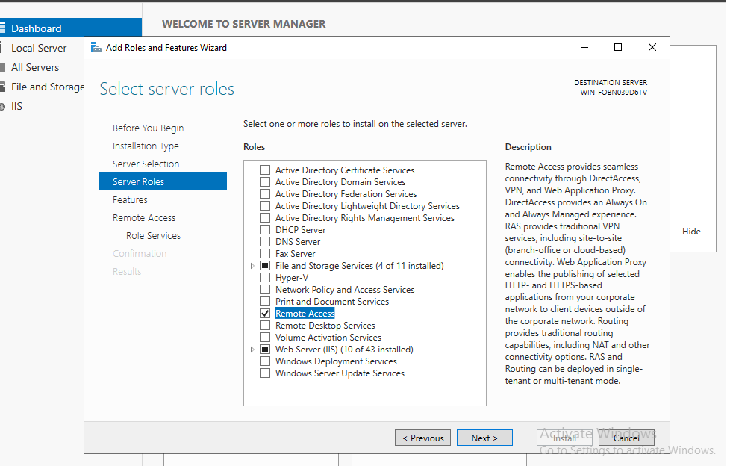
- Role selection.

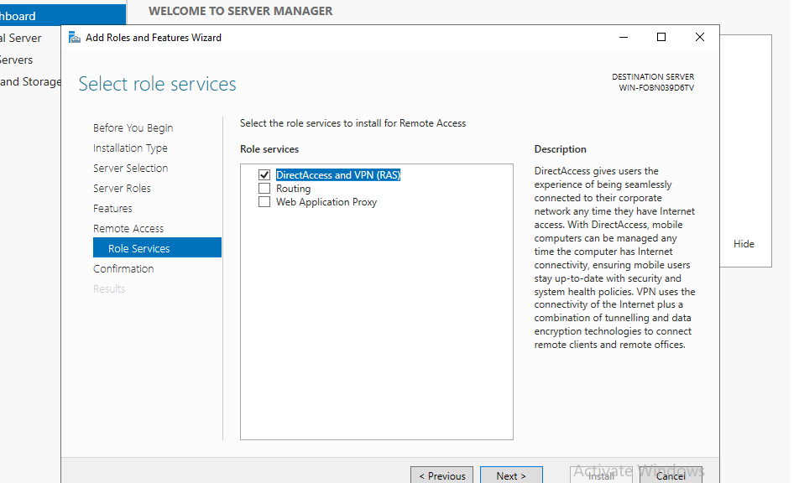
- RAS selection.
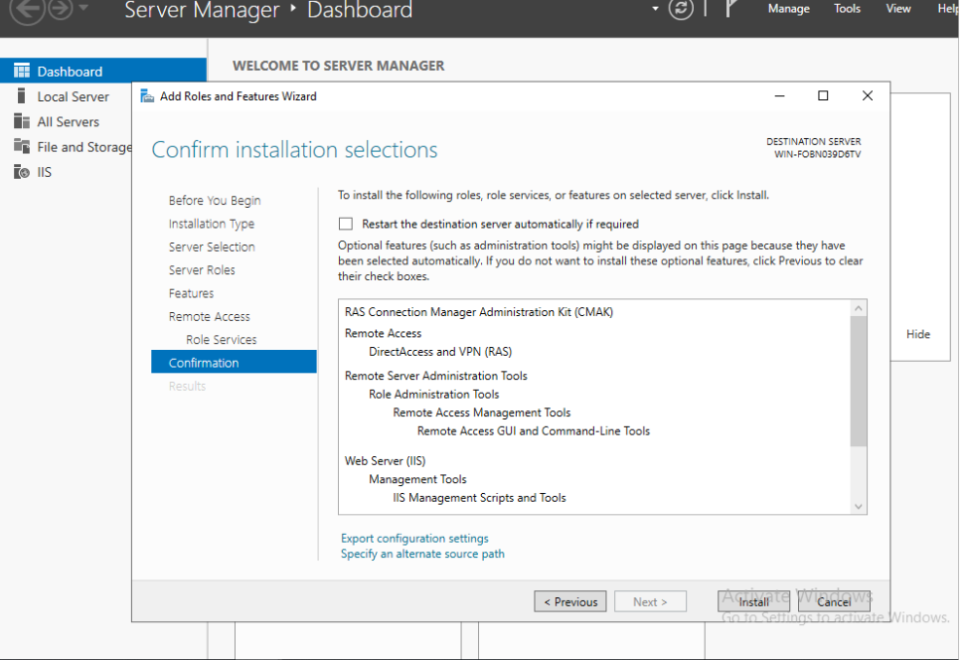
- Settings confirmation.

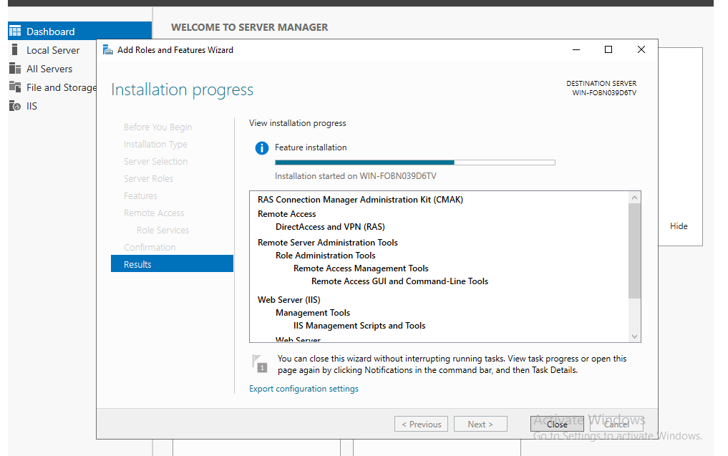
- Installation phase.
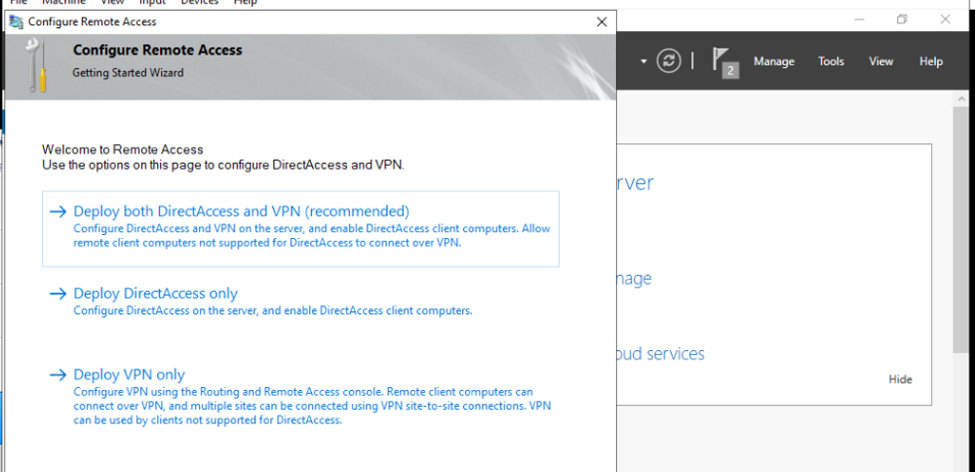
- Deploying VPN only.

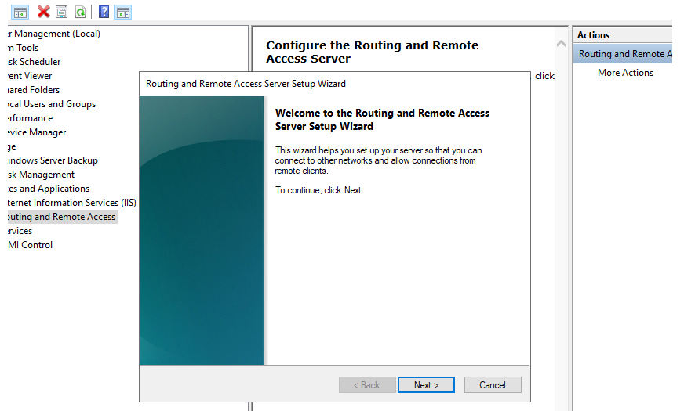
- Server setup wizard.
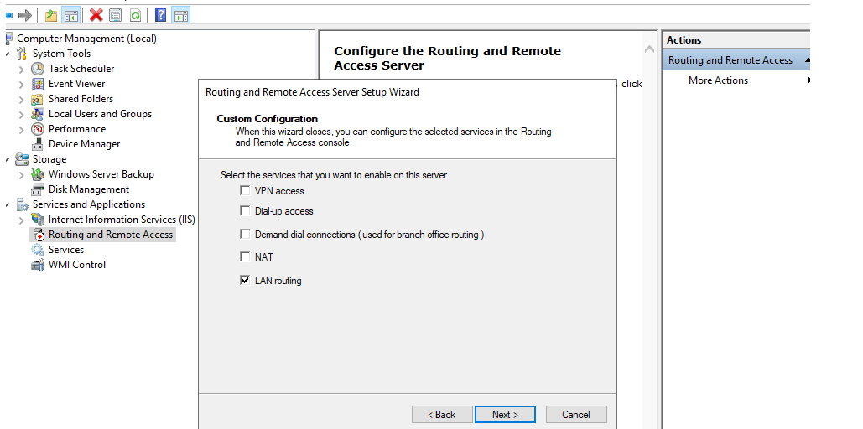
- Lan routing.
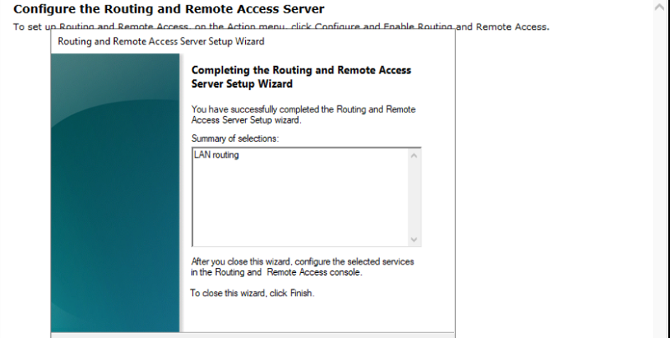
- Confirmation window.
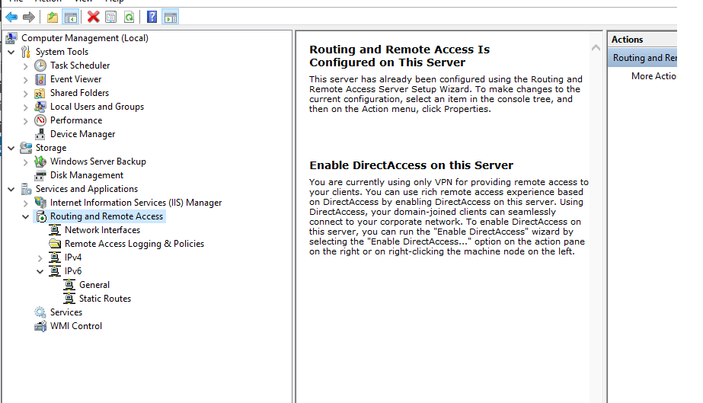
- Successfully deployed routing and remote access.

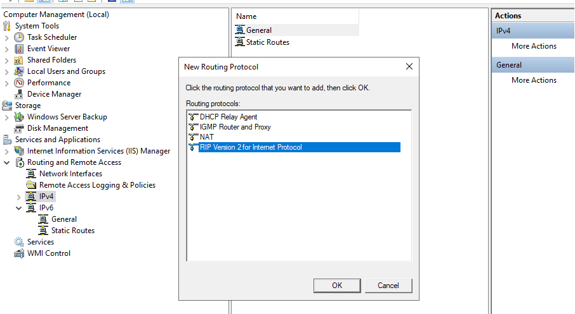
- Enabling RIP.
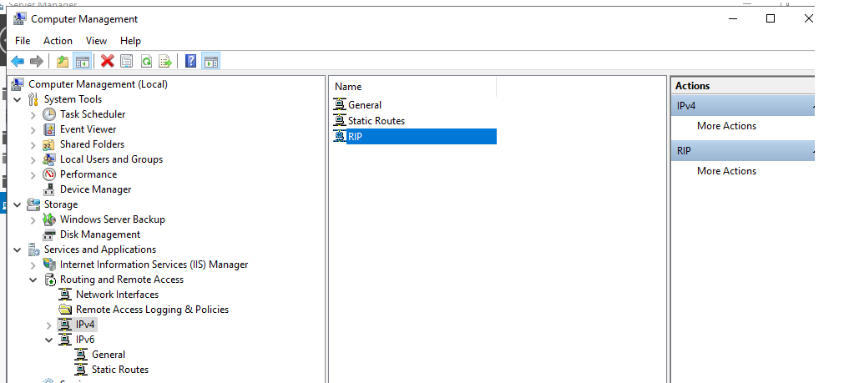
- RIP enabled correctly.

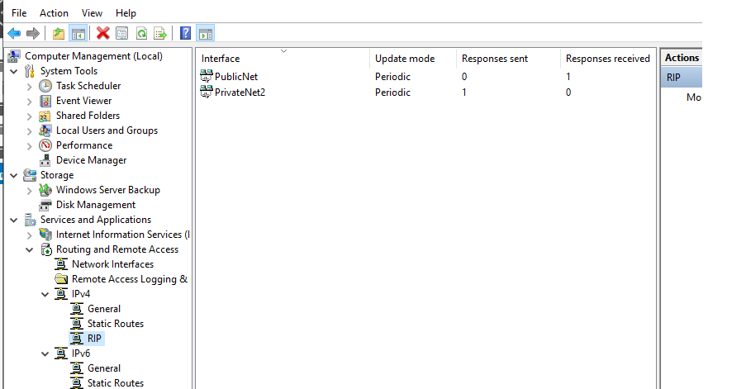
- Routing protocols added to the network interfaces.

To ensure that all configurations were correct, a successful ping attempt from Server 1 to Server 2 was made, as seen in Figure 47.
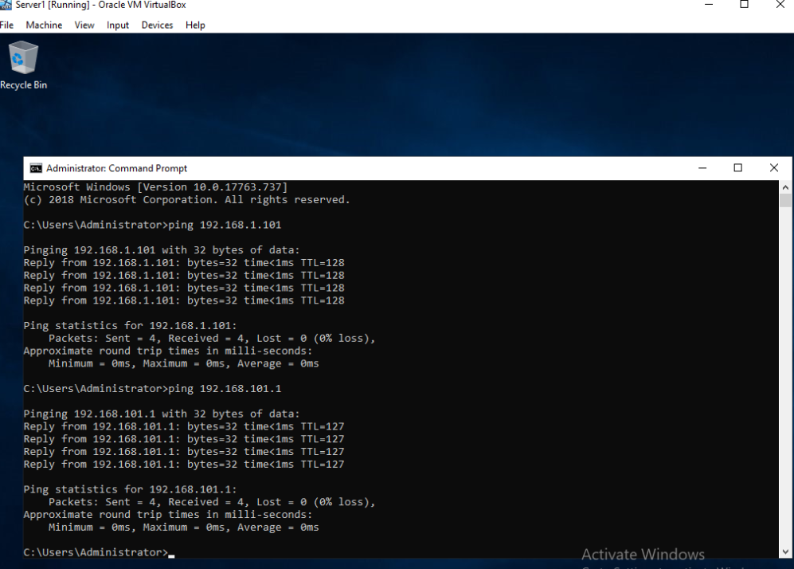
- Successful ping from Server 1 to Server 2.
To ping Client 2 from Client 1, the default gateway settings must be modified as shown in Figures 48 and 49. Following the completion of these configurations, a ping attempt can be made, and if everything is configured correctly, Client 2 will respond as seen in Figure 50.
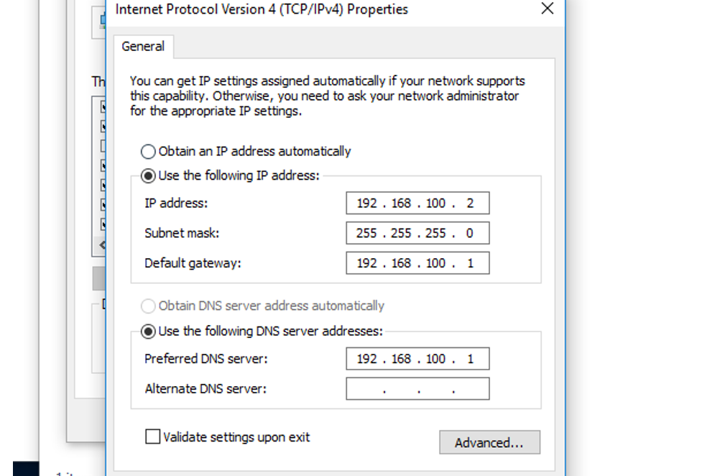
- Gateway settings for Client 1.
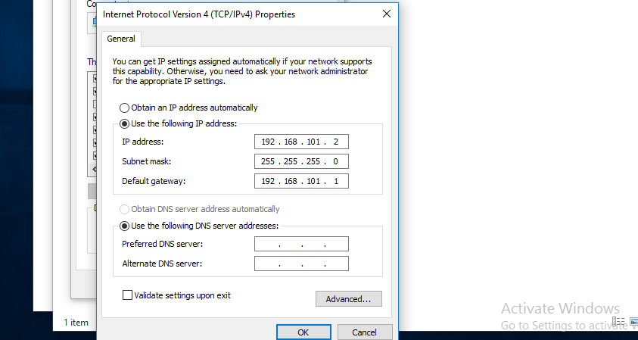
- Gateway settings for Client 2.
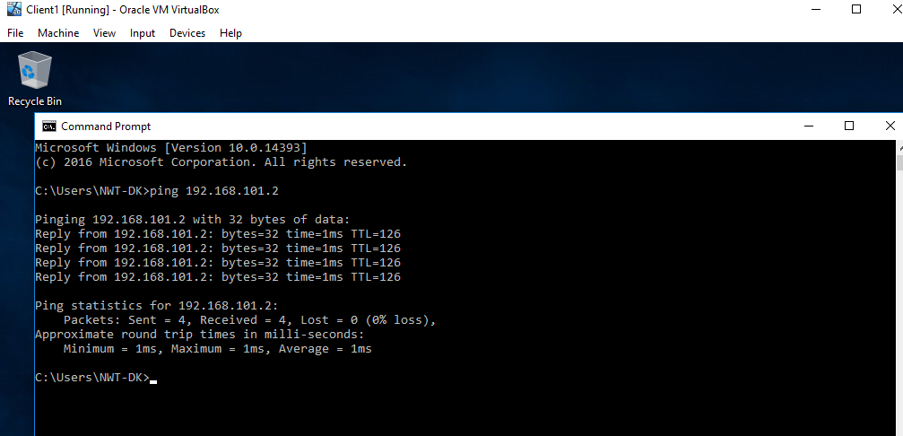
- Successful ping from Client 1 to Client 2.

Task 4: IP Packet Filtering
IP Packet filtering is Microsoft's standard firewall setup feature. It can limit incoming packets by combining source and destination ports and the protocols that these services utilize. inbound and outbound filters are principles used in packet filtering.
To demonstrate these filters, configurations were designed to prevent anyone in PrivateNet1 from pinging the router firewall service. Figures 51 and 52 illustrate this setup, while Figure 53 shows that Client 1 cannot ping the router firewall service but can ping other networks. This is because the filter that has been configured prevents Client 1 from pinging this particular IP address while allowing Client 1 to ping other networks.
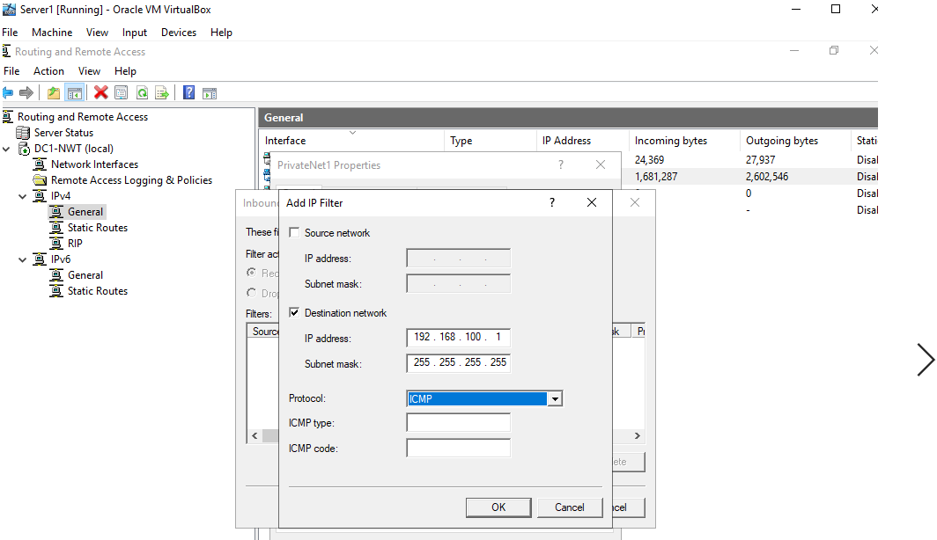
- Inbound filter settings.
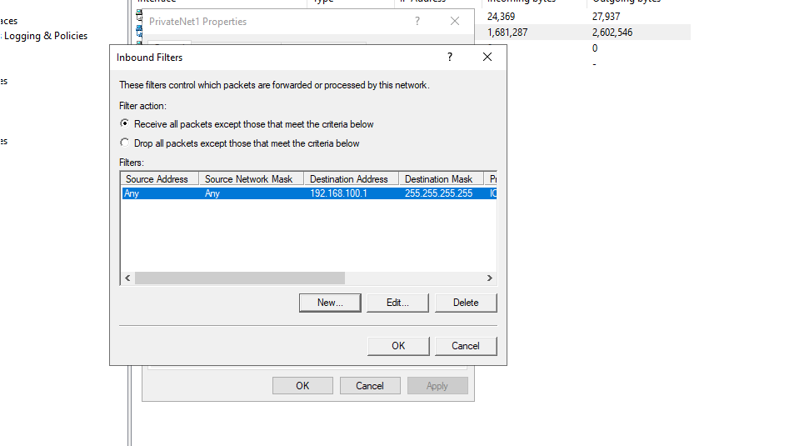
- Successful configuration of inbound filter settings.
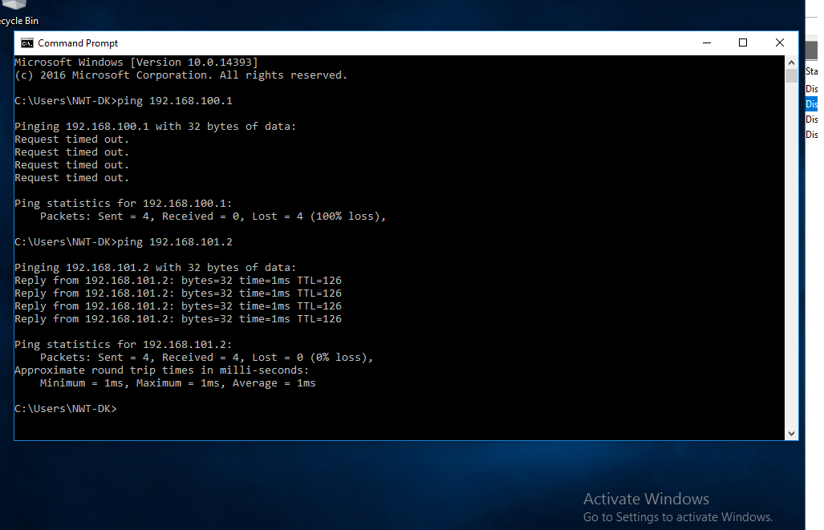
- Prevented ping command from Client 1 to the router firewall service, and successful ping to other networks.

In this section, another potential, somewhat unconventional way of using an outbound filter to prevent hosts on the PrivateNet1 from accessing the FTP service running on another network is illustrated. To prevent entry to the FTP server, the outbound filter on Server 1 was configured as seen in Figures 54 and 55. However, while attempting to connect to the FTP server, Client 1 was able to successfully establish this connection, indicating that this filter is not functioning properly, as shown in Figure 56.
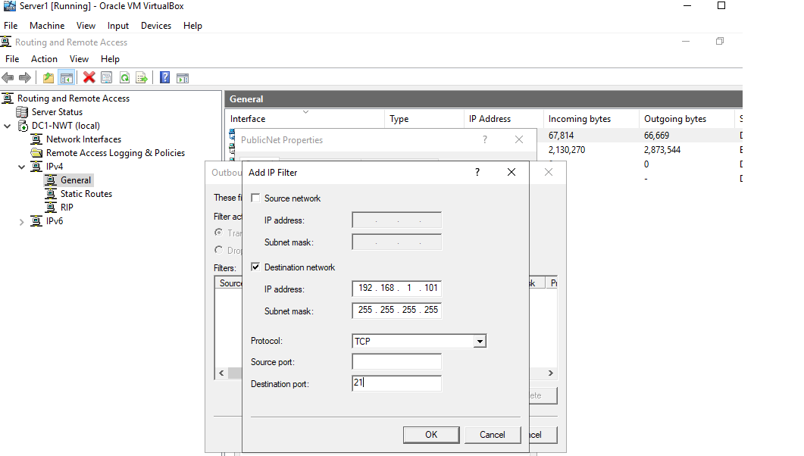
- Configuration of outbound filter settings.
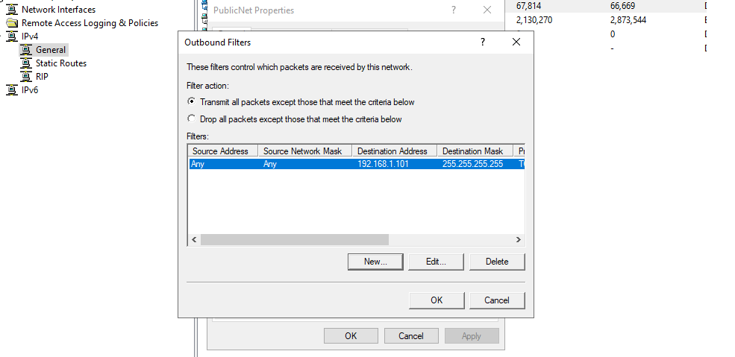
- Filter action enabled.

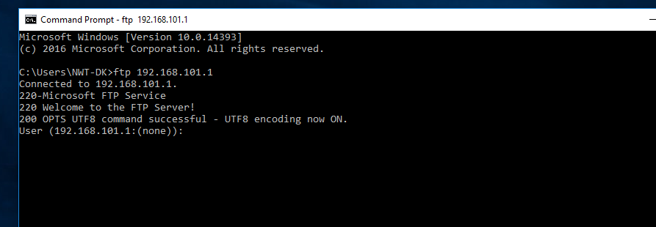
- Successful connection to the FTP server.

Since FTP can operate on two binding ports, a second filter with port 20 instead of 21 was implemented, as seen in Figures 57 and 58. However, while attempting to connect to the FTP server, Client 1 was able to successfully establish this connection, indicating that this filter is not functioning properly, as shown in Figure 59.
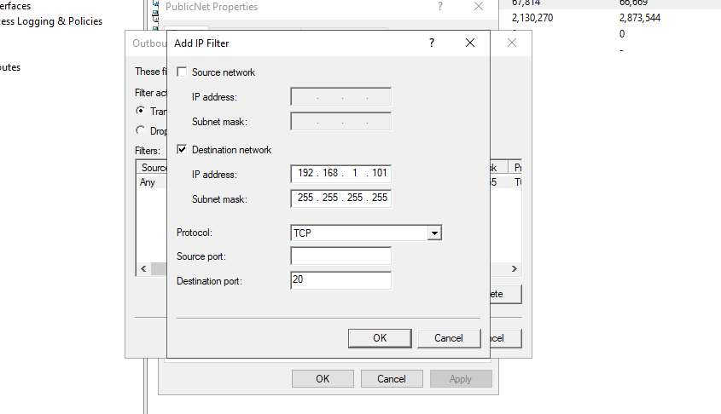
- Configuration of outbound filter settings.

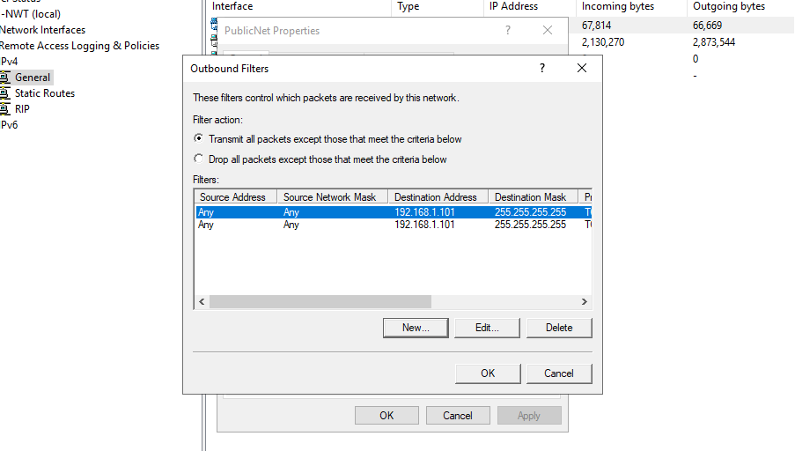
- Filter action enabled.
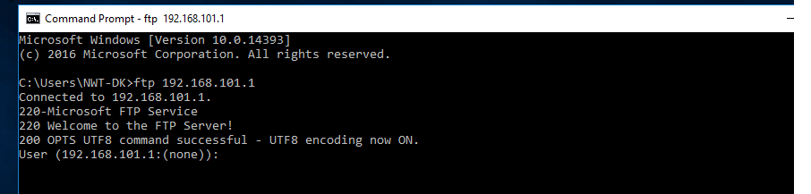
- Successful connection to the FTP server.

To accommodate this requirement, an inbound filter was implemented on Server 2, as seen in Figures 60 and 61. Furthermore, while attempting to connect to the FTP server, Client 1 was unable to establish a successful connection, indicating that this filter is working properly, as shown in Figure 59.
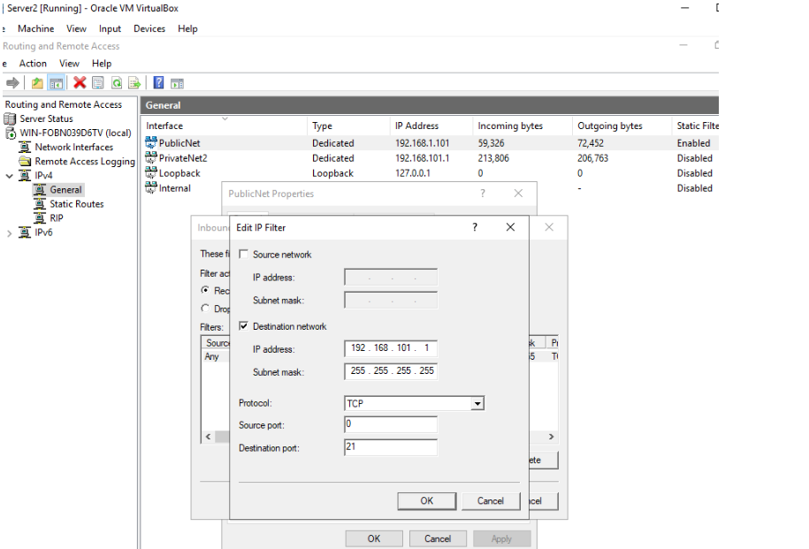
- Configuration of inbound filter settings.
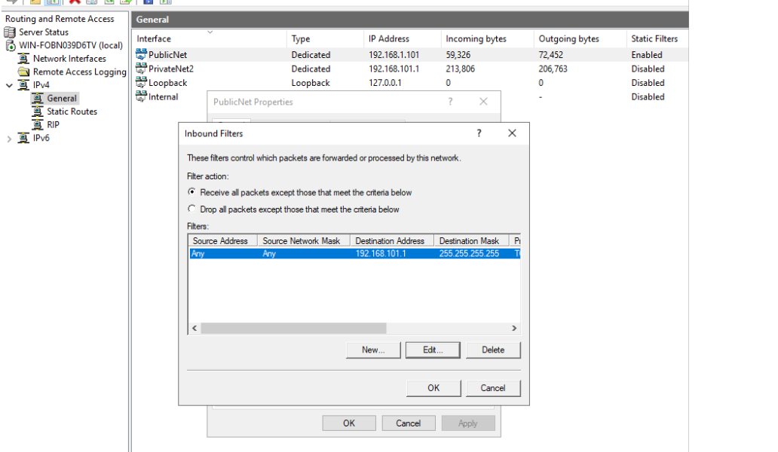
- Filter action enabled.
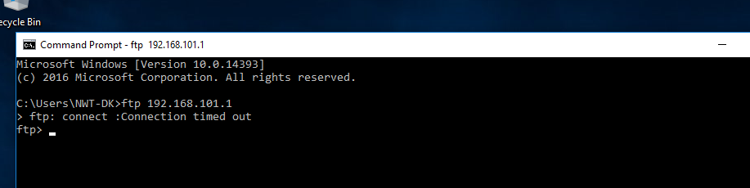
- Unsuccessful connection to the FTP server.

Filter 3 requires creating a specific rule to limit FTP access to everyone except 192.168.100.2 (Client 1). Figures 63-65 show this implementation, where the filter is configured for both ports 21 and 20. Connections from Client 1 and other network nodes were attempted to test this filter, as seen in Figures 66-68. It is worth noting that all users except Client 1 were unable to connect to the server, indicating that this filter is functioning properly. Due to some problems with the Virtual Machine environment, additional constraints were imposed on the FTP site, as seen in Figures 69-71, to ensure that only 192.168.100.2 (Client 1) has access to the FTP server. These constraints generated the same results as before, as seen in Figures 72-74. This rule grants access to a specific IP address while blocking access for all unspecified users. As a result, the FTP site can only be reached by the IP address specified below.
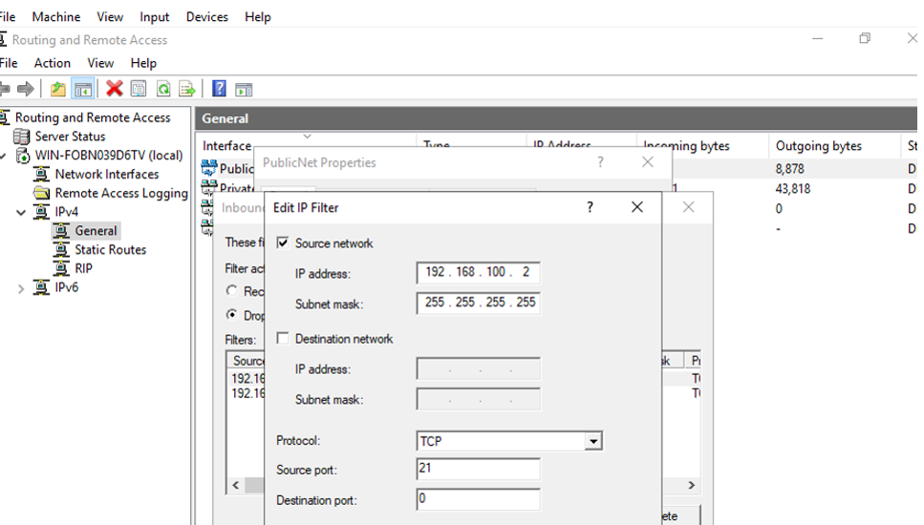
- Configuration of inbound filter settings.

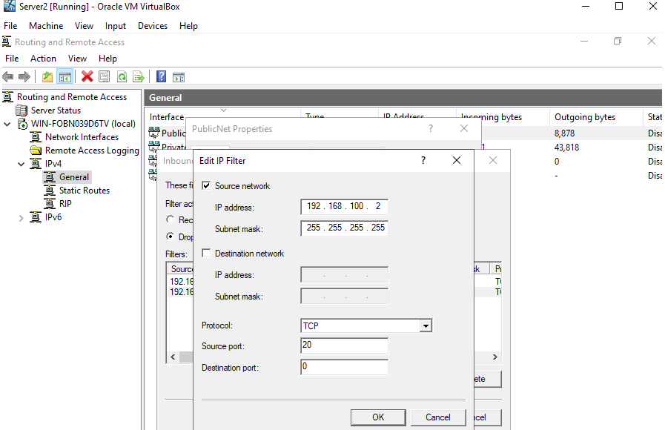
- Configuration of inbound filter settings.
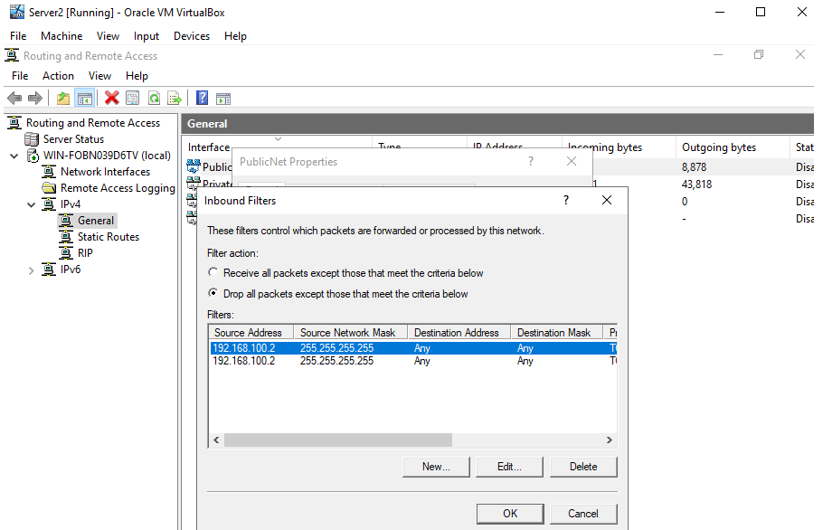
- Filter action enabled.

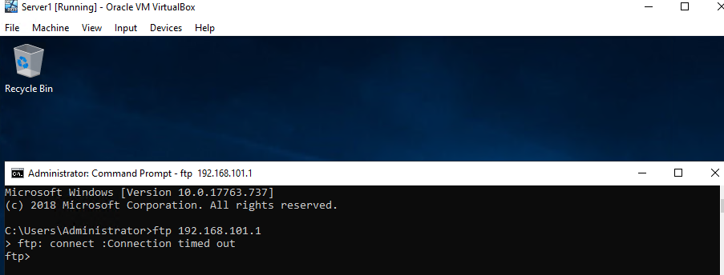
- Unsuccessful connection to the FTP server from Server 1.
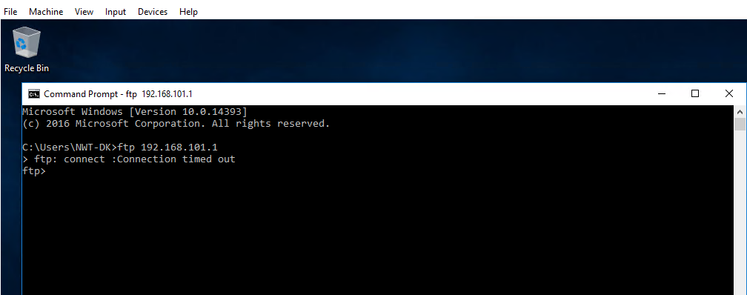
- Unsuccessful connection to the FTP server from Client 2.
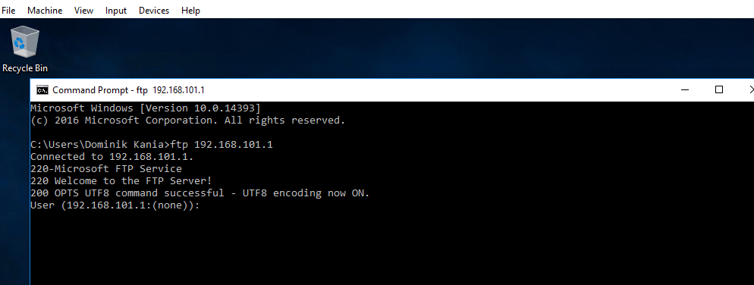
- Successful connection to the FTP server from Client 1.

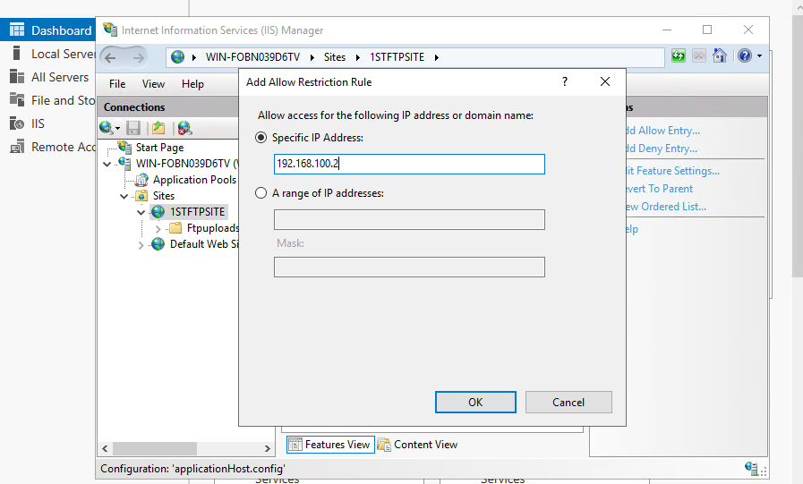
- Restriction rule settings.
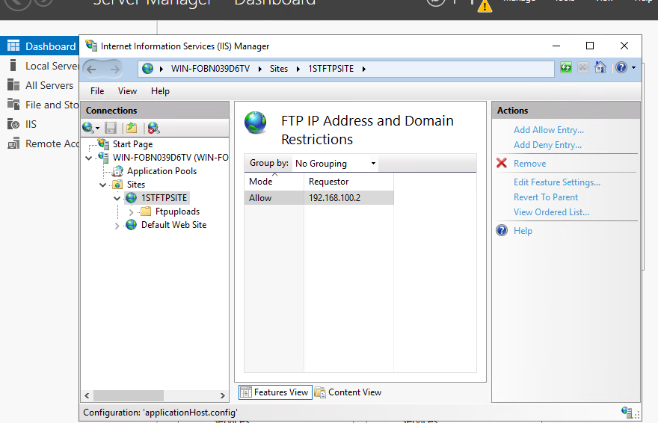
- Restriction rule enabled.

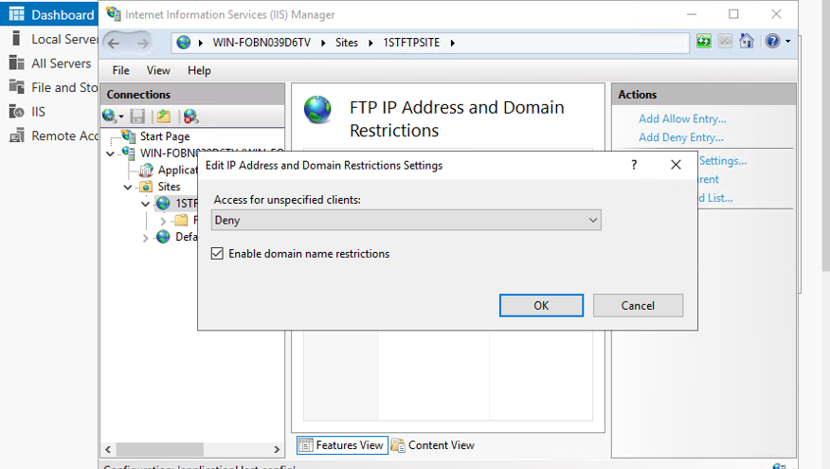
- Access for unspecified clients denied.
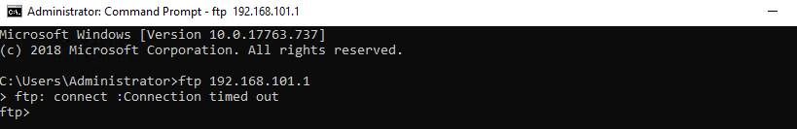
- Unsuccessful connection to the FTP server from Server 1.
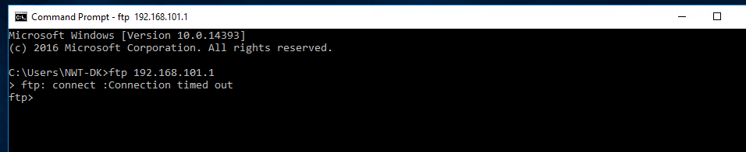
- Unsuccessful connection to the FTP server from Client 2.
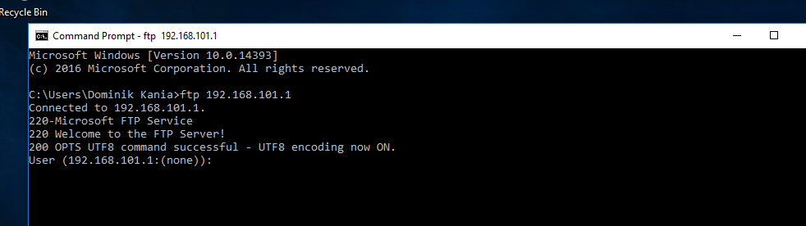
- Successful connection to the FTP server from Client 1.

Worksheet 4 – Observational Tasks

Task 3: Router Operation
A router shares details with other routers in order to make routing choices. Conversely, the router may be programmed manually to connect to a given network. A router's routing table contains relevant data on the following topics:
- Routes that are directly connected – These routes originate from the active router interfaces. When an interface is equipped with an IP address and enabled, routers attach a directly connected route.
- Remote routes – Networks that are linked to other routers. Routes to these networks may be statically defined or acquired dynamically using dynamic routing protocols.
A routing table is a RAM-based data structure that contains route details for both locally attached and remotely linked networks. Network or next-hop connections are stored in the routing table. These connections inform a router that the only way to reach a certain endpoint is to deliver the packets to the router that constitutes the next hop on the path to the specific location. The outgoing or exit interface to the next location may also be the next-hop connection [1] [2].
Routers provide Internet access to machines and other equipment. A router serves as a controller, selecting the most efficient path for data to travel. It links all enterprises to the rest of the planet, defends data from security attacks, and can also choose some devices over others. Routers determine the shortest data route between linked machines on a network and transfer data through that route. Routers do this by using a "metric value", also known as a preference number. If a router has two options to the same destination, it will take the one with the lowest metric value. Furthermore, the metric values are stored in a routing table, which aids the router in determining which direction it should follow [1] [2].

Task 5: Failover Clustering
A failover cluster is a group of computer servers that collaborate to deliver high availability or continuous availability environment. When one of the machines stops working, another device in the network will take over its workload with little to no interruption using a mechanism known as failover. Such failover clusters may utilize physical computers, while others use virtual machines. A failover cluster's primary goal is to incorporate high availability or continuous availability environment for software and services. Continuous availability clusters, also known as fault tolerant clusters, enable end users to continue using applications and services even though one or more servers start to malfunction. Users, on the other hand, can experience a temporary outage as a result of high availability clusters, but the device will immediately rebound with no information loss and minimal disruption. A cluster is made up of two or more devices that send data and applications over physical infrastructure or a dedicated secure channel. Certain types of clustering technology may accommodate load balancing, storage, and simultaneous or parallel processing. In certain cases, failover clusters are combined with external clustering technologies [3] [4].
This section demonstrates how to use the Failover Cluster Manager snap-in to construct a failover cluster. The subject describes a standard implementation in which computing objects for the cluster and their related clustered roles are generated in Active Directory Domain Services. To begin, any server that will be added as a failover cluster node must have the Failover Clustering function installed, as seen in Figures 75 and 76. It is a safe practice to evaluate configuration in the Failover Cluster Manager Console after installing the Failover Clustering feature, as seen in Figure 77. Following that, as seen in Figure 78, a server must be specified, which will be added as a cluster node. Finally, as seen in Figure 79, the testing phase will begin, and a report with all results will be produced. Failover Cluster Manager can now be used to build a Cluster on each node. When attempting to deploy the Failover Clustering role, the following factors must be taken into account [3] [4]:
- Every server that needs to be added as a cluster node must be running the same Windows Server version.
- Hardware demands must be checked to ensure that all setups are compatible.
- In order to add storage during cluster creation, all servers must be able to access it.
- All servers incorporated as cluster nodes must be members of the same Active Directory domain.
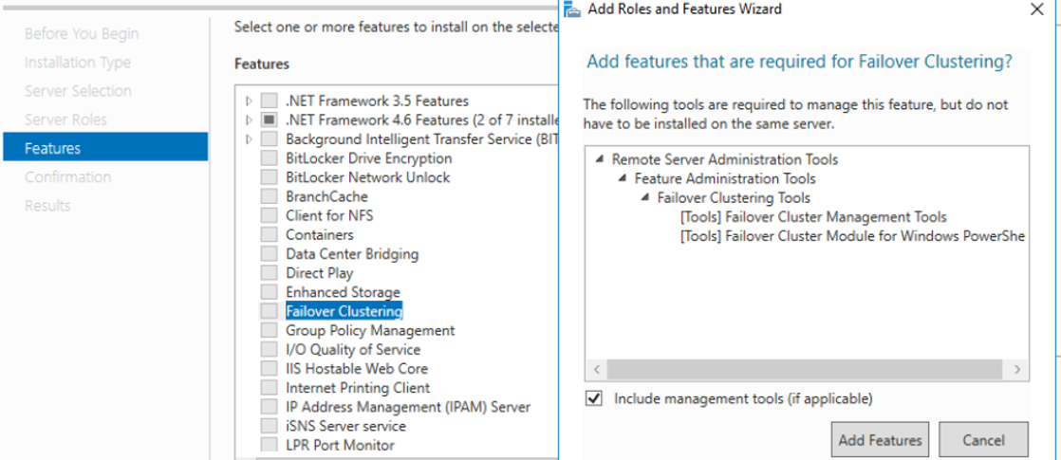
- Failover Clustering function selection.
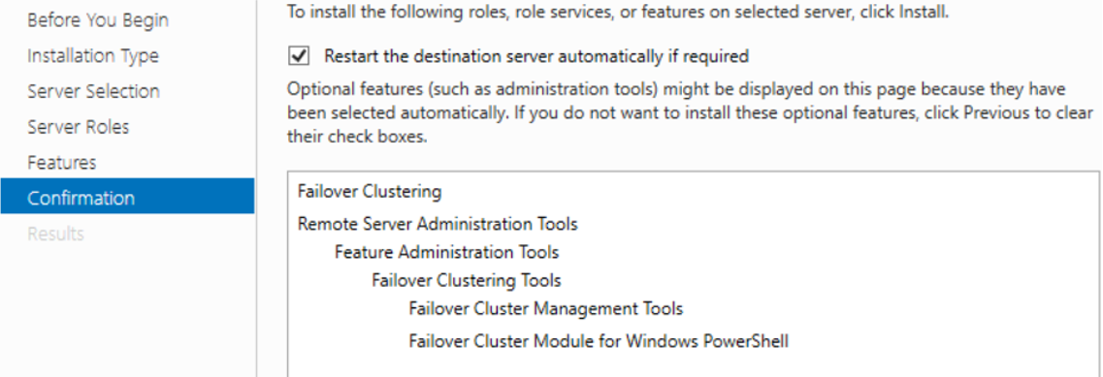
- Failover Clustering function installation.
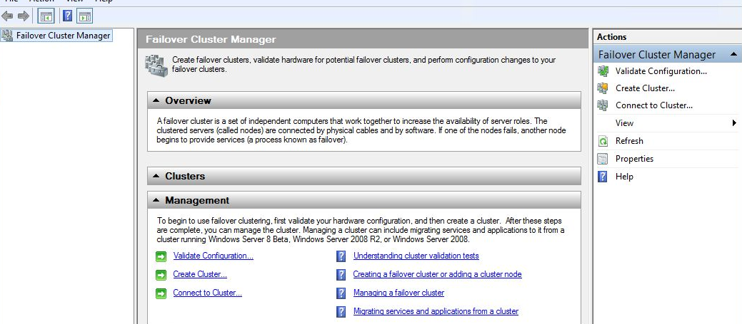
- Failover Cluster Manager Console.
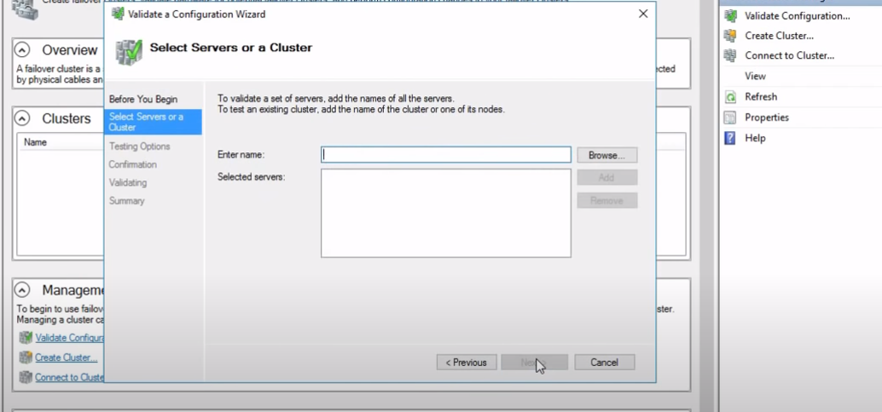
- Server selection.
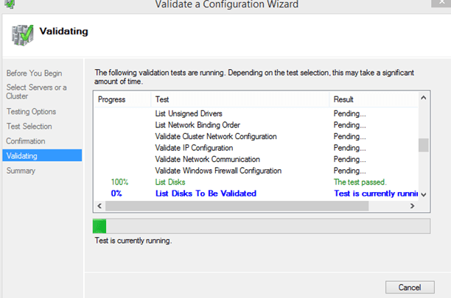
- Validating process.

High Availability Failover Clusters
A high-availability cluster is a set of individual nodes that distribute information and resources across the whole infrastructure. Shared storage is available to all machines in this failover cluster. Machines in high-availability clusters may also verify the health or performance of the other nodes through a monitoring link. Besides that, a cluster has at least one active device and at least one inactive device at all times. In a basic two-device setup, for example, if one machine fails, the second machine recognises the malfunction and automatically configures itself as the active machine via the monitoring link. Users connect to an active device using a clustering application, which is configured on each device in the cluster [5] [6].
Significantly bigger clusters may necessitate the use of specialized machines for cluster administration. A cluster control system constantly sends out electronic signals to identify whether either of the machines is experiencing difficulties and, if so, which machine should take over the workload. Through merging the computers and the physical servers they operate on into a cluster; several cluster administration technologies can achieve high availability for virtual machines. If one of the nodes crashes, the virtual machines on that node are relaunched on another node. Shared infrastructure poses a significant threat as a potential single point of failure. Using RAID 6 and RAID 10 simultaneously, on the other hand, would merely ensure the service continues even though two hard drives malfunction. If all nodes are wired to the same power source, the electrical power link may also become a single point of failure. For each node, a unique uninterruptible power source that offers emergency power to a load when the main source of electricity or input power source fails may be used to secure it [7] [6].

Continuous Availability Failover Clusters
A continuous availability failover cluster, in comparison to a high availability design, constitutes of several systems that adopt a common copy of a computer's operating system. Thus, the application instructions of one machine are also implemented on the other machines. Continuous availability cluster mandates that the company use formatted technology infrastructure as well as a backup UPS. The operating system in a continuous availability failover cluster has a controller from which a software engineer can verify vital data at predetermined stages of an operation. The failure point can be automatically discovered, and a contingency feature or mechanism can be implemented without causing performance degradation. Continuous availability failover cluster can only be accomplished by operating the service on a constantly accessible and virtually identical replica of a physical or virtual machine. Several other continuous availability failover configurations are possible with clustering technologies, which can combine multiple nodes to function as a single virtual node. A cluster, for example, can be designed such that if one of the virtual nodes crashes, the others react by effectively suspending the virtual node from the cluster. The workload is then immediately redistributed among the available nodes before the affected node can be brought back up to speed [8] [9].
A hardware server with duplicated physical parts is an alternative to continuous availability failover clusters. These servers execute operations separately and concurrently on specific hardware modules. In these hardware configurations, the outputs from both physical servers are controlled by a complex mechanism that handles synchronisation. Although this approach offers protection, it can be more costly than other solutions. According to Stratus, a manufacturer of these sophisticated fault-prone hardware systems, annual unit failure would be less than 32 seconds. That being said, the price of one Stratus system with two central processing units for each coordinated component is expected to be about $160,000 per configured machine [9].

Concepts Pertaining to the Failover Clustering
Load balancing, recovery, and redundancy are all common uses for high availability and continuous availability clusters. To be configured successfully, the hosts in these clusters must all be connected to the same common infrastructure. This enables Virtual Machines on a specific system to failover to another system without disruption in the event of a malfunction. When contemplating the use of such a system, there are a few critical concepts that must be carefully considered, which are as follows [9]:
- Environment: If all of the servers are in the same physical location, a natural disaster like a hurricane or tsunami may completely destroy the whole infrastructure. Having multiple servers in various data centres and geographical regions enhances dependability.
- Hardware and software: Power cuts and equipment malfunctions, including certain storage devices and network connections, should be expected by systems. The entire computing infrastructure, including operating systems and programmes, must be equipped to handle catastrophic failures, which could necessitate a system overhaul.
- Data and network: Security vulnerabilities and instability can be influenced by a variety of causes, including hard drive failures. In the case of a malfunction, highly accessible applications must provide for information security. Unplanned system disruptions are another potential vulnerability factor for highly accessible networks. As a consequence, it is critical to have a robust network solution in operation in the event of emergencies.

Task 6: Network Structure

DTK’s Network Policy
The main objective of this policy is to provide an overview of DTK’s security protocols. All workers employed by DTK must follow the guidelines outlined here. This policy would not be deviated from in any circumstances. Any individual who is deemed to be in violation of this agreement will have their employment dismissed and their access terminated permanently.

- Network Access:
  - User Identification and Passwords:
    - Each user is assigned with a unique set of login credentials. Logon passwords must not be noted down or revealed to another person. The owner of a certain account will be held accountable for any activities taken under that account.
    - When transferring to a different position or place inside DTK, employees must alert the IT Service Desk. This guarantees that the correct configurations for providing immediate access to some of the most relevant mail and file servers can be implemented.
    - Administration must alert the IT Service Desk of any personnel changes that could have an impact on the security and stability of the company network. A person that has access to controlled sensitive customer data but is transferred to another position where this access is no longer necessary is an example of this.
    - All authorized users have the corresponding password configurations:
      - Passwords must be at least 8 characters long.
      - Passwords must contain at least one uppercase letter (e.g., A, B, C).
      - Passwords must contain at least one lowercase letter (e.g., a, b, c).
      - Passwords must contain at least one integer digit (e.g., 1, 2, 3).
      - Passwords must contain at least one special character (e.g., !, ?, @").
      - Passwords must not contain any simple pattern (e.g., cat, 123, cat123").
      - Passwords must be changed every 30 days.
      - Passwords must not be reused.
      - Accounts are locked after three failed authentication attempts.
  - Access to DTK information:
    - Any information stored on the networks, including correspondence, data files, and repositories, are the property of DTK, and employees should have no right to privacy about this content.
    - While tracking correspondence, data files, repositories, and other activities is not a standard practice performed by DTK, the company reserves the right to do so for the safety of its employees, user experience, compliance, reporting, privacy, security, or investigative purposes, as well as to shield itself from possible corporate liability.
    - Queries to use the system account of a member of the staff who is away from the workplace must be addressed in person to the IT Service Desk by the appropriate administrator. Access is allowed by updating the login credentials and granting the appropriate administrator or an employee direct access to the account. If this access is given, it must be used solely for research purposes.
    - Employees must not disclose any details to third-party companies unless specifically authorised to do so.
    - Employees must only have access to digital data and information that they need to conduct their tasks.
    - If sensitive data is compromised, whether as a result of the loss of a personal computer, digital files, or other security violation, the IT Service Desk must be alerted as soon as possible.
    - All machines must be turned off at the end of each day. This activity removes any remaining data from the system memory and aids in the overnight antivirus security upgrades.
  - Personal use of computer systems:
    - Although DTK devices are made available for company purposes, they can be used for personal reasons on a restricted basis. This restricted personal use of devices is permissible as long as it does not conflict with the individual's work obligations or have a detrimental impact on the device's or network's efficiency.
    - Employees must not use DTK programmes or devices for commercial purposes unrelated to the business of DTK.
  - Device security:
    - General security:
      - Devices must not be left unsupervised for extended periods of time when signed on, such as during meal or coffee breaks. When users are leaving their computers, they must either log off or use a password-protected lock screen. The lock screen should be configured to activate automatically after 5 minutes of inactivity.
      - Devices must not be relocated from DTK facilities until written permission from the IT department is obtained. Registered off-site backups are exempt, as long as they are properly secured from unauthorised access. Before leaving the DTK grounds, all devices must be signed for.
    - Software security:
      - Without the explicit authorization of the IT Department, information must not be copied, deleted, or distributed to any third-party companies or non-organizational devices, such as personal computers.
      - Only applications approved by the IT Department can be used on devices linked to the DTK infrastructure.
      - Without explicit authorization from the IT Department, downloading any executable files or applications from the Internet is prohibited. This permit can be granted to employees depending on their particular work specifications.
    - Data security:
      - When not in use, sensitive information contained on electronic media must be kept safe and secure.
      - Devices destined for destruction must have their hard drives securely erased by a relevant person before being shipped outside of DTK.
- Data backups:
  - The IT Department must perform routine online and offline backups on all company servers:
    - Online backups:
      - An online backup must be performed every day and made accessible for restoration within two hours.
      - Online backups must be accessible only to server managers and used for system repairs. The copies must never be wiped from the system or removed from the premises.
    - Offline backups:
      - Periodic offline backups must be performed weekly and monthly. These copies must be transferred to an off-site storage centre and recoverable within 24 hours in the case of a major disaster.
      - DTK has an agreement with MG Storage Solutions for offline data backup management. MG Storage Solutions is liable for storing data in accordance with the same or stricter data and security protocols as DTK.
      - Confidential information must never be transferred from the DTK premises for any purpose other than off-site backup storage.
  - Documents and programmes must always be stored on the network rather than the local hard drive. This ensures that copies are created every day and are accessible for retrieval. Individuals should be informed that the IT Department does not back up data stored on local hard drives.
- User authentication and passwords:
  - Following an initial duration of disablement, all inactive accounts must be erased. Management teams must notify the IT Department as employees depart DTK and guarantee that their accounts are deleted as soon as possible.
  - Following notice to the IT Department by the individual changing site, employees switching positions within DTK must have their access rights checked and changed depending on their current roles.
  - Usernames must adhere to the DTK naming convention. The convention must be followed uniformly across all sites and devices.
  - When the IT Department is uncertain of the identity of the person demanding a password update, permission from the appropriate manager must be obtained before the query can be processed.
  - When installing hardware and applications, the vendor-supplied login credentials must be modified. This is relevant for both test and live situations.
- Third-party access:
  - Third-party access is described as providing someone who is not a DTK employee access to DTK IT services or data.
  - Third-party examples include:
    - Software distributor who is providing professional assistance.
    - Consultant and contractor.
    - Service provider.
    - A person who provides DTK with outsourced resources that necessitate access to applications or records.
  - Third-party access can be granted only after a confidentiality clause, which must be included in the written agreement with DTK, has been signed. Employees of DTK must never allow someone else to use their login credentials to enter the DTK network.
  - Additional provisions for granting third-party access include:
    - The risk assessment procedure.
    - Approval from the IT Department.
    - Approval from the data holder.
    - Third-party access must be granted only to premises and information that are needed to execute unique agreed-upon activities defined by DTK.
    - Third-party access must be periodically investigated twice a year for compliance breaches, unauthorised use, and need analysis.
- Employee background checks:
  - In combination with conventional human resource screening protocols, all employees will be subjected to a criminal background check conducted by a third-party agency.
- Access to the data centre:
  - Physical access to data centre servers must be limited to IT management only.
  - Visitors are strictly prohibited, with no exceptions.
  - IT administrators must supply security personnel with an up-to-date data centre access list.
- Data handling:
  - Customer data must be stored in the data centre at all times.
  - Private information copied onto DTK support and administrative employee's devices must be erased from local computers within 24 hours. When data is stored for an extended period of time, administrators must be made aware of this and an explanation must be given.
  - Confidential information must never be downloaded onto the unauthorised computers of workers or contractors.

Network Design
A star topology was chosen for this network design, which is a topology in which every device in the system is directly attached to one central switch. Every computer in the network is linked to the switch directly and indirectly to every other device. The main system hub is classified as a server, and other computers are considered as clients. The root server is in charge of coordinating data transfers across the entire infrastructure and serves as a repeater. Star topologies are the most widely encountered since they allow users to access the whole network from a single point: the central switch. As a result, if a device other than the root server fails, the network will remain operational. This adds a degree of security to star topologies from deficiencies that are not necessarily found in other topology configurations. Similarly, they can connect new machines without shutting down the network, which is usually necessary for a ring topology. When it comes to physical network structure, star topologies necessitate fewer cables than other forms of topologies. As a consequence, they are easy to configure and maintain in the long run. When technicians encounter network technical problems, the general functionality of the network architecture makes troubleshooting relatively easy [10] [11].
When the network stops working, everything comes to a halt. While for others, a few minutes of downtime is not critical, for some, like those that own online companies, a few minutes of downtime means lost revenue. As a consequence, the proposed physical and logical network topologies were constructed with users in mind. They are designed with an extended star topology and complete redundancy at the core and aggregation levels to have full network redundancy and fault tolerance. A fault tolerant architecture allows a network to remain operational even though a component fails. Using several links and paths across the network improves efficiency, increases throughput, and reduces network latency. The illustrations below depict proposed network topology designs for the DTK company.
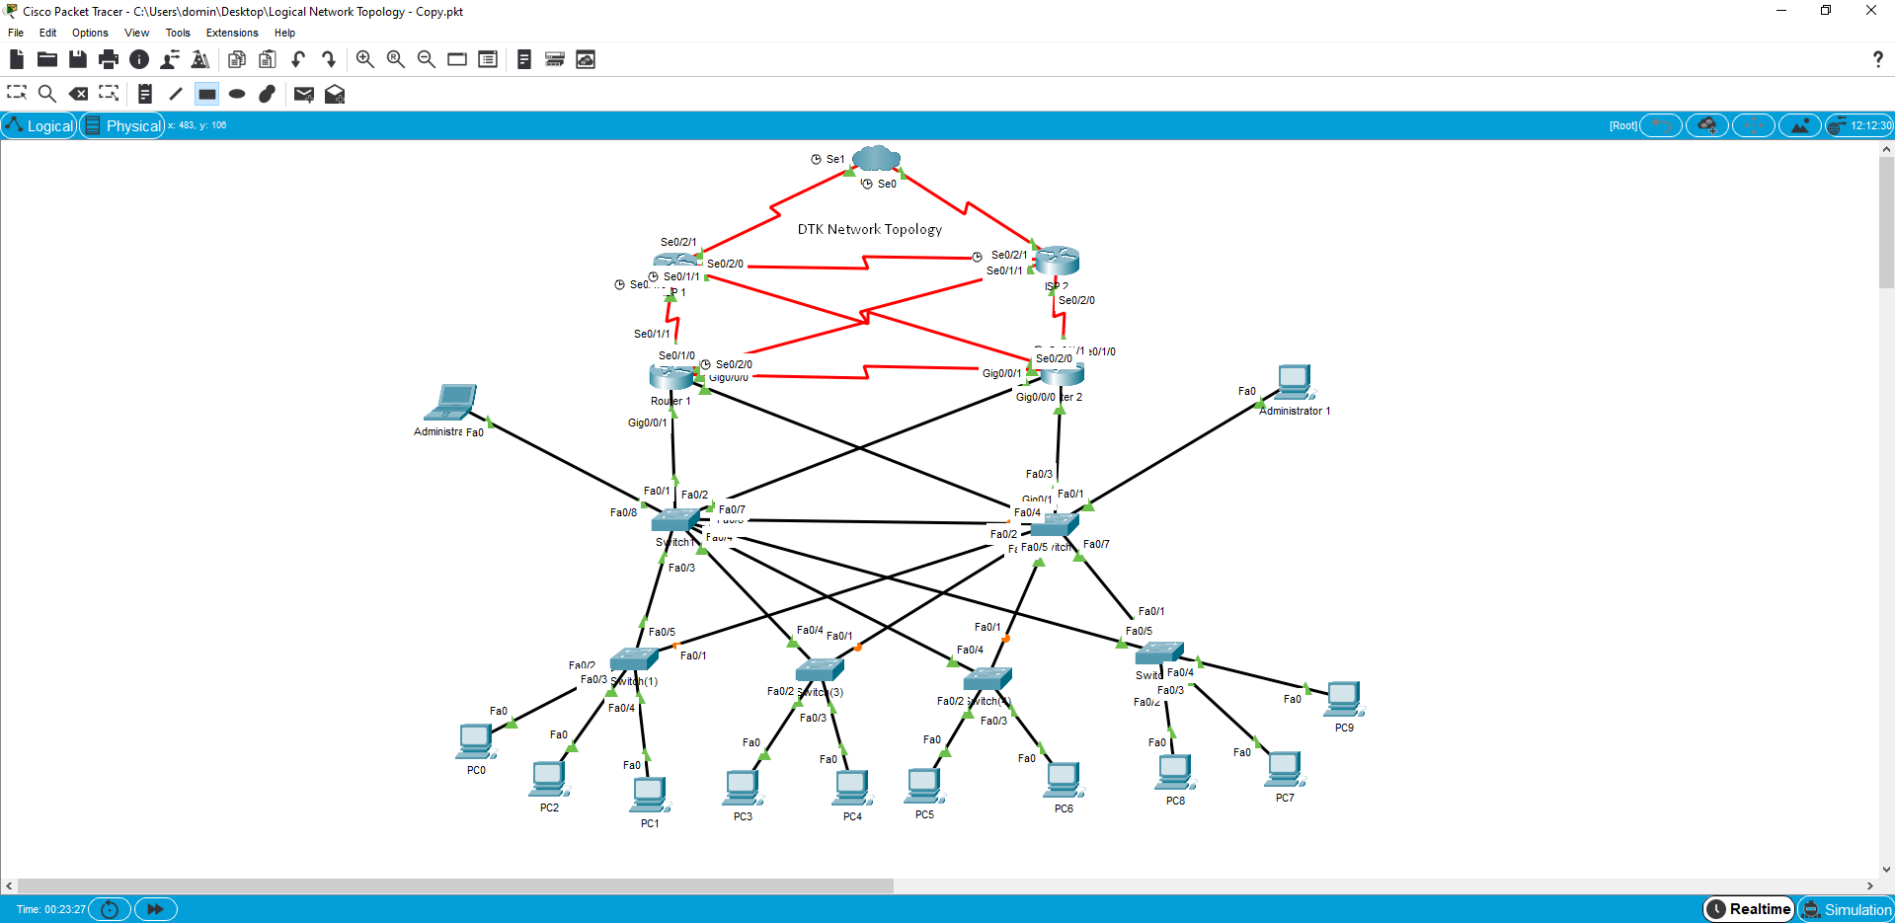
- Logical network topology.
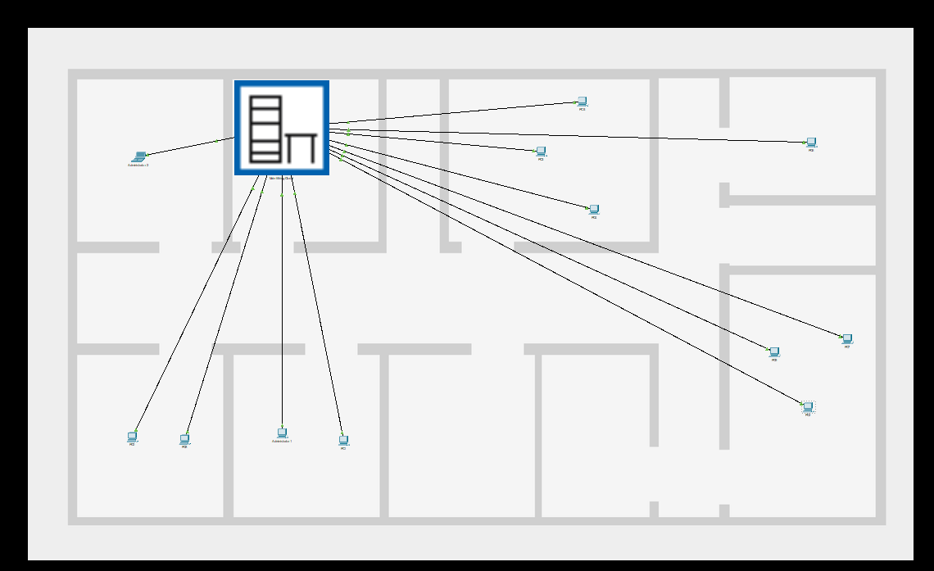
- Office design.
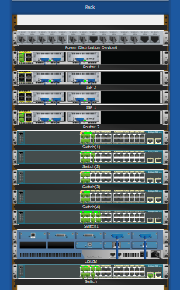
- Rack design.

Network Access
Network Access Control (NAC) assists businesses in implementing policies that regulate the system and user access to their infrastructure. Among other restrictions, NAC can create rules for assets, role, machine, and geographical location-based access and implement security adherence with security and patch management regulations. NAC is an attempt to get harmony out of the confusion of internal and external relations. Employees, clients, suppliers, contractors, and visitors all need some degree of access. In some instances, access is provided from inside the premises, and in others, access is provided from outside the premises. Bring Your Own Device (BYOD) regulations, the proliferation of phones and laptops, and the growth of the Internet of Things (IoT), all contribute to the complication. These complexities were thoroughly examined, and the Network Policy for the aforementioned organisation was created. The Network Policy, as can be found above, outlines network access to the DTK's infrastructure. All aspects of network access, including third-party access and data handling, as well as user authentication methods, were defined [12].

Security Team
With the introduction of new technologies, there has been a tremendous increase in interest for IT security professionals all over the world. Companies have recognised the value of cyber-security and are willing to invest in infrastructure and people to combat cyber-attacks. This guarantees the general security of internal networks as well as the confidentiality of sensitive personal information. The DTK company's proposed IT security team consists of the following departments [13] [14] [15]:
- IT Service Desk: The IT Service Desk is designed to serve as the main point of contact between employees and an IT company. A traditional service desk handles user interaction about matters such as breakdowns and scheduled service updates, as well as emergencies and problem resolution. A wide-ranging IT Service Desk is intended to provide users with a single point of contact with all of their IT requirements. As a result, the support desk becomes critical in promoting the convergence of enterprise operations with the technology environment and wider service management architecture.
- IT Department: The IT Department manages the implementation and upkeep of a company's computer network infrastructure. This may only necessitate a single IT professional, or a department in the case of broader businesses. Its main role is to keep the network running seamlessly. The IT Department must assess and configure the appropriate hardware and software to keep the network operating smoothly. Working through a budget that assigns the amount of money the organisation can spend on network hardware and applications is a part of this. The IT Department must ensure that the equipment it invests in meets the demands of the enterprise while remaining under budget. Furthermore, based on their scale and structure, networks can be straightforward or highly complicated. Staff members may need university degrees in a computing field to properly address the problems that occur in running such a network, in addition to keeping updated on developments in technological innovation.
- IT Security Management: Assessing and mitigating external risks is one of the most critical tasks of a corporate IT management. These safety and protection risks may range from information theft and sabotage to natural disasters. Members of security management analyse the threats that their organisation faces on a daily basis and use this knowledge to identify options that can alleviate the conundrum. When risk assessment is done right, it results in effective mitigation techniques that can eliminate or help alleviate multiple potential threats.

Enforcement of Policies
Organizations develop policies in order to govern, administer, and, in some cases, monetize their goods and resources. Network policy implementation aids in the automation of information and asset protection controls, including BYOD mandates. It enables a company, for example, to demand various rates for certain services or to set up usage hours. It can also be used to effectively implement corporate ethical practices (such as the use of business resources and time for personal purposes), as well as to better identify and control network use. Usually, policy implementation is performed by software or hardware that acts as a gateway, firewall, or other centralised point of access in the network. Policies must be established first, as well as one or more steps that will be undertaken if a breach happens. Once policies are established, the software or hardware in the network becomes a policy enforcement point, a place where policy enforcement happens. A policy might, for example, recognise known dangerous IP addresses and require all traffic from those addresses to be denied. More sophisticated policies can encourage a single user to connect to certain services but not others, or to engage in activities that cost more when directly linked, such as watching a video content on a high-resolution screen. Compliance with more complex and precise requirements, such as the existence of unexpired licenses, the model or configuration of a system or application being used to communicate, or the lack of indicators of behaviour associated with threats, may be required for network policy implementation. A policy implementation strategy often includes an overview or documentation of the entire operations and maintenance process, including nonadherence events [16].

Risk Analysis
Whether the company is simple or complex, a network risk analysis is one of the most crucial matters businesses can do for their personnel to maintain security over the network and information systems while also minimize the possibility of security threats, which can bring any company to its knees. A network risk evaluation examines the network that the company and its staff use on a daily basis. By using risk management techniques, the assessment aids in understanding the threats to the vital infrastructure and confidential data. If the organisation has recognized and discovered these threats, it can begin organising the information based on the level of danger. Individuals must first answer three critical questions before they can consider assessing cyber threats [17]:
- What are the organization's vital information technology properties, or the data whose disappearance or disclosure will have a significant effect on company operational activities?
- What are the company's main activities that make use of or necessitate this information?
- What risks could jeopardise the capacity of certain company activities to function?

Security Operations Monitoring and Breach Mitigation
To increase network protection, an organisation should use a variety of technologies. These technologies aid in the protection of the network from malicious attacks and the detection of any warning signals that suggest a security violation or vulnerability. A Network Performance Monitoring (NPM) tool increases reliability by continuously monitoring the network's efficiency levels. Tracking bandwidth utilisation, analysing network flow, and testing the state of devices and nodes are all part of this. NPM systems can capture and interpret packets of data that pass across a network as part of their performance managerial activities. This assists them in identifying performance problems such as packet loss and reduced bandwidth. It can also be used to detect network security vulnerabilities by searching for malicious activities or unusual content [18] [19].
Information security is a major problem for companies of all sizes. Cybercriminals actively investigate enterprise networks for device bugs in order to obtain access to critical software, confidential data, and other internet-based properties. Regrettably, many individuals achieve success. As a consequence, most companies maintain breach prevention plans. When computer hackers acquire access to corporate networks, IT experts and other corporate partners implement these plans to safeguard as many personal documents and applications as possible. Although individual activities vary, most companies adhere to a standard breach prevention procedure that includes the following main steps [18]:
- Detection and recognition of breaches.
- Breach avoidance in the short term.
- Group-based planning.
- Long-term strategy.
- Customer interaction.
- Post-breach procedures.

High Availability and Security Best Practises
Selecting and adopting the framework that best meets a company's availability needs can pose a significant challenge. This infrastructure must offer sufficient replication, provide appropriate support from all forms of disruptions, maintain constant high efficiency, and be easy to implement, maintain, and distribute. Needless to say, this framework should be guided by well-defined market criteria. A company requires high availability best practises that include both technological and organisational elements of its IT infrastructure and enterprise operations in order to develop, execute, and manage such an infrastructure. Such a series of best practises eliminates the difficulty of implementing a high availability infrastructure, greatly increases availability by consuming the fewest device resources, lowers the deployment and operational costs of the existing high availability systems, and makes it simple to replicate the high availability framework in other sectors of the enterprise. A company with the most comprehensive series of high availability and security best practises that include high availability research systems, market drivers, and device functionality will benefit from increased organisational flexibility and operational efficiency [20].

Network Security Best Practices
This paper addresses a collection of best security practises for improving enterprise network security. These best practises are established on a consensus opinion; however, opinions and technologies evolve with time, and this document will be revised periodically to accommodate such adjustments. Some of the most effective network security practises are described below [20] [21]:
- Effective network controls: Administration of network security components such as network virtual appliance features, virtual network and subnet configuration management, and IP addressing.
- Zero trust approach: Zero trust networks eradicate the idea of trust depending on a network's position within a perimeter. Zero trust structures, on the other hand, use system and user trust statements to restrict access to the company data and services.
- Strong data encryption: Encryption safeguards personal secrecy by securing all private and public networks. Various organisations use it to safeguard legal paperwork, correspondence, health records, government files, and company activities. It is also important for the dignity of human relationships.
- Implementation of a firewall: Firewalls are the most widely available and commonly distributed network protection software on the market. They are used to provide a barrier between the internet and the local network, restricting traffic and eliminating risks.
- Deployment of a perimeter network: A perimeter network is a physical or logical network section that offers an extra layer of protection between the infrastructure and the internet. Sophisticated network access control systems at the periphery of a network permit only desired traffic through the network infrastructure.
- Restricted use of the RDP and SSH: The risk of using these mechanisms over the internet is that criminals can use dictionary attack tactics to obtain access to the virtual machine. After gaining entry, the perpetrators could use the virtual machine as a steppingstone to compromise other devices on the virtual network or even networked computers outside of infrastructure.

High Availability Best Practices
When it comes to establishing reliable IT processes, eliminating disruption and system outages is often a primary concern. Regardless of how stable the systems and applications are, complications can arise that cause the software or servers to malfunction. Incorporating high availability into enterprise networks is a viable approach for mitigating the effects of certain incidents. Highly available technologies will immediately recover from system or element malfunction. Some of the most effective high availability practises are described below [22] [21]:
- Geographic redundancy: It is the only safeguard against infrastructure disruption in the presence of catastrophic incidents such as natural disasters that trigger system blackouts. As with geographic reproduction, various servers are distributed at geographically differentiated locations. Places should be spread geographically rather than being clustered in a geographic region.
- Network load balancing: It is a powerful method for improving the availability of vital web-based services. As cases of system malfunction are identified, they are immediately substituted when data is dynamically transferred to servers that are still operational. Load balancing not only ensures high availability, but it also allows for gradual scalability.
- Data backups: A solid backup and disaster recovery strategy is the cornerstone of a successful data security policy that safeguards against system malfunction. Important data must never be retained without copies, redundancy, or the capability to restore information. Every data centre should prepare ahead of time for information loss or theft. Data errors can wreak havoc on end-user authentication, financial records, and, as a result, the reputation of the private sector.
- Clustering: All software services are expected to crash at some stage, even with the best software development. The aim of high availability is to provide application services even when errors occur. In the event of a failure, clustering can provide immediate failover application services.
- Failover: A high availability architecture is traditionally made up of several linked servers with failover capability. Failover is essentially a recovery operating mechanism in which the activities of a system component are performed by a secondary system in the instance that the initial system crashes or remains inactive either due to malfunction or scheduled maintenance.
- Backup plan: Regardless of the fact that implementing high availability best practises is simply preparing for disaster, there are other steps an organisation may take to improve its disaster preparedness in the case of a breakdown that results in an outage. A contingency strategy should not only be well defined, but it should also be reviewed on a daily basis to guarantee that it works in the event of unforeseen interruptions. Employees’ professional development in reliability engineering can enhance their abilities to plan, implement, and manage high availability environments. Safety protocols can also be implemented to reduce the likelihood of device outages caused by security violations.

Conclusion
Humans live in a knowledge-obsessed environment, and the value put on information in this modern era has turned it into a rare and important asset that all governments and groups of people around the world are vying for. Since data has become a valuable and necessary asset, it is now absolutely essential to secure sensitive information that is being exchanged. In addition, there is an increasing number of cybersecurity attacks and data breaches aimed at stealing sensitive information, especially user information and credentials. Furthermore, malicious network users could sell the details of their customers to a fraudster for a fee. The capacity to preserve the integrity of an organisation’s network, data, and internal ecosystem is referred to as network security and administration in ICT. Governing entry, restricting use, and setting emergency measures in place are all part of this. It also includes user authentication and control, investigating unauthorised access, and safeguarding data, equipment, and services. Human behaviour, whether unintended, deliberate, or incompetent, may lead to security violations, as can inappropriate installation, setup, or activity.

References

[1] | E. Tittel, K. Hudson and J. M. Stewart, “Routers,” in Networking Essentials, Coriolis Group, 2000, pp. 74-82.
[2] | D. Minoli, “Routing Function,” in Designing Green Networks and Network Operations: Saving Run-the-Engine Costs, CRC Press, 2011, pp. 75-84.
[3] | R. Morimoto, M. Noel, O. Droubi, R. Mistry and C. Amaris, “Determining the Correct Clustering Technology,” in Windows Server 2008 Unleashed, Sams Publishing, 2008, pp. 1001-1019.
[4] | A. Hirt, “Failover Clustering Basics,” in Pro SQL Server 2008 Failover Clustering, Apress, 2009, pp. 1-32.
[5] | A. Kaur and S. Verma, “Performance Measurement and Analysis of High-Availability Clusters,” ACM SIGSOFT Software Engineering Notes, vol. 40, no. 2, pp. 1-7, 2015.
[6] | A. Martin, E. Gamess, D. Urribarri and J. Gómez, “A Proposal for A High Availability Architecture for VoIP Telephone Systems based on Open Source Software,” International Journal of Advanced Computer Science and Applications, vol. 9, no. 9, pp. 1-11, 2018.
[7] | C. Bassek, S. Pierre and A. Quintero, “Redundancy Schemes for High Availability Computer Clusters,” Journal of Computer Science, vol. 2, no. 1, pp. 33-37, 2006.
[8] | S. Bartkowski, C. De Buitlear, A. Kalicki, M. Loster, M. Marczewski, A. Mosaad, J. Nelken, M. Soliman, K. Subtil, M. Vrhovnik and K. Zimnol, “Failover Cluster Concepts,” in High Availability and Disaster Recovery Options for DB2 for Linux, UNIX, and Windows, IBM Redbooks, 2012, pp. 102-115.
[9] | C. Brooks, C. Leung, A. Mirza, C. Neal, Y. Lei Qiu, J. Sing, F. Wong and I. Wright, “Business Continuity Program Design,” in IBM System Storage Business Continuity: Part 1 Planning Guide, IBM Redbooks, 2007, pp. 67-88.
[10] | M. Barranco, J. Proenza, G. Rodriguez-Navas and L. Almeida, “An Active Star Topology for Improving Fault Confinement in CAN Networks,” IEEE Transactions on Industrial Informatics, vol. 2, no. 2, pp. 78-85, 2006.
[11] | N. Absar, M. Alam and T. Ahmed, “Performance Study of Star Topology in Small Internetworks,” International Journal of Computer Applications, vol. 107, no. 2, pp. 45-53, 2014.
[12] | A. Lakbabi, “Network Access Control Technology - Proposition to Contain New Security Challenges,” International Journal of Communications, Network and System Sciences, vol. 5, no. 8, pp. 505-512, 2012.
[13] | M. Harcenko, P. Dorogovs and A. Romanovs, “IT Service Desk Implementation Solutions,” Scientific Journal of Riga Technical University Computer Sciences, vol. 42, no. 1, pp. 68-73, 2010.
[14] | O. Apampa and R. Olatunji, “Evaluation of ICT Penetration in Selected Insurance Companies: The Lagos Experience,” Journal of Emerging Trends in Computing and Information Sciences, vol. 1, no. 1, pp. 24-30, 2010.
[15] | A. Maglyas, U. Nikula and K. Smolander, “What are the roles of software product managers? An empirical investigation,” Journal of Systems and Software, vol. 86, no. 12, pp. 3071-3090, 2013.
[16] | F. Kargl, F. Schaub and S. Dietzel, “Mandatory Enforcement of Privacy Policies Using Trusted Computing Principles,” in Intelligent Information Privacy Management, AAAI Spring Symposium, Stanford University, USA, 2010.
[17] | S. Sulaman, K. Weyns and M. Höst, “A Review of Research on Risk Analysis Methods for IT Systems,” in International Conference on Evaluation and Assessment in Software Engineering, New York, USA, 2013.
[18] | S. Sproule and F. Vachon, “The Prevention and Mitigation of Breaches of Personal Information Databases: A Theoretical Framework,” Journal of Technology and Human Usability, vol. 11, no. 1, pp. 1-17, 2015.
[19] | J. Matogoro, K. Majogoro and N. Mvungi, “Design and Implementation of Network Monitoring System Using Open Source Software (Oss); A Case of University Of Dodoma Network,” Journal of Informatics and Virtual Education, vol. 1, no. 1, pp. 12-17, 2011.
[20] | Q. Docter, “Security Best Practices,” in CompTIA IT Fundamentals Study Guide, Sybex, 2018, pp. 489-533.
[21] | G. L. Stefanek, “INFOSEC Network Architecture Design Rules,” in Information Security Best Practices: 205 Basic Rules, Elsevier, 2002, pp. 19-68.
[22] | E. Serrelis and N. Alexandris, “From High Availability Systems to Fault Tolerant Production Infrastructures,” in Proceedings of the Third International Conference on Networking and Services, Washington, USA, 2007.

