

MASTERS OF BUSINESS ADMINISTRATION (MBA)

MARKETING MANAGEMENT
MODULE CODE — LCMB7024
ASSESSMENT: PORTFOLIO – PRESENTATION, REPORT, AND
REFLECTION
SUSTAINABLE BRAND EXTENSION : SOSYO HAJOORI
BEVERAGES PVT. LTD.
LECTURER : TAONGA KAONGA SOBERE - SNITHERS
____________________________
SUBMITTED
BY

( Dhrumilkumar H Makrubiya )
STUDENT ID – 2536596
Table of Contents

Table of Contents 1
Element 1: Poster Presentation 1
Element 2: Segmentation, Targeting, Differentiation and Positioning (STDP) Analysis 1
Segmentation 1
Targeting 1
Differentiation 1
Positioning 1
Element 3: Marketing Mix (7Ps) 1
Product 1
Price 1
Place 1
Promotion 1
People 1
Process 1
Physical Evidence 1
Integration and Critical Evaluation 1
Element 4: Reflection 1
Reference List 1

Element 1 : Poster Presentation

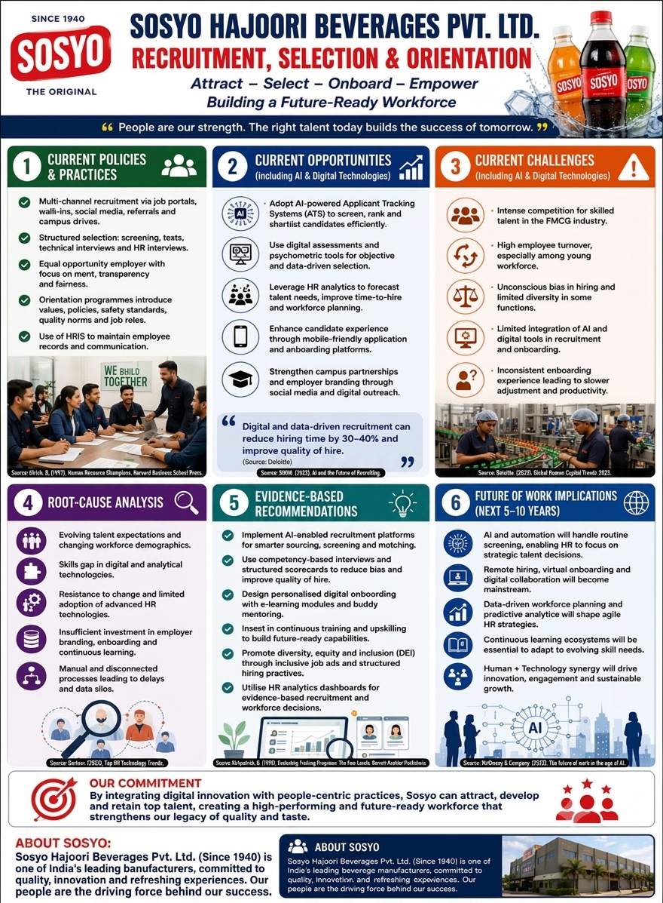

Element 2 : STDP Analysis for SOSYO HAJOORI BEVERAGES PVT. LTD

Market Segmentation refers to the process whereby an existing diverse market structure is broken down into smaller markets consisting of consumers with common wants or attributes in order to develop different marketing offers for each market (Kotler et al., 2024). Four segmentation variables have been used in the Sosyo Verde brand extension.

Segmentation

Geographically, Sosyo Verde is to be launched in the beginning in urban and semi-urban marketplaces of Gujarat, Maharashtra, and Rajasthan, where the brand of Sosyo itself has gained widespread recognition and presence (Statista, 2024), before moving on to a gradual expansion into other Tier-1 market places of India like Delhi, Bangalore, and Pune. It is necessary for the product to have an infrastructure of quick commerce and retail that includes services like Blinkit, Zepto, and Swiggy Instamart.

Demographic-wise, the core target market consists of adults aged 22 to 40 belonging to the socio-economic class of NCCS A & B, who earn enough disposable income to be willing to pay a premium for their colas against mainstream brands. A second target demographic market is formed by Gen Z individuals aged 18 to 24 who are socially aware and active with sustainability messaging on social media sites (Mintel, 2024).

From the psychographic point of view, it can be argued that the target group consists of “conscious consumers”, meaning that people perceive buying behavior as an extension of their identities and values, actively seek brands which prove themselves environmentally responsible, and are ready to pay more money because of that (Belz and Peattie, 2012; Mintel, 2024).

From the behavioral perspective, the segment is known for its occasion-oriented consumption which not only relates to festival and celebratory occasions but also involves day-to-day occasions of hydration and refreshing; category switching behavior where consumers loyal to global cola brands today are willing to try more credible 'better-for-you' choices; and early adopter behavior where a set of consumers deliberately tries out more sustainable products before others (Rogers, 2003).

Targeting

Based on the segmentation above, the Sosyo Verde will take the approach of differentiating itself with a concentrated targeting approach that is particularly geared toward upper-middle-class millennials and Gen Z consumers, aged 22 to 35, in Tier-1 and Tier-2 cities in India, who are not only health-oriented but are also tech-savvy and environmentally sustainable. The targeted approach helps Sosyo, as a small company in terms of its national status, be more relevant than the multinational competitors like Coca-Cola and PepsiCo, since it is not about competing against them in terms of scale and budget.

Differentiation

The differentiation strategy of Sosyo Verde rests on three foundations. Firstly, it has to do with heritage authenticity since Sosyo is different from multinationals because it can claim its product to be "India's own" brand, trading uninterruptedly since 1940 and thus providing extra weight to the narrative of sustainability. Secondly, there is functional differentiation which is implemented by changing the recipe to include natural botanical extracts and lower sugar content to address health concerns that are currently shaping the category of soft drinks (Euromonitor International, 2023). Finally, there is packaging differentiation, which consists of a unique, fully compostable, plant fibre bottle and thus addresses criticism of multinationals of lacking actual impact in reducing plastic pollution (Kapferer, 2012).

Positioning
These aspects of differentiation lead to a definite positioning approach. The company Sosyo Verde is positioned in the category of “premium wellness and sustainability,” which combines two axes – quality/price premium axis and sustainability credentials (refer to Figure 2). Placed against this model, the international brands like Coca-Cola and PepsiCo find themselves in the high-quality but low or moderate sustainability quadrant because despite a lot of their environmental activities, they are considered to be incremental rather than revolutionary (Kapferer, 2012); local mass brands are situated in the low-price but low-sustainability quadrant, and local wellness startups are in the high-sustainability but low-trust quadrant due to their recent formation. It allows identifying an entirely unoccupied niche of premium wellness and sustainability that could be occupied by Sosyo Verde (Aaker, 1996).
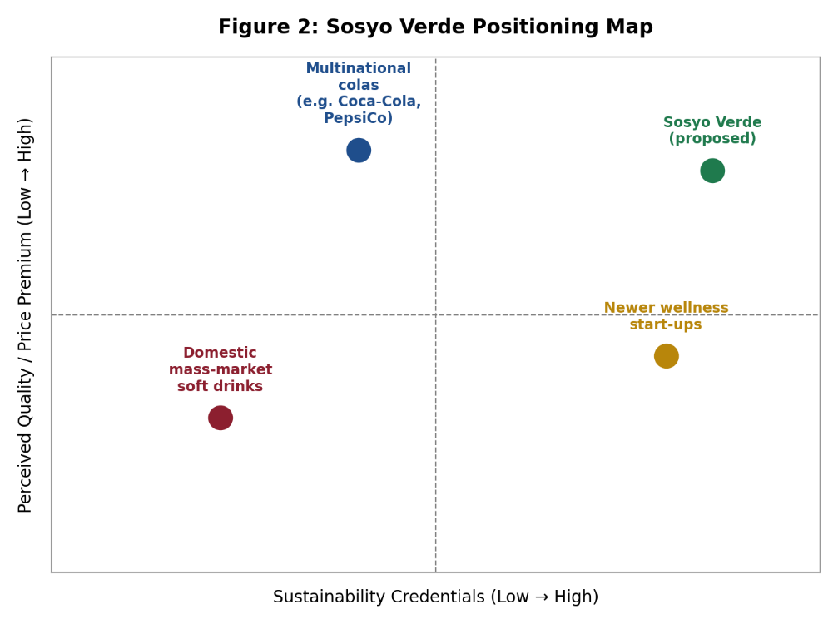

Figure 2: Sosyo Verde Positioning Map (author's own illustration, based on the differentiation analysis above)
This is evident from the consistent use of positioning throughout the communication channels, package and retail environment of the brand, as suggested by Kotler et al. (2024) for effective positioning, which states that all aspects of the marketing mix need to be aligned towards a certain positioning rather than just one advertisement. This positioning statement can thus be stated as: for value-oriented Indian urban consumers looking for refreshing drinks that have a taste they are familiar with, Sosyo Verde offers the sustainable soft drink range in zero waste packages, unlike the multinationals who care more about scale than sustainability, and unlike the new wellness products that lack brand legacy.
It is essential to understand that there are certain risks associated with this particular STDP strategy. Focusing on such a narrow niche implies limited volumes in the initial period of time and, therefore, restricted economies of scale; positioning which is largely based on the company’s sustainability claims also puts the brand at risk in case of later discrediting of either compostability or sourcing claims, something which is often seen in the context of “greenwashing” sustainability campaigns (Belz and Peattie, 2012). Still, due to the evident gap in the market and high equity of the existing brand, it seems that this differentiation-based approach is a more reasonable way to go.

Element 3 : Marketing Mix (7Ps)
Marketing mix is the strategy used to formulate the market offering from STDP strategy. For Sosyo Verde, all the seven components of extended services marketing mix have been crafted for emphasizing the sustainable nature of the brand extension (Kotler et al., 2024).
1. Product
Sosyo Verde is a family of low sugar, plant-infused sparkling drinks offered in three flavors to start, aimed at reducing the amount of added sugar by around 40 percent compared to regular Sosyo drinks, yet maintaining the same taste experience of the Sosyo brand. Yet, the unique feature of this product is its packaging – the plant-based, compostable bottle that will decompose in 180 days in industrial composting environment, directly solving the problem of single-use plastics which is changing the consumer perceptions of beverages (NielsenIQ, 2024). This is a thought-through brand extension in line with Ansoff's (1957) growth matrix approach to extend the brand by launching a new but related product and meeting the brand extension fit requirement posed by Keller (2013), remaining close to the core competency of the brand in carbonated soft drinks while expanding into an adjacent sub-category.
2. Price
Premium pricing is chosen, where Sosyo Verde is priced approximately 25 to 30 percent higher than the regular Sosyo drink and roughly inline with the other premium "better-for-you" beverages. Value-based pricing is done here since it accounts for the extra cost of sustainable packaging and organic products. This is supported by the fact that there is a proven willingness on behalf of consumers to pay more for sustainability, even in India (Mintel, 2024). A discounted sampling price will be used for the first three months to entice early adopters.

3. Place
The distribution strategy would comprise conventional general merchandise wholesalers and kirana shops, where the mother brand, Sosyo, already has a high degree of penetration, along with new-age retail chains, in addition to quick-commerce apps such as Blinkit, Zepto and Swiggy Instamart, which have taken a significant market share from the FMCG discovery and purchase stage of urban Indian consumers as e-commerce adoption levels rise (NielsenIQ, 2025). A direct-to-consumer website and subscription service would also be introduced for developing a one-to-one relationship with the most committed consumers.

4. Promotion
The integrated marketing communications strategy will include content creation on social media platforms such as Instagram and YouTube, micro-influencer collaborations that focus on sustainability, sampling at university campus events and fitness/wellness events, as well as public relations related to the innovation of compostable packaging. The promotion theme will continue to associate the brand’s eighty-year legacy with its current sustainable position, and this differentiating strategy will be supported by the theory that integrated communication creates greater brand equity than isolated advertising (Keller, 2013; Kotler et al., 2024).

5. People
Training of the front-end sales team, distributors, and customer service will be done to ensure proper brand communication through structured training in the sustainability story and value proposition of the Sosyo Verde product. There will also be selection of a few sustainability ambassadors among consumers to advocate for the brand.
6. Process
The sourcing process will include certified providers of botanical ingredients and packaging that is biodegradable through the use of a newly designed manufacturing line that can accommodate both the new and current types of bottles being used. The ordering and delivery process of the DTC will be facilitated using a mobile application so that feedback from the customers can be obtained continuously.

7. Physical Evidence
It is through the use of the uniquely designed bottle, made of plant-based fibres, which comes with the clear indication of its compostability, as well as a specially designed in-store merchandising shelf using recycled materials, that the company would demonstrate its environmental claims at the point of sale (Belz and Peattie, 2012). This is meant to counter any scepticism surrounding the credibility of such environmental claims. Third party verification of both the claim for compostability and sugar reduction will be indicated clearly on the package because Indian consumers trust external claims more than those of the company itself (Mintel, 2024).
Integration and Critical Evaluation
In this regard, all seven of these elements have been consciously designed to complement each other and not work independently. For instance, the high price for a product is necessary for covering costs associated with the use of expensive compostable packaging and the production of the product from natural ingredients as explained in the product component; the place element which involves quick commerce fits the pattern of media usage of the target segment as revealed in the promotion component; and the people and process components make sure that sustainability promises which were made during advertising are being delivered to customers at every point of contact from discovery through purchasing and packaging disposal. It is very important, as according to Kotler et al. (2024) and Porter (1985), it is impossible to create a sustainable competitive advantage through any single component of the marketing mix, but only through a complex activity system.
However, a certain level of criticism for this strategy is justified. The premium pricing strategy has a definite danger of limiting the brand extension to a rather narrow and wealthy market segment, thus making it difficult to benefit from the scale effects that could help the company to negotiate better with retail and packaging partners. Likewise, the dependence on quick commerce channels involves the margin squeeze, which means that commission fees in these channels will be higher than those in traditional general trade channels. However, these trade-offs are justified at the stage of launch of the product, when sustainable positioning becomes more important than the sales volumes for the brand extension.

Element 4 : Reflection
Creating the strategy for the brand extension of Sosyo Verde, and the development and presentation of the poster, has really been a developmental experience that I will reflect upon in this essay through the use of Gibbs' (1988) Reflective Cycle of description, feelings, evaluation, analysis, conclusion and action planning.
In the beginning, it was difficult for me to go beyond a mere descriptive study of the current marketing practices of Sosyo in moving up to the level of evaluation that is expected at Level 7. The creation of STDP analysis forced me to think critically about the reasons why certain segments are appealing rather than just naming them. Thus, it made me go deep into the academic sources on segmentation and targeting that I had not read before. Similarly, going through the marketing mix made me understand trade-offs among "Ps" rather than just describing them separately.
However, creating the poster presentation helped me develop other skills. When you had to condense all the strategy into one artifact for a three to five minutes presentation, I had to select the best and most important arguments which are most relevant to the investors and customers, and eliminate all the information which was interesting but irrelevant to the main story line. The process of giving the presentation also helped me become more confident in presenting marketing ideas in simple terms to an academic/professional audience, which is a very valuable skill for my future career in brand/marketing management.
After careful consideration, the most important knowledge that I learned through this process was an understanding that there needs to be a balance between fit with the main brand and differentiation in the market for brand extensions – something that is easier said than done in practice. I have also improved my abilities to do research and evaluate sources such as reports by NielsenIQ, Mintel and Euromonitor along with marketing literature.
In terms of future development, I plan on enhancing my analytical skills by making use of quantitative data related to the market, such as through the use of consumer panels or point of sale data, rather than secondary reports from within the industry that have been my main resource thus far. Additionally, I plan to get further practice in live presentations of strategies in order to gain more confidence in doing so. On the whole, this assessment not only helped enhance my marketing technical knowledge and communication skills, but it also gave me more insight into brand extension strategy development and justification.
With respect to action planning, I am proposing three specific actions which I will take going forward into future modules and into my professional life. First, I will form a personal habit of triangulating any single industry report with an additional source before considering it a reliable enough information base for developing a strategic recommendation in order to protect myself from the danger of using only one data point as a basis for decision-making. Second, I will look for more chances to practice working on and presenting a strategic proposal under tight deadlines as the compressed timeframe within which this assignment was completed has taught me about the importance of being able to do this. Third, I will focus on further developing my skill of critical evaluation of sustainability marketing claims as such claims are being contested quite often in academic literature and business news media.

Reference List
Aaker, D.A. (1996) Building Strong Brands. New York: Free Press.
Ansoff, H.I. (1957) 'Strategies for diversification', Harvard Business Review, 35(5), pp.113-124.
Belz, F.M. and Peattie, K. (2012) Sustainability Marketing: A Global Perspective. 2nd edn. Chichester: Wiley.
Euromonitor International (2023) Soft Drinks in India. Euromonitor Passport [database]. Available at: https://www.euromonitor.com
Gibbs, G. (1988) Learning by Doing: A Guide to Teaching and Learning Methods. Oxford: Further Education Unit, Oxford Polytechnic.
Kapferer, J-N. (2012) The New Strategic Brand Management. 5th edn. London: Kogan Page.
Keller, K.L. (2013) Strategic Brand Management: Building, Measuring, and Managing Brand Equity. 4th edn. Harlow: Pearson.
Kotler, P., Armstrong, G., Harris, L.C. and He, H. (2024) Principles of Marketing. 9th European edn. Harlow: Pearson.
Mintel (2024) 'Eco-friendly packaging and messaging transparency in food and drink', Mintel Insights, 15 October. Available at: https://www.mintel.com/insights/packaging/eco-friendly-packaging-and-messaging-transparency-in-food-and-drink.
NielsenIQ (2024) 'NielsenIQ reveals 2024 breakthrough innovation winners and top trends driving growth in India', NIQ News Center. Available at: https://nielseniq.com/global/en/news-center/2024/nielseniq-reveals-2024-breakthrough-innovation-winners-and-top-trends-driving-growth-in-india.
NielsenIQ (2025) 'Rural fuels India's 13.9% FMCG growth in Q2, while urban recovery gains momentum', NIQ News Center. Available at: https://nielseniq.com/global/en/news-center/2025/rural-fuels-indias-13-9-fmcg-growth-in-q2-while-urban-recovery-gains-momentum.
Porter, M.E. (1985) Competitive Advantage: Creating and Sustaining Superior Performance. New York: Free Press.
Rogers, E.M. (2003) Diffusion of Innovations. 5th edn. New York: Free Press.
Statista (2024) Beverage market: India. Hamburg: Statista GmbH. Available at: https://www.statista.com

