LEVEL 7 ASSESSMENT SPECIFICATION

Student name: | LAM Pik Lin | Student ID number: | 2235235
Program: | DBA
Module: | Managing in Complex environments: Strategies, Insights and Solutions
Module code: | HKBM7002 | Contribution to Overall Module Assessment (%): | 100%
Lecturer: | Dr. Leo Ho | Internal Verifier:
Assignment Title: | Management Research report | Word count (or equivalent): | 7500 (+/- 10%)
Submission deadline: | 6 March 2023 | Return date of provisional marks & written feedback: | 13 April 2023

Introduction
Under the new wave of the ‘Going Out’ policy and the ‘Belt and Road initiative, the Chinese government incentivizes local firms to advance in technology and expand their market abroad. (Sun and Xie 2022). In the Five-year Plan for 2016 to 2020, the Chinese government’s priority was to boost exports by expanding cross-border e-commerce. (US-China Economic and Security Review Commission, 2017). In 2016, cross-border M&As of Chinese e-commerce firms exceeded USD 42 billion and became a record. Tian and Li (2022) suggested that the growth of Southeast Asia’s economy and the development of its e-commerce sector give a promising future for Chinese firms in Southeast Asia. This paper is to discuss the successful merger of Alibaba with Lazada in 2016 focusing on its cultural integration challenges and approaches. Post M&A Acquisition, Lazada had been facing cultural conflicts between its employees and seniors from China. This paper is to draw some insights from the cultural integration concerns related to managing stakeholders, employee relationships, and senior management changes. It has made some recommendations for handling the post-M&A integration to sustain positive value creation in long term.

Methodology
This study relies on a literature review of academic papers from online library resources of the University of Wales Trinity Sanit David and google scholar website, online articles from professional journals or consultancy firms, public news, posts and recent textbooks. It is to study cultural integration concerns and approaches during M&A and the impacts on value creation post-M&A. It is a case study of a cross-border M&A concerning Alibaba and Lazada using the literature. Due to the limited time and resources, this study does not include primary data e.g. interviews or surveys with the firms or their employees to validate the findings and recommendations.

Alibaba and Lazada – Successful M&A Integration created value effects
In 2016 and 2017, Alibaba invested USD1 billion each year to gain control of Lazada, the top market leader of the B2C e-commerce industry in the Southeast Asia market. In 2018, Alibaba further invested USD2 billion in Lazada. Alibaba achieved its strategic move to enter the targeted market with new business advancements after this deal. In return, Lazada attained greater business performance riding on Alibaba’s strengths in management, payment technology and logistics. Alibaba merged with Lazada, a multi-national firm, implying higher integration risk after this acquisition compared to other M&A. Lazada operates in six countries in Southeast Asia where many civilizations converge. Alibaba managed to mitigate the integration risks covering culture, business, human resources and finance aspects. Alibaba faces challenges to cultivate its own corporate ideas while embracing the local culture of Lazada in the integration. (Wang and Kling, 2022).

Dess et al. (2021, p. 209) suggested that the global presence of a firm increases its scale of operations with a larger revenue and asset base. Sun and Xie (2022) studied cross-border M&As between 2010 and 2018 supporting aggregate scale changes last for two years post-deals. It showed that Chinese cross-border M&A acquirers increased total sales. Tian and Li (2022) adopted a framework to explain the value effect of Alibaba’s horizontal merger with Lazada after the M&A. This framework overcomes the issue of relevance between commercial data throughout the M&A process. It consolidates multi-dimensional data to determine the added value impact of the M&A in long term. It observed that Alibaba and Lazada merger created both short-term and long-term values. Alibaba’s Financial Report 2017 evidenced that 70% of business growth came from Lazada. Alibaba increased retail business revenue in international commerce by 233% in 2016. By Sep 2018, Lazada grew by 80% with 130 million annual active consumers and 159 million monthly active users. Lazada focused to reach $21 billion in gross merchandise value. By Sep 2021, Lazada had 922,000 monthly active sellers on the marketplace and many of whom were from China. It doubled the seller pool in 2020 (Liao, 2021). The M&A resulted in a positive synergy effect for both Alibaba and Lazada financially. As of Jun 2022, Alibaba has become the 2nd leading large capital e-commerce company worldwide according to Statista.

Cultural Integration Matters in Cross-Border M&A
Dang (2022) pointed out that nearly 50-80% of M&A transactions have failed both at strategic and financial levels. Most of the research investigated different reasons for M&A failures from different countries. It revealed that cultural diversity is critical to the success of M&A. McKinsey (2020) suggested that people did not notice culture and its impacts on M&A 15 years ago. Their data shows that managing culture effectively brought a significantly higher chance to reach cost and revenue synergy targets. It suggested that oversight to manage cultural differences can lead to poor results. 95% of executives agreed that cultural fit is a critical success factor for integration. 25% cited a lack of cultural cohesion and alignment as a primary reason for integration failures (Oliver Engert et al. 2019). Another research revealed 50% of executives said that culture fit is the core of a value-enhancing merger. Again, 25% of executives believed that its absence is a main factor for a merger failure. A concern is 80% of them admitted that culture is hard to define. McKinsey (2020) urged executives to focus on management practices demonstrating how people work in a company. Taking culture as certain management practices makes it visible and practical. The firm’s culture is defined by management choices to build and maintain internal and external relationships and its path to innovation.

Alibaba and Lazada – National Culture
Greet Hofstede collected and examined a large database of employee value scores within IBM, a high-tech leading company between 1967 and 1973. It is a comprehensive study of how culture influences values in the workplace. Hofstede suggested understanding and respecting the national culture and not expecting to change it. This study used the Hofstede online tool to understand the national cultural differences in six dimensions. (Hofstede Insights, 2023). It compares the location of Alibaba’s management in China and the locations where Lazada runs its business including six Southeast Asia countries as shown in Chart 1 and Chart 2 below. It aims to provide considerations when choosing culturally acceptable approaches for international organizations to manage cultural differences.

- Power Distance concerns how far subordinates expect and accept that unequal power is distributed. China’s score has the average score among these countries at 80. The scores indicate that all countries align with China accepting hierarchical order and inequalities among people. Subordinates are not protected from offensive power by superiors. Individuals are under the sway of conventional authority and permissions. Malaysia scores 100 given inherent inequalities; centralization is popular and questioning superiors are not accepted. Thailand has the lowest score at 64 supported by privileges are attached to each social ranking. Thai employees earn safeguard and advice by displaying devotion, respect and defense for their superiors. Given the tendency of power distance for all countries, it suggests that a top-down decision from senior leaders on integration may work.

- Individualism concerns the extent of interdependence a society maintains among its members. The average score for all these countries is 21.7. China, Singapore, Thailand and Vietnam have got the same score of 20, near the average score. The Philippines scores highest at 32 where recruitment and career advancement decisions depend on the employee’s in-group, supervision is the supervising the groups. Indonesia had the lowest score at 14. It has a high favor to a firmly defined social structure in which individuals are expected to fit into the ideas of community and their in-groups. All these countries have a collective society and act in the group’s interest instead of self-interest. It appears easier to engage them in the host company’s direction and goals.

- Masculinity concerns what drives people to desire excellence (Masculine) or love their work. (Feminine). China has the highest score at 66 related to their drive to succeed and willingness to sacrifice their personal life to work. Thailand scores lowest at 34 representing a feminine society because they are less assertive and competitive. The average score is close to 50. The drive of people is relevant to include them in the integration.

- Uncertainty Avoidance concerns the degree to which individuals resist uncertainties. The average score is about 35. China has got 30 and is comfortable with ambiguity. Chinese are usually adaptable and entrepreneurial. Thailand has got 64 and prefers to avoid uncertainty. They aren’t quite ready to accept changes and are very risk-averse. They need to see change for the common good of the community they belong to. Singapore got the lowest score at 8. They have a high-power distance score of 74 and are used to abiding by many rules. M&A is full of uncertainties and thus the impacted stakeholders’ attitude toward uncertainties would be a key consideration.

- Long-Term Orientation concerns how every community has to maintain some connections with its history while managing current and future challenges. The average score is 54. China has the highest score at 87 embracing a very pragmatic culture, believing in truth depending largely on circumstances, situations and occasions. They are agile, thrifty and persevere to reach targets. They have saving and investment habits. The Philippines has the lowest score at 27. They are more normative and keener to establish the absolute truth. They focus on achieving short-term outcomes and do not like to keep savings for tomorrow.

- Indulgence concerns the limit to which people attempt to manage their wishes and impulses. The average score is 41. China has the lowest score at 24 and tends to be cynical and pessimistic. They control the satisfaction of their wishes. Malaysia has the highest score at 57 tending to enjoying life and having fun. They follow their instinct to work and spend money.

Chart 1 – Hofstede Country Culture Scores limits to 4 countries (Hofstede Insights, 2023)
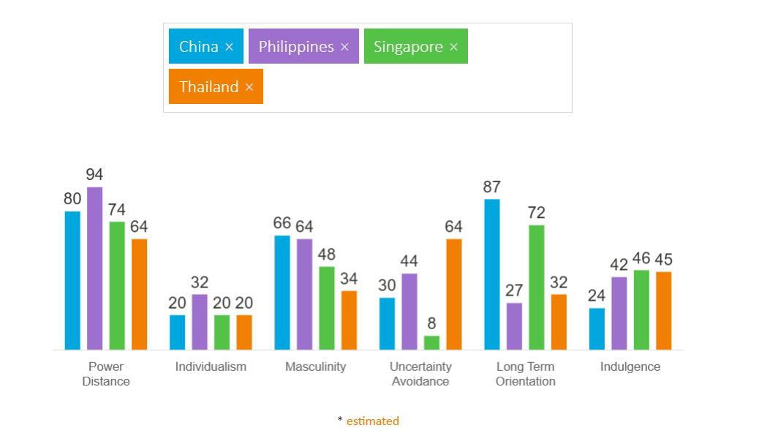
Chart 2 – Hofstede Country Culture Scores limits to 4 countries (Hofstede Insights, 2023)
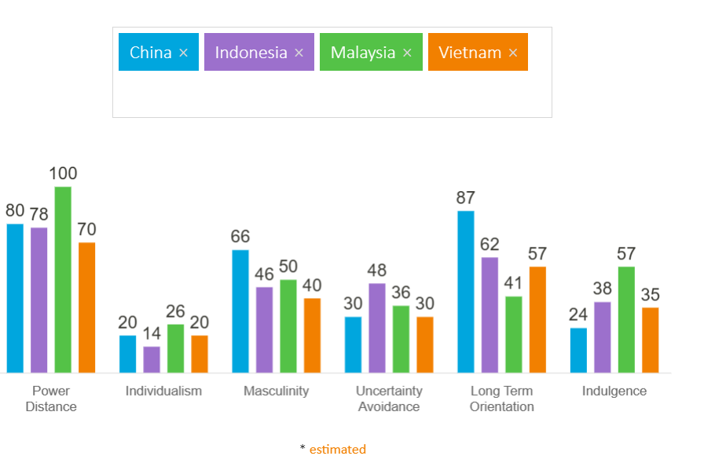
Alibaba and Lazada – Corporate Culture
Sarala et al. (2019) studied the “human side” of M&A literation. It suggested that the patterns of employee emotions in M&As may vary by industry. Usually, High-tech industries are less predictable and more radical compared to the manufacturing sector. Employees in this sector may be more resilient and may use more effective coping mechanisms to manage dynamic circumstances in M&A. After studying the successful cultural integration of Haier and Sanyo in M&A 2011, and the failure of BenQ and Siemens in M&A 2005, it has been recommended to conduct a comprehensive culture assessment of the two firms’ parties from different perspectives before an M&A deal. The evaluation should assess cultural backgrounds, management styles, beliefs, behavior standards and people aspects of both firms. The acquiring firm then chooses a productive cultural integration strategy among the options. The strategy should focus on the value-added side of cross-border cultural diversity. The firms may get new insights from cultural diversity. Forming a good cultural climate would enhance the firm’s capability to compete. With a strong corporate culture, the acquiring firm would not be replaced by the culture of the targeted firm. (Dan Tang, 2022).

As a high-tech company, Alibaba built an innovative, empowering, and entrepreneurial culture. It goes beyond the Chinese traditional culture. In recent research, one of the authors spent 150 hours observing Alibaba Group as a participant in their Global Dreamers training program in 2018. The primary audiences of the program were prospective and new hires. It showed case business practices to form corporate culture. The author subsequently visited their offices in China and conducted official interviews with their employees and employees of other technology companies. It was observed that Alibaba’s culture is openness, worker autonomy, and lack of hierarchy. This observation is quite different from Chinese culture observed by Hofstede’s model. Several interviewees witnessed that they had room to deliver work results using their methods. Most interviewees believed there is no workplace politics. The autonomy granted to employees went with heavy workloads and commitments. Alibaba is a result-oriented company. Its culture keeps pace with fast technological developments and rewards innovation in the dynamic business world (Tse and Li, 2022).

In a study of the high-tech sector in Israeli, the findings highlighted the importance to manage factors like autonomy and independent thinking in post-acquisition integration. The study observed the moderating impact of autonomy giving positive outcomes after the transition though the result is not statistically significant (Verginer et al. 2022). Alibaba’s business integration was successful by choosing to preserve Lazada’s e-commerce platform, its functions and services. It retained customers using Lazada’s ways which fit into the local consumption rituals in Southeast Asia. Wang et al. (2022) observed that Alibaba retained the corporate culture of Lazada and concurrently enforced the bonding of Alibaba’s employees and Lazada’s personnel. Alibaba built a platform to facilitate internal communication. Honest, frequent and clear communications in two ways would help key staff retention as they get relevant information and may discuss their areas of interest (Rodríguez-Sánchez et al. 2019). Alibaba appreciated and showed respect for local culture and religion. It carried out activities to promote the host company’s culture at Chinese festivals to enhance mutual understanding. The attitude to embrace diversity and inclusion has largely reduced hurdles in cultural integration. Assuming that individuals are fundamentally self-interested and selfish, a survey resulted in over 50% of employees choosing to co-operate to act cooperatively. Only 30% of employees choose to act selfishly. An acquiring firm may leverage these collaborative workers by building a cultural system to engage, communicate, and create a sense of common purpose and identity (Dess et al. 2021, p. 271).

Chang-Howe (2019) studied 66 academic papers that highlighted Human Resources (“HR’) roles play in post-M&A transition covering process harmonization, organizational and change management. They are linked and have influences on each other. It suggested adopting an integrated approach for the HR integration framework. The research pointed out that greater involvement of HR practices for both acquiring company and the acquired company would work to ensure both firms would symbiosis post-M&A. The choice of strategy shoud align with the main business strategy and other corporate plans. The top priority is the retention of human resources in the post-M&A period. After the M&A, Alibaba did not change Lazada’s organizational structure immediately and retained Lazada’s CEO supporting knowledge retention, transfer and creation, signifying business continuity to stakeholders. It effectively helped Lazada employees from managing uncertainties (Campagnolo and Vincenti, 2022). Under a collective culture, such as in China and Southeast Asia, it is crucial to understand the web of relationships behind the acquired firm. In particular, an acquiring may understand potential complex relationships with existing suppliers, internal employees, customers, and local government. It would be essential to identify the ‘change agents’ of a company by evaluating the complex relationships and power base under a collective culture. This understanding can help offer individuals incentives to align their interests with those of the company. (Chakravarty and Ghee, 2012, p.155).
Lucy Peng replaced Lozada’s CEO Max Bittner in 2018 to implement growth strategies and strengthen the integration of Lazada into Alibaba (Alibaba and Lazada, 2018). She drove the people and leadership development in the Southeast Asia region. (Woodhouse and Louise, 2018) This change of leader posed a higher risk of cultural conflict in Lazada. The people in Lazada would need to adapt to changes imposed by Alibaba even though the internal organization and structures appeared the same (Yong et al. 2019). In addition, Alibaba being a success story of an e-commerce giant in China tends to copy the product design, marketing approaches and personnel management of Taobao in the China market to Lazada in Southeast Asia. It hindered the development of Lazada to a certain degree. With several adjustments, Lazada is also developing rapidly (Hsu, 2022). In Lazada’s office, there was a big slogan “We are One” to show Chinese executives’ eagerness to embrace Lazada (Ren, 2020). Interviews with practitioners revealed that over-standardization together with a lack of creativity can be a value-destroying combination. Thus, standardization with a certain extent of flexibility would work in building an entrepreneurial culture that promotes creativity. (Delis et al. 2022)
Alibaba’s Core Values Integrate with Lazada
A strong culture can motivate greater employee commitment by providing a common purpose and identity. The Alibaba management believes in the importance of communicating their core values with each employee to change their mindset and behavior accordingly. Alibaba aligns all employees to a common goal and it is well fit for the broader organizational purpose. This approach enables Alibaba and Lazada’s employees to work on the same targets, give the best performance and ensure a strong devotion to the firms (Harry, 2020).

In 2019, Alibaba announced six new core values for the digital era. The same core values are posted on both Alibaba and Lazada websites as of today. In 2020, President of Alibaba Group in North America appreciated that this powerful set of values gives direction and outlines the culture of their teams. Alibaba team cherishes its company culture, talks about and tried to live them. (Caplan, 2020). It shows a high degree of management and employees’ commitment to building a unique corporate culture. Out of 6 corporate values, 3 of them are the most frequently quoted corporate slogans in Alibaba. (Tse and Li, 2022).

Lazada in six Southeast Asia countries all won HR Asia’s “Best Companies to Work for in Asia” for 2022. HR Asia awarded companies with the best HR practices, demonstrating high levels of employee participation and outstanding workplace cultures. (Glassdoor, 2022). For example, Lazada Philippines is certified as a “Great Place to Work” due to its entrepreneurial mindset and positive work culture. It indicated that Lazada Philippines empowers, connects and motivates its employees to grow individually and organizationally level. 77% of Lazadians voted that they work at a great place to work compared to a global company usually has 53% vote from their employees. 90% Lazadians indicated that they will stay for the next two years. The Lazada Employee Awards was created to recognize employees and cross-functional teams who act promptly and demonstrate innovation. Lazadians are recognized by their performance and the impact and value they create. Lazada Philippines CEO Carlos Barrera shared that they treat employees the same way as serving customers and sellers. He recognized the passion and high energy are important to sustain a fast-paced business. The employees care genuinely about their work and have an entrepreneurial mindset that would provide the best service to their business partners (Advertorials, 2023). The local culture in the Philippines to put employees on an equal footing with customers and suppliers is a slight adjustment from the first core value of Alibaba.

External Relationship - Stakeholder Management
The first core values of Alibaba came from the 9th popular Alibaba slogan, “Customer first, employee second, shareholders third”. It guided a moral order in the business world. Alibaba put a high priority to learn and respond to the needs and burdens of customers. It focuses to create sustained customer value that brings growth to employees and shareholders. Ultimately, it will bring to long-term benefits (Tse and Li, 2022). On 10 Apr 2021, Alibaba faced a fine of USD2.75 billion for anti-monopoly violations. It immediately issued a letter to its stakeholders including merchants, consumers, partners and shareholders. It acknowledged that internet platform economies are integral parts of people’s daily life and affect every aspect of the broader economy. It reinforced treating customers first and caring about creating sustainable long-term value for society. (Alibaba Group, 2021). This behaviour matches the Hofstede’s analysis about the Chinese adopting a pragmatic culture to adapt and respond to changes in society’s expectations on the e-commerce industry.

In the Environmental, Social and Governance Report (Alibaba Group, 2022, p.191), Alibaba highlighted its respect for fair competition. They established the internal guidelines in Sep 2021 and compliant culture through continuous training and education. They support sellers in their product management and promotional activities by providing them with digital compliance tools. In page 4 of the report, Alibaba included its action plan to manage stakeholders like policymakers, businesses and the public by setting up an effective, transparent and strong governance system. They work to deliver technology ethically and strive to improve data privacy and security. In 2021, Alibaba published an “Artificial Intelligence Governance and Sustainable Development Practice” white paper to explain artificial intelligence governance systems for sustainable development at the enterprise level and reiterates its ethical and governance aspects. The topics include protecting data privacy and security, customer rights and fairness relevant to the e-commerce industry.

Similarly, Lazada’s ESG Impact Report (Lazada Group, 2022 p13) reported that it valued its stakeholders playing an essential role in building a prosperous e-commerce ecosystem. They identified key stakeholders including buyers, employees, logistics, the public, and sellers. They listed key concerns and engagement methods for each stakeholder. They applied materiality analysis to prioritize them based on the significance of Lazada’s impact on them and their level of influence and interest in Lazada. Then, they design business and sustainability strategies to achieve creating values together and for all. When considering the key concerns of buyers and sellers, there is a common interest in data and privacy protection. Alibaba’s focus and expertise in this area would benefit Lazada to manage similar challenges.
Internal : Employee Engagement
The 10th most popular Alibaba slogan became its 4th company value, “Today’s best performance is tomorrow’s baseline”. Alibaba would celebrate the process but only reward the actual business outcomes. Management expensively supports the law of jungle to survive in a keen market competition under globalization. The corporate culture encourages workers to constantly challenge themselves and strive to always outperform. It echoes that Alibaba is result-oriented (Tse and Li, 2022). This mentality is adopted at Lazada which always looks for ways to improve services. They introduced a one-stop and full logistics solution for business partners empowering them to be major players in global e-commerce expansion in the midst of COVID outbreak (Lazada’s News Hub, 2021). Meanwhile, Alibaba’s last company value is from the 6th popular slogan, “Live seriously, work happily”. It guides employees to treat life sincerely when they work, lives to enjoy work as they love life. Alibaba’ core values seem to respect individuals’ own choice of work-life balance. The founder Jack Ma believes only happiness inspires innovation. He claimed Alibaba differentiates itself by motivating its people to live a meaningful life. (Tse and Li, 2022) Alibaba roots in a purpose-driven work mentality to faithfully serve its brand names and consumers. They run corporate events and activities at its offices around the world to educate employees to demonstrate the unique company culture. (Hsu, 2019)

In the country culture comparison above, Hofstede suggests Chinese perseveres in achieving results. Alibaba’s China President Xi built on the Chinese mentality of overcoming hardship and nationalism to drive employees to become corporate warriors. He said the new era belongs to hard-working people and happiness can only be attained through strong endeavors (BCC News 2021). Working hard and self-scarification become a moral standard in China. All people are educated to carry the pressure of competition. Riding on Hofstede’s study, Chinese and Southeast Asia countries all belong to a collective society, which tends to act in the interest of the group and not in themselves. While the core values may push staff performance, there has been criticism within and outside the firms.

Tse and Li (2022) commented that Alibaba has made its employees take ownership of profit targets. Employees are repeatedly requested to outperform and devote themselves to excessive working hours without extra pay. Jacky Ma suggested, 996 was not a concern if we liked what we do (Koh Ewe, 2021). This hustle culture invited public controversies when the founder Ma supported 996 work style offering extraordinary career opportunities to people in the tech sector. His reputation fell from a role model to a “blood-sucking capitalist” (BBC World Service, 2021). In 2021, the sudden death of two employees in China’s ultra-competitive tech sector aroused public concerns. It was related to the extreme pressure faced by workers in the industry though there was no evidence proving the causation. It was reported employees in that tech company were pushed to spend 12 hours a day at work and 6 days a week. Some resignations were directly related to high job stress. (China Labour Bulletin, 2021). The questionable managerial practices to uplift the ‘996 work schedule’ in the high-tech industry caused the subsequent online 996.ICU movement. It damaged the social contract about employee faithfulness and devotion (Li, 2019) to companies that they belong to. The New York Times (2019) reported that Chinese tech employees named and shamed employers that demand working late nights. Alibaba is one of the offenders on the blacklist of tech companies that demand long work hours. (Tse and Li, 2022). The 996.ICU movement strived to promote eight-hour workdays five days a week as stipulated by the law. Tencent implemented a health day asking employees to leave work by six o’clock on that day. However, there are frequent complaints about contradictory management practices. Employees continue to work overtime without pay and are requested to join calls during leave days. Many people believed that the reform wouldn’t help much as they still work on a holiday. (Guiding, 2021). Public pressure and social media campaigns do not seem to change excessive work hours in the tech sector in Chinese companies. It relies on the sustained effort from workers to achieve a concrete and lasting change (China Labour Bulletin, 2021).
Lazada employees were expected to work longer hours than their competitors following Alibaba’s entrepreneurial mindset (Ren, 2020). Reuters highlighted concerns from Lazada’s employees about the company management and employees’ benefits. They shared that long work hours are not rewarded and complained their employers ignored their well-being. They work in a high-stress work environment with no empathy from their employers when being forced to work under illness. Employees resisted Chinese management’s suggestion about reducing personal and religious gatherings to fulfill work commitments. At an employer-review website Glassdoor, employees rate Alibaba Group at 3.9 out of 5 stars based on about 1,700 anonymous reviews. Most employee reviews are negative. It was said that Lazada CEO Pierre Poignan asked employees in a town hall to write positive reviews. It poses doubts about positive comments posted publicly. (Reuters, 2020). This management practice hinders 2 ways of communication to resolve conflicts at an early stage. Alibaba and Lazada should get HR resources to look into negative comments on employer review websites seriously, evaluate the effectiveness of existing internal communication channels and address the concerns raised in public about employee welfare and leadership. McKinsey promotes adopting big-data processing to study electronic communications like internal emails and anonymous corporate reviews to examine the actual effects of cultural diversity on organizational efficiency and innovation. This people analytics would help to measure, evaluate and explore solutions to tackle cultural issues of firms (Corritore et al., 2020).
Giattino et al. (2020) presented evidence showing working hours for a worker in wealthy countries dropped a lot in the past 150 years. The study highlighted that working hours are important for understanding the economy well-beyond economic output. Chart 3 shows that China has working hours rose in the 1990s and early 2000s before leveling off in recent years. Chart 4 illustrates that China and Southeast Asia work longer hours compared to the rest of the world.
P.T.O.

Chart 3 Annual working hours per worker
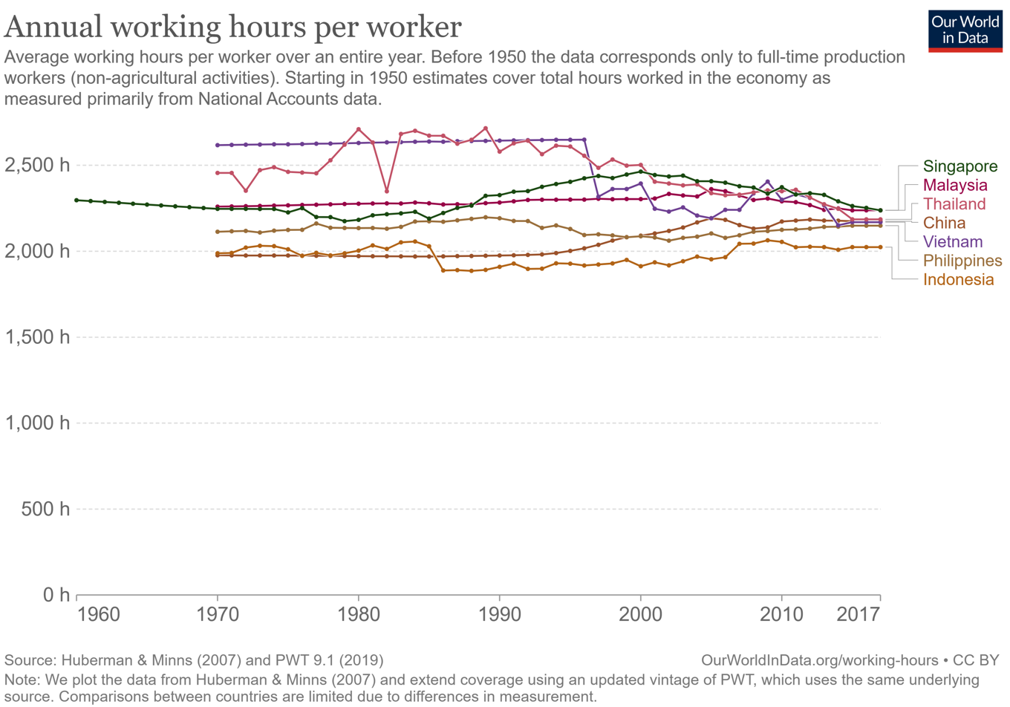
Chart 4 Annual working hours Vs GDP per capita
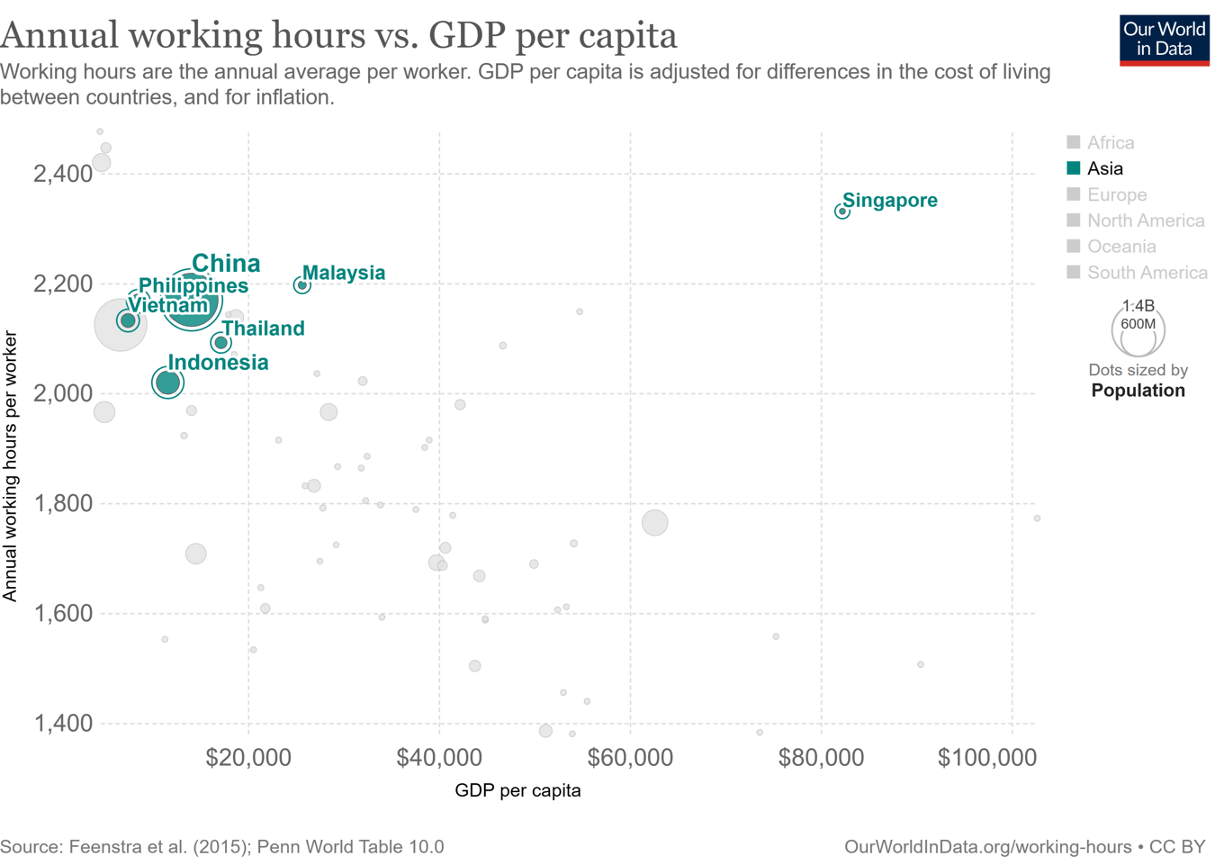
As of December 2022, statistics shows the average working week for Chinese employees was 47.9 hours while employees on private nonfarm payrolls in US have average work hours of 34.7 according to US statistics (Singh, 2023). The work-life balance index suggested working long hours at 50 hours damages physical and mental health. It will increase the cost of offering medical benefits, adversely affecting productivity and business results (OCED Better Index, 2023). Research establishes that the highest risk factor for occupational disease is overwork. Working long hours may imply less time to sleep, exercise, eat unhealthily, smoke and drink to cope with stress (Ro, 2021).
A recent study used data from over 950 knowledge workers in China. The researchers discovered overwork strongly affects retention. It lowers the worker’s job embeddedness causing increasing intention to leave a company. It prompted that China has little awareness of this issue. Even Chinese belongs to a collective culture, the Western about the negative impact of knowledge workers’ overwork on turnover intentions proved valid. This provides insight for Human Resource managers to take care of staff’s well-being in view of the ever-increasing workload and demands on employees, aiming to maintain their job embeddedness and reduce turnover intention (Huang et al. 2021). SCMP (2023) reported that Chinese being laid off by tech companies in the western world prefer a career break rather than sacrificing work-life balance to work in China. It’s urged to promote flexible work mode and consider job sharing to avoid burnout. (Ro, 2021).
Alibaba’s ESG Report (2022) p23 published metrics to report achievement in supporting its employees in terms of learning and career opportunities, equality, diversity and inclusion, benefits such as companionship leave to care for the family. It has adopted a flexible work arrangement and allows hybrid work once a week. Its health benefits cover both physical and mental consultation, regular health and wellness education. It has psychological advice and courses to manage mental health and stress. Lazada’s ESG report mentioned that they offer access to psychological counseling on top of existing comprehensive health and risk-protection insurance coverage. In HR Asia Best Companies to Work 2023 website, it states that Lazada Thailand allows working from home up to 2 days a week. Both firms may consider measuring the actual working hours of their employees, review and reduce it to the statutory requirements or take reference to 48 hours a week following European Union’s standard (Ro, 2021; EU’s Working Time Directive 2003). It will show the firm’s openness and effort to change the long work hours culture.
Measures to resolve employee conflicts
The Wall Street Journal (2020) reported a comment that Alibaba faced culture clashes and failed to understand local markets sometimes. It is helpful to define, identify, and tackle cultural issues by considering management practices. (Engert, 2020) In February 2020, Lazada Singapore asked all employees to respond to health questions in detail daily during COVID outbreak. Lazada communicated that these reports were not mandatory. However, their employees received constant reminder calls to submit the reports. It was offensive to privacy by many Lazada staff in the Philippines Thailand and Indonesia. The actual usage of the health report was challenged and one of the concerns is whether the information would be submitted to governments. The company’s measure about wearing a mask in the Singapore office contradicted the views of Singapore authorities recommending wearing when one fell ill only. (Reuters, 2020). Chinese executives told employees in Singapore to suspend religious activities for combating COVID. Though these policies have proven health benefits and work well in China, they broke the trusted relationship, infringing religious freedom and personal privacy (Ren, 2020). The crash illustrated how Alibaba's standard ways may not apply directly to the Southeast Asia region. It also showed the stress of global companies as they struggled with the unprecedented crisis. The cultural conflict resulted in some changes in the Philippines which oblige more rigid privacy laws. In March 2020, Lazada updated its health check-in program to address privacy protection (Reuters, 2020). Before introducing a new management practice, an acquiring firm should consult local legal and compliance experts, engage employees to communicate well to avoid unnecessary conflicts.
Internal : Senior Management rotation
Literature suggests that M&A involves radical changes and requires leaders to provoke and motivate employees to adopt ideal behaviors. They may offer job security, show empathy and care to employees, ensure open conversations with employees, and turn resistant staff to support the goals of the merger (Oancea and Kamau, 2021, p. 99-105). Facing continuous internal cultural conflicts, Lazada was suggested to change its management team and transform the authoritarian atmosphere to retain staff (Yong et al. 2019). A study suggested appointing a new CEO can minimize conflicts and improve profitability but not growth (Campagnolo and Vincenti, 2022). Alibaba started to send senior executives to Lazada in 2018 and changed 4 CEOs in 4 years. Reuters reported a high turnover of senior executives from China working in Lazada in 2018-19. Lucy Peng, who was co-founder of Alibaba stayed in the Lazada CEO position for nine months in 2018 and stepped down to remain its executive chairwoman. Jing Yin and Jin Luyao stayed in the position of Co-president and Head of the Product team in Lazada respectively for less than one and a half year before they returned to China in Jan 2019. Max Zhang, CEO of Vietnam stayed for a little more than 12 months and returned to China (Reuters, 2020). Alibaba employees became conscious about going to Southeast Asia and negative about working in Lazada (Yahoo Finance, 2020). While training new talents to manage Lazada, Alibaba should motivate Chinese technicians or managers to stay in Southeast Asia for a longer time to deeply understand the local culture, economy, politics and other macro factors (Hsu, 2022). Alibaba intended to run Lazada by adopting native ways (Ren, 2020). They may consider Lazada to recruit more local e-commerce talents. The selection and appointment process should be improved to reduce frequent relocation and replacement of senior management (Fan 2023).
In 2018, the succeeding CEO Poignant replaced Lucy Peng agreed both Alibaba and Lazada have a strong culture, shared and debated in discussing future plans (The Straits Times, 2018). Frequent changes in senior management cast uncertainties. In 2022, a study was published to share observations about how M&A leads experience uncertainties and how the integration team manages conflicting demands cope with or reduce uncertainties. The study was based on two Nordic MNCs that took place in 2014 aiming to create synergy who were key players in the market. To reduce uncertainty, firms embrace evidence-based decision-making during integration. It increases the transparency of organizational processes to enable well-informed decision-making, eliminate assumptions and overcome emotions. Collaboration in both firms implies forming a common understanding about where the uncertainty lies, sharing information and planning actions to overcome it. The firms adopted an adaptive decision-making approach to cope with hard-to-predict or more turbulent situations. Both firms reactively manage uncertainty related to customer and supplier loyalty and key staff retention. They would act when more information is available. (Diduc, 2022).
Proactive decision-making is common for both firms which take actions to explore, foresee and modify integration activities to manage the uncertainty that was impossible to eliminate. Both firms have collective planning taking an agile approach to fit the situation and purposes. It would be hard to measure differences related to the human side, the firms’ culture or work practices. It requires establishing a mutual understanding of circumstantial planning, supporting comprehensive communication during integration and gathering input from experts. (Diduc ,2022).
There are more complex sets of uncertainty that requires an uncertainty-balancing approach. For example, a perceived justice or lack of institutional leadership. The firms had to balance their firm’s own knowledge and practices and explore new practices for newly merged firms. Integration team members from both firms may adopt the approaches of during the M&A transition interchangeably. Continuous collaboration process may cause swapping between uncertainty reduction and uncertainty coping. As stated in the study, a strong emphasis on collaboration in managing uncertainty in M&A integration is particularly relevant to the decision-making style of organizations. (Diduc, 2022).
Limitations
This study has a time constraint of about 1 month and relied on literature resources to evaluate key concerns of cultural diversity critical to cross-border M&A success. Cultural conflict issues about stakeholder management, employee engagement and senior management rotation come from public news and online posts. It may be drawn on personal views or basis. It is a case study of Alibaba and Lazada merger and may not apply to cross-border M&A for the e-commerce industry or other industries in general.
Future Research
Factors impacting cross-border M&A success or failure should be explored more to ascertain actual value creation impacts. An interesting research topic is anonymous comments posted on the employer review website and their impacts on the firm’s efficiency and innovation adopting a people analytics approach.

Conclusion
Culture is defined at the country, industry and corporate levels. Cross-border M&A involves managing cultural diversity to avoid negative and unsatisfaction among stakeholders that affect the long-term value creation target in the case of Alibaba and Lazada. The above discussion of this case study has considered the three levels of culture formation. The recommendations about stakeholder management, employee engagement and senior management rotation based on the situations were provided.
Facing internal conflicts, Alibaba is recommended to put aside its pride in cultural superiority based on its business success started in China. The management practices and motivational factors used to apply in China are perceived differently in other countries which have their own statutory influences, belief and customs. Alibaba and Lazada should attend negative sides of long working hours. It creates bad corporate images, hindering them in recruiting or retaining talents and affecting productivity due to internal grievances, damages on mental and physical health. Alibaba should truly respect localization in Southeast Asia delegating decision-making for responding to situations swiftly and pursuing its aggressive global expansion plan. They may help Lazada employees to develop cultural fit competency while openly listening and addressing integration concerns, allowing time for both sides to run a smooth transition. The cultural post-integration actions should align with its value-creation goals. There is no “one-size-fits-all” culture or management practice. In a dynamic and competitive global e-commerce industry, Alibaba needs to continuously assess the situations and manage the cultural concerns of Lazada by adopting or swapping between uncertainty reduction, uncertainty coping and uncertainty balancing approaches to sustain post-integration success.

Reference List

Alibaba Artificial Intelligence Government Research Governance Research Centre (2022), Artificial Intelligence Governance and Sustainable Development Practice. Available at https://s.alibaba.com/cn/aaig/white-paper (Accessed on 25 February 2023)

Alibaba (2022) Environmental, Social and Governance Report 2022, Available at https://data.alibabagroup.com/ecms-files/1452422558/5feb0e46-f04b-4d9c-9568-e4a5912db37e.pdf (Accessed on 25 February 2023)

Alibaba and Lazada (2018) Alibaba invests Additional USD2 Bullion in Lazada, Available at https://docs-src.alibabagroup.com/en/news/press_pdf/p180319.pdf (Accessed on 26 February 2023)

Alibaba Group (2021) A Letter to Our Customers and to the Community. Available at https://www.alizila.com/ (Accessed: 20 February 2023)

Advertorials (2023) Lazada PH receives Great Place To Work Certification for entrepreneurial mindset and culture at work. Available at www.business.inquirer.net (Accessed on: 25 February 2023)

Caplan John (2020) This Executive Shares His Secret to Managing Workplace Stress. Available at www.community.thriveglobal.com/alibaba-executive-managing-workplace-stress/ (Accessed: 27 February 2023)

China Labour Bulletin, Employee deaths put China’s tech sector under further scrutiny. Available at https://clb.org.hk/content/employee-deaths-put-china%E2%80%99s-tech-sector-under-further-scrutiny (Accessed on 25 February 2023)

Chakravarty Viram and Chua Soon Ghee, Asian Merger & Acquisitions. Riding the Wave. First edition. Singapore: John Wiley & Sons.

Campagnolo, D. and Vincenti, G. 2022. Cross-border M&As: The impact of cultural friction and CEO change on the performance of acquired companies. Journal of International Management 28(4). doi: 10.1016/j.intman.2022.100942.

Chang-Howe, W. (2019). The challenge of HR integration: a review of the M&A HR integration literature. In Journal of Chinese Human Resource Management (Vol. 10, Issues 1–2, pp. 19–34). doi: 10.1108/JCHRM-03-2019-0009.

Dan Tang 2022. Cultural conflicts and integration in Chinese enterprises’ cross-border mergers and acquisitions. Accounting and Corporate Management 4(5). Available at: http://clausiuspress.com/article/4984.html.

Delis M et al. (2022) Management practices and M&A success. Journal of Banking and Finance,134. doi: 10.1016/j.jbankfin.2021.106355.

Dess Gregory et al. (2021) Strategic Management: Creating Competitive Advantages,10th Edition, McGraw Hill

Diduc (Sniazhko), S. (2022). Integration team members’ approaches to uncertainty management in M&A. European Management Journal 40(6), pp. 917–931. doi: 10.1016/j.emj.2022.10.002.

Disis (2021) China blasts “996’ excess work culture. CNN Business Available at www.edition.cnn.com/ (Accessed : 27 February 2023)

EU’s Working Time Directive (2003/88/EC) Available at https://ec.europa.eu/social/main.jsp?catId=706&langId=en&intPageId=205 (Accessed: 3 Mar 2023)

Fan, H. (2023). Strategic Analysis of Chinese Internet Enterprises in Developing Southeast Asian Market Comparison of Acquisition Strategies of Alibaba and Tencent. Proceedings of the 2022 4th International Conference on Economic Management and Cultural Industry Available at: https://doi.org/10.2991/978-94-6463-098-5_148.

Giattino et al. (2020) Working Hours. Our World Data.
Available on https://ourworldindata.org/working-hours (Accessed on 25 February 2023)

Glassdoor (2022) Company Updates, Available at www.glassdoor.ca/. (Accessed on 27 February 2023)

Guiding (2021) How China can chuck its overwork culture. Morning Future. Available on
https://www.morningfuture.com/en/2021/12/17/china-overwork-culture/ ((Accessed on 2 Mar 2023)

Harry (2020) Organizational Culture of Alibaba. Essay48. Available at www.eassy48.com/ 13652-Alibaba-Organizational-Culture. (Accessed on 2 Mar 2023)

Hofstede Insights (2015) Country Comparison. Available at www.hofstede-insights.com/country-comarsion/ (Accessed 28 February 2023)

HR Asia Best Companies to work for in Asia 2023, Lazada Limited, Available at https://hr.asia/awards/2022-event/thailand2022/lazada-limited-th-2022/ (Accessed 28 February 2023)

Hsu Jenny. W. (2019) Work Happily, Live Seriously. Available at https://www.alizila.com/ (Accessed: 25 February 2023)

Hsu, Tommy. (2022). The Effects of Cultural Differences on Post-Acquisition Success for Multinational Firms. Journal of Organizational Psychology 2022, Vol 2, p1-11. Available at https://web.p.ebscohost.com/

Jin, Y.C. (2023) Analysis of Localization Strategy of Multinational Corporations in China. Open Access Library Journal, 10: e9789. https://doi.org/10.4236/oalib.1109789

Koh Ewe (2021) Overworking and humiliation are rampant in China’s toxic workplace. Available at https://www.vice.com/ (Accessed:25 February 2023)

Lazada’s News Hub (2021) Lazada logistics delivers end-to-end e-commerce logistics solutions in Southeast Asia. Available at www.alibbabnews.com (Accessed:26 February 2023)

Lazada, Shaping the Future of the Digital Economy FY2022 ESG Impact Report, Available at https://lazada-com.oss-ap-southeast-1.aliyuncs.com/179-press-release.pdf (Accessed: 25 February 2023)

Lazada website Available at www.group.lazda.com. (Accessed: 25 February 2023)
Matthew Corritore et al (2020) The new analytics of culture. What email, Slack and Glassdoor reveal about your organization? Harvard Business Review. Available at www.hbr.org (Accessed: 25 February 2023)

Liao Rita (2021) Alibaba’s Southeast Asia arm Lazada hits 130M annual consumers. Available at Techcurch.com (Accessed: 25 February 2023)

McKinsey & Company (2020) In Conversation: Culture in M&A. Available at
www.mckinsey.com/~/media/mckinsey/business%20functions/m%20and%20a/our%20insights/in%20conversation%20culture%20in%20m%20and%20a/in-conversation-culture-in-m-and-a.pdf (Accessed: 25 February 2023)

Oancea Camelia and Kamau Caroline (2021) Organizational Psychology of Mergers and Acquisitions. First Edition, New York: Routledge

OECD (2023) Better Life Index Work-Life Balance. Available at www.ocedbetterlifeindex.org (Accessed: 25 February 2023)

Oliver Engert et al. (2019) Organizational cultural in mergers: Addressing the unseen forces. Available at www.mckinsey.com (Accessed: 25 February 2023)

Oliver Engert et al. (2020) A McKinsey perspective on getting practical about culture in M&A. Available at https://www.mckinsey.com (Accessed:25 February 2023)

Reuters (2020) Focus – At Alibaba’s Lazada coronavirus measures become the latest culture conflict. Available at www.nasdaq.com (Accessed: 25 February 2023)

Ren Rebecca (2020) Will Lazada’s 4th CEO in 5 Years finally make a difference? Available at www.pingwest.com (Accessed on 25 February 2023)

Ro Christine (2021) How overwork is killing us. Available at www.bbc.com (Accessed 26 February 2023)

Rodríguez-Sánchez, J.L., Ortiz-de-Urbina-Criado, M. and Mora-Valentín, E.M. 2019. Thinking about people in mergers and acquisitions processes. International Journal of Manpower 40(4), pp. 643–657. doi: 10.1108/IJM-05-2018-0143.

Sarala, R.M., Vaara, E. and Junni, P. (2019) Beyond merger syndrome and cultural differences: New avenues for research on the “human side” of global mergers and acquisitions (M&As). Journal of World Business 54(4), pp. 307–321. doi: 10.1016/j.jwb.2017.10.001.

Singh Amamica (2023) China’s ‘toxic work culture’ a hurdle in country’s plans to lure talent. Wion. Available at www.wionnews.com (Accessed on 25 February 2023)

Statista (2023), Market cap of leading large cap e-commerce companies worldwide as of Jun 2022 (in billion U.S. dollars). Available at www.statista.com (Accessed: 25 February 2023)

Sun, W. and Xie, D. (2022) Cross-border M&As and the performance of Chinese acquiring firms. World Economy 45(5), pp. 1614–1647. doi: 10.1111/twec.13200.

Tian, L. and Li, X. (2022) Global expansion with takeovers and value creation with integration in China: a case study of Alibaba and Lazada. Asia Pacific Business Review. doi: 10.1080/13602381.2022.2129583.

Times, “996 is China’s version of hustle culture. Tech Workers are sick of it”. Available at www.nytimes.com/ /2019/04/29/technology/china-996-jack-ma.html (Accessed: 3 Mar 2023)

The Straits Times (2018) Lazada CEO Lucy Peng to step down after 9 months in role; company veteran Pierre Poignant to take over. Available at www.straittimes.com (Accessed: 26 February 2023)

The Wall Street Journal (2020) Alibaba switches Lazada CEO again in tough e-commerce market. Available at www.wsj.com (Accessed: 26 February 2023)

Tse, T. and Li, X. (2022) Recoupling Corporate Culture with New Political Discourse in China’s Platform Economy: The Case of Alibaba. Work, Employment and Society. p. 095001702210831. doi: 10.1177/09500170221083106.

US-China Economic and Security Review Commission (2017) The 13th Five-Year Plan. Available at www.uscc.gov (Accessed: 3 Mar 2023)

Verginer, L., Parisi, F., de Jeude, J. van L. and Riccaboni, M. (2022) The Impact of Acquisitions on Inventors’ Turnover in the Biotechnology Industry. Available at: http://arxiv.org/abs/2203.12968.

Wang and Wang (2021) The buzzwords reflecting the frustration of China’s young generation. BBC News. Available at www.bbc.com. (Accessed on 27 February 2023)

Woodhouse Alice and Lucas Lousie (2018) Alibaba co-founder Lucy Peng steps down as Lazada chief. Available at www.ft.com (Accessed on: 26 February 2023)

Yong, A. et al. (2019). ‘Lazada Group’, Proceedings of the 4th International Conference of Project Management (ICPM) Manado, Journal of International Conference Proceedings 21st – 22nd 2019 Available at: http://ejournal.aibpmjournals.com/index.php/JICP/article/view/599/593 (Accessed: 26 February 2023).

Zhai Keith and Potkin Fanny, At Alibaba’s Lazada, coronavirus measures become the latest culture conflict. Available at www.ca.finance.yahoo.com. (Accessed: 25 February 2023)

Zhi Wang, Gerhard Kling & Jiayi Li (2022) The effects of political embeddedness on cross-border mergers and acquisitions in China: Alibaba’s case, Asia Pacific Business Review. DOI: 10.1080/13602381.2022.2120661

Chinese government motivated its enterprises to invest aboard from the year of 2000.
Chinese government adopts a strategy involving infrastructure development and investments in 152 countries and international organizations in Asia, Europe, Africa, the Middle East and the Americas.
“996 work schedule” is commonly known in China work practice of working from 9am to 9pm, six working days a week widely applied to big technology companies in the country. (CNN, 2021)

