Action points:
1. Proofread your work
2. Use more theories and combine the old with the new ones.
Children and Young People’s Mental Health and Wellbeing.
The main intention throughout this assignment is to critically investigate the understanding of mental health and well-being. There’s a high possibility young individuals will experience challenging mental health issues within their childhood lives. This essay will research different participating factors that can affect young individuals’ mental health. According to (World Health Organization, 2020) the definition of mental health is ’fundamental to our collective and individual ability as humans to think, emote, interact with each other, earn a living and enjoy life’. Mental health can be both positive and negative in some aspects of our lives. Poor mental health can then affect an individual’s well-being. In 2007 (UNICEF, 2007, p. 4) investigated and reported an overview of young children’s’ wellbeing, their research identified six factors that underpin a child and young person’s wellbeing. They explained the six factors were ‘material well-being, health and safety, education, peer and family relationships, behaviours and risks, and young people’s own subjective sense of well-being’. From this, different elements that can cause challenges and appropriate interventions will be explored in order for young individuals to experience a positive mental health and well-being. There seems to be a number of mental health disorders children and young adults may experience, they can vary from depression, anxiety, ADHD, Autism, post-traumatic stress disorder and so much more. Within this assignment we will critically demonstrate the impact depression has on children and young people then explore the issues it relates to an individual’s wellbeing. Malik (2019) queries ‘why are we happy as children, but unhappy as we grow as adults?’, equally a writer who studies attracting abundance agrees Lim (2008) believes
‘Children are always happy because they find joy in little things. They get excited when they see a butterfly, jump over a puddle or get to go to McDonalds. They do not over analyze situations and do not assume the worst in people or situations. They keep things simple’.
‘Children are always happy because they find joy in the little things. They get excited when they see a butterfly, jump over a puddle or get a McDonalds. They do not analyse situations and do not assume the worst in people or situations. They keep things simple’.
When individual’s state children are always happy they’re not thinking of it evidently, society shouldn’t assume children are happy by looking at them. All children and young people will sense an emotion of upset and anger at some point of their lives, it’s a part of every individual’s developmental growth, and it’s a part of knowing how to regulate emotions. Children and young people can become upset and angry by not winning a race, by falling and hurting themselves, not having the ability to make a choice or get what they want, becoming ill or being uncomfortable. A former blogger and behaviour therapists from Toronto Lively (2015) explains ‘It’s important to remember that anger is a normal and healthy emotion – when expressed in socially appropriate ways’. Although a number of children will express some sort of sadness, challenging indicators may develop a sense of long term sadness which is vital for early identification.
Some children grow up in a happy, caring, safe, secure and healthy environment. Unfortunately this doesn’t imply to all children, some children experience adverse childhood experiences. In fact, according to the First Welsh Survey (Bellis, 2018) ‘for every 100 adults in Wales, 47 have suffered at least one ACE and 14 have suffered four or more’. (Welsh Adverse Childhood Experiences Study, 2015, p.6) explains ‘ACEs are stressful experiences occurring during childhood that directly harm a child’, Bellis (2020) categorised expected adverse childhood experiences into groups and clarified them as the following ‘verbal abuse, physical abuse and sexual abuse’ Bellis also explained the challenges that could occur within the childhood household ‘parental separation, domestic violence, mental illness, alcohol abuse, drug use and incarceration’. What children experience as a child has a huge impact later on in their lives, (Welsh Government, 2012, p.56) demonstrates in their Together for Mental Health policy ‘the foundations of positive mental health and resilience are laid in the first years of life’, PhD director of an American Haven Mental Health Outreach Unit, Yale Medicine (2021) believes ’depressed mothers have been found in some studies to use less emotion and expressivity in their language with their babies. And they make less eye contact’. If a parent experiences a health issue, this will interfere with their children’s development and can shape the way the child views life. (Child Welfare Information Gateway 2001, p.2) agrees and explains ‘our interactions with our environment have a significant impact on how our predispositions will be expressed; these interactions organize our brain’s development and, therefore, shape the person we become’. An information processing theorist called Chomsky believed as children we are born with language Children’s services (2010) ‘children are born with specialised information processing abilities that enable them to figure out structure of development’, whereas unlike Chomsky, psychologist Vygotsky argued a social process is best for children and that they learn best when receiving positive relationships and physical interaction from peers, parents and carers. Children also gain more knowledge when their cognitive understandings were focused on when they were scaffolded by parents, teachers and carers. Vygotsky states First Discoverers (2020) ‘learning is an essentially social process in which the support of parents, caregivers, peers and the wider society and culture plays a crucial role in the development of higher psychological functions’. Growing up with parents who aren’t interacting with their children and exposing them to adverse childhood experiences could cause an emotional disorder, (Hovens, 2015, p.86) studied the meaning of emotional scars and clarified ‘childhood abuse and other adverse childhood experiences have been linked to an increased risk of psychopathology, in particular the emergence of depressive and anxiety disorders in later life’. (Barnes and David 2013, p.389) describes an emotional disorder as ‘emotional disorders (i,e., depression and anxiety disorders) are a set of chronic and often recurrent psychiatric disorders that are associated with significant impairment in quality of life, productivity and interpersonal functioning’. On one hand, witnessing trauma for any individual would be extremely difficult, but on the other hand when a child or young adult continuously witnesses trauma can be more difficult as their unable to relegate their emotions. It can also affect all areas of their development throughout childhood such as, socially, academically, emotionally, physically, internally and externally. Nip in the Bud is an organisation throughout England and Wales and was created to encourage awareness regarding mental health disorders in young children, through a number of years they’ve completed lots of research with relevant information to support parents, education staff and many other agencies. Through their research, Nip in the Bud (2020) found ‘depression affects around 2.8% of children under the age of 13 and 5.6% of 13-18-year olds. An estimated 20% will have had one depressive episode before the age of 18’. Children between these ages would be attending school, Nip in the Bud also states key signs of depression in children are the following ‘worried, tearful, moody, bored, unable to concentrate, problems with sleep, injuring or hurting themselves’. These emotions will affect the individual’s mental health when attending school by overall leading to a poor school performance, if feeling tired, worried and unable to concentrate this will interfere with the child’s progression within lessons and stop them being able to participate and listen in the classroom environment. This could also cause the young child to develop impaired social relationships with other pupils and teachers, referring back to how a parent interacts with their child can also have an impact due to the child observing the way they’ve been treated and thinking it’s a normal form of communication. Again, Nip in the Bud (2020) explains the main symptoms of depression in children are ‘feeling sad for prolonged periods, with worsening of these feelings’, when forming friendships with other peers in the school environment this can be found to become extremely difficult, the child can then feel excluded whilst playing on the playground and completing classroom activities with other pupils. The Crisis Prevention Institute (MAPA, 2018, p.65) is a programme that provides relevant strategies, skills and intervention for school staff to safely respond to challenging behaviours, they focus on adverse childhood experiences and express ‘as the number of adverse childhood experiences increases, so does the risk of negative behavioural and health issues’. Wales NHS (2020) completed surveys within schools and was a useful source of information, they discovered individuals with no adverse childhood experiences ‘3% had hit someone in the last 12 month with 4 or more ACEs 30% had hit someone in the last 12 month’, to reduce this percentage it’s important the correct interventions are put in place at the earliest option. Bronfenbrenner created the Bioecological Model which focused on the value and setting of a child’s environment, (Bronfenbrenner and Morris,1998, p. 995) analyses ‘this construct encompasses particular forms of interaction between organism and environment, called proximal processes, that operate over time, and are posited as the primary mechanism producing human development’. Bronfenbrenner’s theory is split into four layers (see appendice 1) with the individual based in the middle focusing on their needs, their sex, their age and health, the four layers then develop from here. The first layer is called the microsystem, this layer focuses on the immediate environment and focuses on who the child interacts with the most. The Psychology Notes (2021) explains this level as ‘interactions within the microsystem typically involve personal relationships with family members, classmates, teachers and caregivers. How these groups or individuals interact with the children will affect how they grow’. The second layer is called the mesosystem, this level considers the relationships between the previous layer called the Microsystem. The Psychology Notes (2021) suggests this layer as ‘if the child’s parents dislike their child’s peers and openly criticize them, then the child experiences disequilibrium and conflicting emotions, which will likely lead to negative development’. However, continuing with the third layer which is called the exosystem, this layer is an indirect influence. Again, The Psychology Notes (2020) states ‘the exosystem pertains to the linkages that may exist between two or more settings, one of which may not contain the developing children but affect them indirectly nonetheless’, therefore this could vary between local environments, formal networks and services such as, parks, schools, health services and local governments. The last layer is called the macrosystem, The Psychology Notes (2021) explains this layer as ‘the macrosystem is the largest and most distant collection of people and places to the children that still have significant influences on them’. This could be education policies, child care policies, technology or housing policies and everything that supports parents and families to continue raising happy and healthy children. The Bioecological Model focuses on the wellbeing of the child, it considers the involvement and positive relationships the child has between each environment. Children spend at least 30 hours a week in school term time, therefore education staff and the school environment play a crucial part in children’s well-being. The Thrive Approach (2020) was established to support children’s wellbeing
‘based on established neuroscience, attachment theory and child development, the Thrive Approach provides training and an online profiling and action-planning tool to equip adults with the knowledge, insights and resources needed to develop the relationships that help children and young people to flourish and learn’.
Thrive is embedded within the practitioners working environment, (School P, 2020)’s Thrive policy states ‘Thrive is an approach to support the emotional development of our pupils. Thrive helps us to better understand the needs being signalled by their behaviour, and gives us targeted strategies and activities to help them better engage with learning’. This links to School P’s value and wellbeing policy, the four value policy (School P, 2020) explains
‘School P provide support to staff and pupils through planned interventions enhancing both staff and pupil wellbeing. Pupil wellbeing is paramount within School P as we support, prepare and challenge out pupils through our school values of Community, Ambition, Respect, Excitement, and Safety under the moto of School P Cares’.
Thrive focuses on rewiring a brain that’s experienced any sort of early trauma or emotional disorders (see appendix 2), the organisation developed the emotional regulation system and created 3 levels of the process, Thrive Approach (2021) explains the first level is called the physiological level ‘being able to calm, soothe, slow down and make peaceful the bodily systems through breath, touch, voice, rocking, holding and a loving presence’, the second level is called the emotional level ‘being able to signal distress and ask for help, knowing that others experience the same emotion and can understand what we feel’ and lastly, this level is the cognitive level ‘being able to think through what might happen, being able to anticipate and plan or rehearse or remember the ways we've had success before’. Thrive Approach (2021) believes our early experiences form each of these levels therefore the Thrive model is embedded by ‘being, doing thinking, power and identity, the good news is that loving attention and repeated positive experiences can reshape these three levels’. School P has five trained Thrive practitioners, according to The Thrive Approach (2021) their training costs ‘two-year Thrive subscription bundle from just £2,450 per year’ this means School P has invested £12,250 to maintain up to date strategies to support children’s mental health and wellbeing. The qualified practitioners applied Thrive breakfasts as a whole school ethos where both staff and pupils attend a family feel breakfast each morning before they participate in any lessons, this also helps form a balanced diet to those who don’t receive breakfast at home. (School P, 2020)Thrive policy suggests
‘The Pupil Support team not only provide the systems for supporting proactive practice but, it supports class and pupils by providing a pupil referral system to where the team aims to provide expertise and intervention guidance to pupils referred into the team. If a pupil demonstrates a long term sadness, they should then be referred for further one to one support. Referrals are discussed once a week by the team, and proactive interventions are then put in place’.
The Pupil Support Team also set up a healthy competition which engages all pupils once a term; these competitions focus on the wellbeing of every individual throughout School P. The pupils participate in group activities to stay connected and focus on forming positive conversations whilst playing games, this helps children build their self-worth, self of purpose, self-esteem and sense of belonging. Another whole school activity addresses the importance of fitness and how it makes us feel, each teacher delivers a short fitness session in their classrooms whilst every class alter as carousel and participates in each session. This helps children learn new skills, connect with others, and raise self-esteem.
Through completing this assignment, research has opened the practitioner’s eyes a lot more in regards to children’s mental health and wellbeing. The number of children with diagnosed mental disorders is rising (see appendix 3), its crucial interventions need to be accomplished within schools in order to decrease this number. Pupils attend school 30 hours a week therefore it’s extremely important to identify children’s mental health and wellbeing as soon as possible. The brain is the centre of our thoughts, and early experiences have a huge impact upon the brains development, parents should be made more aware of the importance of early interaction and communication with their children and have a deeper understanding of how it develops the brain. Schools are extremely lucky to have the opportunity to embed previous theorists and the models they invented, but if theorists hadn’t developed these models I do wonder what people would refer as to the developments of our brains and education. This assignment has made helped me understand it’s never too late to help a child and reform their thoughts, children aren’t emotionally mature and the benefit of Thrive helps rebuild a healthy foundation for all developing areas of the child. Bronfenbrenner's Bioecological Model explains how the human development is influenced by the types of environment systems, everything around us we take for granted for example the involvement parks have towards a child’s development.

Appendices
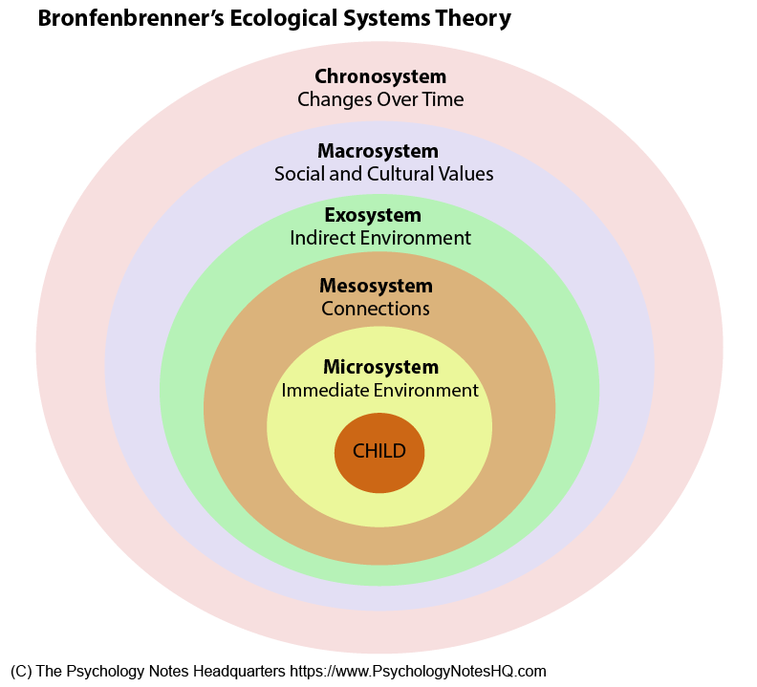
Appendice number 1

- The Psychological Notes (2016) Available at: https://www.psychologynoteshq.com/ bronfenbrenner-ecological-theory/ (Accessed on: 04.01.2021)
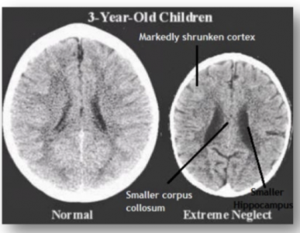
Appendice number 2

- Rosita, Z. (2017) Available at: https:// beyond good health clinics . com.au/adverse-childhood-experiences-aces/ (Accessed on: 02.01.2021)
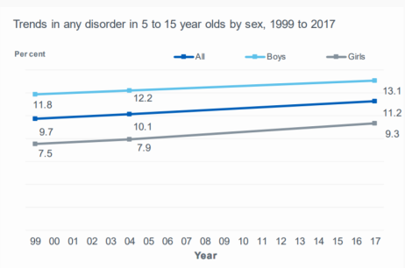
Appendice number 3

- NHS Digital (2017) Available at: https://files.digital.nhs.uk/A6/EA7D58/MHCYP%202017%20Summary.pdf (Accessed on: 07.01.2021)

References
- Barnes, P. and David, C. (2013) Neurological Rehabilitation. Amsterdam: Elsevier.
- Bronfenbrenner, U. and Morris, P. (1998) The ecology of developmental process. New York: John Wiley
- Child Welfare Information Gateway. (2001) Understanding the Effects of Maltreatment on Early Brain Development. Washington DC: Children’s Bureau/ACYF
- Crisis Prevention Institute. (2018) Management of actual or Potential Aggression Foundation Programme for Schools. United States: CPI, MAPA.
- Development public health wales. (2018) Adverse Childhood Experiences in Wales. Available at: http://www.wales.nhs.uk/sitesplus/documents/888/Wales%20Public%20Health%20Conference%20MAB%20Draft%20%5BRe.pdf (Accessed on 16.12.2020)
- First Discoverers, (2020) Child Development Theories: Lev Vygotsky. Available at: https://www.firstdiscoverers.co.uk/lev-vygotsky-child-development-theories/#:~:text=Vygotsky's%20sociocultural%20theory%20asserts%20that,development%20of%20higher%20psychological%20functions. (Accessed on. 03.01.2021)
- Hovens, M. (2015) Impact of childhood trauma on depressive and anxiety disorders. Netherlands: W.J.H. Penninx
- Lets help every child Thrive (2021) Thrive uses a simple model to illustrate how we all develop as human beings. Available at: https://portal.thriveapproach.com/approach/info/underlying-models/ (accessed on: 03.01.2021)
- Lively, S. (2015) Reasons why kids get angry. Available at: https://onetimethrough.com/about/ (Accessed on: 14.12.2020)
- Lim, E. (2008) 7 How-to-be-happy Lessons That Kids Can Teach Us. Available at: https://www.dumblittleman.com/7-how-to-be-happy-lessons-that-kids-can/#:~:text=Children%20are%20always%20happy%20because,worst%20in%20people%20or%20situations. (Accessed on: 16.12.2020)
- Malik, W. (2015)Every day is full of emotions. Available at: https://www.quora.com/Why-are-we-happy-as-children-but-unhappy-as-we-grow-adults-Is-there-something-wrong-with-the-way-the-world-has-been-set (Accessed on: 16.12.2020)
- Nip in the Bud (2020) Recognising Depression in Children. Available at: https://nipinthebud.org/child-mental-health-conditions/recognising-depression/?gclid=EAIaIQobChMIlomYsMmP7gIVDOvtCh1LCwyaEAAYASAAEgLPy_D_BwE (Accessed on: 03.01.2021)
- Public Health Wales. (2015) Adverse Childhood Experiences and their impact on health-harming behaviours in the Welsh adult population. Wales: Public Health Wales NHS Trust.
- School P, Lets help every child Thrive policy. (2020)
- School P, Pupil support policy. (2020)
- School P, Values policy. (2020)
- Shore, R. (1997). Rethinking the brain. New York: Families and Work Institute.
- The Psychological Notes (2021) What is Bronfenbrenner’s Ecological Systems Theory? Available at: https://www.psychologynoteshq.com/bronfenbrenner-ecological-theory/ (Accessed on: 04.01.2021)
- Thrive Approach (2020) Who we work with. Available at: https://www.thriveapproach.com/?gclid=EAIaIQobChMIqM-ypZGQ7gIVGOuyCh3xPQACEAAYASAAEgLkWfD_BwE (Accessed on 29.12.2020)
- UNICEF. (2007) An overview of child well-being in rich countries. Florance: The United Nations Children’s Fund
- World Health Organization. (2020) Mental health: strengthening our response. Available at: https://www.who.int/en/news-room/fact-sheets/detail/mental-health-strengthening-our-response (Accessed on: 14.12.2020)
- Welsh Government. (2012) A Strategy for Mental Health and Wellbeing in Wales. Wales: Crown.
- Yale Medicine (2021) Parental Depression: How it Affects a Child. Available at: https://www.yalemedicine.org/conditions/how-parental-depression-affects-child (Accessed on: 03.01.2021)

