

Project Management

Module Code : LCLM5003

Lecturer Name : Xavier Matieni

Student Name: Andrei Posmosanu

Student ID: 2335692

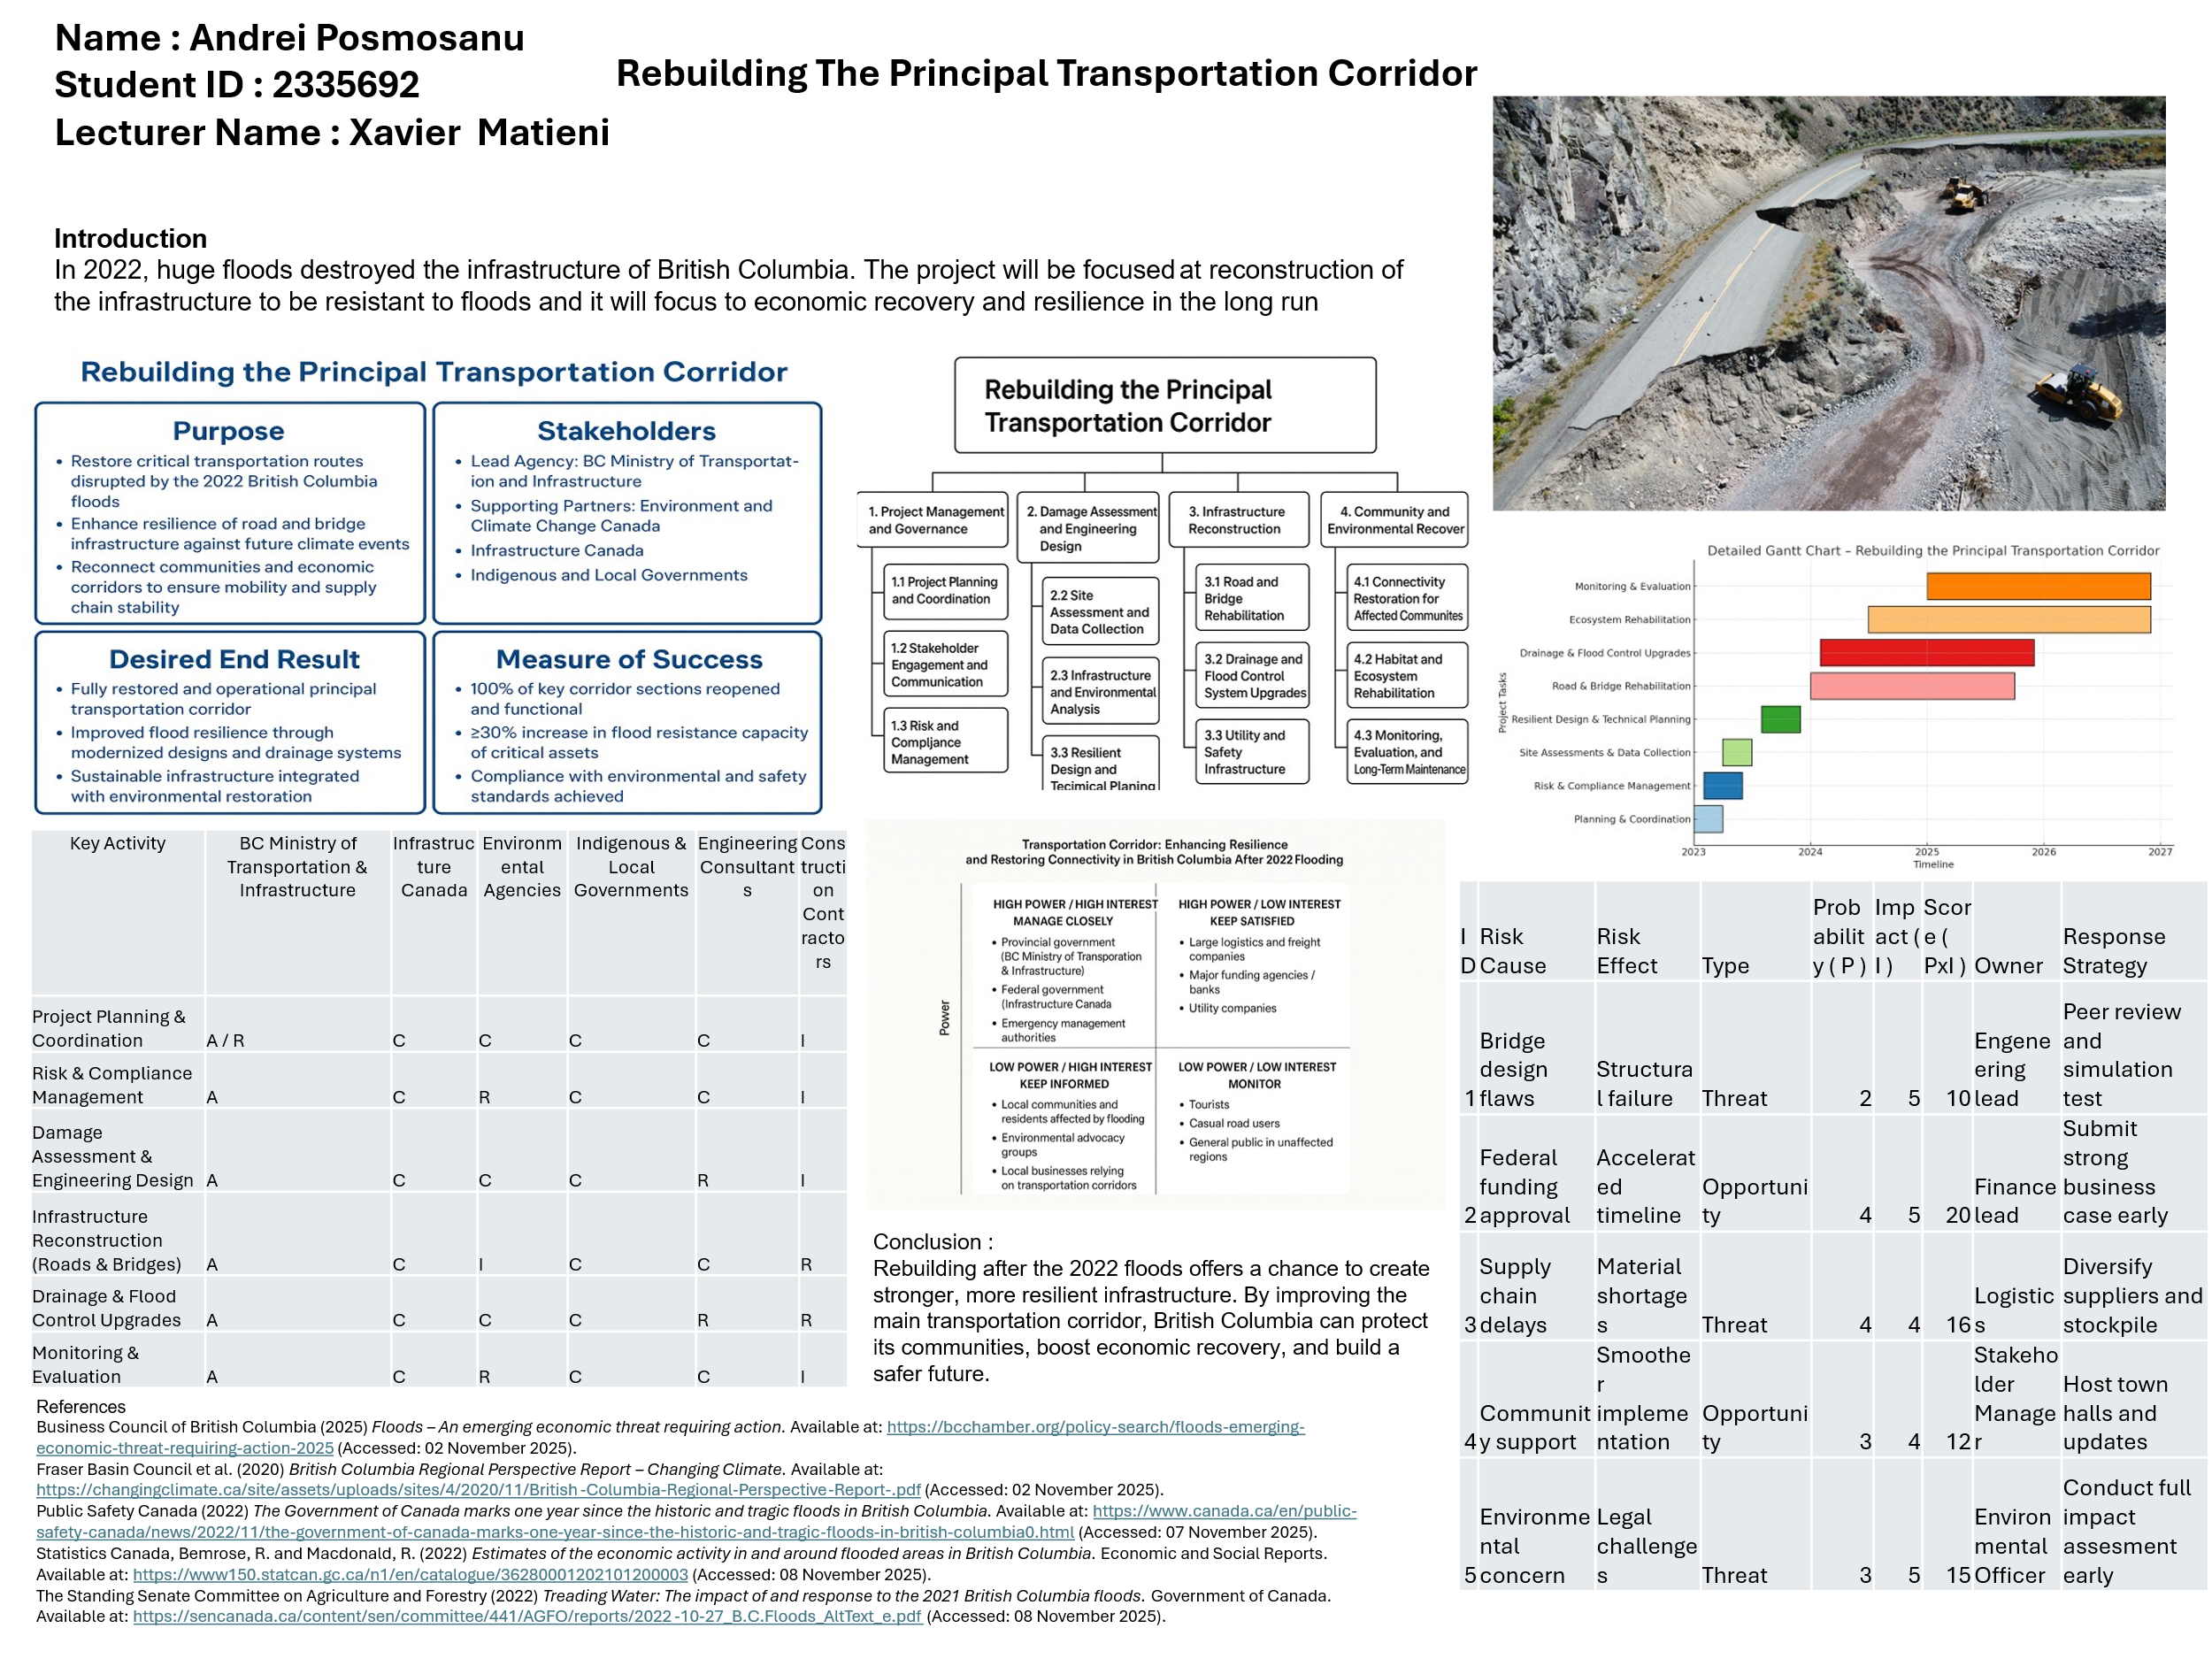

Reflection on Feedback

Contents
Introduction 4
Positive Aspects of Feedback 4
Areas for Improvement 4
Reflection of Learning and Implementation 5
Conclusion 5

Introduction
In this overall project management task the first part was making a poster about the overall project which have already done. The title of the poster is “Rebuilding the Principal Transportation Corridor: Enhancing Resilience and Restoring Connectivity in British Columbia after the 2022 Flooding". This has highlighted the overall details of the project however there were some lack that were identified and this reflection will provide the overall idea of the project process.

Positive Aspects of Feedback
The main objective of the project was very clear and this shows the clear idea about the sustainable process of the overall recovery and principles. Feedback has shown the positive areas of the work and these are also very useful to find areas of improvement of the overall project. The choice of hybrid Waterfall-Agile methodology was praised for the right balance of control and flexibility. This shows best practice in today's infrastructure projects (Kerzner, 2023). Furthermore, the clear articulation of risk management strategies and the integration of a flood resilience framework were perceived as a strength that demonstrated critical awareness of environmental disasters. For example, stakeholders from First Nations communities and local communities were also involved in the process and peers commented positively on this stakeholders inclusion as a moral and equitable project management approach in line with the PMBOK (Pmi.org, 2025). Overall, feedback indicated that the project idea was workable, technically sound and adequately presented.

Areas for Improvement
Despite this positive reception, there were several areas that needed refinement. Feedback indicated that the Work Breakdown Structure (WBS) in the poster was too high level and did not provide enough detail to demonstrate task interdependencies and measurable deliverables. Moralization of the breakdown structure was advised to improve the level of traceability and to provide base for the cost-time control which is a key element of the project governance (Huemann and Turner, 2024). Additionally, the Gantt chart was described as visually informative but without clear dependency arrows and milestone indicators. Critical paths will be colour-coded and the visual hierarchy will be improved in the final plan.
The need for greater specificity with regard to the stakeholder communication plan-particularly in relation to communication frequency, reporting formats and escalation procedures is also highlighted in the feedback process. Combining these will help increase accountability and transparency amongst federal, provincial and local stakeholders.

Reflection of Learning and Implementation
Importantly, the feedback process helped to further clarify the ways in which visual communication and methodological justification influence professional project delivery. Adding the recommendations promoted critical reflection on translating theoretical frameworks into project artefacts. In particular, the development of a refined WBS and an evidence-based stakeholder strategy shows improved skills in planning and integration management which is essential for Level-5 learning outcomes. The iterative feedback loop is consistent with the principles of experiential learning and improves reflective practice as a facilitator of continuous improvement in project implementation (Ajani, 2023).

Conclusion
The comments were extremely helpful in improving the academic and practical requirements of the project. The Project Management Plan will be further developed incorporating more detailed scheduling, stronger communication strategies with stakeholders and more broad-based scholarly justification which will help to enable successful delivery of a strong and sustainable transport corridor in British Columbia.

References
Ajani, O.A., 2023. The role of experiential learning in teachers’ professional development for enhanced classroom practices. Journal of Curriculum and Teaching, 12(4), pp.143-155.
‌Huemann, M. and Turner, J.R. eds., 2024. The handbook of project management. Routledge.
Kerzner, H., 2023. Project Based Problem Solving and Decision Making: A Guide for Project Managers. John Wiley & Sons.
Pmi.org. (2025). PMBOK Guide | Project Management Institute. [online] Available at: https://www.pmi.org/standards/pmbok [Accessed 05 Dec. 2025].

Project Management Plan
Contents
1. Introduction 8
2. Project Description 8
3. Scope 9
4. Work Breakdown Structure (WBS) 10
5. Quad Chart 13
7. Stakeholder Involvement 16
8. Resource Allocation 17
9. Risk Analysis 18
10. Conclusion 20
References 21

1. Introduction
In 2022, an atmospheric river wreaked havoc across British Columbia (B.C.) destroying critical bridges and highways that cut the Lower Mainland off from the rest of Canada. The disaster disrupted transportation, halted supply chains and highlighted the urgent need for resilient infrastructure that can better withstand future climate extremes (Hoekstra, 2022). As a result, this Project Management Plan is a comprehensive plan for the project Rebuilding the Principal Transportation Corridor which enhances flood resiliency, restores connectivity and promotes long-term regional sustainability.
The plan incorporates major principles of project governance, risk management and stakeholder management while using a hybrid Waterfall-Agile approach to ensure that there is structured planning and adaptive implementation (Kerzner et al., 2022). Waterfall processes will be used during early design and procurement stages while Agile processes will be used during construction to make changes on site and to be responsive to environmental and logistical issues. The plan includes specific objectives, scope of the project, work breakdown, resource allocation, scheduling and risk mitigation, providing effective control and delivery completion within 24 months. Also, federal, provincial and First Nations stakeholders are brought together to ensure that the project is inclusive, accountable and socially equitable while meeting current sustainable infrastructure criteria (Pmi.org, 2025).

2. Project Description
The project concerns the rehabilitation of the main transport corridor which links British Columbia's (B.C.) Lower Mainland with the interior. In 2022, catastrophic flash floods of intense flooding damaged stretches of Highway 5 and multiple bridge structures and disrupting access and stopping passenger and freight traffic. This disruption highlited the critical need to reconstruct the corridor with climate-resilient engineering solutions providing long-term safety, adaptability and economic stability (OECD, 2025). The overall objective of the project is the return to full mobility and simultaneously incorporate resilience through state-of-the-art design and sustainability concepts.
Goals and Objectives
- Restore transport corridor and re-open main highway in 24 months
- Incorporate flood resistant materials and construction to minimise closure by at least 50 percent.
- Digital monitoring and maintenance systems to be implemented by Month 20
- contribute to the economic recovery and inter-provincial connectivity (Quium, 2019).
Methodology
There will be a hybrid Waterfall-Agile project delivery model. The Waterfall stages such as feasibility, design and procurement ensure regulatory compliance and structured documentation. Agile methods will dominate the construction phase and commissioning phase which allows for flexibility in response to environmental and geotechnical variations (Watson and Ahn, 2022). Progress will be continuously measured through earned-value analysis and bi-weekly review meetings as well as adaptive scheduling.
Expected Benefits
- Restoration of key logistics and mobility routes.
- Enhanced flood resilience and public safety.
- Strengthened collaboration among stakeholders and First Nations communities.

3. Scope
The project scope entails repairing damaged road and bridge infrastructure of an 80 km section of the major transportation route between Hope and Merritt, British Columbia. This includes a complete many activities, covering design, procurement, construction and monitoring to ensure a restoration of connectivity and resilience to future floods. The major deliverables are completion of engineering designs, procuring sustainable materials, building culverts and embankments, installing real time flood monitoring systems and performing post construction review to ascertain effectiveness and sustainability of the infrastructure in the long run.
In Scope
- Conducting hydrological and geotechnical surveys.
- Designing flood-resistant bridge piers and road embankments.
- Reconstructing severely damaged highway segments.
- Installing drainage networks and early-warning sensor systems.
- Undertaking environmental impact assessments (EIA) and implementing mitigation plans.
Out of Scope
- Reconstruction of private properties.
- Repairs to secondary local roads.
- Non-transport utility installations such as pipelines or telecommunication lines.
Constraints and Assumptions
The entire project budget is approximated at CAD 1 billion (Hoekstra, 2022) and it is expected to be ready within 24 months. External factors influencing the schedule comprise of harsh weather conditions and regulatory approval schedules. Funding is supposed to be paid out over the period the required permits are supposed to be issued by Month 3 and that the cooperation of the stakeholders would remain the same across the project lifecycle.

4. Work Breakdown Structure (WBS)
The Work Breakdown Structure (WBS) subdivides the project into five major stages to make the project have a clear sense of accountability, effective lines of communication and simple implementation. This framework complies with 2021 PMI (2021) project management standards and assists in the coordination of teams, resources and timelines.
Phase | Duration | Key Tasks | Deliverables
1. Initiation | 0-1 month | - Develop project charter  - Appoint project management team  - Conduct feasibility and environmental assessments  - Identify key stakeholders | Approved project charter, feasibility report, and stakeholder register
2. Design & Procurement | 1-3 months | - Finalise detailed engineering designs  - Conduct risk assessments  - Issue RFPs and evaluate tenders  - Obtain regulatory and environmental permits | Finalised design blueprints, procurement contracts and approval documentation
3. Construction Phase 1 | 4-12 months | - Begin bridge foundation and earthworks  - Install culverts, drainage, and erosion control systems  - Monitor site safety and quality compliance | Completed foundations, culvert systems, and progress reports
4. Construction Phase 2 | 13-18 months | - Complete bridge superstructures and road surfacing  - Install flood-monitoring sensors and signage  - Conduct periodic performance reviews | Fully operational corridor sections and installed monitoring systems
5. Commissioning and Monitoring | 19-24 months | - Test and inspect all completed works  - Conduct safety audits and environmental compliance checks  - Train maintenance staff and handover assets | Final safety audit, maintenance training report, and project handover certificate

Each phase is supported by a RACI Matrix which helps to defines responsibilities and ensures effective collaboration in the project:
- Responsible: Project Manager, Construction Lead
- Accountable: B.C. Transport Authority
- Consulted: Environmental Engineers, First Nations Liaisons
- Informed: Local Communities and Business Operators
This framework is organised to ensure that it aligns with the critical path activities, facilitates timely decision-making, and facilitates the effective use of resources to deliver the project successfully (Watson and Ahn, 2022).

5. Quad Chart
The Quad Chart is a brief overview of the main parameters of the project and it allows enabling executives and other stakeholders to analyze the progress and performance of the project in an effective manner. It points out the objectives, deliverables, timelines, risks and quantifiable success indicators that are strategic priorities.
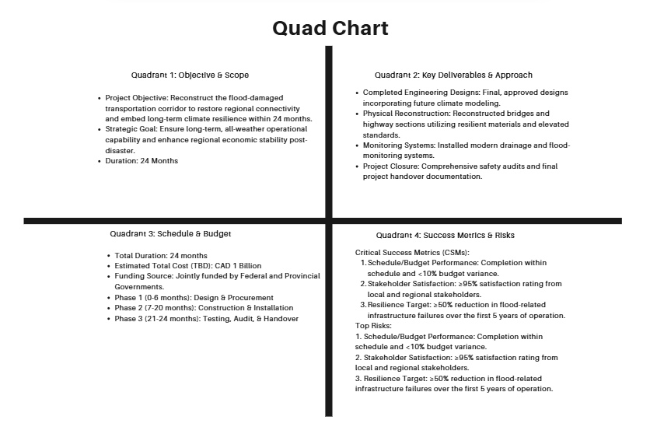

Element | Details
Objective | Reconstruct the flood-damaged transportation corridor to restore regional connectivity and embed climate resilience within 24 months.
Key Deliverables | Completed engineering designs; reconstructed bridges and highway sections; installed drainage and flood-monitoring systems; comprehensive safety audits; and final project handover.
Schedule & Budget | Total duration: 24 months. Estimated cost: CAD 1 billion jointly funded by Federal and Provincial Governments.
Risks | Severe weather delays, labour shortages, supply chain disruptions, cost escalation, and environmental non-compliance.
Success Metrics | Completion within schedule and <10% budget variance; ≥95% stakeholder satisfaction; and ≥50% reduction in flood-related infrastructure failures.

This structured summary supports rapid decision-making, accountability and transparent communication across all project governance levels (Kerzner et al., 2022).
6. Gantt Chart
A 24-month schedule will be visualised in Primavera P6. Major milestones include:
- Month 1: Project initiation and charter approval.
- Month 3: Design and procurement complete.
- Month 12: Completion of foundations and culverts.
- Month 18: Bridge superstructure and road surfacing complete.
- Month 22: System testing and safety inspection.
- Month 24: Final handover and project closure.
Tasks | Month 1 | Month 3 | Month 12 | Month 18 | Month 22 | Month 24
Project initiation and charter approval
Design and procurement complete
Completion of foundations and culverts
Bridge superstructure and road surfacing complete
System testing and safety inspection
Final handover and project closure

Dependencies between design, procurement and construction phases will be represented with critical-path links. Bi-weekly progress reviews will enable adaptive re-scheduling as per Agile principles (Waterworth and Gavin, 2024).

7. Stakeholder Involvement
Effective stakeholder management is essential for the success of the project especially in large-scale public infrastructure projects where various parties have a focus in the outcome (Pmi.org, 2025). The Rebuilding the Principal Transportation Corridor Project involves a number of diverse stakeholders each with unique perspectives, resources and decision-making authority.
Key Stakeholders
- Federal and Provincial Governments: Provide funding, establish regulatory compliance and monitor progress through policy oversight.
- Local Governments and First Nations: Facilitate land-use permissions, cultural consultation and ensure community impacts are appropriately addressed.
- Engineering and Construction Firms: Execute the design, procurement and construction processes under contractual obligations.
- Transport Operators and Businesses: Offer operational feedback to optimise logistics, mobility and economic recovery post-construction.
- Local Communities: Represent end-users who benefit from improved safety, accessibility and economic revitalisation.
Stakeholder mapping is a process of categorising participants according to power and interest levels in order to determine the frequency of communication as well as the method of communication. High-power stakeholders such as government bodies are provided with detailed progress reports on a monthly basis and are involved in steering committee meetings. Medium-power stakeholders such as engineers and contractors attend bi-weekly coordination meetings to ensure technical alignment. Low-power stakeholders such as community members are informed through newsletters, public forums and digital communication platforms.
A comprehensive Stakeholder Engagement Plan (SEP) is designed to set up communication channels, reporting structures and conflict resolution procedures. Applying Freeman's (1984) stakeholder theory, the project focus on inclusivity, transparency and a shared value creation (Bonnafous-Boucher and Rendtorff, 2016). This approach ensures that the considerations of the environment, culture and economy are balanced against all the different groups of stakeholders.
Feedback mechanisms such as surveys, consultations and feedback loops enable continuous adaptation to stakeholder concerns which leading to improved collaboration and accountability. Effective engagement builds mutual trust and long-term support which is essential in achieving the resilience and sustainability goals of the project (Farag, 2018).

8. Resource Allocation
Effective resource allocation helps to ensure that labour, materials, equipment, finance and technology are being managed efficiently to help achieve the project's goals. Proper planning and coordination of these resources is necessary to ensure the integrity of the schedule, control of the cost and maintenance of quality standards for the entire 24-month duration.
Resource Type | Description | Source / Funding
Human Resources | Project Manager, Civil and Structural Engineers, Procurement Officers, Environmental Specialists and approximately 300 Construction Workers. | Funded jointly by government and contractors.
Material Resources | Concrete, asphalt, steel beams, drainage systems, and flood-monitoring sensors prioritising sustainable and locally sourced materials. | Local suppliers with preference for B.C.-based procurement.
Equipment | Excavators, pavers, cranes, trucks, and digital surveying tools such as drones and scanners for terrain mapping. | Leased or rented under approved contracts.
Financial Resources | Project budget of CAD 1 billion, covering all design, construction and contingency allocations. | Shared funding from Federal and Provincial Governments.
ICT Resources | Primavera P6 for scheduling, BIM 360 for design coordination, and ERP systems for cost tracking. | Allocated from the project’s IT and operations budget.

Earned Value Management (EVM) will track progress through Schedule Performance Index (SPI) and Cost Performance Index (CPI) to find deviations (Janaka et al., 2025). Resource leveling and critical-path analysis will maximise productivity and eliminate over-allocations. Routine health and safety training will increase worker competency and conformance with ISO 45001 standards (Lizarzaburu et al., 2025). This structured approach ensures efficiency, accountability and continuous improvement throughout all project phases while ensuring effective delivery within the scope, time and budget limitations.

9. Risk Analysis
Risk management is essential to the continuity of projects and it is extra critical in complex infrastructural projects that are prone to natural and operational uncertainties. Rebuilding the Principal Transportation Corridor Project has environmental, financial and logistical risks which need to be identified, assessed and reduced systematically. Risk register will also be created as a monthly review in order to keep it updated and because of the varying threat levels (Watson and Ahn, 2022).

Risk | Probability | Impact | Mitigation Strategy
Severe Weather Delays | High | High | Incorporate real-time meteorological forecasting, include buffer weeks in the construction schedule, and obtain weather insurance to offset delays.
Cost Overruns | Medium | High | Maintain a 10% contingency fund, enforce strict procurement oversight and monitor costs through Earned Value Management (EVM).
Supply-Chain Disruption | Medium | Medium | Establish agreements with multiple local suppliers, pre-purchase critical materials, and implement just-in-time logistics monitoring.
Labour Shortages | Low | Medium | Initiate early recruitment, provide local workforce training and establish retention incentives to minimise turnover.
Environmental Non-Compliance | Low | High | Conduct continuous Environmental Impact Assessment (EIA) monitoring, enforce waste management protocols and perform regular regulatory audits.
Community Opposition | Low | Medium | Implement transparent communication strategies, community consultations and compensation mechanisms for affected residents.
Safety Incidents | Medium | High | Introduce comprehensive health and safety training, enforce ISO 45001 standards and conduct daily toolbox talks.

The probability-impact matrix identifies risk as either likely or severe and the risks most at risk are weather-related and cost-overrun risks. A dedicated Risk Manager will report to the Project Steering Committee on a monthly basis which will ensure rapid response and accountability.
The risk management process is based on ISO 31000 standards and is characterised by proactive identification, assessment, and mitigation. Risk responses are divided into four strategies: avoid (change plans to eliminate risk), transfer (introduction of outsourcing/contracting, insurance), mitigate (reduce probability/impact) and accept (contingency response planning).
Modelling of cost and schedule variation with sophisticated analytical tools like Monte Carlo simulations which allowing to predictively change the project plan and also scenario planning will be used to determine the effects of climate extremes and supply delays. This integrated and adaptive approach enables resilience, compliance and confidence across all stakeholders needed to successfully complete the project within time and budget constraints (Janaka et al., 2025).

10. Conclusion
This Project Management Plan will provide an in-depth structure of reconstruction of a major transportation route in B.C. after the floods of 2022. It is demonstrated how traditional project management tools (WBS, Gantt diagram, Risk register and Stakeholder matrix) are used in a Waterfall-Agile approach. Its plan is based on sustainability, adaptive planning and inclusive governance in order to give future shocks a cushioning infrastructure. An effective implementation will reinstate connectivity that will assist the economic healing and provide an example on climate-resilient transport infrastructure projects globally. The project assists in enhancing the importance of government, communities and technical specialist collaboration in achieving sustainable results. By incorporating innovation, risk mitigation and participation of stakeholders it demonstrates how infrastructure development can improve resilience and long-term well-being. The lessons will be used as a guiding model of climate adaptation and disaster-recovery programs in future world over.

References
Bonnafous-Boucher, M. and Rendtorff, J.D., 2016. Stakeholder theory in strategic management. In Stakeholder theory: A model for strategic management (pp. 21-39). Cham: Springer International Publishing.
Farag, F., 2018. Understanding social value creation in public construction projects using systems thinking. University of Salford (United Kingdom).
Hoekstra, G., 2022. A year after floods, B.C. estimates cost of climate-resilient highway rebuilds at $1 billion. [online] Vancouver Sun. Available at: https://vancouversun.com/news/local-news/bc-floods-estimate-highway-rebuilds-1-billion [Accessed 6 Nov 2025].
Janaka, V., Manjaree, S. and Langseth, M., 2025. Critical Success Factors for Virtual Teams: Evidence from Undergraduate Students in Sri Lanka. Procedia Computer Science, 263, pp.232-241.
Kerzner, H., Zeitoun, A. and Vargas, R.V., 2022. Project management next generation: The pillars for organizational excellence. John Wiley & Sons.
Lizarzaburu, E., Chavez, M., Garcia, C., Noriegac, E. and Tinoco, D., 2025. ISO 31000 guide: Steps used in all types of organizations in Latin American Countries. Multidisciplinary Reviews, 8(7), pp.2025212-2025212.
OECD. (2025). The Organisation for Economic Co-operation and Development. [online] Available at: https://www.oecd.org/en.html [Accessed 9 Nov. 2025].
Pmi.org. (2025). PMBOK Guide | Project Management Institute. [online] Available at: https://www.pmi.org/standards/pmbok [Accessed 10 Dec. 2025].
Quium, A.A., 2019. Transport corridors for wider socio–economic development. Sustainability, 11(19), p.5248.
Waterworth, A. and Gavin, C., 2024. Managing Projects. Routledge.
Watson, G. and Ahn, J.E., 2022. A systematic review: To increase transportation infrastructure resilience to flooding events. Applied Sciences, 12(23), p.12331.

