
Programme Name: Master of Business Administration
Module code: LCMB7024
Title of submission: Assessment component 2: Marketing Portfolio
Lecturer Name: Dr Laila Maazouz
Student Name: Gurumukh singh pavitar singh sandhu
Student ID: 2434321
Word Count: 2387

Table of Contents
Element 1 – STDP for the New Brand 3
1.1 Company, concept, and why the UK and Sweden 3
1.2 Market problem, trends, and buyer-behaviour implications 4
1.3 Segmentation 5
1.4 Targeting strategy 7
1.5 Differentiation and positioning 8
Element 2 – Marketing Mix (7Ps) 8
2.1 Overview: from STDP to 7Ps 8
2.2 Product 8
2.3 Price 9
2.4 Place 9
2.5 Promotion 10
2.6 People 10
2.7 Process 11
2.8 Physical Evidence 11
Element 3 – Marketing Strategy Pitch 12
Element 4 – Reflection 12
Kolb’s model of Reflection 12
References 15
Appendix 18

Element 1 – STDP for the New Brand

Company, concept, and why the UK and Sweden
IKEA Wear is a vertical clothing brand, which is an extension of the design philosophy of IKEA, i.e., affordable and functional, into a line of clothing designed to last long, be repaired, and reused. The business case of category expansion itself is not the reason why the strategy has been pursued, but rather a reaction to the growing pressure to ensure that fashion brands can prove their environmental credibility and minimise waste as the global sustainable fashion market has reached $10092.9 million in 2025 (Globalgrowthinsights.com, 2025). The comparison of the UK with Sweden is intentional in that it would involve testing the same value proposition in two conditions of adoption. The UK is a larger market generating a revenue of £64.5 billion annually with higher price pressure, and success is attained through making circularity convenient and economical (e.g., durability, cost-per-wear, and repair value) (Smith, 2024). Sweden is smaller yet more sustainability-mature, as 55% of consumers are willing to pay a premium for sustainable options, hence it can serve as a lead market in piloting more circular services and demanding proof points (Voyado, 2024). Such framing maintains the central positioning in both countries and justifies subsequent reasons to believe in STDP and the marketing mix.
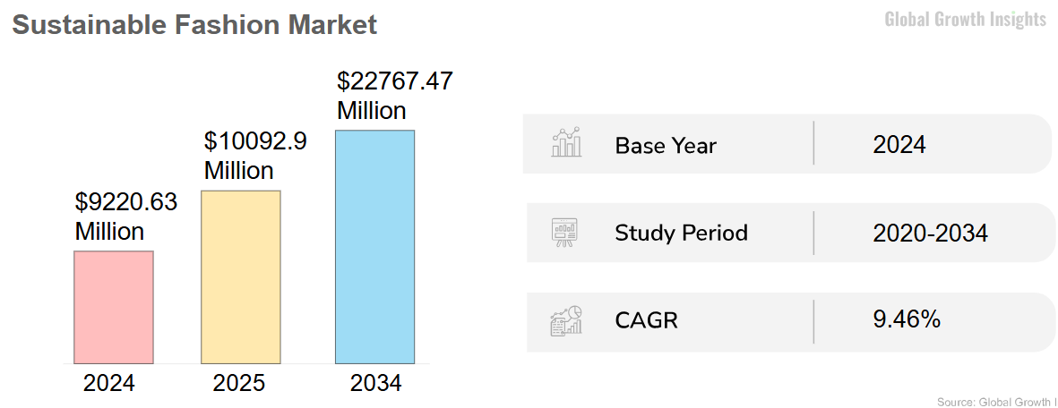
Figure 1: Global sustainable fashion
Source: Globalgrowthinsights.com, 2025
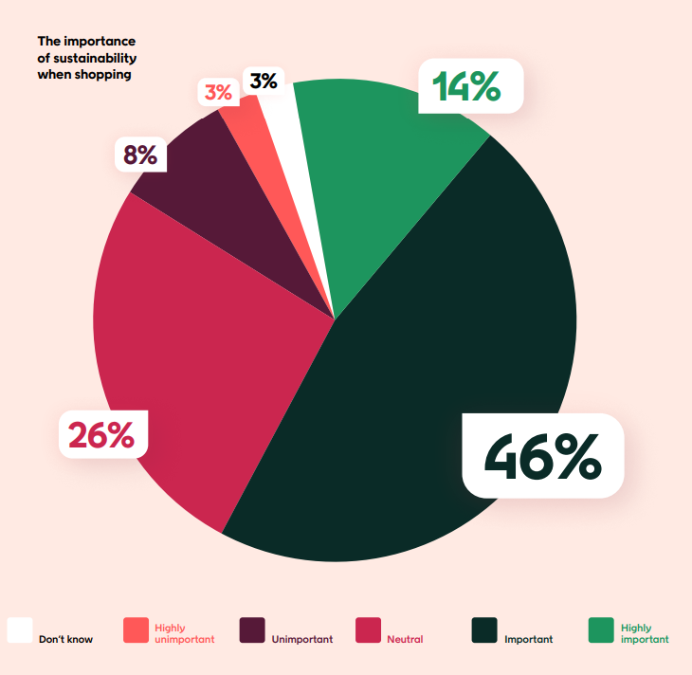
Figure 2: Sustainability stance in Sweden
Source:

Market problem, trends, and buyer-behaviour implications
Excessive consumption and early discarding of clothing are market issues rather than an unsatisfied clothing requirement, as the industry contributes up to 10% of global carbon emissions and 20% of wastewater (Li, 2024). Fashion is linked to significant environmental effects (high water pollution and significant greenhouse gas emissions) around the world, and this is putting pressure on brands, both in regulatory and reputational terms. This alters competitive advantage in favour of novelty towards longevity, take-back infrastructure, and open product information. Even commercial indicators agree on the direction: The UK sustainable fashion is expected to grow exponentially at a CAGR of 23.60% by 2033, which means that it has the chance to grow, but it has a greater risk of being mistrusted if the sustainability claims are not supported (IMARC, 2025).

Segmentation
Segmentation is the process of subdividing a general market into smaller groups that share common needs/behaviours so as to better target and position (Jaiswal et al., 2021).
Segmentation connections between the two countries:

Figure 3: Segmentation
Source: By the author
Potential market segments (UK vs Sweden).
Segment | UK | Sweden
A. Eco-active urban professionals | Adoption depends on credible proof; mistrust of greenwashing is a barrier. | Higher sustainability orientation: 61% sustainability focus.
B. Responsible value switchers | Massive segment because of crisis of cost of living; 42.8 percent anticipate ecological responsiveness but are price conscious (Tan, Yu, and Yan, 2019). | Smaller but relevant; resale and repair services appeal to this group.
C. Circular convenience seekers | Adoption depends on friction-free processes (easy repairs, simple returns). | Already shifting behaviour; 27% reduction in purchase of garments evidencing a behavioural change (Grönlund, Gelebo and Darpö, 2024).

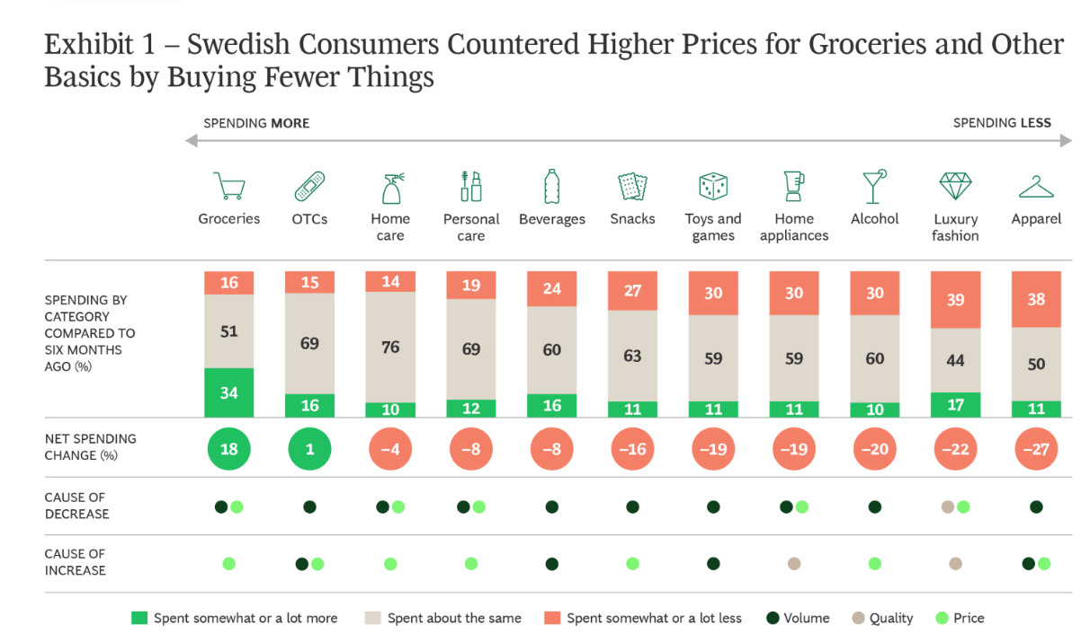
Figure 4: Suitability shift in Swedish consumers
Source: Grönlund, Gelebo, and Darpö, 2024

Figure 5: MASDA application
Source: By the author
Most attractive: Responsible Value Switchers are the most scalable demand in the UK, if the circularity is perceived as a matter of affordability and convenience. Circular Convenience Seekers and Eco-active Professionals in Sweden transform more quickly because of the more well-developed sustainability principles.

Targeting strategy
IKEA Wear uses the differentiated targeting strategy: a single circular brand concept in the two markets, but with country emphasis (Helmold, 2022). UK Target: Responsible Value Switchers (18-35, urban) because ecological expectations are on a rise and affordability is the determining factor -33% of Gen Z have already said in 2025 that they will purchase more than in 2024 due to environmental and cost concerns (PricewaterhouseCoopers, 2025). In Sweden, the targets are the Eco-Active Urban Professionals and Circular Convenience Seekers since sustainability is an even stronger driving purchase force (72% say it affects buying) and the behaviour is changing (30% said they buy less in H1 2024), which is willingness to use the circular services.

Differentiation and positioning
With a (1) modular and durable design to be repaired, (2) built-in and circular (repair, take-back and resale), and (3) QR/app traceability to enhance transparency and compliance in the future (e.g., Digital Product Passports 2027), IKEA Wear stands out. It resembles the differentiation focus of Porter that creates advantage in a unique circular system to a given part of the urban area compared to a price war (Islami et al., 2020).
Positioning statement: IKEA Wear is a circular fashion brand meaning the customer will have a longer life of usage and less waste because of its combination of repairable design, built-in take-back infrastructure, and verified product information to the UK and Sweden, to eco-conscious urban customers aged 18-35.
The strength of proofs UK and Sweden lead with value and impact evidence respectively.

Element 2 – Marketing Mix (7Ps)

2.1 Overview: from STDP to 7Ps
IKEA Wear translates STDP into a circular product-service system: wear that is designed to last longer, is assisted with repair, take-back, and resale channels. This strategy is consistent with the commercial value and the expectation of society that fashion brands must minimise waste and deliver believable sustainability. Market conditions are differentiated by execution. In the UK, adoption is determined by a reduction in the price and effort barriers within a highly competitive environment. Sustainability is a more powerful purchase motivator in Sweden, and thus, the strategy will be able to lead with greater credibility, traceability, and service depth without losing its mainstream appeal. The net effect is to ensure that circular behaviour is the default option, using straightforward design and smooth services as opposed to the use of good intentions only (Bertelli et al., 2025).

2.2 Product
The essence of the advantage is to have fashionable necessities that last longer without being wasted. The product design should be quantifiable and testable, and not idealistic. Some of the SKU standards that IKEA Wear should set are minimum certified fibre content (where applicable), reinforced seams at load-bearing points, standard dimensions, and a stated durability goal (e.g. 5 years of wear under the normal conditions). The augmented product circle includes: (1) repair booking, (2) take-back credits and (3) resale routing. The UK collection needs to focus on entry-level circular basics that have little friction (easy to drop off and easy-to-follow care instructions). Sweden is able to provide more comprehensive bundles (e.g., extended repair services and more extensive traceability features) since the customers will request evidence and will be willing to engage in circular services (Abdelmeguid, Afy-Shararah, and Salonitis, 2024). The transparent repair pricing should be aligned with what the customers consider the normal tailoring costs, so that they will adopt them and not discard them.

2.3 Price
The prices must be based on the value and pegged on lifetime value (durability and access to repairs) rather than only on input costs. The UK pricing model must be at the forefront of affordability and a concise sense of cost-per-wear to overcome the perception that sustainable means high. Promotion of a more price-later capsule in Sweden would not have to involve the luxury purchases checking the influence and service promises (e.g. included repairs, enhanced take-back credits). To protect margins, introduce discount guardrails (limited time-off sale opportunity with limited depth) and come up with a lean service break-even logic: repairs at realistic prices, take-back credits with a customise raise-repeat-purchase ratio to open-ended subsidies (Steinbrenner and Turčinkova, 2021). This makes the pricing method acceptable and measurable.

2.4 Place
Place is a combination of the physical presence of IKEA, online channels, and reverse logistics. The Stores and Wear Corners lower the risk by providing the opportunity to do feel/fit checks and act as service nodes to drop-off/collect and take-back repair. Friction will be eliminated by using digital channels (app and web shop) to book, scan, return, and earn rewards. Reverse logistics will be considered a cost and operational risk since returns of apparel are usually high online. The early hubs of IKEA Wear in large cities (UK: London/Manchester; Sweden: Stockholm/Gothenburg) will therefore be focused, and operational standards of a business, like delivery deadlines per core lines and time of repair turnaround, should be established. The following steps must be centralised in sorting routes, and they may be repaired, resold, or recycled.

2.5 Promotion
Promotion must be taken through customers in intent-behaviour: awareness 1- education 2- trial 3- repeat 4- advocacy. In the UK, make value and practicality (durability, repairability, cost-per-wear) should be the most significant first, and sustainability should be discussed later to withstand scepticism. Sweden has a higher traceability, lifecycle evidence, and higher assumption of sustainability literacy. Generalised green language should not be used in both markets; evidence should be displayed on the product. There are three pillars that a practical content plan can apply: (1) a calculator of the cost per wear, (2) content about repair that normalises maintenance, and (3) traceability information with the use of the QR / app that clarifies materials, care, and end-of-life pathways (Yang, Guo, and Wei, 2025). This goes along with credibility and is a way of preparing the brand against the stricter expectations on product information.
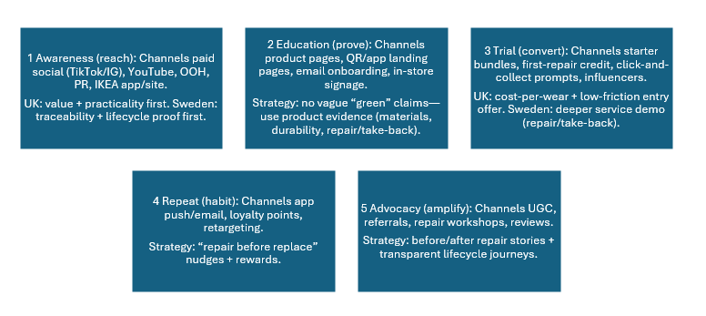
Figure 6: Intent → behaviour funnel
Source: By the author

2.6 People
Credibility and quality of service is compelled by the focus of people as it is human delivery. The key positions are trained store advisers (product and care guidance), repair technicians/partners, and customer service (booking and claims). Develop measurable objectives: the criteria of completion in the training process, the list of repair quality standards, service SLA (e.g. the maximum wait time and the first-time fix rate). Trade-off (cost and convenience) should be one of the challenges that UK training should attempt to tackle. Sweden training will be required to anticipate more detailed sustainability queries and pay attention to the evidence-based narratives.

2.7 Process
The circularity is taken or abandoned depending on the process. Journey should be hassle-free: discovery and purchase and care advice and service and repair appointment and resell. Set KPIs to show the effectiveness: the number of made repairs, the number of takebacks, the number of QR scans, the number of returns, and the increase in the number of repeat purchasers between service users. The 6-12 months implementation in 2 cities in the UK and 1 city in Sweden would be feasible pilot strategy, and monthly learning cycles (testing messages, service pricing, and booking flows). The QR system must also contain the core product information (fields), material, origin, care/repair history, and end-of-life route to improve the transparency and willingness to go further (Jain, Jain, and Jain, 2022).

2.8 Physical Evidence
Physical evidence makes the promise real: just basic fixtures, repair counters in view, sturdy wrappings, labels that can be read, and hints in the form of QR. UK indicators should expect value (transparency of price of repair and durability). Swedish cues should be in the form of foregrounding the verified impact and credibility of partners. These hints would reinforce one consistent brand image and personalise such facts regarding choices to territorial reasons (Zhou, Ho and He, 2024).
The 7Ps operationalised as a mix of a measurable circular product design and service economics, returns-focused logistics and evidence-based communications, IKEA Wear will be value-led in UK and credibility-led in Sweden.

Element 3 – Marketing Strategy Pitch
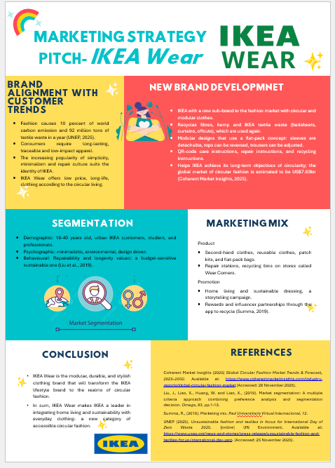

Element 4 – Reflection

Kolb’s model of Reflection
Concrete Experience
IKEA Wear is my sub-brand of circular fashion, and I enhanced the concept into a UK and Sweden marketing approach. I used STDP to determine segments, choose target audiences in all countries, and generate a positioning statement that remained the same but used various proof points. The 7Ps were then operationalised to build the strategy, with the offer being a product-service system (durable essentials with the help of repair and take-back pathways) and not an isolated product. Lastly, I developed the pitch and poster and presented the idea within a tight time frame, which challenged my skills of explaining and convincing about strategic options.
Reflective Observation
The procedure indicated that sustainability intent is not necessarily translated into sustainable behaviour. Perceived risk and effort (fit, quality uncertainty, repair inconvenience) were more apparent in various decisions than in values. I also observed the speed with which I was inclined to move to descriptive segmentation to the point where I had to push myself to explain segment selection in terms of what could be observed and what was practically reachable. Making the pitch also illuminated the other failure, which is that good analysis may be undermined by bad sequencing and time management. It was during the rehearsal in my mind that I noticed I had to tighten my signposting (problem targeted solution proof) instead of attempting to list as many details as possible.
Abstract Conceptualisation
In principle, I did get to know that cross-country strategy must be a compromise between standardisation and adaptation. The UK setting compelled me to shape circularity within the context of value and practicality, whereas Sweden needed more credibility and evidence-based communications. The 7Ps and STDP enabled me to stay on track and keep myself aligned during the process of selecting the target, as well as choosing channels, pricing, and communication. The differentiation focus of Porter made it clear that it brings an advantage when it follows a unique circular system (design, service and proof), rather than when it claims to be sustainable. But frameworks run the risk of simplifying the truth; they are as sound as the evidence that serves to fill them in. This enhanced my research strategy: I was more attentive to the credibility and the recentness of sources, and I viewed statistics as a part of the decision, but not as decorative statistics (Morris, 2020).
Active Experimentation
To improve academic and professional practise, I will: (1) make weekly micro-experiments involving communication or productivity habits, one metric and a brief learning note; (2) practise a 30-second problem-solution-proof pitch every day to learn to persuade concisely; (3) become evidence literate by questioning one source, one date, and one potential bias and practise the habit of writing down one hypothesis, action, metric, result and lesson, and tracking my progress; (5) use a 10-minute rehearsal ritual whenever I have a high-stakes conversation

References
Abdelmeguid, A., Afy-Shararah, M. and Salonitis, K. (2024). Towards circular fashion: management strategies promoting circular behaviour along the value chain. Sustainable Production and Consumption, 48, pp.143–156.
Bertelli, B., Kocollari, U., Merzi, L. and Torricelli, C. (2025). The role of circular economy in reducing corporate default probability: insights from recent research. Current Opinion in Environmental Sustainability, 75, 101555.
Globalgrowthinsights.com (2025). Sustainable fashion market size, growth | CAGR of 9.46%. (Online). Available at: https://www.globalgrowthinsights.com/market-reports/sustainable-fashion-market-105106. (Accessed on: 1 December 2025)
Grönlund, F., Gelebo, N. and Darpö, O. (2024). A challenging economy forces Swedish consumers to spend wiser. (Online). Boston Consulting Group. Available at: https://www.bcg.com/publications/2024/challenging-economy-forces-swedish-consumers-to-spend-wiser. (Accessed on: 5 December 2025)
Helmold, M. (2022). Market segmentation, targeting, differentiation and positioning. In: Performance excellence in marketing, sales and pricing: Leveraging change, lean and innovation management. Cham: Springer International Publishing, pp.105–116.
IMARC (2025). UK sustainable fashion market size, share, growth and industry report. (Online). Available at: https://www.imarcgroup.com/uk-sustainable-fashion-market. (Accessed on: 8 December 2025)
Islami, X., Mustafa, N. and Topuzovska Latkovikj, M. (2020). Linking Porter’s generic strategies to firm performance. Future Business Journal, 6(1), pp.1–11.
Jain, R., Jain, S. and Jain, S. (2022). Analysing and exploring the effectiveness of each element of the 7Ps of marketing mix. International Journal of All Research Education and Scientific Methods, 10(1), pp.2455–6211.
Jaiswal, D., Kaushal, V., Singh, P.K. and Biswas, A. (2021). Green market segmentation and consumer profiling: a cluster approach to an emerging consumer market. Benchmarking: An International Journal, 28(3), pp.792–812.
Li, J. (2024). Fast fashion and emissions: what’s the link? (Online). Earth.org. Available at: https://earth.org/fast-fashion-and-emissions-whats-the-link/. (Accessed on: 8 December 2025)
Morris, T.H. (2020). Experiential learning: a systematic review and revision of Kolb’s model. Interactive Learning Environments, 28(8), pp.1064–1077.
PricewaterhouseCoopers (PwC) (2025). Gen Z spending habits: the paradox of consumer trends. (Online). Available at: https://www.pwc.com/us/en/industries/consumer-markets/library/gen-z-consumer-trends.html. (Accessed on: 15 December 2025)
Smith, P. (2024). Topic: Apparel market in the UK. (Online). Statista. Available at: https://www.statista.com/topics/3348/apparel-market-in-the-uk/#editorsPicks. Accessed on: 15 December 2025.
Steinbrenner, F. and Turčínková, J. (2021). The value-based pricing determination matrix for pricing method selection. Central European Business Review, 10(4), pp.99–111.
Tan, J., Yu, M. and Yan, M. (2019). Corporate social responsibility: consumer perception for UK apparel companies. (Online). Coventry University Repository. Available at: https://pure.coventry.ac.uk/ws/files/26399511/Tan_et_al_Corporate_Social_Responsibility_JMMCB.pdf. (Accessed on: 9 December 2025)
Voyado (2024). Consumer insights report 2024: Swedish consumers and sustainability. (Online). Available at: https://knowledge.voyado.com/hubfs/Swedish%20consumers%20and%20sustainability/Voyado%20-%20Swedish%20consumers%20and%20sustainability%20-%202024.pdf. Accessed on: 15 December 2025.
Yang, J., Guo, H. and Wei, S. (2025). How pricing and promotion strategies influence customer satisfaction in sustainable fashion. International Journal of Electronic Commerce, 29(2), pp.210–234.
Zhou, J., Ho, H.W. and He, W., 2024. Physical evidence, branding, and behavior intention: Differential policy in integrated resorts marketing. Journal of Destination Marketing & Management, 34, p.100930.

Appendix

