Operating Systems
Module Name: Computer Architecture & OS
Module Code: ACCA4022
Student Name: Rehan Majid
Student ID: 2526569
Lecturer Name: Dr Md Shantanu Islam

Submission date: 22/07/2026

Contents
Introduction 4
Key functions of general Operating Systems 4
Task Management: 4
Application/Program Management: 5
File/Directory Management: 6
Device Management: 7
Security Management: 8
Use of Windows OS CLI commands 9
Example 1: 9
Example 2: 10
Example 3: 11
Example 4: 12
Example 5: 13
Example 6: 14
Example 7: 15
Example 8: 16
Example 9: 17
Example 10: 18
Use of Linux OS CLI commands 19
Example 1: 19
Example 2: 20
Example 3: 21
Example 4: 22
Example 5: 23
Example 6: 24
Example 7: 25
Example 8: 26
Example 9: 27
Example 10: 28
Use of Windows OS scripts 29
Example 1: 29
Example 2: 31
Use of Linux OS scripts 32
Example 1: 32
Example 2: 33
Conclusion 34
References 35
Appendices 36

Introduction
Operating systems are essential software that allow users and applications to interact with computer hardware. They manage important system resources such as memory, files, processes, and input/output devices, ensuring that computers operate efficiently and securely. Popular operating systems, including Microsoft Windows and Linux provide graphical and command-line interfaces that help users perform various tasks. This report explores the key functions of general-purpose operating systems and demonstrates the practical use of Windows and Linux command-line tools. It also examines the use of Batch and Bash scripting for automation. Through these activities, the report develops a better understanding of operating system management and administration

Key functions of general Operating Systems
Windows OS Introduction
Microsoft launched Windows in 1985 as an easy-to-use system with pictures and buttons, instead of typing commands. It’s now the most common operating system for personal computers worldwide. It lets you run apps, save files, connect printers and other gear, and browse the internet.

Task Management:
Task Management in Windows
Windows has a built-in tool called Task Manager, which you can see in Figure 1. It shows every app and background process running on your computer, plus how much processing power, memory, storage, and internet each one is using. If a program freezes, won’t close, or is slowing everything down, you can pick it from the list and end it right there. You can also check how your computer is performing overall and stop apps from opening automatically when you turn your PC on. This keeps things running smoothly and helps fix small issues quickly.
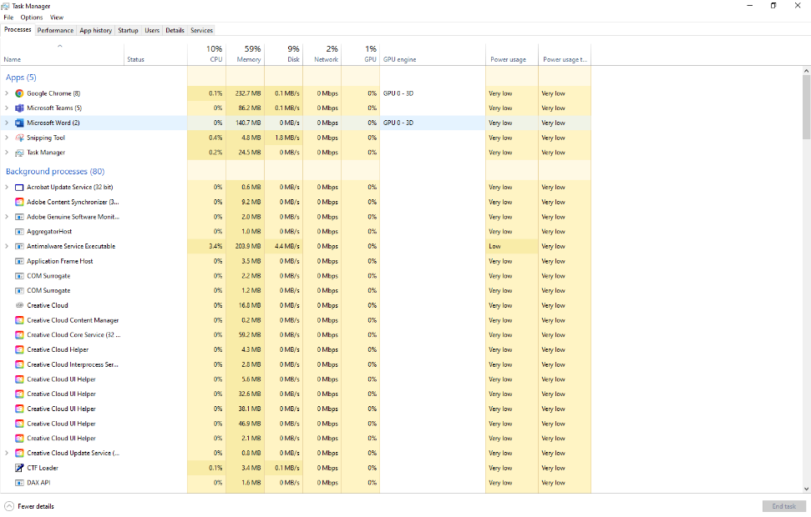
Figure 1: Task Manager

Application/Program Management:
Application/Program Management in Windows
Windows makes it straightforward to handle the apps and programs you use. You can get new ones from the official Microsoft Store or download them from trusted sites and update old ones to get new features and stay safe. When you don’t need a program anymore, you can uninstall it completely through Settings or Control Panel to free up space. You can also choose which apps open certain file types by default, and control which ones are allowed to run in the background.

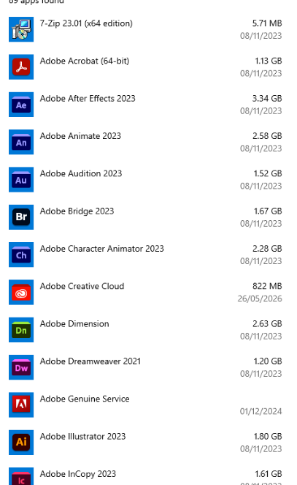
Figure 2: Application Manager

File/Directory Management:
File and directory management is used to organise and control files on a computer. In the picture, Windows File Explorer is shown, with folders such as Desktop, Documents, Downloads, Pictures and OneDrive on the left side. The user can open folders to view their files and can also create, rename, move, copy or delete files when needed. The information shown includes the file name, type, size and date it was modified. This is useful for students because it helps them keep assignments and other schoolwork organised. Good file management makes it easier to find files quickly and helps prevent important work from being lost.

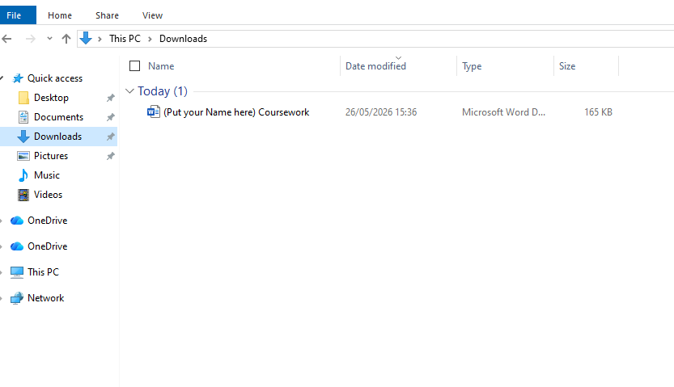
Figure 3: File Explorer

Device Management:
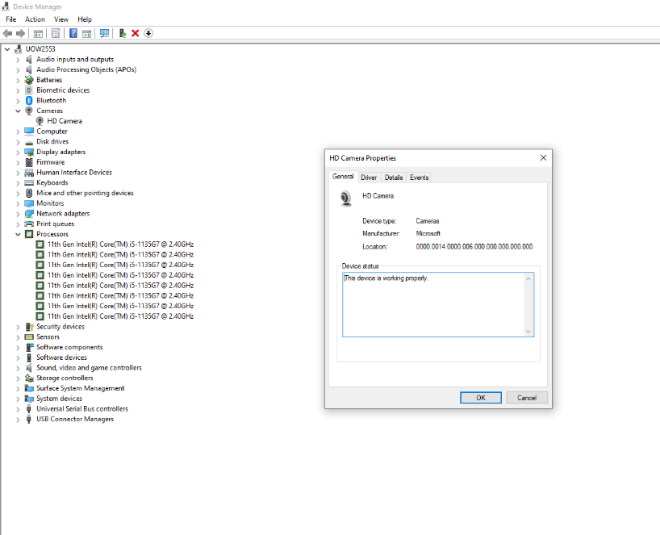
Figure 4: Device manager

Device Management in Windows
Windows device management is how you handle all the hardware hooked up to your computer like your keyboard, printer, or USB drive. The most useful tool is Device Manager. It shows every piece of hardware your PC finds, lets you check if drivers are up to date, fix errors, or turn devices on and off. You can also use Settings or Windows Update to keep things running right. This keeps your computer stable and makes sure nothing stops working out of nowhere. Microsoft says Device Manager is the go‑to spot for fixing most hardware problems.

Security Management:
Security Management in Windows
Windows security management uses built-in tools to keep your computer, files, and accounts safe from threats. The main hub is Windows Security which includes virus & threat protection, firewall settings, account safety controls, app rules, and device health checks. It runs real-time scans, blocks dangerous apps or websites, and helps you manage who can access your system. Keeping these features turned on and updated stops malware, hacks, and data leaks. Microsoft says Windows Security has all the basic protection you need built right in; no extra software required.
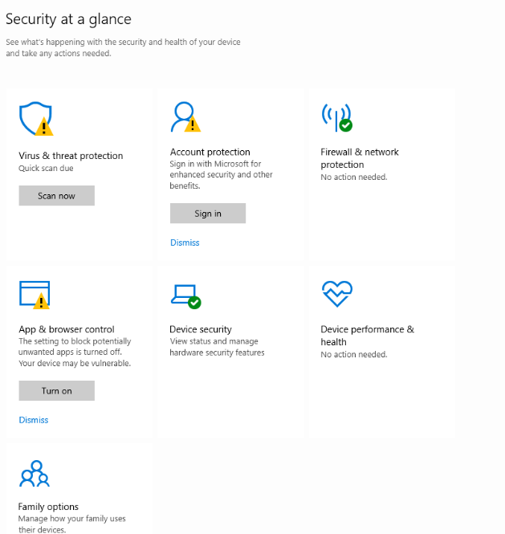
Figure 5: Security manager

Use of Windows OS CLI commands
Use of Windows OS CLI Commands
Windows Command Prompt (CLI) lets you control your system via text commands instead of clicking menus. It works fast for file management, system checks, troubleshooting, and running batch tasks. Common uses include listing files, changing folders, checking disk space, or fixing settings—great for quick or advanced work [1].

Example 1:
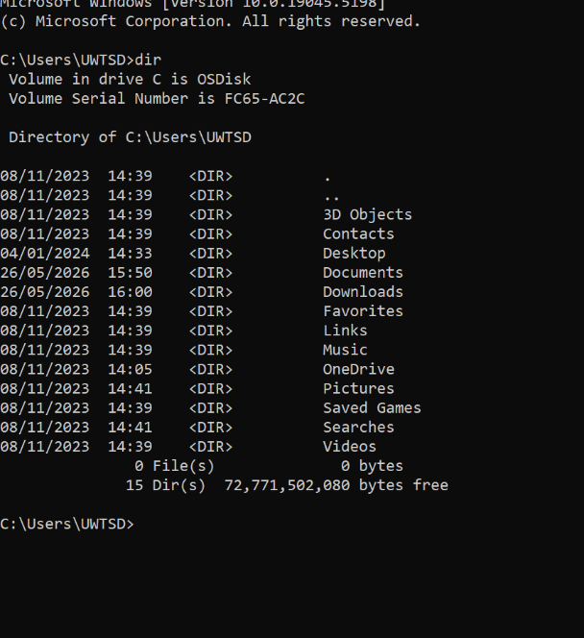

Command: dir.
Explanation: This command lists all files/folders in the current folder (C:\Users\UWTSD), shows their details, and tells you free space left on the drive [1].

Figure 6: Description

Example 2:
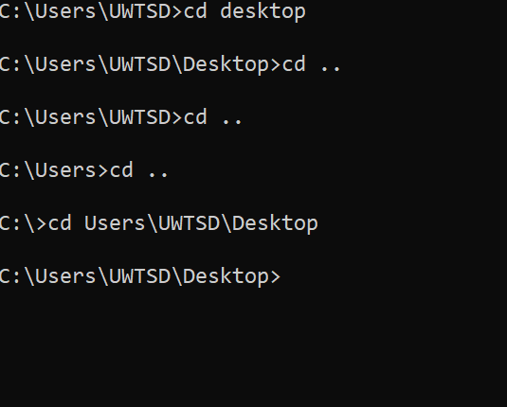
Command: cd (Change Directory)
Navigates between folders: cd desktop enters Desktop, cd. goes up one level, and full paths jump directly to locations.

Figure 7: Description

Example 3:
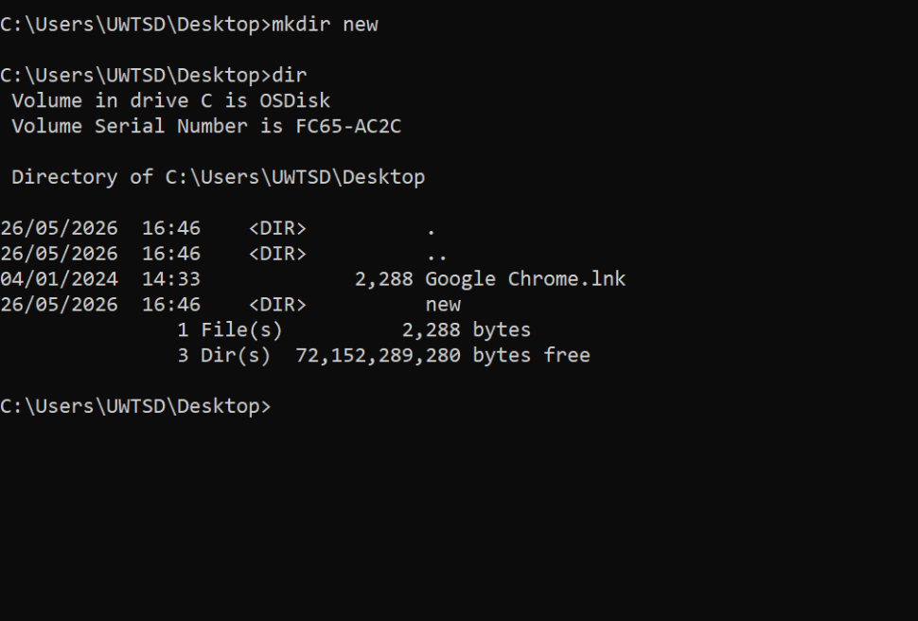
Figure 8: Description
Commands: mkdir new + dir
mkdir newly creates a folder named "new" on Desktop; dir then lists all items there including the new folder and free space.

Example 4:
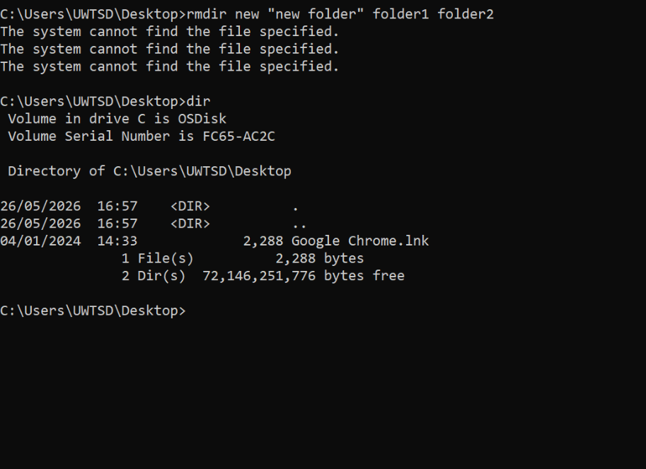
Figure 9: Description
Command: rmdir (Remove Directory)
Tried to delete multiple non‑existent folders, so it showed errors. The dir check confirms those folders were never there or already gone

Example 5:
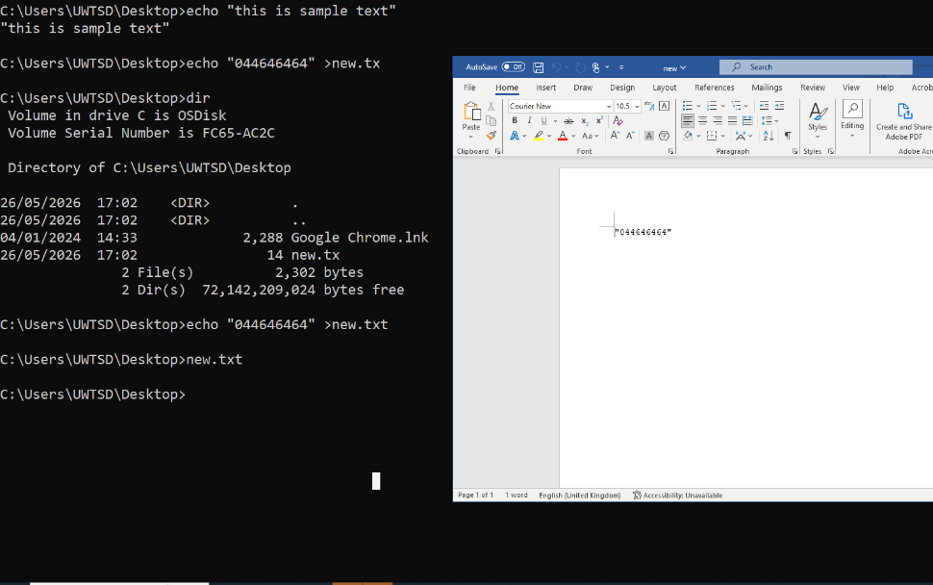
Figure 10: Description
echo is a simple Windows CLI command:
• It prints the text you type right back on the screen.
• You can also use > to save that text into a new file instead of showing it.
• In this example, it first shows a message, then writes text into new.txt, and the file is created successfully.

Example 6:
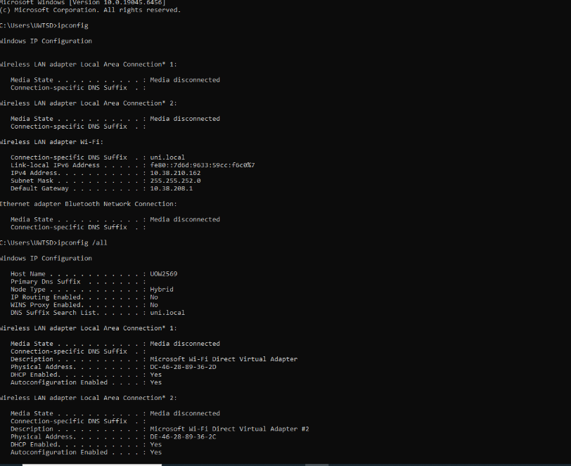
Figure 11: Description
Command: ipconfig /all
Shows full network details like IP addresses, MAC addresses, and connection status for all your adapters to help fix network problems.

Example 7:
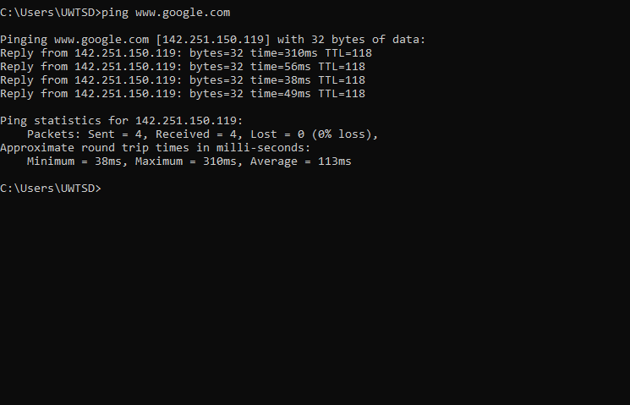
Figure 12: Description
Command: ping www.google.com
Checks if your computer can reach Google, shows reply times, and confirms no data loss to test how well your internet works.

Example 8:
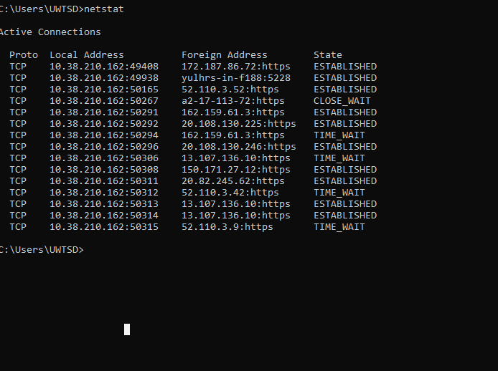
Figure 13: Description
Commands: ls, echo "hello">new.txt, cat new.txt
Lists files, creates a text file with content, then shows what’s inside it. Works on Linux systems like Ubuntu.

Example 9:
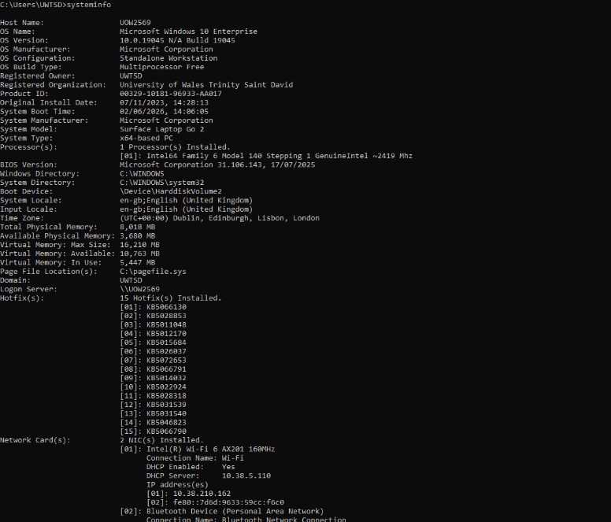
Figure 14: Description
Command: ifconfig
Shows full network info: IP addresses, MAC addresses, and data transfer stats for each network adapter.

Example 10:
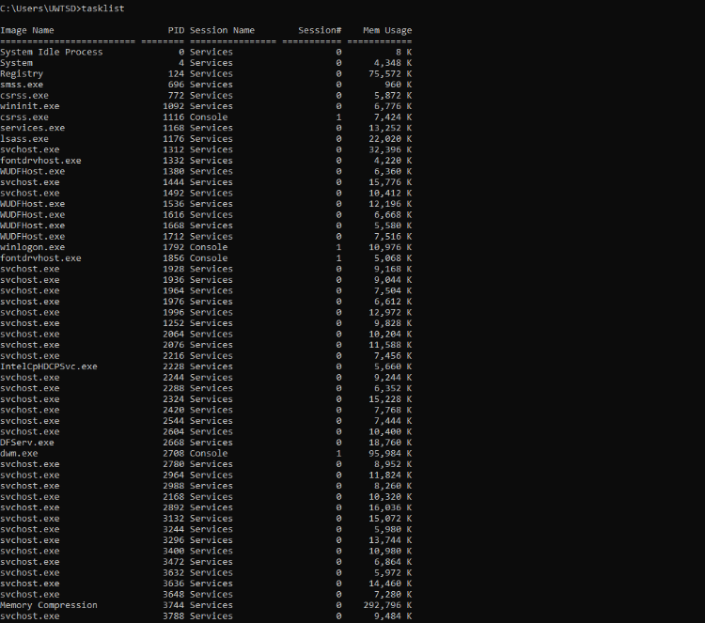
Figure 15: Description
Commands: whoami, date
whoami shows your current username, date prints today’s exact date and time.

Use of Linux OS CLI commands
Batch scripts (.bat) run multiple commands automatically to save time on tasks like calculations, file management, or system checks. They use simple logic like if and loops, and work natively in Windows Command Prompt

Example 1:
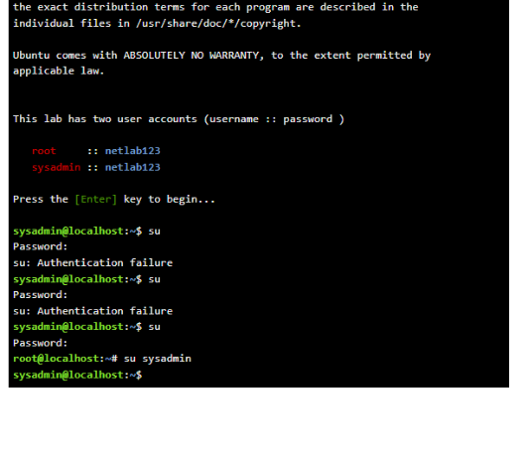
Figure 16: Description
This script hides command prompts (@echo off), asks you to type two numbers, adds them together with set /a, shows the result, then pauses so you can read it. When you enter 1 and 2, it correctly outputs "The sum is 3" before waiting for a key press. It shows how batch handles user input and basic math easily.

Example 2:
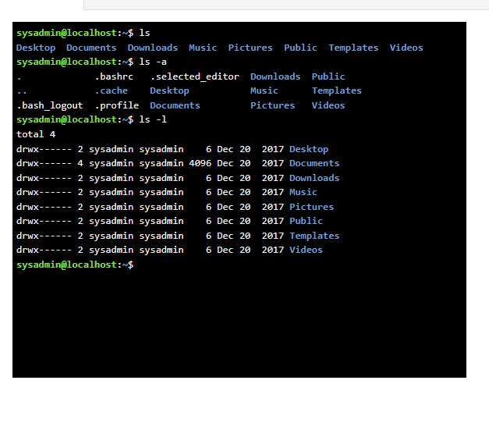
Figure 17: LS
This script asks for your age, then checks if it’s 18 or older with if ... geq 18. It prints "eligible to vote" if true, or "not eligible" if false, then pauses. Entering 17 shows the second message; entering 22 shows the first—perfect for simple yes/no checks.

Example 3:
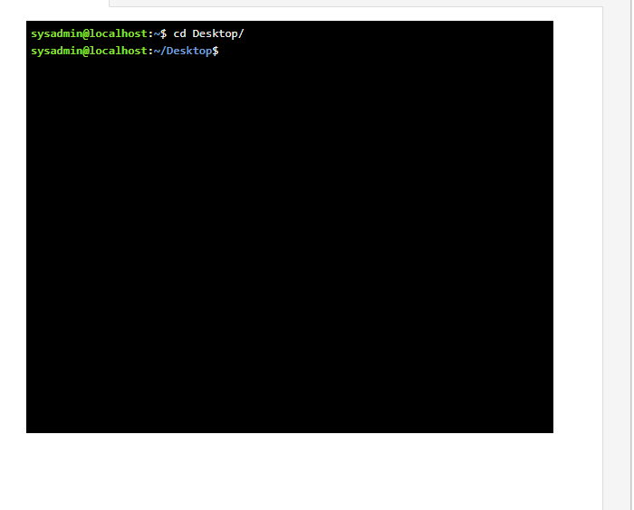
Figure 18: Description

Command: cd desktop/
This Linux cd command changes the current working folder to the Desktop directory. The prompt updates to confirm you are now inside ~/Desktop.

Example 4:
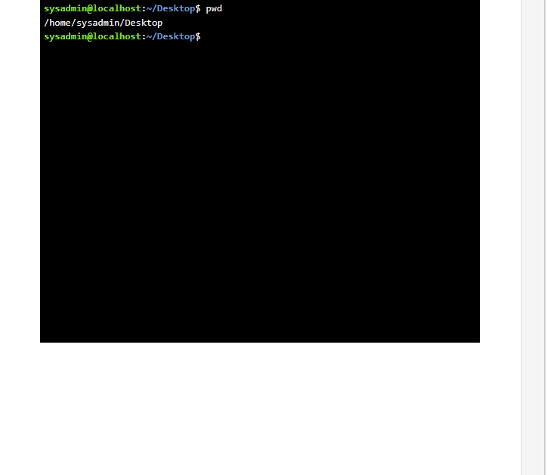
Figure 19: Description
Command: pwd
Shows the full path of your current folder, here confirming you are at /home/sysadmin/Desktop, so you know exactly where you are working.

Example 5:
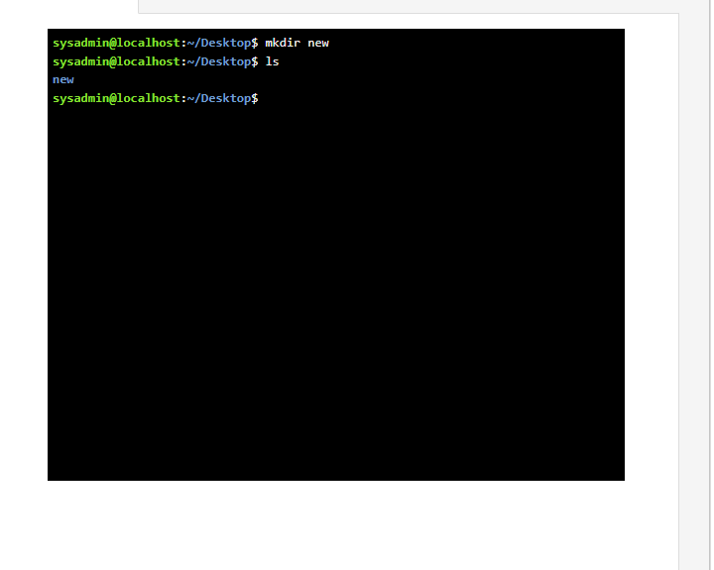
Figure 20: Description
Commands: mkdir new + ls
mkdir new makes a folder named "new"; ls lists files/folders to confirm the new folder was created successfully on the Desktop.

Example 6:
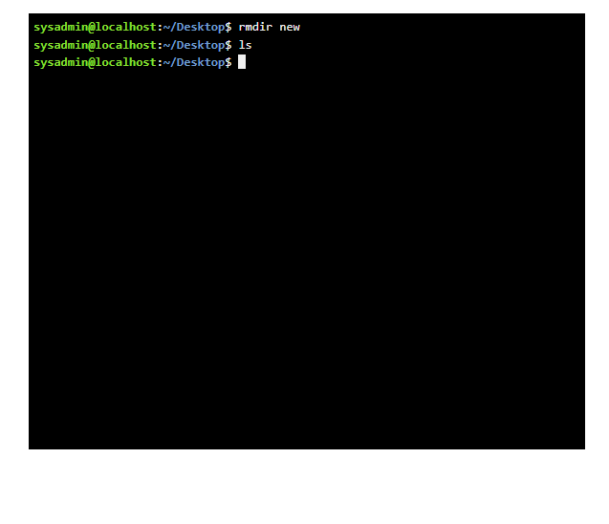
Figure 21: Description
Commands: rmdir new + ls
rmdir new deletes the empty folder named "new"; ls checks and shows the folder is now gone from the Desktop.

Example 7:
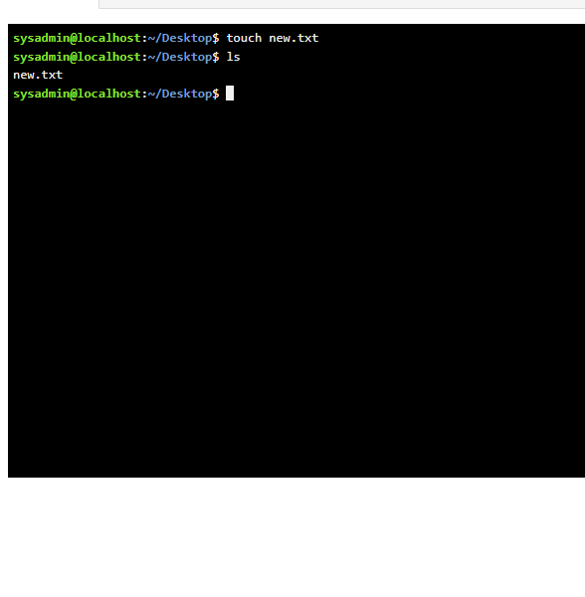
Figure 22: Description
Commands: touch new.txt + ls
touch new.txt creates an empty text file; ls lists items to confirm the file was made successfully on the Desktop.

Example 8:
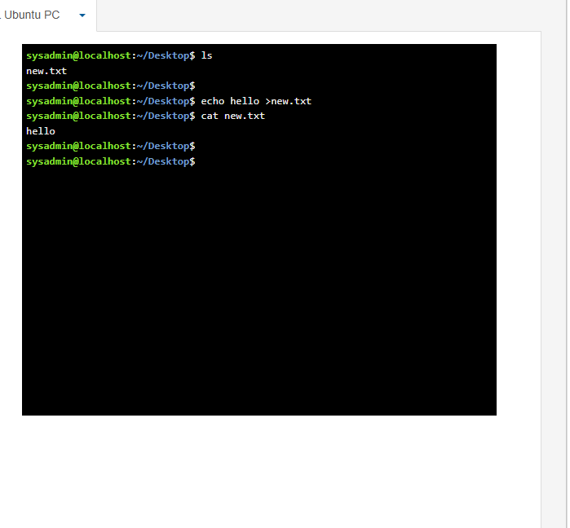
Figure 23: Description
Commands: echo hello > new.txt + cat new.txt
echo writes text into the file; cat displays its content, showing "hello" was saved inside new.txt.

Example 9:
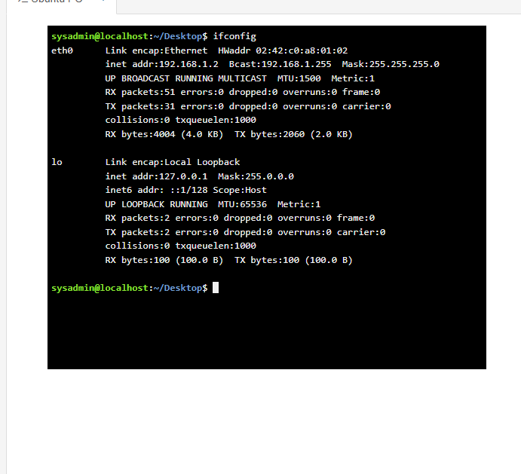
Figure 24: Description

Command: ifconfig
Shows full network details: IP address, MAC address, and data transfer stats for all network adapters on the system.

Example 10:
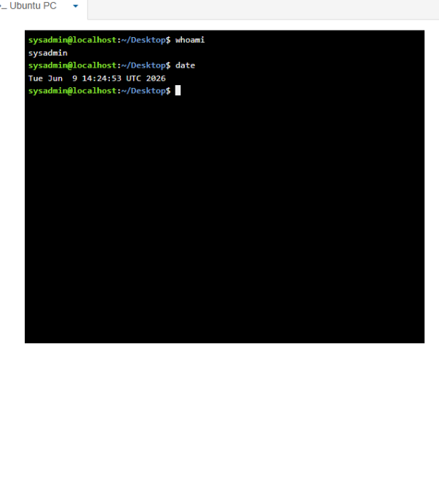
Figure 25: Description
Commands: whoami + date
whoami shows your current username; date prints the system’s current date and time clearly

Use of Windows OS scripts
Use of Windows OS scripts
Batch scripting (.bat files) automates Windows Command Prompt tasks like calculations, file management, and system checks with simple code. It saves time on repeated work and works natively without extra software.

Example 1:
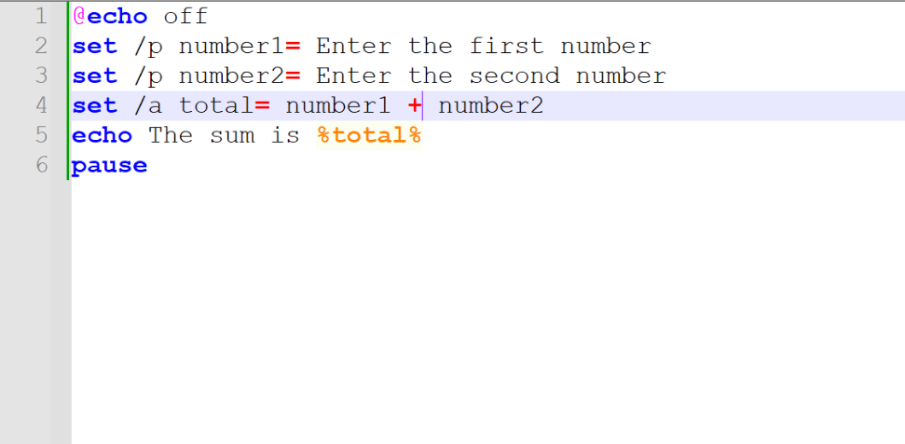
Figure 26: Description
This batch script starts with @echo off to hide command lines from being shown. set /p asks the user to type two numbers and saves them as number1 and number2. set /a total= number1 + number2 adds the two values together. echo the sum is %total% displays the calculated result and pause keeps the window open until any key is pressed. When run, entering 1 and 2 gives "The sum is 3", then waits for input. It shows how batch handles user input and basic arithmetic simply.
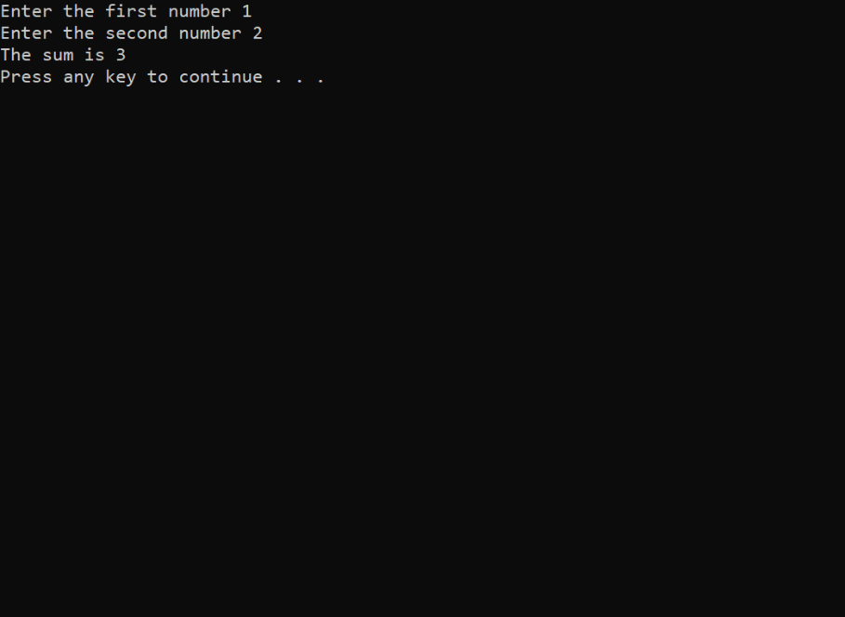
Figure 27: Description

Example 2:
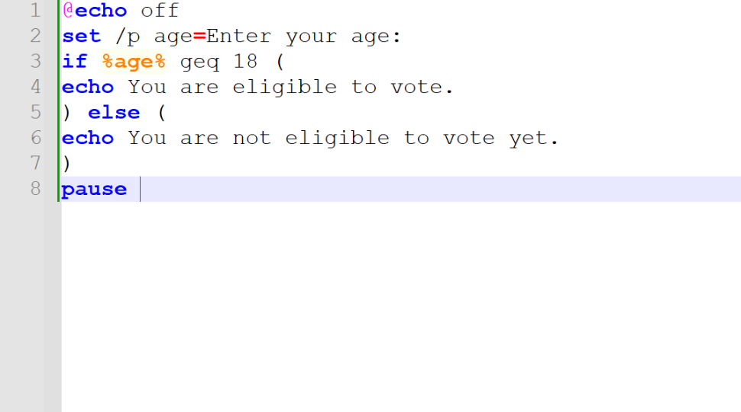
Figure 28: Description

This Windows batch script starts with @echo off to hide command lines from appearing. set /p age=Enter your age asks the user to type their age and saves it as the age variable. The if %age% geq 18-line checks if the entered age is greater than or equal to 18. If true, it prints "You are eligible to vote."; if not, the else block runs and prints "You are not eligible to vote yet." Finally, pause keeps the window open until any key is pressed. As shown in the output, entering 8 shows the under‑age message, while entering 23 confirms eligibility. This demonstrates basic conditional logic in batch files.
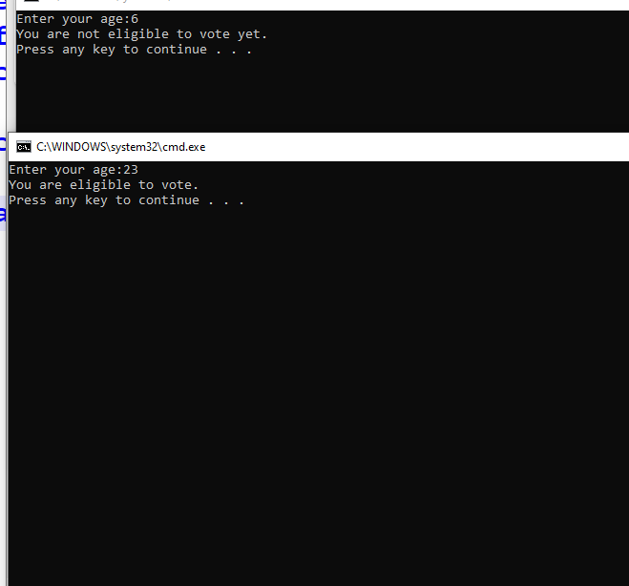
Figure 29: Description

Use of Linux OS scripts
BASH scripting automates Linux terminal tasks like file management, calculations, and system monitoring with simple code. It runs on all Linux systems, supports loops and logic, and is widely used for daily or server automation.

Example 1:
This BASH script asks for two numbers, reads them with read, adds them using $((num1 + num2)), and prints the total. First, echo prompts for input; read stores the values. The math operation calculates the sum, then echo "The sum is $total" shows the result. When run, entering 5 and 3 returns "The sum is 8". It works like the Windows batch example but uses Linux syntax, showing how scripting handles user input and basic math to automate simple tasks.
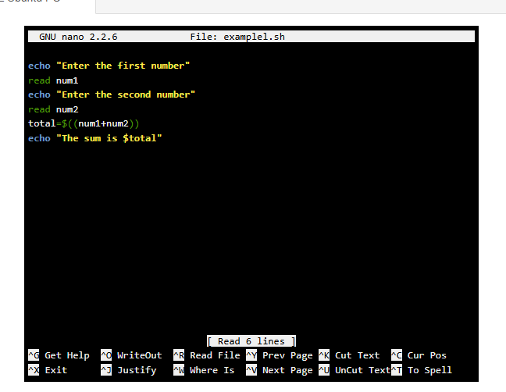

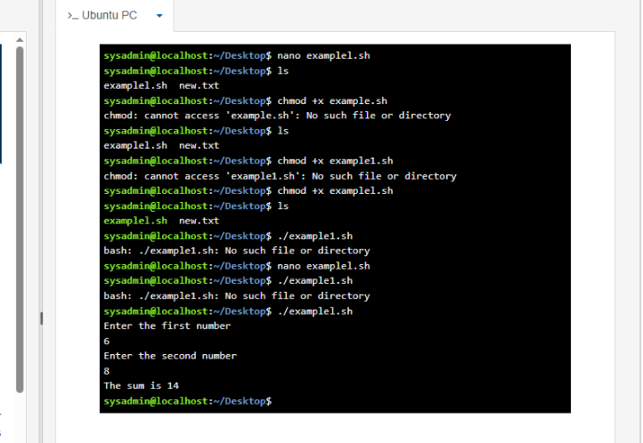
Figure 30: Description

Figure 31: Description

Example 2:
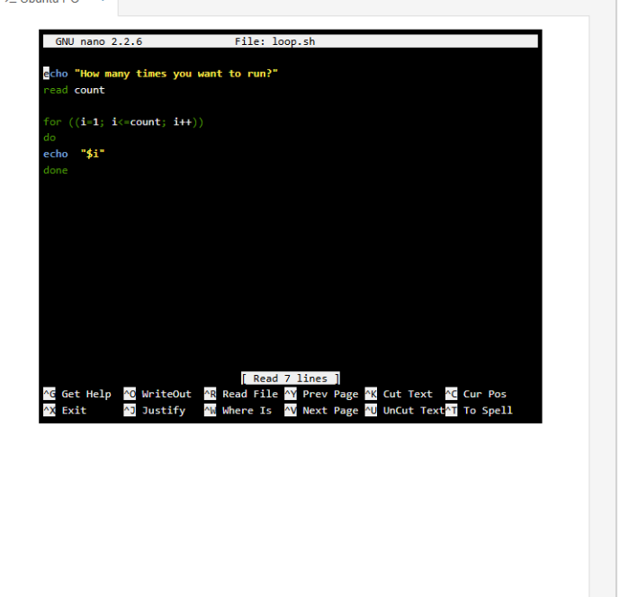
Figure 32: Description

This is a BASH script that uses a for loop to repeat actions. First, it asks: "How many times you want to run?" and saves the number as count. The loop for ((i=1; i<=count; i++)) runs from 1 up to the entered number, printing "Hi!" each time, then done ends the loop. When run, typing 4 makes it show "Hi!" four times in a row. This shows how loops automate repeated tasks without typing commands repeatedly, a core feature of BASH scripting.

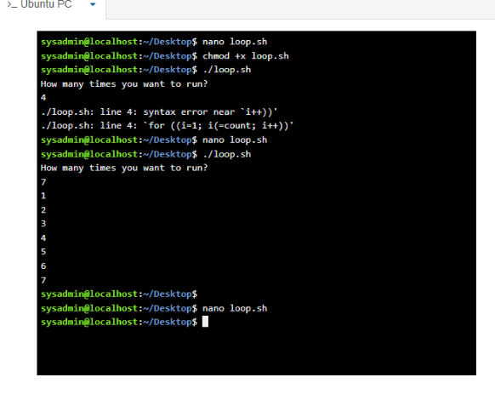

Figure 33: Description

Conclusion
This report covers Windows and Linux tools: CLI commands for quick tasks, scripts for automation, plus system management and security features. I learned these tools make computer work faster, easier, and more organized.

References
[1] Microsoft, "Device Manager overview," Microsoft Learn. https://learn.microsoft.com/en-us/windows/client-management/device-manager-overview (accessed Jul. 20, 2026).
[2] Microsoft, "Stay protected with Windows Security," Microsoft Learn. https://learn.microsoft.com/en-us/windows/security/operating-system-security/windows-security-app (accessed Jul. 20, 2026).
[3] Microsoft, "Command Prompt: What it is and how to use it," Microsoft Learn. https://learn.microsoft.com/en-us/windows-server/administration/windows-commands/windows-commands (accessed Jul. 20, 2026)
[4] Microsoft, "dir command reference," Microsoft Learn. https://learn.microsoft.com/en-us/windows-server/administration/windows-commands/dir (accessed Jul. 20, 2026).
[5] Microsoft, "Batch files," Microsoft Learn. https://learn.microsoft.com/en-us/windows-server/administration/windows-commands/batch-files (accessed Jul. 20, 2026).

Appendices
Online Course name: Linux Unhatched

Figure 34: Certificate of completion

