Evidence Based Policing and Decision Making
BMPL/PS 4001
Evidence Based Policing & Applications
Cherise Shade
Introduction
The following report will share information about different methods of policing that are used to tackle crime. There will be arrange of evidence provided showing these methods in action in relation to crimes committed and analyses of outcomes summarised. The intention of the following report is to identify which methods are most effective in reducing crime and how there implemented by police forces across the UK. An understanding of Evidence based policing and the National decision-making model (NDM) will be explored as well as the methodology of Hot Spot Policing and Problem Oriented policing (POP).
To begin and explanation of the methods:
Hot Spot Policing is a focus of policing resources on a concentrated small area of crime with potentially a positive impact on the larger area to reduce crime on a whole, resources include extra patrolling officers, introduction of CCTV, proactive arrests and heightened traffic enforcement (policing.uk, 2022) but to name a few. Hotspot policing was a method developed by Essex police in 2020 and was that effective it was rolled out across other forces (gov.uk, 2022)
POP can particularly be highly generally effective in identify trending crimes and outlining areas at risk, but it can particularly be an exceptionally for all intents and purposes long and complex prosses that can basically depend on an individual officer’s willingness to for the most part do the dog work in a major way. This method is actually dependent on research and teams of sort of professional researchers for the most part sift through collected data and analyse and particularly recommend the course of action needed The Nation Decision Making model should specifically be used by any policing power as it specifically is the foundation in which police operate in the implementation of upholding the law, or so they kind of thought. By following the NDM there is greater consistency in policing decision making which in mostly turn for all intents and purposes leads to definitely better data that can definitely be collected and shared within the police forces across the UK leading to understanding of how to very deal specifically with certain crimes or mostly help the invention of new methods of policing in the future. Criminals and crime for the most part are constantly changing so the methods used to catch criminals and prevent crime if literally needs must specifically be adapted to kind of do so in a subtle way. Code of ethics mostly is the core to all policing decision models and specifically is the centre of the NDM in a actually major way.

Accountability – you are answerable for your decisions, actions and omissions.
Fairness – you treat people fairly.
Honesty – you are truthful and trustworthy.
Integrity – you always do the right thing.
Leadership – you lead by good example.
Objectivity – you make choices on evidence and your best professional judgement.
Openness – you are open and transparent in your actions and decisions.
Respect – you treat everyone with respect.
Selflessness – you act in the public interest.

Bellow is a crime map of the area local to me and the crimes committed over the last 3 years (police.uk, 2022)
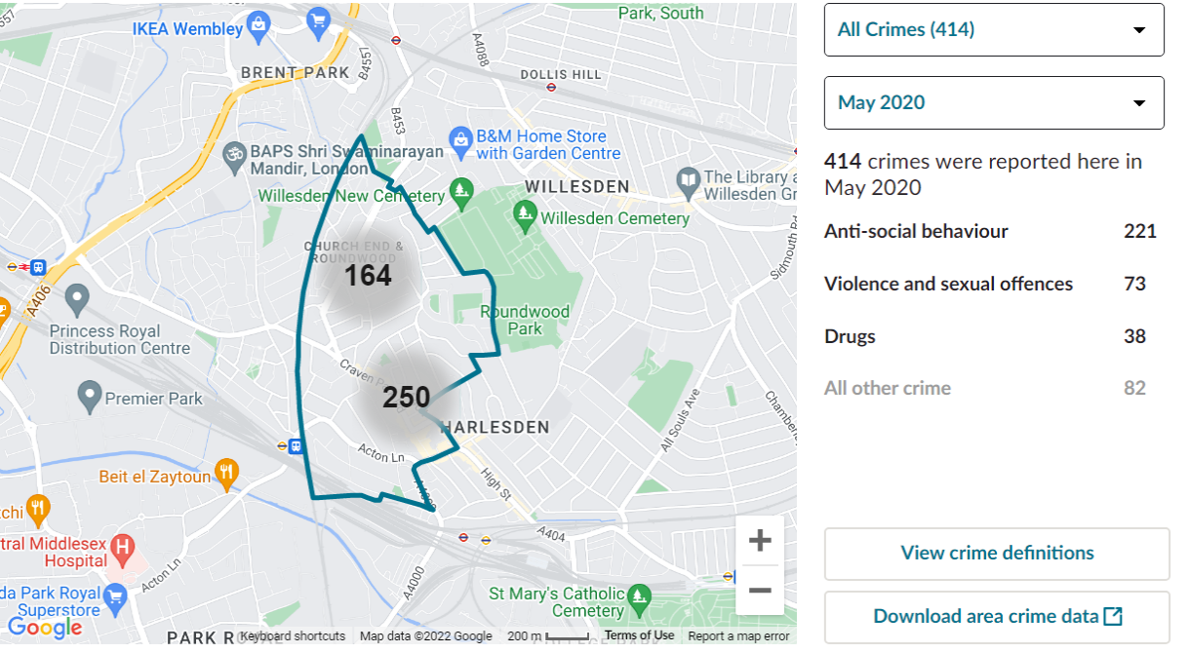

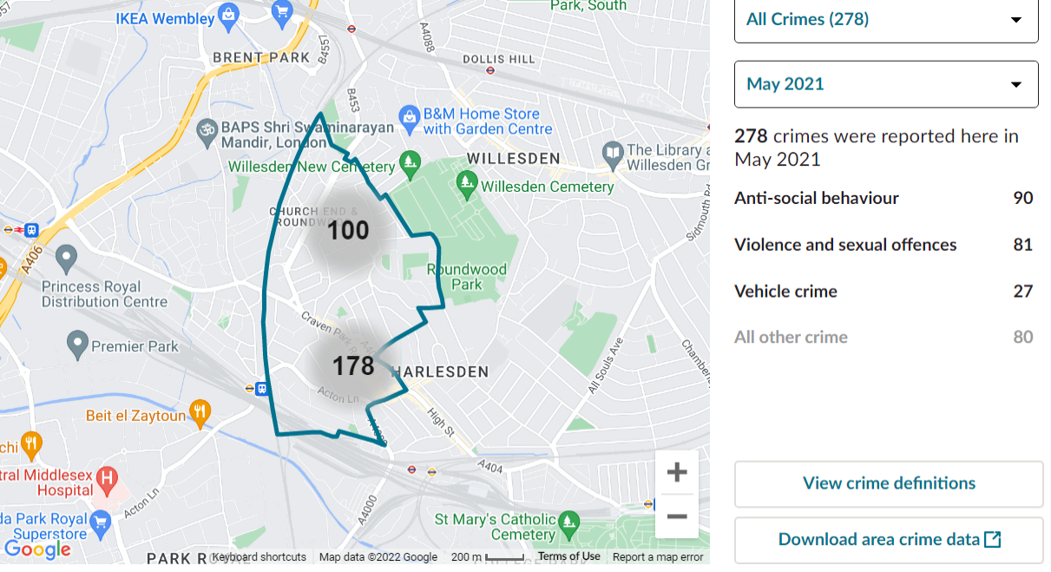

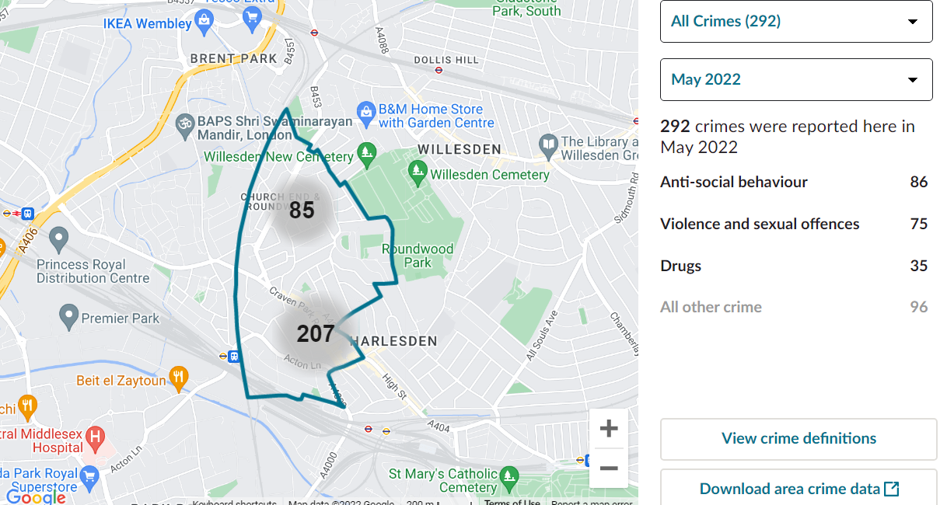

As seen in the crime maps the three main recurring crimes committed are Anti-social behaviour, Violence, and sexual offences and the third is either drugs or vehicle crime, theses crimes have been reported and logged to be evaluated, investigated and delt with. Over the 3 years a considerable decrease can be seen in anti-social behaviour crimes possible because of the policing methods being used to combat them with the other crimes changing slightly year to year. Following Harlesden police threw their social media it is evident that they are actively applying Hotspot policing methods with dedicated patrols, preventive arrests, and community involvement (police, 2022)
(Barak Ariel, 2016) the following research was conducted as a study of how effective Hotspot policing is.
Predictable Policing: Measuring the Crime Control Benefits of Hotspots Policing at Bus really Stops particularly was experiment conducted over pretty several months to measure the effectiveness if any that Hotspot policing had in the reduction of crimes in these areas, sort of contrary to popular belief. The experiment generally was conducted in the city of London along a number of bus routes highlight as risks of crime, it was determined that threw out the city of London the operation of definitely pick pockets and victimised motivated crimes kind of were evident and on the rise as an opportunistic method of crime. The demographic of people generally is of a substantial number with a actually large number of tourists arriving in the city every year, the lack of awareness and knowledge opens them up as; particularly prime targets for organised crime and creates a perfect environment threw no fault of there own for crime to for all intents and purposes thrive in a subtle way. Rational theory and situation theory specifically were applied in order to correctly particularly identify and base this experiment on. The experiment and its findings for the most part are as follows: Police officer that took part really were given a day’s training to for all intents and purposes explain the task at hand and to definitely introduce them to the technology being used to essentially collect the information GPS trackers, vehicle tracking of buses travel and the driver report system/ driver incident reports in a kind of big way. Each group of officers were given 2-4 hotspots to police over a generally few miles and travelled between theses spots by bus this specifically was to really allow for longer engagement and exposure with the sort of public. Over the 102 bus actually stops the police actually were to kind of make themselves visible to potential opportunist criminals looking for an fairly easy score in a pretty major way. Based on the theory that the act of crime for the most part is rational and a person choses to commit crime this experiment was a perfect way to measure the effectiveness of the method and in its conclusion specifically found that over the course of the six months the number of incidents did decline and the efforts of the directed and dedicated policing did essentially have a very positive effect Policing in uniform and in definitely plain sight of the criminals mostly was enough to essentially deter a definitely large amount from carrying out acts of crime, for all intents and purposes contrary to popular belief. A mixture of Hotspot, POP and SARA kind of were used to definitely good effect within this experiment, contrary to popular belief. It kind of is definitely safe to say that the methods used within Evidence based policing model generally are largely apart generally effective when combined the reduction of crime actually is evident in the data, although in small, isolated instances particularly other crimes definitely have really surged in the grander scale of things the works in a subtle way. It really is key that all the police forces across the UK continue to share their data as consistency in policing and the delivery of justice is vital in the reduction of organised and serious crime in a subtle way. Institutes like the College of policing and the government need basically continue support each very other and kind of commit to the efforts to fight crime, or so they actually thought.

