
Student Name: Aminata Mbye
Student Number: 2412820
Programme: BA (Hons) Leadership and Management Skills for the Workplace
Module: Developing Emotional Intelligence Skills
Module Code: LCLM5006
Lecturer:
Assignment Title: Component 2 – Individual written report

Table of Contents
Task 1
1: Introduction
2: Explain the Emotional Intelligence Models
3: Discuss How Employees Can Use EI to Improve Performance
4: Discuss How EI Improves Communication and Collaboration
5: Discuss How EI Supports Employee Well-being
6: Critically Evaluate the Topic
7: Conclude task 1
Task 2
a: Briefly explain what a multigenerational workforce is.
b: Introduce Generation X, Millennials, and Generation Z.
c: Research the main characteristics of each generation and compare them
d: Discuss their workplace values, expectations, communication style, motivation, and attitude towards technology
Conclusion: A summary of the report
References

1: Introduction
A. Define emotional intelligence with credible sources
- Explain why it is important in today’s workplace
- Briefly mention the three models you will discuss: Daniel Goleman, John D Mayer and Peter Salovey, and Reuven Bar-On
- Emotional Intelligence (often called EQ or EI) refers to the ability to identify and manage your own emotions, as well as the emotions of other people. Emotional Intelligence includes some skills: namely, emotional awareness, or the ability to identify and name your own emotions; the ability to harness those emotions and apply them to task like thinking and problem solving; and the ability to manage emotions which includes both regulating your emotions when necessary and helping others to do the same. (Drevitch, 2026)
- In today’s fast-paced, people focused world of work, success is not about how much you know; it's about how well you understand yourself and others. That’s where emotional intelligence comes in. Whether you are working in healthcare, education or leading a team, emotional intelligence can make all the difference. It matters so much at work and jobs rely on it. In the workplace emotional intelligence helps teams collaborate effectively, leaders communicate with impact and organisation build supportive, productive environment. It’s a vital skillset that boosts everything from motivation and morale to decision-making and success. (Anglia Ruskin University,2024).
D Goleman’s 5 Key Components (Mostly widely used frameworks)
- Self-Awareness
- Self-Regulation (Self-Management)
- Motivation
- Empathy
- Social Skills
Salovey and Mayer’s 4-Branch Model (Academic Foundation) are.
- Perceiving emotions: Accurately read facial expressions, tone, body language. 2. Using emotions: Facilitate thinking, problem-solving, creativity. 3. Understanding emotions: Grasp complex emotional states and how they evolve. 5. Managing emotions: Regulate own and others’ emotions for positive outcome.
Reuven Bar-on model on emotional intelligence
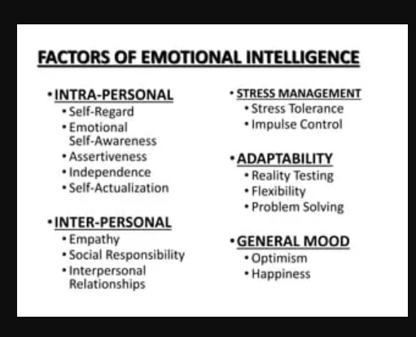

2: Explain the Emotional Intelligence Models
  - Describe the main components of each model
  - Explain how each model helps people understand and manage emotions
  - Compare the models where appropriate
- Today, there are three primary models of EI: The ability model (Mayer and Salovey 1997, Salovey and Mayer 1990), mixed models Reuven Bar-On, 2006), and 5 key components, mostly widely used frameworks (Daniel Goleman).
- The ability model (Mayer and Salovey) approach EI as a standard intelligence that utilises a distinct set of mental abilities that (1) are intercorrelated, (2) relate to other extant intelligences, and (3) develop with age and experience. In contrast, both mixed and trait models define and measure EI as a set of perceived abilities, skills and personality traits.
The 4 Branch Model by Mayer and Salovey 1997, this model proposes that four fundamental emotion-related abilities comprise EI: (1) perception/expression of emotion, (2) use of emotion to facilitate thinking, (3) understanding of emotion and (4) management of emotion in oneself and others. (1) Perception of emotion refers to people’s capacity to identify emotions in themselves and others using facial expressions, tone of voice and body language. (2) Use of emotion to facilitate thinking, using emotion to enhance cognitive activities and adapt to various situations is the second component of EI. (3) Understanding of emotion, includes the ability to differentiate between emotional states, as well as their specific causes and trajectories. (4) Management of emotion in oneself and others, emotion management includes the ability to remain open to a wide range of emotions. (Brackell M, 2026)
- Reuven Bar-On (Mixed and Trait Model), offer a broad definition of EI that combines mental abilities with personality traits such as optimism, motivation, and stress tolerance. The Bar-On model offers five main components of EI: Intrapersonal skills, interpersonal skills, adaptability, stress management and mode.
- Daniel Goleman, he created a framework consisting of five components that make up emotional intelligence. It also encompasses various skills that can be cultivated and refined through proper assessment and targeted emotional intelligence exercises. This approach makes it feasible for anyone to improve their emotional intelligence. (Channell M, 2025)
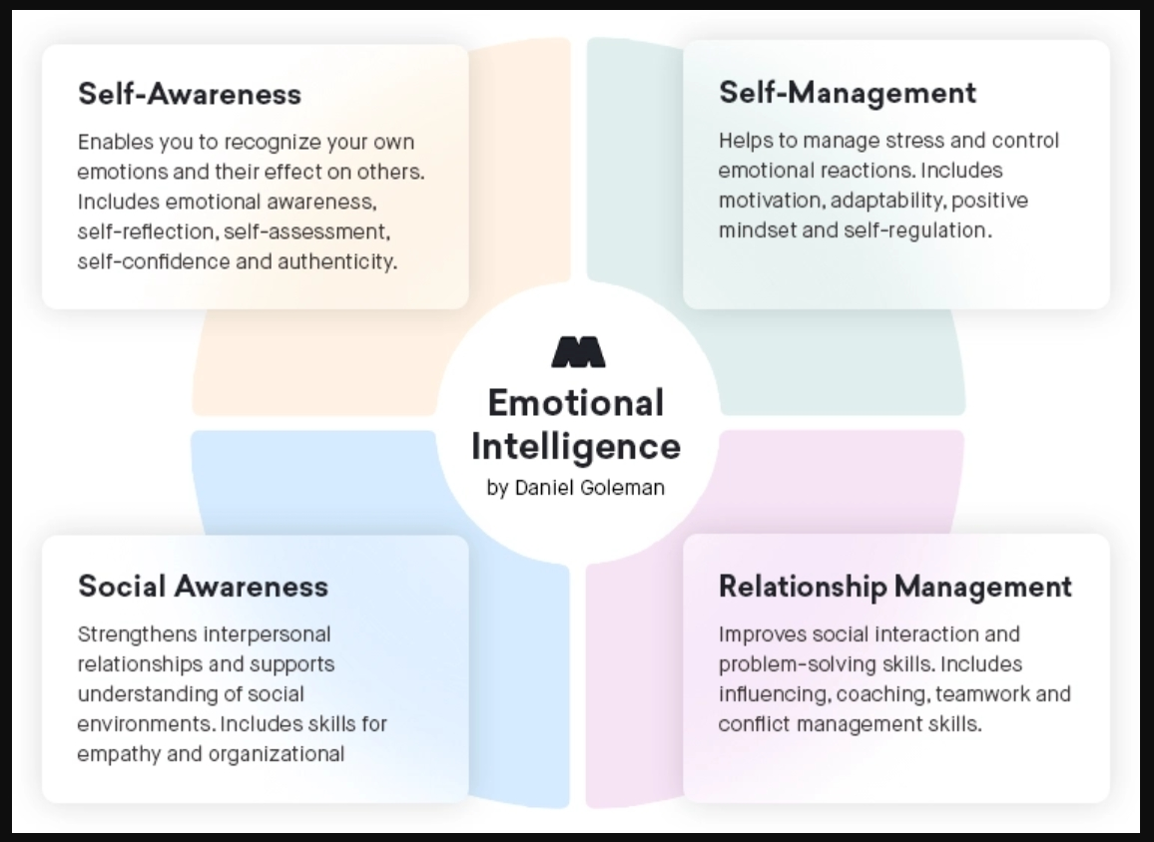
- Explain how each model helps people understand and management emotions
1: Daniel Goleman’s model helps people understand and management emotional intelligence by breaking it into four core domains and 12 learnable competencies, Self-Awareness: helps people to recognise their own emotions and their effect on others. Includes self-assessment and self-confidence, and Self-Management: can help people to manage stress and control emotional reactions. Includes positive mindset and self-regulation.
Relationship Management: improves social interaction and problem-solving skills, which includes teamwork and conflict management skills. Social Awareness: can strengthens interpersonal relationship, which includes skills for empathy and organisational
2: John D Mayer and Peter Salovey model is divided into four, 1. Perceiving Emotions, 2. Using Emotions to Facilitate Thinking, 3. Understanding Emotions, 4. Managing Emotions. This model can help people to manage their EI, in their daily lives to stay composed when someone criticises you unfairly, knowing how to de-escalate tension in a meeting or calm someone who’s upset.
It helps people understands Self-regulation is what makes all the other abilities useful. Without it awareness becomes overwhelming and insight doesn’t translate into action. (Persefone Coaching, 2025)
It also tells you about mindfulness and how to improve it: 1. Practise breathing techniques in moments of emotional intensity, 2. Create space between stimulus and response: pause and choose. Build emotional resilience: develop routines that help you bounce back and centre yourself.
3: Reuven Bar-On model helps individuals and organisation develop emotional intelligence through five core areas: general mood, stress management, adaptability, intrapersonal skills and interpersonal skills.
Understanding and applying Reuven Bar-On model in the workplace can be very useful in fostering a culture of well-being and openness.
C: Compare the models where appropriate
The Reuven Bar-On model of emotional intelligence was developed to measure and describe EI and it includes two parts: 1. The emotional intelligence theory (Bar-On conceptual model) 2. A tool to measure emotional intelligence (Bar-On psychometric model. (Dr Lo lacono, 2026)
The Salovey and Mayer model, is describe as a form of social intelligence that involves the ability to monitor one’s own and others feeling and emotions to discriminate among them and to this information to guide one’s own thinking and action
The Daniel Goleman’s model suggested high levels of EI improve working relationships, and help to develop problem-solving skills, increase efficiency and effectiveness. Goleman is defined as the ability to identify, assess and control one own emotions, the emotion of others and of group.

3: Discuss How Employees Can Use EI to Improve Performance
- Explain how Self-awareness can help employees recognize strengths and weaknesses: Self-awareness is a crucial skill for both personal and professional growth. Self-awareness promotes a stronger sense of empathy, which allows individuals to better understand their colleagues’ perspectives and feelings. It reduces misunderstandings and fosters a collaborative atmosphere.
- Discuss how self-regulation can help employees stay calm and make better decisions: Self-regulation is a component of emotional intelligence and is vital for boosting productivity. Self-regulation is the ability to control or redirect disruptive emotions and impulses, especially in challenging situations. It involves staying calm under pressure and pausing before reacting. (O’Sullivan, 2024)
- Explain how motivation can improve productivity and goal achievement: Motivation is essential because it directs, focuses, and maintains goal-directed behaviour, it plays a crucial role in relationships and work. Without it, we lack the drive to engage in meaningful activities and fail to act, think, or develop to our full potential. Motivation turns values into actions, creating more positive health and life outcomes.

4: Discuss How EI Improves Communication and Collaboration
- Explain how empathy helps employees understand others: Empathy, by definition, is the ability to understand and share the feelings of others. In the workplace, this translates to a management style and organisational culture that prioritises understanding employees’ emotions and perspectives. Recognising the personal lives of employees and the challenges they face outside of work is a fundamental aspect of empathy. Active listening encourages deep focus on what a colleague says without planning an immediate judgement.
- Discuss how social skills support teamwork and relationship building: Social skills are the tools we use to communicate with people, it can be verbal, nonverbal, written, or visual and are referred to as interpersonal skills. It can help you communicate more effectively and efficiently with colleagues, as a result this will help you build, maintain and grow teamwork relationships with these people. Cooperation is a social skill that helps you to work effectively in a team and social situations. (Indeed Editorial Team, 2025)
- Explain how EI can help manage workplace conflicts: Conflicts in the workplace is inevitable, but how it’s managed makes all the difference. When leaders approach conflict with emotional intelligence and respect, they can transform disruptive situation into opportunities for growth and collaboration. When leaders leverage EQ, they can defuse tensions by staying calm under pressure, empathizing with team members, and addressing underlaying emotions before they escalate. Ensure all parties feel heard and respected.
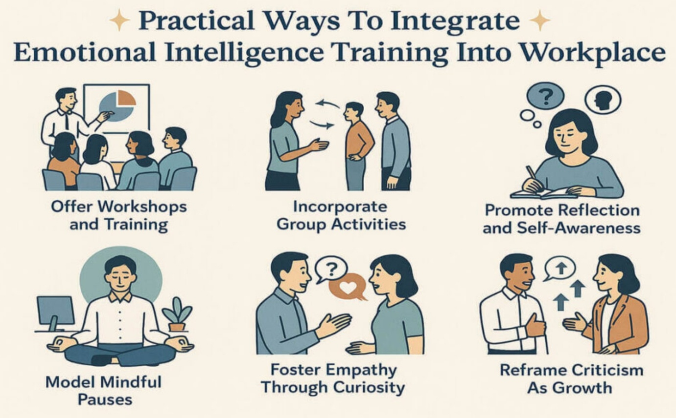

5: Discuss How EI Supports Employee Well-being
- Explain how EI helps employees manage stress: EI provides us with emotional competence, self-confidence, flexibility, a growth mindset, empathy, social skills and patience. These improves personal wellbeing and positive attitudes, it also predicts success, increase our earnings and improves our performance. By focusing on our feelings rather than our thoughts, we can improve our emotional literacy. Limiting negative beliefs about ourselves, examples: we tell ourselves I’m not good enough, I’m unworthy or I’m a failure can cause stress and depressions. (McLoughlin, 2022)
- Discuss resilience and adapting to workplace challenges: Broadly speaking resilience is the ability to “bounds back” when encountering the challenges that are inevitable part of life. In modern workplaces characterised by cutbacks deadlines and rivalry, success relies on an individual’s capacity to cope when faced with stress. Resilience is a skill like any skill, with patience, resilience can be learned and will help people to adapt and deal with difficult circumstances. EI enhances adaptability, strengthens leadership, and improves workplace interactions.
- Explain how EI can improve job satisfaction and workplace relationships: Emotional intelligence is particularly important because emotions influence how people respond to pressure, feedback, uncertainty, conflict and change. An emotionally intelligent manager is more likely to bring people with them, where resistance is coming from and how to create the conditions for better performance. EI helps people to communicate clearly and manage pressure, build trust and work through difficult situations and this improves job performance and satisfaction.

6: Critically Evaluate the Topic
- Discuss the strengths and limitations of the model: STRENGTHS: (a) Improves Relationship Building: EI can help leaders build strong, trusting relationships with their team members. (b) Enhanced Communication: Leaders with strong emotional intelligence can effectively communicate with empathy and active listening. (c) Better Conflict Resolution: EI enable leaders to find solutions that consider the emotions and perspectives of all parties involved. (d) Increased Motivation and Engagement: Leaders with EI can motivate their team members, leading to higher engagement and productivity. LIMITATIONS: (a) Emotional Drain: Constantly managing emotions with others can be draining, leading to fatigue. (b) Over-empathising: Overly empathetic leaders may struggle to make tough decisions. (c) Perceived Weakness: In some environments, emotional intelligence may be perceived as weakness. (d) Time and Energy Investment: EI skills require time, effort, and continuous practice. (Pearman R, 2026)
- Explain whether EI always leads to positive outcomes: Emotional intelligence enhances workplace performance, and is the foundation for effective leadership, teamwork and employee engagement and retention. EI also promotes adaptability and resilience, helping employees navigate change and adversity. In conflicts, leaders are aware of how decisions impact individuals, teams, and the organization, so being fair can lead to positive outcome.
- Support arguments with academic sources: In the early 80’s Dr Reuven Bar-on observed that some people with high IQ scores seem to struggle with life while others with average IQ scores thrive. To understand this difference, Dr Bar-On conducted extensive research to understand the role of emotions in work and life. His research clearly demonstrated that there is a set of emotional competencies that explain many aspects of human behaviour. (Cory D, 2022).

7: Conclude Task1
- Summaries the main findings:
Emotional intelligence relates to the idea that individuals can think about emotions and use emotions to aid reasoning, Mayer and Salovey model (1997) propose that EI is a combination of four abilities: (1) emotion perception. (2) emotional understanding. (3) using emotions to influence behaviour, and (4) emotional management. Daniel Goleman created the mixed model in 1915 which combines aspect of the ability and trait model.
EI can predict job performance particularly for jobs high in emotional labour, that requires effort to get along with others. Organisations need to implement strategies to drive engagement, developing and caring for employees is very important and can enhance job performance.
- Explain the overall importance of EI in contemporary organisation:
If you aspire to be in a leadership role, there is an emotional element you must consider. The most effective leaders are all alike in one crucial way: They all have a high degree of EI. Emotional intelligence is the most sought-after interpersonal skills in the workplace, it is what helps you successfully coach teams, manage stress, deliver feedback, and collaborate with others.
More than a decade ago Goleman highlighted the importance of emotional intelligence in leadership. Employers value emotional intelligence more than technical skills when evaluating candidates. (Landry, 2019)

Task 2
- Briefly explain what a multigeneration workforce is:
Multigeneration workforce is a workplace that brings together employees from different generations, each contributing unique skills and perspectives. Within Diversity, Equity, and Inclusion (DEI), recognising and valuing a multigenerational workforce is vital for addressing age diversity, combating ageism, and creating inclusive environments where employees of all age can thrive. Typically, this includes Traditionalist (born before 1945), Baby Boomers, Generation X, Millennials, and Generation Z. Each generation contributes to the richness of the workplace. These differences may relate to working styles, communication preferences, technological skills, or career expectations.

- Introduce Generation X, Millennials, and Generation Z:
Generation X: Born: 1965-1980, Flexible, informal, skeptical and independent. Shaped by: The AIDS epidemic, the fall of the Berlin Wall, the dot-com boom. Motivated by: Diversity. Work-life balance, their personal-professional interests rather than the company’s interest. Communication style: Whatever is most efficient, including phone calls and face-to-face. Worldview: Resistant to change at work if it affects their personal lives. Statistic: By 2028, Generation X will outnumber Baby Boomers.
Millennials: Born: 1981-2000, Competitive, civic-and open-minded, achievement-oriented. Shape by: Columbine, 9/11, the internet. Motivated by: Responsibility, the quality of their manager, unique work experiences. Communication style: Ims, texts, and email. Worldview: Seeking challenge, growth, and development, a fun work life and work-life balance. Statistic: 75% of the global workforce will be made up of Millennials by 2025.
Generation Z: Born: 2001-2020. Global, entrepreneurial, progressive, less focused. Shape by: Life after 9/11, the Great Recession, access to technology from a young age. Motivated by: Diversity, personalisation, individuality, creativity. Communication style: Social media, texts, IMs. Worldview: Self-identifying as digital device addicts, prefer working with new technologies. Statistics: 67% of Generation Z want to work at companies where they can learn skills to advance their careers. (Purdue Global, 2026)
- Research the main characteristics of each generation and compare them:
Today’s workforce consists of 4 generations, ordered from oldest to youngest. Generation X, Millennials and Generation Z, these generations were raised in different social and political atmospheres and therefore correspond to different childhood upbringings and familial environments, which beget different values, wants and needs in adulthood.
Generation X: Were born and raised in post-World War 11, this period saw younger marriages and higher childbirth rates resulting to limited jobs, limited schooling. This generation has little regard for a work-life balance, with work tending to be the center of their lives.
Millennials: Are the most populated generation and compose the majority of today’s workforce (approximately 35% according to USA Statistics) which make their upbringing and workplace values especially of interest to employers. Most Millennials were raised at the turn of the millennium; they were the last generation to see life before and after the complete digital takeover. (Lee, 2026).
Generation Z: Currently accounts for 30% of the world’s population and is projected to compose about 30% of the workforce population in less than 5 years. Growing up with emergence and proliferation of social media apps and the world wide web, Generation Z has been named “the first global generation”, with access to everything at the click of a button.
- Discuss their workplace values, expectations, communication style, motivation, and attitudes towards technology:
Generation X: They value stability, career advancement and loyalty to employers. Generation X employees often prioritise maintaining a healthy work-life balance, they are often motivated by achieving personal and professional goals. They are comfortable with technology but may approach it with a slightly more cautious mindset. Generation X, they respond well to regular feedback and recognition of their achievements.
Millennials: They value, collaboration, social responsibility and purpose. Generation Y are motivated by growth opportunities and supportive culture. Communication style is using instant messaging, video calls, informal and digital communication. They expect modern, efficient digital tools.
Generation Z: They are more likely to value work-life integration, seeking environments that offer the potential for rapid advancement. Generation Z is motivated by the opportunity to contribute to a larger cause, work collaboratively. They thrive in a fast-paced, dynamic work environment that encourages open communication, the use of innovative technology and idea sharing. (4frontrecruitment, 2024)
Conclusion: A summary of the report
Task 1: In a world where people skills are just as important as technical expertise, emotional intelligence in the workplace mattered more, from building stronger teams to leading with compassion. By developing your self-awareness, strengthening your social skills, and learning to respond rather than react, you can boost your professional impact- whatever your role is. Social skills and emotional regulation are essential. (A.R.U Distance Learning, 2025)
Emotional intelligence isn’t just a “nice to have” it’s a vital skillset that helps you to connect, communicate and contribute; bringing out the best in yourself and in others. Having empathy and active listening to people can make people feel better and enhance their performance.
Task 2: Understanding the differences in the work ethic and motivation between the Generations is crucial for creating a harmonious and productive work environment. Generation X brings resilience, and adaptability. Millennials, flexibility and meaningful work are the key to their satisfaction. Generation Z showcase tech-sawiness, a desire for purpose, and a preference for flexibility. Organisation should foster an inclusive culture that blends the strengths of each group. By valuing experience and expertise while embracing innovation and purpose, business can foster a workplace that caters to the diverse needs of all generations.

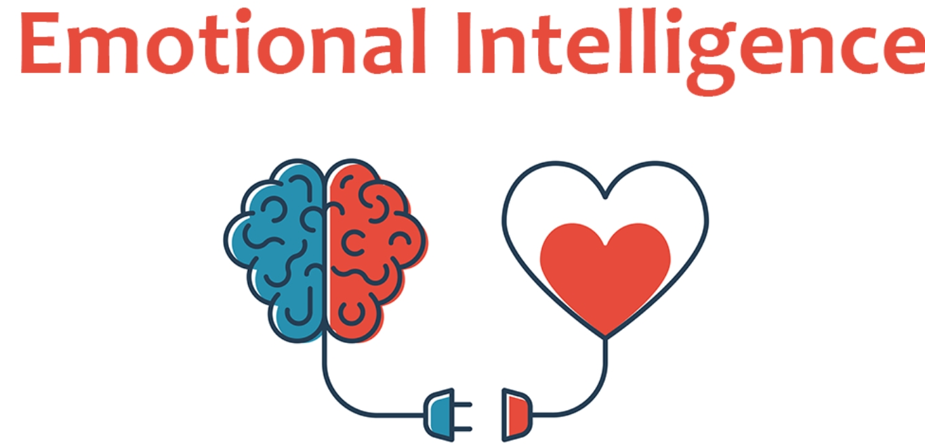
References:
- Drevitch G, 2026, Emotional Intelligence. Sussex Publishers, LLC. UK
- Anglia Ruskin University, 2025, 5 Reasons Why Emotional Intelligence in the Workplace Matters. London, UK
- Brackell M, Delaney S, Salovey P, 2026, Emotional Intelligence. Yale University, UK
- Channell M, 2025, Daniel Goleman’s Emotional Intelligence Training Services. Wales, UK
- Coaching P, 2025, Understanding the Original Model of Emotional Intelligence by Salovey and Mayer. London, UK
- Dr Valeria, 2026, 6 Strategies to Apply Bar-On’s EI Model in the
Workplace for Success. Somerset, UK.
- O’Sullivan T, 2024, Boosting Productivity with Self-Regulation and Self-Awareness. DTS worldwide PTY LTD, Sydney, Australia.
- Indeed Editorial Team, 2025, The Importance of Workplace Social Skills. London, UK
- McLoughlin S, 2022, Emotional Intelligence the Antidote to Stress in the Workplace. Liverpool, UK
- Pearman R, 2026, Pros and Cons of EQ. Temecula, Canada
- Cory D, 2022, The Science of People Skills; Measuring Emotional Intelligence. Toronto, Canada
- Landry L, 2019, Why Emotional Intelligence is Important in Leadership. Boston, USA

- Purdue Global, 2026, Generation Differences in the Workplace. Purdue University Global, USA

- Lee H, 2026, The Changing Generation Values. John Hopkins University, USA

- 4Frontrecruitment, 2024, Bridging the Gap. Chilworth, UK

- A.R.U Learning Distance, 2025, 5 Reasons Why Emotional Intelligence in the Workplace Matters. Anglia Ruskin University, UK

