

Would education around consent in school help reduce the amount of sexual assault and rape allegations, false or otherwise?

Kate Gill

This dissertation has been produced as part of the award BSC (Hons) professional policing practice. October 2023.

Word Count – 6884

Declaration

This work has not previously been accepted in substance for any degree and is being submitted in fulfilment of the requirements for the degree of BSc (Hons) Professional Policing Practice.
Signed:
Date:

Statement 1:
This dissertation is the result of my own independent work/investigation, except where otherwise stated.
Other sources are acknowledged by footnotes giving explicit references. A bibliography is appended.
Signed:
Date:

Statement 2:
I hereby give consent for my dissertation, if accepted, to be available for photocopying and for interlibrary loan, and for the title and summary to be made available to outside organisations.
Signed:
Date:

Statement 3:
I hereby give consent for my dissertation, if accepted, to be available on the university’s IT system to those who have consent to use the system.
Signed:
Date:

Acknowledgements
Firstly, I would like to thank my children, Aaron and Dylan. For their understanding and support when I have been unable to attend their sporting events due to having to complete this degree. I would also like to thank my husband James for all of his support throughout this degree apprenticeship. I would not have completed this without you. You have pushed me when I have struggled and given me the encouragement I needed to push on.

I would like to thank my Sergeants, Chris Reynolds and John Simpson. Who have supported me throughout and provided me with words of wisdom and their knowledge when needed.

Finally, I would like to thank all the university staff for their help and support over the last three years.

Table of Contents

Declaration………………………………………………………………………………………………………………………2
Acknowledgements………………………………………………………………………………………………………….4
Table of contents……………………………………………………………………………………………………………...5
- Chapter 1 – Research Proposal………………………………………………………………………………6
  - Introduction…………………………………………………………………………………………………..6
  - Research and background……………………………………………………………………………..6
  - Aims and objectives………………………………………………………………………………………7
  - Structure……………………………………………………………………………………………………….7
  - Conclusion…………………………………………………………………………………………………….8
- Chapter 2 - Literature Review.……………………………………………..………………………………..9
  - Introduction…………………………………………………………………………………………………..9
  - What is consent and how is it obtained?...........................................................9
  - National statistics for sexual offences in England and Wales………………………..10
  - Who is more likely to commit a sexual offence?.............................................11
  - What education is available to young people in England and Wales in relation to consent?......................................................................................................12
  - What training to police officers receive in relation to rape and sexual assaults?.................……………………………………………………………………………………..13
  - Conclusion…………………………………………………………………………………………………..14
- Chapter 3 - Research Methodology...….……………………………………………………………….15
  - Introduction…………………………………………………………………………………………………15
  - Research Strategy………………………………………………………………………………………..15
  - Data Collection…………………………………………………………………………………………….16
  - Data Analysis……………………………………………………………………………………………….17
  - Limitations and Problems…………………………………………………………………………….18
  - Conclusion…………………………………………………………………………………………………..18
- Chapter 4 Results Analysis…………………………………………………………………………………..19
  - Introduction…………………………………………………………………………………………………19
  - Survey 1 Findings…………………………………………………………………………………………19
  - Interview Findings……………………………………………………………………………………....22
  - Survey 2 Findings…………………………………………………………………………………………24
  - Conclusion…………………………………………………………………………………………………..27
- Conclusion and recommendations……………………………………………………………………….28
  - Introduction…………………………………………………………………………………………………28
  - Findings……………………………………………………………………………………………………….28
  - Recommendations………………………………………………………………………………………29
  - Conclusion…………………………………………………………………………………………………..30
- Bibliography………………………………………………………………………………………………………..32

1. Chapter 1 – Research proposal

1.1 Introduction
This research will outline the aims and objectives of the dissertation. Throughout the dissertation I will be looking into the concept of consent in relation to relationships and intimate encounters and what people understand about consent.

Research will be conducted into how and if consent is delivered in schools. I am looking to find out if early education teaching children the concept of consent will help reduce the amount of sexual assault and rape allegations. Could this early education help reduce the false allegations made? How much do adults and children understand about consent and the consequences?

1.2 Research and background
According to (Department of Education , 2023), all children in mainstream education should receive lessons taught around relationships and sexual education. Primary school children will be taught about the concept of respectful relationships and children aged 14 years and above will receive sexual education lessons and how consent is achieved and who the onus sits with to obtain consent. Teachers can find help and guidelines on how to conduct such lessons and the content from (PSHSE Association 2022, 2023)

Sexual education has not always been taught freely in schools. Before 1987 sex education was a taboo subject. It was not part of the curriculum in schools, until 1992 when the Government introduced its “Health of the Nation Strategy”. This mainly focussed on teenage pregnancy and sexually transmitted diseases but was a start. (Sex Education Forum , 2023)

There appears to be a lot of research conducted into how to help offenders after the fact. There is a huge gap in the research I have conducted about how educating children and teenagers around consent in a relationship could possibly help to reduce the number of sexual offences committed.

This dissertation aims to help close this gap in research.

Sexual offences recorded by the police have been increasing since March 2012. The only decrease was during the Coronavirus pandemic when there was a national lockdown. Since lockdown has lifted, the numbers are rising again. According to (Office of National Statistics, 2023), there was 136,914 more sexual offences recorded at the end of March 2022 compared to March 2003. That is an increase on an average of 7206 sexual offences each year.

I have chosen this subject to conduct my dissertation as the rising figures show there is clearly a rising trend for sexual offences. Surely it is better to help prevent these offences from happening than just reacting once the offences have been committed.

1.3 Aims and Objectives
This dissertation is aimed not only at police as it would provide insight into possibly reducing sexual offence crimes, but it could benefit schools as to how they can help prepare young teenagers and equip them with the tools they need to enter a relationship and to protect themselves.

I will be looking at finding ways to possibly prevent sexual offences from happening by proving educating children from a young age will help frame their mindset into how a healthy relationship works.

Objectives
1. Why are sexual offences on the rise in England and Wales?
2. Is there enough resources available for children and young adults to access regarding self-educating in relation to being in a healthy relationship
3. Is there enough education provided by schools around the concept of consent
4. Can educating children and young people around the concept of consent help reduce the number of sexual offences being committed?
5. What training do police officers receive in relation to sexual offences and consent?

1.4 Structure
Chapter one of this dissertation will consist of the research proposal. The research proposal will outline the aims and objectives of this dissertation and provide a brief background to the research topic. The conclusion will summarise this chapter.

Chapter two will present the literature review. The literature review will consist of relevant research completed to provide the framework from which the theme of dissertation is aimed. Information derived from the research will be analysed to show how necessary the research is. The conclusion of the research will summarise the research performed.

Chapter three will present the research methodology which will show the research carried out and why it is relevant to this dissertation. It will consist of collecting data from anonymous searches in the form of a questionnaire. The questionnaire is aimed at parents from both boys and girls in secondary schools. Data collated from the questionnaire will be presented along with findings and analysed within the conclusion.

Chater 4 will be the conclusion of the dissertation, all information and research will be summarised in order to depict findings and to make any relevant recommendations in future research.

1.5 Conclusion
This research proposal has provided background information in relation to consent and educating school in children on the subject. It has outlined the rising issue relating to sexual offences and the need for preventative measures. The aims and objectives have been outlines and a structure formed as to how all research and data collecting will be performed.

Chapter 2 – Literature Review

2.1 Introduction
Within this literature review, a range of sources will be used to provide structure and background to the research. Sources used will include utilisation of the Moodle online library, internet resources, journals, and newspaper articles. This list is not an exhaustive list. Relevant materials will be utilised surround the topic of this dissertation. The literature review will help to discover the number of sexual assaults recorded and why that number is on the increase.

I will consider literature around the definition of consent. If and how this is taught in schools and could better education in relation to consent help to reduce the number of sexual assaults being committed. Are there any preventative measures that could be put in place in the future instead of reacting once the offence has been committed? Consideration will be given to the age children should be taught and the age-appropriate content of the education.

Could the police and education work together to deliver education in schools?

2.2 What is consent and how is it obtained?
According to (The National Archives , 2023), consent is defined under section 74 of the Sexual Offences Act 2003 as, “a person consents if he/she agrees by choice, has the mental capacity and freedom to make that choice”.

The age at which a person can legally consent to sexual activity within the UK is sixteen. However, UK law states that children of a similar age who engage in sexual activity below this age can consent but must be over the age of thirteen. A child under the age of thirteen is unable to give consent to any sexual activity. (NSPCC, 2023) Thus, persons aged fourteen and 15 can consent to sexual activity, although illegal, may not be prosecuted provided they have both given consent for the activity to take place.

In theory, consent is easy to understand. A person providing consent can use yes words such as “don’t stop”, “I love that” and can use body language to show they are giving consent and in contrast to this they can not give consent by saying “no” and “stop” and again use body language to show they do not consent. However, grey areas arise in situations such as the person consenting is too intoxicated through alcohol or drug use or does not have the mental capacity to consent. (NHS, 2023)

A person does not need to be unconscious through alcohol or drug consumption to be unable to consent. They only need to have consumed enough alcohol or dugs to impair their thought process. As stated in case law (R v BREE, 2007).

As stated by (Crown Prosecution Service , 2021) “consent is a continuing act from entry to withdrawal”. Thus, a person can consent to the original act of sexual penetration but should the person giving consent become notably uncomfortable the person doing the act should seek to obtain further consent and if at any point the consenting person states they do not wish to continue the act, consent is immediately withdrawn and the person doing the act should immediately stop. If they continue with the act, they have committed the offence.

2.3 National statistics for sexual offences in England and Wales
As shown by (Office of National Statistics, 2023), the number of sexual offences being committed in England and Wales have risen considerably since March 2003. Although there was a decrease in offences committed during the coronavirus lockdown, numbers have again started to rise since the national lockdown has been lifted.

Statistics show that 1.1 million adults over the age of sixteen have reportedly been a victim of sexual assault between March 2022 and March 2023. Equating to 2.3% of adults in the UK. Of which 3.3% of those figures and women and 1.2% were men.

Police recorded sexual offences have continued to rise also. There were 56,652 recorded sexual offences in March 2003 compared to 193,566 in March 2023. Although this increase could have been impacted by the interim report released by HMICFRS stating that many forces within the UK were not recording sexual offences as they should and were coming up short when supporting victims of sexual offences. (HMICFRS, 2014)

Owing to the above research, within the England and Wales, there is a need for preventative measures to help reduce the vast number of sexual offences being committed. Although it is understandable that not all sexual offences can be prevented, education could go a long way to help people understand the consequences of their actions and possibly make them think twice about the act they are about commit to.

2.4 Who is more likely to commit a sexual offence?
Sexual violence is defined as “any form of sexual activity that takes place without the other person’s full and informed consent. This includes physical contact, words, or photographs”. (Victim's first, 2023)

There is no definitive answer to the above question. Everyone has their own reasons for committing sexual offences. However, there are some common traits and background characteristics that many sexual offenders have in common according to Dr Patrick Tidmarsh as outline in (Smith, 2021). Although this is not an exhaustive list.
1. Problems navigating the adult world
2. Refusal to accept blame
3. Self-entitlement
4. Seeing women as sexual objects
5. Damage minimisation

According to (Rape Crisis, 2023), one in two rapes against women are committed by a current or previous partner and 98% of sexual offences against women are committed by men. Although these statistics are only recorded for offences against adult women the general trend is that men are more likely to commit a sexual offence than women.

Owing to the figures, the UK government in 2021 released a new strategy to tackle violence against women and girls. With a view to prioritise prevention. (Home Office, 2021)

From my research, I have found that most statistics and articles are based on men committing sexual assaults and rape. This does not mean that women do not commit these crimes. The number is considerably lower, less than 10% of women are found to commit sexual offences. That is not to say the offence is less traumatic for the victim. (OASH, 2022)

There has been a sharp rise in “peer-on-peer” sexual abuse and harassment. This is defined as “a form of harmful sexual behaviour (HSB) that takes place between children of a similar age or development stage. It can take place between children of any age or at any stage of development” (NSPCC, 2023)

2.5 What education is available to young people in England and Wales in relation to consent?
Sex education has become part of the curriculum in mainstream public schools. Starting at primary school age. This only became mandatory from 2020. (House of Commons, 2023)

Section 34 of the Children and Social Works Act 2017 states “the secretary of state must make provisions requiring relationships education to be provided to all children of compulsory age to attend school and relationship sex educations to be delivered to children in secondary school” (The National Archives , 2023)

There are several resources online available to teachers and accessible by parents to help guide them on age-appropriate content and what should be taught in line with the current curriculum. However, from my research I could find nothing to show what age different topics should be taught.

There appears to be a gap in research as to how the lessons are delivered. There is a lot of positivity around the new compulsory relationship sexual education programme but not enough on why it should be taught and the benefits. This could be due to the curriculum being very new and not enough research on the outcomes of the curriculum has on the changes of attitudes of pupils after the lessons have been delivered.

After the lessons are delivered is there any form of feedback from the children and do the teachers quiz the children on their understanding? Until the effects of the new lessons have been researched there is no way to know at this point if it will influence the number of sexual offences committed by those pupils in adulthood.

In relation to self-educating, there is a vast library of websites online available to children and teenagers about healthy relationships and advise surrounding sex and what is right and wrong. Such as,
www.teenagerhelpline.org.uk
www.childline.org.uk
www.nspcc.or.uk
www.kidshealth.org

However, how do children find out about these websites? Are they talked about in school? Do they only find out about them after they have experienced some form of sexual abuse? There is no information I could find that actively advertises websites such as the ones listed above.

2.6 What training do police officers receive in relation to sexual offences and consent?
As a police officer there is a vast amount of learning within the first six months of training, before one can deal with live incidents. Within South Wales Police, once a student officer has started their initial six months training, they begin to learn about legislation and offences that are commonly dealt with by response police officers.

The learning and development centre allows officers to learn and make mistakes in a safe environment. This is accomplished by classroom learning and applying what is learned in the classroom in scenarios based on what is currently being studied.

One part of the initial learning phase is learning the legislation and how to deal with rape and sexual offences. This is delivered during a classroom presentation and students are given the legislation to learn. There are videos shown by survivors and how they were helped by the police to provide an account of what happened and to bring the perpetrators to justice.

Since I completed my initial six months training, the learning and development centre have changed the way they teach sexual offences. Every officer that passes out will have completed a sexual offence liaison officer course (SOLO). This ensures that each officer that started training from 2022 will pass out with this qualification. Meaning they should be equipped to deal with all sexual offences and how to best deal with victims and perpetrators.

According to (College of Policing , 2023), once a student has completed the training, they should be able to understand that offending starts with the offender and be able to identify any tactics offenders may use and look at how the offender’s mind may work. They should be able to conduct the relative risk assessments and consider any risks posed to the victim. They should be able to conduct the “Golden Hour Principles” (HMICFRS, 2023) and preserve any evidence or scenes as necessary.
A SOLO trained officer should be the first to attend a rape or sexual assault (College of Polciing , 2023). They have had the extended training, whereas officers who have joined before 2022 and did not elect to have the SOLO training may not be aware of the importance of preserving certain types of evidence and taking victims to the Sexual Assault Referral Centre (SARC) (NHS, 2023).

The National Police Chief’s Council NPCC states they are improving the services delivered to victims of rape and sexual assaults. They are looking to deliver sufficient training to help officers deal with these incidents to help improve the outcomes of the cases. To restore victim’s confidence within the police and to encourage others to come forward and report the assaults. (NPCC, 2021)

2.7 Conclusion
This literature review concludes the research carried out in relation to consent, it’s definition and how it is obtained retracted. It has outlined the grey areas in relation to capacity and levels of intoxication.

The review has shown how the number of sexual offences is continuing to rise each year to an unacceptable level. The review has outlined the possible traits of perpetrators and who is more likely to commit a sexual offence.

The review has discussed the education process in schools and why it has now become compulsory to teach such topics within schools from an early age. However, the review also points out the gap in information provided into delivering the lessons and how it is shown that children understand the topics that are being taught to them.

Its has shown how dedicated police forces in England and Wales are in providing the correct training for officers to deal with such incidents. Keeping the victims at the heart of the training to ensure they receive the service they deserve and to get the best outcome for the investigation. Rape and sexual assaults impact victims in such a way that they may feel too embarrassed or blame themselves so are less likely to report the crimes. The police are looking to eradicate victim blaming and provide sufficient support to the victims so they feel they can come forward knowing that they are going to be believed and supported by those investigating the crimes.

Chapter 3 – Research Methodology

3.1 Introduction
The research methodology chapter of this dissertation will show how the data was collected from the previous sources as stated in the above literature review. Answers will be sought to answer the following question,
“Would education around consent in school help reduce the amount of sexual assault and rape allegations, false or otherwise?”
During this chapter of the dissertation quantitative research will be used in the form of a survey of parents of children in secondary education, interviews with two children in the presence of their legal guardian, newspaper articles and internet articles to try to establish if there is a connection with the level of education supplied in relation to consent has any bearing on sexual offences committed.

3.2 Research Strategy
During this research I have defined consent and the grey areas that could pose difficult to understand. I have researched the data surrounding the number of sexual assaults that are committed in England and Wales and the police recorded sexual offences committed. I have depicted what education is provided by primary and secondary schools and what traits offenders have in common. I will now take a deeper look at these in more detail.

I will ask parents of school children to complete an anonymous survey in relation to any education their child/children have received from schools. I have also conducted two interviews with children aged twelve and fourteen in the presence of their legal guardians to help understand what they have been taught in school in relation to consent.

The survey will be conducted online and a link sent to parents via What’s App for them to compete should they wish to participate. This is a quick and easy way to target the intended audience and to gather a vast amount of information in the quickest way. The questions within the survey are relevant to answer my research question. All surveys are completed anonymously and can be terminated at any point should the subject not wish to answer any further questions. In this case the questions they have already answered will be disregarded. All data collected is stored on Google docs and protected by a password. Once the data has been analysed and used it will then be deleted. No other persons have access to this information and all subjects are made aware of this before they complete the survey.

The interviews will consist of asking age-appropriate questions in relation to what education has been received by the pupils so far in school in relation to consent and what they understand of it. The interviews have been conducted separately and in the presence of a legal guardian. The interviews are informal and no personal information will be stored. Only the answers to the questions asked. The subject and their legal guardian will have the option to terminate the interview as and when they wish. There is no pressure on completing the interview should they wish to stop answering the questions.

The interviews have been conducted to collect first hand data in relation to education currently being taught at schools and if the pupil understands what is being taught and the consequences if consent is not obtained.

Finally, a survey will be completed by serving police officers. This survey will require the willing participant to answer a total of ten questions in relation to training around rape and sexual assaults. It will seek to discover if every officer has received the training and how effective they believe the training is when first responding to a rape or sexual assault.

In addition to the data I have collected, I will research further materials to assist in deriving an argument for the research question.

3.3 Data collection
In relation to both surveys, data was collected via google docs. Before any questions were answered a statement was made explaining that the survey was anonymous, and no personal details would be asked on the participant. Once this statement had been read, the participant would click next to continue to answer the questions.

The targeted audience for survey 1, were parents with children aged twelve and above. This audience was targeted to collect date from the education provided by primary schools as well as comprehensive schools. Once I had completed the survey, a web link was sent via What’s App and the survey was kept open for one calendar month to enable enough time for people to complete.

I have then asked within the What’s App group if any of their children would be willing to answer a few questions around what their children have been or are currently being taught in school. It was explained that the interviews would be conducted anonymously over the telephone. It was explained to the legal guardian of the participant that all data collected would be saved in a file on my personal laptop and said file would be password protected. I explained that only I have access to my personal laptop. Once the data had been collated and used, the dissertation would be submitted and when the results of the dissertation were in, the data would be deleted as it would not longer need to be used.

The data for survey 2, will be collected in the same way as mentioned above. I will use Google Docs to collect the data. This survey again, will be confidential. Each willing participant will have the option to opt out at any time. No personal details are required from the participant and before they complete the survey, there will be a statement advising the participant that the survey is completely confidential, and the results of the survey can only be accessed by a file saved on my work laptop and protected by a password. They will be advised that the results will be kept until my dissertation has been marked.

This survey is aimed at serving police officers. The survey link was placed on the South Wales Police Intranet and was emailed to colleagues. Once 50 participants had completed the survey, I would have enough data to analyse.

The interviews were conducted with two children. I will refer to them as pupil A and Pupil B. Each pupil were interviewed separately and with their parent in the room. Consent was provided by each parent via a written consent form. No personal details other than age and gender were asked. The interview was not recorded, to protect the identity of the pupils and to make them feel more at ease. The interviews were relaxed and conducted as if we were having a conversation, again to make the pupil at ease. They were told that if they didn’t want to answer a certain question or wanted to end the interview, they could at any point.

3.4 Data Analysis
Once the data has been collected from the survey and interviews, I will compare, analyse, and evidence the findings. From the data collected, I will look for any patterns and themes and compare them to the data already known to establish if there is a connection and what this means.

Reflection of the findings will explain if the qualitative findings relate to the quantitative findings. This in theory should provide the answer to my research question. “Would education around consent in school help reduce the amount of sexual assault and rape allegations, false or otherwise?”

3.5 Limitations and problems
As with every research study conducted, it will be met with limitations and possible problems.

The biggest restraint during my research was the sample size. There were only two willing participants that cam forward to be interviewed and both were male. Therefor, the data produced from the interviews were limited and cannot be analysed thoroughly.

Another limitation from my research was the children whose parents answered the survey all attend the same school. This does not provide enough evidence as to how schools conduct lessons in consent as there was no data to compare. Again, the sample is small with only thirteen willing participants.

Consent and sexual education can be a taboo subject that not many parents like to talk about with their children. This could be due to not knowing how to approach the subject pr feeling uncomfortable talking to their children about sex. (NSPCC, 2023)

3.6 Conclusion
In conclusion the research methodology has described how data is to be collected and how this will help answer the research question. The research methods have been outlined and how the data will be stored and used. Also outlined are the limitations faced during the collection of data

Chapter 4 – Results Analysis

4.1 Introduction
I will now present the findings from the secondary research. The results have been collated, analysed and manufactured, in order to answer the objectives of this dissertation, which were,
1. Why are sexual offences on the rise in England and Wales?
2. Is there enough resources available for children and young adults to access regarding self-educating in relation to being in a healthy relationship
3. Is there enough education provided by schools around the concept of consent
4. Can educating children and young people around the concept of consent help reduce the number of sexual offences being committed?
5. What training do police officers receive in relation to sexual offences and consent?

Once the primary research was completed as outlined in the literature review, the next step was to conduct a survey aimed at parents of children in secondary school to help understand what is being taught in school in relation to consent and how much they understand.

This information is then compared to the finding within the primary research.

4.2 Survey 1 Findings
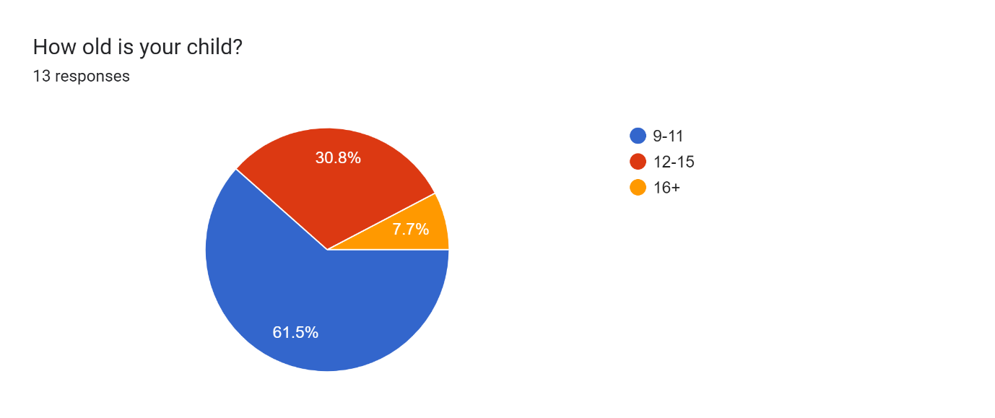
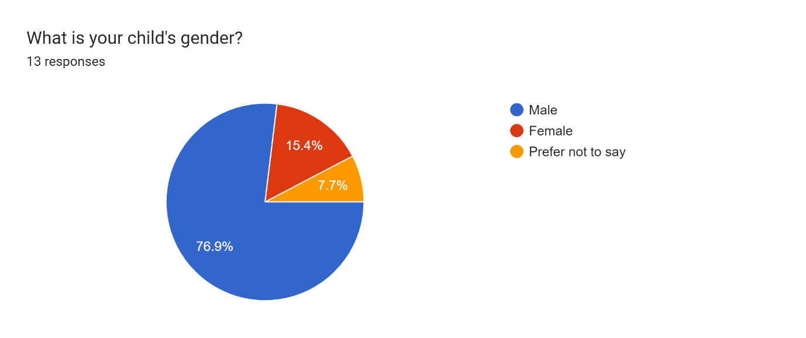
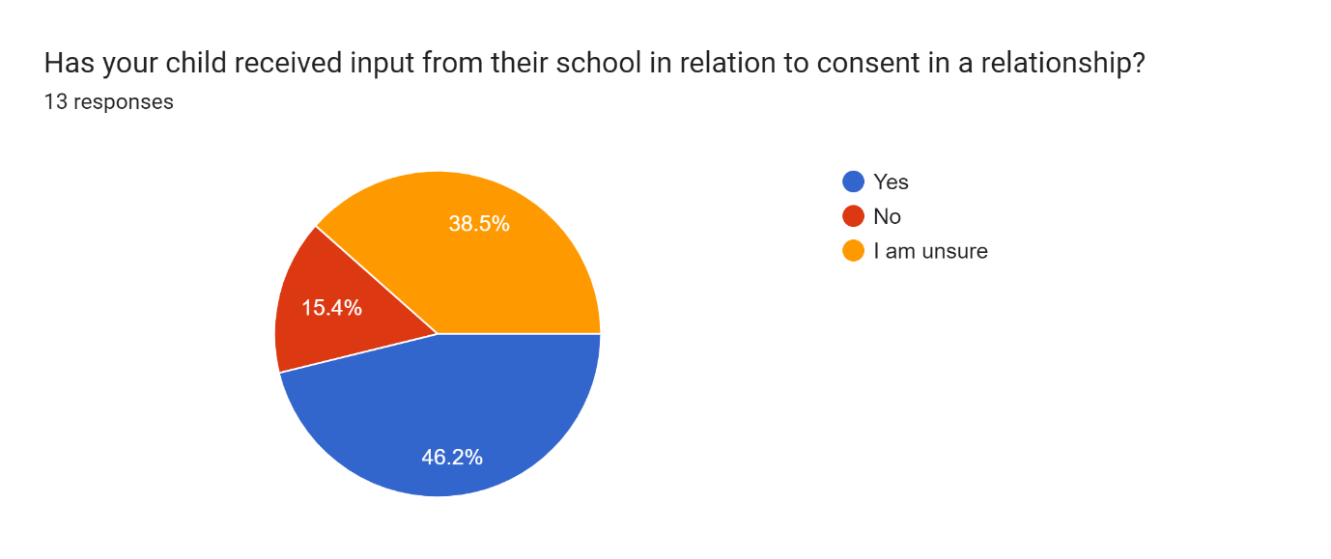
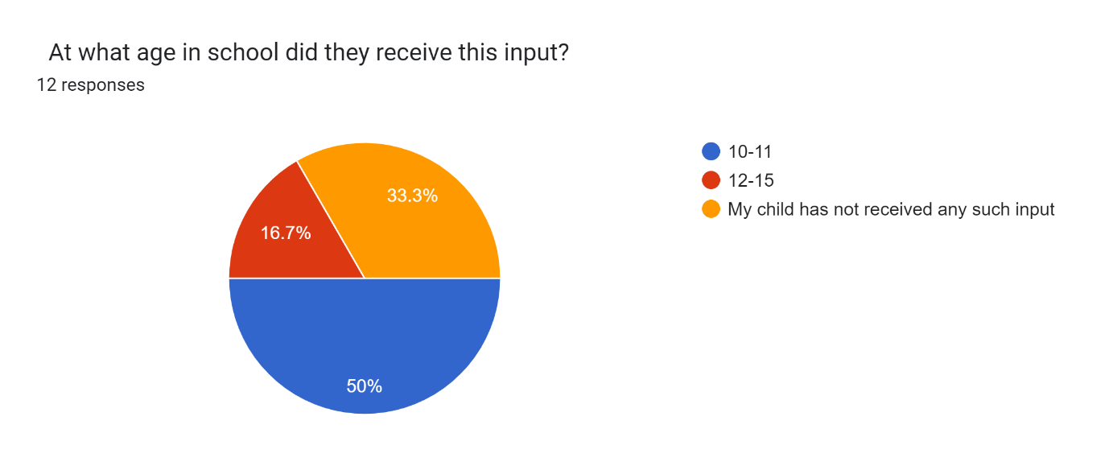
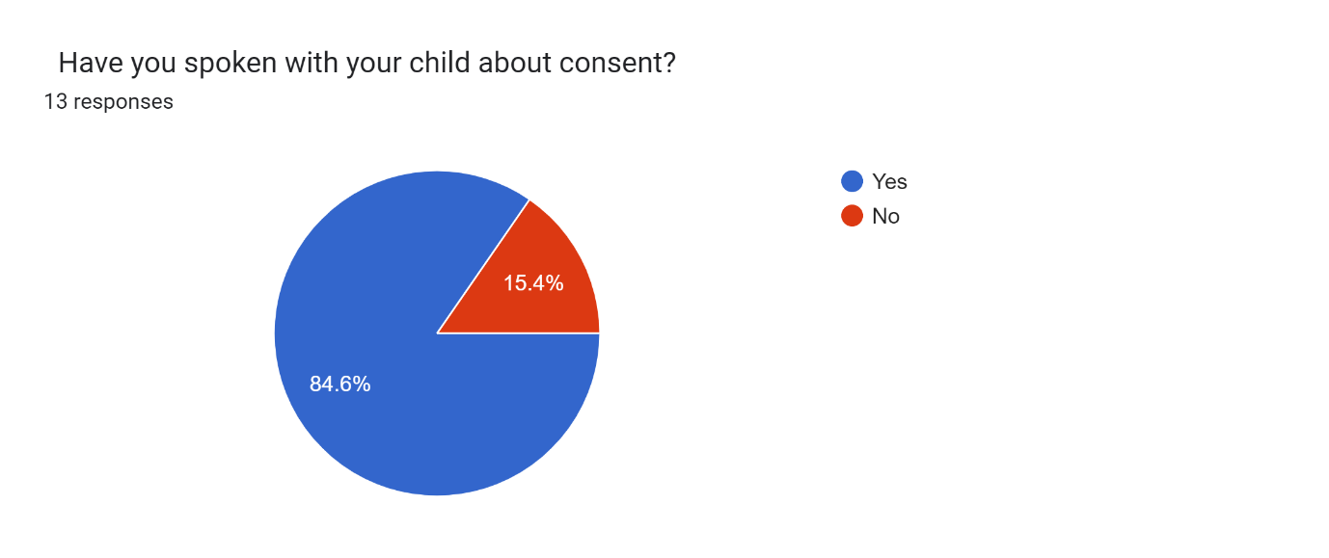
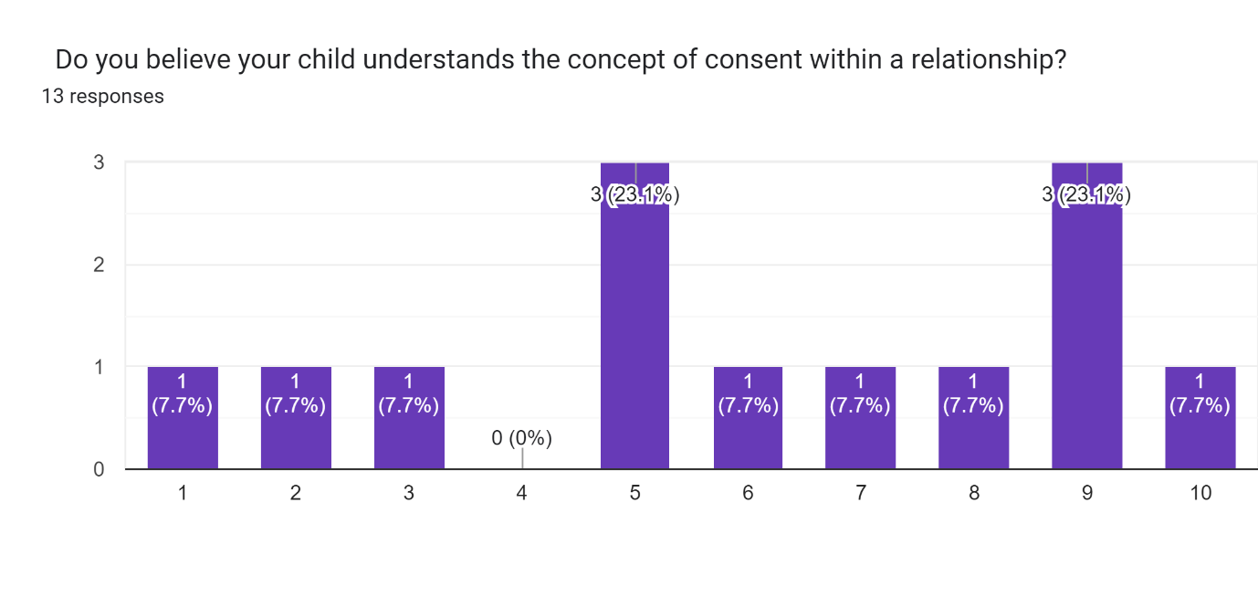
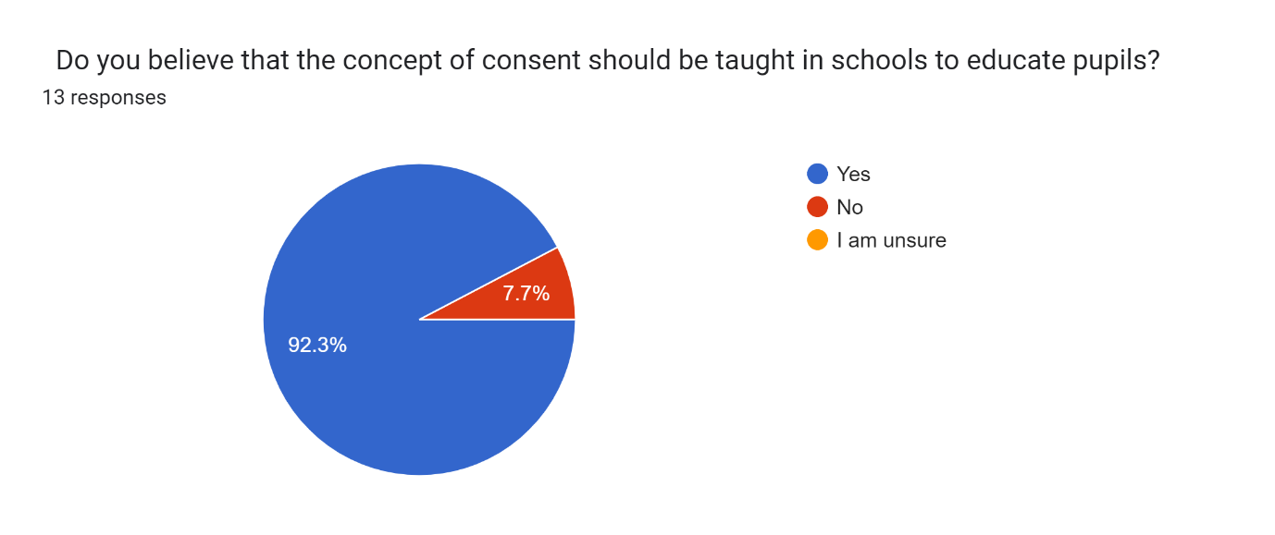
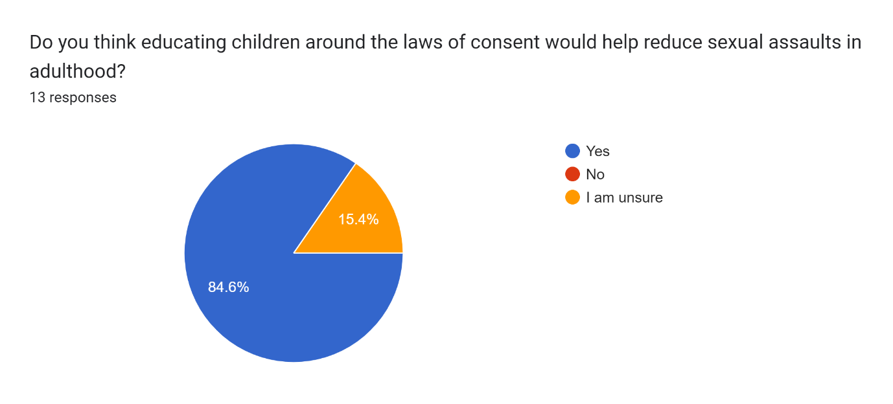
Although the data sample is small in relation to the above survey, it appears that most parents believe consent is important. 84.6% of parents and guardians felt it was important enough to educate their children about consent. 92.3% of parents believe consent should be taught in schools. This is a clear indicator of how important parents feel it is that their children understand the concept of consent.

From the data obtained, there does not appear to be any contact between schools and parents surrounding sexual education and consent. 53.9% of parents stated that they not now know if their child has received any input from school about consent within a relationship. This could possibly indicate a lack of communication between the school and parents.

This is alarming considering sexual education has been mandatory in school since 2020 and parents have the consideration at the moment for their child to opt out.

4.3 Interview Findings
Interviews were conducted with two male pupils. For anonymity, I will refer to them as Pupil A and Pupil B.
Both pupils were asked the same questions in relation to the education they have received in school around consent and what consent means to them.
Interview 1
Pupil A is twelve years old and is in his first year of secondary school. Pupil A stated he remembered having one lesson in primary school and he believes he was about 10 years old. The lesson was called “love”. Pupil A stated that he and his classmates were taught the different kinds of love. He stated that they were told about interracial relationships, same sex relationships and relationships where people were old and young. Pupil A said he understood that grown ups could be old and young and still be in a relationship. When asked what he meant by adults, pupil A claimed that he understood that to be in a relationship grown ups must be 18.

Pupil A was asked if he knew what consent was. Pupil A believed that consent was agreeing to something. Pupil A was asked if he knew what consent was within the concept of a relationship. He stated that he understood that if you are in a relationship and wanted to hold your partners hand if they said no then you could not hold your partners’ hand. Pupil A had no understanding of sexual consent or the legal age to engage in any sexual activity. Pupil A stated that he had not had any lessons in school about sexual education.

Pupil A was asked if he knew where to find any information on any questions he may have in relation to consent and relationships and he said no.

Interview 2
Pupil B is a fourteen-year-old boy in his third year of secondary school. Pupil B remembered having a similar lesson to pupil A in primary school but described it as the teachers saying there are different types of love. He stated that it was explained to him in primary school that everyone can love everyone.

Pupil B was asked the same questions as pupil A and he has had two lessons about sex education. One in the second and one in the third year of secondary school. Pupil B appeared to understand more about consent than pupil A. Pupil B stated that he knew that if a girl says no to anything like kissing, then you must not kiss her as you can get into trouble with the police. Pupil A was asked about the age of sexual consent and believed it to be 18 as that is what his mother told him. Pupil B did not know the age of consent but stated it was wrong to do something to someone who said no.

When asked if he knew where to find out information about sexual consent and the law surrounding it, he stated it was probably online somewhere.

4.4 Survey 2 Findings
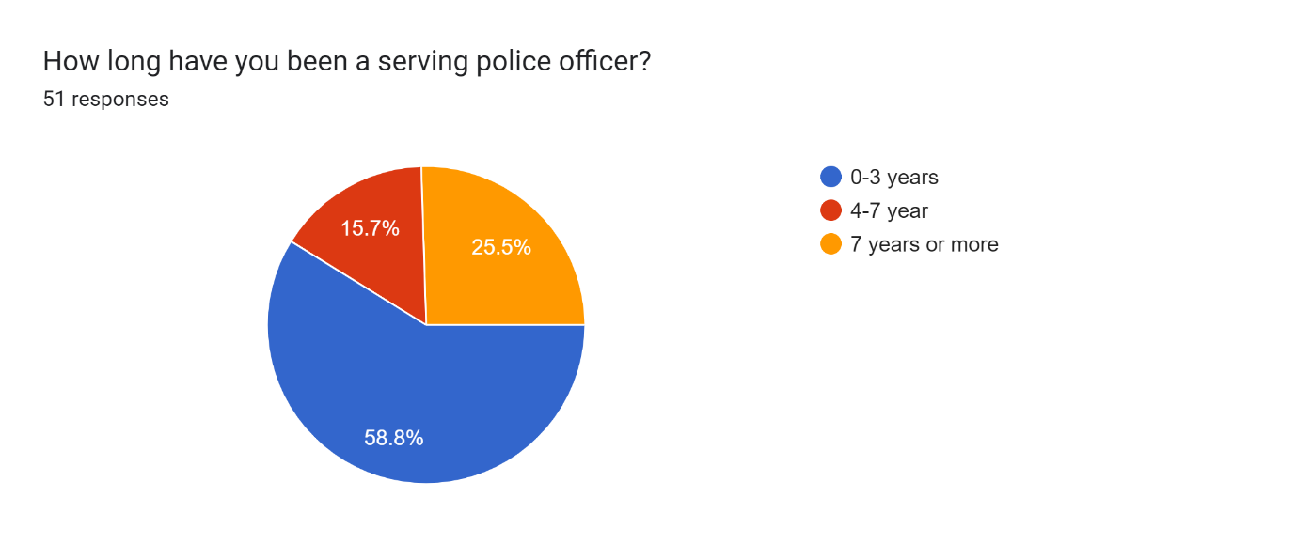
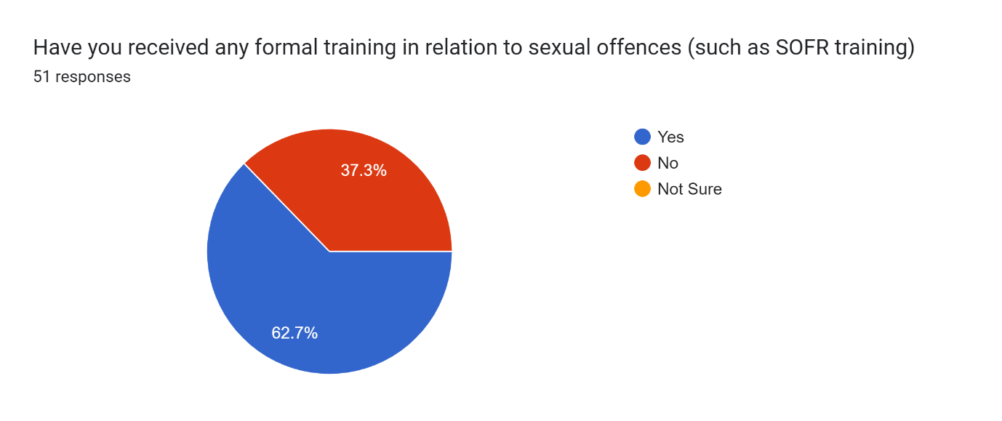
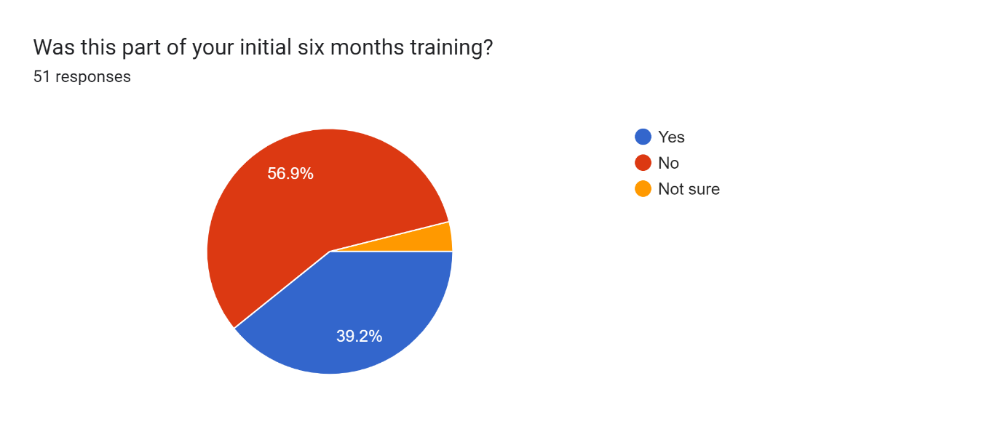
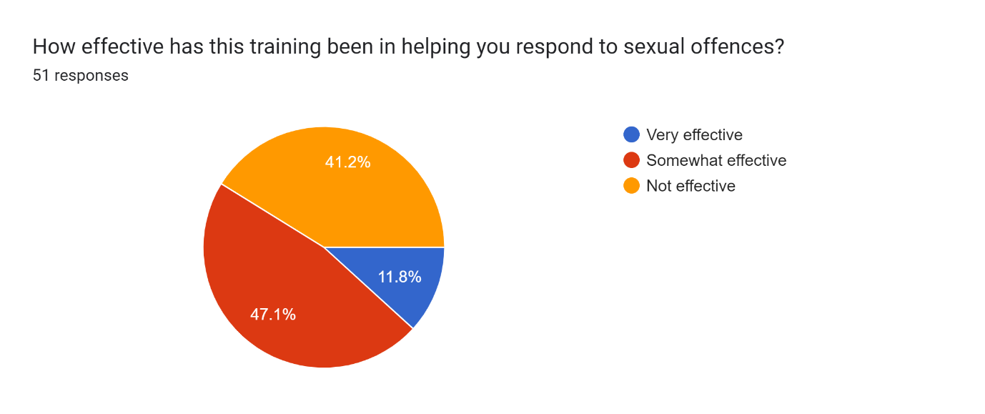
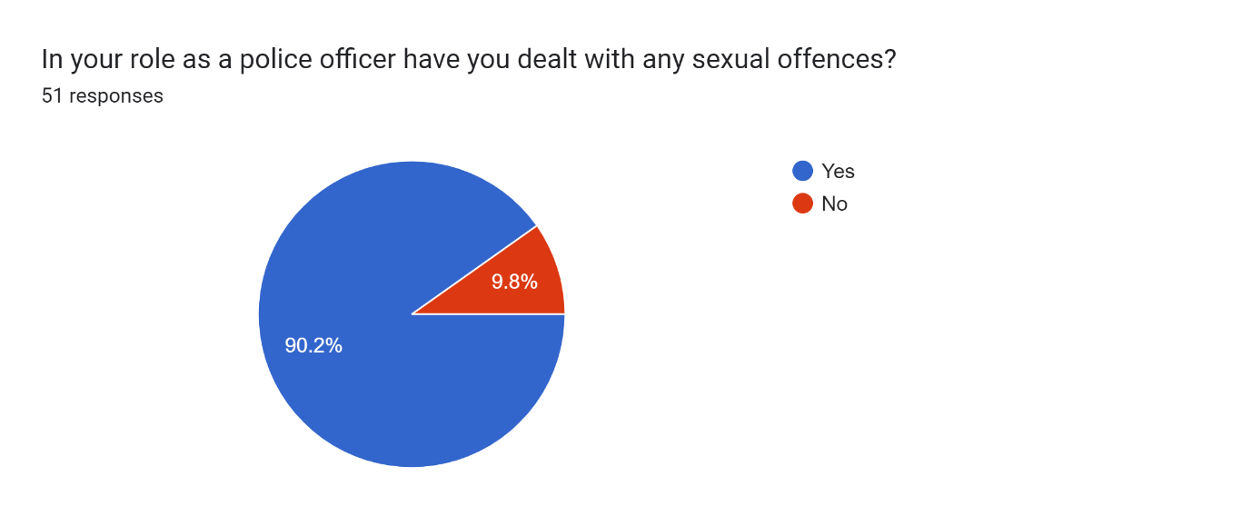
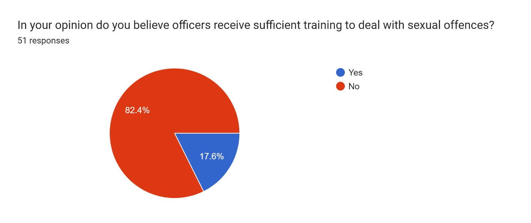
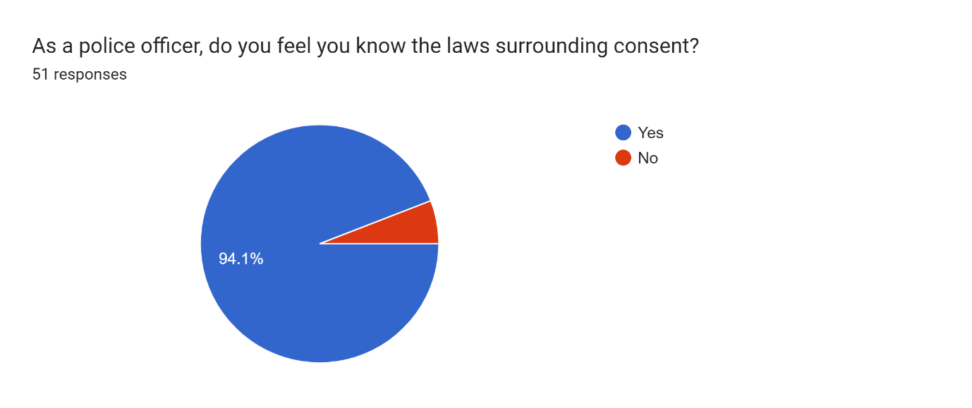
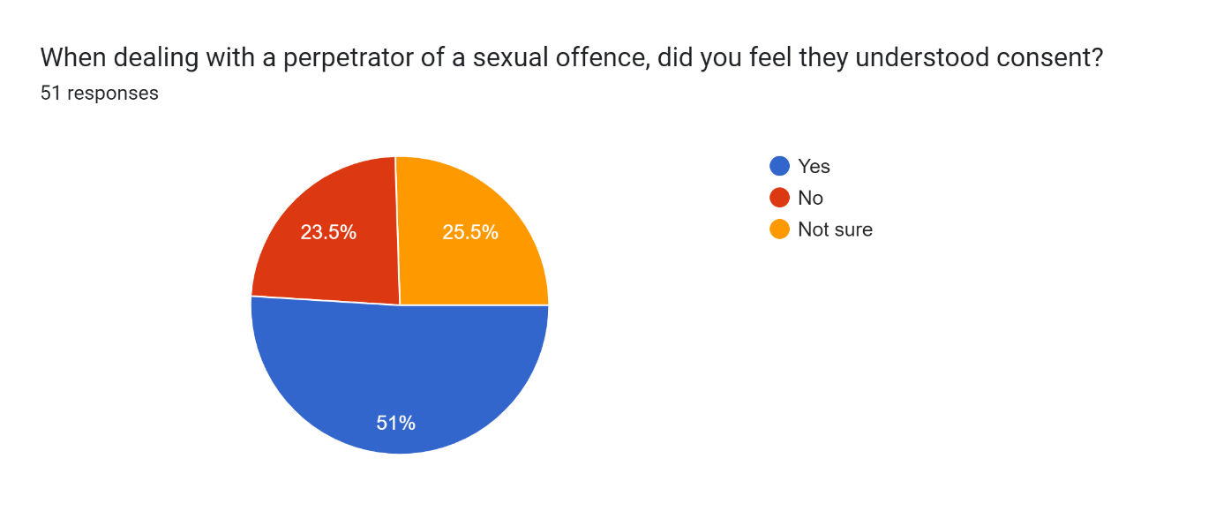
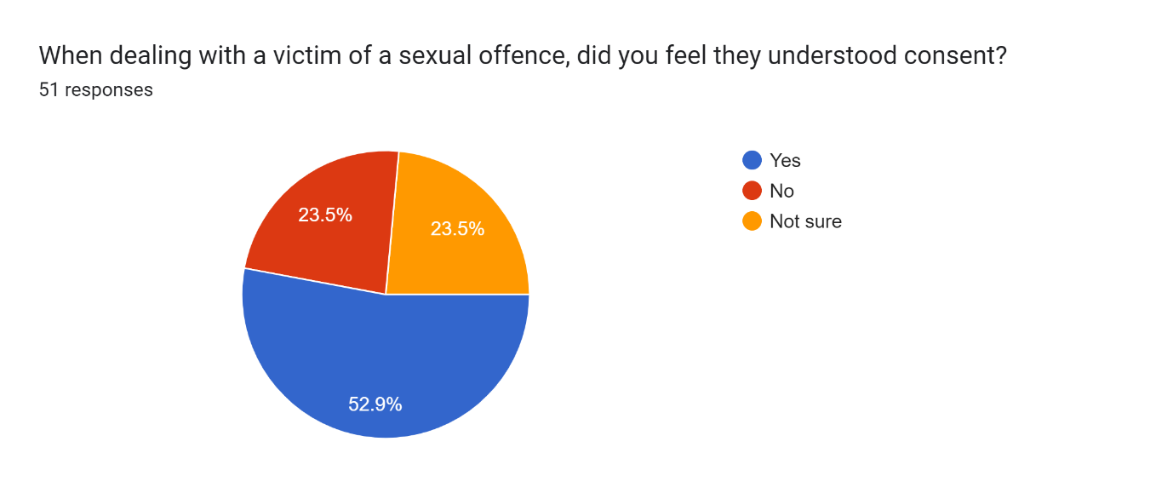
51 serving police officers have completed the above questionnaire. Of those 51 officers more than half (58.8%) have less than three years’ service. According to the survey only 39.2% of the officers completing the survey has confirmed they have received training in relation to rape and sexual offences. This is a worrying number considering the number of sexual offences is on the rise in England and Wales.

56.9% of officers have stated that they did not receive this as part of their initial 6 months training. This indicates they have had to elect or be chosen for further training.

90.2% of officers stated they have dealt with rape and sexual offences and 82.4% of officers believe they have not received sufficient training in how to deal with sexual offences. The contrast between these figures show how a large number of officers have had do deal with rape and sexual assaults but feel they haven’t had the correct training. This could impact on their confidence to deal with the incident, therefor this could hinder the service provided to the victims.

The results show that officers understand that the training they have is insufficient almost all officers stated they understood the laws surrounding consent. 94.1%. As a police officer responding to rape and sexual assaults, every officer should understand the laws surrounding consent.

4.5 Conclusion
The results have been analysed and collated to show the findings of the two surveys conducted and both interviews. The results can now be used to provide feedback and recommendations to parents, educators and the police services in England and Wales about further education in relation to consent.

Chapter 5 – Conclusion and recommendations

5.1 Introduction
The conclusion and recommendations are the final chapters of the dissertation. This chapter will reflect on the findings from the data analysis where three out of the five main objectives have been answered. Those being, “Is there enough resources available for children and young adults to access regarding self-educating in relation to being in a healthy relationship”, “Is there enough education provided by schools around the concept of consent” and “What training do police officers receive in relation to sexual offences and consent?”.

5.2 Findings
Within this dissertation, information has been provided to show how schools are meant to include consent into the curriculum. It has suggested that from the research this is still yet to be delivered completely in line with government guidelines.

Although there is no concrete evidence from the research that there is a clear link between the education being provided to children in relation to consent and sexual offences committed as an adult. If children are taught about consent within a relationship, the line becomes blurry, and they may not believe that what they have done is wrong or understand that they are or have been a victim of rape or sexual assault.

The onus is not solely on the educators to educate children about consent. Society should work together to ensure all children have a good understanding of consent. Parents should take some responsibility to help educate children around the laws of consent.

As outlined in the literature review, there are far more measures in place to stop offenders reoffending than there is to prevent the offence from happening.

In relation to the training police officers receive to respond and investigate rape and sexual offences, the survey has proven that officers do not receive adequate training. They are attending incidents and do not feel confident in how to efficiently deal with these incidents. It could be perceived from the survey that if officers are not confident in their ability to deal with rape and sexual assaults, they may not be providing the victim with sufficient support and the standard of service received by the victims are inadequate. This could lead to victims not reporting rape or sexual assaults due to the lack of trust in the police.

5.3 Recommendations
From the research and analysis conducted, schools should be doing more to support parents in the education around consent. Although parents believe their children generally understand the concept of consent. They appear to understand a generalisation of consent. “No means no and yes means yes”.

Parents are unsure what their child is being taught in school around consent and some believe their children have been taught nothing. As this subject is important in building healthy relationships and understanding how a relationship works it is my belief that parents should be included somewhat in the education process, so they understand how to approach the subject and talk to their children about consent.

Consent is about setting boundaries and making people feel safe within a relationship. Everyone should be taught this, and everyone has a right to be taught this whether by parents or teachers.

If a person has a better understanding of boundaries, then this could help to reduce sexual offences being committed. Although this will not eradicate the offences as education is not the only solution.

It could be beneficial for authorities such as the police to work with schools and youth services to deliver input on consent and sexual offences. It appears that children have a vague understanding of what consent means.

The schools could send out a courtesy letter to advise parents of when the lesson will be taking place and what the contents of the lesson are. This would give parents a better understanding of what age-appropriate conversations to have with their children.

With regard to the survey answered by police officers. I would recommend that every officer that joined the force prior to 2022 have mandatory training in relation to rape and sexual assaults. This would improve the number of officers that will feel confident in dealing with types of incidents.

This could be completed within mandatory training days that officers have every month. This could be classroom based or could even be delivered via teams.

Officers state that the training they receive is not efficient. I recommend that the College of Policing review the content of the training. They could ask officers what they struggle with when dealing with these types of incidents and incorporate this into future training.

It would not only be beneficial for the officers by restoring their confidence in dealing with rape and sexual assaults, but it could go a long way into restoring the confidence victims have of the police and lead to further reports being made and justice provided for the victim.

5.4 Conclusion
This dissertation has highlighted how the school system is not up to standard in teaching children the concept of consent and the law surrounding it in line with the mandatory content to be delivered as stated by the UK Government. There appears from the research to be little or no understanding of the consequences of not obtaining consent.

Although there are guidelines set out on what should be taught, there is a long way to go in educating young people and getting them to understand the concept of consent.

There are far more reactive measures in place in dealing with offenders who have already committed the offences. There is a lot of research around rehabilitating. However, there is little in the way of preventative measure. Surely it would be better to prevent such crimes rather than reacting when it’s been committed. Understandably there will be no way to prevent every rape or sexual assault. I believe that with the right education more of these crimes could be a way to prevent some of them. Leading to less stress on the police, courts, and most of all there will be less victims.

Although the police service has started to change the way they train officers in relation to rape and sexual offences. There appears to still be room for improvement. There is a lack of training for longer serving officers and officers themselves have identified the lack of training they have received. There is a long way to go before officers feel confident in dealing with rape and sexual offences. If the police officers have identified weaknesses in training, it is only right that the organisation educate the officers. This would not only be beneficial to the officers and victims but will benefit the police service in demolishing the barrier between the police and the public they serve.

Chapter 6 – Bibliography

Bibliography
College of Polciing , 2023. www.college.police.uk. [Online]
Available at: https://profdev.college.police.uk/professional-profile/sexual-offences-liaison-officer/
[Accessed 2023].
College of Policing , 2023. www.college.police.uk. [Online]
Available at: https://www.college.police.uk/article/rape-and-serious-sexual-offences-training-first-responders
[Accessed 2023].
Crown Prosecution Service , 2021. www.cos.gov.uk. [Online]
Available at: https://www.cps.gov.uk/legal-guidance/rape-and-sexual-offences-chapter-6-consent
[Accessed 2023].
Department of Education , 2023. www.gov.uk. [Online]
Available at: https://www.gov.uk/government/publications/relationships-education-relationships-and-sex-education-rse-and-health-education/annex-a-regulations-for-relationships-education-relationships-and-sex-education-rse-and-health-education
[Accessed 2023].
Gupta, S., 2023. www.verywellmind.com. [Online]
Available at: https://www.verywellmind.com/consent-importance-types-and-examples-6890731
[Accessed 2023].
HMICFRS, 2014. justiceinspectorates.gov,uk. [Online]
Available at: https://assets-hmicfrs.justiceinspectorates.gov.uk/uploads/2014/05/crime-data-integrity-interim-report.pdf
[Accessed 2023].
HMICFRS, 2023. www.hmicfrs.justiceinspectorates.gov.uk. [Online]
Available at: https://hmicfrs.justiceinspectorates.gov.uk/glossary/golden-hour-principle/
[Accessed 2023].
Home Office, 2021. www.gov.uk. [Online]
Available at: https://www.gov.uk/government/publications/tackling-violence-against-women-and-girls-strategy/tackling-violence-against-women-and-girls-strategy
[Accessed 2023].
House of Commons, 2023. commonslibrary.parliment.uk. [Online]
Available at: https://commonslibrary.parliament.uk/relationships-and-sex-education-in-schools-whats-changing/
[Accessed 2023].
NHS, 2023. www.letstalkaboutit.nhs.uk. [Online]
Available at: https://www.letstalkaboutit.nhs.uk/directory-of-services/sexual-assault/consent/
[Accessed 2023].
NHS, 2023. www.nhs.uk. [Online]
Available at: https://www.nhs.uk/live-well/sexual-health/help-after-rape-and-sexual-assault/
[Accessed 2023].
NPCC, 2021. www.NPCC.police.uk. [Online]
Available at: https://news.npcc.police.uk/releases/police-and-cps-collaboration-to-drive-up-performance-on-rape-and-serious-sexual-offences
[Accessed 2023].
NSPCC, 2023. learning.nspcc.org.uk. [Online]
Available at: https://learning.nspcc.org.uk/child-protection-system/children-the-law
[Accessed 2023].
NSPCC, 2023. learning.nspcc.org.uk. [Online]
Available at: https://learning.nspcc.org.uk/child-abuse-and-neglect/harmful-sexual-behaviour#:~:text=Peer-on-peer%20sexual%20abuse%20is%20a%20form%20of%20HSB,of%20a%20similar%20age%20or%20stage%20of%20development.
[Accessed 2023].
NSPCC, 2023. www.nspcc.org.uk. [Online]
Available at: https://www.nspcc.org.uk/keeping-children-safe/sex-relationships/
[Accessed 2023].
OASH, 2022. www.womenshealth.gov. [Online]
Available at: https://www.womenshealth.gov/relationships-and-safety/sexual-assault-and-rape/sexual-assault
[Accessed 2023].
Office of National Statistics, 2023. www.ons.gov.uk. [Online]
Available at: https://www.ons.gov.uk/peoplepopulationandcommunity/crimeandjustice/bulletins/sexualoffencesinenglandandwalesoverview/march2022
[Accessed 2023].
PSHSE Association 2022, 2023. pshe-association.org.uk. [Online]
Available at: https://fs.hubspotusercontent00.net/hubfs/20248256/Guidance/Documents/Teaching%20about%20consent%20-%20teacher%20guidance.pdf?hsCtaTracking=ff60c667-bdf9-46d2-93c1-62986c000924%7Cc388c8eb-7b52-4d5e-9cab-c502e76a3523
[Accessed 2023].
R v BREE (2007) Crown .
Rape Crisis, 2023. rapecrisis.org.uk. [Online]
Available at: https://rapecrisis.org.uk/get-informed/statistics-sexual-violence/
[Accessed 2023].
Sex Education Forum , 2023. www.sexeducationforum.org.uk. [Online]
Available at: https://www.sexeducationforum.org.uk/about/our-history-30-years-campaigning
[Accessed 2023].
Smith, T., 2021. www.dailymail.co.uk. [Online]
Available at: https://www.dailymail.co.uk/news/article-10261595/Criminologist-Patrick-Tidmarsh-reveals-five-common-traits-sex-offenders-share.html
[Accessed 2023].
The National Archives , 2023. www.;egislation.gov.uk. [Online]
Available at: https://www.legislation.gov.uk/ukpga/2017/16/section/34/enacted
[Accessed 2023].
The National Archives , 2023. www.legislation.gov.uk. [Online]
Available at: https://www.legislation.gov.uk/ukpga/2003/42/section/74
[Accessed 2023].
Victim's first, 2023. www.victims-first.or.uk. [Online]
Available at: https://www.victims-first.org.uk/crime-info/guidance-and-support/rape-and-sexual-assault/
[Accessed 2023].

