ACMA 5001

Control and Automation

Design of a specialist automatic control system

Robert Goodson

Barrie John

1811176

Contents.
- List of Figures………………………………………………………………………………………….2
- Introduction……………………………………………………………………………………………………….2
- Why automate an aquarium………………………………………………………………………………2
- Design requirements………………………………………………………………………………………….3
- Design……………………………………………………………………………………………………………..…3
- Use of hydraulics in an aquarium……………………………………………………………………….9
- Final Concept…………………………………………………………………………………………….………11
- Conclusion…………………………………………………………………………….………………..12
- References………………………………………………………………….....……………………..13

1.List of figures and tables.
- Marine filtration system.
- Chemical filtration system.
- PH sensor.
- Graph to track water PH levels.
- Diagram of a hydro pneumatic system.
- Automatic fish feed unit.
- Example of a leak detection system.
- Example of a water flow meter.
- Example of a water temperature controller.
- Diagram of a hydraulic control system.
- Example of a hydraulic control valve.
- Diagram of hydraulic wave machine.
- Diagram of aquarium control system.

2.Introduction.
This report compiled by Barrie John for a marine conservation organisation looks at the complete automation of a specialist aquarium to nurture endangered species. It will look at the processes and designs needed to maintain a natural environment. Several factors will be considered such as data recording, cleanliness, and the environmental conditions.

3.Why automate an aquarium?
Aquariums can be time-consuming, especially saltwater! Ensuring that you maintain water parameters as best you can to ensure stability which leads to a healthier tank, the amount of time an aquarium requires can soon mount up.

In an ever-busy world the amount of time we have available is limited. To leave your aquarium for a day or so is manageable but to leave for longer periods requires help. This is where automation of an aquarium is ideal. In short, every aquarium can benefit from some form of automation. (The Begininers Reef, 2022)

4.Design requirements.
The design will need consider the following requirements.
- Data recording for both research and process control.
- Alarm notifications, this will be to ensure the aquarium does not go out of parameters.
- Environmental conditions. Some automation systems may not be suitable to the conditions.
- Will total automation be possible or will some aspects of the design still need to be completed manually.

5.Design.
There are several steps to the design on an aquarium, below is a breakdown of each component and if automation is both required and possible.
- The tank- ensuring the correct size and type of glass or acrylic is used is essential for any tank. There are pros and con to both the use of glass and acrylic. Glass is less expensive, while acrylic is lighter. While unlikely glass can break where has the acrylic tank is much stronger. The key factor in choosing the tank material is size. It is recommended that a tank over 200 gallons be made from acrylic. For this report, I have chosen to use acrylic in the manufacture of this tank. (Oceans Aquarium, 2019)

- Tank cleaning- it is possible to install a self-cleaning tank by installing a filtration system to the tank. There are several options for a filtration system.

Mechanical Filtration – this is when the water in the tank is simply passed through a spongy material such as foam which traps the debris and stops it from re-entering the tank. The foam is then simply replaced on a regular basis to maintain effectiveness. A simple timer can be installed to alert you as to when the foam needs to be replaced.

Biological Filtration – This is the most important filtration process for your aquarium. This is done not through any form of automation but by cultivating a colony of beneficial bacteria which help maintain the natural nitrogen cycle within the tank.

Chemical Filtration – This filtration process removes dissolved wastes by flowing water through activated carbon. Activated carbon is extremely porous and when water flows by, it the pores trap dissolved wastes and minerals such as phosphate. While you can manage without chemical filtration this would mean there would be a need to change the water on a much more frequent basis. (Rate my fish tank, 2022)

In conclusion, a blend of all three types of filtrations will be used in the design, a mechanical filtration system along with chemicals that both can be monitored automatically through timers and PH sensors, along with biological filters by means of plants to aid in the cleaning of the tank.

Figure 1 below shows the type of marine filtration system that will be used.

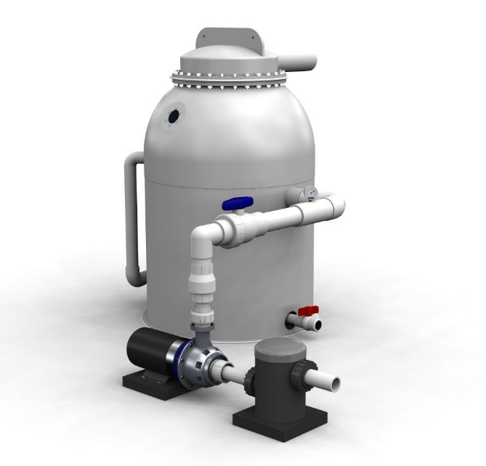 (Aquaculture Systems Technologies, 2022)
Figure 1.

Figure 2 below shows a typical chemical filtration system that could be used and monitored
by means of a PH sensor.

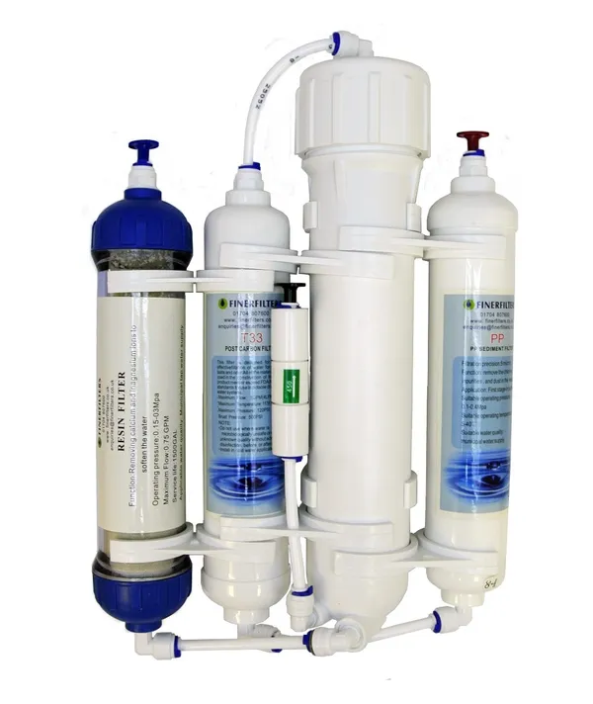 (Finer Filters, 2021)
Figure 2.
What are PH sensors?

A pH sensor is an instrument used to measure acidity or alkalinity of a solution - this can also be referred to as ph.

It is important to control the pH measurement to maintain the correct hydrogen ion concentration of the water. Figure 3 below shows a typical example of the types of pH sensors available.

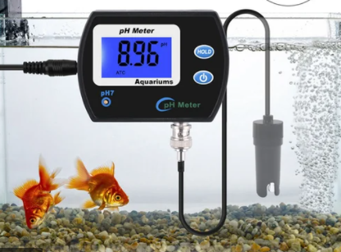 (Zoodmall, 2022)
Figure 3.

Data from these monitors can be recorded and used to monitor and track water levels to understand the time scale etc. between the need to empty the tank. Figure 4 below shows a typical example of the type of graph that can be generated and understand the reasons for the changes in pH values.

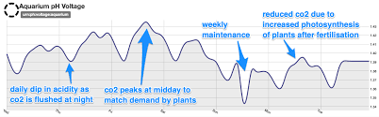
Figure 4.

- Water levels. - maintaining the correct water level is crucial to a healthy tank.
The use of a hydro pneumatic system will ensure this.
The hydro pneumatic system consists of a pressure pump and pressure tank this allows for a constant flow of pressurised water to the aquarium. This is ideal as it will work automatically, and no manpower is required.

The hydro-pneumatic system works by providing water automatically to the tank at a defined pressure & quantity. This can even be done at many locations using a single pumping system. This system can operate on variety of different pressures. It operates automatically by ensuring the pressure stays within a pre-set pressure range. (Civil Engineers Book, 2022)

Figure 5 below shows an example of the hydro pneumatic system that can be installed.

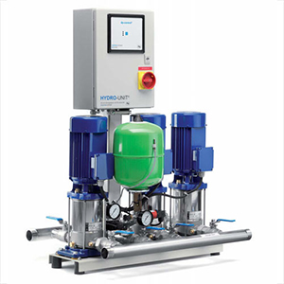 (Ensys Engineers, 2014)
Figure 5.

- Feeding. - ensuring the right quantities of food are dispensed at the right times is essential to maintain a healthy marine system.

It really is as simple as it sounds, an auto fish feeder is an electronic device designed to feed your fish when you are not around to do so.

It is simply a food container that can be filled with fish food and has a programmable timer fitted.

All you need to do is simply fill the container with fish food and program the timer for when and how often you want to feed your fish.

Figure 6 below is a typical feeding system that can used to easily automate the feeding schedule of the aquarium.

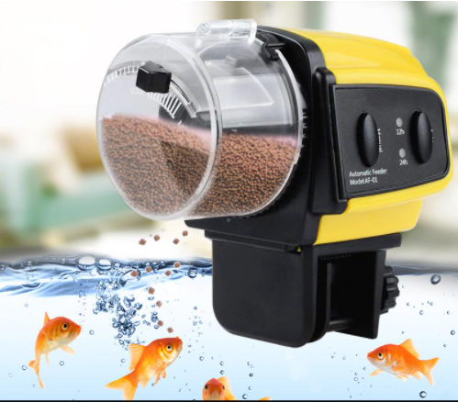 (Joom, 2022)
Figure 6.

- Leak detectors. – most leaks start off small such as a drip that if left undetected can soon become a major issue. That’s why it is vital that any leaks in the tank are picked up and addressed immediately. This is where an automated leak detector is essential. This can be done easily by installing a leak detection kit. This is simply a kit with sensors that are positioned outside the tank where a leak is most likely to occur (such as the joins in the glass) should these sensors encounter any water an alarm is triggered and can alert the user via an audible alarm or even a txt message. Figure 7 below shows a typical leak detection system.

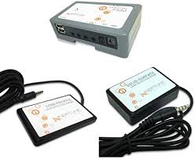 (Neptune Systems, 2018)
Figure 7.

- Flow meters. – it is important to ensure that there is an accurate flow of water through the aquarium. This can be controlled using a flow meter.

Water flow meters are an ideal way to monitor the volume of water in your aquarium this is important when understanding if your aquarium needs filling or re-filling and when adding treatments. Figure 8 below is an example of a flow meter that can be used.

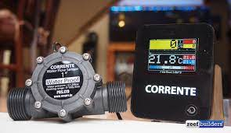 (Reef Builders, 2018)
Figure 8.

- Temperature controller. – it is essential for aquatic life thrive that the correct water temperature is maintained. This can be done using a temperature controller.

Aquarium temperature controllers are the best way to regulate the temperature of your aquarium. This is done by simply switching the water heater on and off to maintain the desired setting. (Matos, 2020)

Figure 9 below shows a temperature controller.

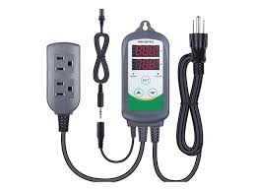 (Matos, 2020)
Figure 9.

6.Use of hydraulics in an aquarium.

To understand if hydraulics could play a role in the automation of an aquarium it is first important to understand how hydraulics work.

The science behind hydraulics is called Pascal's principle. This is because the liquid in the pipe is incompressible, this will cause the pressure to stay constant all the way through it, even whether you're pushing it hard at one end or the other. This pressure is defined as the force acting per unit of area. (Woodford, 2021)

Figure 10 below is typical example of a hydraulic system.
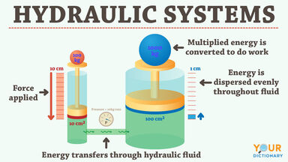 (Your Dictionary, 2022) Figure 10.

Use of a hydraulic system in an aquarium would be ideal for larger tanks such as a commercial aquarium. This is because the water pressure involved in these tanks would be vast due to the volume of water involved. Simple operations such as opening and closing valves when controlling water levels for example would need a hydraulic system due to the pressure placed on the valves.
Figure 11 below shows an example of a pressure relief hydraulic control valve that can be used to control the water flow.
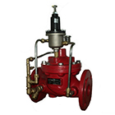 (Valfon, 2020) Figure 11.

Another good example of the use of hydraulics in an aquarium would be if you were to try and replicate the marine life’s natural habitat by introducing waves in the tank. For this you would need a hydraulic system capable of displacing large volumes of water.
The machinery that is used to create waves is quite simple. A high-speed fan will blow air into a wide metal pipe. This leads into an exhaust port at the base. In the middle of this pipe, there is a butterfly valve, a wide disc with a swivelling metal axis rod. When the rod is swivelled one way, the disc rests horizontally in the pipe, blocking the air flow. When the rod is swivelled the other way, the disc moves to a vertical position so the air can pass.
A hydraulic piston swivels the rod back and forth at regular intervals, allowing short bursts of pressurized air to flow up to the exhaust port. These air blasts blow on the water at the base of the tank, generating the flowing ripples. (Harris, 2022)
This would be an optional extra depending on the conservation teams requirements and budget.

Figure 12 below shows a hydraulic wave machine which could be used to in an aquarium setting.

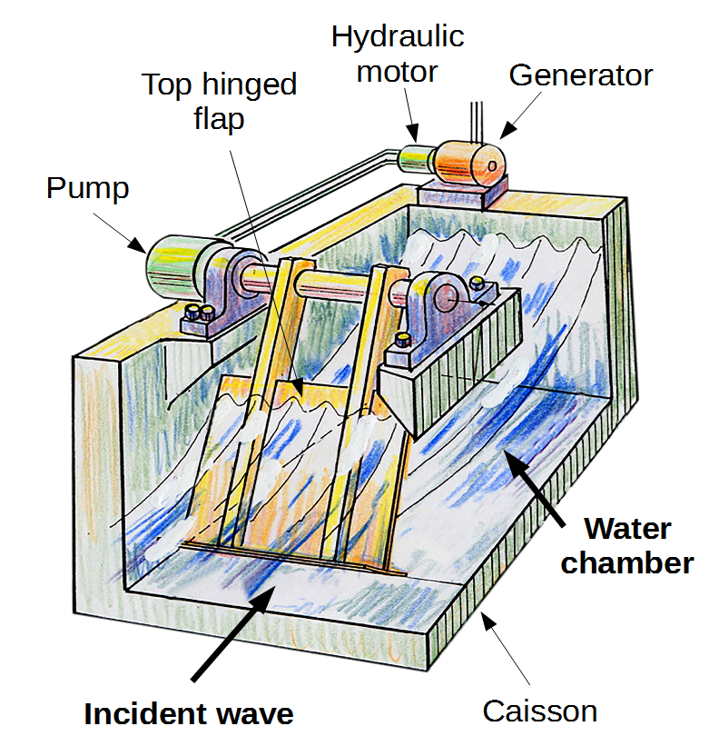 (Research gate, 2008)
Figure 12.

7.Final Design Concept.

The final design concept will be based on a large-scale aquarium.
- Acrylic will be used for the tank. This will allow for a large tank to be produced with minimal cost and maximum safety.
- A filtration system to be installed. This will include a wireless data recording that will feedback the water quality and allow for tracking and data recording of the environmental conditions.
- Water controls, a hydro pneumatic system will used to ensure the correct controls are in place.
- An auto feed unit to be installed. This will allow for the food to be dispensed in controlled quantities and at set times.
- Leak detectors to be added around the aquarium. This will monitor any change in the tank condition.
- Flow meters, this will ensure there is a steady stream of fresh water and monitor any change such as a blockage in the hydro pneumatic system.
- Temperature controllers, this will ensure that the aquarium water will be maintained at the optimum temperature at all times.
- Hydraulic pressure valves, these will be used to help control the pressure of the system.
- A closed loop management system to be installed to allow the aquarium to be controlled remotely.

To control multiple systems working simultaneously a management system will be installed. Thisclosed loop system will control all aspects of the aquarium and automatically adjust and raise alarms when needed.

Figure 13 below shows a typical aquarium controller that will be used. This will allow for one system to have over all control and allow for adjustments to be made remotely.

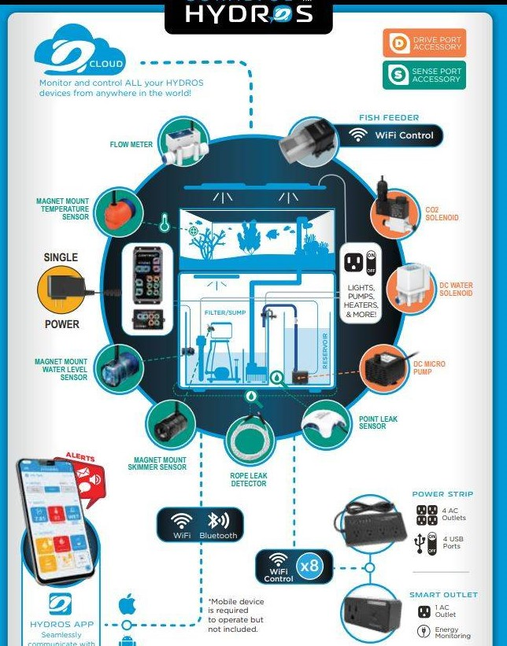 (Brennab Lahn, 2022) Figure 13.

8.Conclusion.
In conclusion I believe this design will meet all the marine conservations needs and total automation of the aquarium. The design considers the need to have data recording for analysis purpose, the closed loop management system allows for adjustment of the aquarium parameters remotely. Hydraulic pressure controls valves add a safety element which enables the production of a large aquarium allowing for a wide range of marine life to be housed in one tank.

9.References.
Aquaculture Systems Technologies. (2022, 03 21). Commercial Aquarium Filters. Retrieved from astfilters.com: https://astfilters.com/aquatic-systems/applications/commercial-aquarium-filters-zoos/
Brennab Lahn. (2022). Hydros control valves. Retrieved from bulkreefsupply.com: https://www.bulkreefsupply.com/content/post/md-2021-04-hydros-control-by-coralvue-the-next-generation-of-aquarium-controllability
Bulk reef supply. (2022). auto top offs. Retrieved from bulkreefsupply.com/: https://www.bulkreefsupply.com/content/post/md-2020-01-auto-top-off-and-evaporation
Civil Engineers Book. (2022). HYDRO-PNEUMATIC Systems. Retrieved from askinglot.com: https://askinglot.com/open-detail/119689
Ensys Engineers. (2014). Hydro pneumatic systems. Retrieved from ensys.in: https://ensys.in/hpsystems.html
Finer Filters. (2021). finer filters. Retrieved from finerfilters.co.uk: https://www.finerfilters.co.uk/finerfilters-4-stage-reverse-osmosis-unit-with-di-resin-filter-for-tropical-marine-disc
Harris, T. (2022). how wave pools work. Retrieved from science.howstuffworks.com: https://science.howstuffworks.com/engineering/structural/wave-pool.htm
Joom. (2022, 03 22). Adjustable Electronic Automatic Fish Feeder. Retrieved from joom.com: https://www.joom.com/en/products/1508296457342593113-24-1-26193-2448801909
Matos, K. (2020, june 11). Why Use An Aquarium Temperature Controller. Retrieved from kavemanaquatics.com: https://kavemanaquatics.com/aquarium-temperature-controller/
Neptune Systems. (2018). Advanced Leak Detection. Retrieved from neptunesystems.com: https://www.neptunesystems.com/getstarted/ald/
Oceans Aquarium. (2019, july 04). Glass or Acrylic Aquarium? Retrieved from oceansaquarium.com: https://oceansaquarium.com/2019/07/glass-or-acrylic-aquarium/
Rate my fish tank. (2022). Choosing the right filtration system. Retrieved from ratemyfishtank.com: https://www.ratemyfishtank.com/blog/choosing-the-right-filtration-system-for-your-aquarium
Reef Builders. (2018, 04 24). The Perks of Using A Digital Water Flow Meter. Retrieved from reefbuilders.com: https://reefbuilders.com/2018/04/24/the-perks-of-using-a-digital-water-flow-meter/
Research gate. (2008). hydraulic wave machine. Retrieved from researchgate.net: https://www.researchgate.net/figure/Concept-of-the-Pendulor-device-7_fig1_301247379
The Begininers Reef. (2022, 03 22). Aquarium controllers. Retrieved from thebeginnersreef.com: https://www.thebeginnersreef.com/what-is-an-aquarium-controller/
Valfon. (2020). Hydraulic valves. Retrieved from valfon.com: https://www.valfon.com.tr/en/products/hydraulic-valves-186/water-works-188/g-qrv-series-pressure-relief-hydraulic-control-valve-208/
Woodford, C. (2021, 11 19). How Hydraulics work. Retrieved from explainthatstuff.com: https://www.explainthatstuff.com/hydraulics.html
Your Dictionary. (2022, 03 24). How Hydraulics work. Retrieved from yourdictionary.com: https://examples.yourdictionary.com/how-do-hydraulic-systems-work-examples-explained
Zoodmall. (2022). pH sensors. Retrieved from zoodmall.az: https://www.zoodmall.az/en/product/14842102/accurate-ph-meter-for-aquarium-multiparameter-water-quality-monitor-online-ph-monitor-acidity-metereu-plug/

