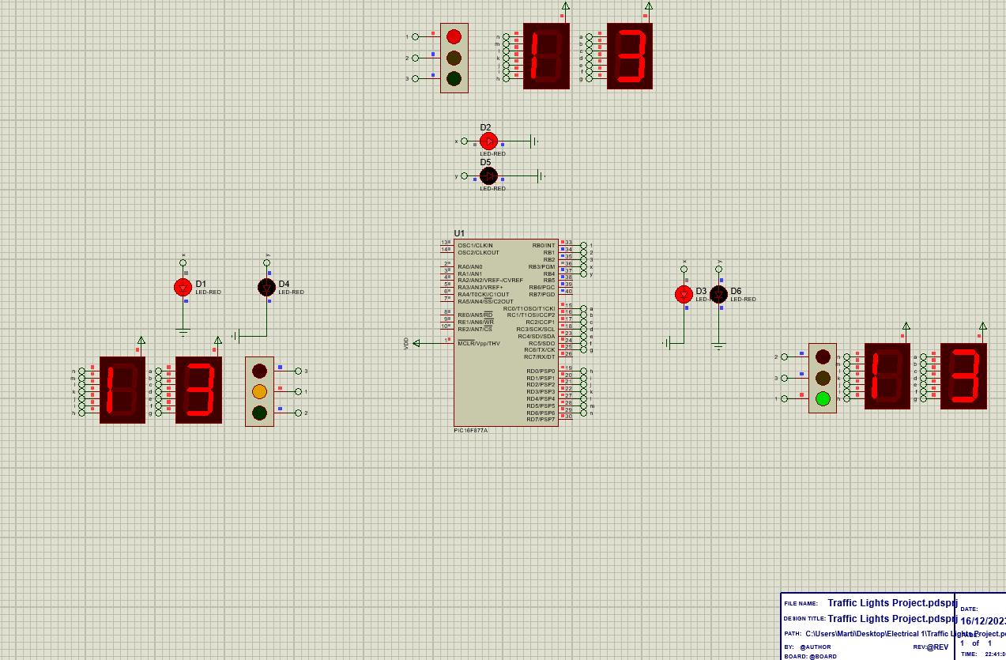

Traffic Light project
  - Electrical 1
Martin | Embedded Electronics System Design | 17/12/2023

Introduction
In this assignment, I was challenged to showcase the skills of designing and implementing a circuit using PIC16F/PIC18F microcontrollers that I was taught during my lectures of Electrical 1. The task involved creating a comprehensive design, complete with code, and rigorously testing your circuitry. While Proteus is recommended for initial circuit creation and simulation, I had the option to elevate the experimentation by testing components on real-world breadboards. Unfortunately, I did not have the ability to do so with the time allotted for this project. The task was simple I had to research a standard UK road T-junction and recreate it using Proteus 8 using different components found within the software. I melded this created system with code that was implemented using another software called MikroC which was designed specifically for work with different versions of PIC.
Within this report I will be covering the knowledge I gained about the operation of traffic lights within the UK as well as their different states. I will cover basic information such as different types of traffic lights and junctions, whilst also covering the design of my circuit with reasoning as to why it was designed in such a way and the code used to run the circuit.

Background Research
In the United Kingdom Traffic lights at a T-junction (or a three-way intersection) are used to help mediate between all the road users and enable safe traversal for all participants.
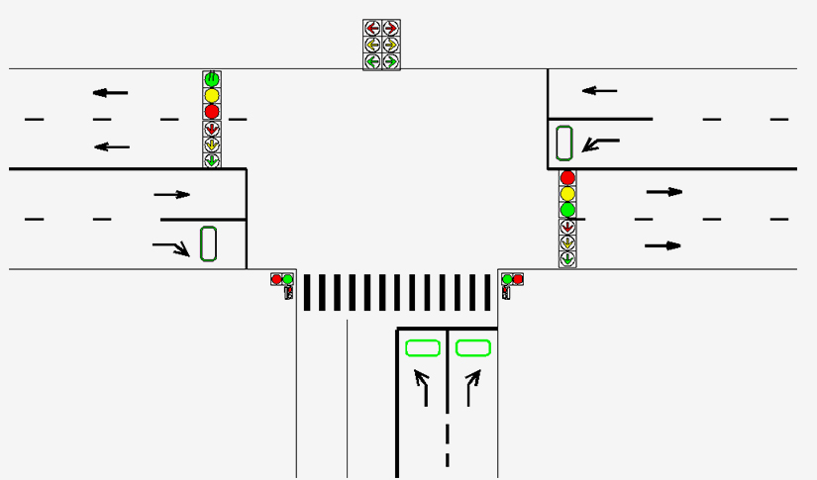[1]
The simplest form of this would be single lanes for vehicles on each entry point to the junction with a light at each segment. Only one light permitted to be green at a time meaning that only one of the 3 flows of traffic would be in motion at any given time.
Some routes as shown above might give crossings for pedestrians included which can be handled in one of a few different methods. The first would be that the pedestrian lights would turn green while all 3 traffic lights for the road users turn red which would simply mean creating a timer routine for the lights similar to a 4-way junction. Although this would be the simplest method it would cause a hindrance to the flow of traffic.
Although some traffic light systems utilize sensors or a mix of both sensors and timers, the system I am focusing on is purely timer based. This means that the lights will alternate through the cycle equally and have a set time for each state of use. The timer for how long a light will remain green for depends on the flow of traffic in that area. According to the NACTO (National Association of City Transportation Officials) “The prefect amount of time for a light to remain red is between 60 and 90 seconds).[2]
Traffic Lights in the United Kingdom have a set format for their operation.

rOAD USER TRAFFIC LIGHTS
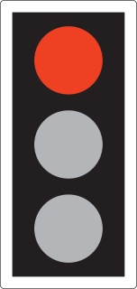[3]
The light will start as a singular solid red light. This light is to inform the user of the junction that they must stop as other road users and pedestrians will be in motion.
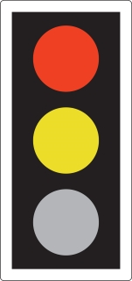[3]
Following the singular red light the light will change to a mix of red and amber. This still means that the road user must wait at the lights but it is to inform the road user that the lights are about to turn green to allow them to prepare for the change.
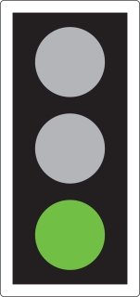[3]
The light will next change to emit a singular green light. This is to inform the road user that it is their turn to start using the junction and that it is safe for them to begin moving.
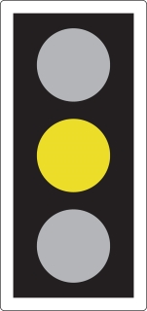[3]
The green light will change once more to a singular amber light. This is to inform the road user that the light is about to return to the beginning of the cycle and change to a singular red light once more. When this light is visible it once again is to inform the road user that they must stop. The road user is only permitted to ignore this light if they have already crossed the white line the traffic light is held above.

pEDESTRIAN tRAFFIC LIGHTS
There are many different methods for pedestrians to cross a road. These are designed to allow pedestrians to safely cross busy roads and lessen the risk to human life whilst doing so. Motorized vehicles are able to cause serious grievous bodily harm and even death at most speeds over 10 Miles per hour. The most common method is the Toucan crossing.
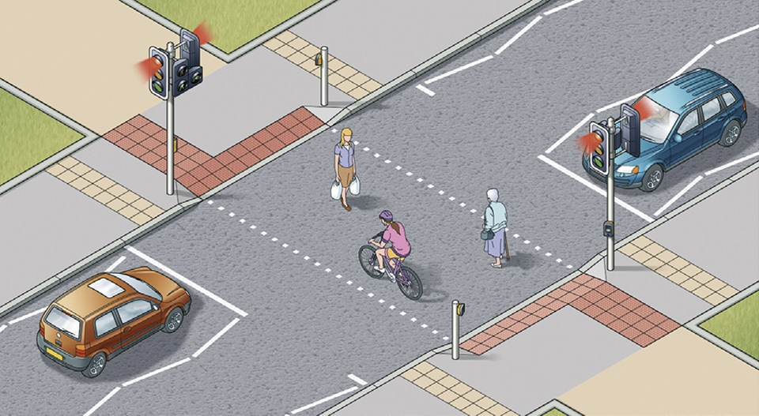[4]
The Toucan crossings very simple in design, there was push buttons either side of the road that when pressed will start a timer to make the traffic lights turn read and the pedestrian lights turn green enabling both pedestrians and cyclists to cross the road safely. There are staggered versions of this crossing that have a central island in the road protected by fencing which perform the same purpose just with a set of lights for either direction the vehicles are traveling.
[4]
With pedestrian lights when there is a singular red light it means that you must not cross. This is because the lights for the road users is currently green so it will be dangerous to cross. When the light is a singular green light its to signal pedestrians that it is save to cross the road with caution. This is due to the pedestrians still crossing a road where motorized vehicles potentially traveling at great speeds have a risk of colliding and causing serious harm. When the singular green light is flashing it means that you must not start to cross the road. If you are already crossing the road you must continue to the other side.

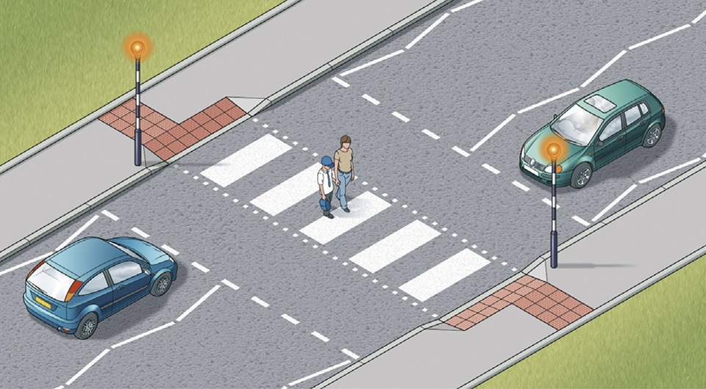[4]
Another crossing used for safe traversal of pedestrians on roads are Zebra Crossings these crossings are not operated by traffic lights at all instead it follows the simple rule that road users must give way to pedestrians. The danger of this crossing is that drivers may not see the pedestrians therefore may not stop in time. Because of this fact when crossing using a zebra crossing pedestrians must wait for road users to completely stop for their own safety, looking both ways while doing so to make sure this has happened for both flows of traffic.

The Circuit
I undertook the task of constructing a bespoke traffic management circuit, inspired by the iconic traffic light systems prevalent on the roads of the United Kingdom. The specific focus of the design was to replicate a simple T-junction traffic light setup, incorporating three traffic lights. To enhance user engagement and facilitate comprehension, I integrated two 7-segment displays alongside each set of traffic lights. These additional displays serve the purpose of presenting a timer to the user, counting incrementally from 0 to 40. The inclusion of a 300ms delay in the timer's progression adds a nuanced realism to the simulation, providing a more authentic representation of the typical traffic light sequences encountered in real-world scenarios.

The whole circuit is powered by a PIC16F877A which I have added a Hex file created by MikroC with the code to run the traffic lights correctly.
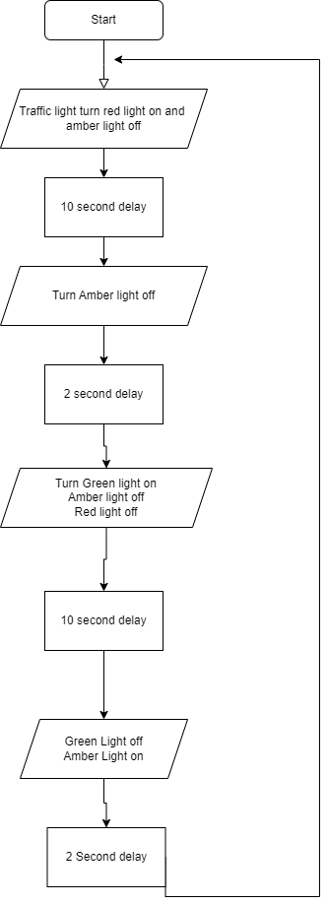
The flowchart provided above offers a comprehensive visualization of the intricacies underlying the operational design of a well-functioning traffic light system. Within this dynamic system, the traffic lights undergo a meticulously orchestrated sequence of states, each transitioning at specific intervals. Importantly, this orchestrated cycle is precisely synchronized with the timing of other lights positioned at the junction. This meticulous synchronization is a crucial aspect of the design, meticulously calibrated to ensure the seamless and safe utilization of the junction. By facilitating a harmonized flow of traffic, this synchronization contributes to the overall efficiency and effectiveness of the traffic management system, thereby promoting a safer and more orderly navigation experience for road users.

Testing the simulation

To thoroughly assess the simulation, I embarked on a straightforward yet essential process. I began by crafting the requisite code using MikroC, a programming environment that facilitated the generation of a HEX file. This HEX file was instrumental in configuring and executing the simulation within the Proteus platform, leveraging the capabilities of the PIC16f877A microcontroller. With the HEX file seamlessly integrated into the PIC, my next step involved closely monitoring the program's execution to ascertain its alignment with the intended functionality. This supervision process entailed overseeing a complete cycle of the traffic light procedure encoded in the program, a pivotal step in ensuring the comprehensive evaluation of its performance and adherence to the design specifications. This meticulous approach allowed me to validate not only the code's syntactic accuracy but also its dynamic execution within the simulation environment, thereby enhancing the reliability and functionality of the overall traffic management system simulation.

Conclusion

In conclusion, this assignment was a practical application of skills learned in designing circuits with PIC16F/PIC18F microcontrollers. The project involved creating and testing a circuit replicating a standard UK road T-junction using Proteus 8 and MikroC. Background research explored UK traffic light operations, influencing the circuit design to mirror prescribed operational states for road users and pedestrians.

The circuit featured 7-segment displays for user comprehension and a timer-based system, reflecting real-world traffic scenarios. Synchronization of lights, as detailed in the flowchart, aimed for a seamless and safe traffic flow, aligning with transportation standards.

Testing involved generating a HEX file in MikroC and executing the simulation in Proteus with the PIC16F877A microcontroller. Close monitoring ensured the program's adherence to intended functionality, validating both code accuracy and dynamic execution. This approach enhanced the reliability of the traffic management system simulation.

In summary, the assignment successfully merged theoretical knowledge with practical circuit design, resulting in a well-functioning T-junction traffic light simulation. This comprehensive exploration contributes to a safer and more orderly navigation experience for road users.

Looking forward, I recognize that incorporating the embedded C topic into future iterations of this project would enhance its efficiency. Unfortunately, unforeseen circumstances precluded its inclusion in the current timeline. However, delving into the significance of this project's foundation reveals the critical interplay between circuit design and embedded C programming. A more robust understanding of embedded C, particularly in the context of microcontrollers like PIC16F877A, would not only streamline the current project but also provide a solid foundation for upcoming endeavors.

The importance lies in the synergy between circuitry and embedded C, offering a comprehensive toolkit for designing intricate systems. Proficiency in embedded C could facilitate seamless integration of code and hardware, enabling more sophisticated functionalities and control over the traffic management system. Beyond the current project, this foundational knowledge opens avenues for scalability, adaptation to complex traffic scenarios, and incorporation of advanced features.

While the absence of embedded C in the initial presentation posed challenges, it emphasizes its pivotal role in shaping the trajectory of future work. Building on this foundation enhances the project's efficiency and lays the groundwork for ambitious developments in traffic management systems. This investment in knowledge promises dividends through innovation and adaptability for future projects in this format.

References

[1]“T-Junction application |,” Shenzhen NOBLE OPTO Co., Ltd. https://www.nobleled.com/solutions/t-junction-application/ (accessed Dec. 12, 2023).

[2]“You’ll Spend This Much of Your Life Waiting at Red Lights,” Yahoo Life, Sep. 19, 2018. https://www.yahoo.com/lifestyle/ll-spend-much-life-waiting-140236110.html (accessed Dec. 12, 2023).

[3]“Light signals controlling traffic - The Highway Code - Guidance - GOV.UK,” www.gov.uk. https://www.gov.uk/guidance/the-highway-code/light-signals-controlling-traffic (accessed Dec. 12, 2023).

[4]“Rules for pedestrians - Crossings (18 to 30),” THE HIGHWAY CODE. https://www.highwaycodeuk.co.uk/rules-for-pedestrians-crossings.html (accessed Dec. 12, 2023).
‌

