

Assessment 1 – Reading Task
PART 1: Upload your photo of your A3 in-class notes here:
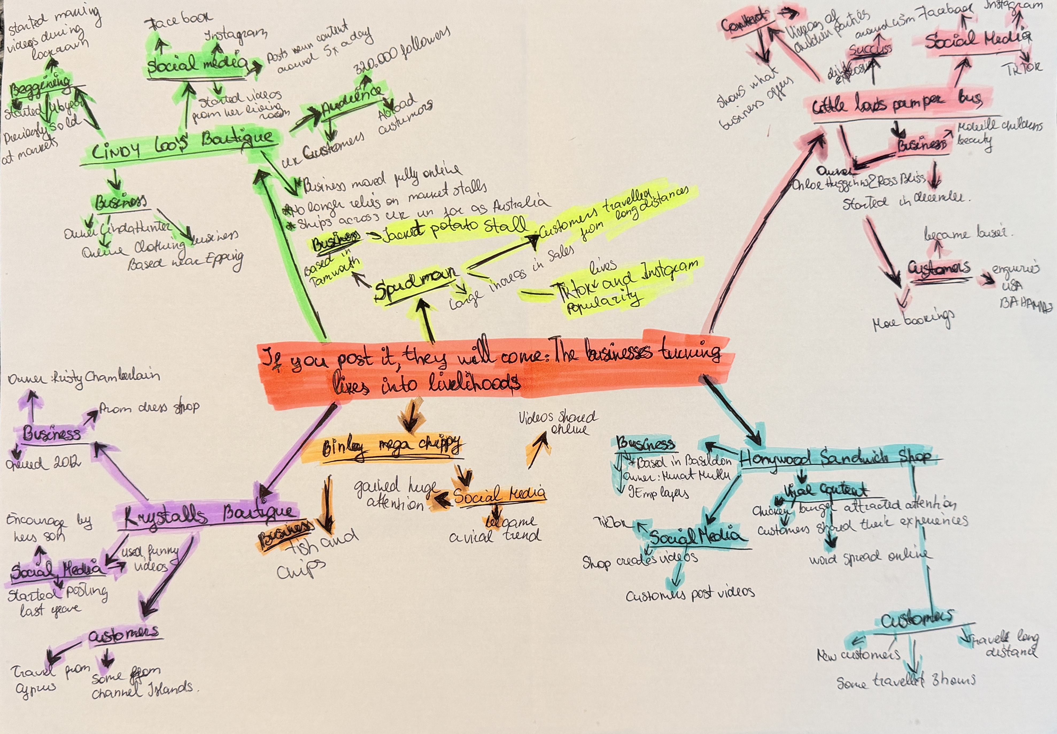

PART 2:
- Answer every question below in 1-3 full sentences.
- Use your own words. Do not use generative AI to answer these questions.
- Include a specific detail from the text when asked.
REMINDER
- The main idea is the overall message of the whole text.
- A key point helps to explain the main idea.
- A specific detail or example from the text shows that the key point is true.

- What is the main idea of the whole text?
The main idea of the text is that social media can have a huge positive impact on small businesses. Platforms like TikTok, Instagram and Facebook allow businesses to reach large audiences through entertaining and relatable videos. The article gives examples of businesses that have gone viral and gained more customers increased sales and even attracted people from far away.

- What is one key point that supports the main idea, and which specific example from the text shows this?
I think one key point is that social media can help a business get more customers. For example, like what happened to Honywood Sandwich Shop become more popular, some people travelled three hours to try their chicken burger.

- What is a different key point that supports the main idea, and which specific example from the text shows this?
Another key point is that social media can help businesses reach customers from far away. For example, Krystalls Boutique became popular because of its funny videos on social media. Some customers travelled from Channel Islands and even Cyprus to visit the shop. This shows how social media can help a small business attract customers from different places.
- Which part of the text do you think is most important, and why?
In my opinion most important part is how social media helps small businesses get more customers. As example of Lindy Loo’s Boutique. Linda started making vidoes during lockdown and later built a large following of about 320,00 followers. Her business became fully online and now sells across Australia and UK.

Reflection:
- What did you find difficult in this task (including in-class components), and why was it difficult?
I had a bit of trouble choosing the right answers because there was a lot of information in the text. The in-class activities, such as making mind map, finding the main idea. Sometimes I wasn’t sure which parts were important, so I reread the text to understand it better. I also had a bit of trouble with mind map, because I wasn’t sure which information was the most important for it.

- What helped you with this difficulty, and how did it help you?
Reading the text multiple times helped me cope with this difficulty. A mind map also helped me organize the information and understand which points are the most important. I also looked at examples in the text, which helped me better understand the main ideas. That made choosing answers easier.

