Name:_________________________Chahir Bentrad________

Student Number: ____2223851____________________
__________________________________________________________

WORKSHEET 4 – TESTING (Dice Duel)

- Original code:
[Copy and paste your original code from Moodle into this box. Do not change it.]
import random

def roll_dice():
return [random.randint(1, 6) for _ in range(3)]

user_wins = 0
computer_wins = 0
round_history = []

print("--- Welcome to Dice Duel---")

while user_wins < 5 and computer_wins < 5:
ready = input("\nRoll dice? (y/n): ").lower()
if ready != 'y':
break

user_rolls = roll_dice()
comp_rolls = roll_dice()

user_total = sum(user_rolls)
comp_total = sum(comp_rolls)

print("\nYour rolls:", user_rolls)
print("Computer rolls:", comp_rolls)

if user_total > comp_total:
print("You won this round!")
user_wins += 1
result = "You won"
elif comp_total > user_total:
print("Computer won this round!")
computer_wins += 1
result = "Computer won"
else:
print("Draw!")
result = "Draw"

round_history.append(f"Round {len(round_history)+1}: {result}")

print(f"\nScore → You: {user_wins} | Computer: {computer_wins}")

print("\nGame Overr!")

- Code Testing
For each test below (i – ix), run your code and show the results of the scenarios below. Present a screenshot of what happened when the programme ran. Did the programme behave correctly or did it do something unexpected, and if so, why?

Part a)
- Computer wins round
- User wins round
- Draw
- “Go again” – enter y
- “Go again” – enter n
- “Go again” – enter Y
- “Go again” – enter b

Part b)
- Show score/score tracking (depending on how you have implemented your program)
- Show an overall win (however this is achieved eg first to 5, best of 12 etc)

Part c)
x. Analyse your code and write a short paragraph commenting on the efficiency of the original code. Could efficiency be improved and if so comment on what is currently inefficient?

Template for tests:
Test: i
Computer wins round

Screenshot(s) of output:
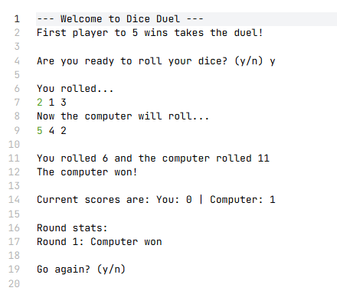
Result: Did the programme behave as expected ie syntactically and logically correct?
YES (delete as appropriate)
If YES, comment on what happened.
The program correctly rolls dice, sums values, compares totals, awards 1 point to the computer, updates score and history, and prompts for next round.

If NO, what went wrong and why? Suggest how things could be improved

Test: ii
User wins round

Screenshot(s) of output:
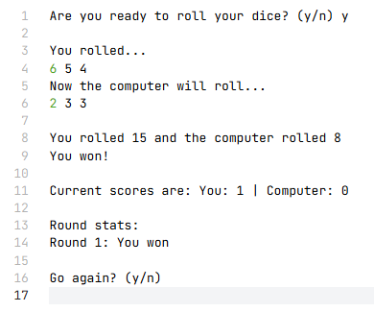
Result: Did the programme behave as expected ie syntactically and logically correct?
YES (delete as appropriate)
If YES, comment on what happened.
Logic correctly identifies higher user total, awards user a win, updates scoreboard, and proceeds as expected.

If NO, what went wrong and why? Suggest how things could be improved

Test: iii
draw

Screenshot(s) of output:
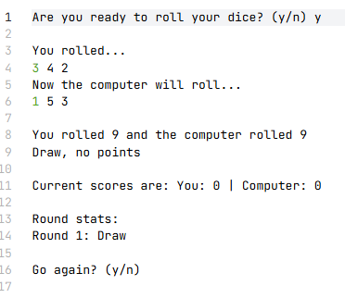
Result: Did the programme behave as expected ie syntactically and logically correct?
YES(delete as appropriate)
If YES, comment on what happened.
Draw condition works correctly, no points are given, and the round is recorded in history.

If NO, what went wrong and why? Suggest how things could be improved

Test: iv go again enter y

Screenshot(s) of output:
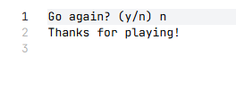
Result: Did the programme behave as expected ie syntactically and logically correct?
YES (delete as appropriate)
If YES, comment on what happened.
Input is accepted , loop restarts, and the game continues for the next round
If NO, what went wrong and why? Suggest how things could be improved

Test: v go again enter n

Screenshot(s) of output:
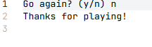
Result: Did the programme behave as expected ie syntactically and logically correct?
YES/NO (delete as appropriate)
If YES, comment on what happened.
The game ends cleanly, exits the loop, and prints a closing message.
If NO, what went wrong and why? Suggest how things could be improved

Test: vi go again enter Y uppercase

Screenshot(s) of output:
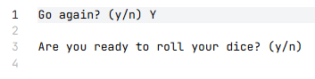
Result: Did the programme behave as expected ie syntactically and logically correct?
YES (delete as appropriate)
If YES, comment on what happened.
. lower() converts input to lowercase, so both y and Y work as expected.

If NO, what went wrong and why? Suggest how things could be improved

Test: vii go again enter b

Screenshot(s) of output:
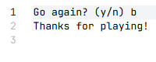
Result: Did the programme behave as expected ie syntactically and logically correct?
YES/minor improvement possible
If YES, comment on what happened.
- Any input other than y/Y exits the game. Works logically but could be improved to ask again for valid input instead of exiting immediately.

If NO, what went wrong and why? Suggest how things could be improved

(Consider the results of the above tests and your analysis of program efficiency and revisit your original code in order to address any tests that failed and/or improve code efficiency.

(Note: you may not be able to solve all of the problems that were encountered, but solve as many as you can.)

Paste your full revised code here :

[Copy and paste your full revised code here – note, do not use a screenshot]
import random

def roll_dice():
"""Generate 3 dice rolls between 1 and 6."""
return [random.randint(1, 6) for _ in range(3)]

def get_valid_input(prompt):
"""Keep asking until user enters 'y' or 'n'."""
while True:
response = input(prompt).strip().lower()
if response in ("y", "n"):
return response
print("❌ Please enter only 'y' or 'n'")

def play_round():
"""Play one full round and return the result."""
user_rolls = roll_dice()
comp_rolls = roll_dice()
user_total = sum(user_rolls)
comp_total = sum(comp_rolls)

print("\n🎲 You rolled:", *user_rolls)
print("🤖 Computer rolled:", *comp_rolls)
print(f"📊 Totals → You: {user_total} | Computer: {comp_total}")

if user_total > comp_total:
print("✅ You win this round!")
return "user"
elif comp_total > user_total:
print("❌ Computer wins this round!")
return "computer"
else:
print("⚖️ This round is a draw!")
return "draw"

def main():
user_wins = 0
computer_wins = 0
round_history = []
WIN_TARGET = 5

print("=" * 40)
print("🎲 WELCOME TO DICE DUEL 🎲")
print(f"🏆 First to {WIN_TARGET} wins the duel!")
print("=" * 40)

while user_wins < WIN_TARGET and computer_wins < WIN_TARGET:
ready = get_valid_input("\nReady to roll? (y/n) ")
if ready == "n":
print("\n👋 Game ended by user.")
break

result = play_round()
round_num = len(round_history) + 1

if result == "user":
user_wins += 1
round_history.append(f"Round {round_num}: You won")
elif result == "computer":
computer_wins += 1
round_history.append(f"Round {round_num}: Computer won")
else:
round_history.append(f"Round {round_num}: Draw")

# Show current status
print(f"\n📈 Score: You {user_wins} - {computer_wins} Computer")
print("\n📋 Round History:")
for entry in round_history:
print(" -", entry)

# Check for end of game
if user_wins >= WIN_TARGET:
print("\n🎉 CONGRATULATIONS! You won the duel!")
break
elif computer_wins >= WIN_TARGET:
print("\n💻 The computer wins the duel! Better luck next time!")
break

# Ask for next round
if get_valid_input("\nPlay next round? (y/n) ") == "n":
print("\n👋 Thanks for playing!")
break

if __name__ == "__main__":
main()

