Effective Team Working & Communication
Assignment Term 1- Group 3 Weekends, 2020

COMMUNICATION

Author: Rebeca Romanyuk 1912286 Lecturer: Afzal Munna

TABLE OF CONTENTS

- Introduction
- Communication
- Importance of communication
- Effective Communication and why it is important.
- Methods of communication
5.1 Verbal communication
5.2 Non-verbal communication
6. Theories of communication
6.1 Shannon-Weaver Model of Communication
6.2 Berlo Model of Communication
6.3 Schramm Model of Communication
7. Effective communication at my workplace
8. Conclusion
9. References
- Introduction

Communication is considered a very important tool and skill in every individual. The aim of this presentation is to offer a better understanding of what communication is and why it is so important. I will explain Effective communication and define the methods of communication. Moreover, I will give some examples from Shannon-Weaver, Berlo and Schramm models of communication. In order to highlight the importance of transferring information, I will use my workplace as an example of what kind of communication channels and methods we use and how much it helps in the day to day operations of the company.

- Communication:

Communication can be defined in many ways and we can understand it is an exchange of information which is sent from one place to another throughout different channels. (Cambridge Dictionary, 2020)
Looking back in the history, we find out that the word communication comes from Latin “communicare” which translate into the verb “to share” and means the transmission of information from one individual or group to another one by using sings, symbols and semiotic rules. (Harper Douglas, 2013)
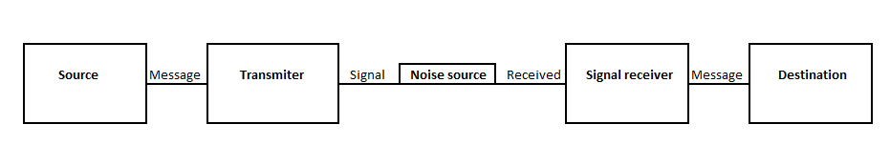
Communication can also be defined as a message taken from a source, using a sender to transmit the information throughout different ways or channels to the receiver or a destination. (C.E. Shannon, 2017)

- Importance of communication

Communication brings people together and helps them to understand each other. Communication is also associated with all the management functions helping individuals or groups to fill in the gap in between each other with a flow of information. More than a passing information tool, communication can be seen as a source of training, helping people get a better understanding of a task and how they should act accordingly to the message transmitted to them. We use communication to understand other individuals, to get to know them better and how we should approach and interpret their actions by using different channels of receiving the information.
The main aim of communication can vary depending on what the scope is. We can use the ability of spreading information to include ideas, beliefs, emotions, states of mind and to help people to learn new skills for private or professional purposes.
Communication in general can be used to fulfil a goal, avoid isolation, creating awareness, highlight problems, educational and for personal development.

- Effective communication and why it is important.

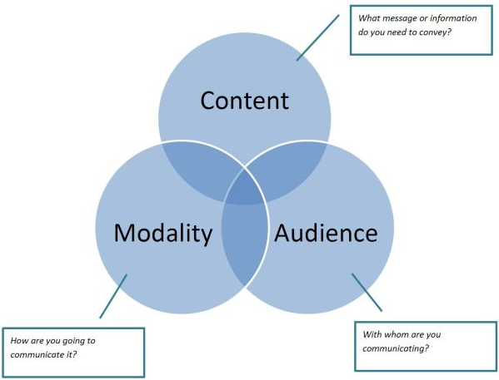
The word effective can be defined as being efficient in producing a result. Effective communication is the ability of transmitting information which is very easy to be understood by the others. In class, our lecturer explained us how many times the efficient communication can be blocked by some cultural or linguistic barriers. Also, when we are addressing to a big group, we tend to analyse the capabilities of our audience so we can transmit a clear message to the individuals or groups. The importance of effective communication reflects many times on academic and professional environments. At the university, the lecturers are analysing the competence of the students just to understand the way they will pass all the information flow in an effective way. In professional life, effective communication is checked since the interview stage. Employers are looking for people who speaks plainly to create productivity. As it is considered one of the managerial functions, employers are looking to hire individuals who can lead workers using efficient communication to do a job well in an efficient time. As said, we are looking for people who can introduce different methods of communication to understand and achieve everyone’s desirable results.

- Methods of communication
On the path of making communication effective, we use different methods of transmitting information. From my own professional, personal, and academic experience, I have seen and learned that apart of the spoken information is also very important the non-verbal communication. We tend to understand situations and information by using visual contact or using signs and symbols.
5.1 Verbal communication

In theory, verbal communication means the use of words, messages, or linguistic forms. It refers to oral communication manly face-to-face and in academic areas can mean also written information and sometimes sign language (A dictionary of M& Communication, 2011).
By reading some articles and reports (Journal of Communication, 2012), we get to understand that in most of the situations, people react better to verbal communication. In the business sector, customers tend to buy more when the offers are verbally transmitted to them. Making a short reference to myself, I tend to learn quicker and memorise information if it is verbally communicated to me. In many cases I choose to watch videos for the purpose of learning and skills improvement.

5.2 Non-verbal communication

Non-verbal communication can be defined as passing information throughout non-verbal channels like body language, facial expressions, eye contact, gestures, physical environments, or appearance and by the tone of voice. Even if it is the opposite of verbal communication which many times can prove itself as being more efficient, non-verbal communication is expressed throughout more platforms and it can be considered to carry more meaning that the verbal message (M. Stephen, 2019). In my own experience, I have always used the non-verbal communication when the verbal information passed to me was not enough to help me in dealing with a problem. I have also used it many times to understand the position of some individuals in my professional life and to “read between the lines” when I felt insecure of the information passed over.

- Theories of communication
Theories of communication discusses about the sender, the message and receiver. It refers to the production of information sent, how is delivered and how meaningful the message needs to be and shared. Communication theories speaks also about the ability to understand other people mental states like understanding their beliefs, desires, intentions and so on. It also helps us understand how two human beings influence each other and how the new knowledge challenges our beliefs (Graham Williamson, 2014). Therefore, I will describe some models of communication like Shannon-Weaver, Berlo and Schramm to highlight the study of communication theories.
6.1 Shannon-Weaver Model of Communication
Shannon-Weaver is a model of communication which claims that communication can be fragmented down into 6 important concepts: sender, encoder, channel, noise, decoder, and receiver. The model is also known as being the Shannon model as Shannon was the key person who established the ideas. The main aim of Shannon-Weaver model is to present how messages are created, sent and received. Also, it is explaining how messages can get misinterpreted in the process of sending and receiving (7 Key Concepts, 2020).
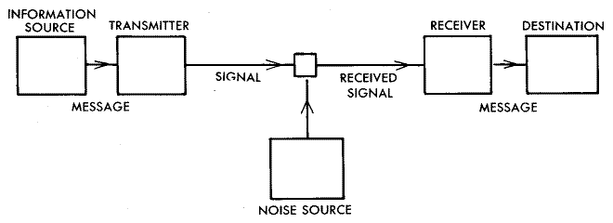
Shannon-Weaver model speaks about the help of non-verbal communications. It is called to be “the models of models” as it presents the interruption of information and how the way we communicate can be improved.
As an example of Shannon-weaver model of communication we can imagine that our brain is the sender, the mouth is the encoder, air would be the channel and the other person ears could be the receptor, his brain would be the decoder and receiver. In this scenario the noise could be the sound of rain or wind blowing outside which will make the receiver job hard in not to understand the words in a different way.

6.2 Berlo Model of Communication

Berlo Model of Communication explains the communication in a very simple method. In 1990 David Berlo developed Shannon-Weaver’s model of communication and created SMCR process. SMCR represents the sender, message, channel, and receiver. He also discussed about the communication skills, awareness level, social and cultural system. Even if David Berlo managed to improve the linear model of communication, he was avoiding the usage of something which makes human beings different from other creatures, the capacity of thinking, analysing, and understanding.

6.3 Schramm Model of Communication
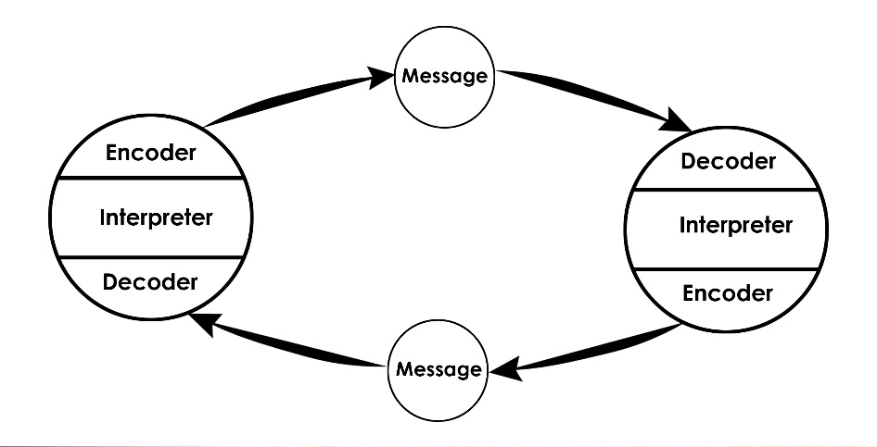
Schramm is considered as being one of the pioneers of mass communication. He gave a contribution in developing the mass communication like print news, television and so on. He created a circular way of messaging. As every other model, the identifying components of Schramm’s model of communication are sender, message, receiver, and semantic barriers. In his model he explains how a sender can become a receiver by waiting for a feedback from the person he passed an information to in the first place. He also attached the notion “Field of experience” believing two individuals can communicate a subject only if they have the same level of knowledge. For example, we understand that an Engineer would not be so lucky in communicating with a nursery class as they do not share the same field of experience. The main aim of this model would be the ability of a sender to encode and decode the information transmitted before another individual receive it. Once the message is passed, the receiver could interpret the message on its own way and pass a feedback to the sender (Osgood-Schramm Model of Communication: Definition & Application).

7. Effective communication at my workplace
I have an experience of around 6 years in Hospitality Industry currently holding a position of Assistant Reservations Manager for a big group of restaurants around the world. The main duty of my job is to communicate with people to satisfy their needs. As said my job is based on communication and customer service. One thing which I have absorbed from my professional career is that you need to learn how to use the non-verbal communication to have good results in the verbal one. Daily I am receiving an hight amount of calls end emails with different enquiries and questions. We use phone system, emails, websites, face to face meetings for the purpose of creating efficient communication. In order to complete and answer some of the queries, I need to communicate with the other departments like kitchen or front of house staff. Inside of the organisation we are communicating as well throughout different methods like emails, phone calls or even WhatsApp. The main aim of following up with work colleagues or customers is to achieve everyone’s desirable results in a professional manner. As I am office based, I handle a lot of phone calls and emails where I can easily get a different understanding of what the customers needs are just by misunderstanding the message. I found it easier in the past for myself to understand better individuals face to face. Ever since, I have worked on my communication capabilities and focus more on the non-verbal communication.

- Conclusion

In the end, we understand how important communication is in building relationships, professional career and in academic fields. We understand now how vital the communication in any form is. We have got a better understanding of the methods of communication, when and how we can use it. Looking at the communication theories, we see how much the concept of communication evolved over the years and helping us in understanding that the communication ability is a big advantage, and sometimes it can also be a disadvantage if we do not listen carefully and interpret the information in a wrong way. Before communicating be careful and decode your own information which you want to transfer and the manner you do it so your message is understood in a correct way. Do not forget to keep on improving your communication skills so you can feel the achievement in life.

9. References:
1. Communication:
- Cambridge Dictionary, 2020. https://dictionary.cambridge.org/dictionary/english/communication
- Harper, Douglas. "communication". Online Etymology Dictionary. Retrieved 2013-06-23.
https://www.etymonline.com/word/communication
3. C.E. Shannon. "A Mathematical Theory of Communication" . Math.harvard.edu. Retrieved 2017-05-01.
http://people.math.harvard.edu/~ctm/home/text/others/shannon/entropy/entropy.pdf
5. Methods of communication:
5.1 Verbal communication:
1. Journal of Communication, Volume 62, Issue 5, October 2012, Pages 833–850; https://academic.oup.com/joc/article-abstract/62/5/833/4085818?redirectedFrom=fulltext
2. A dictionary of Media and Communication, 1st ED, Published by Oxford University press, 2011
5.2 Non-verbal communication:
1. MCCORNACK, STEVEN (2019). CHOICES & CONNECTIONS: An Introduction to Communication (2 ed.). Boston: BEDFORD BKS ST MARTIN'S. p. 138.
6. Theories of communication
1. Communication Theory, Graham Williamson, 10TH January 2014. https://www.sltinfo.com/communication-theory/
6.1 Shannon-Weaver model of communication:
1. Helpfulprofessor, C.D. (2020). Shannon-Weaver Model of Communication | 7 Key Concepts (2020). Retrieved 10 April 2020, from https://helpfulprofessor.com/shannon-weaver-model/
6.3 Schramm model of communication:
1. Osgood-Schramm Model of Communication: Definition & Application. Study.com, 11 July 2018, study.com/academy/lesson/osgood-schramm-model-of-communication-definition-application.html

