University of Wales Trinity Saint David London
DIGITAL SKILLS AND RESEARCH METHODS A1
Name: Marian Bogdan Isacescu
ID: 1812780
Lecture Name: Anupam Mazumdar

Table of Contents

Introduction 4
Findings 4
Evaluating modern technologies 4
Web conference 5
Analysis 8
Discussing about use of social media 8
Face book 9
Twitter 9
LinkedIn 9
Conclusion 10
Reference List 11
Appendices 13

Introduction
Modern technologies including strong networking system and digital technology assist in communicating with national and international consumers in an easy way. Based on that, business organizations are able to gather information regarding demand of consumers and current market trends. Use of social media along with different web applications have been significant ways to gather information related to demand and life standard of modern generations. Business organizations are able to implement key strategy by reviewing social media on daily basis. The current report discusses social media and consideration of digital technology in case of emerging business process and increasing number of targeted consumers. Along with that, it sheds light on benefits and impact of using social media on business process as well as competitive advantages for business organizations.

Evaluating modern technologies
Modern technologies such as use of social media and web applications have been significant ways of enhancing consumer awareness regarding quality and price range of different products. As per views of Robinson et al. (2015, p.571), social media is key platform for all business organizations due to assisting in advertising different products and its features so that national and international customers are able to review it quickly. Digital technology has been key way to provide chance to different business organizations to acquire ranking in first page of search engine result page (Raju, 2014, p.169). Based on that, large number of targeted customers and existing customers can be able to view latest launched products and offered discounts of particular company. As an example, Squid and Pear of UK is already taking benefits of digital media for the purpose of getting leading position in first page with the aid of daily basis SEO optimization process. Thus, they are able to increase their number of customers and satisfy them by delivering best quality foods and offering suitable price range (influenced by Robinson et al. 2015, p.571).

Web conference
Web conference is great platform for all people and business organizations to find out appropriate and useful elements for their daily basis work. As opined by Bower (2016, p.19), strong networking system and web conference are two significant paths through which business organizations can be able to discuss with large number of consumers about their problem directly. Generally, this is taken place by sharing of multiple electronics screens and mobiles. Characteristic of the form of online communication process is generally synchronous rather than being asynchronous type of communication process. As opined by Laratta and Mekongo (2015, p.26), in case of synchronous communication process, messages and important information related to business process can be sent easily to customers and related reply can be obtained within short period. On the other hand, asynchronous type of communication process is the reasons of delaying important messages and sharing information to particular person such as consideration of email communication (Nixon and Troncy, 2014, p.101).
Two web conferencing equipments are generally Skype and ezTalks which are generally used for the purpose of conducting meeting by incorporating all responsible members. As opined by Laratta and Mekongo (2015, p.26), web conferencing tools including Skype can assist in incorporating all members by sharing with them regarding important information of business process. For an example, staffs of Bread and Honey are enough concerned in gathering information and views of senior managers due to which they are able to fulfil requirements of business objectives such as quality production of food items. From this point, it is clear that with the aid of taking benefits of web conferencing tools, business organizations are able to recruit right quality employees by analyzing their characteristics without travelling and sharing important information by verbal communication process. As mentioned by Bower (2016, p.19), web conferencing tools including Skype is great platform for different business organizations due to getting advance information related to business process and views of senior managers on the basis of specific topic through strong networking technologies.

Figure 1: Web Conference
(Source: influenced by Bower, 2016, p.19)

Different features of Skype on the basis of business process | Different features of ezTalks
Subscription cost is lower as compared to cost for individual account for merchant business | Subscription is higher as compared to cost of creating additional account
It is fully web based and available at different format such as android and windows phone | It is web based application and available at iphone and android.
The following application is suitable for connecting with 250 people at a time | The range of contact is limited due to having feature of contacting 100 people at a time

Table 1: Features of Web conference tools
(Source: influenced by Bower, 2016, p.19)
Based on obtained feedback from customers, it can be discussed that Skype is more effective tool due to having low subscription cost and offering great features in case of communicating with people. As per views of Dehghani and Tumer (2015, p.599), customers are oriented to get best quality products due to which communication with them on daily basis through strong web based applications are required. Different business organizations take advantage of web conferencing tools such as Skype for the purpose of contacting with customers and other stakeholders immediately.

Cloud storage
Cloud storage offers storage and protection of important information into different cells within cheapest price range due to which different business organization take benefits. As opined by Sari (2015, p.147), presence of cloud storage in an organization is simply reason of storing and protecting important information based on which intellectual properties can be secured. Issues regarding loss of control of information after uploading data into different cell of cloud storage are the reason of focusing on local storage. Senior managers of organizations could consider regular basis updating information and free of local storage which assists in avoiding loss of control over data. Two different types of cloud storage such as Dropbox and Google Drive are discussed below so as to find out appropriate way of storing and securing important information.

Figure 2: Importance of Cloud storage
(Source: influenced by Sari, 2015, p.147)
Advantages of Dropbox | Advantages of Google Drive
It assists in sharing large number of files within short period | Due to having large free storage, large number of files are shared and all are kept secured
It can be accessed from different systems such as android mobiles and laptops as well as tablets and changes are synchronized by incorporating all members | It can be accessed from different systems such as android mobiles and laptops as well as tablets  Based on system version, changes are made to process data and store properly
Capacity of storing data is limited due to which Dropbox does not allow to store large amount of information (Yu et al. 2014, p.7793) | It has large amount of free storage and capacity of storing information is high
It does not allow multiple users to make certain changes into data | It allows multiple users to edit in the way of real-time processing

Table 2: Advantages of Dropbox and Google Drive
(Source: influenced by Yu et al. 2014, p.7793)

Disadvantages of Drop box | Disadvantages of Google Drive
It creates confusion among users at the time of using for first time due to having complex steps | Creation and arrangement of different information from various accounts are not easy way
It has limited storage for creating free accounts | It cannot be used through offline method
Administrators and senior managers of hierarchy have full right to make changes and delete information (Sari, 2014, p.143) | Filling of form and overcoming different steps of text editing are required
It cannot be used through offline method | Lack of advance method to recover and update old data into storage

Table 3: Disadvantages of Drop box and Google Drive
(Source: influenced by Sari, 2014, p.143)

Evidence of my online presence

Marketing
Marketing method includes increasing number of targeted customers and enhancing consumer’s awareness based on which business organizations are able to fulfill objectives of business process such as increased rate of profit. Through effective use of social media, business organizations are able to communicate with national and international trade partners and customers. As per views of Tiago and Veríssimo (2014, p.713), use of social media and consideration of digital technology are significant aspects in context of developing growth of business and enhancing reputation in competitive market.

Gathering important information
Social media assists marketing department of an organization to gather information regarding demand of customers and latest market trend. Based on which, effective marketing strategy related to production of innovative products and changing price level can be taken. As opined by Dehghani and Tumer (2015, p.599), digital technology and use of social media assist in sharing important information related to quality and price level of different items and reach towards large number of targeted customers.

Strong communication within organization
With the help of popular web based applications such as Face book and Whatsapp, strong communication between senior managers and lower staffs is maintained effectively due to getting update news and sharing messages. As suggested by Ashley and Tuten (2015, p.19), web based applications and use of social media within workplace are ways of interacting with each other and sharing latest workplace related information with each other. Keeping this in mind, different organizations of UK are fully concerned to maintain strong communication process and avoiding workplace conflict. Due to getting advance and quick information related to current situation of organization through social media, senior managers of different organizations are able to take strategy regarding the way of avoiding future problems such as shortage of cash and lack of raw materials (Laratta and Mekongo, 2015, p.19).

Face book

Figure 3: London Kitchen facebook profile
(Source: https://www.facebook.com/TheLondonKitchen/)
Source: https://www.facebook.com/bogdanisacescu
Through use of face book within workplace, an organization is able to make improve into certain factors by reviewing feedback and decision of consumers on regular basis (influenced by Tiago and Veríssimo, 2014, p.705). As an example, owner of the London Kitchen maintains daily basis sharing information related to food items and price range to consumers through face book so as to reach towards large number of targeted customers. Personal face book account assists in getting advance information related to employment and job opportunities and communicating with different people (Refer to Appendix 1).

Figure 4: Importance of face book
(Source: influenced by Tiago and Veríssimo, 2014, p.705)

Twitter
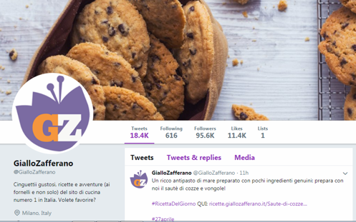
Figure 5: Twitter account of Giallo Zaferrano
(Source: https://twitter.com/giallozafferano?lang=en)
Consideration of Twitter is necessary for getting advance update of employment and job opportunities as well as communicating with different persons. As opined by Dehghani and Tumer (2015, p.599), maintenance of strong communication and sharing important message of current trend are major advantages of Twitter. As an example, head of Zafferano share information related to features and delivery service through Twitter so as to enhance consumer awareness (nibusinessinfo.co.uk, 2019). Twitter provides important information regarding changing trends and market demand (Refer to Appendix 2).

LinkedIn
LinkedIn is helpful for professionals as well as students due to having advance features regarding connection network and message sharing procedure. Different organizations take advantage of LinkedIn for the purpose of listing jobs and recruiting right candidates and having quality of lead generation.
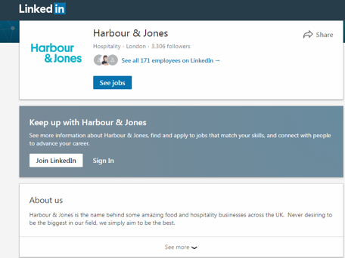
Figure 6: LinkedIn profile of Harbour & Jones
(Source: https://in.linkedin.com/company/harbour-&-jones-ltd)
Students can update skills and abilities into LinkedIn so that organizations can view and select their profile (fsb.org.uk, 2019). As an example, Harbour and Jones is concerned in updating information related to job vacancy and roles into LinkedIn so as to get right quality candidates for business (harbourandjonesevents.com, 2019).

Conclusion
Thus, it can be concluded that face book is the biggest platform to contact with large number of national as well as local and international customers and get fast information regarding their feedback. Social media and strong networking system allow large number of targeted national and international consumers to provide own feedback on the basis of quality and price range of particular product. Social media has provided opportunities to large number of business organizations by expanding business process and targeting new market. It can be added that face book is the platform where customers and senior head of marketing team and other departmental heads of an organization can be able to share their views freely and make strong relationship.

Reference List
Ashley, C. and Tuten, T., (2015). Creative strategies in social media marketing: An exploratory study of branded social content and consumer engagement. Psychology & Marketing, 32(1), pp.15-27.
Bower, M., 2016. A framework for adaptive learning design in a web-conferencing environment: Journal of Interactive Media in Education, 11(3), pp. 1–21,
Dehghani, M. and Tumer, M., (2015). A research on effectiveness of Facebook advertising on enhancing purchase intention of consumers. Computers in Human Behavior, 49(3), pp.597-600.
fsb.org.uk. (2019). Impact of LinkedIn. Available at: https://www.fsb.org.uk/resources/10-ways-to-make-an-impact-on-linkedin [Accessed on: 02/04/19]
harbourandjonesevents.com. (2019). Harbour and Jones. Available at: http://www.harbourandjonesevents.com [Accessed on: 02/04/19]
Laratta, D. and Mekongo, Y., (2015). Web Conferencing for Business: Digital communication. 13(5), pp.13-29.
nibusinessinfo.co.uk. (2019). Benefits of Twitter in Business. Available at: https://www.nibusinessinfo.co.uk/content/advantages-and-disadvantages-twitter-business [Accessed on: 02/04/19]
Nixon, L. and Troncy, R., (2014). Survey of semantic media annotation tools for the web: towards new media applications with linked media. In European Semantic Web Conference. 13(5), pp. 100-114.
Raju, J., (2014). Knowledge and skills for the digital era academic library. The Journal of academic librarianship, 40(2), pp.163-170.
Robinson, L., Cotten, S.R., Ono, H., Quan-Haase, A., Mesch, G., Chen, W., Schulz, J., Hale, T.M. and Stern, M.J., (2015). Digital inequalities and why they matter. Information, communication & society, 18(5), pp.569-582.
Sari, A., (2015). A review of anomaly detection systems in cloud networks and survey of cloud security measures in cloud storage applications. Journal of Information Security, 6(2), pp.142-149.
Tiago, M.T.P.M.B. and Veríssimo, J.M.C., (2014). Digital marketing and social media: Why bother?. Business horizons, 57(6), pp.703-708.
Yu, Y., Ni, J., Au, M.H., Liu, H., Wang, H. and Xu, C., (2014). Improved security of a dynamic remote data possession checking protocol for cloud storage. Expert systems with applications, 41(17), pp.7789-7796.

Appendices
Appendix 1: Importance of Face book
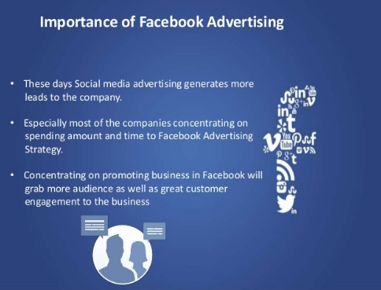
(Source: https://www.slideshare.net/zuantechnologies/5-important-things-to-consider-for-facebook-marketing-strategy)

Appendix 2: Importance of Twitter

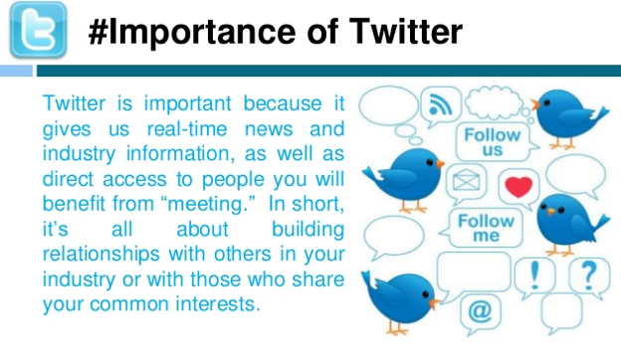
(Source: https://www.slideshare.net/AchchuthanSeetharan/twitter-45670158)

