DS1: My Digital

In this fast ,modern and digital era, lots of digital tools are fully integrated in my day to day life. These tools take an important role to manage my daily routine well organized and acting as a teacher ,mentor and guider to navigate my life easy and efficiently.
My digital ecosystem contains many essential applications and platforms.

Screenshot/Photo 1
1.Academic platforms
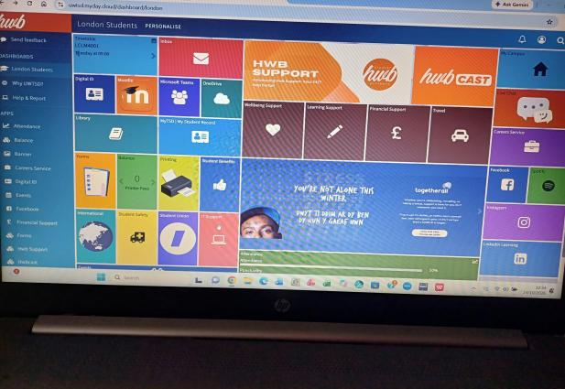
I always use online learning platforms like canvas to asses my course materials ,submit assignments and updates with announcements.

Screenshot/Photo 2
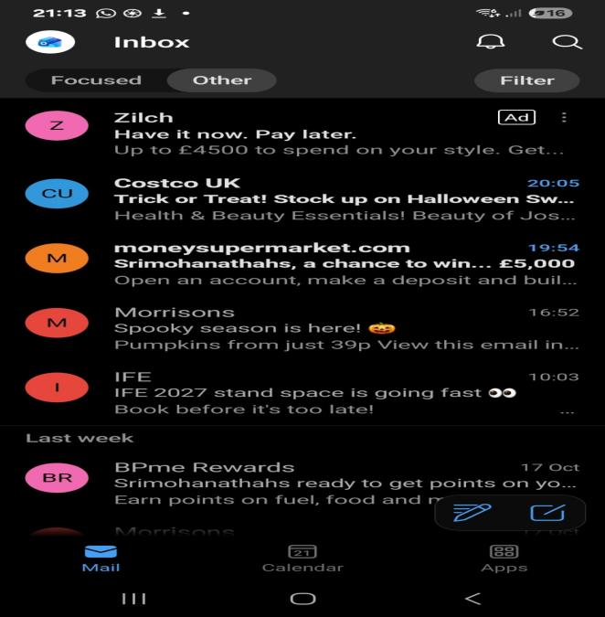
Communication - Digital communication tools allow me to connect and interact with people collaborate and share information with anyone . anywhere. For example, Eamil. This is an official channel for formal information,enquirers,receiving university announcements and professional conversations.

Screenshot/Photo 3
Navigation and Commuting
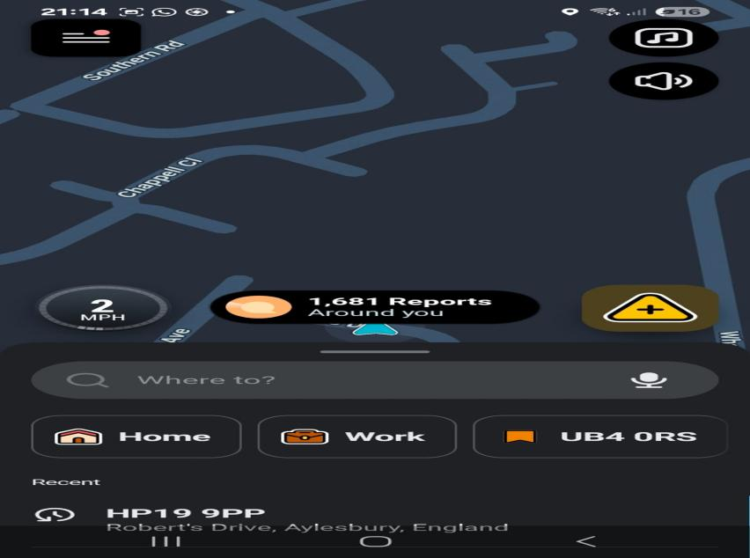
It plays a vital role in my daily life by providing real time GPS tracking updates and transport schedules.

Screenshot/Photo 4
Artifical Intelligence.
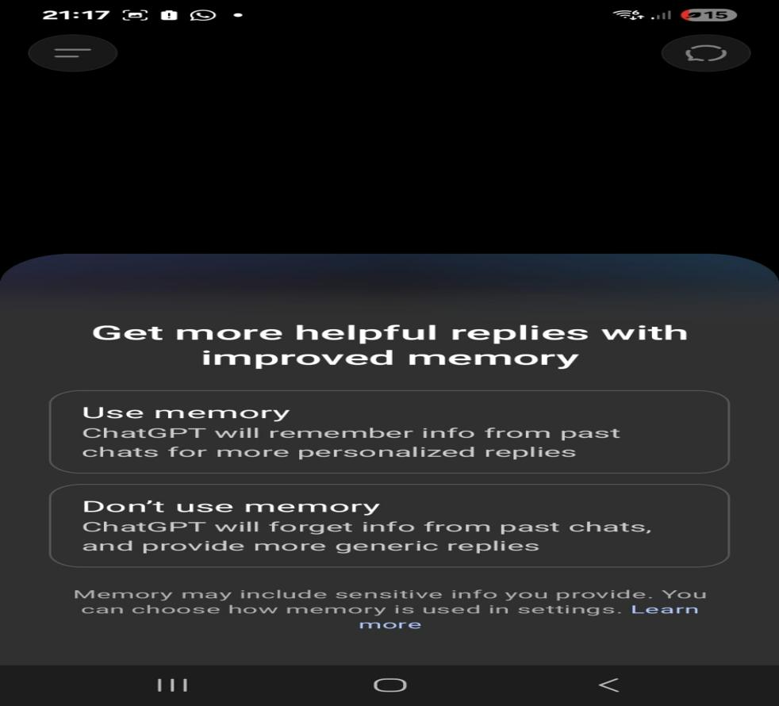
I use AI tools like ChatGpt and Microsoft, Copilot to help getting ideas,clear explanation and proofread my text.

Screenshot/Photo 5
Writing and creativity
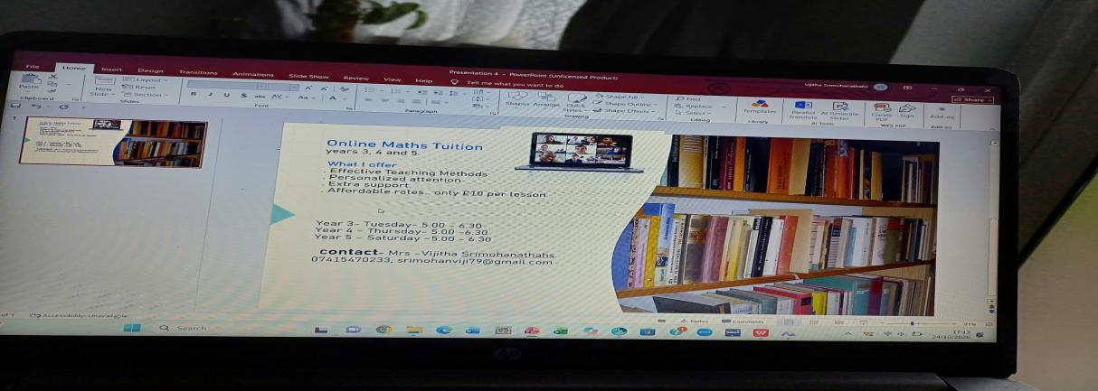
For writing essays,planning notes-and making assignments I normally use Microsoft office 365 like word,power point and google work space.

My short reflection
Using digital tools feels genuinely rewarding when they serve as seamless extension of your intentions ,allowing me to seam-line my daily task. They help me improve my personal well- being and feel independence. Maps ,messaging apps and calender tools reduce stess from travelling and planning. All the communication system in the digital technology like video calls and group chats keep me close to my family and friends who live from far away saying connect with others . I can improve my knowledge by learning online courses,podcasts and tracking apps and help me to my personal growth. Creative software lets you express my ideas easily.
I need to focus on taking back control of my time and reducing distractions. I need improve selecting match and specific software categories to my daily routine for example, use Notion or Trellis to build a digital second . I need use Grammarly for my browser, phone keyboard,and desktop apps to check spelling ,correct grammar and polish my writing..
Digital tools are important in my life because they help me staying organized, improve my focus and develop my knowledge. They build confidence in my communication and save my time.

Sentence starters
- I use digital tools to …
- I feel confident when I …
- I want to improve …
- I often use these tools: …
- I sometimes feel nervous about …
- I hope this module will help me …
- Digital skills are important for me because …
You can write more if you want.

Submission Checklist
Before you submit, please check:
​​​ ☒ I added 4–6 screenshots

☒ I wrote short sentences for each screenshot
☒ I wrote my short reflection
☒ My work is my own
☒ My file opens correctly
​​☒ My file opens correctly

