
Bsc (Hons) Health and Social Care
Protecting and Supporting Families in Health and Care BMHP5021
Student Nane: Mariatu Bangura
Student ID: 2328124
Lecture Name: Dr Diola Bijlhout
Submission Date: 12th December 2025
14:00 (2PM)
A report on
Early Help Signposting to UK Familkies: A Comparative Analysis Of Leeds, Northfolk, and Staffordshire;

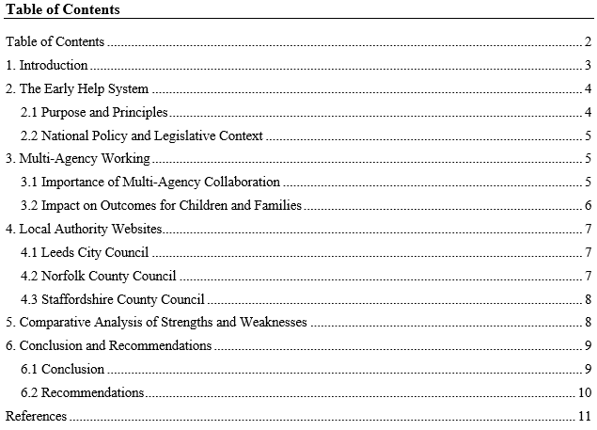

1. Introduction
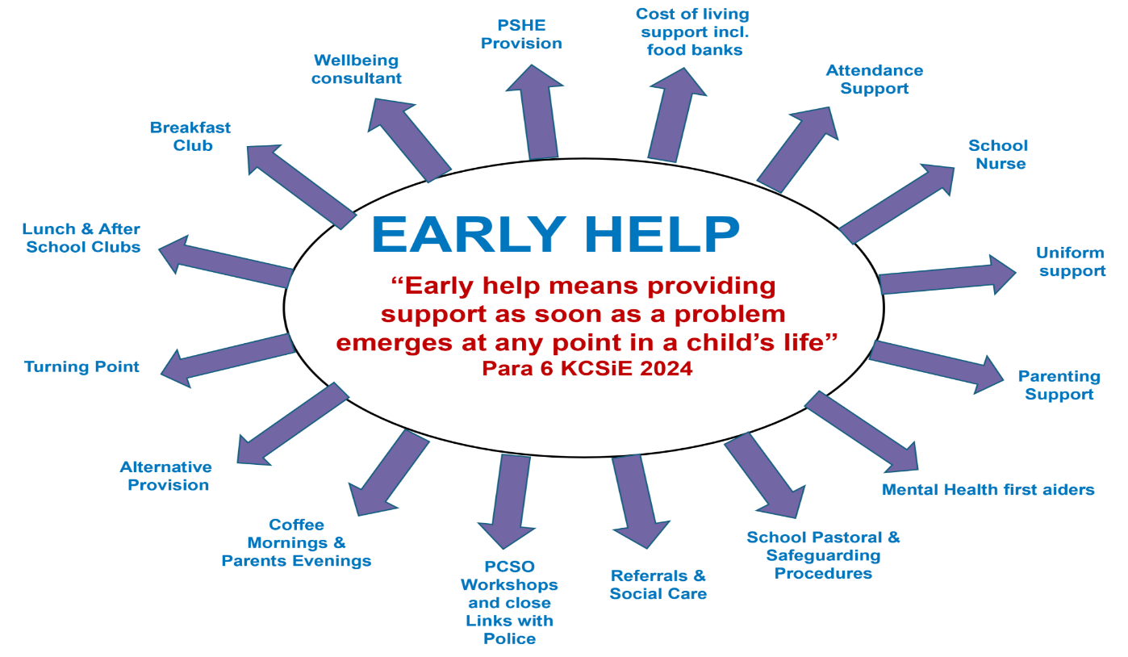
Figure 1: Early Help System
Sources: (Cantrell et al., 2024)
Early Help forms a significant component of the UK safeguarding. It provides services to children, youth and families at an early stage. This is to prevent the escalation of the problems. The authorities should clarify Early Help in a simplistic manner to their locals. A lot of families initially get to know about Early Help by visiting council websites (Cantrell et al., 2024). These sites should be user-friendly and user-understandable. In this report, the researcher will be analysing three websites: Leeds City Council, Norfolk County Council and Staffordshire County Council. It assesses the way each council defines Early Help. It also verifies the national guidance adherence that is undertaken by each website. Some of the important guidelines are the Early Help System Guide and Working Together to Safeguard Children 2023. The review is based on the clarity, layout and accessibility. It also takes into consideration the manner in which each site describes the partnership work. A comparison is then made. The report is concluded with a conclusion and practical recommendations.

2. The Early Help System

2.1 Purpose and Principles
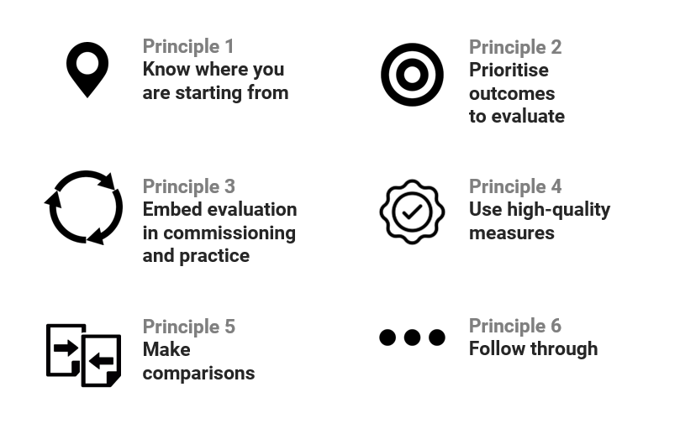
Figure 2: Key Principles of Early Help
Sources: (Lucas & Archard, 2021)
Early Help helps in the initial period of time. It aims at minimising risks when they are minimal. It assists in behaviour, emotional, attendance, and parenting problems. It will also be able to assist those families that are strained by finances or strained relationships. The guide to the Early Help System covers the key principles (Lucas & Archard, 2021). One of these principles is early identification. Another is a partnership with families. The system also emphasises strengths rather than weaknesses. Early Help is voluntary. Families have the option of participation. This aids in the minimisation of fear and worry. Local authorities would have to describe Early Help in a friendly but laid-back manner. The system aims not to have duplicity in assessment. It facilitates collaboration in services. It also ensures that the voice of the child is heard. All the plans are guided by the needs of the children. Early Help enhances the aspect of resiliency and stability. Prevention is its primary intention. It helps in ensuring long-term well-being among children and young people.

2.2 National Policy and Legislative Context
The national policies and laws support Early Help. These are documents that establish definite responsibilities. The Working Together to Safeguard Children 2023 describes the role of the local authorities, health services, and the police. It further says that families ought to access transparent information (Sari et al., 2023). The Children Act 1989 has established a responsibility of agencies to safeguard the welfare of children. The Children Act 2004 recommends working in conjunction with the services. Both Acts approve of early intervention. The Early Help System Guide is further elaborated. It describes good practice, evaluation instruments, and reference anticipations. It further adds that the information should be comprehensible to the families. The policy framework is in favour of prevention. It promotes proactive measures other than a reaction to a crisis. Shared responsibility is also encouraged by national guidelines. It points out the need to have coordinated assistance. The websites of the local authorities are important. They assist families to know the system and seek assistance within a short time. Effective communication is a must.

3. Multi-Agency Working

3.1 Importance of Multi-Agency Collaboration
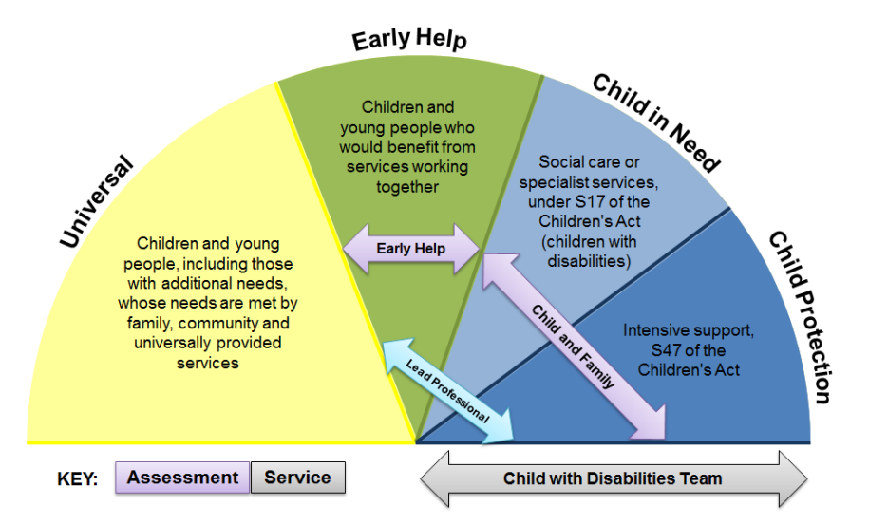
Figure 3: Multi-Agency Early Help Strategy for Children, Young People
Sources: (Owens & Lloyd, 2023)
Multi-agency working is one of the components of Early Help. At any given time, families usually confront several challenges. These may be school, health, behaviour, emotions or home life. Various professionals have different interpretations of various aspects of the situation. Teachers see one part. Health workers see another. Otherwise, it is something different to social care teams. Services communicate significant information when they cooperate (Owens & Lloyd, 2023). This will draw a better picture of the needs of the child. The Early Help System Guide facilitates joint assessments and joint plans. Consistency is also maintained through regular communication. Working together prevents repetition of information by the families. It also eliminates unnecessary time wastage. Cooperation makes families feel encouraged. It lessens the confusion and stress. It also enhances protection since concerns are identified in time. Early Help works better when personnel work in collaboration. It simplifies support to manage as well. Partnering in the work has the effect of making services one team.

3.2 Impact on Outcomes for Children and Families
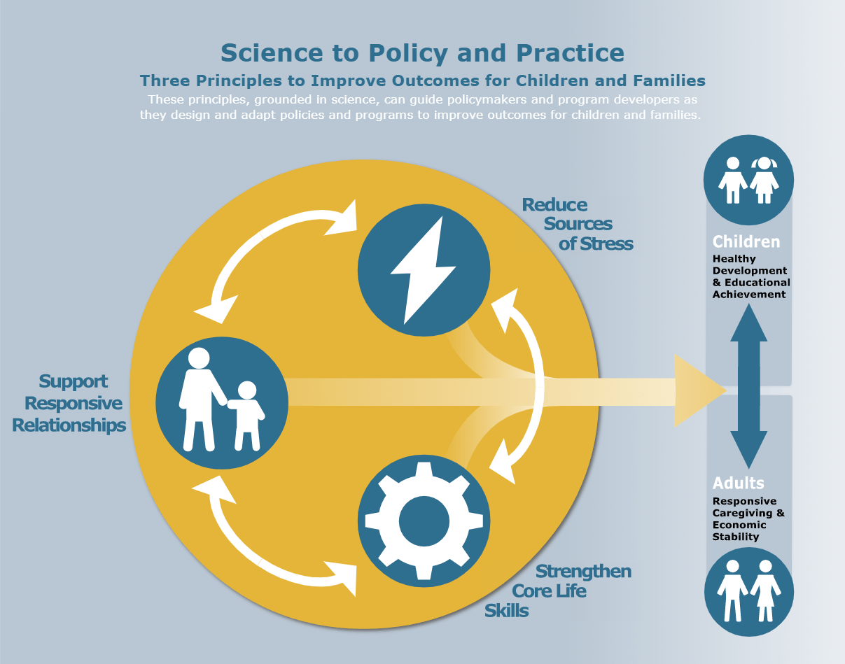
Figure 4: Three Principles to Improve Outcomes for Children and Families
Sources: (Gustafsson et al., 2022)
Effective multi-agency collaboration has more positive results. In the case of sharing information among the services, support becomes faster and more precise. Families get assisted in a way that suits them. This will avoid the aggravation of problems. Working Together 2023 promotes the importance of effective communication. It also identifies the necessity to minimise repetitive tests. One definite plan is to the advantage of families (Gustafsson et al., 2022). They also enjoy regular consultation. Collaborative work can be used to discover latent issues, including emotional problems or hazardous conditions. Children have a more stable and enhanced school involvement. They also become better off since support is arranged. Working together with services in families makes them feel safer. None of the agencies is in charge of the entire responsibility. Responsibility with each other enhances safety. It also strengthens trust. The multi-agency work will assist in the long-term development. It lowers the necessity of statutory intervention. It maintains a coordinated and supportive response of services.

4. Local Authority Websites

4.1 Leeds City Council
Leeds City Council has a well-defined Early Help section that is easily accessible to families. Early Help has been defined in brief and clear sentences on the site. It mentions who is eligible to receive support and the manner in which the process begins. The design is well-organised, and the arrangement of all pages is consistent (Geddes et al., 2023). Headings are used to direct users to the next point. The city of Leeds also has its own full Early Help Strategy. Families will be able to read the guidance documents and verify links to family hubs in the area. These connections assist users in getting support within their locality. Another way in which the site indicates the relationship between Early Help and broader safeguarding work is through its connection. The majority of the text is simple to a layperson. Some words are more professional in some pages, but it does not influence the clarity. The site provides information about the services, referral procedures, and instructions in a straightforward manner. Leeds is very attentive to open information. The support alternatives can be seen clearly by families, and the structure of the content allows the families to navigate across the pages without any trouble.

4.2 Norfolk County Council
The Early Help presented by Norfolk County Council is in the form of Family Hubs. The use of language is brief, cosy and appropriate to the family members seeking information fast. The language of every page is friendly, which can make the user relaxed. The online self-referral form is one of the strengths. Support may be requested by the families themselves, and this eliminates delays. Norfolk also gives access to parenting organisations, wellbeing initiatives, and local programs (Collins & Lowe, 2025). Such links provide other alternatives of support. The information is, however, covered on many pages as opposed to a single section. Users are left confused about what to do next. This has the ability to decelerate the details search process. The tone is generally positive and helpful all over the site. The content is presented in a manner that meets the national requirements of clear information. Norfolk is a good place with a supportive style that attracts families with various needs. A centralised layout will enable scanning of the website to be easier. Nevertheless, the location provides broad access to services and invites families to receive help at an early stage.

4.3 Staffordshire County Council
Staffordshire County Council disseminates the Early Help information on its Children and Families pages. The site provides brief definitions and contact information. It also contains links to family support workers, parenting help and wellbeing services. These links indicate the scope of assistance in the county (Savoia et al., 2025). The information is, however, not located in any one Early Help section. The user is required to navigate between the various pages to learn how the process works. This may complicate the use of the site. There are sections whose text can be found more suitable for professionals. This can be confusing to families that require simple descriptions. The process of Early Help does not explain each step in detail. Also, families are not aware of the way they should start. Nevertheless, the site has practical information and advice. The site can also serve the purpose of supporting families with better clarity and less complicated language. Staffordshire has vast resources but requires a more precise outlay. An opening Early Help page would help navigation be easier, as well as enhance ease of understanding for first-time users.

5. Comparative Analysis of Strengths and Weaknesses
The three local authority websites demonstrate varying strengths and weaknesses in the manner in which they disseminate the Early Help information. The contents are the most comprehensive at Leeds City Council. The site describes the process of Early Help by its components in an orderly manner. Families can be able to see the connections between various services (Hunter et al., 2022). This assists users to learn the fit of Early Help in a broad context. The biggest weakness is the usage of a few specialist words, which can be challenging for families that are new to the topic.
The language employed by Norfolk County Council is plain and easy to understand. This renders the information a simple follow-up for most families. The biggest strength is the online form, whereby the families can make a personal referral. This provides individuals with greater autonomy in requesting assistance (El-Hoss et al., 2023). The layout is the primary weakness. The information about Early Help is spread out on numerous pages. Sometimes the user might be required to scroll up and down to locate all the information required.
The County Council of Staffordshire also offers several useful links and resources. Families are able to read about the forms of assistance in the county. Nevertheless, there is no single Early Help page on the site (Thoburn, 2023). Users will have to visit numerous places to know the entire process. The explanations are also less detailed and might not provide sufficient information to the family that requires direct steps. Overall, Leeds is the most powerful one because its structure is well organised and detailed. Norfolk is the simplest to use since the language is simple to use, and the self-referral option helps in making fast access. Staffordshire provides a wide variety of resources, but it is not clear or easy to navigate.

6. Conclusion and Recommendations

6.1 Conclusion
The review demonstrates that Leeds City Council shares information concerning Early Help most efficiently. Its website is organised logically, and explanations are clear, and the guidance and services are easily accessed. Families are able to learn in a short time how to seek support and manoeuvre services (Grimm et al., 2022). The content of the Norfolk County Council is friendly and easy to understand, and therefore can be used by all types of families with varying reading skills. But the information is distributed across multiple pages that might complicate the process of finding essential information for users. Staffordshire County Council has a large variety of support services; however, Early Help information is not as well organised and can be presented in a rather dull professional language, which is not always understood by families. In general, Leeds offers the most detailed and structured resource, Norfolk is easy to understand and simple, and Staffordshire should be better structured and use less complex language.

6.2 Recommendations
The three councils can enhance their Early Help pages by emphasising clarity and usability. The websites must be written in plain and simple language that the families can comprehend easily, particularly in Leeds and Staffordshire. Norfolk and Staffordshire ought to consolidate all the information about Early Help in a single section so that they can easily navigate (Waid et al., 2022). The use of visual aids, charts, and diagrams would facilitate a clear explanation of how things work. In Norfolk and Staffordshire, navigation needs to be streamlined to allow users to access important information in the shortest number of steps. Staffordshire can do more detailing of the referral procedures to enable the family to know how to do it. These enhancements would ensure that the Early Help information is more accessible, easy to follow and supportive to the families and assist them to access services at an early stage.

References
Cantrell, A., Booth, A., & Chambers, D. 2024. Signposting services for people with health and care needs: a rapid realist review. Health and Social Care Delivery Research, 12(26), 1-86.
Collins, D. and Lowe, J., 2025. Is There a Connection Between Mental Health Issues and Poverty? A Service Evaluation of East Norfolk/Suffolk Youth Service Patients. BJPsych Open, 11(S1), pp.S184-S184.
El‐Hoss, T., Thomas, F., Gradinger, F. and Hughes, S., 2023. The role of the voluntary, community and social enterprise sector in Early Help: Critical reflections from embedded social care research. Child & Family Social Work, 28(4), pp.1150-1162.
Geddes, E., Harford, T., Hill, D., O'Keefe, R. and Skinner, A., 2023. Evaluation of the Early Help services provided as a part of the Cluster Collaborative in Leeds. Leeds Beckett University.
Grimm, F., Alcock, B., Butler, J., Fernandez Crespo, R., Davies, A., Peytrignet, S., Piroddi, R., Thorlby, R. and Tallack, C., 2022. Improving children and young people’s mental health services.
Gustafsson, B.M., Steinwall, S. and Korhonen, L., 2022. Multi-professional and multi-agency model PLUSS to facilitate early detection and support of pre-school children with neurodevelopmental difficulties–a model description. BMC Health Services Research, 22(1), p.419.
Hunter, R., Glazebrook, K. and Ranger, S., 2022. The Leeds infant mental health service: early relationships matter. Journal of reproductive and infant psychology, 40(1), pp.91-104.
Lucas, S. and John Archard, P., 2021. Early help and children’s services: exploring provision and practice across English local authorities. Introduction. Journal of Children's Services, 16(1), pp.74-86.
Owens, R. and Lloyd, J., 2023. From behaviour-based to ecological: Multi-agency partnership responses to extra-familial harm. Journal of Social Work, 23(4), pp.741-760.
Sari, I.P., Khairani, L. and Ginting, R., 2023. Enhancing Disaster Resilience: Evaluating the Implementation of an Early Warning System through Tabletop Exercises. PERSPEKTIF, 12(4), pp.1253-1260.
Savoia, E., Su, M., Gray, S., Montrond, A., Vasaturo, A. and Testa, M.A., 2025. Implementation and formative evaluation of a youth mental health first aid (YMHFA) training program for teachers in Brockton, Massachusetts. Children and Youth Services Review, p.108289.
Thoburn, J., 2023. Child welfare and child protection services in England. The Oxford Handbook of Child Protection Systems, pp.135-155.
Waid, J., Tomfohrde, O. and Kutzler, C., 2022. Promoting health and social equity through family navigation to prevention and early intervention services: a proof of concept. BMC Public Health, 22(1), p.1972.

