Big Data model and warehouse for Pestron Foods
[ACUA6002]
[Balasa Alexandru ]
[1814696]
[Terry Scott]

Abstract
Analyzations and Utilization of big data have revolutionized the way organizations assess their performance and the way they make strategic as well as critical business decisions. Big data is the form of data that is very large in size such that normal analytics tools are not capable enough to derive useful and precise insights from it. Big data can be characterized by 3 Vs. These are volume, velocity, and variety. The volume is associated with the large size of data, velocity is associated with the fast and constant growth of data, and variety is associated with the different types of data that are now available. Small business organizations with little workforce and tight budgets are key factors in enhancing a particular economy. Small organizations must perform successfully. However, small organizations are seen to be significantly slower in terms of adopting big data analytics for better business insights. The primary focus of this research study is to determine the challenges that are faced by small organizations. This study is particularly associated with a mini-supermarket chain, Preston Foods. The Researcher has proposed a data warehouse model that will be suitable for Preston Foods which is one of the objectives of conducting this research study. The tools and software that the researcher has used for the design and development of the proposed data warehouse have also been mentioned by the researcher.

Table of Contents
1. Introduction 4
1.1 Background and Introduction 4
1.2 Problem Statement 4
1.3 Aims and Objectives 5
2. Literature Review 6
2.1 Significance of Big Data in smaller organizations 6
2.2 Factors and Challenges of Big Data 8
3. Methodology 10
3.1 Data Warehouse 10
Introduction 10
Significance 11
Types of Data Warehouse Architecture 11
Architectural Components 12
3.2 Knime 14
3.3 Proposed Design 15
4. Results 15
4.0 Introduction 15
Datawarehouse 15
Data visualization 19
5. Limitations 30
6. Conclusion 31
References 32

1. Introduction

1.1 Background and Introduction
Data has to be analyzed and processed in order to be converted into useful Information. This analyzed information becomes the source of trends and patterns which aids businesses and organizations to make efficient and effective business decisions. When such a large amount of data is accumulated that it can no longer be analyzed and processed by the conventional data processing tools, it becomes big data [7]. Big data is a type of structured, semi-structured, and unstructured data [8] growing at a fast and constant rate [9] that normal and traditional data processing tools are no longer able to process efficiently.
The hype of big data was recently created in 2011 and now businesses want to use big data to make better business decisions. Big data is a large set of data that cannot be analyzed with the naked eye but with the help of the right tool to process the data can give us insight knowledge. How organizations are analyzing and utilizing big data is revolutionizing their stance in the market. Data is generated by social media, the stock exchange which accounts for hundreds of terabytes per day [10] [11]. These are some of the examples of big data which are not only used by social media companies or stock exchange-related organizations but other organizations also take this big data into consideration while making efficient and critical business decisions.
Big data is helping big organizations in many ways, furthermore, smaller organizations can also get benefits from it. As bigger organizations have more resources so they don’t get subjected to as many challenges as compared to smaller organizations. But handling and utilizing big data efficiently can take small organizations to another level. Therefore, the projected research is going to focus on the role of Big Data in smaller organizations. How small organizations can be benefited from utilizing the big data, what are the challenges that small organizations are subjected to when storing, processing, and utilizing big data, and how (using which tools and architecture) such organizations can store, process, and utilize data that is this huge in number is going to be the focus of conducting this research study.

1.2 Problem Statement
The approach towards big data from different organizations matters because different organizations have different problems and one of the problems which are very common among them is a lack of proper understanding of the data. So it is understandable that smaller organizations have more problems understanding the data. And it matters because analyzing big data can identify new opportunities which automatically leads better business strategies, more profits, and more satisfied customers. So using data analysis in this research will help us better to understand big data and to overcome the challenges which come with it.
In today’s competitive and fast-paced world, data is everything [12]. For companies first and foremost problem as to where to get data from. Information that companies have needs to be analyzed in order to be converted to data. The trends and patterns identified in this analyzed data will then make critical decision-making, to a certain extent, very convenient. Big Data holds a notably significant value for every company. Managing, storing, utilizing this big data is the most common problem that every company and organization is being subjected to.
The problem that is research focuses is on is regarding a mini-supermarket chain known as Pestron Foods. With the constantly growing sales there rose a problem of storing this large data and utilizing it in the most effective manner. The problem of designing a suitable data warehouse for Preston Foods and what challenges will be faced by Preston Foods and other small organizations in order to manage, store and utilize big data are being focused on by the researcher in this research.

1.3 Aims and Objectives
The aim of this study is to determine the role of big data in different organizations, especially in smaller organizations. This Research aims at providing an idea of how a data warehouse will be designed for storing, managing, and utilizing big data of a small organization. Overall, among all the small organizations, this research mainly aims at designing a data warehouse for Preston Foods. This research targets small organizations to raise awareness regarding the importance of big data and what challenges will the company be subjected to while analyzing and utilizing this big data.
In this research, the following objectives will be focused on by the researcher:
- To study the significance of big data in an organization.
- To identify the benefits, challenges, and opportunities of using big data in an organization.
- Exploring different types of data warehouses.
- Designing a suitable data warehouse for a small organization.

2. Literature Review
This section of the research study demonstrates and incorporates the findings obtained from previous studies, journals, books, and papers to support the context of the topic. It further sheds the light on the gap, significance, and important models applied in the previous research and how the proposed research is different based on theoretical constructs of the topic.

Significance of Big Data in smaller organizations
The reason behind organizations’ success is competitive pressure, therefore, every organization is looking for every possible way to improve their performance. Big data can be one of the critical factors that allow an organization to stand out in its respective market [13]. Big data is being generated at an exponential rate [14].
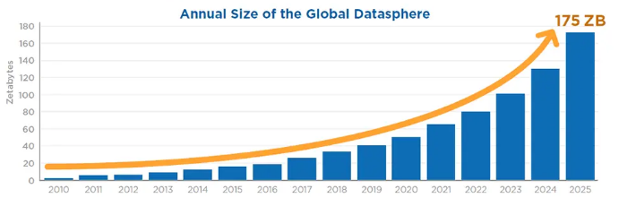
Figure 1 – Source: Data Age 2025 [1]
The main reasons for such exponential growth of data are the increased use of devices that generate data which includes gadgets that are incorporating sensors, mobile phones, the increased adaptation of 5G, advancements in cloud computing and IoT devices, and advancements in other technical fields such as computational photography and artificial intelligence [15] [16]. All these applications generate massive datasets. This large number of data can become a hassle for organizations if not managed properly but when managed and processed properly using the right tools, this same dataset will prove to be the revolution in the success of that organization [17]. The important and useful insights that will be developed by the trends and patterns identified in the processed data will be utilized by organizations and will provide them the opportunity to acquire a number of benefits [18]. These include optimizing the overall cost, personalizing their promotional offers, services, products, attaining maximum possible marketing potential that is driven by data, automating the pricing process to ensure consistent price models while mitigating manual errors [19].
Almost every organization in the world would second with the fact that big data benefits them by providing deep and thorough insights into their customers’ behavior [20]. These insights are then used by organizations to develop and implement effective, efficient, and productive strategies and business decisions [21].
The majority of the population is of the view that only giant corporations enjoy the benefits of utilizing big data but in the same way, big data also helps smaller organizations to generate significant value. Like, big data helps an organization to reduce their cost by working in an efficient way. The most significant value big data provides to a small company is a competitive advantage because when a business knows more about the behavior of their customers then it is easy to put a personal touch to give them what they like and dislike. Following is a comprehensive brief of how big data can benefit small organizations:
Shirokova and Iliashenko, in their research study, proposed that big data helps small organizations to efficiently improve their inventory management [2]. Analysis of big data allows organizations to have a look into their detailed performance [23] and precisely identify any inefficiency if there’s any [24]. Being aware of the inefficiencies, companies can manage and strategize accordingly which can further result in overall cost reduction [22] and will also allow them to enhance their efficiency and productivity. Businesses will be able to identify their customers' preferences [25] with the help of which they can develop personalized promotional offers, services, and products. This further provides them with the opportunity to experience an increase in sales and thus overall revenue [26]. By allowing small businesses to assess their finances, big data can help small organizations to compare their prices with their respective competitors.
Businesses will be able to get a better insight and make effective decisions regarding increasing or lowering the prices of their products or services accordingly [27].
As big data provides small businesses with an opportunity to have a better insight into customer behavior and their purchasing intentions, businesses will have an increased understanding of the local market. With this chunk of information, businesses can create productive and effective target marketing strategies providing them with the chance of experiencing a competitive advantage [28] [29]. The fact that only big companies can make effective use of big data analytics, is not true. As small businesses comprise tight and low budgets, there are certain big data analytics tools are available in the market that small businesses conveniently afford [28] [30].

2.2 Factors and Challenges of Big Data
Over recent years big data has been gaining a significant amount of attention from many researchers and business owners. Big data analysis is a proven method that provides businesses with the opportunity to gain better business insight and generate increased revenue [31]. There exist several methods and approaches that aid businesses to determine and evaluate the financial potential of their big data investments [32]. Different businesses adopt different methods according to their suitability. Some businesses incorporate the Return On Investment approach whereas others might take up the Benefit-Risk Analysis approach in order to assess the respective investments [3].
In addition to these approaches, the Critical Success Factors is another approach that is being adopted by a number of different researchers [3]. According to Eybers and Hattingh [4], the Critical Success Factors allow businesses to evaluate the risks prior to investing in big data. Most of these critical success factors that are incorporated in the research study conducted by Golzer and Demmelhuber [5] are based on data warehouse and Business intelligence systems because of how they are mostly used to manage, store, and analyze big data. Sai, Abdullah, and Husin [3] mention in their research study that in order to implement and utilize big data properly and successfully, mere technical capabilities for data analysis would not be enough. They argue that managing the data in an appropriate manner [5] and accessibility of proper analysis tools [6] are also some of the critical aspects of successfully implementing big data in an organization. Both these factors, proper management, and software availability allow businesses to have a better understanding of data to develop effective strategies and make effective business decisions [3].
The management and analysis of small data are comparatively easy as they can be done manually by humans or simple machines [30]. However, dealing with a large amount of data can give rise to a number of immense challenges. Many researchers have been facing difficulties while mining and analyzing large data sets to derive useful business insights from them. Different challenges are subjected at different phases of big data analysis, for example, data gathering, storing this large amount of data, managing this data, creating visualizations from such diverse data. In addition to these, sharing such an amount of data searching through this data can also be very challenging for organizations [30].
Just as big and developed companies, small organizations are also subjected to different challenges while utilizing big data to gain a better understanding of the market, their business, clients, performance, etc. Unlike big organizations, smaller ones are not equipped with the appropriate understanding of big data. According to [30], in terms of big data, the first and foremost problem that is subjected to small and medium-sized enterprises is whether their data can be considered as big data or not. Whether they should hop on to the big data train or not.
Giant corporations are capable of purchasing software and tools that allow effective and efficient analysis of big data. Whereas for smaller companies, because of their little revenue generations, tight budget, and small scale business it becomes rather difficult to invest in big data analytics [30]. Incorporating small budgets, smaller organizations face difficulties in hiring new employees who acquire the capabilities of analyzing and further managing the big data. Big data will be of zero significance if not managed properly [36].
There exists a lack of success stories of utilizing big data in smaller organizations. This can be considered as a critical factor for channeling big data innovation among smaller organizations [35]. As compared to large corporations, small companies are more concerned about the security of their data. Due to a lack of tech and infrastructure management and expertise in small organizations their data is more vulnerable and is more prone to data breaches and data theft. In contrast to big companies, a small company will not be able to compensate and survive through a critical data breach and cyber-attack [34]. There are certain legal considerations that must be followed by every organization in order to perform big data analytics. Small companies mostly lack such expertise and would require the services of a third party. Such services are expensive which most of the small companies are not able to afford [30]. Most of the small-scale organizations are subjected to information asymmetry with financial institutions which is the reason that they experience a lack of financial resources. With little financial resources, small companies are hesitant to invest in fields that do not complement their particular business model [33].

3. Methodology

3.1 Data Warehouse

Introduction
A data warehouse is system software that falls under the category of data management systems. It is a collection of a large amount of data that aids in insightful decision-making. Organizations make use of their data warehouse to make efficient and effective business decisions. The primary purpose of a data warehouse is data organization and to cleanse the data so that it becomes subject-oriented, time-referenced, non-volatile, and integrated. These characteristics are required in data so that it can be analytical and beneficial insights can be derived from it [37]. A Data warehouse is different from a database [38]. A data warehouse incorporates multiple databases which makes data analysis convenient.

Significance
There exist several different benefits of implementing and utilizing data warehouse applications. These benefits include both tangible and intangible benefits [39]. The most prominent among the tangible benefits are better and favorable information [41] and the other one is the amount of time an organization saves when it is equipped with a data warehouse application [40].
A data warehouse makes access to data more convenient [42]. Organizations generate a lot of data regarding their customers on a day-to-day basis. Useful information is clustered up and buried deep down in the database of a certain department. A data warehouse extracts data from different internal databases of an organization and organizes it in a more presentable manner that makes it easy to access information which the managers and analysts can make use of while developing strategies and decision making [43] and effective strategies that are made possible via a data warehouse, provide an organization with the opportunity to have a competitive advantage in their respective market. Data warehouses allow organizations to have a better understanding of their performance and their current stance in the market. With this information, managers can develop and implement suitable strategies that are effective and efficient [44].

Types of Data Warehouse Architecture
There are three types of data warehouse architecture i.e. single-tier, two-tier, and three-tier data warehouse architecture [52]. The single-tier data warehouse [55] is suitable for organizations that generate simple and will not be suitable for organizations that incorporate a large number of data streams and complicated data requirements. The two-tier data warehouse [54] incorporates a database server and a system and is suitable for small-scale companies that are equipped with data marts as their server. This data warehouse is more efficient than the single-tier data warehouse but it lacks scalability to incorporate complex big data. The three-tier data warehouse architecture is the most commonly used one as it is most efficient in generating useful insights from raw unorganized data. The bottom tier of this three-tier data warehouse incorporates the databank server the purpose of which is to create an abstraction layer over the transactional database being utilized by the front-end users. The middle tier incorporates the OLAP server i.e. the Online Analytical Processing server. This level of data warehouse arranges and organizes data such that it will be conveniently analyzed. The third and the top tier of the three-tier data warehouse incorporates the tools and APIs the purpose of which is to perform high-level analytics, evaluation, and generating reports. Figure 2 can help understand the three-tier data warehouse architecture in a better way. [53]
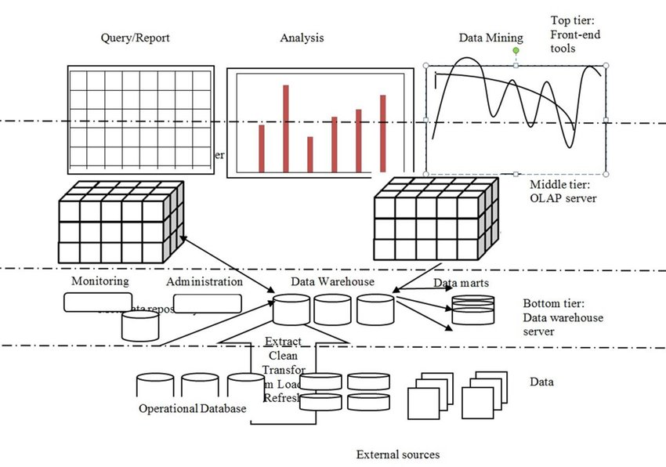
Figure 2 – Source: [49]

Architectural Components
According to Astera [45], a data warehouse system primarily comprises 6 components. These components are database, ETL (Extraction, Transformation, and Loading) tools, metadata, access tools, the data warehouse bus, and the last one is a reporting layer.

1. A Central Database
The main component of the data warehouse architecture is the central database where all the data is being accumulated and stored in a proper and organized manner for further reporting and analysis. There are different types of databases that are suitable for different organizations depending upon their business models. Following are the three types of databases that can be used:
- Relational database: This is a table of related values. These databases are row-centered which means that every row incorporates a different real-life entity of a particular organization. These rows in the tables are related to each other. These are the databases that are most commonly used by different organizations in the world [46]. Some of the most prominent examples of relational databases are DB2 by IBM, Oracle, SQLite, Microsoft SQL Server, MySQL, SAP, RDB by Oracle, Informix Dynamic Server by IBM.
- Analytical Database: the main purpose of an analytical database is to manage and sustain data or the sole purpose of data analytics. The type of data that is primarily managed and organized in this type of database is the big data of an organization which includes customer data and the market data or businesses and organizations. Analytical databases are the most scalable ones among the types of databases [47]. Some of the most prominent examples of the analytical database are Greenplum and Teradata.
- Cloud-based Databases: these databases operate as traditional relational and analytical databases with an added feature of cloud computing. These databases can be accessed via an API that is provided by a vendor or via a web interface. Provides organizations with the opportunity to not spend any additional revenue on tools and equipment related to data warehouses. Organizations only pay for what they use [48]. Some of the most prominent examples of cloud-based databases are Microsoft Azure SQL, Amazon Redshift, MongoDB Atlas,l and Google BigQuery.

2. ETL Tools
These tools are the main essence of the data warehouse system. These will aid in the extraction of data from various sources, proper organization of that extracted data, and allows that data to be imported into the data warehouse. ETL activities hold crucial value for a data warehouse system as they are carried out on a regular basis for the data warehouse to be well maintained. With the help of these ETL activities and the respective tools, the aggregation, transformation, and calculations of data are verified. ETL tools do not require any technical expertise to be operated. These allow data to be transported and imported into the data warehouse which counts as the first and foremost step of data warehouse analytics. [56]

3. Metadata
In simple words, metadata is the data and information related to a data warehouse that is required by the user for better understanding. Metadata incorporates information regarding the description and the whereabouts of the data warehouse components, integration and analytical techniques that are being implemented, and the list of access controls. Metadata provides organizations with the opportunity for creating, maintaining, and utilizing the data warehouse in an enhanced and efficient manner. [57]

4. Data Warehouse Access Tools
It is not possible for every small-scale organization to employ database administrators for managing their databases for efficient data warehouse analytics. Therefore, there exist data warehouse access tools that do not require any code to be written for their operation. These tools aid in the creation of reports.
5. Data Warehouse Bus
This is the architectural component that defines how the data is being transmitted through different components and phases. The data mart is incorporated in this architectural component [45].
6. Data Warehouse Reporting Layer
This architectural component of the data warehouse incorporates the business intelligence database architecture and allows the users to access it. This architectural component is considered as the dashboard that represents all the final analysis that is generated by the data warehouse. This analysis includes reports, data visualizations through charts and graphs, and every other kind of required information [45].

3.2 Knime
Knime is a software that is based on the graphic user interface and provides the services such as data integration, data visualization, and data analysis. These processes incorporate data mining and machine learning for efficient and effective results. Knime is a convenient and easy-to-use software that does not require coding and programming language of any sort. Users that lack technical and analytical skills are also able to make effective use of Knime to generate important visualizations for effective decision making. It also provides the feature of plugging in and importing data from different data analytics and business intelligence tools. Knime being an open-source software makes it feasible for it to be used by small companies and generate useful insights into their business [51].

3.3 Proposed Design
The primary objective of conducting this study was to propose, develop, and implement a data warehouse design that would be suitable for a small company and would cater to its big data generation. This research study has been conducted with its primary focus on Preston Foods. The phpMyAdmin data warehouse has been opted by the researcher. Big data of Preston Foods will be managed, stored, and analyzed using phpMyAdmin. As it is an open-source tool that incorporates MySQL administration tools, this would provide Preston Foods an opportunity for cost reduction. According to [50], many small companies are often equipped with phpMyAdmin as their data warehouse. Among all the organizations that are using phpMyAdmin as their data warehouse, 39% are small-scale companies incorporating a workforce of fewer than 50 employees.
Knime has been opted by the researcher as the data analytics tool. phpMyAdmin arranges the Preston Foods data in a database model and further into two tables i.e. Preston Food Store and Preston sales. This tabular form of data is imported in Knime to derive trends, patterns, and visualizations. These patterns and visualizations are then utilized by the managers of Preston Foods to strategize accordingly for the purpose of enhanced performance, competitive advantage, and to gain better insights of their business.

Results

4.0 Introduction
This chapter comprises of different sections which discusses the results that are obtained after implementation. Further this chapter includes the procedure which is followed for the sake of implementation of the data warehouse. Data visualization charts are also shown and explained in this chapter.

Datawarehouse
Data warehouse is seem to be an effective way to store large bulk of data. Datawarehouse is created using phpmyadmin. To install phpmyadmin, xampp is which is downloaded and connected while switching on the ports of mysql, Apache and Filezilla. The below picture shows the picture of the pestron database. Pestron database contains two tables which are named as pestron food store and pestron sales. Below is the structure of tha pestron database.
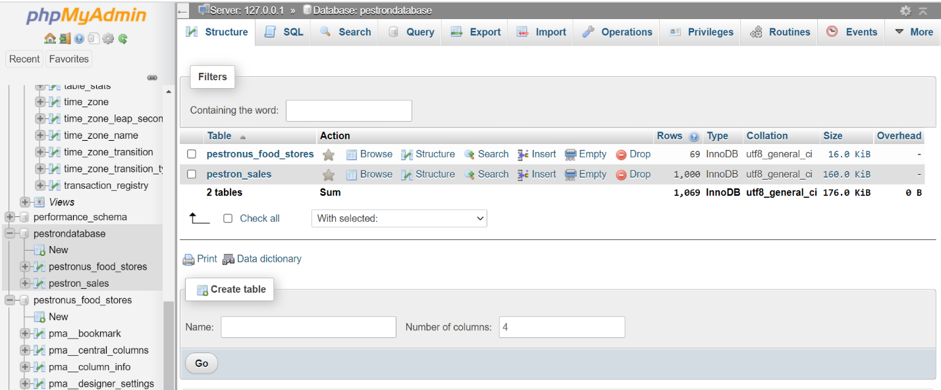
Figure 1(Pestron database)
After successfully creation of Pestron database, tables are created. One of the table is shown below which are named as pestron_food_stores. The table has number of entities which includes city, Columbus_area, ebt, name, phone_number, state, street address, wic and zip_code. These all are created using sql queries, setting its types and number of attributes in the database table. These is no primary key in the above table as the data is redundant and equally significant.
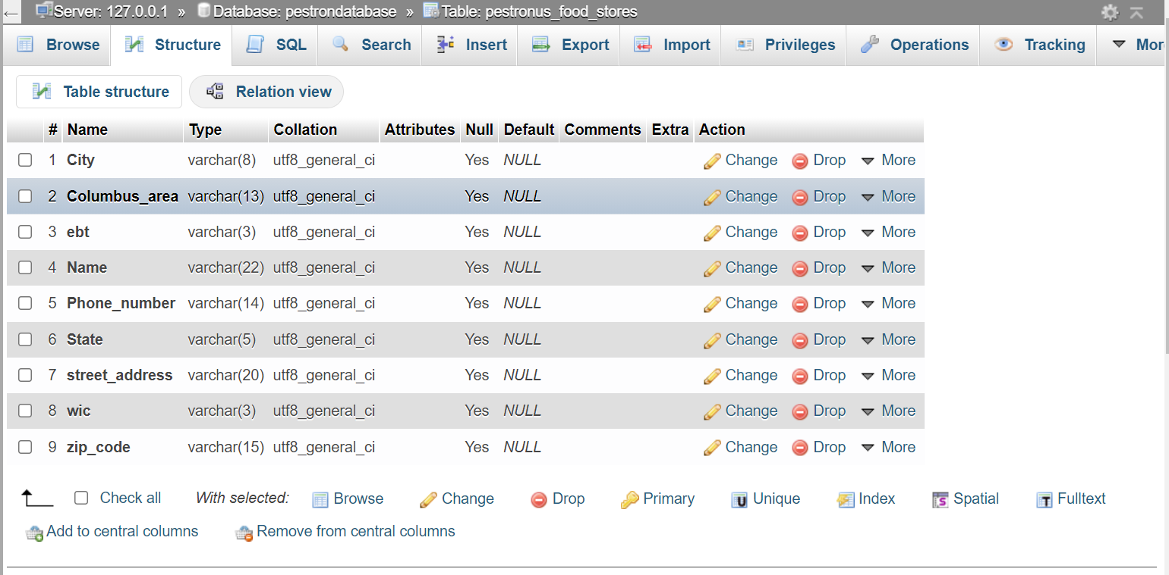
Figure 2 (pestron food store)

The below picture shows the data of the table pestron_food_stores. The above data is successfully imported and loaded in the table.
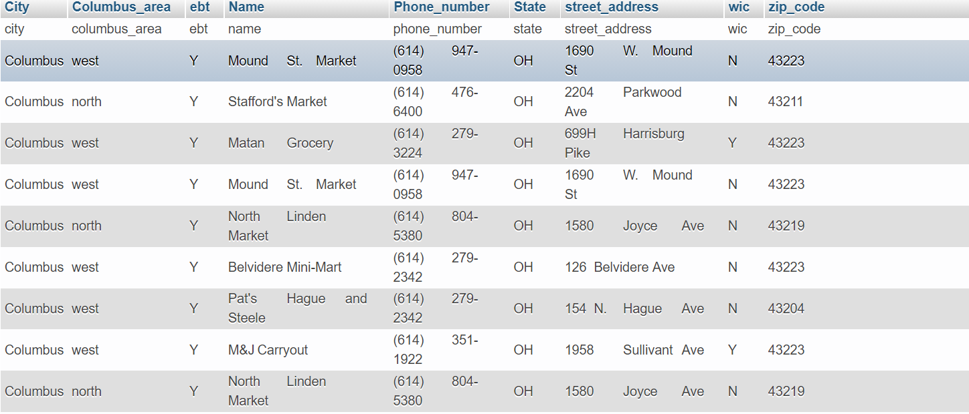
Figure 3(pestron food store data)

The below picture shows the structure of pestron sales. InvoiceID is identified as a primary key as it contains the unique data which is also not redundant. Further it shows the number of entities which are invoiceID, Branch, city, customer, gender, productline, quantity, tax, total,date, time, payment, cogs, gross margin percent, gross income and rating. The structure of table is created with the help of sql queries. Different types is set for different entities in the table.
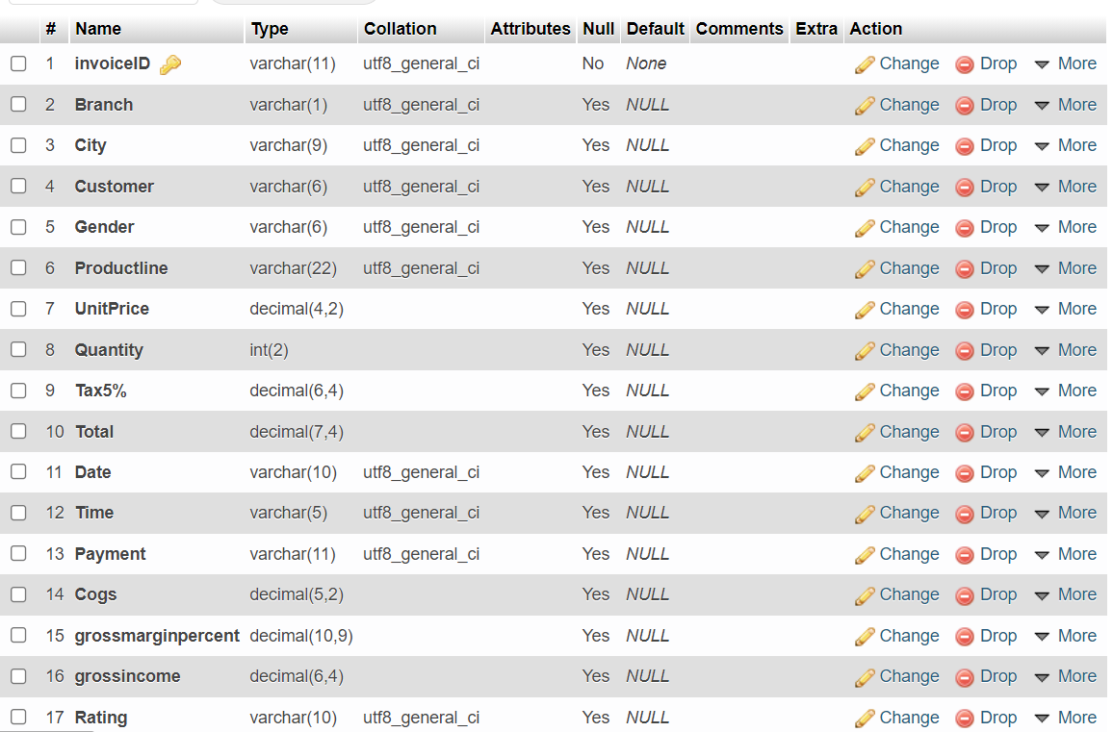
Figure 4 (structure of pestron sales table)
Data is imported in the table which can be shown in the below picture. It provides the easy access of data. Data can also be entered manually in the table using insertion sql query.
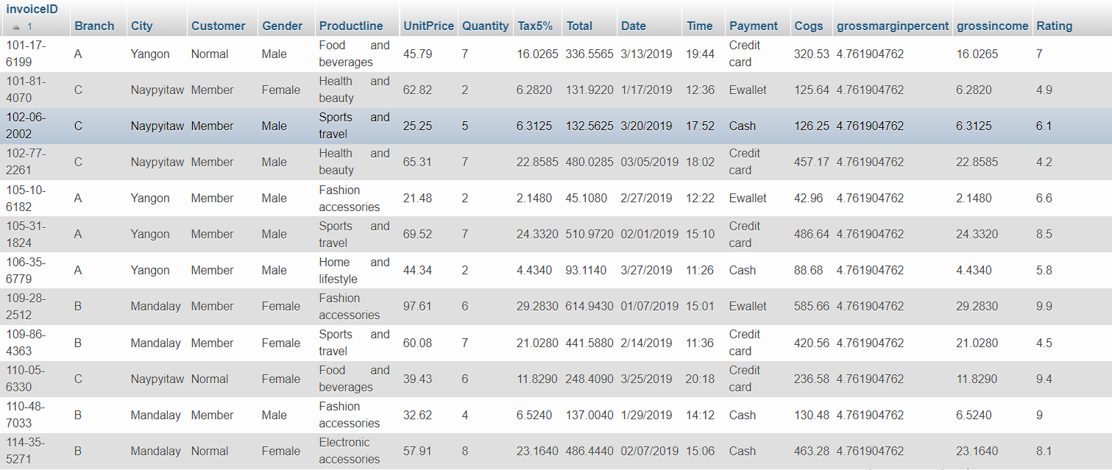
Figure 5(data of pestron sales table

Data visualization
Data visualization presents the idea to show the relationship between different attributes of the tables. Data visualization has been done using the knime software which is an open source software and it provides the number of privileges to represent the data.
Knime provides the ease to work on different data using data different workflows hence it is easy to maintain the large amount of data and visualize them. Different nodes are created using from the node representative option. Pestron food store file is attached in the csv reader node. To graphically represent data, various nodes are created which includes the box plot, bar chart, pie/donut chart, heat map, sunburst chat, bar chart and interactive histogram chart.
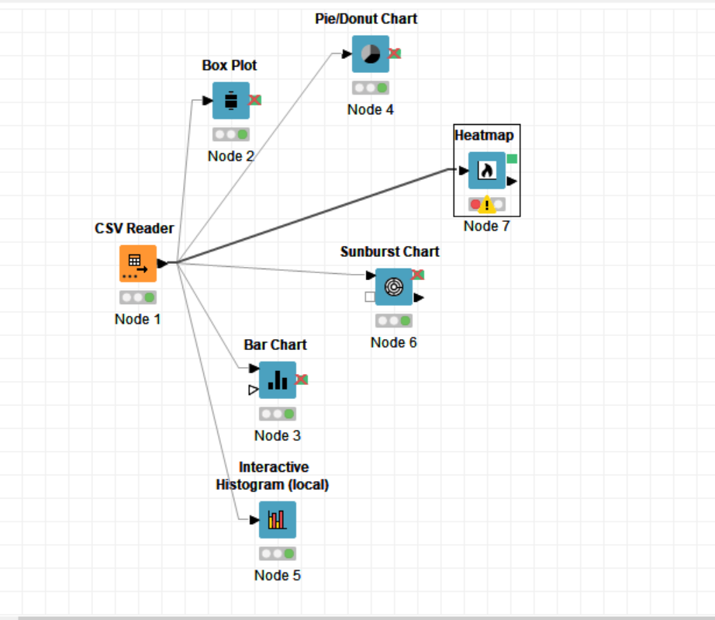
Figure 6(workspace of pestron food store)

Below is the bar chart representation of the number of occurrence of the data. It shows the probability of data in the form of yes or no.
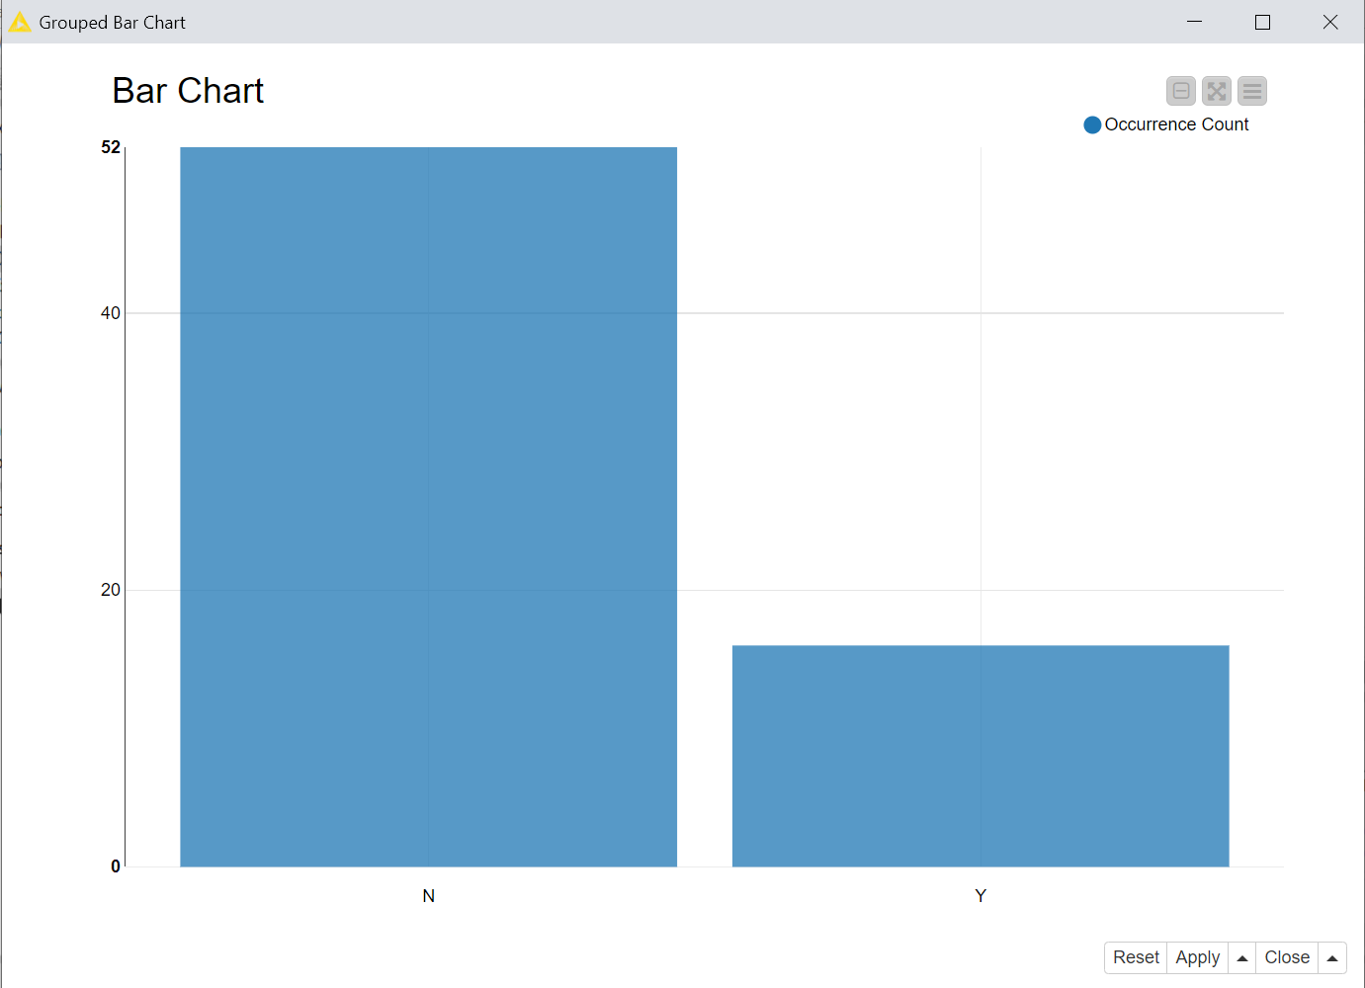
Figure 7(bar chart)

Then box plot is created which shows the data, in the upper quartile, middle and lower quartile using one numerical value which is zip_code of different food stores. Box plot can also be shown using various numerical values. The results for various numerical values can be seen from figure (9).
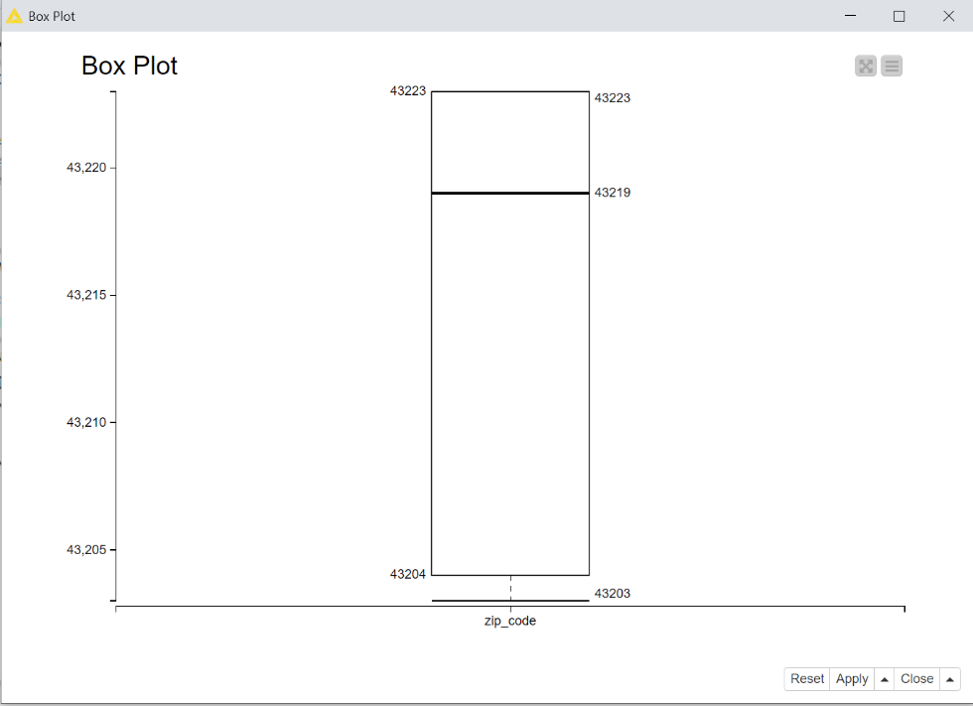
Figure 8(box plot)

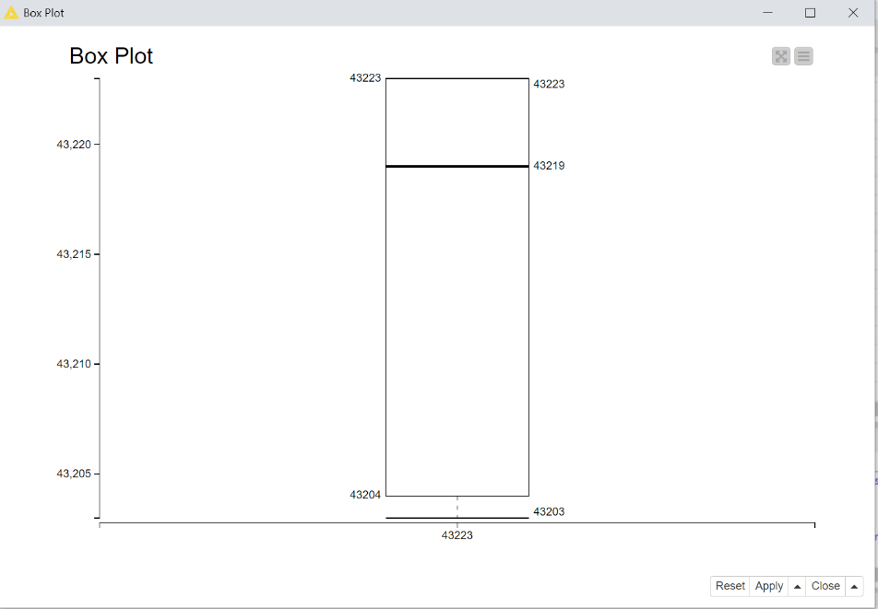
Figure 9(box plot of multiple values)

The below picture shows the histogram representation of the data. Histogram is build usin NVD3 library. It provides an ease to change the x-axis and the flying aggregation column which keeps on changing. From the implementation, Columbus is set on x-axis which is the city.
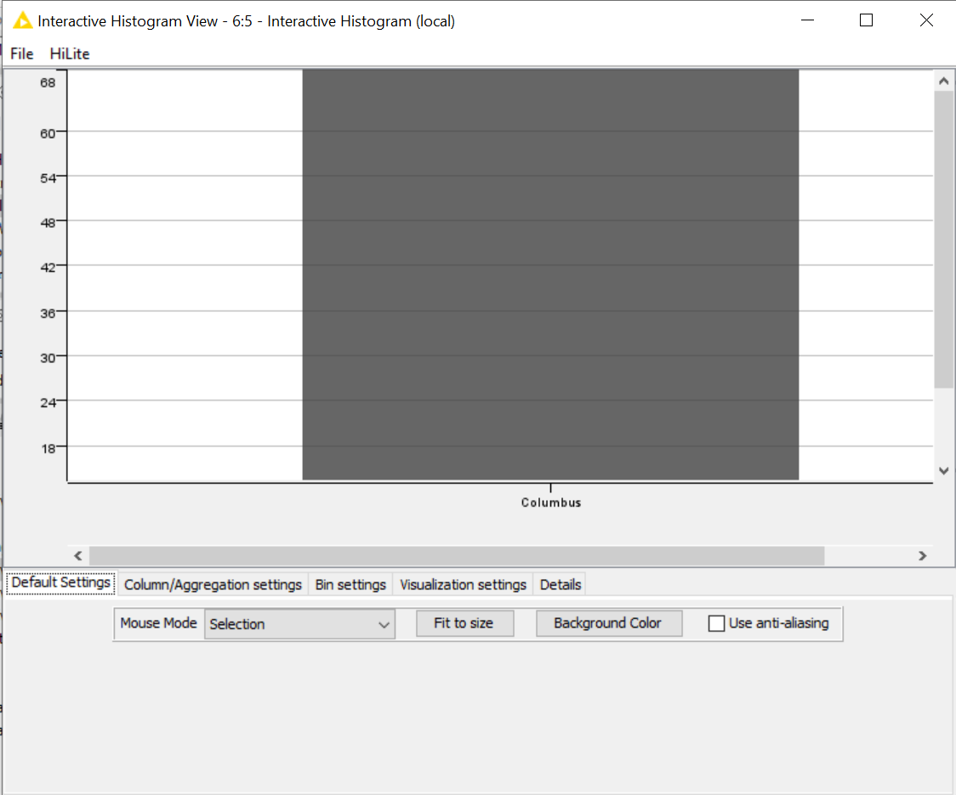
Figure 10(histogram)

The picture which is attached below shows the pie-chart, it represents the results on the basis of ebt numerical value. It shows that 16% probability in no and 52% in yes. This probability shows that 16% of the customers does not pay for the food with the help of card and 52% customers pay from their cards.
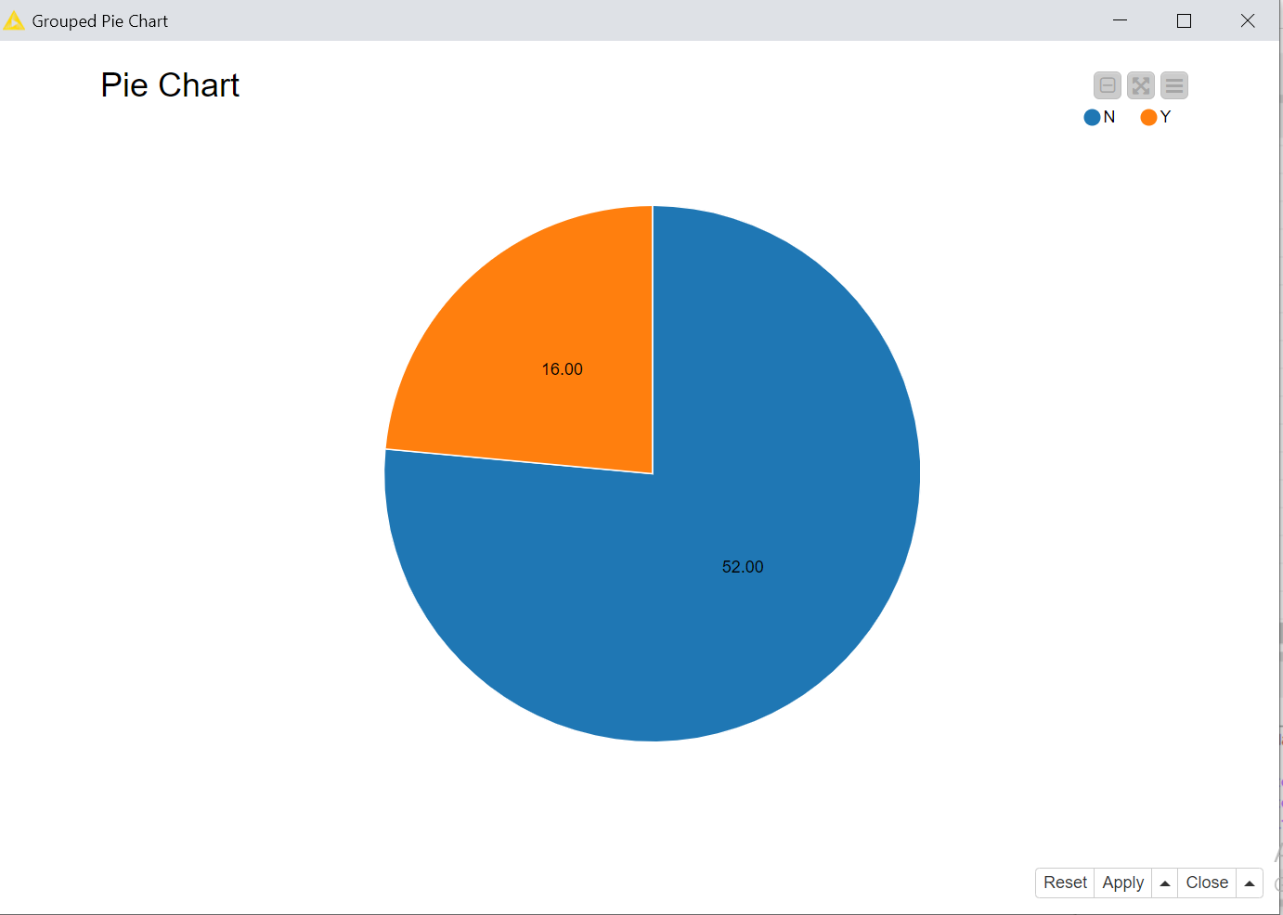
Figure 11(pie-chart)

Sunburst chart helps to represent the categorical features of the data using their numerical values in the form of rings. This chart shows the multiple variables at the same time.
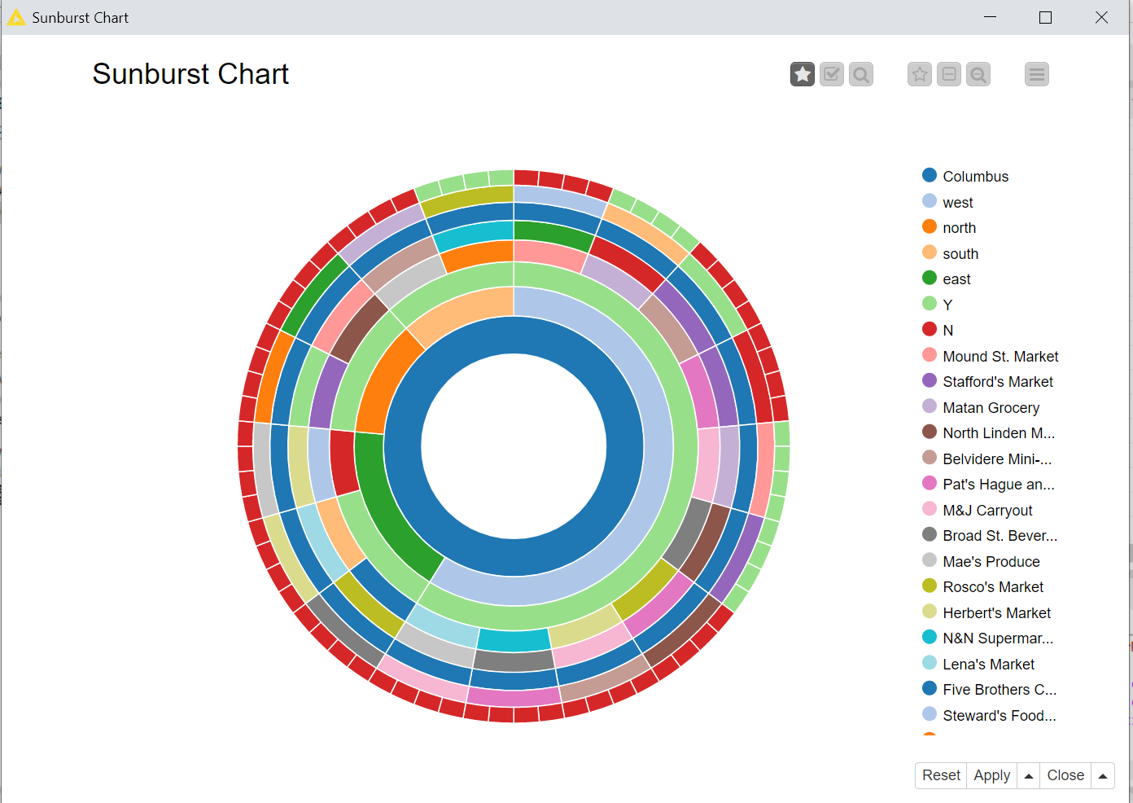
Figure 12(sun-burst)

Similarly, workspace for pestron sales is created using similar methods. Below picture shows the creation of csv reader node and various data visualization nodes.
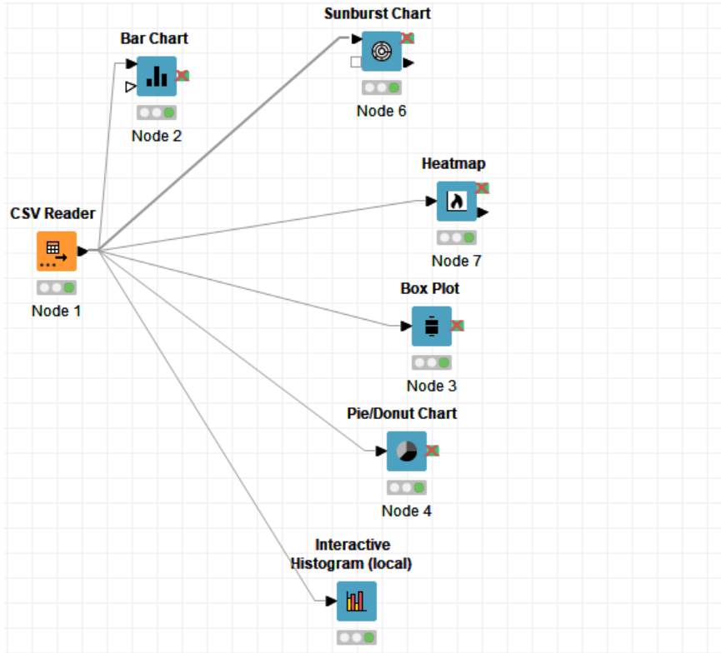
Figure 13(workspace of pestron sales table)

Below is the picture which shows the pie-chart depending on the data. It shows that there are various methods for the payment which includes the cash, Ewallet and credit card.
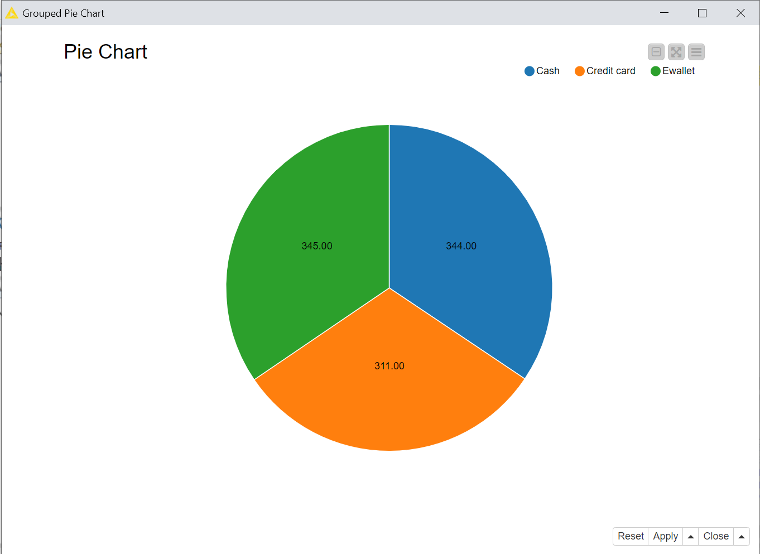
Figure 14(pie-chart)

Below picture shows the sunburst representation of the data. Every ring is sliced based on the numerical value of the data.
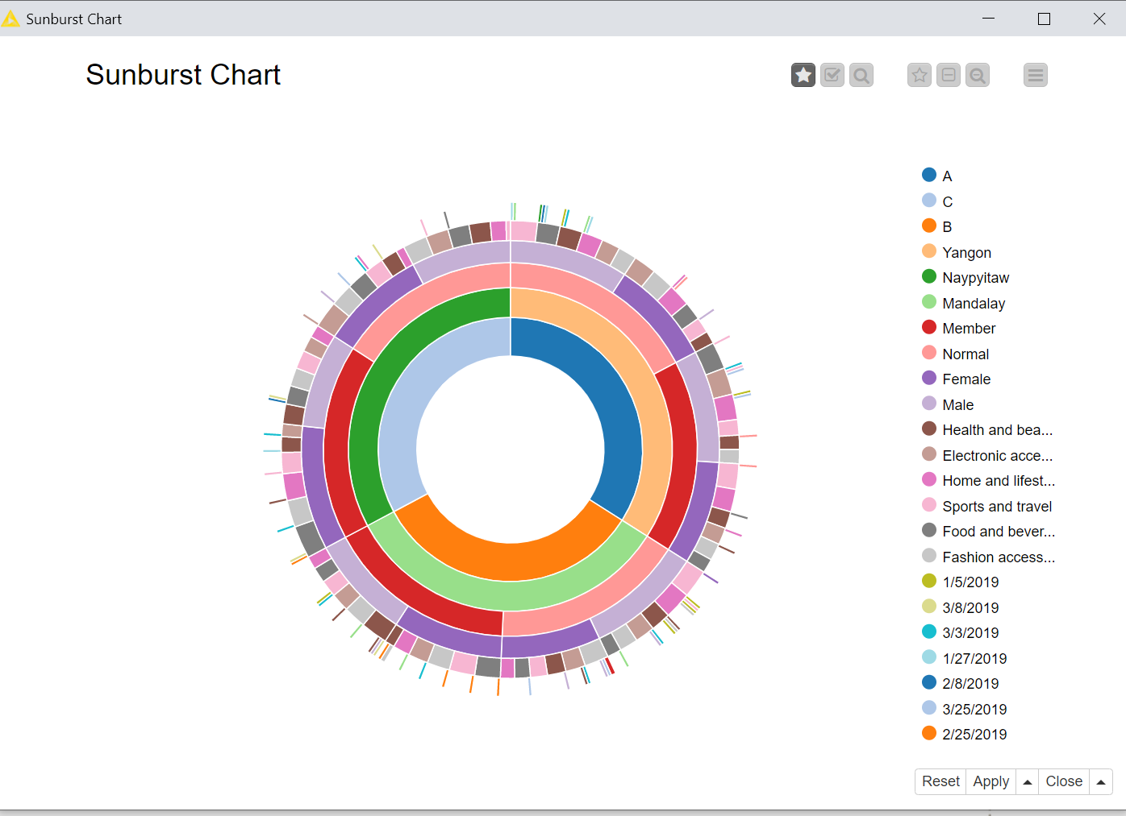
Figure 15(sunburst)

Below picture represents the histogram which shows different values on x and flying aggregation values of unit price, quantity and tax, total, cogs, gross margin, gross income and rating.
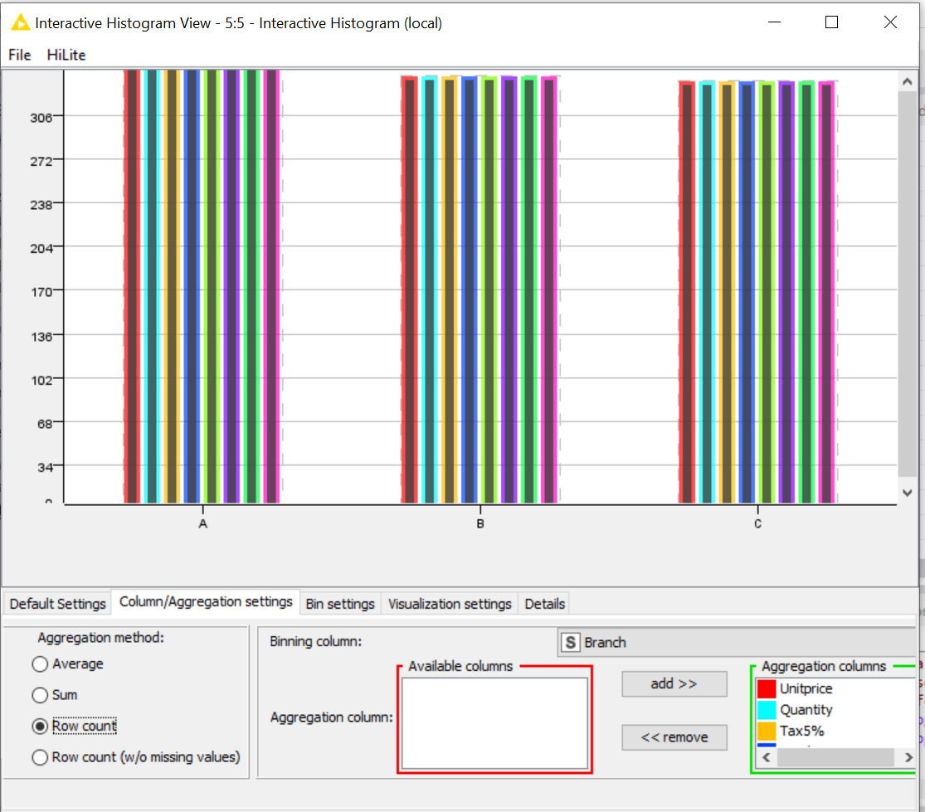
Figure 16(histogram)

Box plot representation is shown using the pestron sales data. It includes the minimum, lower quartile, median, upper quartile and maximum value.
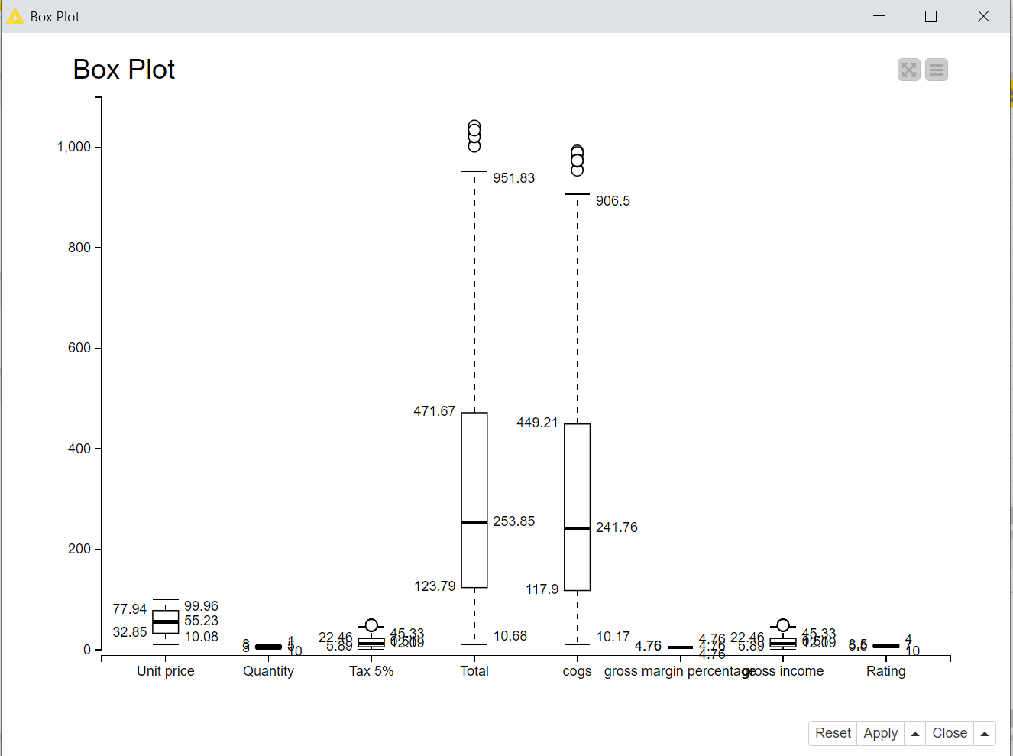
Figure 17(Box-plot)

5. Limitations
Just like every other research, this study was also subjected to certain limitations that, to some extent, influenced the conduction of this study and the overall execution. While researching the factors that might affect the utilization of big data in small-sized companies, the researcher experienced a notable deficiency of critical success factors regarding the big data domain in the literature. In addition to this, while developing the data warehouse for Preston Foods, due to a large amount of data it was difficult for the researcher to determine and define the primary keys and the foreign keys of the two developed databases. Furthermore, the installation of the software i.e. phpMyAdmin and Knime required certain specifications for which the researcher had to put in additional time and effort.

6. Conclusion
The purpose of conducting this research study was to design and implement a data warehouse system for a mini-supermarket chain Preston Foods in order to cater to the company’s big data generation. This study will aid in raising awareness among small companies regarding the importance of utilizing big data and how it will benefit their organization as it is also supported by the previous study given by Shirokova and Iliashenko which clearly indicates the various benefits of big data in smaller organizations. There might exist challenges that the companies will be subjected to but still, the benefits of big data analytics surpass them all. There exist techniques and methods following which small companies can also experience the benefits of big data to its full potential. The phpMyAdmin data warehouse is being utilized by the researcher to cater to Preston Food’s big data. Furthermore, for the purpose of generating useful insights from the company’s big data, the researcher has utilized the services of Knime software.

References
[1]Data Age 2025: the datasphere and data-readiness from edge to core", i-SCOOP. [Online]. Available: https://www.i-scoop.eu/big-data-action-value-context/data-age-2025-datasphere/. [Accessed: 19- Jul- 2021].
[2]S. SHIROKOVA and O. ILIASHENKO, "Decision-making support tools in data bases to improve the efficiency of inventory management for small businesses", Universitypress.org.uk. [Online]. Available: http://universitypress.org.uk/library/2014/russia/bypaper/MEAS/MEAS-31.pdf. [Accessed: 19- Jul- 2021].
[3] Z. Al-Sai, R. Abdullah and M. Husin, "Critical Success Factors for Big Data: A Systematic Literature Review", IEEE Access, vol. 8, pp. 118940-118956, 2020. Available: 10.1109/access.2020.3005461 [Accessed 19 July 2021].
[4] S. Eybers and M. Hattingh, "Critical success factor categories for big data: A preliminary analysis of the current academic landscape", in IST-Africa Week Conference, 2017.
[5] P. Cato, P. Golzer and W. Demmelhuber, "An investigation into the implementation factors affecting the success of big data systems", 2015 11th International Conference on Innovations in Information Technology (IIT), 2015. Available: 10.1109/innovations.2015.7381528 [Accessed 19 July 2021].
[6] K. Blasiak, ‘‘Big Data; A management revolution,’’ M.S. thesis, Dept. Appl. Sci., Bachelor Bus. Admin., Helsinki Metropolia Univ., Vantaa, Finland, 2014.
[7] R. Ramadan, "Big Data Tools-An Overview", International Journal of Computer & Software Engineering, vol. 2, no. 2, 2017. Available: 10.15344/2456-4451/2017/125 [Accessed 20 July 2021].
[8] A. Katal, M. Wazid and R. Goudar, "Big data: Issues, challenges, tools and Good practices", 2013 Sixth International Conference on Contemporary Computing (IC3), 2013. Available: 10.1109/ic3.2013.6612229 [Accessed 20 July 2021].
[9] I. Yaqoob et al., "Big data: From beginning to future", International Journal of Information Management, vol. 36, no. 6, pp. 1231-1247, 2016. Available: 10.1016/j.ijinfomgt.2016.07.009 [Accessed 20 July 2021].
[10] M. Ahmed, N. Choudhury and S. Uddin, "Anomaly Detection on Big Data in Financial Markets", in 2017 IEEE/ACM International Conference on Advances in Social Networks Analysis and Mining (ASONAM), Sydney, NSW, Australia, 2021.
[11] Dodiya, I.N., 2018. ROLE OF BIG DATA IN ACADEMIC LIBRARY. INTERNET OF THINGS AND CURRENT TRENDS IN LIBRARIES, pp.30.
[12] J. Valach et al., "Everything is Data – Overview of Modular System of Sensors for Museum Environment", The International Archives of the Photogrammetry, Remote Sensing and Spatial Information Sciences, vol. -57, pp. 439-442, 2015. Available: 10.5194/isprsarchives-xl-5-w7-439-2015 [Accessed 20 July 2021].
[13] K. Vassakis, E. Petrakis and I. Kopanakis, "Big Data Analytics: Applications, Prospects and Challenges", Mobile Big Data, pp. 3-20, 2017. Available: 10.1007/978-3-319-67925-9_1 [Accessed 20 July 2021].
[14] M. Gokalp, K. Kayabay, M. Akyol, P. Eren and A. Kocyigit, "Big Data for Industry 4.0: A Conceptual Framework", 2016 International Conference on Computational Science and Computational Intelligence (CSCI), 2016. Available: 10.1109/csci.2016.0088 [Accessed 20 July 2021].
[15] "Study on Causes and Issues of Big-Data", INTERNATIONAL JOURNAL OF ENGINEERING SCIENCES & RESEARCH TECHNOLOGY, vol. 3, no. 2, pp. 626-629, 2014. [Accessed 20 July 2021].
[16] A. Maskooki, G. Sabatino and N. Mitton, "Analysis and performance evaluation of the next generation wireless networks", Modeling and Simulation of Computer Networks and Systems, pp. 601-627, 2015. Available: 10.1016/b978-0-12-800887-4.00021-3 [Accessed 20 July 2021].
[17] M. Sarker, M. Hossin, A. Frimpong and Y. Xiaohua, "Promoting information resource management for e-government through big data approach", Proceedings of the 2018 International Conference on Information Management & Management Science - IMMS '18, 2018. Available: 10.1145/3277139.3277155 [Accessed 20 July 2021].
[18] S. Sagiroglu and D. Sinanc, "Big data: A review", 2013 International Conference on Collaboration Technologies and Systems (CTS), 2013. Available: 10.1109/cts.2013.6567202 [Accessed 20 July 2021].
[19] F. Almeida, "Benefits, Challenges and Tools of Big Data Management", Journal of Systems Integration, vol. 8, no. 4, 2017. Available: http://dx.doi.org/10.20470/jsi.v8i4.311 [Accessed 20 July 2021].
[20] S. Marwaha, J. Bughin and J. Livingston, "Seizing the potential of ‘big data’", Mckinsey.de, 2011. [Online]. Available: https://www.mckinsey.de/~/media/McKinsey/Business%20Functions/McKinsey%20Digital/Our%20Insights/Seizing%20the%20potential%20of%20big%20data/Seizing%20the%20potential%20of%20big%20data.pdf. [Accessed: 20- Jul- 2021].
[21] T. H. Davenport, "How strategists use “big data” to support internal business decisions, discovery and production", Strategy & Leadership, vol. 42, no. 4, pp. 45-50, 2014. Available: 10.1108/sl-05-2014-0034 [Accessed 20 July 2021].
[22] I. Lee, "Big data: Dimensions, evolution, impacts, and challenges", Business Horizons, vol. 60, no. 3, pp. 293-303, 2017. Available: 10.1016/j.bushor.2017.01.004 [Accessed 20 July 2021].
[23] A. McAfee and E. Brynjolfsson, Big Data: The Management Revolution. Harvard Business Review, 2012.
[24] A. Popovič, R. Hackney, R. Tassabehji and M. Castelli, "The impact of big data analytics on firms’ high value business performance", Information Systems Frontiers, vol. 20, no. 2, pp. 209-222, 2016. Available: 10.1007/s10796-016-9720-4 [Accessed 20 July 2021].
[25]D. Van Horn, A. Olewnik and K. Lewis, "Design Analytics: Capturing, Understanding, and Meeting Customer Needs Using Big Data", Volume 7: 9th International Conference on Design Education; 24th International Conference on Design Theory and Methodology, 2012. Available: 10.1115/detc2012-71038 [Accessed 20 July 2021].
[26]T. Boone, R. Ganeshan, A. Jain and N. Sanders, "Forecasting sales in the supply chain: Consumer analytics in the big data era", International Journal of Forecasting, vol. 35, no. 1, pp. 170-180, 2019. Available: 10.1016/j.ijforecast.2018.09.003 [Accessed 20 July 2021].
[27]J. Costa Junior, J. Rezende, E. Cabral, D. Florentino and A. Soares, "The Impact of Big Data on SME´s Strategic Management: A Study on a Small British Enterprise Specialized in Business Intelligence", Journal of Management and Strategy, vol. 9, no. 4, p. 10, 2018. Available: 10.5430/jms.v9n4p10 [Accessed 20 July 2021].
[28]M. Agu, C. Udanor and B. Ogbuokiri, "Implementing bigdata analytics for small and medium enterprise (SME) regional growth", Journal of Computer Engineering, vol. 17, no. 6, pp. 35-43, 2015. Available: 10.9790/0661-17643543 [Accessed 20 July 2021].
[29]D. Sen, M. Ozturk and O. Vayvay, "An Overview of Big Data for Growth in SMEs", Procedia - Social and Behavioral Sciences, vol. 235, pp. 159-167, 2016. Available: 10.1016/j.sbspro.2016.11.011 [Accessed 20 July 2021].
[30]M. Iqbal, S. Kazmi, D. Manzoor, D. Soomrani, S. Butt and K. Shaikh, "A Study of Big Data for Business Growth in SMEs: Opportunities & Challenges", in International Conference on Computing, Mathematics and Engineering Technologies, 2018.
[31]D. Jelonek, "Big Data Analytics in the Management of Business", MATEC Web of Conferences, vol. 125, p. 04021, 2017. Available: 10.1051/matecconf/201712504021 [Accessed 20 July 2021].
[32]U. Sivarajah, M. Kamal, Z. Irani and V. Weerakkody, "Critical analysis of Big Data challenges and analytical methods", Journal of Business Research, vol. 70, pp. 263-286, 2017. Available: 10.1016/j.jbusres.2016.08.001 [Accessed 20 July 2021].
[33]Davidsson P. Entrepreneurship – and after? A study of growth willingness in small firms. Journal of Business Venturing 1989; 4:211–226.
[34]Lacey D, James BE. Review of Availability of Advice on Security for Small/Medium Sized Organisations. Information Commissioner’s Office: Wilmslow, UK, 2010.
[35]Karim, S., Al-Tawara, A., Gide, E., & Sandu, R. (2017, May). Is big data too big for SMEs in Jordan?. In Information Technology (ICIT), 2017 8th International Conference on (pp. 914-922). IEEE.
[36] Russegger S, Freudenthaler B, Güntner G, Kieseberg P, Stern H, Strohmeier F. Big Data und Data-driven Business für KMU. Digital networked Data -Verein für Innovation und Erforschung vernetzter digitaler Daten: Salzburg, Austria, 2015.
[37]P. Suri and M. Sharma, "A Comparative Study Between the Performance of Relational & Object Oriented Database in Data Warehousing", International Journal of Database Management Systems, vol. 3, no. 2, pp. 116-127, 2011. Available: 10.5121/ijdms.2011.3208 [Accessed 20 July 2021].
[38]J. Foley, Comparison of Data Warehousing DBMS Platforms. Illuminate.
[39]H. Watson, D. Goodhue and B. Wixom, "The benefits of data warehousing: why some organizations realize exceptional payoffs", Information & Management, vol. 39, no. 6, pp. 491-502, 2002. Available: 10.1016/s0378-7206(01)00120-3 [Accessed 20 July 2021].
[40]Cooper, R. and Arbuckle, S., 2002. How to thoroughly test a data warehouse. Software Testing Analysis and Review (STAREAST).
[41]B. Lin, Y. Hong and Z. Lee, "Encyclopedia of Data Warehousing and Mining, Second Edition", 2009. Available: 10.4018/978-1-60566-010-3 [Accessed 20 July 2021].
[42]J. Li and B. Xu, "ETL tool research and implementation based on drilling data warehouse", 2010 Seventh International Conference on Fuzzy Systems and Knowledge Discovery, 2010. Available: 10.1109/fskd.2010.5569836 [Accessed 20 July 2021].
[43]S. Gardner, "Building the data warehouse", Communications of the ACM, vol. 41, no. 9, pp. 52-60, 1998. Available: 10.1145/285070.285080 [Accessed 20 July 2021].
[44]Mohanty, S., Jagadeesh, M. and Srivatsa, H., 2013. Big data imperatives: Enterprise ‘Big Data’warehouse,‘BI’implementations and analytics. Apress.
[45]N. Fatima, "Data Warehouse Architecture: Types, Components, & Concepts", Astera, 2019. [Online]. Available: https://www.astera.com/type/blog/data-warehouse-architecture/. [Accessed: 20- Jul- 2021].
[46]Jatana, N., Puri, S., Ahuja, M., Kathuria, I. and Gosain, D., 2012. A survey and comparison of relational and non-relational database. International Journal of Engineering Research & Technology, 1(6), pp.1-5.
[47]Raasveldt, M., 2018, May. Monetdblite: An embedded analytical database. In Proceedings of the 2018 International Conference on Management of Data (pp. 1837-1838).
[48]Korotun, O., Vakaliuk, T. and Soloviev, V., 2020. Model of using cloud-based environment in training databases of future IT specialists.
[49]M. Chaudhary, K. Gupta, A. Jijja and R. Vohra, "Mathematical Analysis of Data Mining in Higher Education", International Journal of Computer Science & Emerging Technologies, vol. 2, no. 3, 2011. [Accessed 20 July 2021].
[50]"phpMyAdmin commands 0.45% market share in Software Development Tools", Enlyft.com. [Online]. Available: https://enlyft.com/tech/products/phpmyadmin. [Accessed: 20- Jul- 2021].
[51]"Sparking Data Literacy with KNIME and Making Better Decisions | KNIME", KNIME. [Online]. Available: https://www.knime.com/solutions/success-story/sparking-data-literacy-with-knime-and-making-better-decisions. [Accessed: 20- Jul- 2021].
[52]M. Khachane, "DATA WAREHOUSE ARCHITCTURE AND DATA ANALYSIS TECHNIQUES". [Online]. Available: http://dspace.vpmthane.org:8080/jspui/bitstream/123456789/3171/1/Data%20Warehouse%20Architecture.pdf. [Accessed: 20- Jul- 2021].
[53]Seah, B.K. and Selan, N.E., 2014, August. Design and implementation of data warehouse with data model using survey-based services data. In Fourth edition of the International Conference on the Innovative Computing Technology (INTECH 2014) (pp. 58-64). IEEE.
[54]Chowdhury, R., Chatterjee, P., Mitra, P. and Roy, O., 2014. Design and implementation of security mechanism for data warehouse performance enhancement using two tier user authentication techniques. International Journal of Innovative Research in Science, Engineering and Technology, 3(6), pp.165-172.
[55]Sinha, R., 2019. Analytical Study of Data Warehouse. Journal Homepage: http://www. ijmra. us, 8(1), p.1.
[56]Majchrzak, T.A., Jansen, T. and Kuchen, H., 2011, March. Efficiency evaluation of open source ETL tools. In Proceedings of the 2011 ACM Symposium on Applied Computing (pp. 287-294).
[57]Laxmaiah, M. and Govardhan, A., 2013. A conceptual metadata framework for spatial data warehouse. arXiv preprint arXiv:1306.1730.

