Introduction to Health and Social Care
Component 1 Guidance – Portfolio (Poster + Essay)
Madiha Ghaffar 2522577
Module: LCHS4003
Dr Helen Parsons

Community antenatal midwifery services provide care and support to pregnant women throughout pregnancy in community settings such as GP surgeries, health centres, children's centres and the woman's home. Midwives monitor the health of both mother and baby, provide health education, identify risks and coordinate care with other healthcare professionals. (NHS England, 2024)

Community Antenatal Midwifery Services

Brief History of community Antenatal Midwifery Services
Key Roles
- Booking appointments and assessments
- Monitoring maternal and fetal wellbeing (NICE, 2023)
- Providing health promotion and education (NHS England, 2024)
- Supporting informed decision-making
- Identifying complications and referring to specialist services (NMC,2023)
- Preparing women and families for birth and parenthood

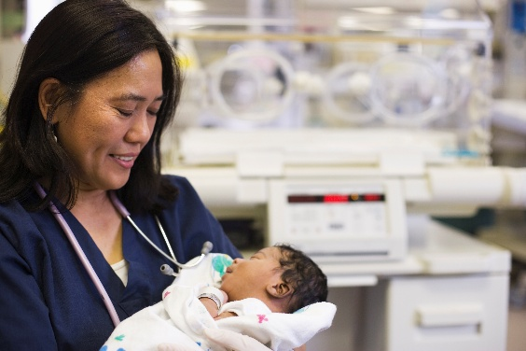
Challenges faced by the Community Antenatal Midwifery Service:
1. High Caseloads and Staffing Shortages
A major challenge is the increasing number of pregnant women needing care while many maternity services face shortages of qualified midwives (Royal Collage of Midwives, 2024). This can lead to:
- Reduced time for each appointment
- Delays in routine antenatal checks
- Increased pressure and burnout among midwives
2. Managing Complex and Diverse Needs in the Community
Community antenatal midwives care for women from varied backgrounds (NICE, 2023), each with different health, social, and cultural needs. Challenges include:
- Supporting women with high-risk pregnancies (e.g., diabetes, hypertension, obesity)
- Addressing language and communication barriers
- Safeguarding concerns such as domestic abuse, mental health issues, or substance misuse


References
- NHS England (2024) Maternity services.
- Nursing and Midwifery Council (2023) Standards for Midwives.
- Royal College of Midwives (2024) Maternity Workforce Report.
- NHS (2024) Your antenatal appointments.
- Department of Health and Social Care (2023) Women's Health Strategy.
- NICE (2023) Antenatal Care Guidelines.

Community Antenatal Midwifery Services: History, Development and Importance

Community antenatal midwifery services are an important part of maternity care in the UK. They support women during pregnancy by offering check-ups, health advice, emotional support, and referrals if any problems come up. Community midwives usually work outside hospitals and see women in local clinics or at home. This essay will look at where these services came from, how they have developed over time, how they work today, and why they are important for improving women’s quality of life.
The roots of community midwifery go back to when childbirth mainly happened at home. Midwives were often women from the local area who supported other women through pregnancy and birth. They were trusted because they understood the community and provided continuous care (Donnison, 1988). Things started to change with the Midwives Act 1902, which introduced official training and regulation for midwives in the UK. This helped improve safety and made midwifery more professional (Page, 2003).
A major change happened when the NHS was created in 1948. Midwives became part of a national healthcare system and began offering antenatal and postnatal care more formally. However, over time, more births moved into hospitals, which made maternity care more medicalised. While this improved safety in complicated pregnancies, it also meant that care became less personal and more focused on hospital routines rather than continuity with one midwife (Department of Health, 1993).
The Changing Childbirth report in 1993 was an important moment in shaping modern maternity care. It pushed for more woman-centred care, better communication, and continuity between women and midwives (Department of Health, 1993). This report helped bring back the idea that pregnancy is a normal life event and not just a medical condition, and that women should feel more involved in their care.
Today, community antenatal midwifery services focus on regular check-ups during pregnancy, monitoring the health of both mother and baby, and giving advice on things like diet, smoking, mental health, and preparing for birth. Midwives also play an important role in spotting risks early and referring women to hospital services when needed. They often work closely with doctors, health visitors, and other professionals to make sure care is joined up (NICE, 2021).
One of the most important parts of modern midwifery is continuity of care. This means women ideally see the same midwife or small team throughout pregnancy. Research shows that this can improve trust, communication, and overall satisfaction with care (Morgan et al., 1998). It can also help women feel more confident and less anxious because they build a relationship with someone who understands their situation.
However, community antenatal services also face challenges. In some areas, there are not enough midwives, which means care can feel rushed or inconsistent. Some women may see different midwives at each appointment, which affects continuity. There are also ongoing issues with health inequalities, where women from deprived backgrounds or minority ethnic groups may have worse pregnancy outcomes or find it harder to access care (NICE, 2023). This shows that while the service is very important, it is not always delivered equally.

Despite these issues, community antenatal midwifery has a big impact on improving women’s quality of life. Pregnancy can be a stressful time, especially for first-time mothers or those with complications. Having regular support from a midwife can help reduce anxiety and make women feel more informed and in control. Early identification of health problems like high blood pressure or gestational diabetes can also make a big difference to both mother and baby’s health outcomes.
Midwives help promote healthy lifestyles and provide emotional support, which can have long-term benefits for families. Overall, community antenatal midwifery services are important because they offer not just medical care but also reassurance, education, and continuity during pregnancy.
In conclusion, community antenatal midwifery has developed from informal home-based care into a structured part of the NHS. Although it has changed a lot over time due to medicalisation and policy changes, its main aim is still to support women through pregnancy in a safe and personal way. Even though there are challenges like staffing and inequality, the service continues to play a key role in improving both health outcomes and the overall experience of pregnancy.

Reference List
- NHS (2024) Your antenatal care. Available at: https://www.nhs.uk/pregnancy/your-pregnancy-care/your-antenatal-care/⁠�

- National Institute for Health and Care Excellence (NICE) (2021) Antenatal care for uncomplicated pregnancies (NG201). Available at: https://www.nice.org.uk/guidance/ng201⁠�

- NICE (2023) Continuity of carer in maternity services (Quality standard QS22). Available at: https://www.nice.org.uk/guidance/qs22⁠�

- Royal College of Midwives (2024) Our history of midwifery. Available at: https://www.rcm.org.uk⁠� (Search: “RCM history midwifery”) (Accessed: 18 June 2026).

- Department of Health (1993) Changing Childbirth Report. Available at: https://www.gov.uk⁠� (Search title exactly) (Accessed: 18 June 2026).

- World Health Organization (WHO) (2022) Midwifery. Available at: https://www.who.int⁠� (Search: “WHO midwifery”) (Accessed: 18 June 2026).

