
development solution to improve recycling

John ReeS
Daniel Algie 1706977

Table of Contents
Abstract 2
Introduction 2
The idea 3
Time scales 4
Resources 6
Research 7
What is hoped to be achieved? 8
Objectives 8
Is it achievable? 8
Limitations 8
The users 9
Surveys 9
Public testing 9
The user’s need’s 9
Conclusion and recommendations 10
Bibliography 11

Abstract
Every product bought from a supermarket has a Barcode it is this concept which will be investigated using a barcode scanner to determine if the product is recyclable or not and will be discussing the reasons behind the project proposal and how it is planned to be achieved.

Introduction
This proposal will be explaining and discussing the possibility of using products barcodes to discover if a product is recyclable or not to make it easier and more efficient way to recycle products. Recycling has come a long way with the products we use today more and more products are recyclable but it is still confusing which products are recyclable with this product is hoped to be achieved to make it easier to recyclable and help lower the rate of products sent to land fills to help keep the environment clean.

The idea
The main goal is using a barcode scanner to register barcodes to determine if the product scanned is recyclable or not.
The original idea was to have this attached to bins to help users know which bin to recycle the product due to the nature of this it is not achievable due to leaving equipment unsupervised.
With all the different types of plastic used in products it is difficult to understand which are recyclable or not [1].
This is to be achieved using a Raspberry pi [2] to run software to read the barcode and connect to a database to check the product and determining if the product is recyclable or not and have a screen to display to the user whether or not the product is recyclable by displaying on a screen and changing the screen colour to green for recyclable and red for non-recyclable.

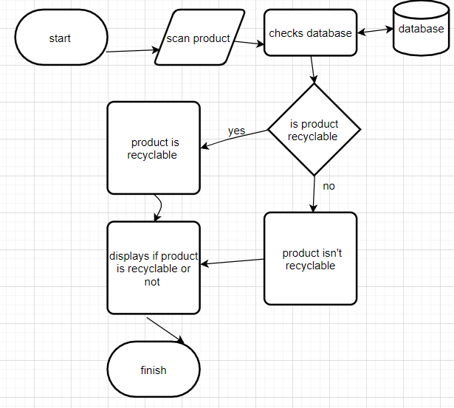
Figure 1-flow chart
The image above shows a flow chart of how the product will work by scanning the product barcode and checking with the database to check if the product is recyclable or not and displaying to the user to understand if the product if recyclable.

Time scales
Due to timescale of the project a Gantt chart was created to help guide and show timescales and how long the project should take to complete
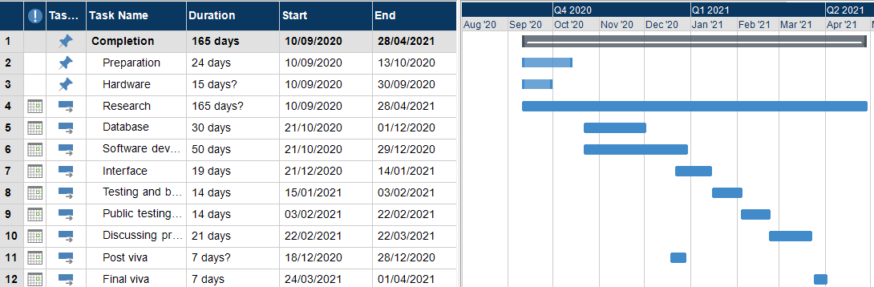Figure 2Gantt chart

The Gantt chart shows the timescale set for completion as follows:
- Completion of the whole project will take 165 days starting from 10/09/2020 and finishing on the 28/04/2021
- Preparation will take 24 days this will be used to investigate further ways and different concepts on how the project will be run and created.
- Hardware will take 15 days this will be setting up and connecting hardware together to make sure all is correct, and all hardware is functioning correctly and ready to use.
- Database this will take 30 days this is where it will be created to store data which is scanned using the barcode scanner and corresponds with the backend software.
- Software development will take 50 days this is where all the backend development to connect the interface with the database to make sure the user can receive the correct information to help with which product is recyclable.
- Interface this will take 19 days to complete this will be creating a website for the users to use the product and displaying all information about the product which has been scanned.
- Testing and Fixing will take 14 days this will be used to check and test the completed product to make sure everything created is working correctly and working smoothly for the user.
- Public testing this will take 14 days this is where it will be used by general public to help get feedback and find out any issues the user has when using the product to help refine and improve the product to make better.
- Research this will last the whole 165 days this was set to the whole-time frame due to consent research will be used to check for solutions and ways to fix problems.
- Discussing the project this will take 21 days this is where the project will be reported to discuss what was done to achieve the project and the findings from the project.
- Viva will last a week this will be where it will be explaining how the project is progressing and how the project is on track and anything which has changed with the project
- Final viva will be showing the final product created on the project and how it works and runs.
This is just a rough guide for the first Gantt chart this is likely to change due to the nature of the project problems will arise and time scales will change due to deadline not finalised. It will be looked into at the end of every month on how the project is going and making sure the project is on track and will change Gantt chart to help make this project achievable during the timescale there will also be parts of the Gantt chart which might be longer but also will be a short timescale to complete this will also help with completing the project within the timescale.
Some resources were not included in the Gantt chart due to it subject to change facilities which will be used though all hardware is easy to transport. It will be looked at to conduct most work in the electronic lab facilitated in the University of Wales Trinity Saint David for the purpose of if any parts of the hardware break or need changing they have the equipment and parts to fix or replace equipment to help with completion of the project. It was also not included meeting with mentors which will help guide and steer in completion of the project.

Resources
What will be needed to complete this project:
For hardware a Raspberry Pi or Arduino will be used to run all software along with a barcode scanner to read the product’s barcode the scanner will be a USB connected to easily connect to the Raspberry Pi or Arduino [3] [2].
An application program interface (API) will be used to get information from an Open-source database to get information about the product being scanned [4].
The database will be created using phpMyAdmin [5] or Microsoft MYSQL [6] depending on the equipment being used and the computer languages that the hardware can run. It will be taking the data which has been compared with the API and storing it to help create the database.
A website will be created for the interface it will be designed so compatible with all devices (small and large) not to compromise the usability and experience for the user this will be created with HTML(Hyper Text Mark-up Language) [7], JavaScript [8] and jQuery [9] to correspond with the API.
Backend development for the project will be programmed in either C++ [10], C# [10] or python [10] depending on which hardware will be used and which languages are capable of running.

Research
It was set that by 2020 that all household recycling would reach 50 % set by the European Union, but it is reported that in 2018 only wales has been achieving these targets reaching 54.1 % percent with Northern Ireland in second with 47.7 % England and Scotland below 45% with a combined recycling rate of 45% of recycled waste down from 45.5% in 2017 [11]. It was published in January 2020 that in Sandwell that a total of 36,187 Recycling bins were left due to recycling the wrong products. This is a staggering amount of 676 bins a week [12] refused for collection this is just a small town with a population of just 327,378. This shows the importance of recycling and that people need to do more to understand what is recyclable [1]. With the government expecting everyone to understand what is recyclable and what isn’t recyclable [13] its harder than ever to know what products are recyclable or not it should be up to the household to follow rules with recycling but it’s just not that simple [13]. The concept to change this is making it easier for consumers to understand what products recyclable and which products cannot be recycled by scanning the barcode and displaying the information for the consumer making it easier to recycle and improve the amount the consumers recycle.

There are similar concepts out on the market today. There are companies using invisible barcodes on packages that the user won’t be able to see but due to water marks the barcode scanner can make them out to help decide in landfill sorting plants which product are recyclable or not [14]. Research papers show that students in Bangkok have worked on making it easier for blind and partial sighted people to go shopping to scan products and it displays to your phone and reads out the pricing and what the name of the product to make it easier for blind people to shop [15]. There is an Artificial Intelligence(AI business which created a product using AI and visual recognition to discover on a conveyor belt to determine which products are recyclable and have a robotic arm which sorts recyclable items and leave all non-recyclable items [16]. Detecting if a product is withing date for partial sighted people this concept works on barcode scanning and checking if the product is within date to help partial sighted people not eat out of date products which could make them very ill [17].

What is hoped to be achieved?
To create a simple to use product for consumers to interact with ease a simple users-interface is essential this isn’t designed for one type of consumer it is deigned with the idea that everyone will be using this product to help improve environment and the way we recycle our waste.

Objectives
- Running an API to discover products details
- Creating a personal database to store all scanned items and check API details to make sure recyclable
- Register barcodes to recognise products
- Website to show the user if product is recyclable or not
- Backend development to connect database to barcode scanner and website
- Data mining to show when busiest times the product is used, most recycled products and how many products weren’t recycled

Is it achievable?
it is possible, it is documented that similar products and ideas are out there created for different purposes and reasons, but concepts are similar that they read barcodes. It comes down to resources and capability the knowledge is there and the determination there will be changes and limits to what is available. There are always alternative ways and techniques to make this project a success due to the time scale it might be limited to the number of products that the product will be able to register if recyclable or not.

Limitations
There are some fields needed to improve and learn before the project is started and a success with knowledge with Arduino [3] and Raspberry Pi [2] is limited there will be a lot more understanding of how they work to understand which product will be best to use for the project.
Backend development depends on what languages can be used on the hardware if python [10] is the only language available to use there will be limitations at the start of project as python programming language has never been used before but will be looked in full before project begins to get up to speed with the language.
It will also be looked at talking to recycling plants and companies in the recycling industry to help understand what the differences is with different plastics and how products are recycled to get a better understanding why products are made with same materials but aren’t all recyclable the same way.

The users

Surveys
Surveys will be used to find out better information about how much waste the public are recycling and what products they find confusing to recycle. Using the feedback and working with the feedback to deal with these products first to deal with these recycling problems. It will also be used to see how many people would use this product getting some feedback with what they would like to see with the product to help create a product people will use.

Public testing
Once product is ready for testing there will be consumer research to see how the product runs and how the users fell using the product and help testing and solving any issues and also to help get feedback with ideas that could improve the product.
The test product will also be left with the team from learning services at University of Wales Trinity Saint David to use to help see what products are recycled and to get multiple users using the product, to help with checking for bugs.
This will also help with being used and then mining the data to find out busiest times of use and what products are most recycled or not recyclable products if the weather makes a different to increase or decreases in use.

The user’s need’s
It was discussed already about making this as simple and easy to use for the user to make it an easy experience for the user because of this it will need to be looked in deeper for it to be available with all users.
Users which are colour blind might have difficulty using the product with the colour scheme of showing red for not recyclable and green for recyclable this is a same problem for people with bad eye vision so it will be looked into ways to make the experience just as easy to use for the users one way this could be rectified is by setting a voice control where the barcode is scanned the data comes back to the user with a voice instead of colour on screen this will also help with people who have difficulty reading.

Conclusion and recommendations
In conclusion the project could change the way people recycle and will help to improve the amount of recyclable waste ending up in landfills and making a significant positive impact to the environment. This project just doesn’t show what is recyclable or not, but it shows how technology is having a positive effect on our day to day lives for the better with the project showing how barcode can be read and give information to the user this can help further other ideas and help move forward other ideas to use technology to make a better impact on the environment. There is a lot to achieve to make this project a success but determination and looking forward to different ways and concepts to create this project will make it a success. For the success of the project during university summer break it will be looked into improving and learning resources and fundamentals of the software and hardware aspect to be prepared to move forward to completing the project before the deadline to help with any issues or problems which arise and have more time to look at ways to improve the project.

Bibliography

[1] | E. Brennan, “turbo future,” 7 january 2020. [Online]. Available: https://turbofuture.com/industrial/PVC-Polypropylene-and-Polyethylene-How-Plastics-are-Used-in-the-Home. [Accessed 20 march 2020].
[2] | t. p. hut, “the pi hut,” [Online]. Available: https://thepihut.com/products/raspberry-pi-4-model-b?variant=20064052674622.
[3] | arduino, “arduino,” [Online]. Available: https://www.arduino.cc/.
[4] | “omnisci,” [Online]. Available: https://www.omnisci.com/technical-glossary/open-source-database. [Accessed 19 april 2020].
[5] | p. m. admin, “php my admin,” [Online]. Available: https://www.phpmyadmin.net/. [Accessed 19 April 2020].
[6] | “my sql,” [Online]. Available: https://www.mysql.com/why-mysql/windows/. [Accessed 20 april 2020].
[7] | “developer mozilla,” [Online]. Available: https://developer.mozilla.org/en-US/docs/Web/HTML. [Accessed 20 April 2020].
[8] | “javascript,” [Online]. Available: https://www.javascript.com/. [Accessed 20 April 2020].
[9] | “jquery,” [Online]. Available: https://jquery.com/. [Accessed 21 April 2020].
[10] | “w3schools,” [Online]. Available: https://www.w3schools.com/cpp/cpp_intro.asp. [Accessed 20 April 2020].
[11] | d. f. e. f. a. &. r. affairs, “Uk Statics on waste,” 2020.
[12] | R. Guttridge, “Express and Star,” 13 january 2020. [Online]. Available: https://www.expressandstar.com/news/local-hubs/sandwell/2020/01/13/125000-recycling-bins-uncollected-in-sandwell-over-wrong-rubbish/. [Accessed 27 march 2020].
[13] | s. government, “southampton gov,” [Online]. Available: https://www.southampton.gov.uk/bins-recycling/recycling/. [Accessed 21 march 2020].
[14] | d. shaw, Director, Could 'invisible barcodes' revolutionise recycling?. [Film]. United Kingdom: bbc news , 2019.
[15] | N. Jethjarurach and Y. Limpiyakorn , “Mobile Product Barcode Reader for Thai Blinds,” bangkok, 20014.
[16] | A. Cortex, “cortex,” [Online]. Available: https://www.amprobotics.com/amp-cortex. [Accessed 1st April 2020].
[17] | E. Peng, P. Peursum and L. LI, “Product Barcode and expiry data detection,” international conference on digital image computing techniques and applications, 2012.
[18] | [Online]. Available: https://www.pinterest.co.uk/pin/595108538237442647/. [Accessed 16 march 2020].

