ASSESSMENT 2



Student name: Awinnie Ferreira
Student ID: 1905625
Module name: Mental Disorders and Psychopathology
Module Code: BMHP6006
Lecturer Name: Bianca Sanfilippo
Date: 5/01/2022

CONTENT

- Introduction
- General Anxiety Disorder
- Schizophrenia
- Autism
- Conclusion
- References
- Appendix

INTRODUCTION
The aim of this report is to analyse 3 mental health disorders that can be found on the ICD-10 manual (WHO,2010). The disorders that will be examined are general anxiety disorder, schizophrenia and autism. The report will be supported by different literature sources. Each disorder will include a definition, causes, signs and symptoms, when can the disorder be diagnosed, current treatments and measurements of rehabilitation. Is important to have a knowledge of these disorders. Many people that currently live in England suffer from mental health problems, not everyone understand the concept of having a mental health disorder. Is important to seek for help which can help the patient treat the disorder.
GENERAL ANXIETY DISORDER
According to the NHS (2021), general anxiety disorder is when someone feels worried or scared, it can be mild or severe. Many people go through anxiety in their life. Having anxiety can impact your everyday life. Feeling stressed, worried are common symptoms of this mental health disorder. Having different issues is what makes someone have anxiety, it can be extreme sometimes. The person never knows when will the anxiety go away because there is always a new issue that makes the anxiety get worst. General anxiety disorder is classified in the ICD-10 manual within ‘F40-F48 Neurotic, stress related and somatoform disorders’, general anxiety disorder is under F41.1. The ICD-10 manual is where all the diseases and related health problems are classified (WHO,2010).
PEOPLE SUFFERING GENERAL ANXIETY DISORDER IN THE UK
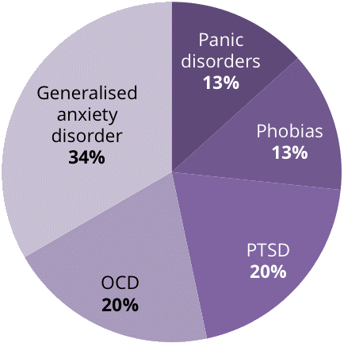
Source: mentalhealth.org.uk

Anxiety disorders affect around 8 million people in the United Kingdom, making it one of the most frequent psychiatric disorders in the world. Anxiety is a fear that is frequently triggered by the prospect of a threat or something going wrong in the future, it can also be triggered by something that is occurring right now. In 2013, 8.2 million people in the UK suffered from anxiety. Anxiety problems affect about twice as many women in England as they do men. The mental health foundation offers ‘Be mindful’ online, an online mindfulness course. According to research conducted on the online course in 2013, the 273 persons who completed it had a 58 percent decrease in anxiety levels on average.
CAUSES OF ANXIETY
Although the specific cause of anxiety is unknown, most patients causes are multifaceted, with the following contributing factors which are genetic predisposition, psychological, personality types, trauma, drugs, co-existing mental health problems and medical conditions. If you have an anxious parent, the chances are even higher to get anxiety. Anxiety disorders are more likely to develop in people who are busy and have type A personalities. Abuse, life-threatening occurrences, and bullying are all examples of situations that can lead to anxiety. Large doses of drugs may increase the risk of developing anxiety. Anxiety is more common when there are coexisting mental health issues such as depression. Other medical diseases can all cause anxiety feelings.
SIGNS AND SYMPTOMS
General anxiety disorder can have both physical and mental consequences. Some people only experience one or two symptoms, while others have numerous. If anxiety is interfering with your daily life or giving you suffering, you should seek medical help. General anxiety disorder can alter your behaviour as well as how feel can result in symptoms such as restlessness, difficulty concentrating, irritability. General anxiety disorder includes several physical symptoms which are muscle aches and tension, dry mouth, excessive sweating, stomach-ache, difficulty falling or staying asleep, being tired (NHS,2021). People tend to feel anxious when they continuously thinking about something that worries them deeply. People that experience these symptoms do not think much of it, do not seek for medical help.
WHEN ANXIETY CAN BE DIAGNOSED
Is important to take into consideration the signs someone has when having anxiety. If anxiety is interfering with your daily life or giving you suffering, it is important to consult a doctor. They will be able to identify the disease based on the symptoms the person has which may include restlessness or agitation. Anxiety becomes severe when someone starts having problems on their daily life which affects the way they concentrate, at school or university or even at work. Having panic attacks, not being able to be somewhere because you feel scared, having repetitive behaviours. As soon as these signs start showing up is important to seek for help.

CURRENT TREATMENT
When someone gets diagnosed with general anxiety disorder, the doctor will advise you to try psychological treatment before start taking medication. Cognitive behavioural therapy is the most effective treatment when it comes to treat general anxiety disorder. The person that has this disorder will meet with a therapist every week for an hour for 3 to 4 months. If meeting a therapist does not work the person that suffers with general anxiety disorder are offered medication. Some of the medication prescribed by the doctor can be taken on a short-term basis, while other medication needs to be taken for longer periods. Is important for the doctor to know if the medication is making any side effects so the doctor can prescribe another medication or change the dose.
MEASUREMENTS OF REHABILITATION
If the treatment for general anxiety disorder is not effective, one of the measurements that can be used is the ‘Generalised anxiety disorder questionnaire (GAD-7). This generalised anxiety assessment is a seven-item questionnaire designed to determine the severity of general anxiety disorder. Each question asks the person to rate the severity of their symptoms during the previous two weeks. There is another tool that can be used that measures a patient’s anxiety, an experienced clinician should administer this tool. This tool should only be used when the anxiety is severe. GAD-7 in the other side helps patients know what type of anxiety they have and what type of treatment they can have, based on the answers from the questionnaire.
SCHIZOPHRENIA
Schizophrenia is a serious long-term mental illness (NHS,2021), it results in a variety of psychological problems. Schizophrenia is frequently referred to as a form of psychosis by doctors. This implies that the person may not always be able to tell the difference between their own thoughts and ideas and reality. It has an impact on how you think and deal with daily life. Hallucinations, delusions, disorganised thinking, and a lack of interest for daily activities are common symptoms of schizophrenia. Schizophrenia is classified in the ICD-10 manual within ‘F20-F29 Schizophrenia, schizotypal and delusional disorders’, schizophrenia is under F20 (WHO,2010). Schizophrenia patients are 2-3 times more likely than the normal population to die young. This is frequently linked to preventable physical ailments such as cardiovascular disease, metabolic disorders, and infections.

PEOPLE SUFFERING SCHIZOPHRENIA IN THE UK
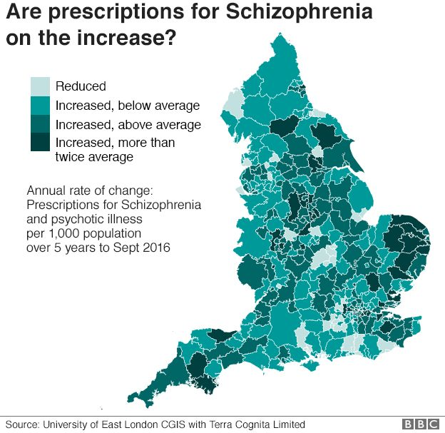
Source: University of East London CGIS with Terra Cognita Limited

In the United Kingdom, around one in every six people will require mental health therapy at some point in their lives. One out of every 100 people will experience a psychotic episode at some point in their lives. Schizophrenia is a serious mental condition that affects many people. In the United Kingdom, the NHS treats around 220,000 people with this condition at any given time. Schizophrenia is a life-threatening disease. People that suffer from this condition have a 5 to 10% likelihood of killing themselves within ten years of diagnosis.
CAUSES OF SCHIZOPHRENIA
Schizophrenia is yet to be identified. However, most experts feel that a combination of hereditary and environmental factors is to blame for the illness. Some people are thought to be more prone to developing schizophrenia, and circumstances, such as a stressful life event or drug abuse, might set the disorder off. There is not a single factor that has been established through research, schizophrenia is thought to be caused by a combination of genes and a variety of environmental circumstances. Psychosocial variables may potentially play a role in the development of schizophrenia (WHO,2019). Is important to seek for medical help if the symptoms become severe and affect your daily life.

SIGNS AND SYMPTOMS
Schizophrenia manifests itself in the following ways, hearing or seeing things that do not exist outside of the mind are referred to as hallucinations; delusions, irrational views based on hallucinations or delusions confused ideas based on hallucinations or delusions; loss of interest in daily activities, avoid contact with others, particularly friends. Schizophrenia does not make someone violent, nor does it generate a split personality. Fixed incorrect ideas or suspicions persisted despite evidence showing the opposite (WHO,2019). Schizophrenia can include a wide range of experiences and behaviours. They can appear out of nowhere or develop steadily over time. Everyone’s experience is distinct. A doctor will give you a diagnosis based on the signs and symptoms the patient is experiencing.
WHEN SCHIZOPHRENIA CAN BE DIAGNOSED
If a patient thinks they could be suffering from schizophrenia, they should consult a doctor as soon as possible. The sooner schizophrenia is diagnosed and treated, the better. There is no one-size-fits-all test for schizophrenia. It is usually diagnosed when a mental health expert, such as a psychiatrist, examines you. It is uncommon before the age of 15, but it can begin at any age after that, with many cases occurring between the ages of 15 and 35. After a thorough psychiatric evaluation, only a psychiatrist may provide a diagnosis. Several diseases share the characteristics of schizophrenia. It may be difficult to make an accurate diagnosis as a result of this.
CURRENT TREATMENT
Schizophrenia is typically treated with a mix of medication and therapy that is tailored to the patient’s needs. Antipsychotic medications and cognitive behavioural therapy will be used in most cases. A community mental health team usually assists people with schizophrenia daily, providing care and therapy. Many people recover from schizophrenia; however, they may experience relapses at times. Support and treatment can assist to lessen the effects of the illness on daily living. It is feasible to lower the risk of severe relapses if schizophrenia is effectively controlled, this can include things like recognising the symptoms of an acute episode, taking medication as directed, and talking to others about the problem. There are numerous organisations and support groups that provide information and support to those living with schizophrenia. Most people find it reassuring to chat to others who are in a similar situation.
MEASUREMENTS OF REHABILITATION
With this illness, we can only assess the quality of care and therapies provided in order o successfully control and manage the condition and avoid complications like self-harm and suicide, substance abuse, neglect and self-neglect, lack of dignity, and human rights violations. The variables used to assess long-term mental problems can also be used to assess quality of life. ‘Quality indicator for rehabilitative care (QuIRC-SA)’ is an acronym for ‘Quality Indicator for Rehabilitative Care’. This tool has precise indicators that demonstrate that effective and high-quality care is being provided to manage the condition. Schizophrenia is a long-term illness, so it is critical to help service users maintain a high quality of life. This can be measured using rehabilitative treatment indicators that apply to all long-term mental health problems. Supported housing is divided into three categories. Residential care homes are often communal facilities that are staffed 24 hours a day and offer food, medication management, and occasionally personal care. Supported housing is available in shared or individual tenancies, with on-site support available up to 24 hours a day. Staff from floating outreach programmes are based off-site and visit clients in their own tenancies many times per week. People suffering from complex psychosis and other serious mental health diseases sometimes have a high level of need, with numerous issues impeding their rehabilitation and recovery. It has long been expected that improved rehabilitation services, as evidenced by the availability of effective therapies and a positive service user experience, will result in better results for service users.
AUTISM
Autism is a long-term developmental condition that impacts people’s capacity to communicate and engage with others. Being autistic does not imply that you have a disease or illness. It signifies that your brain functions differently from other people’s. It is either something you are born with or something that shows up when you are young. If someone is autistic, they will have the condition for the rest of their life. Autism is not a medical illness that can be treated or cured. However, some people require assistance with specific tasks. Being autistic does not have to prevent anyone from living a fulfilling life. Individuals that have autism, like everyone else, have things they excel at and things they struggle with. Being autistic does not rule out the possibility of making friends, forming relationships, or finding work. However, you may require additional assistance with these matters. Autism is classified in the ICD-10 manual within ‘F80-F89 disorders of psychological development’ (WHO,2010).
PEOPLE SUFFERING AUTISM IN THE UK

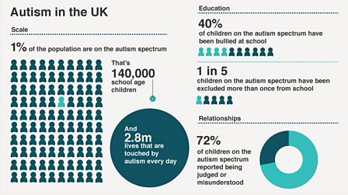
Source: National autistic society 2016
Autism is thought to affect roughly 700,000 individuals in the United Kingdom. Autism spectrum disorder affects one in every 100 children in the United Kingdom. Every person with autism is unique, some autistic people require little to no assistance. Others may require daily assistance from a parent or caregiver.
CAUSES OF AUTISM
Nobody knows what causes autism, or even whether it does. It has the potential to afflict members of the same family. As a result, it is possible that it will be passed down to a child by their parents. Autism is not brought on by vaccines or an infection that can spread to others. Autism may be inherited, according to evidence. For several years, scientists have been trying to figure out which genes are linked to autism. Rather than a single gene, autism is believed to be caused by a combination of genes. It is not, however, due to emotional deprivation or upbringing. Vaccines do not cause autism. Over the years, a great deal of research has been done on this topic, with the conclusions concluding that there is no link. Some autistic people are intelligent or better than average. A learning problem affects certain autistic individuals. As a result, individuals may struggle to care for themselves and require assistance with daily tasks (National Autistic Society,2021)
SIGNS AND SYMPTOMS OF AUTISM
Adults with autism are likely to have the following symptoms, having difficulty comprehending what others are thinking or experiencing , finding it difficult to establish friendships or rather be alone without meaning to, not understanding when other individuals are being sarcastic, having the same daily pattern and becoming nervous if it varies. Women and men with autism can have different symptoms. Autistic women may hide their emotions and appear to handle social settings better. As a result, if you are a woman, it may be more difficult to detect your autism. Autism symptoms in young children include avoiding eye contact and not answering to their name, they do not smile back. They do not talk as much as other children and repeat the same phrases.
WHEN AUTISM CAN BE DIAGNOSED
Is important to seek for help if someone or their child have symptoms of autism. You may want to contact, a general practitioner, a health visitor for children under the age of five. Specialists in autism conduct an evaluation. It is the only way to determine whether you or your child has autism. An autism assessment is a procedure in which a group of autism specialists determines whether you or your child is autistic. A group of experts could inquire about any issues you or your child are having and keep an eye on how you or your child interacts with others. Consult others who are familiar with you or your child, for example, your doctor. A report will be given at the end of the evaluation that will tell you if you or your child is autistic. Getting an autism evaluation is not always simple. It can take longer than usual. If the patient is having trouble getting an assessment, they can request to meet with someone else such as another general practitioner, this is known as obtaining a second opinion. It may also be beneficial to speak with others who have experienced a similar circumstance. (NHS,2019)
CURRENT TREATMENT
Autism is a lifelong disorder that cannot be cured at this time. Autism, on the other hand, can be treated, and with the correct early intervention, most children’s quality of life improves significantly. Following and autism diagnosis, it is critical that therapies begin as soon as possible. Because autism is a lifelong impairment, early intervention can help an individual maximise their abilities and reach their full potential as adults. Although there is no single treatment for autism, adequate therapies such as speech and language, physiotherapy and behavioural management tactics can all help people with autism. Medication may be prescribed for someone with autism to assist control seizures or depression, for example. It is critical that the caregivers are trained on behavioural tactics and any therapeutic procedures so that they can support the interventions at home.
MEASUREMENTS OF REHABILITATION
The ‘Childhood Autism Rating Scale (CARS)’ is a diagnostic evaluation approach a composite score ranging from non-autistic to mildly autistic, or severely autistic to people on a scale ranging from normal to severe. Number 1 indicates that your child is typical for his or her age, number 2 indicates that your child is somewhat abnormal, number 3 indicates that your child is substantially abnormal, and number 4 indicates that your child is severely abnormal. The range of scores is fifteen to sixty, with number thirty indicating a diagnosis of mild autism. Values of thirty to thirty-seven suggest mild to moderate autism, and scores of thirty-eight to sixty indicate severe autism. The measure was created to distinguish children with autism from those who have other developmental disabilities.
CONCLUSION
In conclusion, this report has discussed three different conditions that are all part of the ICD-10 manual chapter 5. Is important to treat everyone in a person-centred approach. A person-centred approach places the person at the centre of the service and treats them as such. The focus is on the individual and what they can accomplish, rather than their illness or impairment. Support should be adapted to the person’s requirements and circumstances in order to help them achieve their goals. People are legally protected from discrimination in the workplace and in society under the Equality Act of 2010. It outlines the various ways in which it is illegal to treat someone.

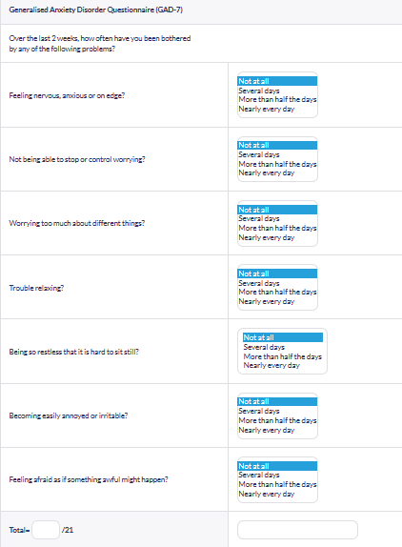
APPENDIX

This is a 7-item questionnaire that assess the severity of someone that has anxiety. Is usually use for two weeks.
REFERENCES
- NHS (2021), Generalised anxiety disorder in adults. (online). Available at: https://www.nhs.uk/mental-health/conditions/generalised-anxiety-disorder/overview/ (Accessed 3 January 2022)
- World Health Organisation, WHO (2010), ICD-10 VERSION. (online). Available at: https://icd.who.int/browse10/2010/en (Accessed 3 January 2022)
- Clinical Partners (2021), What is anxiety? (online). Available at: https://www.clinical-partners.co.uk/for-adults/anxiety-disorders/what-causes-anxiety (Accessed 3 January 2022)
- NHS (2021) Symptoms- generalised anxiety disorder. (online). Available at: https://www.nhs.uk/mental-health/conditions/generalised-anxiety-disorder/symptoms/ (Accessed 3 January 2022)
- NHS (2021) Treatment- generalised anxiety disorder. (online). Available at: https://www.nhs.uk/mental-health/conditions/generalised-anxiety-disorder/treatment/ (Accessed 3 January 2022)
- NHS (2019) Schizophrenia. (online). Available at: https://www.nhs.uk/mental-health/conditions/schizophrenia/overview/ (Accessed 3 January 2022)
- World Health Organisation, WHO (2019) Schizophrenia (online). Available at: https://www.who.int/news-room/fact-sheets/detail/schizophrenia (Accessed 3 January 2022)
- National autistic society (2022) What is autism? (online). Available at: https://www.autism.org.uk/advice-and-guidance/what-is-autism (Accessed 3 January 2022)
- NHS (2019) Autism and everyday life (online). Available at: https://www.nhs.uk/conditions/autism/autism-and-everyday-life/ ( Accessed 3 January 2022)
- ASDClinic (2022) How is autism treated? (online). Available at: https://www.asdclinic.co.uk/conditions/autism/how-is-autism-treated.php (Accessed 3 January 2022)
- NICE (2021) Psychosis and Schizophrenia in adults (online). Available at: https://www.nice.org.uk/guidance/cg178/evidence/full-guideline-490503565 (Accessed 3 January 2022)
- NICE (2021) Autism spectrum disorder in under 19s: support and management (online). Available at: https://www.nice.org.uk/guidance/cg170 (Accessed 3 January 2022)
- Legislation.Gov. UK (2010) Equality Act 2010 (online). Available at: https://www.legislation.gov.uk/ukpga/2010/15/contents (Accessed 3 January 2022)

