Luke Andersen (1603319)

BEng Electrical and Electronic Engineering

Power Electronics and Drives
ACDA6004
Power Factor Correction and Variable Frequency Drives

Contents
1. Abstract 4
2. Introduction 4
2.2 Power Factor Correction 4
2.2.1 Power Factor Formula 5
2.3 Motor Drives 5
2.4 Three Phase Inverters 5
2.4.1 Working Principle of a Three Phase Inverter 6
2.5 Variable Frequency Drives 6
3. Method 7
3.1 Power Factor Correction 7
3.1.1 Phase Angle 8
3.1.2 Current Amplitude 9
3.1.3 Testing 9
3.1.4 Power Factor 9
3.1.5 Power Supplied 10
3.1.6 Fault Detection 10
3.2 Pulse Width Modulation 12
3.2.1 Three Phase Inverter 13
3.2.2 Over-Current Protection 14
4. Results 15
4.1 Power Factor Correction 15
4.1.1 No PFC 15
4.1.2 PFC C2 16
4.1.3 PFC C2+C3 17
4.1.4 PFC C2+C4 18
4.2 Power Factor 19
4.3 Fault Code A 20
4.3.1 No PFC 20
4.3.2 PFC C2 20
4.3.3 PFC C2+C3 21
4.3.4 PFC C2+C4 21
4.3.5 PFC C3 22
4.3.6 C3+C4 23
4.4 Three Phase Inverter 24
4.5 Over-Current Protection 25
4.6 Single Phase Synchronous Motor 25
4.7 Fault Code B 25
5. Discussion 26
5.1 Power Factor Correction 26
5.1.1 Fault Code A 26
5.2 Over-Current Protection 26
5.2.1 Fault Code B 26
6. Conclusion 27
References 27

Figure 1 Power Factor Triangle [2] 4
Figure 2 Three Phase Inverter [6] 6
Figure 3 Variable Frequency Drive and Motor [7] 7
Figure 4 Circuit 1 7
Figure 5 Oscilloscope 8
Figure 6 Oscilliscope 2 10
Figure 7 Circuit 2 11
Figure 8 Waveform 12
Figure 9 Circuit 3 12
Figure 10 Sine Wave 13
Figure 11 Circuit 4 14
Figure 12 No PFC 15
Figure 13 PFC C2+C3 17
Figure 14 PFC C2+C4 18
Figure 15 Positive half cycle 24
Figure 16 Negative half cycle 24
Figure 17 Multimeter 1 25

Table 1 9
Table 2 11
Table 3 15
Table 4 23

Abstract
This report will investigate the effects of Power Factor Correction and will look further into its implementation within a single phase AC motor circuit. Tools from the programme LJ Create will be used to analyse various waveforms, read voltages and currents. Factoring in different levels of capacitor correction, these will be recorded, calculated and analysed to find an optimal power factor correction capacitor per circuit.
The second part of the report will investigate pulse width modulation and how the input DC supply is manipulated via the output pulses of a microcontroller. Over-current protection of a three phase supply will be analysed as a short circuit fault will be implemented into circuitry.

Introduction

2.2 Power Factor Correction
Power Factor is the ratio between the useful power (kW) to the total apparent power (kVA). It is a measure of how efficiently electrical power is converted into useful work output. [1] When the power factor has been calculated, any thing less than 1.0 means that extra power is required to achieve the task at hand.
Active Power (P) = the power needed for useful work, such as powering a motor or providing light. It is expressed in watts (W) or Kilowatt (kW).
Reactive Power (Q) = a measure of the stored energy reflected to the source which does not do any useful work. Expressed in Var or Kilovar (kVAR).
Apparent Power (S) = the vector sum of active and reactive power. Expressed in Volt Amperes or KiloVolt Amperes (kVA). [2]
The Power Factor triangle is shown below in Figure 1.
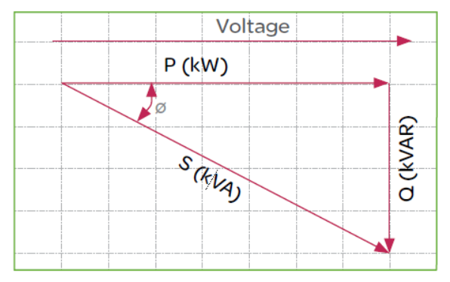
Figure 1 Power Factor Triangle [2]
A typical uncorrected electrical load will operate in the region of 0.80 power factor, meaning it would consume 20% more power. It will also result in an increased demand by 20% resulting in higher energy bills. Electricity suppliers will penalise for low power factors. [3]

2.2.1 Power Factor Formula
The power factor formula is shown below:-
$$Pf=\frac{P}{S}= \frac{Active Power (kW)}{Apparent Power (kVA)}$$

The phase angle between activate power and apparent power can be calculated using the formula:-
$${Cos}^{-1}\left(Power Factor\right)$$

Active Power can be calculated using Apparent Power and Cos Phase Angle, as shown below.
$$Q=P x Cos(ϕ)$$

2.3 Motor Drives
Motor drives are electronic devices that have the ability to control position outputs, torque and motor speed. Power enters the motor and the drive modifies it so that the motor has the required output. Motor drives and motor controllers are frequently used interchangeably as controller circuits are usually combined with drive circuits to create a single unit. [4]
Listed below are several types of motor devices:-
- DC Drive
- AC Drive
- Servo Motor
- Stepper

2.4 Three Phase Inverters
An inverter is an electronic device which can convert power in DC form to AC form, at the required frequency and voltage output. Inverters are classified into two main categories:-
- Voltage Source Inverter (VSI)
- Current Source Inverter (CSI)
The VSI has stiff DC source voltage that is the DC voltage has a limited or zero impedance at the inverter input terminals. The CSI is supplied with a variable current from a DC source that has a high impedance. [5]

2.4.1 Working Principle of a Three Phase Inverter
A three phase inverter can convert a DC input into a three phase AC output via pulse width modulation technology. Three phase inverters are typically used in high power and variable frequency drive applications. The working principle of a three phase inverter consists of three inverter switches with a single phase. Each switch can be connected to the load terminal, and can be synchronized to the operation of the basic control system. A switch works to create a ‘line to line’ output waveform. This includes six steps, at every 60 degrees of the basic output waveform. The wave involves a zero voltage stage between two sections, like positive and negative of a square wave. Once the pulse width modulation technology is applied to this wave, the original shape of the wave can then be taken in order for the third harmonic and its multiplication will be cancelled. [6]
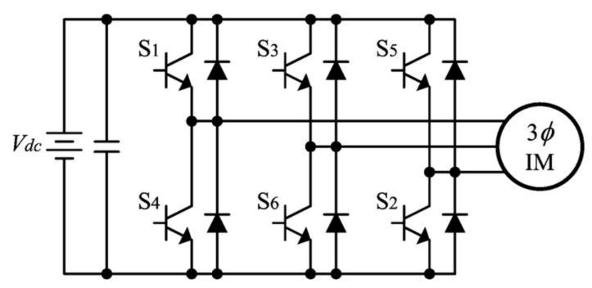
Figure 2 Three Phase Inverter [6]

2.5 Variable Frequency Drives
A variable frequency drive (VFD) is a type of motor controller that drives an electrical motor by varying the frequency and voltage of its power supply. Variable frequency drives have the ability to control ramp up and ramp down of the motor during start or stop.
Variable frequency drives control the frequency and power to the supplied motor, this is referred to as speed control, since it is the adjustment of motor speed. In today’s market, variable frequency drives integrate networking and diagnostic capabilities to better control performance and increase productivity. [7]
The most common uses of a variable frequency drive are for:-
- Control of fans
- Control of pumps
- Control of compressors
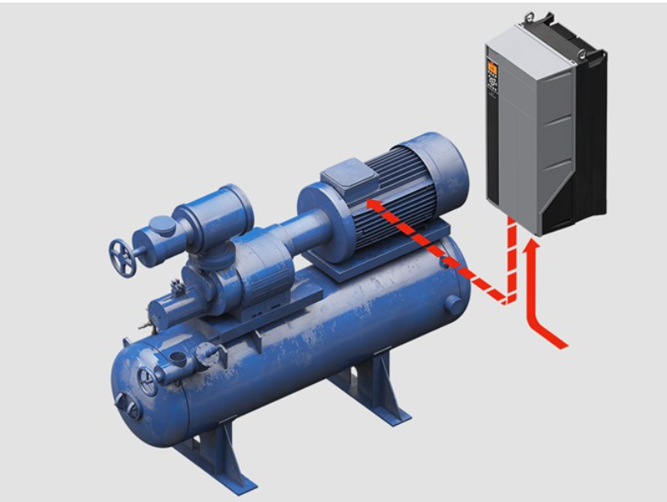
Figure 3 Variable Frequency Drive and Motor [7]

Method
This chapter will describe the steps taken throughout this project. The chapter will be broken down into two sub-sections where the method for identifying the best power factor correction and the investigation of pulse width modulation within variable frequency drives will be described.

3.1 Power Factor Correction
The software used for this part of the project was LJ Create, within LJ Create the power supply unit, multimeter 1 and the oscilloscope were opened ready for operation. Once opened, the following inductive circuit was created as shown in Figure 4.
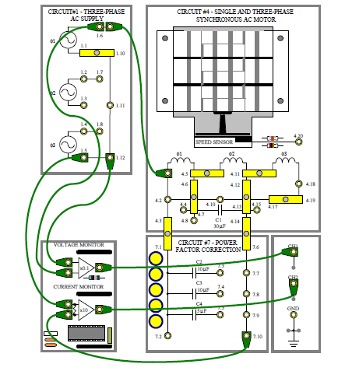
Figure 4 Circuit 1
As the circuit shown in Figure 4 was successfully set up, it was then time to follow the instructions given in Task 1, to activate the circuit and set up the oscilloscope in the correct way. The power supply must be switched on in order to continue. Via the frequency control, the inductive reactance of the motor windings can be increased or decreased.
Within the circuit, capacitors were going to be added to reduce the reactive power. By reducing reactive power this would increase the power factor. Before the addition of any capacitors within the power factor correction part of the circuit, as shown in Figure 4, I would have to record my phase angle and current amplitude. The reason I had to take this reading was to allow myself to have a base reading to compare my results to.

3.1.1 Phase Angle
The formula used to calculate the phase angle (ϕ) is as follows:-
ϕ = (Δt / T) x 360
Δt = Time Delay
T = Period of waveform
In order to gather data for the time delay, the oscilloscope was used to read the peaks of the waveforms. The white line is the waveform of the Voltage and the yellow line is that of the Current. To read the two peaks, two points of focus were selected by myself using the left and right buttons on the mouse as shown in Figure 5. The times of X1 and X2 can be rearranged into the calculation X2 – X1 to equal the time delay (Δt) which is in milliseconds. As shown in Figure 2 the time delay (Δt) can also be seen as DX, which is the calculation of X2 – X1.
The period of the waveform (T) is based on the setup of the oscilloscope which was adjusted at the beginning of the task. The time control was attuned for a half cycle to cover 9 divisions on the oscilloscope.
Once the values for the time delay (Δt) and period of the waveform (T) have been recorded, the time delay is then divided by the period of the waveform, and then multiplied by 360 to calculate the phase angle (ϕ).
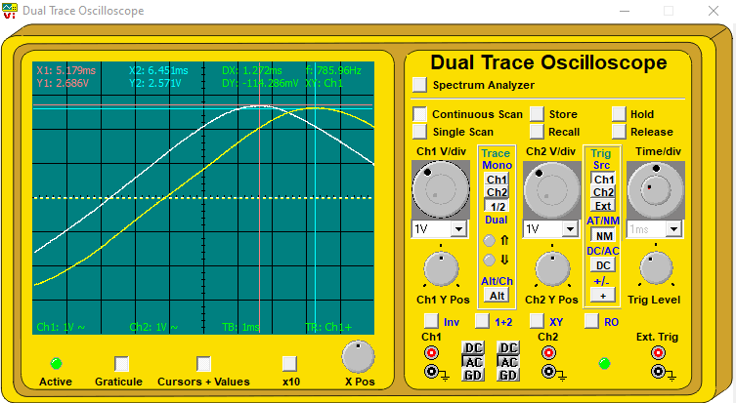
Figure 5 Oscilloscope

3.1.2 Current Amplitude
The formula used to calculate the current amplitude is as follows:-
mA p-p (2 x Peak x 1000) / 10
This formula was used to convert the display of the half cycle which is in volts, to a current in mA. The Peak is replicated as Y2 on the oscilloscope, as shown in Figure 2.

3.1.3 Testing
Using both formulas for the phase angle and the current amplitude, I completed the column highlighted yellow as shown in Table 1. This was to gain the base values of both the phase angle and current amplitude of the system.
Correction Capacitor | None | C2-10uF | C2+C3-20uF | C2+C4-15uF
Phase Angle (Lead/Lag) | Lead/lag ° | Lead/lag ° | Lead/lag ° | Lead/lag °
Current Amplitude | mA p-p | mA p-p | mA p-p | mA p-p
Table 1
Once the base value of the phase angle and current amplitude were recorded, it was time for the addition of the correction capacitors. The capacitors would be added to the circuit via shorting links, C2 would be connected between 7.3 and 7.7, C3 would be connected between 7.4 and 7.8, and C4 would be connected between 7.5 and 7.9.
The values of the capacitors are listed in Table1, C2 is equal to 10μF,C3 is equal to 10μF and C4 is equal to 5μF, these are highlighted in green and have been added in combinations labelled C2, C2+C3 and C2+C4. The calculations for the phase angle and current amplitude would be repeated for each correction capacitor combination, and were recorded within Table 1.
Once the calculations for the phase angle and current amplitude were repeated for all capacitors, it would be clear to see the value of the shunt capacitance which would give the nearest complete phase angle.

3.1.4 Power Factor
The formula used to calculate Power Factor is as follows:-
Power Factor = Cosϕ
ϕ = phase angle
The formula of power factor is used to express energy efficiency. This formula was used to calculate the power factor for the circuit shown in Figure 4, with no correction capacitor and also with the best correction capacitor. If possible the power factor should be 1.0, if not, the result should be as close to 1.0 as possible, as this signifies how good the power factor of the circuit is.
The supply voltage was also taken by referencing the voltage display on the oscilloscope as shown in figure 6. The voltage was measured from peak to peak and the result of that is labelled as DY, as shown in figure 6.
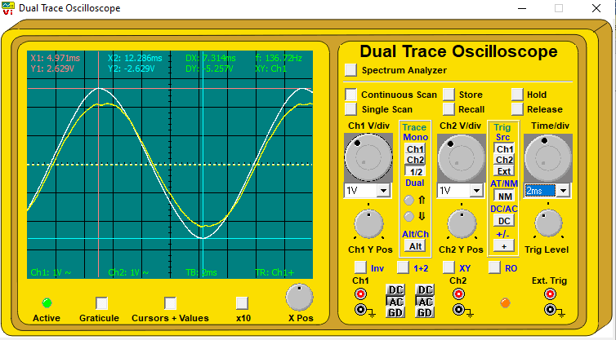
Figure 6 Oscilliscope 2

3.1.5 Power Supplied
The formula used to calculate power supplied with no correction capacitor is as follows:-
$$P=\frac{V}{2\sqrt{2}}×\frac{I}{2\sqrt{2}}=\frac{V×I}{8}$$
This formula is used as both the voltage and current are measured from the oscilloscope. The reason as to why $2\sqrt{2}$ is used in the formula is to convert to RMS.
The voltage used in this formula is the voltage from 3.1.4 where DY was multiplied by 10. The current used is the current amplitude from table 1, where there were no correction capacitors added.
The same formula was used to calculate the power supplied with the best correction capacitor in the circuit.

3.1.6 Fault Detection
Two faults were separately introduced into the circuit, the faults were inserted in order to use investigational skills and to gain a greater knowledge of the circuitry and it’s components.

3.1.6.1 Fault Code A
Fault Code A was introduced into the circuit to deduce which component has become faulty. To detect Fault Code A the initial calculations and table 1 will need to be revised. By looking at the oscilloscope it will be clear to see that the circuit has changed. Table 1 will be used again to calculate the new phase angle and current amplitude of the circuit, using the same process as before in chapter 3.1.3.
After taking the new base value reading for the phase angle and current amplitude, it was evident that the values differ, due to Fault Code A being inserted. In order to find out which component has now become faulty table1, will have to be expanded as shown in table 2.

Correction Capacitor | None | C2-10uF | C2+C3-20uF | C2+C4-15uF | C3-10uF | C3+C4-15uF
Phase Angle (Lead/Lag)
Current Amplitude
Table 2
Once the results have been recorded for each correction capacitor, it will be clearly evident which component has become faulty under Fault Code A.

3.1.6.2 Fault Code B
Fault Code B introduces a different type of fault in comparison to Fault Code A. Before introducing the fault, the circuit needs to be set up as it is shown in figure 7. The link between 4.3 and 7.1 is removed if compared to circuit 1. This link is the connection to the power factor correction sector of the circuit.
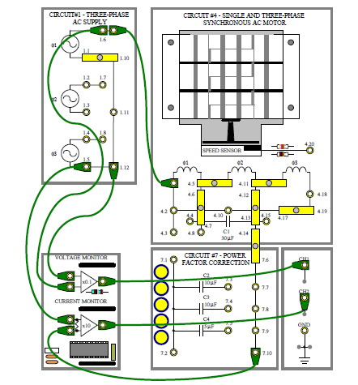
Figure 7 Circuit 2

After removing the power factor correction link, VR1 and VR2 are set to maximum to give a single phase supply at maximum frequency. The power module is then switched on and the following waveforms are present on the oscilloscope as shown in figure 8.
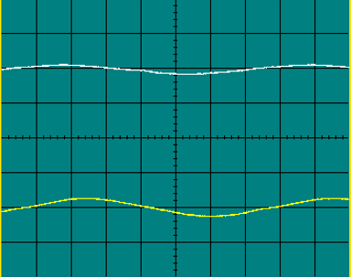
Figure 8 Waveform
The power factor correction sector of the circuit was now needed to be applied and the link between 4.3 and 7.1 was re-added. Fault Code B was also introduced and it made the motor come to a halt and stop working. To deduce the fault condition different areas of the circuit were to be probed using the multimeter to investigate whether the voltage or current have changed.

3.2 Pulse Width Modulation
The software used for this part of the project was LJ Create, within LJ Create the power supply unit, multimeter 1 and the oscilloscope were opened ready for operation. Once opened, the following circuit was created as shown in Figure 9.
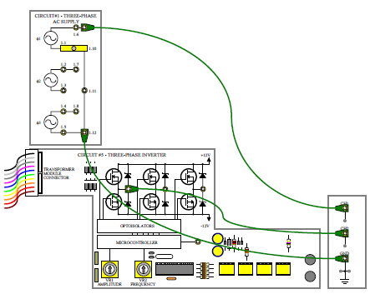
Figure 9 Circuit 3

3.2.1 Three Phase Inverter
Once the oscilloscope and the circuit shown in Figure 1 were successfully set up, VR1 was set to position 3 and the VR2 frequency control was adjusted for one cycle of output on CH.1. The way in which the oscilloscope was set up this time around, was to be able to be to see each individual output pulse from the microcontroller. Once followed correctly the oscilloscope will now show pulse width modulation and a resultant sine wave.
Figure 10 shows an approximation to the generation of one sine wave. The pulses are integrated to give a sine wave output and as shown in figure 2 the ripple is smoothed.
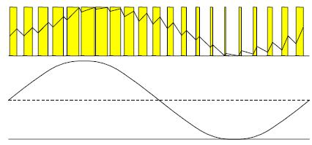
Figure 10 Sine Wave
By using the MOSFET amplifiers on CH.2, the individual pules from the microcontroller were visible. Also, changing the time base speed to 1ms/div, the positive half cycle of the sine wave will become visible on the oscilloscope, this was done to investigate how the positive peak of the sine wave and microcontroller pulses’ behave. In order to get a negative half cycle sine wave, the triggering on the oscilloscope was changed to negative, this was done to investigate the number of positive pulse in one half cycle. Once both positive and negative sine waves were visible, the CH.1 Y-amplifier setting was increased to 10V/div to investigate if the sine wave would have any ripple.

3.2.2 Over-Current Protection
The three phase supply generator has a two stage over-current protection built in. This is to prevent damage to it in the event of a short circuit. The circuit in question is connected up as shown in figure 11.
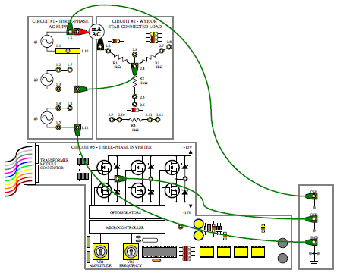
Figure 11 Circuit 4
The Multimeter 1 was connected to the 200mA AC range whilst the circuits amplitude control VR1 is set to maximum and the frequency control VR2 is set to maximum, to give a single phase supply at maximum frequency. Once the oscilloscope was set up accordingly, the power module was turned on and the value of current flowing was recorded in mA AC.
Once the value of current flowing was recorded, a short circuit was placed across the load with a connecting lead between sockets 2.2 and 2.3. When the connecting lead has been inserted the effect on the current, the voltage and the microcontroller pulses were to be observed, and the value of the current in mA was recorded. This had to be done immediately as the short was only allowed to remain for two minutes.
Once the short was removed, the voltage and current were observed to see if they would change. After observing the voltage and current, the power module was turned off and then switched back on immediately. This was done to observe the power supply, to see if it was allowed to return to normal.
The module supplies were then switched off and left for five minutes, then switched back on. The power supply was then observed once more.

Results
This chapter will compare and contrast my results throughout the project. The chapter will be split into two sub-sections, where my findings from identifying the best power factor correction and the investigation of pulse width modulation within variable frequency drives will be described.

4.1 Power Factor Correction
Table 3 was used to record all results for power factor correction. It contains all phase angles and current amplitudes for the relevant correction capacitors. Throughout chapter 4.2 the formulas and calculations behind these results will be proven and discussed accordingly.
Correction Capacitor | None | C2-10uF | C2+C3-20uF | C2+C4-15uF
Phase Angle (Lead/Lag) | 50.88 lag | 18.72 lag | 44.64 lead | 21.44 lead
Current Amplitude | 514.2 mA | 422.8 mA | 485.8 mA | 440 mA
Table 3

4.1.1 No PFC
As shown in figure 12 this is the reading from the oscilloscope which contains the base value of the circuit and does not contain any power factor correction capacitors.
Figure 12 No PFC
The formula to calculate the base value phase angel is as follows:-
X1 = 5.179ms, X2 = 6.451ms
X2 – X1 = 1.272ms
Dx = 1.272ms
T = 9
$$ϕ = \left(\frac{Δt}{T}\right) x 360$$
$$ϕ=\left(\frac{1.272}{9}\right)x 360=50.88°$$
As the phase angle is positive, this means it is lagging behind the voltage by 50.88 degrees.

The formula to calculate the base value current amplitude is as follows:-
Y2 = 2.571V
$$Current Amplitude=\left(\frac{2 x Peak x 1000}{10}\right) \\ Current Amplitude=\left(\frac{2 x 2.571 x 1000}{10}\right)=514.2 mA$$

4.1.2 PFC C2
The formula to calculate the phase angle for power factor correction (PFC) C2 is as follows:-
X1 = 5.045ms, X2 = 5.513ms
X2 – X1 = 0.468ms
Dx = 0.468ms
T = 9
$$ϕ = \left(\frac{Δt}{T}\right) x 360$$
$$ϕ=\left(\frac{0.468}{9}\right)x 360=18.72°$$
As the phase angle is positive, this means it is lagging behind the voltage by 18.72 degrees.

The formula to calculate the current amplitude is as follows:-
Y2 = 2.114V
$$Current Amplitude=\left(\frac{2 x Peak x 1000}{10}\right) \\ Current Amplitude=\left(\frac{2 x 2.114 x 1000}{10}\right)=422.8 mA$$

4.1.3 PFC C2+C3
The waveforms shown when C2+C3 PFC were applied to the circuit are shown in Figure 13.
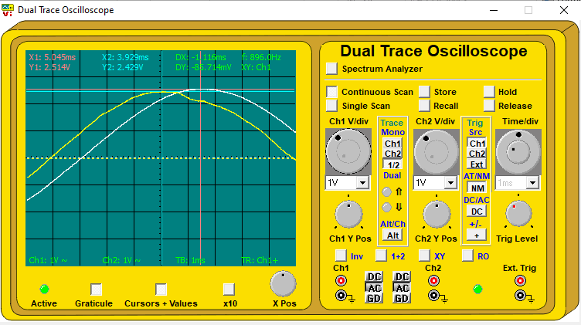
Figure 13 PFC C2+C3
The formula to calculate the phase angle for PFC C2+C3 is as follows:-
X1 = 5.045ms, X2 = 3.929ms
X2 – X1 = - 1.116ms
Dx = - 1.116ms
T = 9
$$ϕ = \left(\frac{Δt}{T}\right) x 360$$
$$ϕ=\left(\frac{- 1.116}{9}\right)x 360=-44.64°$$
As the phase angle is negative, this means it is leading the voltage by 44.64 degrees.

The formula to calculate the current amplitude is as follows:-
Y2 = 2.429V
$$Current Amplitude=\left(\frac{2 x Peak x 1000}{10}\right) \\ Current Amplitude=\left(\frac{2 x 2.429 x 1000}{10}\right)=485.8 mA$$

4.1.4 PFC C2+C4
The waveforms when C2+C4 are inserted into the circuit are shown in Figure 14.
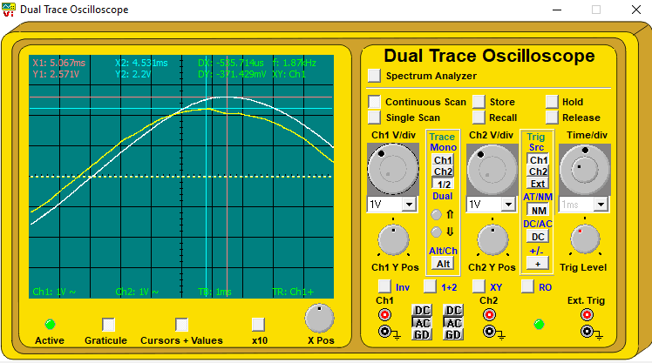
Figure 14 PFC C2+C4
The formula to calculate the phase angle for PFC C2+C4 is as follows:-

X1 = 5.067ms, X2 = 4.531ms
X2 – X1 = - 0.536ms
Dx = - 0.536ms
T = 9
$$ϕ = \left(\frac{Δt}{T}\right) x 360$$
$$ϕ=\left(\frac{- 0.536}{9}\right)x 360=-21.44°$$
As the phase angle is negative, this means it is leading the voltage by 21.44 degrees.

The formula to calculate the current amplitude is as follows:-
Y2 = 2.2V
$$Current Amplitude=\left(\frac{2 x Peak x 1000}{10}\right) \\ Current Amplitude=\left(\frac{2 x 2.2 x 1000}{10}\right)=440 mA$$

4.2 Power Factor
The power factor was calculated within the circuit with no correction capacitor and also calculated with the best correction capacitor inserted into the circuit. Referring back to Table 3, it is clear to see that the value of the shunt capacitance that gives the nearest to complete phase angle is C2.
The power factor was calculated to visualise how the insertion of C2 impacted the voltage and power of the circuit. In order the compare, the power factor was firstly calculated for the circuit with no correction capacitor as shown in the calculation below:-
$$Power factor=Cosϕ \\ Power Factor= Cos\left(50.88\right)=0.63$$
The calculation was then repeated with the best correction capacitor in the circuit, which was C2, as shown below:-
$$Power factor=Cosϕ \\ Power Factor= Cos\left(18.72\right)=0.947$$

The supply voltage was then calculated for the circuit as shown below:-
$$Dy= 5.257V \\ 5.257V x 10=52.57 V p-p$$

The calculation of the power supplied with no correction capacitor in the circuit is shown below:-
$$VIcosϕ$$
$$\frac{V}{2\sqrt{2}} x \frac{I}{2\sqrt{2}}=\frac{V x I}{8}$$
$$\frac{52.57 x 0.514}{8}=3.37W$$

The calculation to find out the power supplied from VI with the best correction capacitor in the circuit is shown below:-

$$VIcosϕ$$
$$\frac{V}{2\sqrt{2}} x \frac{I}{2\sqrt{2}}=\frac{V x I}{8}$$
$$\frac{52.57 x 0.422}{8}=2.77W$$

4.3 Fault Code A
As Fault Code A was inserted into the circuit as shown in Circuit 1. The replication of table 2 was needed and the new base value reading for the phase angle and current amplitude was also needed.

4.3.1 No PFC
The following formula was used to calculate the phase angle:-
Dx = 885.71μs
885.71 micro seconds = 0.886ms
T = 9
$$ϕ = \left(\frac{Δt}{T}\right) x 360$$
$$ϕ=\left(\frac{0.886}{9}\right)x 360=35.44°$$
As the phase angle is positive, this means it is lagging behind the voltage by 35.44 degrees.

The formula used to calculate the base value current amplitude is as follows:-
Y2 = 2V
$$Current Amplitude=\left(\frac{2 x Peak x 1000}{10}\right) \\ Current Amplitude=\left(\frac{2 x 2x 1000}{10}\right)=400 mA$$

4.3.2 PFC C2

The following formula was used to calculate the phase angle of C2:-
Dx = -857.14μs
-857.14 micro seconds = 0.857ms
T = 9
$$ϕ = \left(\frac{Δt}{T}\right) x 360$$
$$ϕ=\left(\frac{-0.857}{9}\right)x 360=-34.28°$$
As the phase angle is negative, this means it is leading the voltage by 34.28 degrees.

The formula used to calculate the current amplitude is as follows:-
Y2 = 2.057V
$$Current Amplitude=\left(\frac{2 x Peak x 1000}{10}\right) \\ Current Amplitude=\left(\frac{2 x 2.057x 1000}{10}\right)=411.4 mA$$

4.3.3 PFC C2+C3

The following formula was used to calculate the phase angle for C2+C3:-
Dx = -1.686ms
T = 9
$$ϕ = \left(\frac{Δt}{T}\right) x 360$$
$$ϕ=\left(\frac{-1.686}{9}\right)x 360=-67.44°$$
As the phase angle is negative, this means it is leading the voltage by 67.44 degrees.

The formula used to calculate the current amplitude is as follows:-
Y2 = 2.514V
$$Current Amplitude=\left(\frac{2 x Peak x 1000}{10}\right) \\ Current Amplitude=\left(\frac{2 x 2.514x 1000}{10}\right)=502.8 mA$$

4.3.4 PFC C2+C4

The following formula was used to calculate the phase angle for C2+C4:-
Dx = -1.286ms
T = 9
$$ϕ = \left(\frac{Δt}{T}\right) x 360$$
$$ϕ=\left(\frac{-1.286}{9}\right)x 360=-51.44°$$
As the phase angle is negative, this means it is leading the voltage by 51.44 degrees.

The formula used to calculate the current amplitude is as follows:-
Y2 = 2.229V
$$Current Amplitude=\left(\frac{2 x Peak x 1000}{10}\right) \\ Current Amplitude=\left(\frac{2 x 2.229x 1000}{10}\right)=445.8 mA$$

4.3.5 PFC C3

The following formula was to calculate the phase angle: for C3-
Dx = 400μs
400 micro seconds = 0.400ms
T = 9
$$ϕ = \left(\frac{Δt}{T}\right) x 360$$
$$ϕ=\left(\frac{0.400}{9}\right)x 360=16°$$
As the phase angle is positive, this means it is lagging behind the voltage by 16 degrees.

The formula used to calculate the current amplitude is as follows:-
Y2 = 1.771V
$$Current Amplitude=\left(\frac{2 x Peak x 1000}{10}\right) \\ Current Amplitude=\left(\frac{2 x 1.771x 1000}{10}\right)=354.2 mA$$

4.3.6 C3+C4

The following formula was used to calculate the phase angle for C3+C4:-
Dx = -542.8μs
542.8 micro seconds = 0.542ms
T = 9
$$ϕ = \left(\frac{Δt}{T}\right) x 360$$
$$ϕ=\left(\frac{-0.543}{9}\right)x 360=-21.68°$$
As the phase angle is negative, this means it is leading the voltage by 21.68 degrees.

The formula used to calculate the amplitude is as follows:-
Y2 = 1.857V
$$Current Amplitude=\left(\frac{2 x Peak x 1000}{10}\right) \\ Current Amplitude=\left(\frac{2 x 1.857x 1000}{10}\right)=371.4 mA$$

The final results of the phase angles and current amplitudes for each correction capacitor were recorded in table 4.
None | C2-10uF | C2+C3-20uF | C2+C4-15uF | C3-10uF | C3+C4-15uF
35.44 lag | 34.28 lead | 67.44 lead | 51.44 lead | 16 lag | 21.68 lead
400 mA | 411.4 mA | 502.8 mA | 445.8 mA | 354.2 mA | 371.4 mA
Table 4

4.4 Three Phase Inverter
On the oscilloscope the timebase speed was set to 1ms/div, as a result of that the positive half cycle of the sine wave and its associated pulses were present as shown in figure 15.
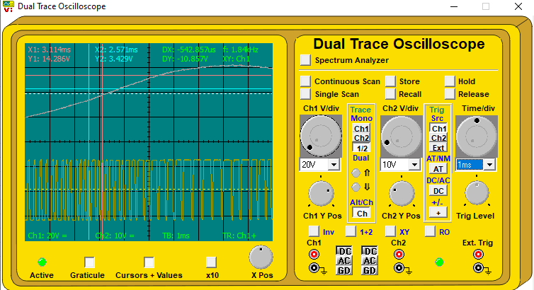
Figure 15 Positive half cycle
At the positive peak of the sine wave, the microcontroller pulses have become broader.
The triggering on the oscilloscope was then changed to negative as shown in figure 16. Due to this a negative half cycle sine wave was displayed. It was clear to see that at the negative peak of the sine wave, the microcontroller pulses became smaller.
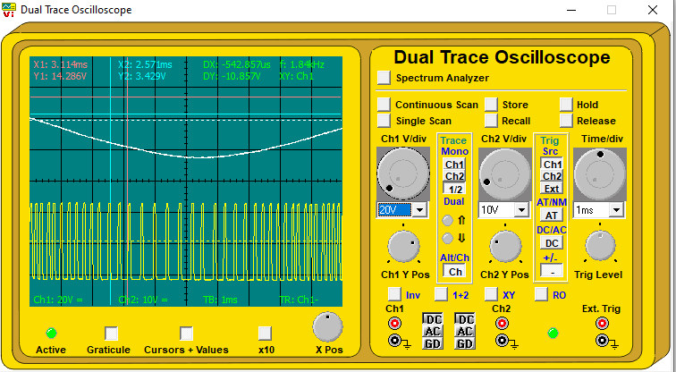
Figure 16 Negative half cycle
It was noted that the total number of microcontroller positive pulses in one half cycles were approximately 40.
Via the oscilloscope the CH.1 Y-amplifier setting was changed to 10V/div and it was evident that there was no visible ripple.

4.5 Over-Current Protection
Once the module supply was switched on, the recorded value of the current flowing was 26.2mA AC, as proven in figure 17. This was recorded with the use of the LJ Create, Multimeter 1.
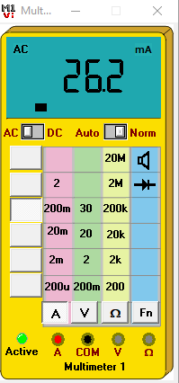
Figure 17 Multimeter 1
A short circuit was placed across the load with a connecting lead between sockets 2.2 and 2.3. The effect on the current, voltage (on CH.1) and the microcontroller pulses were observed. The short circuit across the load immediately caused the supply voltage to reduce to 0V. As the short circuit across the load remained, the load current increased to a maximum and progressively reduced to 67mA.
The short circuit was removed and via the oscilloscope, the waveforms were observed. It was evident that the supply voltage and current had returned to normal.
With the short circuit removed the power supply was switched off and immediately switched back on again, the power supply instantly returned to back to normal. The power supply was then switched off once more, but was left off for 5 minutes. Once turned back on it was evident that the supply was restored back to normal, this was obvious by looking at the waveform on the oscilloscope.

4.6 Single Phase Synchronous Motor
Power factor correction was applied to the circuit by connecting a shorting link between the sockets 4.3 and 7.1. By doing this, it introduced the power factor correction part of the circuit, into the main circuit.

4.7 Fault Code B
By using Multimeter 1 within LJ Create, it was evident that the entire capacitor bank within the power factor correction part of the circuit had be shorted, as it was reading 0V. Before the link was inserted the voltage of the circuit read 43V.

Discussion
This chapter will explain the results recorded, and compare them with the systems used throughout this project to understand why they behave the way they do, the fault diagnosis will also be reasoned. The chapter is split into two sections, power factor correction and pulse width modulation.

5.1 Power Factor Correction
Analysis of the results shown in table 3 shows that the shunt capacitor which gives the nearest to complete phase angle is C2(10µF). The phase angle of C2 lags a total of 18.72°, which is a significant improvement from the original circuit which does not contain any power factor correction and lags by a total of 50.88°. The power factor with no correction was 0.81, with the inclusion of the C2 this improved the power factor, taking it up to a total of 0.99, which is an almost perfect power factor rating.

5.1.1 Fault Code A
By analysing the result from tables 3 and 4 it is evident that the phase angle of the correction capacitor C2 was the fault. When comparing both tables it is visible that the phase angle of C2 is a similar rated angle of C2+C3 in table 3. This has been proven as C2 and C3 are separately rated 10µF, C3 from table 4 has a similar phase angle to that of C2 in table 3. But, when the fault has been introduced it is clear to see C2’s phase angle shifts from lagging by 18.72°, as shown in table 3, to leading by 34.28°, as shown in table 4.

5.2 Over-Current Protection
The over-current protection was introduced into the power supply to prevent it from delivering more current than its circuit can safely withhold. The three phase supply has a two stage over-current protection built in. This is to prevent damage to it in the event of a short circuit. The immediate effect of the protection is to close down the output voltages to a low value, but to allow the current to rise.
If the short circuit remains, and the current is an exceptionally high value, then a thermal protection circuit is initiated. The thermal protection circuit alters the pulses from the microcontroller via the amplifiers. By altering the pulses from the microcontroller it reduces the output voltage and also brings the output current back to a safe and sufficient value. Once this process is complete, the supply must be turned off for a short while in order for the thermal fuse to recover.

5.2.1 Fault Code B
It is clear to see that the shorting link that is connected to the supply voltage is the fault, as when this is connected the supply voltage drops to 0V. By measuring the voltage with multimeter 1 across the capacitor bank and taking readings prior to the addition of the shorting link, it is sufficient evidence that Fault Code B has been deduced.

Conclusion
In this investigation it can be seen:-
- The method used by the microcontroller to generate three phase sine wave supplies is based on pulse width modulation.
- An inverter is a device used to convert AC into DC.
- The frequency of the supplies produced by a three phase generator can be varied by changing the clocking rate of the microprocessor.
- A broader pulse from a microcontroller within a three phase supply can give a more positive output voltage.
- The program for generating sine waves via the inverter is stored in EPROM.
- The purpose of the over-current protection circuit in a power supply is to prevent damage to the power supply.
- In a mixed load, true power will still be dissipated in the resistive component.
- Reactive components, capacitors and inductors do not dissipate power.
- A capacitor charges up to the peak of an applied voltage as it rises to a maximum, to store energy.

References

[1] | The IET , “Power Factor Correction,” May 2006. [Online]. Available: https://electrical.theiet.org/media/1687/power-factor-correction-pfc.pdf. [Accessed 4 April 2022].
[2] | Electrical Apprentice, “ElectricalApprentice.co.uk,” 2022. [Online]. Available: https://electricalapprentice.co.uk/power-factor-correction-what-is-it-why-is-it-required-how-is-it-achieved/. [Accessed 7 April 2022].
[3] | Energy Ace, “Energy Ace,” 2021. [Online]. Available: https://energyace.co.uk/2019/01/18/what-is-power-factor-correction-and-how-does-it-work-uk/. [Accessed 7 April 2022].
[4] | Global electronic services inc., “Gerespair,” 2022. [Online]. Available: https://gesrepair.com/motor-drive-types/. [Accessed 8 April 2022].
[5] | Tutorials Point, “Power Electronics,” 2022. [Online]. Available: https://www.tutorialspoint.com/power_electronics/power_electronics_types_of_inverters.htm. [Accessed 8 April 2022].
[6] | V. Patil, “Electrical Gang,” 2022. [Online]. Available: https://electricalgang.com/three-phase-inverter/. [Accessed 8 April 2022].
[7] | Danfoss, 2022. [Online]. Available: https://www.danfoss.com/en-gb/about-danfoss/our-businesses/drives/what-is-a-variable-frequency-drive/. [Accessed 8 April 2022].

