Management & Organisational Behaviour
BMIH5005

Lecturer: Charlotte Joyner
Student name: Roxana Jurj
Student id: 2126298
Word count: 2159

Table of Contents
Introduction 3
Organizational structure, culture and goals 4
IHG organizational structure 5
IHG Culture 6
IHG Goals 8
Initiatives 9
Strategic direction 9
Conclusion 10
References 12

IHG GROUP

Introduction
InterContinental Hotels Group (IHG), headquartered in Denham, United Kingdom, is a multinational corporation that is widely regarded as a frontrunner in the hotel industry. IHG possesses an extensive collection of hotel brands, which comprises renowned designations such as Kimpton, Crowne Plaza, Holiday Inn, and InterContinental, among others. With a portfolio of over 5,900 hotels spanning over 100 countries, the organisation effectively addresses the diverse requirements of customers in various market sectors (IHG, 2023). The vastness of this network highlights the substantial presence of IHG in the international hospitality sector, where it exerts considerable influence over the experiences of countless guests and travellers around the globe. Not only has the organization's dedication to innovation, expansion, and hospitality excellence contributed to its own growth, but it has also significantly influenced the hotel industry as a whole, positioning it as a prominent participant in the worldwide tourism sector (IHG, 2023). The objective of this report is to analyse the complex interplay among organisational structure, culture, and human elements in the context of IHG Hotel Group. It will investigate the ways in which these elements collectively impact and advance the performance of the organisation. The study aims to comprehend the intricacies of managerial labour, the responsibilities of leadership positions, and the influence of behavioural management on the accomplishment of strategic goals.
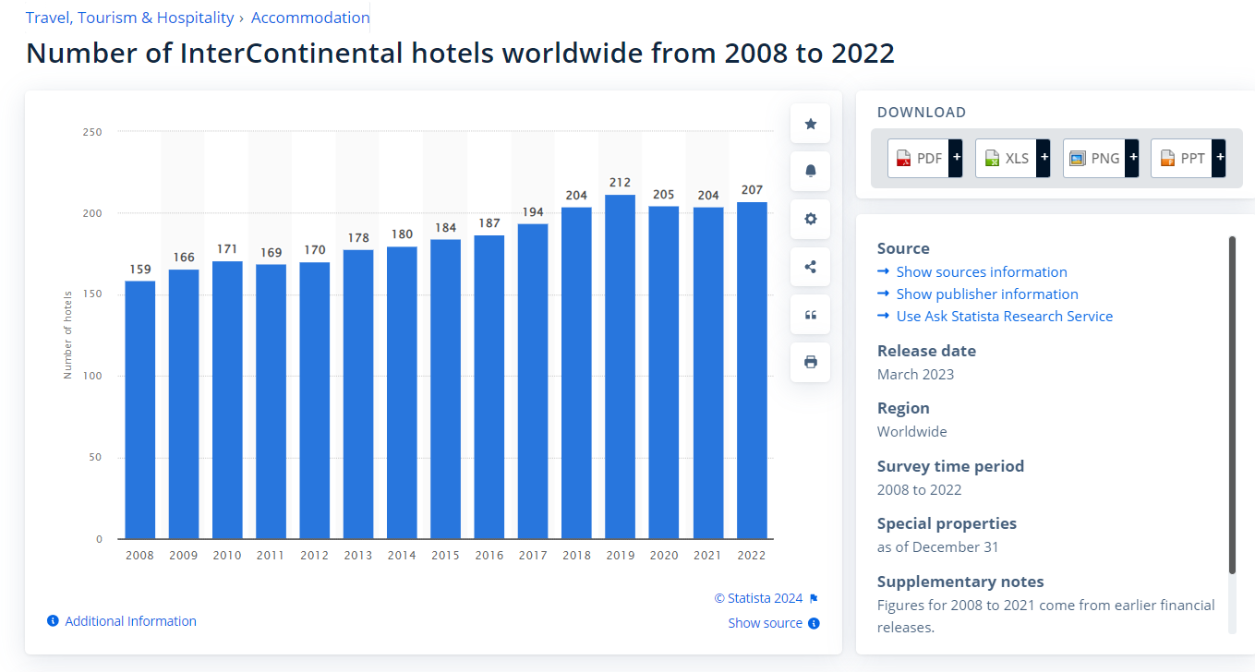
Fig 1. Statista. (2023). InterContinental hotels worldwide 2020.

Organizational structure, culture and goals
Organisational objectives, identity, and operations are profoundly influenced by its organisational structure, culture, and goals. Every individual contributes significantly to the success and operational effectiveness of the organisation. The term "organisational structure" alludes to the framework comprising communication channels, reporting relationships, responsibilities, and workflows that interconnect the various components of an establishment. (Boddy, 2014). The organization's structure dictates the flow of information, establishes the delineation of roles and responsibilities for various components, and impacts the coordination and efficiency of operations. Hierarchical and centralised structures contrast with flat and decentralised ones, each of which serves a distinct set of strategic objectives and operational requirements (Armstrong, 2012). Culture comprises the shared values, beliefs, norms, and practices that exert an impact on the manner in which tasks are executed within an organisation. It influences the attitudes and conduct of employees, providing direction for their interactions with one another, clients, and stakeholders (Mullins, 2016). The influence of organisational culture on employee satisfaction, innovation, and performance can be substantial. A robust and optimistic culture cultivates a setting in which personnel are esteemed and inspired, in this manner potentially augmenting output and the standard of service rendered. Conversely, a noxious culture may result in diminished morale, increased employee attrition, and subpar productivity. Organisational goals encompass the precise aspirations that an organisation endeavours to attain (Buchanan, and Huczynski, 2007). Objectives furnish guidance and a sense of purpose, organising strategy and decision-making at every organisational level. Objectives can be classified as either short-term or long-term, and they encompass a spectrum of subjects. Financial objectives comprise revenue growth, while non-financial aims concentrate on enhancing customer satisfaction or promoting sustainability (Armstrong, 2012).

IHG organizational structure
IHG maintains a hierarchical and, to some extent, centralised organisational structure, wherein authority is conspicuously delegated from global operations to regional affairs. This is demonstrated by the regional organisation of hotel operations and development (Americas, EMEAA, and Greater China), which is bolstered by the presence of global functions in critical domains including finance, human resources, corporate affairs, marketing, commercial and technology, business reputation and responsibility, and corporate affairs (IHG Annual Report, 2023). This configuration implies a hierarchical structure in which strategic directives and decisions are delegated from the global leadership team to regional teams, in accordance with a centralised governance model. The endorsement of a Global Delegation of Authority Policy serves to reinforce the hierarchical configuration of IHG's organisational framework. This policy establishes controls for financial commitment and expenditure approval, specifying that approval from higher levels of the organisational hierarchy is necessary for decisions with substantial financial implications (InterContinental Hotels Group PLC, n.d.). In this process, the Group's Capital Committee and, in the case of specific thresholds or proposal types, the Executive Committee are typically involved. The organization's approvals from higher-level management and the implementation of a structured approach to decision-making highlight the hierarchical and, to some extent, centralised nature of IHG's structure (IHG Annual Report, 2023). Additionally, a hierarchical structure is further supported by the comprehensive enumeration of committees in the IHG Annual Report, which comprises the Audit Committee, Nomination Committee, Remuneration Committee, Responsible Business Committee, Executive Committee, Disclosure Committee, and General Purposes Committee. Every committee is endowed with distinct duties and obligations, which collectively contribute to the governance and supervision of the institution across multiple tiers. Hierarchical organisations are distinguished by the establishment of specialised committees and the delineation of roles; governance structures are, to some degree, centralised and precisely defined in order to maintain control and oversight over global operations.

IHG Culture
A set of fundamental values serves as the foundation of IHG's culture, directing the conduct and decision-making of every individual within the organisation. Demonstrate concern, Do the right thing, Celebrate diversity, Strive for excellence, and Collaborate more effectively are these values (IHG, 2022). Integral to IHG's reputation as a reputable, ethical, and well-governed organisation is this culture. An effective analysis of the dynamic organisational culture demonstrated by InterContinental Hotels Group can be achieved by employing Edgar Schein’s Model of Organisational Culture and the Competing Values Framework (CVF). As per Schein's model, IHG's culture is evident in tangible artefacts, including conscious inclusion training initiatives and cultural celebrations. These observances serve as tangible proof of the organization's dedication to fostering an inclusive workplace atmosphere (Arnold, 2005). These initiatives serve as concrete manifestations of the values that IHG espouses, namely doing the right thing, demonstrating concern, valuing diversity, striving for excellence, and collaborating more effectively. These values inform the ethical business strategy of the organisation and influence the ethos of its workplace. Moreover, it is probable that the fundamental tenets of IHG are centred on the conviction that hospitality has the capacity to bring about substantial changes and the criticality of ethical behaviour in cultivating confidence among stakeholders (Mullins, 2020). These assumptions are crucial in guiding the strategic priorities and operational decisions of IHG, ensuring that they are consistent with the organization's fundamental values and mission. Concurrently, the Competing Values Framework (CVF) provides an alternative lens through which to examine IHG's culture, associating it with the Adhocracy and Clan cultures. The manifestation of the Clan culture is apparent in IHG's internal orientation and the importance attributed to adaptability; it cultivates a familial ambiance that strongly promotes collaboration and active engagement (Lavine, 2014).This exemplifies the endeavours of IHG to foster an environment that is inclusive and supportive of its personnel. Conversely, IHG exhibits characteristics of an Adhocracy culture through its emphasis on flexibility and external focus, as well as its commitment to sustainability, adoption of novel technologies, and implementation of innovative strategies. These qualities underscore IHG's preparedness to confront obstacles and strive for expansion, with the objective of satisfying the changing demands of its clientele and the broader hospitality sector. Through the application of these frameworks, it becomes evident that IHG's culture has been carefully designed from a combination of internal and external components, achieving a balance between innovative practices, visitor satisfaction, and the welfare and inclusion of its workforce (IHG Development, n.d.). The amalgamation of cultural components serves as the foundation for IHG's operational effectiveness and strategic goals, contributing significantly to the organization's continuous prosperity and its capacity to deliver Authentic Hospitality to all.

IHG Goals
The objectives of IHG, as delineated in their strategic pillars, pertain to the overhaul of their operations, the augmentation of their portfolio to encompass 19 brands, and the substantial fortification of their enterprise. The previously mentioned evolution is additionally bolstered by the implementation of an upgraded IHG One Rewards loyalty programme, fresh alliances, and an improved online and mobile presence (IHG, 2019). At the heart of these undertakings lies IHG's constant commitment to True Hospitality for Good, an ideal that continues to shape their brands and organisational ethos. By simplifying its objective to become the hotel company of choice for owners and visitors, IHG is striving to expedite expansion through the enhancement of its strategic pillars and the implementation of novel practices that cultivate a success-driven mindset (IHG Development, n.d.). By connecting IHG's objectives to Locke and Latham's Goal Setting Theory, one can gain insight into the manner in which establishing explicit and demanding goals can result in enhanced performance. Goals that are both specific and challenging, in conjunction with suitable feedback, have a substantial influence on task performance, according to this theory. This theory is consistent with IHG's strategic orientation, which emphasises brand expansion, loyalty programmes, and a commitment to sustainability and community impact via the Journey to Tomorrow initiative (Locke and Latham, 2013). IHG strives to achieve both business performance enhancement and environmental and community sustainability by establishing objectives that are both ambitious and workable. This strategic approach exemplifies the company's incorporation of Goal Setting Theory into its operational procedures; by employing well-defined objectives to inspire and direct employee performance in the pursuit of organisational triumph and the fulfilment of their dedication to True Hospitality for Good.

Initiatives
Recent change initiatives at IHG have centred on enhancing the visitor experience, promoting sustainability, and increasing workforce diversity. IHG's dedication to innovation and expansion is demonstrated by the introduction of the IHG® One Rewards programme, which utilises a novel mobile application to revolutionise loyalty for both guests and proprietors (InterContinental Hotels Group PLC, n.d.). Furthermore, the inclusion of Iberostar Hotels & Resorts in the portfolio further underscores IHG's strong commitment to these objectives. These endeavours have played a crucial role in stimulating financial performance and earnings, underscoring IHG's strategic orientation towards providing an extensive assortment of brands and high-quality lodging experiences (InterContinental Hotels Group PLC, n.d.) In addition, IHG's Journey to Tomorrow initiative highlights their commitment to sustainability through measures such as carbon emission reduction and increased diversity in corporate leadership. The aforementioned change initiatives exemplify IHG's strategic intent to construct an organisation that is more robust, environmentally aware, and inclusive. The positive influence on staff engagement and expansion management, as indicated by the feedback and participation of teams throughout the organisation, is consistent with the change management principles emphasised by David MacLeod and Nita Clarke. These principles underscore the significance of staff engagement and the identification and resolution of areas requiring development in order to sustain elevated service standards and efficiently oversee growth. By doing so, IHG guarantees its competitiveness and ability to adapt to the changing demands of guests, owners, and the wider community.

Strategic direction
The strategic trajectory of IHG is unambiguously delineated through its mission, aspirations, and priorities, which are assessed through the utilisation of KPIs to guarantee the implementation of its strategy and sustained prosperity. The key performance indicators are structured in accordance with IHG's overarching strategy, highlighting the organization's dedication to expansion and its principal stakeholders—which comprise proprietors, visitors, staff, investors, and localities—on the same page. The evaluation of IHG's performance in the fiercely competitive hotel industry is heavily reliant on this strategic focus (IHG, 2022). The strategic objectives encompass augmenting visitor experiences via endeavours such as the IHG® One Rewards programme and diversifying the portfolio to encompass an extensive array of brands that accommodate a wide range of guest preferences. Furthermore, IHG's commitment to human rights and emphasis on sustainability via initiatives such as the Journey to Tomorrow demonstrate a comprehensive approach to business operations that is in line with modern stakeholder expectations (IHG Annual Report, 2022). IHG faces intense competition from alternative lodging options, traditional hotel chains, and local businesses in the financial sector. The company's strategic emphasis on branded hotel experiences and loyalty programmes serves the purpose of preserving and augmenting its market presence, financial gains, and connections with owners (IHG Development, 2023). By prioritising customer experience, brand diversity, and responsible business practices, IHG establishes a comprehensive strategy that enables the company to thrive and expand in the worldwide hospitality industry.

Conclusion
In conclusion, the InterContinental Hotels Group (IHG) serves as a model of innovation and excellence in the worldwide hospitality sector, supported by its well-planned organisational framework, corporate culture, and commitment to achieving objectives. IHG's ambitious objectives are firmly grounded in a culture that places a premium on excellence, diversity, and ethical conduct, which is harmoniously integrated with its hierarchical yet adaptable organisational structure. These encompass the augmentation of its brand portfolio, the improvement of visitor experiences, and the dedication to sustainable practices. Prominent examples of IHG's commitment to innovation, sustainability, and inclusivity include the Journey to Tomorrow initiative and the IHG® One Rewards programme. Through the utilisation of key performance indicators and the alignment of its strategic direction with stakeholder interests, IHG not only fulfils but surpasses industry benchmarks, in that way solidifying its position as a frontrunner in the provision of genuine hospitality on a global scale.

References

Armstrong, M. (2012) Armstrong’s Handbook of Management and Leadership (3rd Ed), London: Kogan Page.
Arnold, J. (2005) Work Psychology (4th edition) Harlow: Prentice Hall.
Boddy, D. (2014) Management: An Introduction (6th Ed), Harlow, Pearson
Buchanan, D. And Huczynski, A. (2007) Organisational Behaviour: An Introductory Text (6th edition), Harlow: Prentice Hall.
IHG Development. (n.d.). Hotel brands. [online] Available at: https://development.ihg.com/hotel-brands.
IHG Development. (n.d.). On a journey towards a better future. [online] Available at: https://development.ihg.com/sites/ihgplc/files/IHG/A%20sustainable%20business/I-H-G-R-B-R-Interactive-280222.pdf.
InterContinental Hotels Group PLC. (n.d.). IHG and Iberostar sign a strategic alliance for resort and all-inclusive hotels in the Caribbean, Americas, Southern Europe and North Africa. [online] Available at: https://www.ihgplc.com/en/news-and-media/news-releases/2022/ihg-and-iberostar-sign-a-strategic-alliance-for-resort-and-all-inclusive-hotels.

IHG (2019). Our strategy. [online] InterContinental Hotels Group PLC. Available at: https://www.ihgplc.com/about-us/our-strategy.

IHG (2022). Annual Report. Key performance Indicators. Available at: https://www.ihgplc.com/~/media/Files/I/Ihg-Plc/about-us/our-strategy/annual-report-2022-kpis.pdf
IHG (2022). What we stand for. [online] InterContinental Hotels Group PLC. Available at: https://www.ihgplc.com/en/about-us/what-we-stand-for.

IHG (2023). Our History. [online] InterContinental Hotels Group PLC. Available at: https://www.ihgplc.com/en/about-us/our-history.

IHG Annual Report (2023). Annual Report. [online] InterContinental Hotels Group PLC. Available at: https://www.ihgplc.com/en/investors/annual-report.

InterContinental Hotels Group PLC. (n.d.). Policies and Position Statements. [online] Available at: https://www.ihgplc.com/en/responsible-business/policies-and-position-statements.
InterContinental Hotels Group PLC. (n.d.). IHG One Rewards Mobile App: Redefining Travel Through Technology. [online] Available at: https://www.ihgplc.com/en/news-and-media/news-releases/2023/ihg-one-rewards-mobile-app-redefining-travel-through-technology.

Lavine, M. (2014). Paradoxical Leadership and the Competing Values Framework. The Journal of Applied Behavioral Science, 50(2), pp.189–205. doi:https://doi.org/10.1177/0021886314522510.

Locke, E.A. and Latham, G.P., 2013. Goal setting theory: The current state. In New developments in goal setting and task performance (pp. 623-630). Routledge.

Mullins, L. (2016) Management and Organisational Behaviour (11th edition) Harlow: Pearson
‌Mullins, L (2020) Organisational Behaviour in the Workplace (12th edition) Harlow:Pearson

