Design & Access Statement

Written statement for the proposed construction of a leisure complex which includes an enclosed Olympic sized swimming pool, open are football/rugby ground and 5 tennis courts with all other necessary facilities and amenities included.

Statement prepared on behalf of:
UWTSD Built Environment and Architecture school



Contents
Introduction 3
Environmental Sustainability 4
Townscape Setting and the Local Environment 4
Energy 4
Sustainable Materials 4
Water Usage 5
Waste Management 5
Climate Resilience 5
Aesthetics 6
Scale 6
Layout 6
Appearance 6
Landscaping 6
Community Safety 7
Accessibility 8
On-Site Parking 8
Access to the Development – Highways 8
Vertical Circulation 8
Accessible Switches, socket outlets and Other 8

Introduction

This design and access statement is in support of the proposal for an olympic sized leisure complex with 5 outdoor tennis courts and a rugby/football pitch.

This report displays the considerations and influences of the site leading to the proposed design incorporating Swansea City Council’s planning polices and Welsh building regulations.

This document should be read in conjunction with all produce final drawings which accompany this proposal.

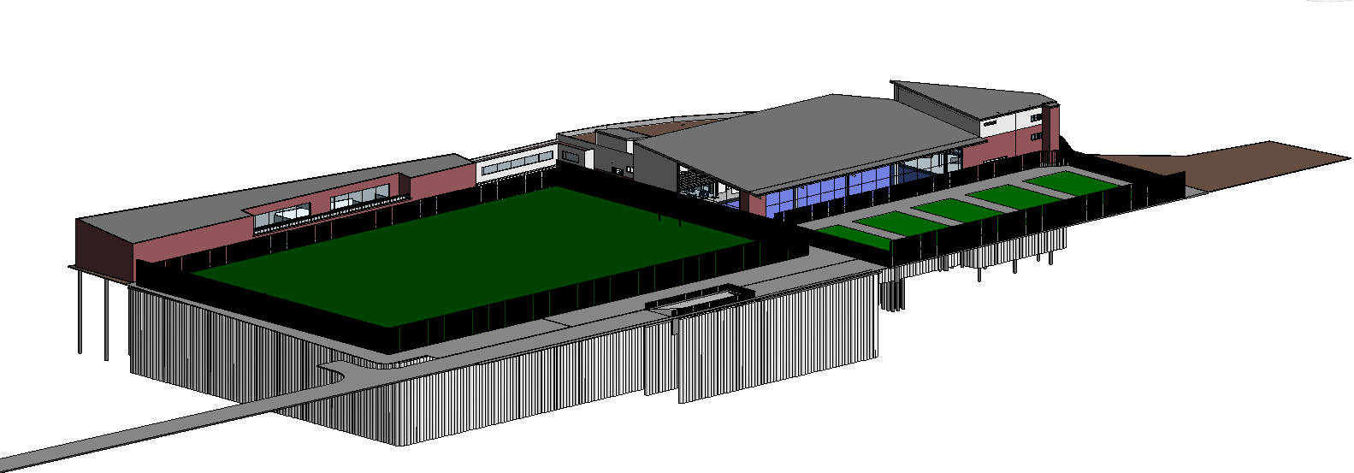

Environmental Sustainability

Townscape Setting and the Local Environment
The proposed site is a brownfield site situated on the Swansea coast. Surrounding the site is the Prince of Wales Dock and part of the British Ports land. The residential development directly over the opposite side of the dock are brick constructions being multiple storeys high.

Energy
The proposed construction will be energy efficient with majority of elements exceeding minimum building regulation requirements. The wall construction will provide a U-value of 0.26W/m2.k with 50mm of Kingspan K108 (Building regulations require 0.35W/m2.k), the ground floor construction will provide a U-value of 0.13W/m2.k with 25mm of Kingspan K103 (Building regulations require 0.25W/m2.k), and the pitched roof constructions will provide a U-value of 0.10 W/m2.k with King span roof panel providing 115mm of insulation coupled with an extra 200mm of Rockwool internally (Building regulations require 0.25 W/m2.k), these thermal insulations will also be met with a rockwool acoustic membrane. The green flat roof will be designed to the manufactures specification and will aim to provide a U-value of 0.23W/m2.k using 150mm of Kingspan Greenguard GG300 insualtion. All windows will be gas filled units providing a U-value of 1.5W/m2.k, regulations call for a minimum of 2.2W/m2.k. The swimming pool basin includes 80mm insulation to provide a U-value of 0.25W/m2.k. The main entrance door to the complex uses a lobby system as well as automatic closers and high thermal capacity doors to provide a U-value of 3.5 W/m2.k. Insulated walls and doors will be used between the ground floor and car park to reduce air and heat leakage. Construction detail will be accurate and precise to ensure an air permeability will be no greater than 10.0 m3/h.m2 at 50 Pa.
PV solar panels will be used on the pitched roofs facing North to provide renewable source of electricity. Solar exposure and surface heat loss via windows will be controlled with the use of double glazing, solar glass and appropriate designing.

Sustainable Materials
The materials used in the construction will be obtained locally where possible. The use of elements which can receive repairs or replacement, like wise the use of long-life materials will be favoured.

Water Usage
Water saving devices and appliances will be incorporated into the refurbishment. Water saving toilets will be incorporated into the proposal along with water saving shower appliances saving up to 70% of the water used by the existing installation in equivalent use. In addition to this, spray taps will be used, offering a potential saving of up to 72% less water usage in comparison with a standard tap. The appropriate appointment for pool maintenance will result is a more efficient pool upkeep.

Waste Management
Rain water harvesting will be available for the community garden area.

Climate Resilience
Materials will be durable and maintenance free where possible.

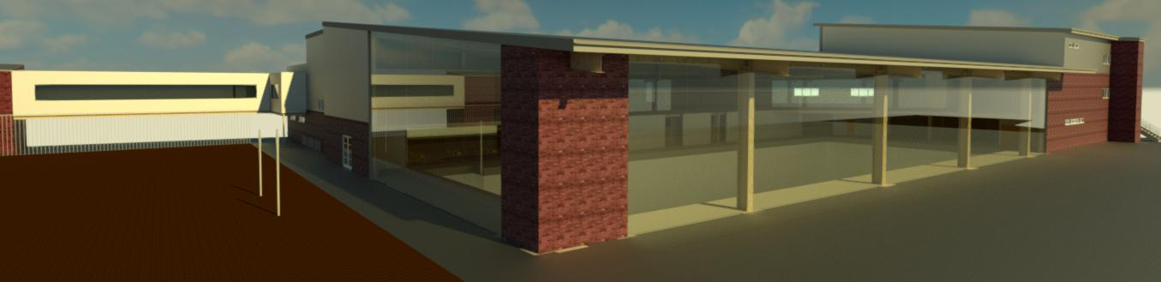

Aesthetics

Scale
The design has been scaled appropriately being most space efficiency where possible whilst still providing the necessary requirements for the proposal. It was desired that the proposal does not look too large of a scale when being overlook by the neighbouring residential development.

Layout
The layout of the design takes inspiration from Sport England guidance; the design includes an entrance/reception area which provides spectator viewing into the pool with refreshments from the café as well as a toilet and reception access. The reception can then provide access to the main changing area or to the main stairwell, users coming from the lower ground car park need to be checked in to prevent people ‘sneaking’ into the facilities. The main changing accommodates all types of users with toilet facilities, this provides access for both the main pool users and rehabilitation pool users; included within the changing room are 9 family cubicles, 21 single and 48 double cubicles. The pool is centrally lined with the centre of the adjacent pitch to create a coherent design flow; pool has been designed following FINA guidance.
The first floor has 2 points of access, the external one being primarily used for the tennis court users, and the internal one being used by other users. Included to the floor is a 450m2 gym area and 2 fitness suites both having access to their own changing facilities. There is also provision for storage, disable toilets, access to the sky bridge used to access the club house and access to both points of seating for the pool area. Each door in the long corridor is spaced every 15m for fire protection purposes.
The second floor is access through the internal stairwell adjacent to the external stairs, this floor is used for the tennis court changing facilities coupled with disable toilet provision. Due to the limitation of 2 fire exits a maximum of 600 occupants is allowed.
The lower ground houses the plant for the pool along with some storage; included to this plant roof will be a firefighting shaft.

Appearance
It is proposed to use a brick external appearance to match the existing street scape of the surrounding developments, the use of rain screens is for the exposed elevations due to the higher durability of a rain screen. The pitched roof is to use a Kingspan standing seam roof panel with the green roof to the rear. The step in the east facing elevation help signifies the entrance area to the complex. Brick facing foundation course to run around the leisure centre.
The club house is to tie into the appearance of the leisure centre, more detailed design to be confirmed with Wernick.

Landscaping
The landscaping has been derived in association with the ecological survey, no protected species were identified. Biodiversity enhancements are included to the community garden area, the use of native species will be incorporated; these have to consider the harsh weather environments associated with the locality of the site.

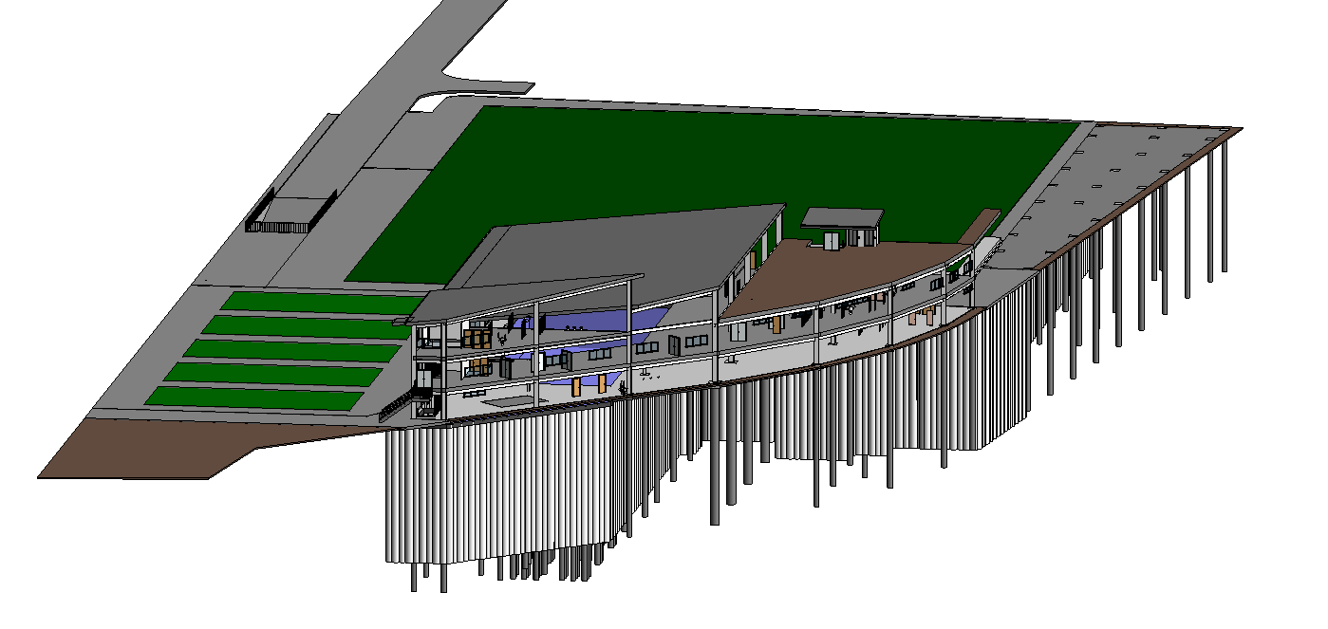

Community Safety
The proposal aimed to create no dark corners or hidden areas where anti-social behaviour may develop given liberation. The use of CCTV and secure access points will be used.

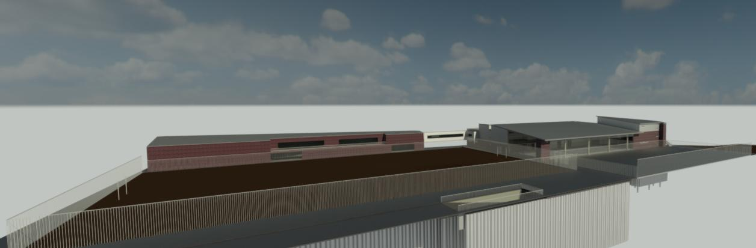

Accessibility

On-Site Parking
On-site parking will be enclosed underground with appropriately designed ventilation and fire protection measures, parking will be designed to BPA (British Parking Association) specification. The parking will contain 14 disabled bays, 5 appointed staff bays, 5 family bays and 246 standard parking bays with 18 accommodating electric charging. Cycle bars will also be provided to the lower ground and ground floor.
Off-site drop off for coaches will be further up the access road and will accommodate multiple spaces for coach stopping as well as safety measures like traffic lights and road crossing points.

Access to the Development – Highways
Access to the site is via an existing road which leads to the lower ground parking area, this area will be gated with availability for certain parking subscriptions and the like. Access from the parking area to the leisure complex will be provided through a staircase and 2 8 person lifts which provides access to the ground floor reception area. Access to the ground floor entrance door will be level with gradual ramps used with necessary.

Vertical Circulation
Vertical circulation within the proposal will be achieved through 2 appropriately sized stairs connecting the floors and two 8 person lifts with another external 8-person lift. Stairs will be compliant to building regulations.

Accessible Switches, socket outlets and Other
The switches and sockets shall be situated at a suitable height to accommodate those with limited reach. Some areas will provide floor outlets housed within the floating floor, these will be installed appropriately ensuring no trip hazards are created.

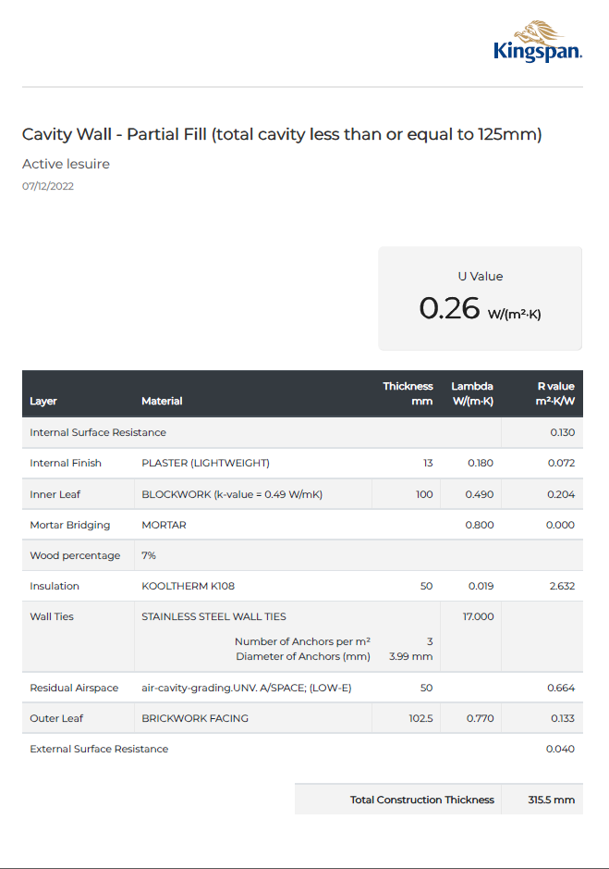
Appendices



