University of Wales, Trinity St. David
A Design Investigation:
Measuring Concentrations of CO₂ in Ambient Air Utilising Two PIC-based Platforms
Module: Embedded Microcontrollers (M3X8529)
Author: Thorbjørn Ravnaas Kristiansen
Course: BEng Computer Systems and Electronics (L6)
Lecturer: Mr. Gareth Jones
3149 words
February 2019

Abstract
A CO₂ detection system based on vintage electronic parts was emulated utilising modern digital components, proving the superiority of embedded microcontrollers over discrete logic and external electronic components. A second system was designed from the ground up, based on the PIC18F25K50 microcontroller from Microchip. Microcontrollers were deemed a practical, efficient and cost-effective approach for this application.

Table of Contents
Abstract 1
Background research 4
System Analysis and MCU selection 5
The PIC16F18345 6
Packaging Options 8
Redesigning the Original System 9
Electrical Details 11
Ultrasonic Transmitter and Receiver 11
Thermometer Circuit 11
Button Inputs 12
Operational Details 12
Flowchart 13
Parts List 14
Contemporary System 15
The PIC18F45K50 15
Circuit Details 16
Schematic Sheet 1 16
Schematic Sheet 2 18
Principle of Operation 21
Flowchart 22
Parts List 23
Conclusion 23
User Manual 24
Appendix: Datasheet Snippets 26
References 37

Table of Figures
Figure 1 - Original system architecture block diagram 5
Figure 2 - Microchip selection of 8K RAM PICs 6
Figure 3 - PIC16F18345 packaging options 8
Figure 4 – Electrical schematic diagram for redesigned circuit 10
Figure 5 - Ultrasonic system flowchart 13
Figure 6 - PIC18F45K50 15
Figure 7 - Modern system circuit diagram (sheet 1/2) 17
Figure 8 - Modern system circuit diagram (sheet 2/2) 20
Figure 9 - Modern system flowchart 22
Figure 10 - 3V LCD datasheet snip 26
Figure 11 - Button matrix datasheet snip 27
Figure 12 - 3v3 voltage regulator datasheet snip 27
Figure 13 - Battery datasheet snip 28
Figure 14 - Buzzer datasheet snip 29
Figure 15 - Charging IC datasheet snip 30
Figure 16 - Enclosure datasheet snip 31
Figure 17 - Bluetooth module datasheet snip 32
Figure 18 – CO₂ sensor datasheet snip 33
Figure 19 - Schmitt trigger/inverter datasheet snip 34
Figure 20 - Thermocouple datasheet snip (see red mark) 35
Figure 21 - TL071 Opamp datasheet snip 36

Table of Tables
Table 1 - Original system overview table 5
Table 2 - Comparison between PIC16F18344 and PIC16F18345 7
Table 3 - Parts list for redesigned system 14
Table 4 - Input/output table for modern system 15
Table 5 - Modern system parts list 23

Background research
Measuring CO₂ is an important aspect of the modern world. Atmospheric CO₂ concentrations affect global warming, room concentrations affect human alertness and wellbeing. Industrial applications include measuring the CO₂ content of automobile exhaust and industrial processes. Very high concentrations can induce loss of consciousness and death due to oxygen deprivation[1]. CO₂ is not a toxic gas, it merely replaces oxygen in the air mixture.
Measuring CO₂ can be accomplished in several ways. Laser spectroscopy have been proposed[2], along with smaller more efficient systems such as anode reduction techniques[3].
An NDIR (Non-Dispersive Infrared) sensor is the most common approach. They can exhibit an accuracy of 0.5%, making them reliable for room concentration measurements[4].
Possible applications for this product are areas with a risk of high concentrations of CO₂ such as pub cellars and hospitals.

System Analysis and MCU selection
Table 1 - Original system overview table
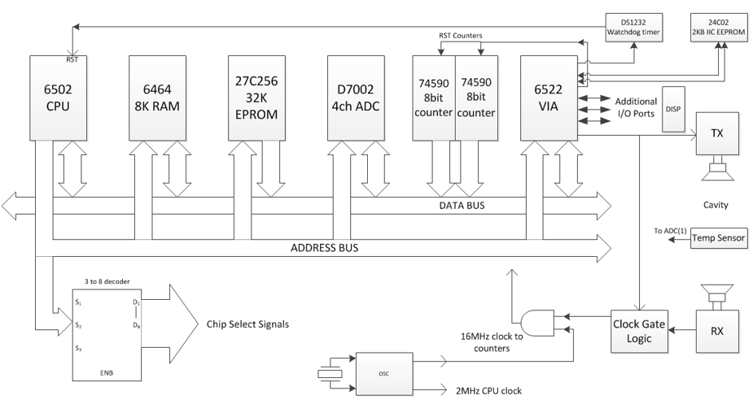
A previously designed system for detecting CO₂ levels was implemented utilising a modular approach, with a 6502 processor at its core. The modular nature of this system is a product of technological limitations at the time. Components like RAM (random access memory), ADC-modules (analogue to digital converter) and counters were individual components as opposed to the all-in-one nature of a modern MCU (microcontroller unit). As seen in figure 1, the original system was designed utilising a Von Neumann architecture. The system had 8KB of RAM and used an external oscillator (presumably a quartz crystal) as a clock source. See table 1 for reference table.
Figure 1 - Original system architecture block diagram
Module | Relevant details | Purpose
6502 CPU[5] | 3MHz max clock speed | Central processing unit
6464 8K RAM[6] | 8-bit RAM module | Random access memory
27C256 EPROM[7] | 32K light-erasable non-volatile memory | Program memory
D7002 4ch ADC[8] | 12-bit resolution | Analogue to digital conversion
74590 8bit counter[9] | - | Counter for time of flight measurement
6522 VIA[10] | 2 8-channel peripheral ports (16 I/O channels) | Interface adapter.  Allows for I/O expansion.
DS1232 Watchdog timer[11] | - | Restarts CPU in the event of  errors/hanging system
24C02 2KB IIC EEPROM[12] | Electrically erasable, securing calibration data | Calibration memory
3 to 8 decoder | - | Chip selector system
OSC | Divides the raw crystal output frequency  to usable frequencies | Oscillator circuit (generates 16/2MHz)
Clock Gate Logic | - | Logic for ultrasonic pulse detection  and synchronisation

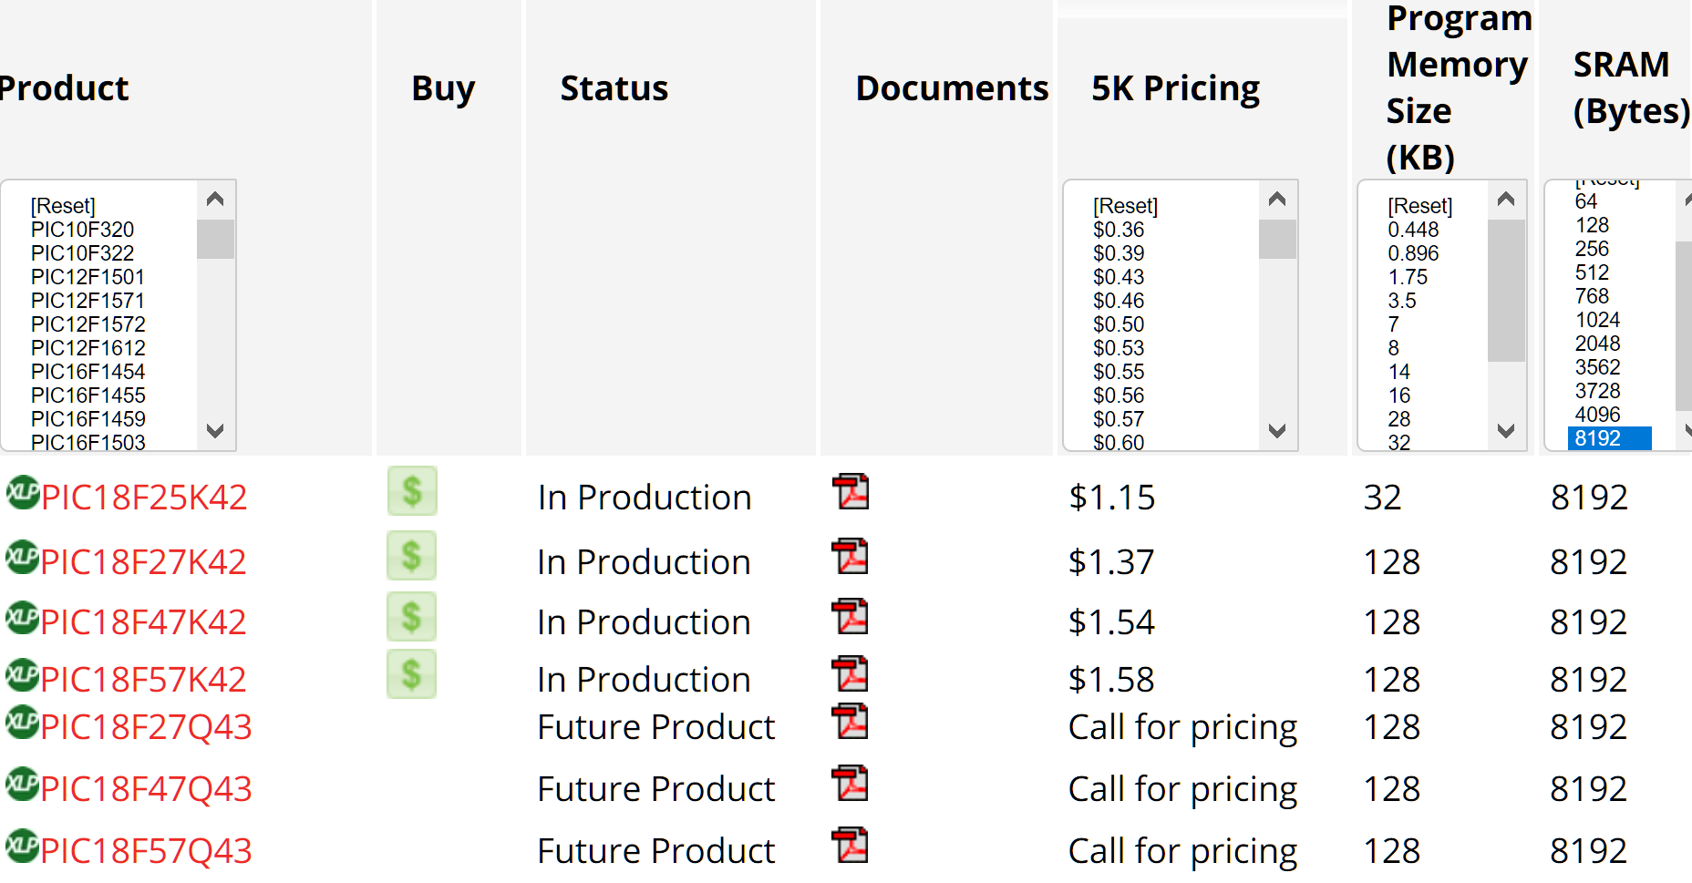
Choosing a microcontroller for redesigning this system was accomplished utilising Microchip’s parametric search function for 8-bit PICs (Microchip’s brand name for MCUs; Programmable Interface Controller). The parametric search function reveals that 8KB RAM the largest capacity Microchip is currently offering (figure 3). Since the potential complexity of both purpose and software for MCUs has increased since the initial design of this system, it can be argued that 8K RAM is excessive. Only 7 PICs offer this capacity, and they are comparably expensive relative to other options explored in this report.
Figure 2 - Microchip selection of 8K RAM PICs
As seen in figure 2, the PIC18F25K42 mirrors the original system in terms of RAM and program memory size. It is also a 28-pin device, which is desirable for future upgrades.

The PIC16F18345
The chosen microcontroller for this application is the PIC16F18345. It was chosen with the following search parameters:
- Pin count: 20
- Watchdog timer: Yes
- ADC modules: >0
- Program memory: <=16KB
- EEPROM: >0
This yielded a result of 2 microcontrollers, as seen in table 2 on the next page.
PIC | PIC16F18344 | PIC16F18345
Status | In Production | In Production
5K Pricing | $0.70 | $0.77
Family | Enhanced Mid-Range | Enhanced Mid-Range
Program Memory Size (KB) | 7 | 14
Program Memory Size (KWords) | 4 | 8
SRAM (Bytes) | 512 | 1024
Emulated EEPROM in Flash | 256 | 256
Max I/O Pins | 18 | 18
Pin count | 20 | 20
Max CPU Speed (MHz) | 32 | 32
Brown-Out Reset | BOR | BOR
Low Voltage Detection | LVD | LVD
Power On Reset | Yes | Yes
Internal Oscillator | 32 MHz, 32 kHz | 32 MHz, 32 kHz
Watch Dog Timer | Yes | Yes
Number of ADCs | 1 | 1
ADC Input | 17 | 17
Max ADC Resolution (Bits) | 10 | 10
Max ADC Sampling Rate (ksps) | 100 | 100
Max 8-Bit Digital Timers | 4 | 4
Max 16-Bit Digital Timers | 3 | 3
Capture / Compare/PWM (CCP) | 4 | 4
UART | 1 | 1
SPI | 1 | 2
I₂C | 1 | 2
Table 2 - Comparison between PIC16F18344 and PIC16F18345
Although both PICs could conceivably be used to fulfil the intended purpose, the PIC16F18345 was chosen for its larger program memory capacity and RAM size. This provides some margin in terms of software development, as these requirements are extremely difficult to accurately predict. It also has extra I₂C and SPI channels allowing for extended serial interfacing.

Packaging Options
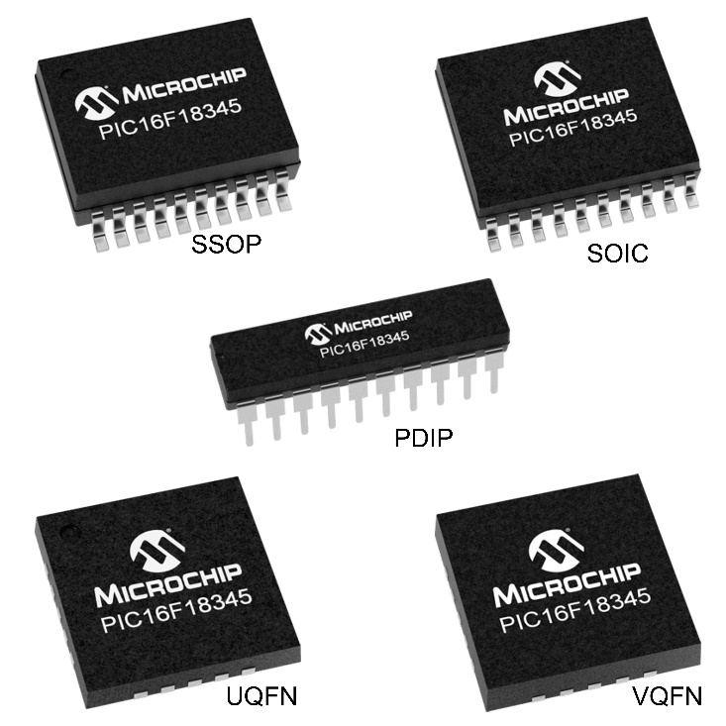
Figure 3 - PIC16F18345 packaging options
The chosen packaging for the initial prototype is the PDIP version (plastic dual in-line package). This was done to accommodate simple prototyping, as through-hole components are unproblematic to manually manipulate. The other alternatives are surface mounted components (figure 3), making them ideal for production runs as they occupy less PCB space. They are also marginally less expensive.

Redesigning the Original System
Since a microcontroller contains all the digital circuitry in figure 1, the design requirements for a microcontroller-based system change substantially. As seen in figure 4 on the next page, the only necessary auxiliary components are analogue system blocks such as buttons, operational amplifiers and LEDs (disregarding the digital LCD). Noise mitigation was accomplished primarily using 100nF capacitors. These values could be subject to change, as the circuit will need real life testing to tune the system to a satisfactory level.
In figure 4, the system is broken down into 8 blocks, where each block has its own connections to the PIC.
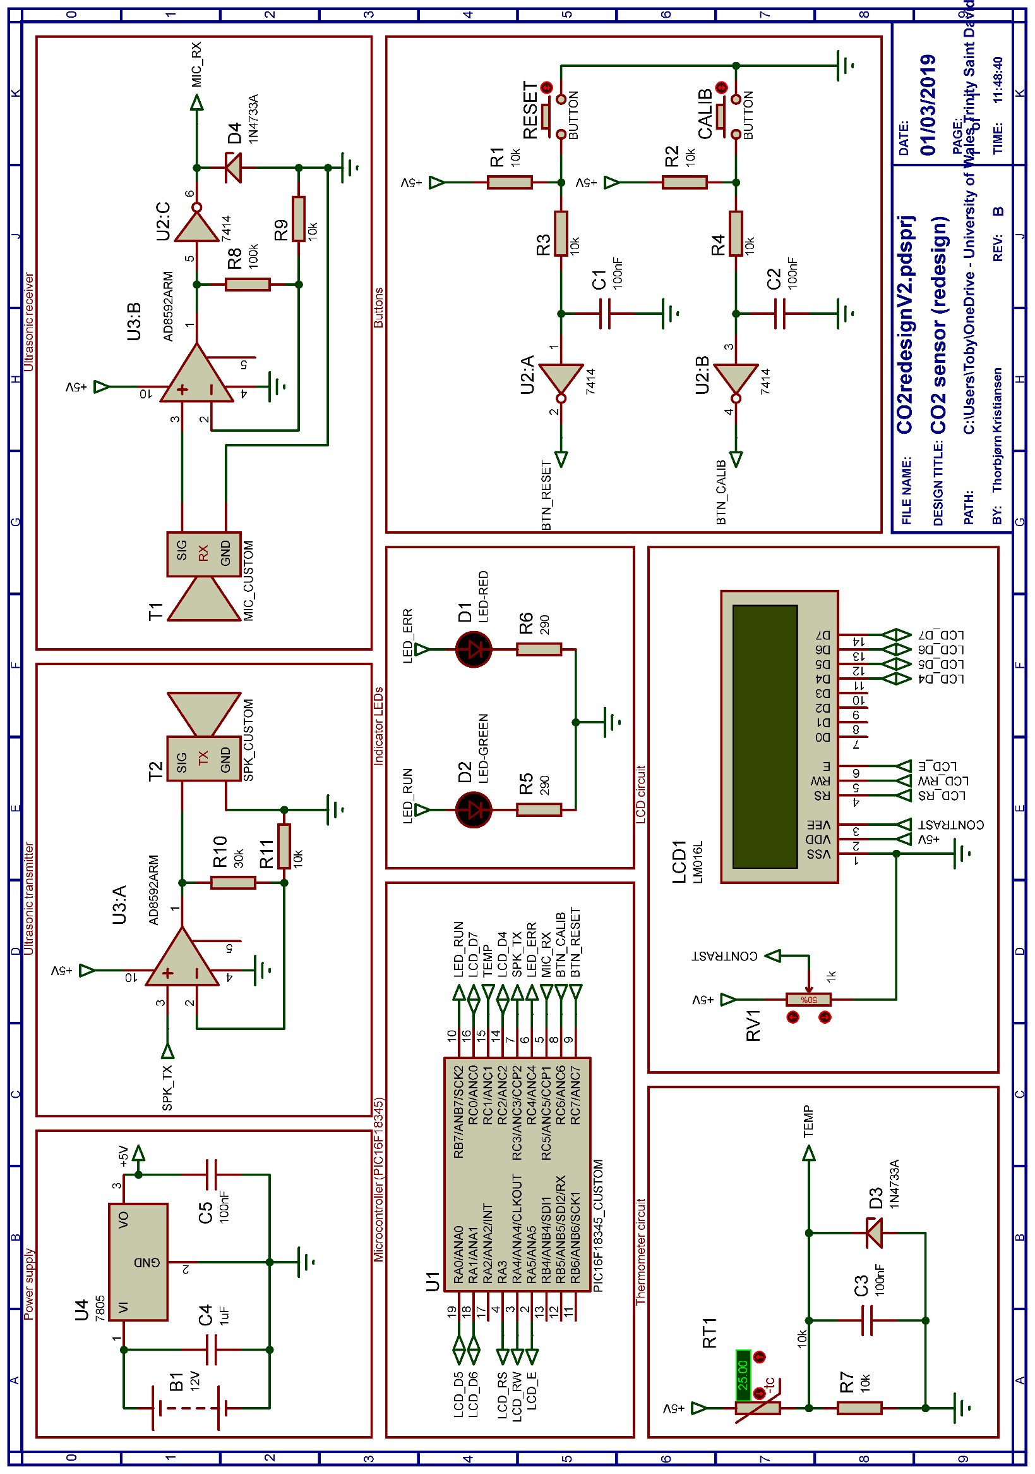
Figure 4 – Electrical schematic diagram for redesigned circuit

Electrical Details
The redesigned circuit is simplistic by nature, in that a microcontroller is performing all digital control operations except for the internal LCD controller. This renders the circuit design minimalistic, so a brief explanation for each block will suffice, where necessary. The power supply is included as an example, as no power supply was specified in the original block diagram.
All operational amplifiers have the negative supply rail grounded, as all signals are on a DC level.

Ultrasonic Transmitter and Receiver
The datasheet for the ultrasonic transmitter does not specify power consumption, only maximum peak to peak input voltage[13]. However, it is reasonable to assume that the transmitter requires some form of amplification, as the PIC has a limited current drive. Amplification was accomplished through the use of a AD8532 dual operational amplifier, chosen for its high current drive capability (250mA)[14].
Gain was calculated by:
$$K=\left(\frac{R10}{R11}\right)+1$$
Since the rail voltage of the amplifier is only 5V, amplification does not make much difference, and the op-amps main purpose is to act as a buffer to provide current drive and a sharper transition due to overloading the amplifier.
The receiver has a gain of 101, which is a preliminary setting as the transmitter/receiver system has not been tested in real life. In the prototyping stage, R8 would be temporarily replaced with a potentiometer to accurately adjust and verify the necessary gain. The output is clamped at 5V, and Schmitt-triggered to provide an adequate edge trigger for the PIC.

Thermometer Circuit
An NTC thermistor was chosen since the resistance decreases as the temperature rises. This gives it a desirable attribute, in that the on-current is relatively low in cold rooms (cellars, refrigerators, etc). The circuit is a simple potential divider with the 5V clamped output feeding directly to the on-chip ADC unit.

Button Inputs
The button system consists of 5V pull-up resistors (R1, R2), debouncing capacitors (C1, C2) and a Schmitt trigger system to provide hysteresis for the debouncing operation. The resistors R3 and R4 provide current limiting when the capacitor discharges, to prevent arcing at the switch point.

Operational Details
As explained in the background research, the speed of sound through air is directly affected by the CO₂ content and temperature. The system is comprised of a transmitter and a receiver placed apart in a passively ventilated chamber. The separation distance is predetermined and must be included in the calibration phase.
When the system starts up, a temperature reading is taken from the thermistor and stored in memory. A 40KHz square wave is outputted from the PWM generator within the chip and sent to the ultrasonic transmitter. At the same time, the timer1 value is reset. When the first ultrasonic pulse reaches the ultrasonic receiver, the signal is amplified and squared. The output of the receiver is coupled to the capture/compare module of the PIC, which saves the value of timer1 to a holding register when the first edge is detected.
This value is therefore the time of flight it takes for the ultrasonic signal to travel from the transmitter to the receiver. Together with the temperature level, a floating-point calculation can be performed to accurately determine the CO₂ content of the air in the chamber.
Calibration can be accomplished by placing the unit in an environment where the exact temperature and CO₂ content are known variables. The calibration button is then pressed, and the unit self-calibrates to these values. The calibration settings can be stored in the internal EEPROM of the PIC.

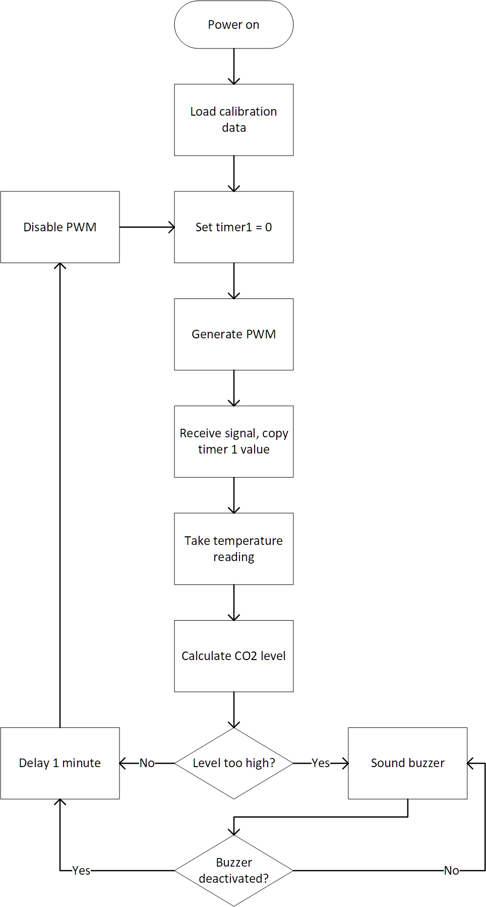
Flowchart
Figure 5 - Ultrasonic system flowchart

Parts List
Component | Manufacturer | Manufacturer  part number | DigiKey part  number | Price | Notes
Microcontroller | Microchip | PIC16F18345-I/P | PIC16F18345-I/P-ND | £1.07 | -
Ultrasonic  transmitter | Murata | MA40S4S | 490-7707-ND | £5.73 | 20v Pk-Pk
Ultrasonic  receiver | Murata | MA40S4R | 490-7706-ND | £5.73 | -
Voltage regulator | Texas Instruments | UA7805CKCS | 296-13996-5-ND | £0.58 | 5V
Thermistor | Littelfuse | PS103J2 | 615-1003-ND | £2.39 | 10kOhm
Operational  amplifier | Analog Devices | AD8532ARMZ | AD8532ARMZ-REELCT-ND | £0.95 | -
Schmitt trigger/  inverter | Texas Instruments | SN7414N | 296-33604-5-ND | £1.84 | 6 channel
LCD | Lumex Opto/  Components Inc. | LCM-S01602DTR/M | 67-1781-ND | £7.23 | No  backlight
Casing | Bud Industries | CU-3011-A | 377-1098-ND | £22.47 | Aluminium  1' long
 |  |  | Sum: | £47.99
Table 3 - Parts list for redesigned system

Contemporary System
Designing a system based on current technology allows for greater flexibility when implementing more functionality than the original system. Microcontrollers have great toolsets built in, completely accessible by software alone.

The PIC18F45K50
When choosing a microcontroller for this task, pin count is paramount. This allows all peripherals to be connected without the need for multiplexers or other external components for I/O expansion. Table 4 is a simple input/output table:
I/O
 | Digital | I2C | UART | Other | SPI
Sensor | 1 | 2
VCC |  |  |  | 1
GND |  |  |  | 1
USB |  |  |  | 4
Buttons | 6
LCD | 7
Bluetooth | 8 |  | 2
SD card |  |  |  |  | 3
Buzzer | 1
 |  |  |  | Sum: | 36

Table 4 - Input/output table for modern system
As seen above, a PIC with at least 36 pins is required. This perfectly coincides with Microchip’s selection, as the closest PIC has 40 pins. A Bluetooth unit is the largest occupier of pins, as it needs a minimum of 7 pins to function satisfactory. In the parametric search function, 5 attributes were specified:
- UART: >0
- SPI: >0
- I2C: >0
- USB: >0
- Pin count: 40
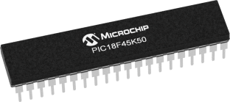
This yielded a result of only 1 PIC, the PIC18F45K50.
Figure 6 - PIC18F45K50

Circuit Details
Since a requirement for this system was USB charging and data passthrough, a choice to lower the supply voltage to 3.3V was made. This was not a problem, as all the components in the schematic have at least 3.3V minimum voltage requirements. The reasoning behind this choice was to remove the need for DC-DC boost converters, as single-cell lithium batteries have a potential of between 3V-4.2V, depending on charge level. USB standard voltage is 5V, which makes single-cell lithium ideal for USB charging.

Schematic Sheet 1
In sheet 1 (figure 7), we find the button array, SD-card interface, warning buzzer, the LCD screen and the sensor module itself. The button array design is identical to the previously discussed circuit. The only changes are a lower supply voltage and more buttons.
The SD-card interface is a simple SPI-based unit, with 2 data lines and 1 clock line. The PIC generates the clock signal, and the SD-card acts as an SPI slave.
The LCD screen was chosen for its lower supply voltage as the circuit is now running on 3.3V.

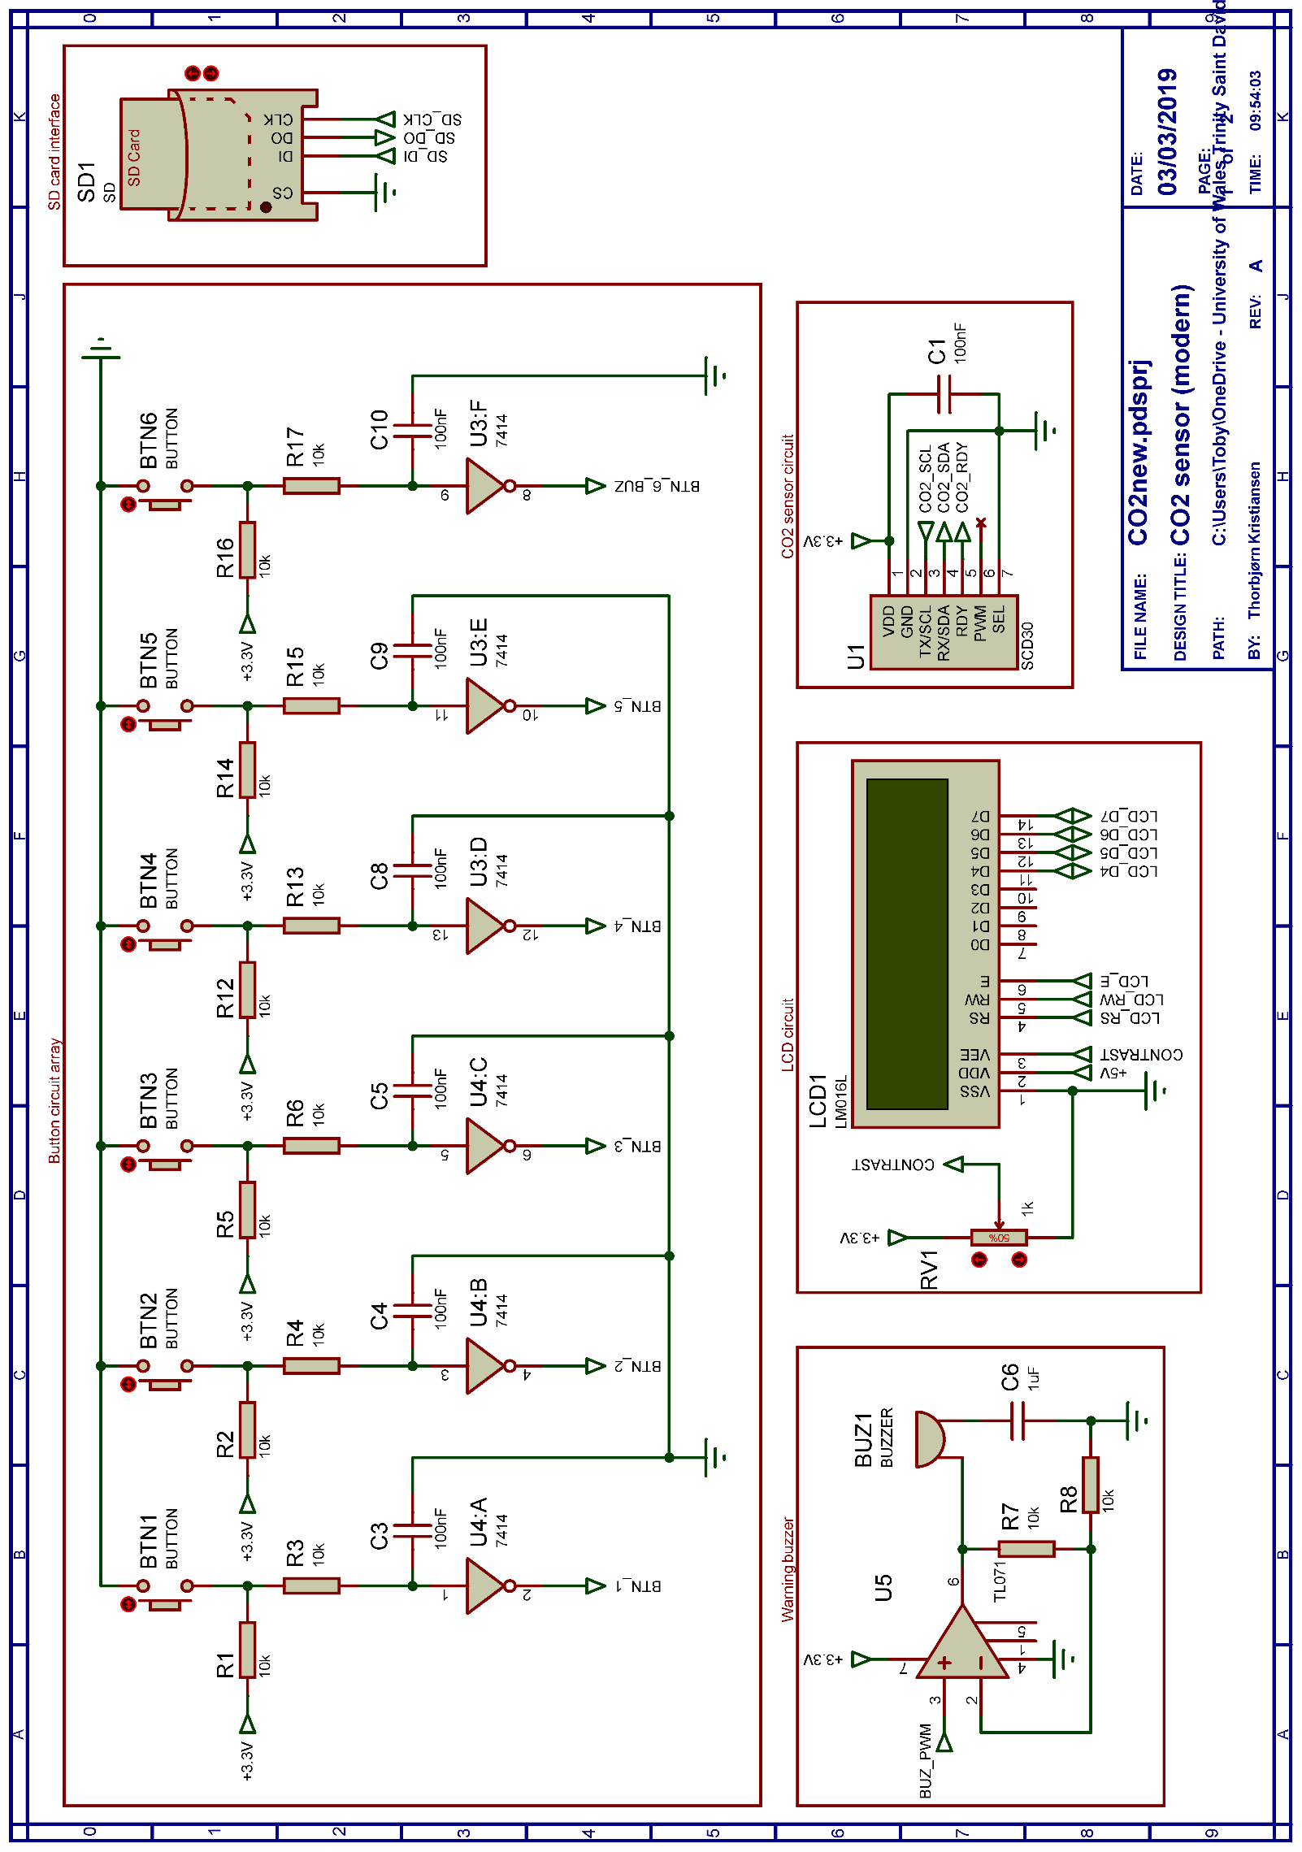
Figure 7 - Modern system circuit diagram (sheet 1/2)

Schematic Sheet 2
Sheet 2 (figure 8, next page) contains the microcontroller itself, the power supply and the Bluetooth module. The RN4020 Bluetooth module from Microchip offers MLDP (Microchip Low-energy Data Profile), which can transmit data at a lower power consumption than standard Bluetooth modems. If a baud rate of 2400 is selected, the module does not need to be fully awake for data transmission to happen. The three LEDs provides information on connection status, on-status and transmission status.
The power supply is sourced from 2 lithium cells in parallel. This offers higher capacity, but the cells need to be closely matched to prevent short cell life or dangerous situations such as high quiescent currents between the cells due to differing internal resistances and charges. A 3.3V voltage regulator regulates and supplies the entire system. The charger (LTC4053) can supply up to 500mA, which is the limit for most USB hosts. A 10k NTC thermistor monitors the battery temperature, offering safer charge control in case of overheating. The charge current is also selectable, with options of 100mA and 500mA. In the current configuration, the charge current is set to max (500mA). Since the voltage regulator can supply a maximum of 200mA and the batteries have a 6700mAh capacity, the worst-case battery life can be calculated:
$$\frac{6700mAh}{200mA}×0.7=23.45h$$
In this equation, the 0.7 is a “consumption rate” factor (provided by Digi-Key[15]), which attempts to correct the equation for real-life factors such as battery wear and temperature changes. Since the system will never reach 200mA, a more sensible approach would be to halve the current consumption. This is still a very conservative approach, as most of the components in the circuit draw less than 100mA. The unit can therefore comfortably operate for 24 hours on a single charge. $\frac{6700mAh}{100}×0.7=46.9h$
The PIC itself has 3 available I/O ports for future expansion. The power supply and ground pins are not visible in this schematic. Pin 18 (VUSB3v3) is coupled to ground through a ceramic low-ESR capacitor, as per the datasheet instructions.

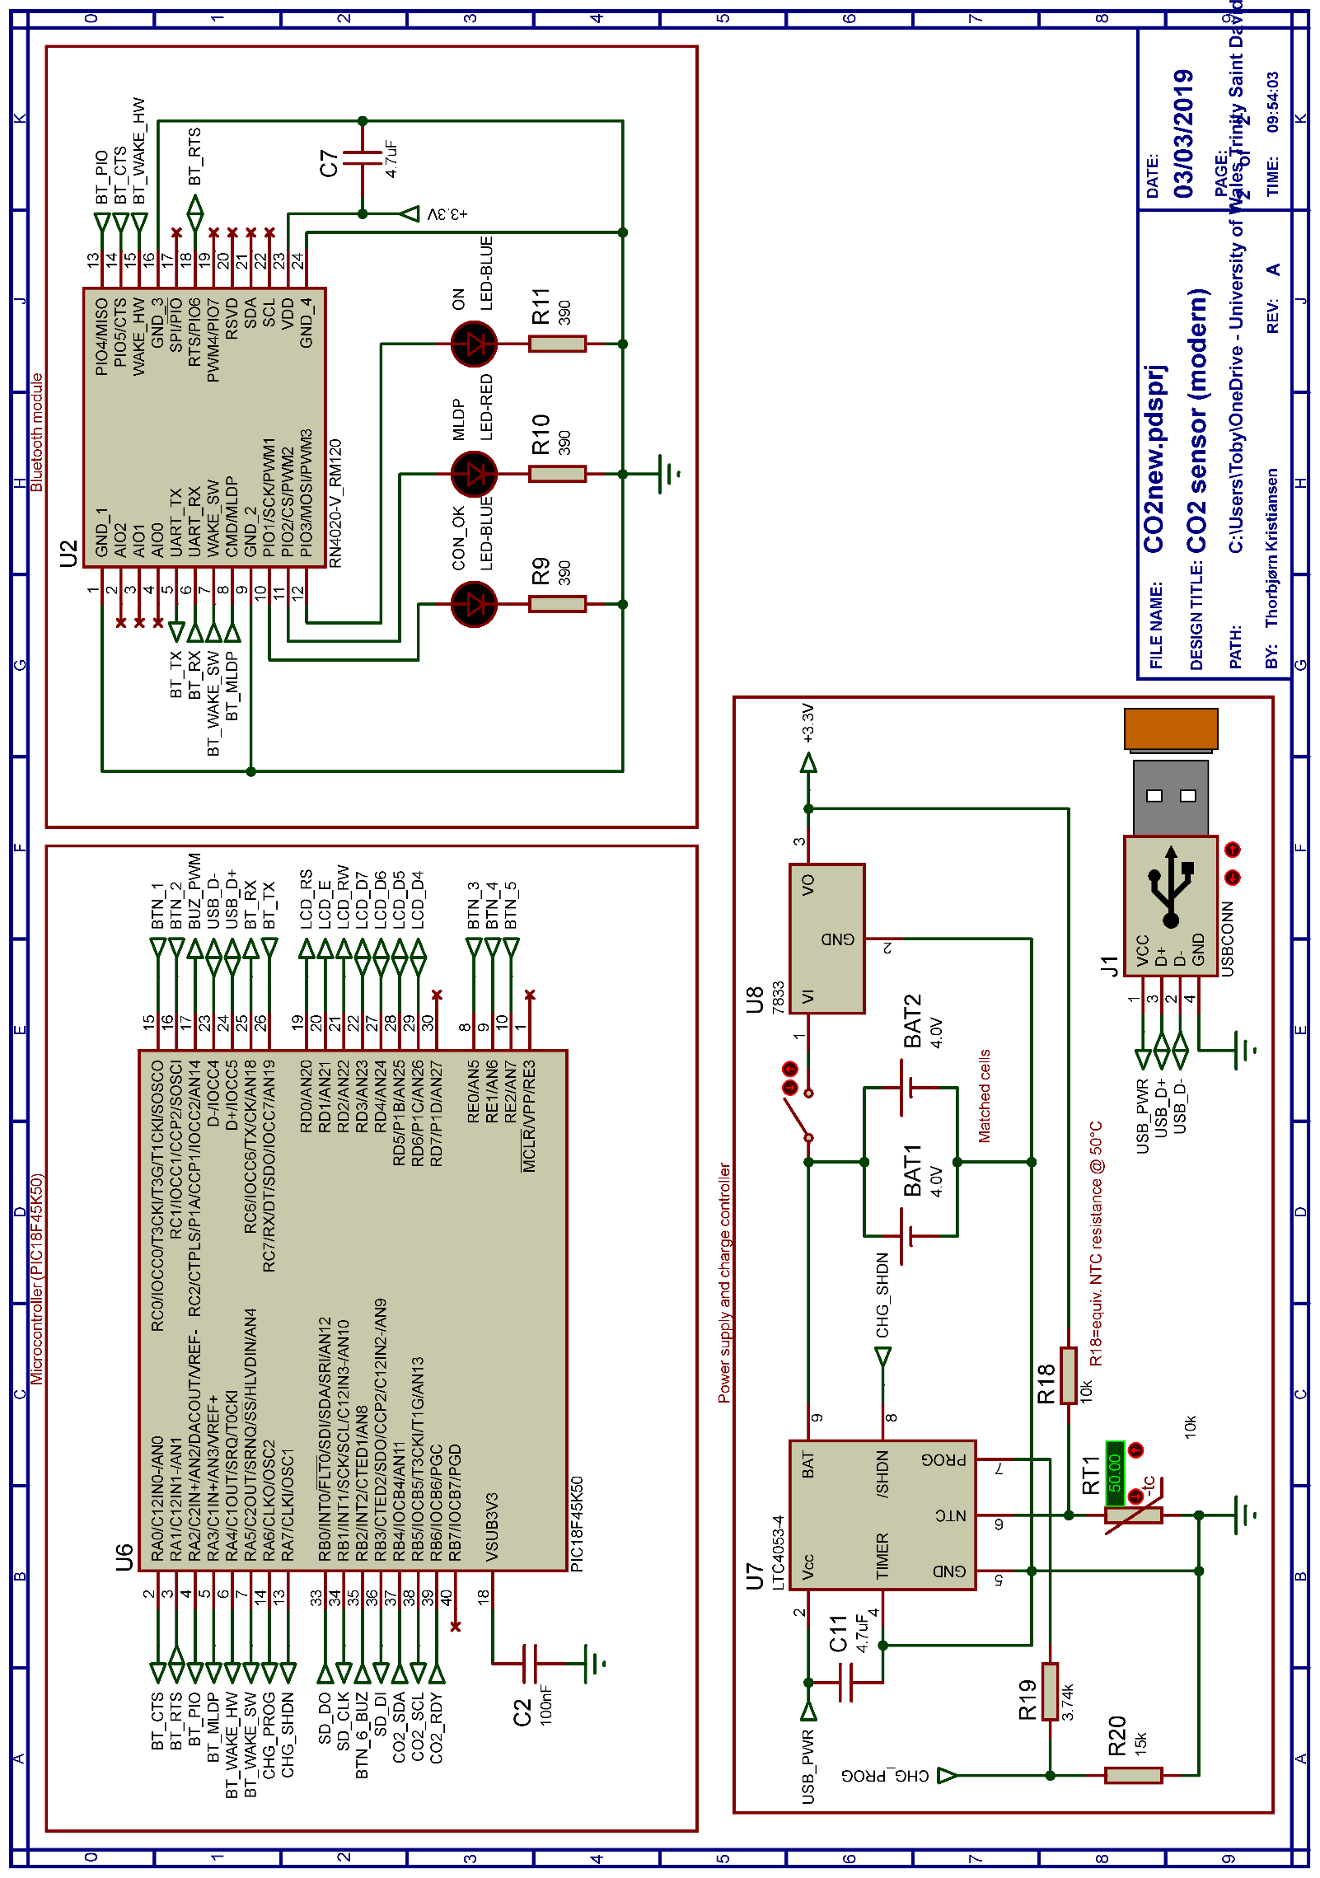
Figure 8 - Modern system circuit diagram (sheet 2/2)

Principle of Operation
This sensor system is based on an I2C protocol between the sensor module and microcontroller. The sensor module itself is an NDIR sensor, which is not reliant on a chamber of a certain size like the ultrasonic version.
On the next page, in figure 9, the flowchart explains the operation of the program during normal use. At first, the user is prompted with a voluntary setup routine. If declined, the system will run as normal but without Bluetooth or SD-card capabilities. The setup routine also prompts the user with inputting the date/time.
When the normal program flow starts, a CO₂ measurement is taken. If the level is too high, the program sets a flag. The purpose of this flag is to create a different time interval so the user can temporarily disable the buzzer. The buzzer only gets permanently deactivated if the CO₂ level drops to a safe level.
The interrupt routine handles both the silencing of the buzzer and a system-wide reset if necessary. It accomplishes this by recording the button depression time and executing a system reset and SD-card wipe if the button is depressed for more than 5 seconds. If the button is pressed in rapid succession, the PIC records this, and if it reaches 5 depressions, it takes the user into setup mode without the user having to power off beforehand.

Flowchart
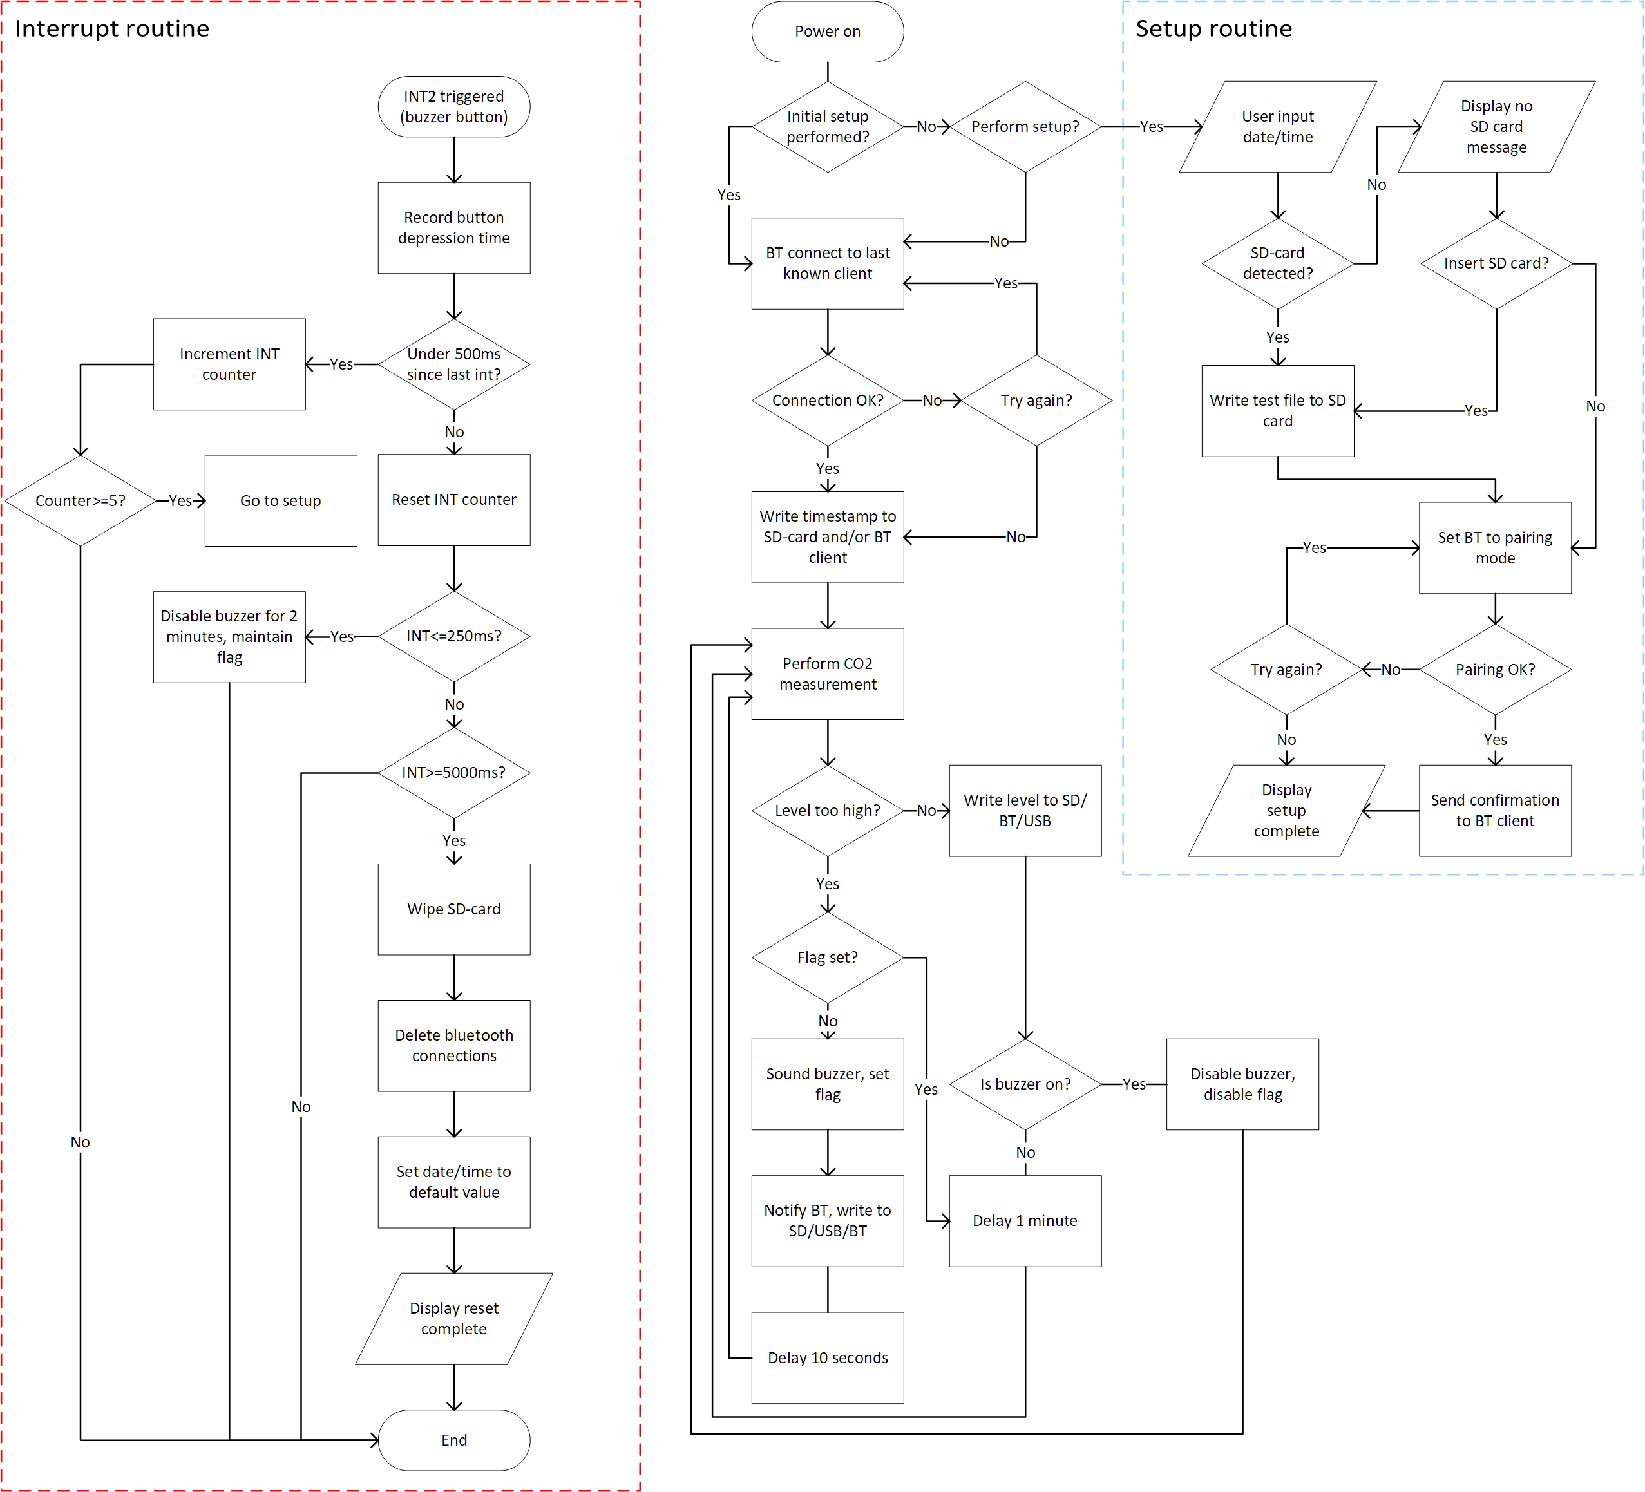
Figure 9 - Modern system flowchart

Parts List
Component | Manufacturer | Manufacturer  part number | Vendor | Vendor part  number | Price | Notes
PIC[16] | Microchip | PIC18F45K50-I/P | DigiKey | PIC18F45K50-I/P-ND | £2.26
Bluetooth  module[17] | Microchip | RN4020-V/RM120 | DigiKey | RN4020-V/RM120-ND | £6.81
Charging IC[18] | Linear Technology | LTC4053EDD-4.2#PBF | DigiKey | LTC4053EDD-4.2#PBF-ND | £2.88 | 500mA
Voltage  regulator[19] | Texas Instruments | TLV70033DDCR | DigiKey | 296-27937-1-ND | £0.36 | 200mA
Batteries[20] | Panasonic | PICPAULLNB46 | Farnell | 2819211 | £39.73 | 1S2P configuration
Thermistor[21] | Littelfuse | PS103J2 | DigiKey | 615-1003-ND | £2.39 | 10kOhm
CO2 sensor[22] | Sensirion AG | SCD30 | DigiKey | 1649-1098-ND | £43.06 | NDIR
LCD[23] | FORDATA | FC1602N04-  NSWBBW-91*E | Farnell | 2674135 | £12.47 | Transmissive
Op amp[24] | Texas Instruments | TL071IP | DigiKey | 296-7188-5-ND | £0.42
Schmitt trigger/  inverter[25] | Texas Instruments | SN7414N | DigiKey | 296-33604-5-ND | £1.84 | 6 channel
Casing[26] | Hammond | 1554DGY | Farnell | 4080828 | £9.76 | IP66
Buttons[27] | Grayhill | 87HC3-201 | DigiKey | 87HC3-201-ND | £11.80 | 6x1 matrix
Buzzer[28] | Pro Signal | ABI-042-RC | Farnell | 1827949 | £1.96 | 80dB
 |  |  |  | Sum: | £135.74
Table 5 - Modern system parts list

Conclusion
Embedded microcontrollers are very practical for purpose-specific applications such as CO₂ detection. Eliminating the need for full size computers proves very practical when size and portability is desirable. Older systems utilised discreet logic and modular digital chips, rendering the PCB complex and expensive. Collecting all digital circuitry on a small microcontroller makes the system smaller, more efficient and more portable. With the high energy density of lithium battery packs, the system can be designed to last for days without human intervention or charging.

User Manual
Contents:
- Device overview
- Initial setup
- Changing default values
- Data logging on SD-card
- USB connection
- Bluetooth connection
Device Overview
The CO₂ detector has been crafted with usability, stability and safety in mind. The system consists of a splash-proof case with the sensor opening on top and an LCD display moulded into the casing. The female USB connector is located to the side of the unit. To access the SD-card tray, simply unscrew the 4 screws holding the lid of the unit in place.
To navigate the different menus, 4 arrow keys and an “OK” button is placed on the top of the unit. A button to deactivate the buzzer is also present.
The unit has an internal rechargeable battery pack which is guaranteed to last at least 36 hours for logging purposes.
Initial Setup
To start using the device, power it on by connecting the battery pack to the connector on the printed circuit board and flip the main switch on the side of the unit. The LCD screen will then display “Perform setup?”.
The setup is not mandatory for operating the device but is necessary if logging and connective capabilities are required.
Perform the setup by first entering the date and time with the arrow keys. Press OK to confirm. The next screen will show “Insert SD-card?” if the card is not already present. Insert the SD-card if applicable. To skip this step, press the right arrow. When the SD-card is inserted, the device will write a test file in the .txt format to the SD-card. Please ensure proper operation by inserting the SD-card into a computer and confirming the output.
The device will now go into Bluetooth pairing mode. To connect, simply select the “EasyCO2” unit in the device list of your Bluetooth device. If the pairing is successful, the display will show “Setup complete” and automatically start its normal sequence of operations. If pairing is unsuccessful, an option to try again or skip appears.
Setup can be easily accessed at any time by pressing the buzzer button 5 times in rapid succession.
Normal Operation
The device requires no maintenance or user intervention during normal operation. If the CO₂ level should rise to an unsafe level, a buzzer will sound. A notification will also be sent to any connected Bluetooth devices, displaying the current CO₂ content and urging the user to investigate the cause of the problem.
Pressing the buzzer button will deactivate the buzzer for 2 minutes. The unit will now start taking readings every 10 seconds as opposed to every minute. This is designed to aid with troubleshooting, as ventilating the room will have an immediate effect on the CO₂ level of the room.
Resetting the Unit to Factory Settings
To reset all values and delete the list of Bluetooth clients, hold down the buzzer button for 5 seconds. This will display the message “reset complete” on the LCD screen.
Note: Resetting the device to factory settings also deletes all information stored on the SD-card. Proceed with caution.

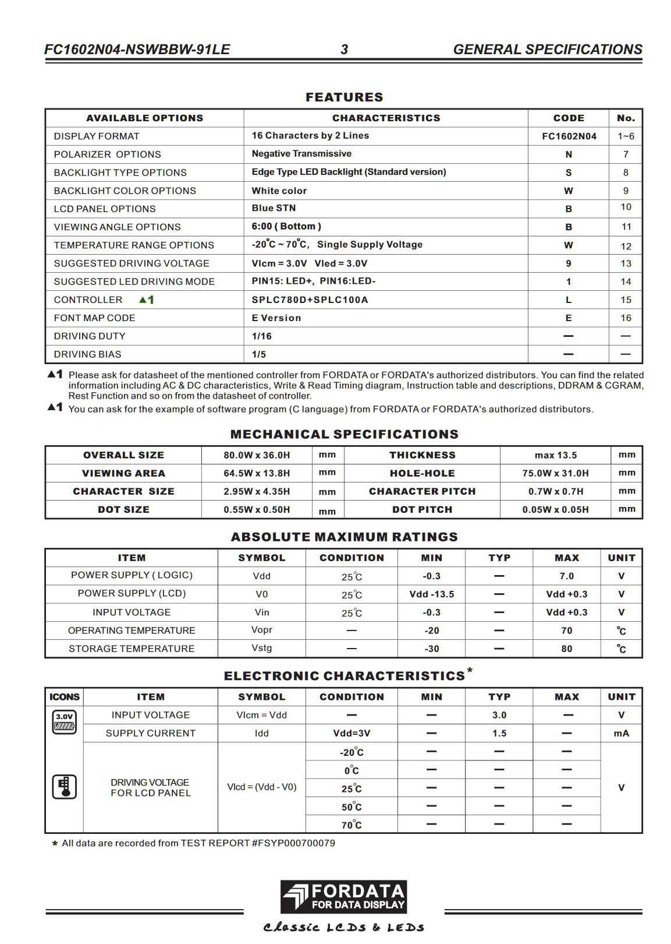
Appendix: Datasheet Snippets
Figure 10 - 3V LCD datasheet snip

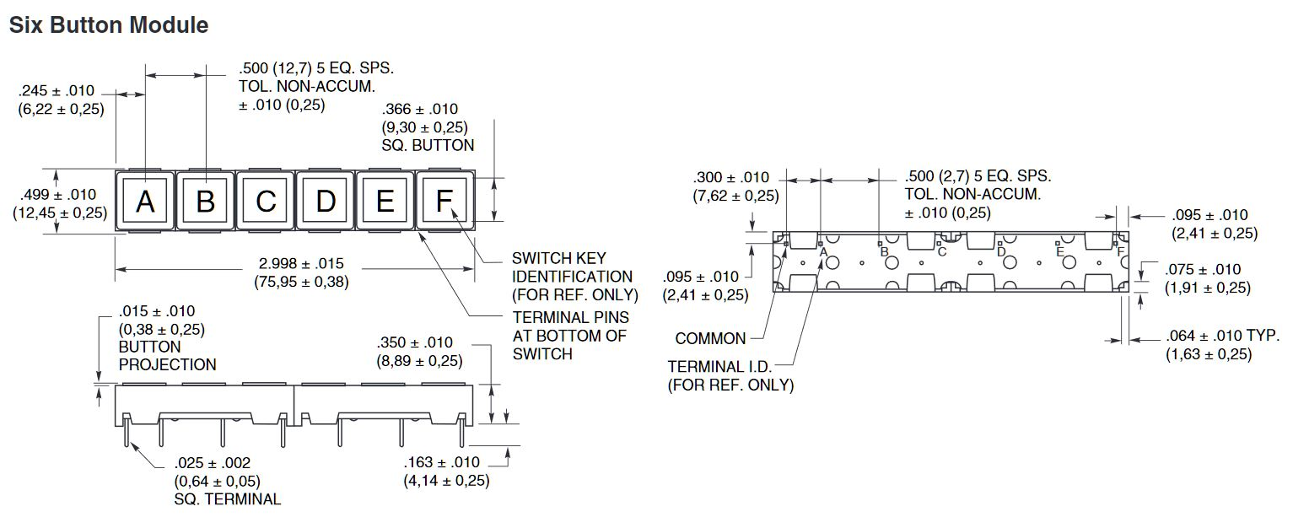
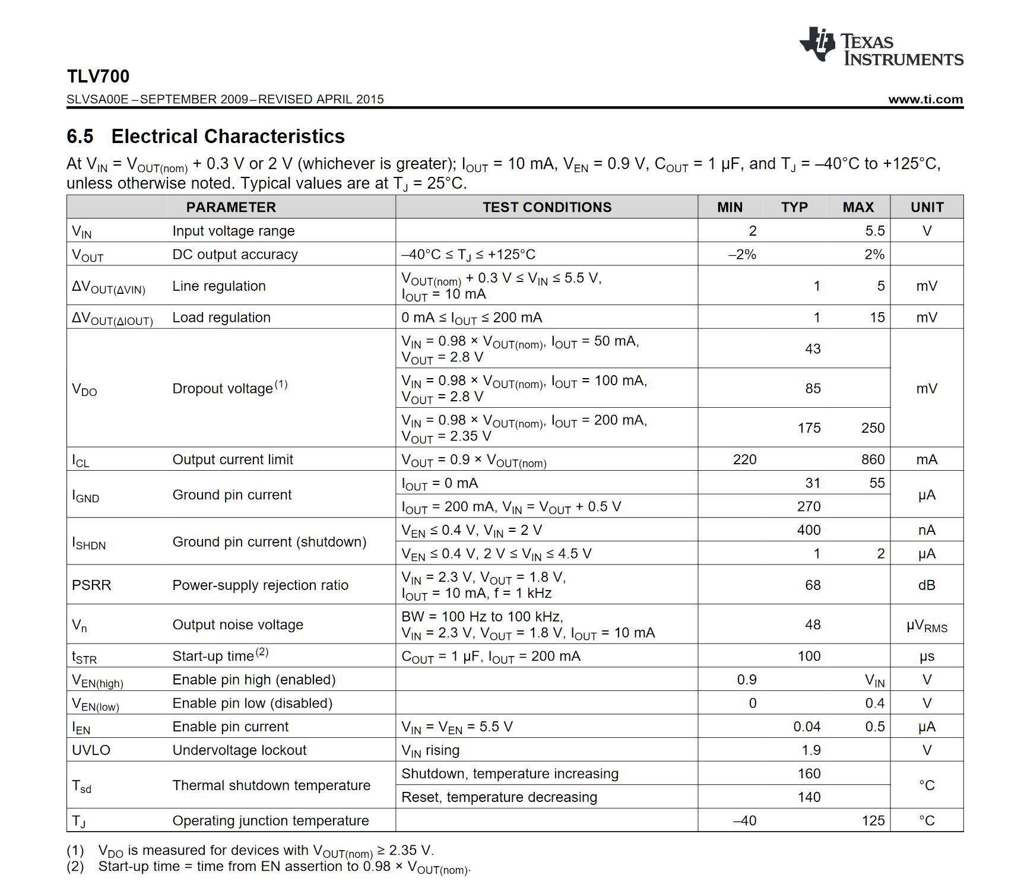
Figure 11 - Button matrix datasheet snip
Figure 12 - 3v3 voltage regulator datasheet snip
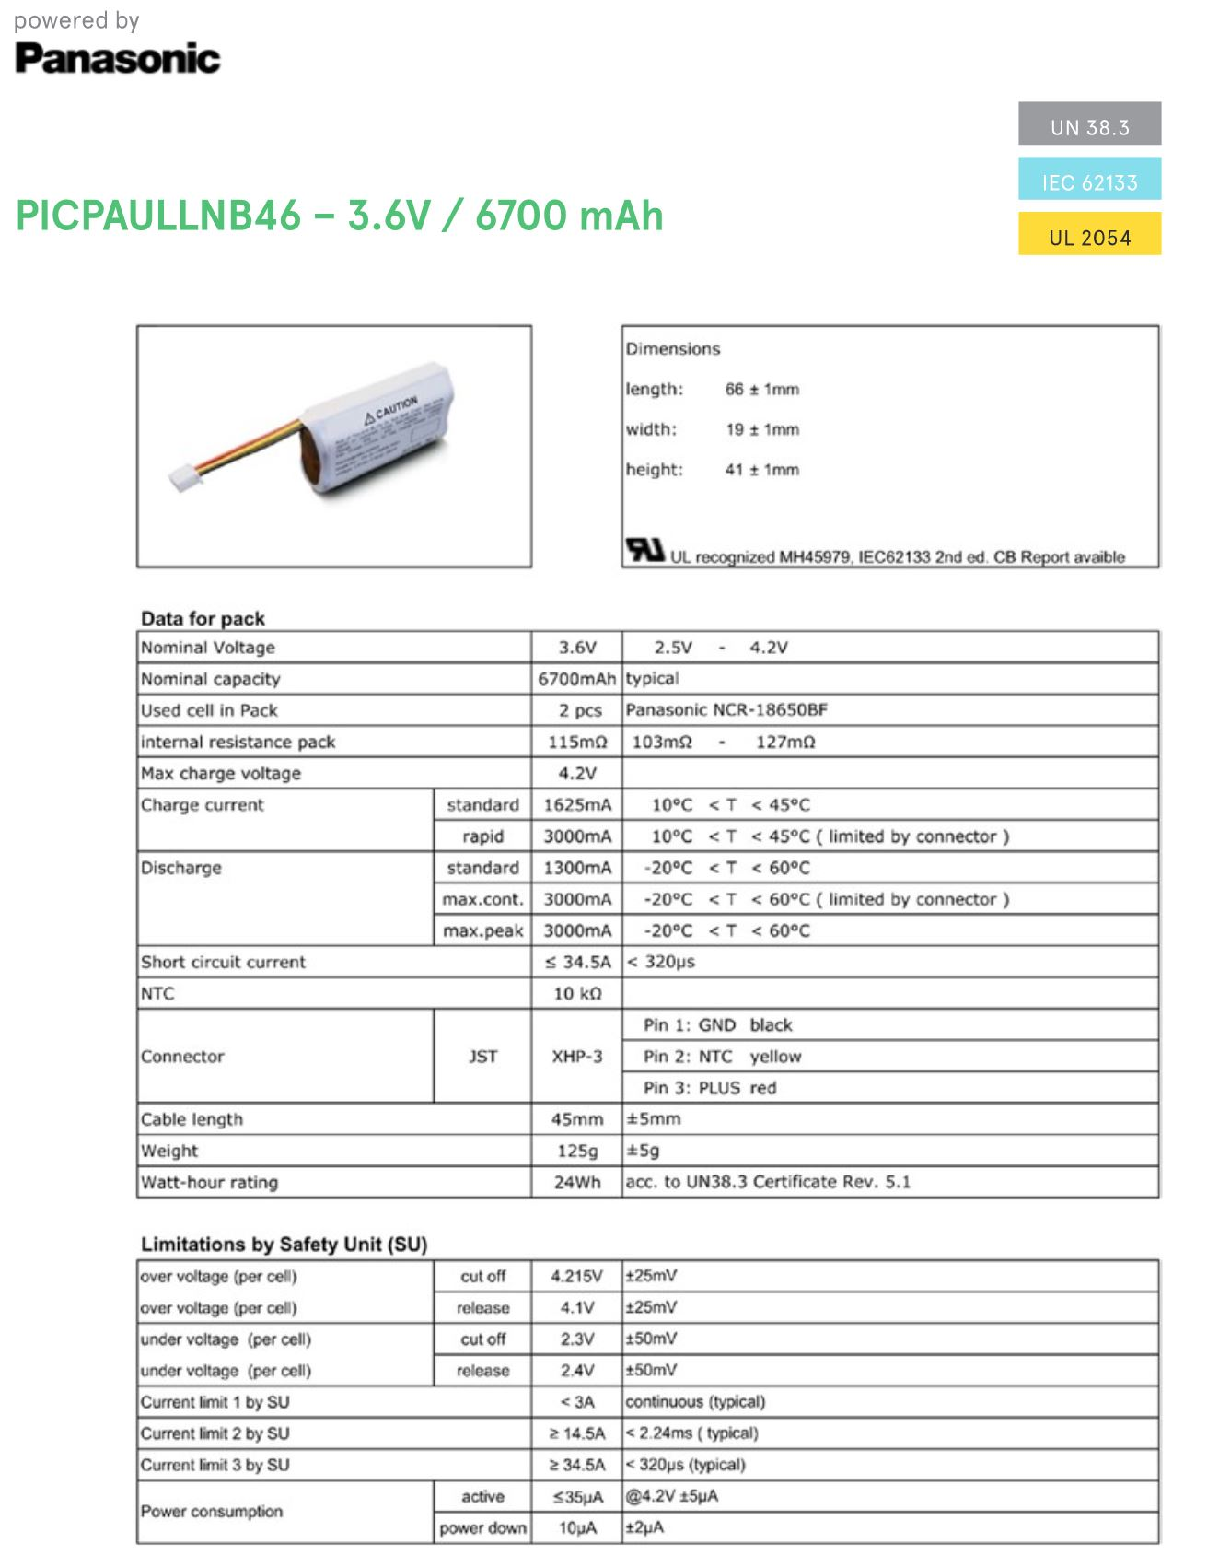
Figure 13 - Battery datasheet snip
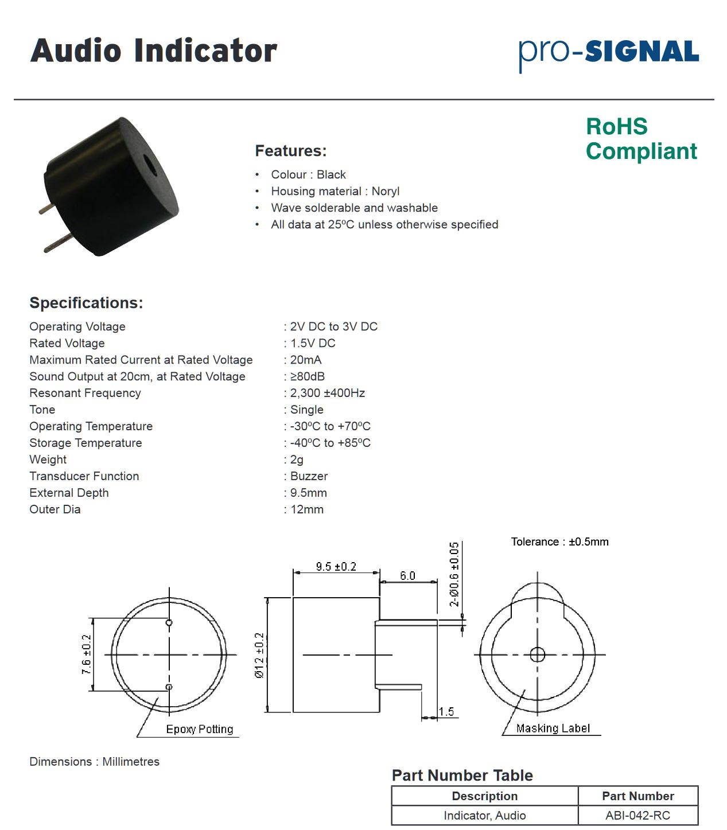
Figure 14 - Buzzer datasheet snip
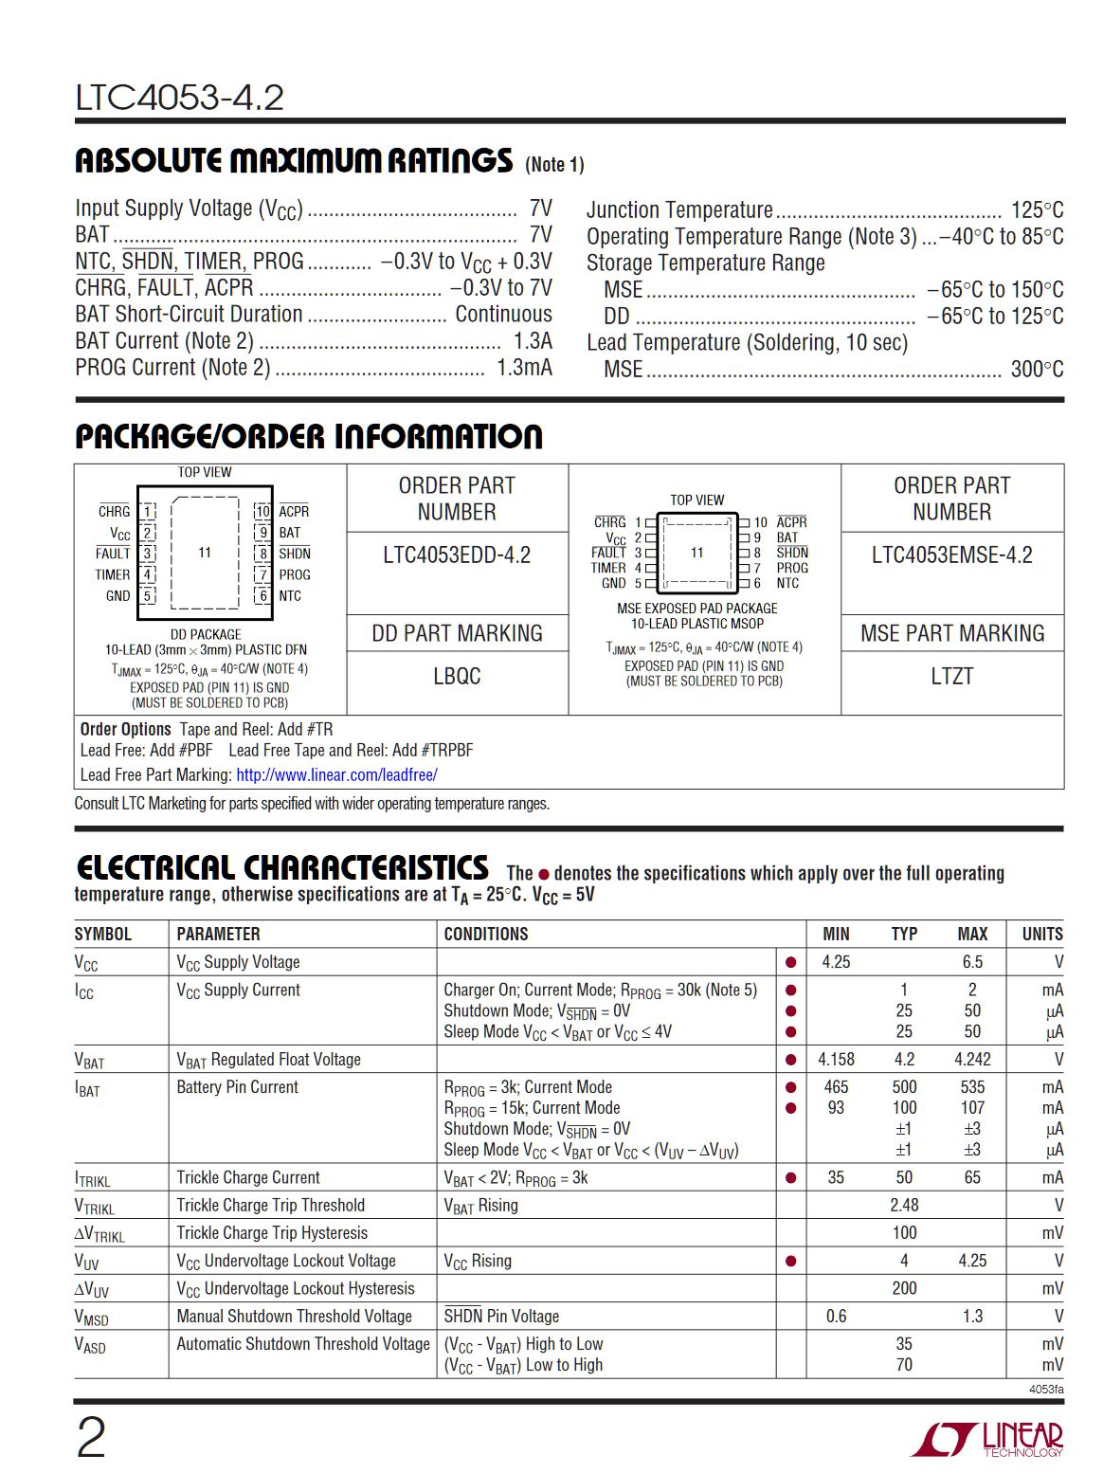
Figure 15 - Charging IC datasheet snip
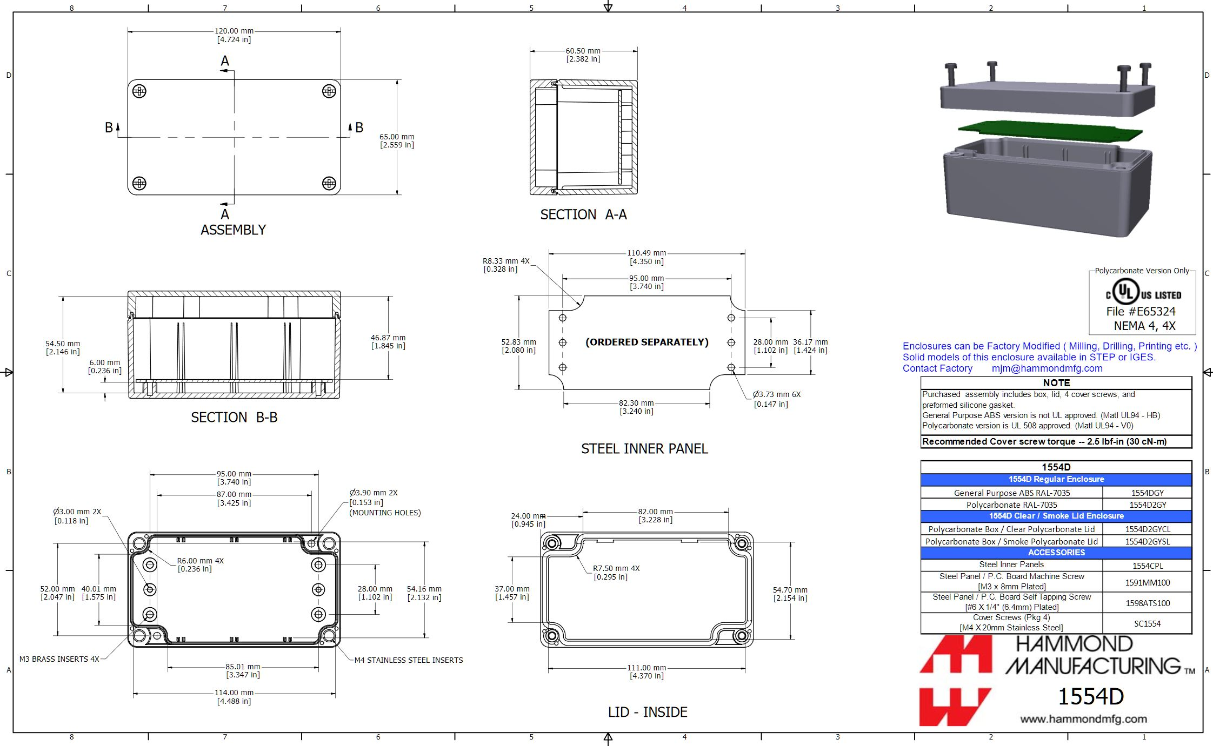
Figure 16 - Enclosure datasheet snip
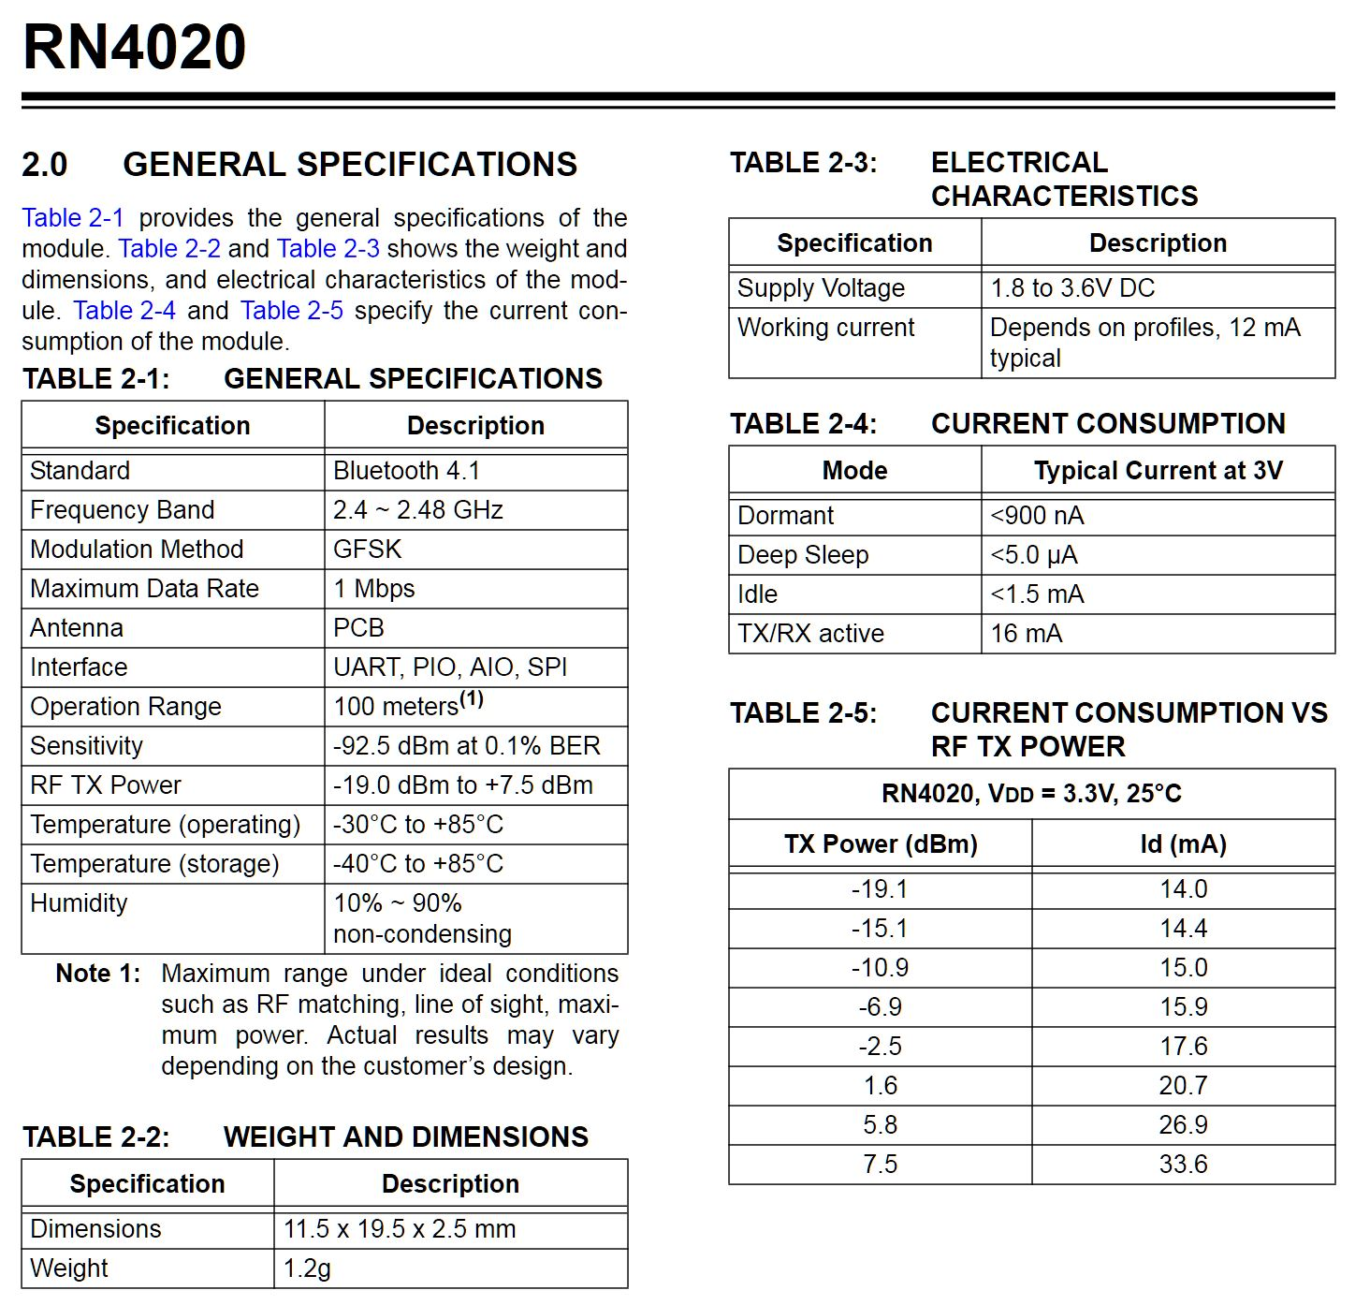
Figure 17 - Bluetooth module datasheet snip

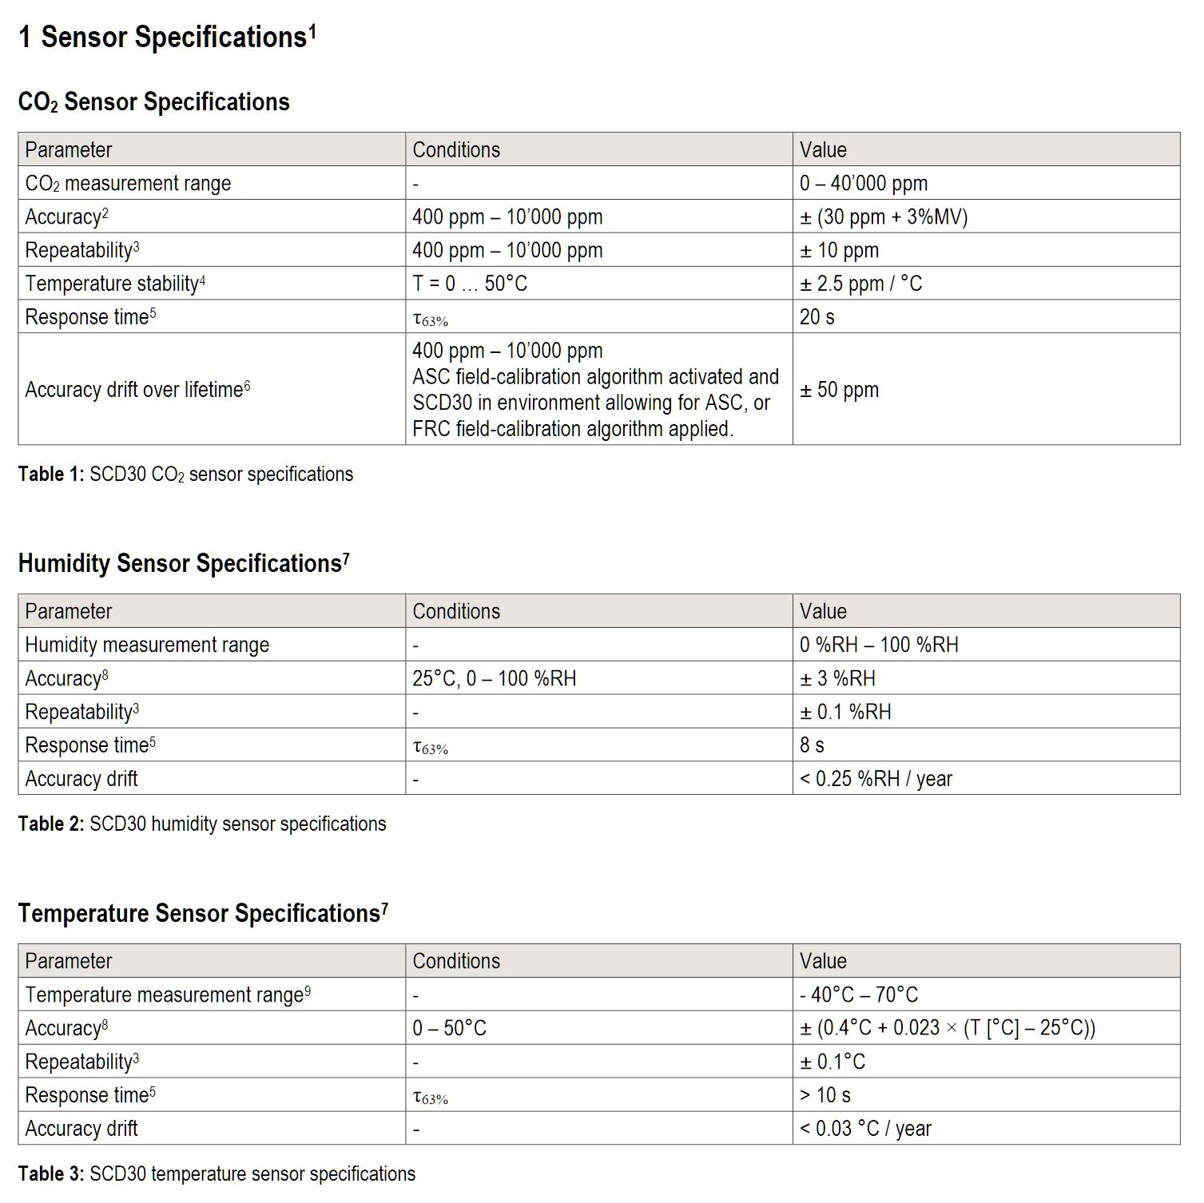
Figure 18 – CO₂ sensor datasheet snip
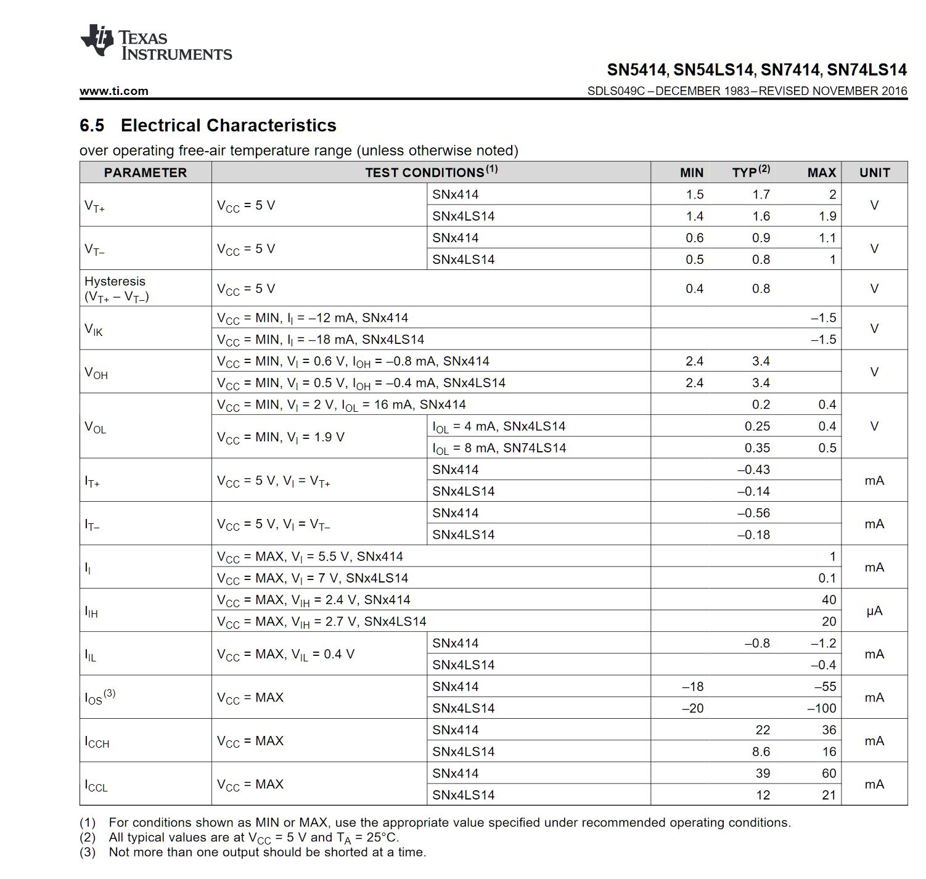
Figure 19 - Schmitt trigger/inverter datasheet snip
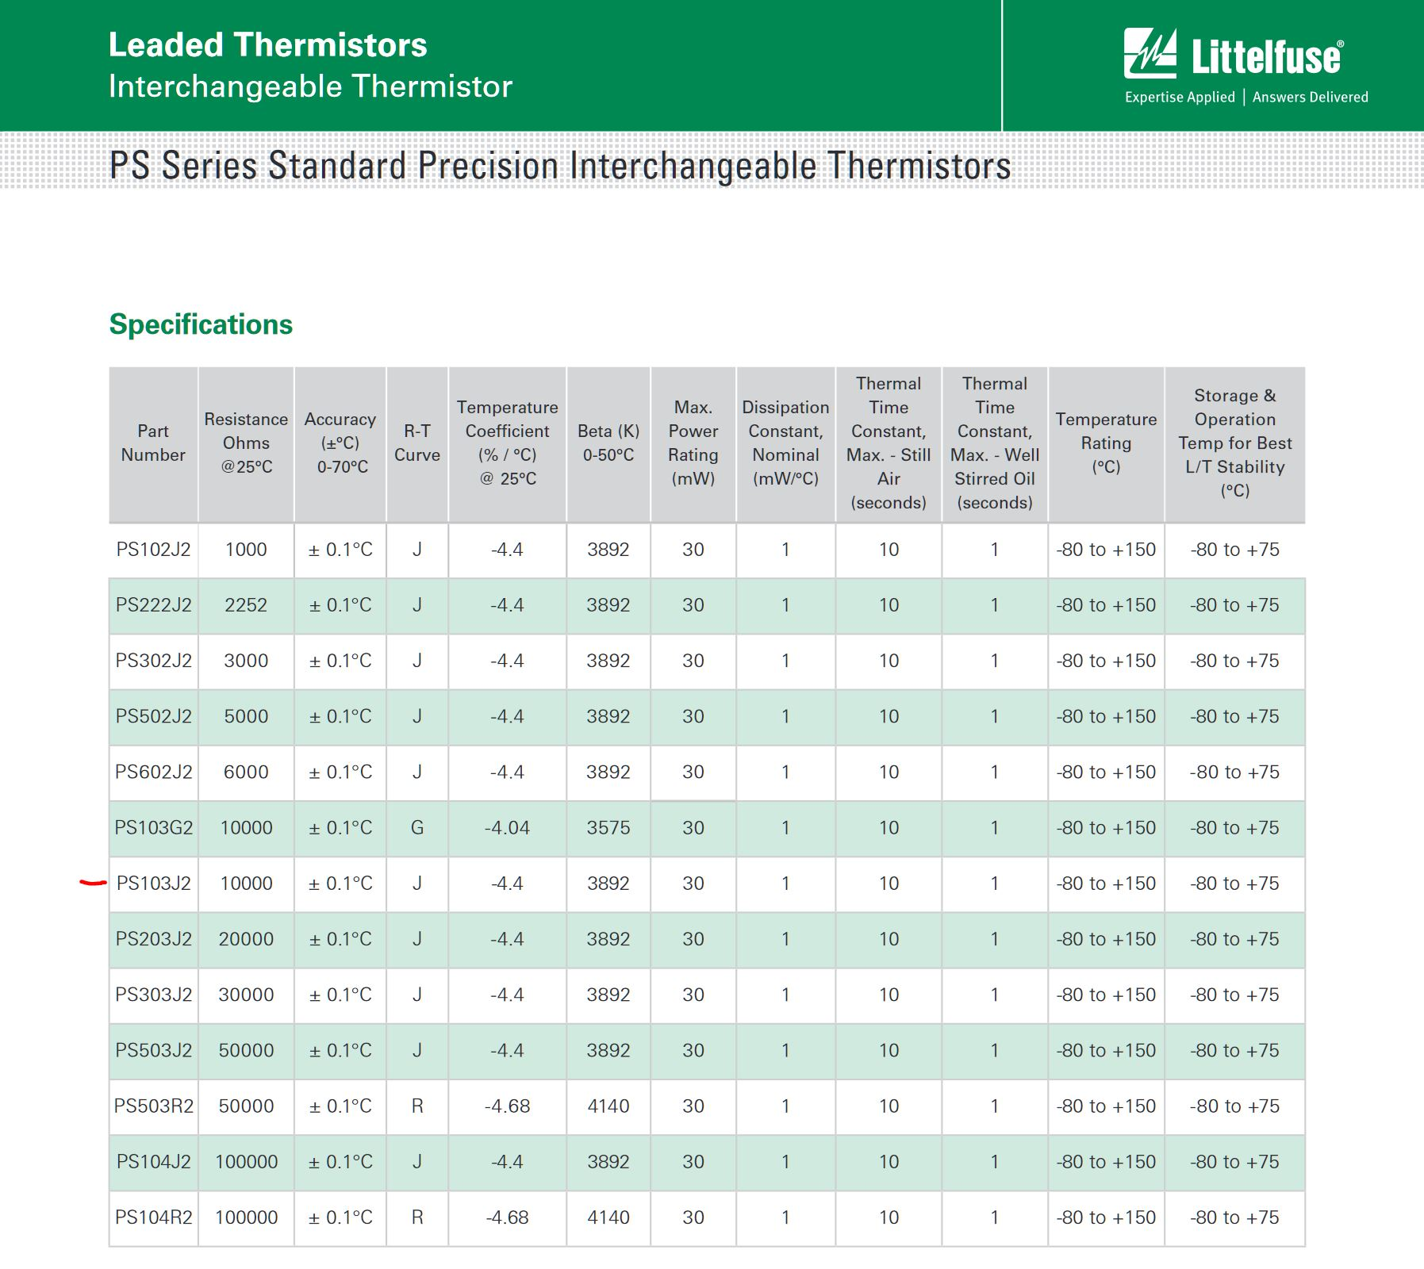
Figure 20 - Thermocouple datasheet snip (see red mark)
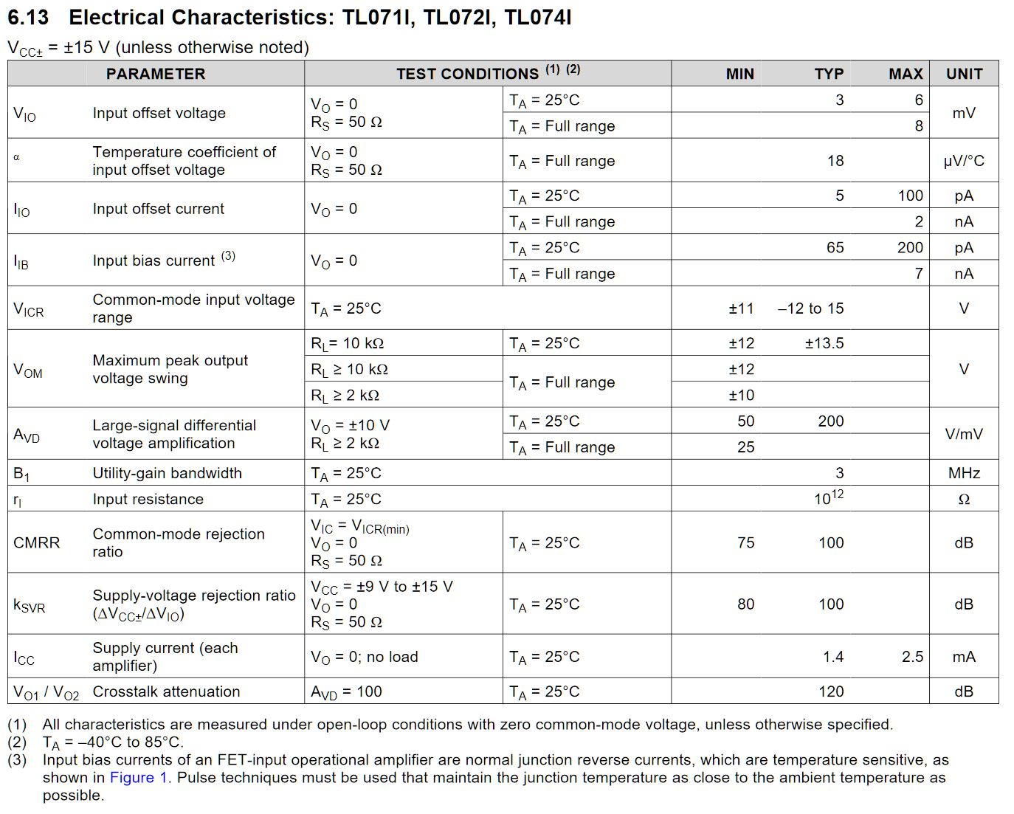
Figure 21 - TL071 Opamp datasheet snip

References
[1] Centers for Disease Control and Prevention, “Carbon Dioxide.” [Online]. Available: https://www.cdc.gov/niosh/idlh/124389.html. [Accessed: 03-Mar-2019].
[2] B. Wang, G. Somesfalean, L. Mei, H. Zhou, C. Yan, and S. He, “DETECTION OF GAS CONCENTRATION BY CORRELATION SPECTROSCOPY USING A MULTI-WAVELENGTH FIBER LASER,” 2011.
[3] B. A. Rosen, A. Salehi-Khojin, and R. I. Masel, “A microfabricated carbon dioxide sensor for portable applications,” in 2010 IEEE Sensors, 2010, pp. 365–368.
[4] S. Z. Ali et al., “Low power NDIR CO2 sensor based on CMOS IR emitter for boiler applications,” in IEEE SENSORS 2014 Proceedings, 2014, pp. 934–937.
[5] MOS Technology, “MCS6500 Microprocessors,” 1976. [Online]. Available: https://www.mdawson.net/vic20chrome/cpu/mos_6500_mpu_preliminary_may_1976.pdf.
[6] Motorola, “MCM6464C RAM,” 1995. [Online]. Available: http://users.ece.utexas.edu/~valvano/Datasheets/MCM6264.pdf.
[7] Microchip Technology Inc, “27C256 EPROM,” 2004. [Online]. Available: https://www.jaapsch.net/psion/pdffiles/Eprom032k_datasheet_27C256.pdf.
[8] NEC Microcomputers, “PD7002 A/D Converter.” [Online]. Available: http://stardot.org.uk/mirrors/www.bbcdocs.com/filebase/hardware/datasheets/PD7002-pdf.pdf.
[9] Texas Instruments, “SN54HC590A 8-bit Counter,” 2003. [Online]. Available: https://www.ti.com/lit/ds/symlink/sn74hc590a.pdf.
[10] MOS Technology, “MCS6522 Versatile Interface Adapter,” 1977. [Online]. Available: http://archive.6502.org/datasheets/mos_6522_preliminary_nov_1977.pdf.
[11] Dallas Semiconductor, “DS1232 MicroMonitor Chip.” [Online]. Available: https://datasheets.maximintegrated.com/en/ds/DS1232.pdf.
[12] ST Microelectronics, “24C02 EEPROM,” 1997. [Online]. Available: https://www.engineersgarage.com/sites/default/files/Serial EEPROM 24C02.pdf.
[13] muRata, “MA40S4S Ultrasonic Transmitter,” 2015.
[14] Analog Devices, “AD8532 Dual OpAmp,” 2008. [Online]. Available: https://www.analog.com/media/en/technical-documentation/data-sheets/AD8531_8532_8534.pdf.
[15] Digi-Key, “Battery Life Calculator | DigiKey Electronics.” [Online]. Available: https://www.digikey.co.uk/en/resources/conversion-calculators/conversion-calculator-battery-life. [Accessed: 03-Mar-2019].
[16] Microchip Technology Inc, “PIC18F45K50,” 2014. [Online]. Available: http://ww1.microchip.com/downloads/en/DeviceDoc/PIC18F2X_45K50-30000684B.pdf.
[17] Microchip Technology Inc, “RN4020 Bluetooth® Low Energy Module,” 2015. [Online]. Available: http://ww1.microchip.com/downloads/en/DeviceDoc/50002279B.pdf.
[18] Linear Technology, “LTC4053 Charger.” [Online]. Available: https://www.analog.com/media/en/technical-documentation/data-sheets/4053-4.2fs.pdf.
[19] Texas Instruments, “TLV70033DDCR Voltage regulator,” 2015. [Online]. Available: http://www.ti.com/lit/ds/slvsa00e/slvsa00e.pdf.
[20] Avnet, “Panasonic PICPAULLNB46 Battery.” [Online]. Available: http://www.farnell.com/datasheets/2585501.pdf?_ga=2.233023067.410702796.1551631400-1021869973.1545040726.
[21] Littelfuse, “Littelfuse PS103J2,” 2018. [Online]. Available: https://www.littelfuse.com/~/media/electronics/datasheets/leaded_thermistors/littelfuse_leaded_thermistors_interchangeable_thermistors_standard_precision_ps_datasheet.pdf.pdf.
[22] Sensirion, “Sensirion SCD30Sensor Module,” 2018. [Online]. Available: https://media.digikey.com/pdf/Data Sheets/Sensirion PDFs/CD_DS_SCD30_Datasheet_D1.pdf.
[23] Fordata, “FC1602N04-NSWBBW-91*E LCD.”
[24] Texas Instruments, “TL07xx Low-Noise JFET-Input Operational Amplifiers,” 2017. [Online]. Available: http://www.ti.com/lit/ds/symlink/tl071a.pdf.
[25] Texas Instruments, “SNx414a nd SNx4LS14 Hex Schmitt-Trigger Inverters.” [Online]. Available: http://www.ti.com/lit/ds/symlink/sn7414.pdf.
[26] Hammond Manufacturing, “1554DGY enclosure.” [Online]. Available: http://www.farnell.com/datasheets/1816763.pdf?_ga=2.262237129.410702796.1551631400-1021869973.1545040726.
[27] Grayhill, “87HC3-201 switch array.” [Online]. Available: http://www.grayhill.com/assets/1/7/Keypads_87.pdf.
[28] Pro Signal, “ABI-042-RC,” 2013. [Online]. Available: http://www.farnell.com/datasheets/1685314.pdf?_ga=2.23359359.410702796.1551631400-1021869973.1545040726.

Bibliography
P. Horowitz and W. Hill, The Art Of Electronics, 3rd ed. Cambridge University Press, 2016.

