STUDENT FEEDBACK FORM
Student name: | Rhiannon Clapham | Student ID number: | 2420536
Programme: | HNC Electrical/Electronic Engineering & Instrumentation Engineering
Module: | Embedded Systems
Module code: | PCEE4004 | Contribution to Overall Module Assessment (%): | 100%
Lecturer: | Sarah Williams | Internal Verifier: | Jason Pointer
Assignment Title: | Office Security Management System | Word count (or equivalent): | 2000 words
Submission deadline: | 15th May 2025 | Return date of provisional marks & written feedback: | 12th June 2025
Submission method: | All written assessments, where practical and possible, must be submitted via Turnitin unless otherwise instructed by the Lecturer. (Please DO NOT put this assessment specification into Turnitin or it will match many similarities with other students’ submissions.)  Alternative submission method (if applicable):  Late submission of the assessment will result in a late penalty mark:  Work which is submitted up to 1 week late will be capped at 40% for the first attempt and will be awarded a mark of 0% for re-assessment. Late submission penalties may be lifted only if there is an approved extenuating circumstances claim.  Work submitted more than 1 week late will be considered as a non-submission and will not be marked. The work may be considered as a submission for reassessment if offered by an Examining Board or if there is an approved extenuating circumstances claim.
Academic honesty / referencing: | Academic honesty is required. In the main body of your submission you must give credit to authors on whose research and ideas your work is based. Append to your submission a reference list that indicates the books, articles, etc. that you have used, cited or quoted in order to complete this assessment.

Generic Assessment Criteria | Marks available | Marks  awarded
1. Engagement with Literature Skills
.
 | 0
2. Knowledge and Understanding Skills

Hardware: In your discussion about components, make it clear which type of servo motor you used; not all have the functionality required for this scenario. You explain clearly how the components will be utilised in your system, however very little about how they work to achieve this. You talk about other components you might have used as alternatives and attempted to justify the decisions you have made. You needed more detail here, for example the Arduino Mega has more pins available, which would be needed if there were more components to control should this prototype be further developed into an actual system. The circuit diagram is very clear.  Software: Pseudocode included contains logic of the problem, however you should end if statements with END IF. You also miss END SETUP and END LOOP, which indicate where the key parts of the sketch end. By indenting your code inside the IF statement, it helps identify the structure of your pseudocode. Printing must refer to serial print as there is no other output component that has this capability. Serial print is useful for testing purposes but not really required in the final project, so I would not consider this in pseudo code. Flowchart logically correct and correct symbols used. | 30 | 17
3. Cognitive and Intellectual Skills

In your evaluation, you have not included a discussion about the effectiveness of language C to control the Arduinos. C is used with the Arduino as it is a relatively "light" language in terms of its footprint, portable across platforms with minimal changes and allows direct memory management. Your idea to allow the users to adjust the light levels that activate the system is a good one, but this would also need some visual component so the user can see the adjustment they are making, such as an LCD. You have considered the need for other changes that would be required to the prototype, should hte system be used in real life well. | 15 | 7
4. Practical Application Skills

Good use of constants for naming pins and values that determine the responses from the system. The code is not well annotated, although in the report you describe what the code is doing. Program offers required functionality by rolling up or down the blinds using an LDR to detect light levels and sonic sensors to detect what position the blind is in. You are also writing to the serial monitor which is useful for testing but not needed when the system is in operation. Consider commenting this code out, as you may reuse this if you make any additional changes to the program.  Testing: you have created a test plan which includes typical operations and unexpected event. I would also be concerned about the motor moving if the blind is moved away from the sonic sensor by hand / wind rather, as potentially this could "overwind" the blind if it is already in the correct position for the current ambient light | 50 | 35
5. Transferable Skills for Life and Professional Practice

You have included a front page and contents page with clear section headings. Pages are numbered. Meaningful section headings have been used. All figures should be labeled. Make sure you spell check your work prior to submission. | 5 | 3

Assessment Mark (Assessment marks are subject to ratification at the Exam Board. These comments and marks are to give feedback on module work and are for guidance only until they are confirmed. ) | Late Submission Penalties (tick if appropriate) |  | 62 %
 | Up to 1 week late (40% Max) |  | 62 %
 | Over 1 week late (0%) |  | 62 %

HNC Instrumentation
PCEE4004
Embedded Systems
Office Security Management System

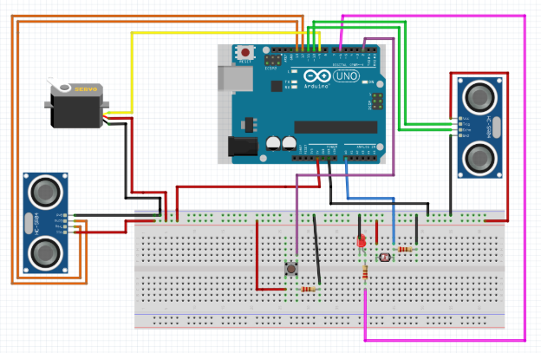

Rhiannon Clapham
2024536

Contents
Introduction 3
Hardware Design 4
Software Design 7
Implementation 11
Testing 14
Discussion, Evaluation and Conclusions 16
Appendix 18

Introduction
A simple security system is needed to make it appear that there are people in the office when there aren’t. During daylight hours, the system will wind up the blinds and switch off the office lights. As it gets dark, it should roll down the blinds and turn on the lights. A prototype is made to show how the system would work in a real life setting.
This simple system can be made by using the components listed below:
- Arduino Uno
- LDR
- LED
- Servo Motor
- Sonic Senor
- Resistors
This is designed to show how the system would work, however certain aspects have been removed or changed in order for the simulation to work properly. For example, there are no blinds in the system, only the motor to simulate them. Other components can also be used in a security system, however this shows a basic model where only a few components are needed.

Different stages had to be completed in order for the system to be created. A list is shown below:
- Schematic diagram of components
- Flowchart
- Pseudo code
- Testing
- Evaluations

Hardware Design

Components Used
Arduino Uno: This would be used to control the whole security system using the code.
LDR: A light dependent resistor. This will activate the system either when it becomes light, or dark. This will depend on the time of day.
LED: An LED would be needed to replicate the lights that would be turning on and off from the LDR.
Servo Motor: Used in the system to replicate the motors that would be needed to wind the blinds up and down. The servo motor only requires one pin to work. However, in a real life setting, more motors and an external power source would be required as there would be more than one blind.
Sonic Sensors: Sonic sensors would be used to replicate the ones that would be used at the top and bottom of the blinds. Two would have to be used for this.
Push Button: This is used to turn the system on or off. Although it is not needed in the simulation, in a real life scenario, this would give the people in the office the option to have the system on or off.
Resistors: Resistors would be used in the system to ensure the correct amount of current is going through the components. This ensures that it will not damage them.
Data sheets have been included in the appendix.

Alternatives
DC Motor: A DC motor could be used instead of a servo motor. A DC motor has more power, meaning that in a real setting, it would be the preferred choice. A DC motor also requires a H-Bridge controller, meaning there is another component to add to the system that has the potential to go wrong. A DC motor requires three pins (one for speed, two for direction), which is unnecessary when a servo motor needs one.
Slide Button: A slide button or push button can be used as a switch to activate the security system.
Push Button: This is used to turn the system on or off. Although it is not needed in the simulation, in a real life scenario, this would give the people in the office the option to have the system on or off.
Arduino Mega: In a professional setting, the Arduino mega may need to be used as there are multiple blinds and lights that would have to be moved and switched on/off. However, as this is a prototypes system, the Arduino Uno has the means to run it.

Schematic and Drawing of the System
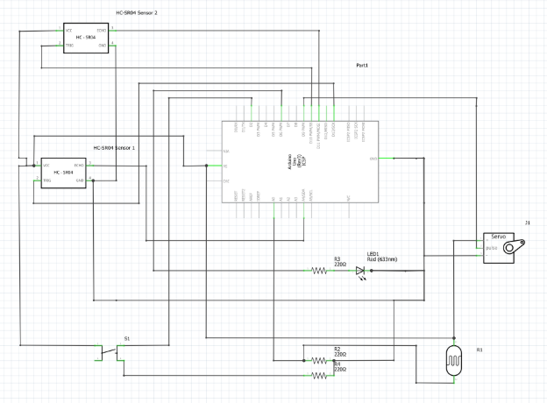

The image above shows a schematic diagram of the system and the components within it. The pins on the Arduino also show which component is connected and where.

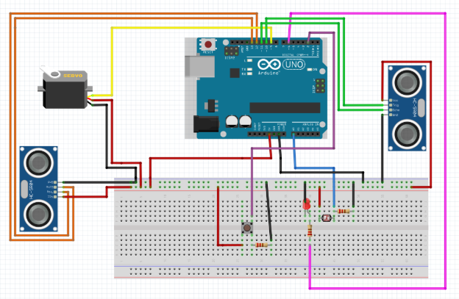
The drawing above shows the drawing that was made in order to complete the schematic. As seen in both the schematic and the drawing above, a button was included in the original design. However, this component was scrapped to allow for the system to be completed on time.

Software Design
Flowchart
A flowchart was created as the first part of the coding process. This was used in order to identify the order of how the system needs to work as well as if any loops were needed. This flowchart can then be used to help create the pseudo code, as it was created using this. The flowchart created can be seen below:
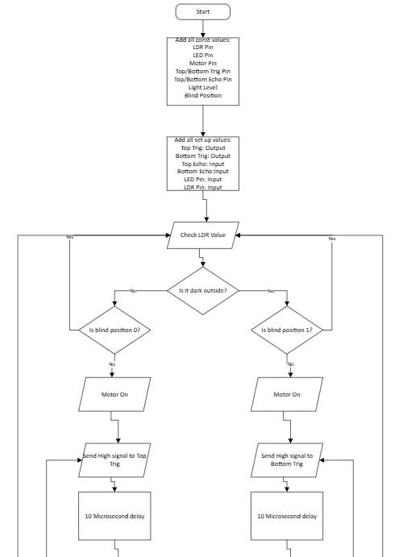

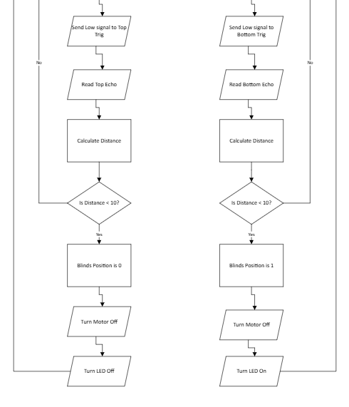

Pseudo Code
Below shows the pseudo code that was created before the code was written. This was to help plan how it could be written and the different parts that were needed for it. For example, which parts of code needed to be in the void loop, void set up, etc. The pseudo code for the system can be seen below:
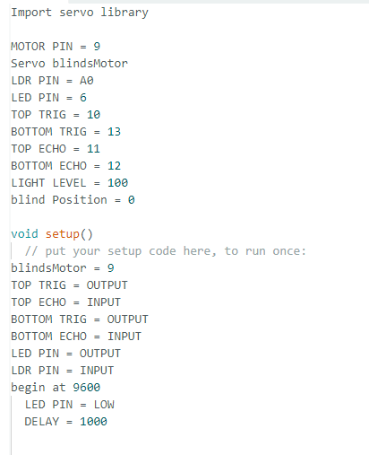

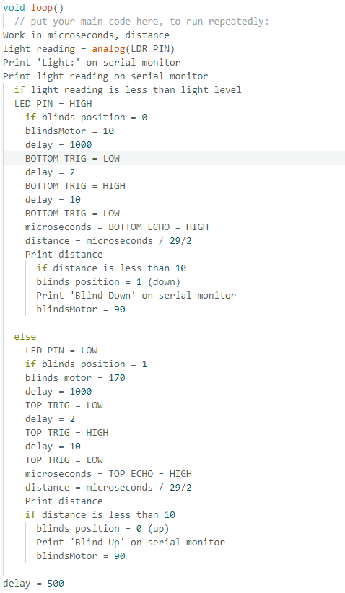

Implementation
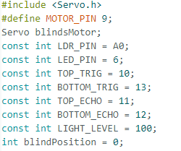

The code above shows how each pin has been labelled and which pin they identify to. The blind position shows what state the blind is in initially.

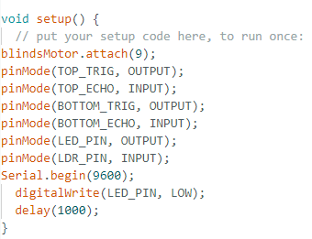

The motor, ultrasonic sensors, LDR and LED pins have been stated, including whether they are input or output pin. The LED is shown as low, meaning that it will not be on when the system is first turned on (unless the light level gets lower).
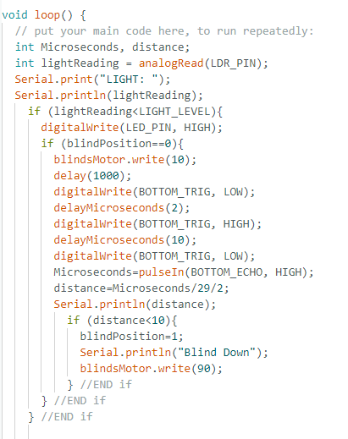

This part of the code highlights how if the light level is low, the LED will come on and the motor will turn on. The bottom sonic sensor will then measure to see if the ‘blind’ (a hand) is at a distance that is less that ten centimeters. If this is the case, the motor will stop and the code will say that the blind is down.

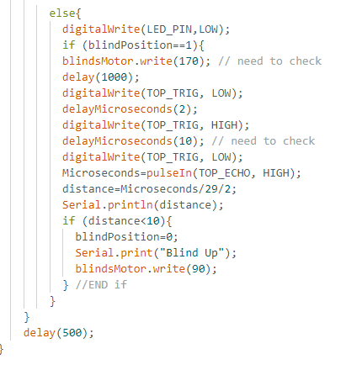

This part of the code shows how the LED will turn off and the motor will rotate. It will continue to rotate until the sonic sensor stops it. The serial monitor will then print “Blind Up”.

Testing
Different tests were conducted in order to show the effectiveness of the system, and whether it would work properly. Stated below are the different tests that took place, including the inputs that were needed for the system to run. The expected outputs are the ones that should work according to the code and the actual outputs are the ones that were shown in the practical usage. Issues could be raised if there were any problems with the system. This could be due to multiple reasons, including human error or coding error.
A video has been uploaded to go with the testing.

Test Number | Test | Inputs | Expected Outputs | Actual Outputs | Issues
Test 1 | LED is on when LDR is covered | Light reading | LED turns on | LED turned on | No issues
Test 2 | Motor turn and stop when sonic sensor is covered | Light reading,  Sonic sensor covered | Motor rotates and stops when sonic sensor is covered | Motor turned until sonic sensor was covered and it stopped | No issues
Test 3 | LED turns off when LDR is uncovered | Light reading | LED turns off | LED turned off after LDR was uncovered | No issues
Test 4 | Motor turn and stop when sonic sensor is covered after LDR is uncovered | Light reading,  Sonic sensor covered | Motor rotates and stops when sonic sensor is covered | Motor turned until sonic sensor was covered | No issues
Test 5 | Will LED remain on after sonic sensor is uncovered  (real life scenario: if wind blows blind away from sonic sensor) | Light reading,  Sonic sensor uncovered | LED remains on after sonic sensor is uncovered | LED remained on after sonic sensor was uncovered after motor stopped turning | No issues

Discussion, Evaluation and Conclusions

Different stages had to be competed in order for the system to work. Drawing had to first be made in order to see which components should be used and how they interact with other components in the system. From this a flowchart and pseudo code were made to plan how the code would be written. From these, the code was written to program the Arduino. The testing could then be conducted on the prototype.
After conducting multiple tests, the prototype security system worked efficiently with no issues. Different tests were conducted to ensure that the system fully works and the last test shows an example of a scenario that could happen in the work place. The tests involved ensuring the LED turned on and off in accordance to whether the light levels were high and low. The motor would turn in the appropriate direction depending on the light level and would stop when the appropriate ultrasonic sensor was covered. The tests were done to reflect when the light level was high, and then low. The final scenario is a simulation of if the wind was blowing the blinds when they are down. This in theory would mean that the bottom ultrasonic sensor would no long be covered, but the LED should remain on. This test was completed successfully, as the LED remained on when the sonic sensor was uncovered.
Currently, there is no button written into the code, so the only way to turn the system completely off would be to unplug it at the power source (the mains). Originally, the system was going to include a push button (as can be seen in the design stage of the project), however this component was not in the final code. A reason this was not included is because this is a prototype system, and was not specified that a button was needed. However, including a button would be useful so that the system would not have to be removed each time there were people in the office. Another alternative to the push button is the slide switch. This switch would allow the user to see more easily whether the system is on or off.
Additional power sources and components will be needed when creating the real system. The prototype has been created on a 5V supply and only one LED and motor were used, meaning that if any more components (multiple motors, multiple lights), the system would not be able to run. The system would also require blinds to work properly as this was not included in the prototype. These would then be used to close the distance on the ultrasonic sensors.
Different factors will affect the system in different ways when in full operation. For example, during winter months, it will become darker outside in general. This means that the system may turn on and off more erratically during the day (e.g. if a dark cloud passes over it may become dark enough to turn the system on). The code cannot be easily changed, as it would have to be partially rewritten to make these changes. The LDR would have to have a lower light reading compared to the summer to limit the chances of it turning on before it gets dark. Each season change, it would then have to be changed in accordance to how dark it is. A keypad could be included in the system so that the settings could be manually changed by those in the office.

Appendix

Data sheets:
Servo Motor - POLOLU-2820.pdf
Ultrasonic Sensor - HC-SR04
Arduino Uno - localhost:8123/A000066/2b9ps-datasheet.html

