

Programme: Master of Business Administration
Module: International Marketing: Principles and Practices
Module code: LCMB7026
Lecturer: Tushara Balendran

Table of Contents

1. Introduction ···························································· 3
2. Comparative Macro-Environment Analysis (PESTEL) ···························································· 3
2.1 Political Factors ···························································· 3
2.2 Economic Factors ···························································· 4
2.3 Social and Cultural Factors (incl. Hofstede) ···························································· 4
2.4 Technological Factors ···························································· 5
2.5 Environmental Factors ···························································· 5
2.6 Legal Factors ···························································· 5
3. STP Analysis and Brand Positioning ···························································· 6
3.1 Segmentation ···························································· 6
3.2 Targeting ···························································· 6
3.3 Positioning and Perceptual Map ···························································· 6
4. The International Marketing Mix (7Ps) ···························································· 7
5. Directional Development Strategy – IKEA in China ···························································· 9
5.1 Ansoff Matrix ···························································· 9
5.2 BCG Matrix ···························································· 10
6. Ethical Issues in IKEA's Marketing Mix ···························································· 10
7. Recommendations ···························································· 11
8. Conclusion ···························································· 12
Section 2: Reflective Account (Gibbs Cycle) ···························································· 12
Reference List ···························································· 14

SECTION 1: International Marketing Report

1. Introduction
IKEA, founded in Sweden by Ingvar Kamprad in 1943, has grown into one of the world's most recognised furniture and home furnishings retailers. Operating in over 60 countries, IKEA generated global revenue of approximately €47.6 billion in financial year 2023 (IKEA, 2024). The company's business model rests on offering well designed, functional products at low prices through large format stores, a flat pack distribution system, and a carefully orchestrated retail experience (Jonsson and Foss, 2011). Whilst the brand's core identity remains largely consistent across borders, its international marketing strategy requires significant adaptation to address the cultural, economic, and structural differences of individual host markets.
This report examines IKEA's international marketing strategies in the United Kingdom (UK) and China two commercially significant but culturally and economically divergent markets. The UK represents a mature, high income Western market where IKEA has operated since 1987, whilst China is a rapidly expanding emerging market where IKEA opened its first store in 1998. The report analyses the macro environment using PESTEL, evaluates STP and 7Ps strategies, examines directional development, considers ethical dimensions, and concludes with strategic recommendations.
The name IKEA is an acronym derived from Kamprad's initials (I.K.), the farm where he grew up (Elmtaryd – E), and his home parish (Agunnaryd – A) (Jonsson and Foss, 2011). The company introduced furniture in 1948 and opened its first showroom in 1953, pioneering the flat-pack self-assembly concept central to its global identity.
IKEA's mission is "to offer a wide range of well-designed, functional home furnishing products at prices so low that as many people as possible will be able to afford them" (IKEA, 2024). Its vision is "to create a better everyday life for the many people" – positioning democratic design and accessibility at the heart of the brand's purpose (IKEA, 2024).
IKEA entered the United Kingdom in 1987, opening its first store in Warrington, and has since expanded to 22 stores across the country, making the UK one of its most established European markets (IKEA, 2024). IKEA entered China in 1998, opening its first Chinese store in Shanghai. By 2024, IKEA operated 37 stores in China with ambitious plans for continued expansion into Tier 2 and Tier 3 cities (Swoboda, Elsner and Morschett, 2014).

2. Comparative Macro-Environment Analysis (PESTEL)
A PESTEL analysis examines the Political, Economic, Social, Technological, Environmental, and Legal forces shaping a business environment (Johnson, Whittington and Scholes, 2017). The following comparative analysis identifies key similarities and differences between the UK and China as host markets for IKEA. Figure 5 below presents a visual overview of favourability scores across each PESTEL dimension.

2.1 Political Factors
UK Favourable : The UK operates as a liberal parliamentary democracy with a stable, rules based institutional framework offering strong protections for intellectual property and foreign direct investment. Post Brexit, however, new trade regulations and supply chain complexities may increase IKEA's operational costs, particularly for goods sourced from the European Union (Dhingra et al., 2017).
China Moderately Favourable: China's single party political system provides policy continuity but introduces regulatory unpredictability and censorship compliance obligations (Meyer and Tran, 2006). Whilst IKEA operates in China as a wholly foreign owned enterprise (WFOE), it must navigate state directed economic priorities.
Similarity: Both markets are broadly open to foreign retail investment.
Difference: China's political environment presents considerably higher regulatory risk than the UK's stable democratic framework.

2.2 Economic Factors
UK Favourable: A high income advanced economy with a GDP per capita of approximately US$46,000 in 2023 (World Bank, 2024). Consumer purchasing power is relatively high, though inflationary pressure in 2022–23 constrained household spending and intensified price sensitivity (Office for National Statistics, 2023).
China Highly Favourable : GDP per capita of around US$12,600 in 2023, but coastal cities such as Shanghai and Beijing exhibit purchasing power approaching Western standards. China's expanding middle class represents substantial long term opportunity for IKEA's affordable-quality proposition.
Similarity: Both markets contain large consumer bases with capacity for discretionary spending on home furnishings.
Difference: The UK is a mature, slower growth market, whilst China offers significantly higher growth potential.

2.3 Social and Cultural Factors
Social and cultural differences constitute arguably the most critical dimension of IKEA's adaptation challenge. Hofstede's Cultural Dimensions model (Hofstede, Hofstede and Minkov, 2010) provides a widely used framework for systematically comparing national cultures. Figure 1 below visualises the key dimensional differences between the UK and China.

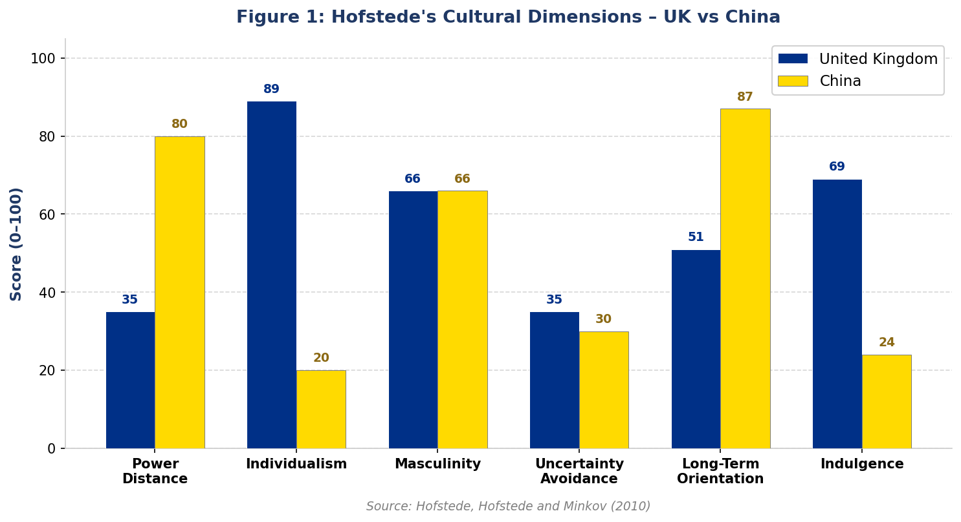
Source: Hofstede, Hofstede and Minkov (2010)

Table 1 below summarises the key dimensions and their marketing implications for IKEA:

Dimension | UK | China | Implication for IKEA
Power Distance | 35 (Low) | 80 (High) | Chinese consumers expect more formal brand engagement; family hierarchy influences purchase decisions
Individualism | 89 (High) | 20 (Low) | UK marketing emphasises personal expression; Chinese marketing must appeal to family & collective identity
Uncertainty Avoidance | 35 (Low) | 30 (Low) | Both markets relatively open to new product concepts and retail formats
Long-Term Orientation | 51 (Medium) | 87 (High) | Chinese consumers may prioritise durability and investment value over immediate gratification
Indulgence | 69 (High) | 24 (Low) | UK consumers more hedonistic in purchase behaviour; Chinese consumers more restrained and value-driven
Source: Hofstede, Hofstede and Minkov (2010)
Advantages of Hofstede's model: It provides a quantifiable, cross nationally comparable framework for understanding cultural differences; it has been validated across a large number of countries; and it offers practical directional guidance for marketing adaptation decisions (Soares, Farhangmehr and Shoham, 2007).
Disadvantages: The model has been criticised for overgeneralising national cultures and treating nations as homogeneous entities, masking significant internal regional and demographic diversity (McSweeney, 2002). The original data was collected from IBM employees in the 1960s–70s, raising questions about contemporary relevance. It also neglects the dynamic nature of culture (Baskerville, 2003).
Cultural assessment for IKEA: UK cultural factors are favourable. High individualism aligns with IKEA's emphasis on personal home expression; low uncertainty avoidance supports openness to flat pack self assembly; and an egalitarian culture resonates with democratic design. Chinese cultural factors are moderately favourable but require significant adaptation. Low individualism and high power distance mean IKEA's self-service retail format was initially culturally unfamiliar. However, high longterm orientation aligns with IKEA's sustainability narrative. The concept of 'face' means home furnishings carry social status implications that IKEA can leverage in its aspirational positioning (Zhang and Khare, 2009).
Similarity: Both cultures demonstrate relatively low uncertainty avoidance, meaning consumers are generally open to new product concepts.
Difference: The UK's high individualism closely aligns with IKEA's core values, whilst China's collectivist culture requires more extensive adaptation.

2.4 Technological Factors

In the United Kingdom, technological factors are highly favourable for IKEA, as the country benefits from a mature and well developed digital infrastructure. The UK has a sophisticated e-commerce ecosystem supported by high internet penetration, widespread broadband access, and a strong culture of online shopping. IKEA has capitalised on this environment by offering advanced digital tools such as augmented reality (AR) room visualisation, which allows customers to virtually place furniture in their homes before purchase. Additionally, services such as Click & Collect and app based planning tools enhance customer convenience and support a seamless omnichannel experience (IKEA, 2024). These technologies not only improve customer engagement but also reinforce IKEA’s value proposition of convenience and functionality.

In China, technological factors are even more favourable, although they operate within a significantly different digital ecosystem. China’s digital landscape is characterised by a mobile first approach, where consumers rely heavily on integrated “super apps” such as WeChat, Tmall, JD.com, and Douyin for communication, shopping, and payments. Recognising this, IKEA has invested heavily in its Tmall flagship store and developed a WeChat mini programme to engage directly with consumers within these platforms (China Internet Network Information Center, 2023). This approach reflects the importance of platform integration in China, where traditional standalone websites are less influential.

A key similarity between the two markets is that both possess advanced digital infrastructure and high levels of technological adoption, enabling IKEA to leverage digital tools to enhance customer experience. However, a significant difference lies in the structure of the digital environment. While the UK relies more on web based platforms and independent applications, China’s mobile first super app ecosystem requires IKEA to adopt a fundamentally different digital strategy. This demonstrates that technological adaptation is essential for international marketing success, as firms must align their digital strategies with local consumer behaviour and technological norms.

2.5 Environmental Factors
Both markets Favourable: IKEA's 'People & Planet Positive' sustainability strategy aligns with growing consumer and regulatory expectations in both countries (IKEA, 2023). China's 'dual carbon' policy targets create opportunities for brands demonstrating environmental leadership (Zhang, 2021).
Similarity: Sustainability is a growing priority in both markets.
Difference: UK consumers are further advanced in environmental accountability expectations than the average Chinese consumer, though this gap is narrowing.

2.6 Legal Factors
UK Favourable: Robust consumer protection under the Consumer Rights Act 2015 and UK GDPR provides a predictable compliance environment. China Moderately Favourable: More complex regulatory landscape including product safety standards, advertising restrictions, Mandarin language labelling requirements, and provisions of the Foreign Investment Law (2019) (OECD, 2022).
Similarity: Both require compliance with product safety and consumer protection standards.
Difference: China's legal environment is more opaque and subject to more frequent regulatory change.

3. STP Analysis and Brand Positioning

3.1 Segmentation
IKEA employs a multi-variable segmentation approach in both markets, drawing on demographic, psychographic, geographic, and behavioural variables (Kotler and Keller, 2016). In the UK, IKEA segments primarily by demographics (young adults aged 18 to 35, students, first time homeowners, growing families) and psychographics (value-conscious home enthusiasts). In China, segmentation is additionally informed by geographic tiers and income levels within the growing middle class.
Similarity: Both markets target value conscious, design aware consumers.
Difference: In China, geographic tier and income level play a more pronounced segmentation role given the country's vast internal economic diversity.

3.2 Targeting
In the UK, IKEA adopts a differentiated targeting strategy, addressing multiple consumer segments simultaneously through its broad product range, loyalty scheme, and urban planning studio format. In China, IKEA initially targeted a narrow affluent urban segment for whom Swedish design carried premium lifestyle connotations, but has progressively shifted towards a broader middle income target market as the consumer base has expanded (Swoboda, Elsner and Morschett, 2014).
Similarity: Both strategies ultimately seek to reach a large mass market consumer base.
Difference: China's targeting strategy required a deliberate journey from premium niche to mainstream.

3.3 Positioning and Brand Image
IKEA's core positioning in both markets centres on democratic design: functional, well-designed, sustainable products accessible to the majority (IKEA, 2024). In the UK, this resonates as a go-to value destination. In China, IKEA has positioned itself simultaneously as an aspirational lifestyle brand, with KOL collaborations reinforcing aspirational appeal. Figure below illustrates IKEA's perceptual positioning relative to key competitors in both markets.

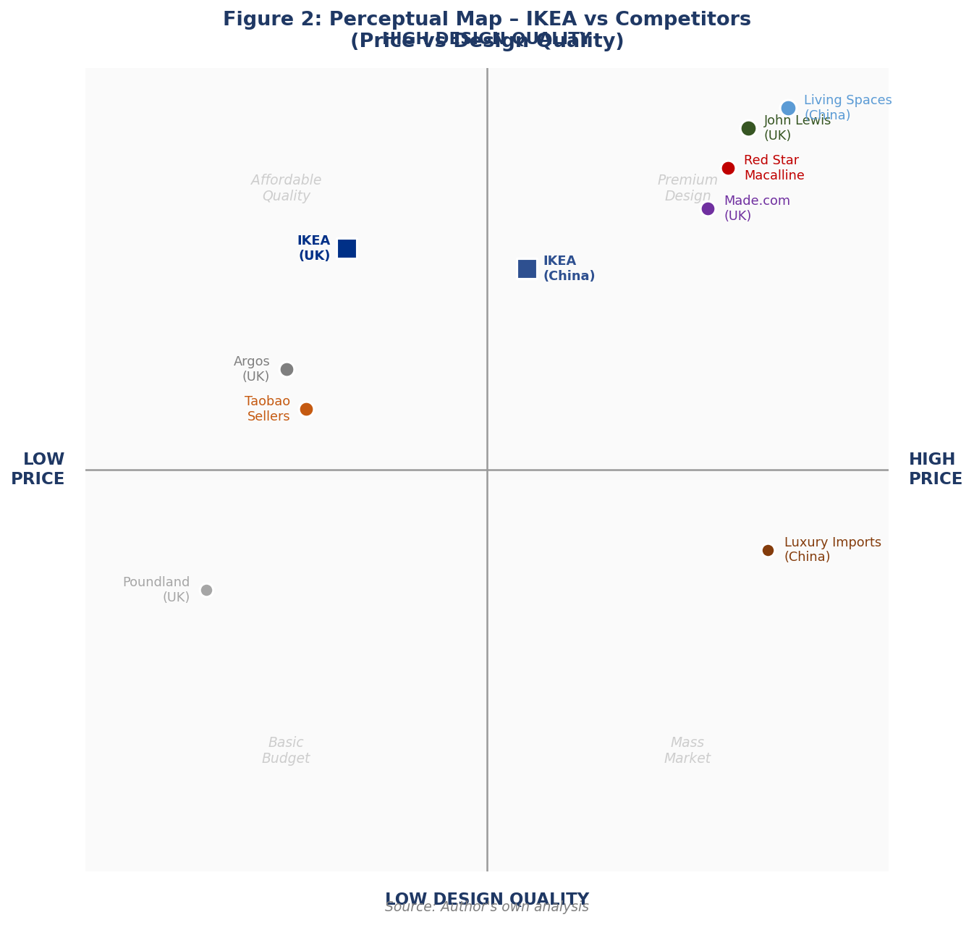
Source: Author's own analysis
Brand Image Comparison (Table 2):
Attribute | United Kingdom | China
Primary brand perception | Affordable, practical, reliable everyday home store | Aspirational lifestyle brand with Scandinavian premium identity
Price perception | Value for money | Affordable-premium (historically perceived as premium; now more accessible)
Sustainability | Increasingly central to brand image | Growing relevance; less central than in UK
Customer experience | Destination shopping trip with entertainment value | Aspirational social experience; historically a leisure destination

4. The International Marketing Mix (7Ps)
Figure 6 below illustrates the degree of marketing mix adaptation required in each market across all seven elements of the extended marketing mix (Kotler and Keller, 2016). China consistently requires a higher degree of adaptation than the UK across almost all dimensions.

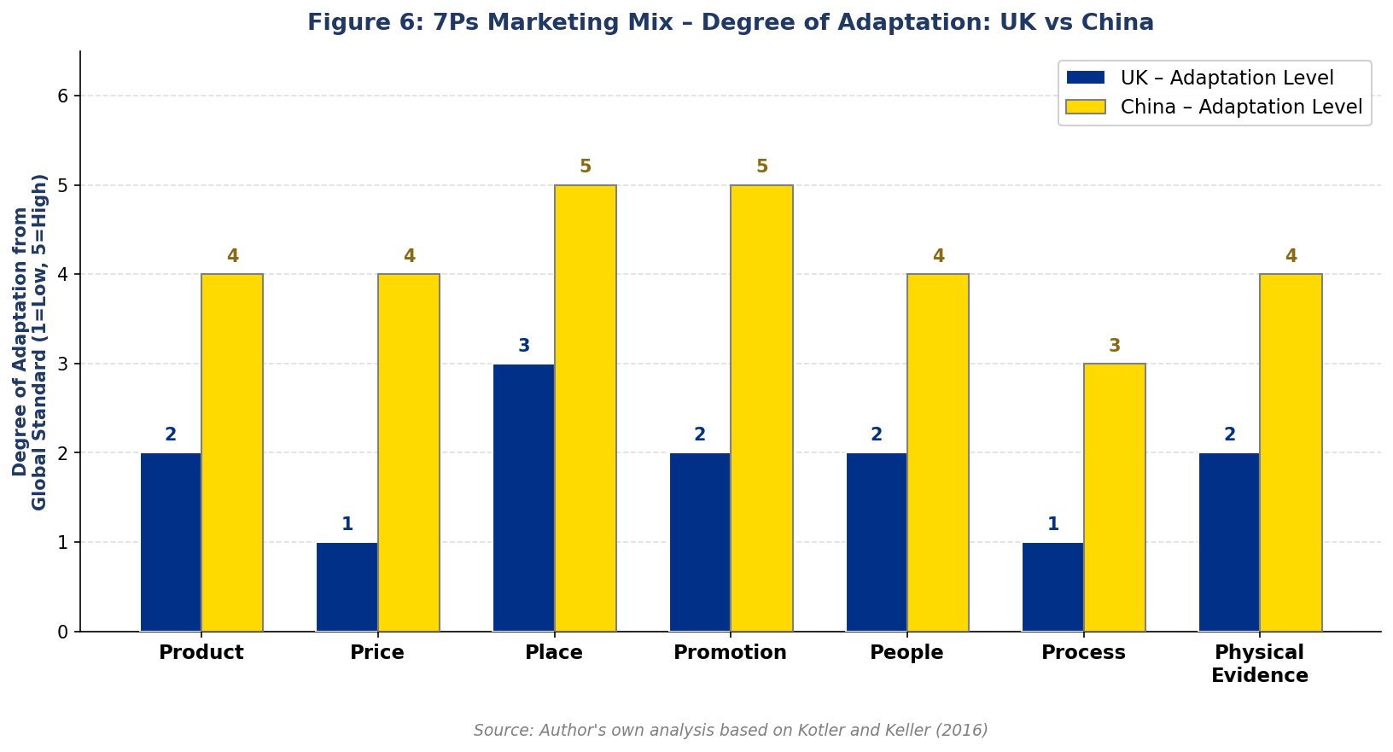
Source: Kotler and Keller (2016)

4.1 Product
UK: The product range is largely standardised, reflecting Scandinavian design heritage, with sustainability-focused products prominent. China: Meaningful product adaptations include kitchen designs modified for woks, adjusted bed sizes, and a localised in store restaurant menu featuring congee and Chinese-spiced meatball variants (Swoboda, Elsner and Morschett, 2014). Room display sets use smaller dimensions reflecting typical Chinese apartment layouts.
Similarity: Core product range and design philosophy are globally consistent. Difference: China requires more extensive localisation of kitchen products, bedroom dimensions, and food offerings.

4.2 Price
UK: Everyday low pricing (EDLP) strategy, with the IKEA Family card providing member discounts and seasonal promotions. China: Historically 60–65% higher than European prices due to import duties and logistics costs (Johansson and Thelander, 2009). Progressive price reductions achieved by sourcing locally approximately 30% of global IKEA products are now sourced from China have brought prices closer to Western market levels whilst preserving accessible premium positioning (IKEA, 2023). Similarity: Both markets benefit from IKEA's global scale economies and commitment to value pricing.
Difference: Pricing in China remains structurally higher than the UK.

4.3 Place (Distribution)
UK: Large out of town megastores complemented by urban Planning Studios in London and Manchester; Click & Collect, home delivery, and assembly services (IKEA, 2024). China: Pronounced omni-channel strategy Tmall flagship, JD.com, WeChat mini programme combined with smaller urban format stores to penetrate Tier 2 cities (Swoboda, Elsner and Morschett, 2014).
Similarity: Both markets are transitioning away from exclusive reliance on large format stores.
Difference: China's digital commerce investment is substantially deeper, reflecting the country's more advanced mobile commerce infrastructure.

4.4 Promotion
UK: Witty, culturally resonant advertising; digital marketing through Instagram and YouTube; IKEA Family loyalty scheme; seasonal promotions. Print catalogue discontinued in 2021 (IKEA, 2021). China: WeChat campaigns, Douyin short-video content, KOL (Key Opinion Leader) partnerships, and major shopping festival participation Singles' Day (11 November) and the 618 festival .
Similarity: Both strategies emphasise digital first communication and loyalty programme engagement.
Difference: China's promotional strategy requires entirely different platforms, formats, and cultural references.

4.5 People
UK: Emphasis on diversity, inclusion, flexible working, and living wage commitments, reflecting UK labour market expectations. China: Localised HR strategy with Mandarin speaking staff and management practices adapted to higher power distance workplace norms (Hofstede, Hofstede and Minkov, 2010).
Similarity: Both markets emphasise staff as brand ambassadors.
Difference: China requires greater adaptation of management style to align with local cultural norms.

4.6 Process
UK: Standard IKEA self-service process showroom walkthrough, flat-pack collection, home assembly is well-established and culturally accepted. China: Historically, Chinese stores tolerated customers spending extended periods resting on showroom furniture, accommodating early brand familiarity building in an unfamiliar retail format As the market has matured, the in-store process has converged closer to global standards.
Similarity: Core self-service retail process is globally consistent.
Difference: China required a longer consumer education process.

4.7 Physical Evidence
UK: Standard blue and yellow megastores with showrooms, Swedish food hall, and self-service warehouse. China: Stores are notably larger to accommodate high footfall; showroom layouts use smaller room dimensions reflecting typical Chinese apartment sizes; design elements incorporate Chinese aesthetic sensibilities (Swoboda, Elsner and Morschett, 2014).
Similarity: Both share IKEA's globally consistent store identity.
Difference: Chinese stores are larger, and showroom designs are more extensively adapted to local living conditions.

5. Directional Development Strategy - IKEA in China
A directional development strategy refers to the strategic choices a firm makes regarding the direction and scope of its growth (Johnson, Whittington and Scholes, 2017). Two complementary frameworks the Ansoff Matrix and the BCG Matrix are applied below to analyse IKEA's strategic direction in China.

5.1 Ansoff Matrix
The Ansoff Matrix (Ansoff, 1957) analyses growth strategy across two dimensions: products (existing vs new) and markets (existing vs new).
Figure illustrates IKEA's concurrent strategic initiatives mapped across all four quadrants.

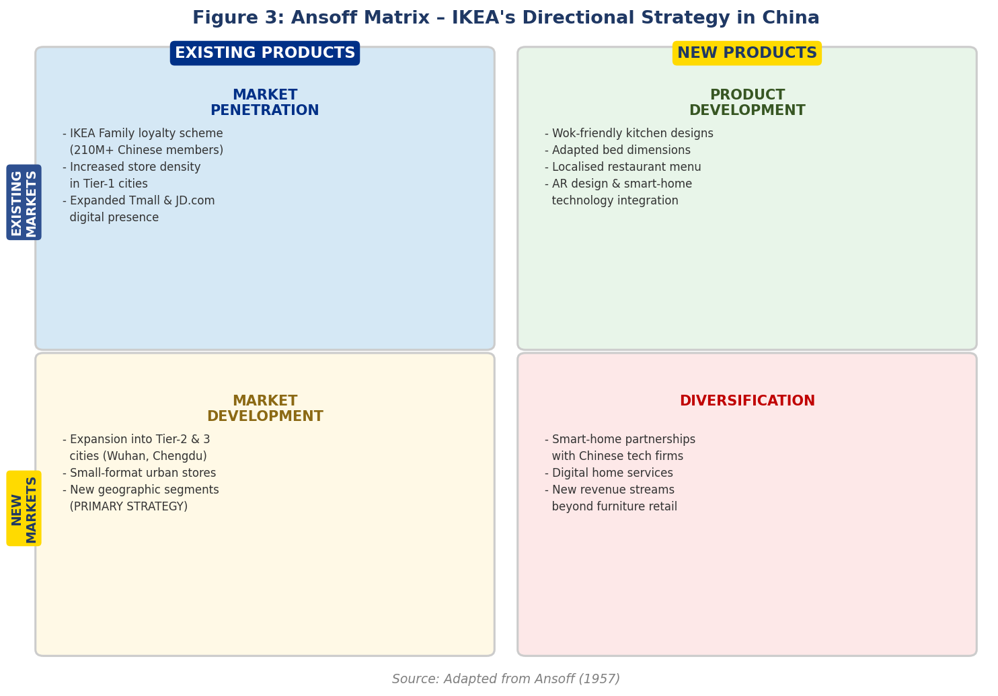
Source: Ansoff (1957)
IKEA's dominant growth strategy in China is market development geographic expansion into Tier-2 and Tier-3 cities via the small format store concept. Simultaneously, product development through localisation of product ranges and digital tools, and market penetration through the IKEA Family loyalty scheme (210 million Chinese members by 2022; IKEA, 2023), reflect a multi pronged strategic approach that balances growth ambition with manageable risk.

5.2 BCG Matrix
The BCG Matrix (Boston Consulting Group, 1970) classifies business units by market share and market growth rate. Figure applies the BCG Matrix to IKEA's key business units in China, providing a portfolio perspective that clarifies where investment should be directed.

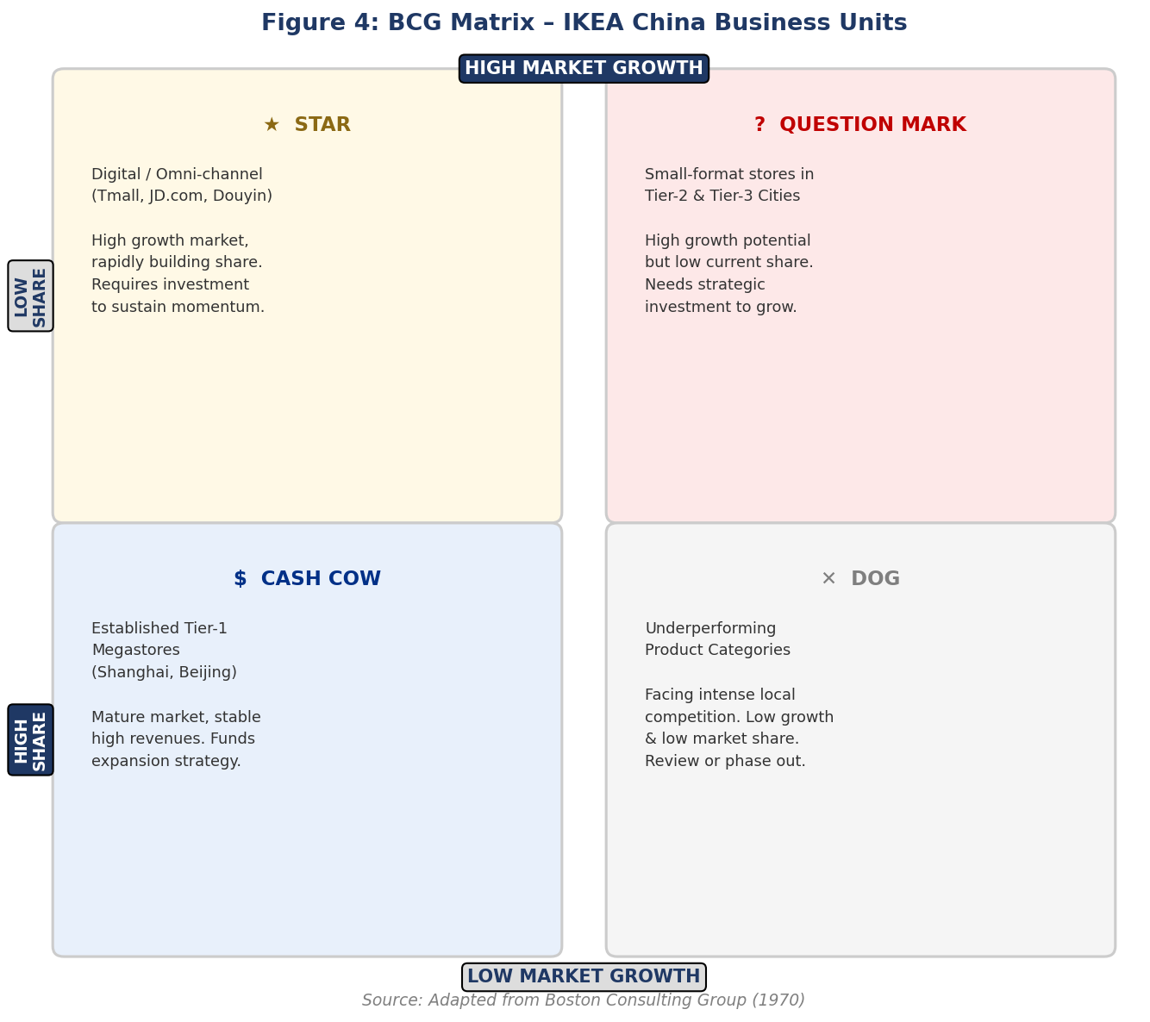
Source: Boston Consulting Group (1970)
The BCG analysis suggests IKEA should continue to invest in its digital 'Star' and Tier-2 city 'Question Mark' units, using cash flows from established Tier-1 'Cash Cow' megastores to fund this expansion a strategy consistent with the market development direction identified in the Ansoff Matrix.

6. Ethical Issues in IKEA's Marketing Mix
Ethics in international marketing refers to the moral principles guiding marketing conduct across borders, encompassing dimensions of honesty, transparency, social responsibility, and respect for consumer rights (Kotler and Keller, 2016). This section focuses primarily on China, where IKEA's marketing practices have faced more significant ethical scrutiny than in the UK's more tightly regulated environment.

6.1 Country-Specific Ethical Context (China)
China's ethical marketing environment is shaped by a complex interplay of cultural norms, regulatory requirements, and evolving consumer rights expectations. The rapid growth of e-commerce and social media marketing in China has created new ethical challenges relating to influencer disclosure, data privacy, and the consistency of product safety standards across markets.

6.2 Ethical Marketing Practices
First Sustainability Commitment: IKEA's 'People & Planet Positive' strategy commits to sourcing 100% of wood from sustainable sources and transitioning to 100% renewable energy by 2030 (IKEA, 2023). In both the UK and China, IKEA promotes buy-back and recycling schemes, aligning with China's 'dual carbon' environmental policy goals. The UK's Furniture Take Back scheme, launched in 2020, is a notable example of ethical product stewardship (IKEA, 2024). This represents an ethical application of the product and place elements of the marketing mix.
Second Transparent Pricing: IKEA's everyday low pricing strategy, communicated clearly through published price lists and in-store labelling in both markets, avoids misleading pricing tactics such as artificially inflated 'was' prices a practice that has attracted regulatory scrutiny for other retailers (Competition and Markets Authority, 2022). This reflects ethical application of the price element of the marketing mix, building consumer trust through honesty and transparency.

6.3 Unethical Marketing Practices
First Malm Dresser Recall Inconsistency (China): Between 2016 and 2019, IKEA's response to the Malm dresser product recall involving a dresser found to tip fatally when not wall anchored was criticised as significantly slower and less comprehensive in China than in the United States and Europe, where full recalls and proactive consumer notifications were issued promptly (Reuters, 2019). This differential treatment represents an unethical application of the product and promotion elements of the marketing mix, privileging consumers in higher profile Western markets over Chinese consumers.
Second Saudi Arabia Catalogue (Promotional Ethics): In 2012, IKEA digitally removed women from its Saudi Arabian catalogue, drawing global condemnation as an implicit endorsement of gender discrimination (BBC News, 2012). Whilst this occurred outside the UK and China, it established a precedent of promotional adaptation that crossed ethical boundaries. IKEA publicly acknowledged the adaptation violated its core values, illustrating the tension between local cultural compliance and universal ethical standards a tension directly relevant to IKEA's promotional strategy in China where social media marketing practices are increasingly subject to scrutiny .

7. Recommendations
Based on the foregoing analysis, the following five strategic recommendations are proposed for IKEA's international marketing strategy:

- First: IKEA should continue its accelerated investment in China's Tier-2 and Tier-3 city markets through the small format store model, ensuring that localisation of product ranges and in-store experiences keeps pace with geographic expansion. The risk of over standardisation as the company scales rapidly is significant, and culturally nuanced retail experiences will be essential to sustaining differentiation from growing local competitors (Swoboda, Elsner and Morschett, 2014).
- Second: IKEA should implement a unified global product safety communication protocol, ensuring that product recalls and safety notifications are issued simultaneously and with equal prominence across all markets. The Malm dresser case demonstrated the reputational and ethical cost of inconsistent safety standards (Reuters, 2019).
- Third: In China, IKEA should deepen its investment in AI powered personalisation on Tmall and JD.com, leveraging its 210 million strong IKEA Family membership database to deliver targeted product recommendations, building on its digital 'Star' business unit identified in the BCG Matrix.
- Fourth: In the UK, IKEA should intensify its sustainability marketing, communicating the tangible, third party verified impact of its People & Planet Positive strategy to capitalise on growing UK consumer demand for environmentally responsible brands, reducing the risk of greenwashing accusations (Polonsky and Rosenberger, 2001).
- Fifth: IKEA should establish a formal cross cultural ethics review process for all promotional adaptations, ensuring that any market specific content is assessed against the company's global values before publication, preventing recurrences of the type of ethical failure illustrated by the Saudi catalogue case (BBC News, 2012).

8. Conclusion
This report has examined IKEA's international marketing strategies in the UK and China, demonstrating both the consistency of the brand's core identity and the depth of adaptation required across culturally and economically divergent markets. The PESTEL analysis reveals that whilst both markets present broadly favourable conditions, China's political complexity, cultural distinctiveness, and mobile first digital ecosystem require particularly intensive strategic adaptation. The comparative STP analysis shows that IKEA occupies different perceptual positions in each market primarily a value brand in the UK and an aspirational lifestyle brand in China. The 7Ps analysis confirms that promotion, price, and place require the greatest market specific adaptation. IKEA's directional strategy in China, analysed through the Ansoff and BCG matrices, reflects a sophisticated multi-pronged approach combining market development, product development, and penetration strategies. Ethically, IKEA demonstrates genuine leadership in sustainability and pricing transparency but must urgently address inconsistencies in product safety communication across markets. The recommendations proposed offer a strategic roadmap for sustaining IKEA's competitive advantage whilst strengthening the integrity of its global marketing practice.

SECTION 2: Reflective Account

Reflective Account Using the Gibbs Reflective Cycle
The Gibbs Reflective Cycle (Gibbs, 1988) provides a structured framework for reflection, comprising six stages: Description, Feelings, Evaluation, Analysis, Conclusion, and Action Plan. This cycle is used below to reflect on the process of researching, analysing, and preparing the preceding report.

Description
The task required comparative report on the international marketing mix of IKEA across the UK and China, covering PESTEL, Hofstede's cultural dimensions, STP (including a perceptual map), 7Ps analysis, directional development strategy using the Ansoff and BCG matrices, ethical issues, and strategic recommendations. The research process involved identifying and reviewing academic literature on international marketing, cross cultural consumer behaviour, and IKEA's specific market strategies; applying multiple theoretical frameworks; and synthesising these into a coherent, structured analytical report.

Feelings
At the outset of the process, I felt a degree of anxiety regarding the scope of the task. assignment requiring critical application of multiple frameworks across two distinct international markets felt initially daunting. I was particularly uncertain about how to integrate the perceptual map and the dual development strategy frameworks (Ansoff and BCG) in a way that felt analytically coherent rather than mechanically descriptive. However, as I began to structure my research and identify credible academic and industry sources, I grew increasingly confident. The richness of IKEA as a case study, particularly given the sharp contrasts between its UK and Chinese market contexts, made the research genuinely engaging. The ethical section generated the most personal discomfort, requiring me to make normative judgements about a brand I had largely regarded positively, confronting the gap between stated values and documented practices.

Evaluation
A significant strength of my process was using the assignment guidance brief as a structural scaffold from the outset, ensuring all required components were addressed systematically. My decision to select IKEA proved wise, as the contrast between the two markets generated substantive comparative material across every analytical section. The Hofstede comparison, in particular, yielded meaningful insights into how IKEA's core brand values map onto and, in some respects, sit in tension with Chinese cultural norms.
A notable limitation was my initial tendency to rely on corporate sources such as IKEA's own sustainability reports before grounding analysis more rigorously in peer reviewed academic literature. This was a habit I needed consciously to correct as the drafting process progressed. Additionally, I found the ethical analysis section particularly challenging, as it required genuine evaluative judgement about cases where ethical dimensions were complex and contested.

Analysis
Engaging with Hofstede's Cultural Dimensions model comparatively was one of the most intellectually stimulating aspects of this assignment. Applying it to IKEA's UK and Chinese markets brought it to life in a way that abstract study had not. However, critically evaluating the model's limitations particularly its potential to oversimplify cultural diversity within nations (McSweeney, 2002) was equally important. China's internal cultural diversity between coastal urban elites and inland consumers means that even a well calibrated nationally averaged cultural profile can mask important within market variation that IKEA must account for in its segmentation strategy.
The Ansoff and BCG analysis of IKEA's China strategy generated genuine analytical insight. Mapping IKEA's multiple concurrent strategic initiatives onto the Ansoff Matrix helped me understand that IKEA is simultaneously executing market development, product development, and penetration strategies a sophisticated multi-pronged approach reflecting the complexity of operating in such a vast and rapidly evolving market. The BCG Matrix complemented this by providing a portfolio perspective on Chinese business units, clarifying where investment should be directed and where established cash flows can fund new ventures. The perceptual map exercise was valuable in forcing me to think about brand positioning in a visual, comparative way rather than purely through prose, crystallising the key insight about IKEA's different positional status in the two markets.

Conclusion
Overall, this assignment deepened my understanding of the fundamental tension in international marketing between standardisation and adaptation. IKEA's case is particularly illuminating because it represents a brand with a very strong, globally consistent identity that nevertheless requires substantial strategic localisation to succeed across culturally and economically divergent markets. I gained a more nuanced appreciation of the ethical dimensions of international marketing strategy, recognising that ethical consistency across markets is not merely a compliance matter but a fundamental component of long-term brand equity. I concluded that a stronger initial literature review would have improved the efficiency and depth of my work.

Action Plan
Going forward, I will apply three lessons to future academic and professional practice. First, I will conduct a structured literature review at the outset of any research project, using academic databases to identify peer-reviewed sources before engaging corporate or news materials. Second, when applying theoretical frameworks such as Hofstede's model or the Ansoff Matrix, I will consciously evaluate both their explanatory power and their limitations simultaneously, treating them as analytical lenses rather than objective truths. Third, when undertaking ethical analysis, I will deliberately seek out contradictory evidence and multiple stakeholder perspectives before forming evaluative judgements. These commitments reflect my understanding that effective international marketing management requires not just conceptual knowledge but the critical judgement to apply that knowledge responsibly in complex, real world contexts.

Reference List
Ansoff, H.I. (1957) ‘Strategies for diversification’, Harvard Business Review, 35(5), pp. 113–124. (Accessed: 12 April 2026).
Baskerville, R.F. (2003) ‘Hofstede never studied culture’, Accounting, Organizations and Society, 28(1), pp. 1–14. (Accessed: 12 April 2026).
BBC News (2012) IKEA apologises for removing women from Saudi catalogue. Available at: https://www.bbc.co.uk/news/world-europe-19826244 (Accessed: 12 April 2026).
Boston Consulting Group (1970) The Product Portfolio Matrix. Boston: BCG. (Accessed: 12 April 2026).
China Internet Network Information Center (2023) The 52nd Statistical Report on China's Internet Development. Beijing: CNNIC. (Accessed: 12 April 2026).
Competition and Markets Authority (2022) Misleading pricing practices: guidance for traders. London: CMA. (Accessed: 15 April 2026).
Dhingra, S., Ottaviano, G., Sampson, T. and Van Reenen, J. (2017) ‘The impact of Brexit on foreign investment in the UK’, CEPR Brexit Analysis, 3, pp. 1–10. (Accessed: 15 April 2026).
Gibbs, G. (1988) Learning by Doing: A Guide to Teaching and Learning Methods. Oxford: Further Education Unit, Oxford Polytechnic. (Accessed: 15 April 2026).
Hofstede, G., Hofstede, G.J. and Minkov, M. (2010) Cultures and Organisations: Software of the Mind. 3rd edn. New York: McGraw-Hill. (Accessed: 15 April 2026).
IKEA (2021) IKEA discontinues its iconic catalogue after 70 years. Available at: https://www.ikea.com/gb/en/newsroom (Accessed: 15 April 2026).
IKEA (2023) IKEA Sustainability Report FY23. Delft: Inter IKEA Group. (Accessed: 15 April 2026).
IKEA (2024) IKEA Annual Summary FY24. Delft: Inter IKEA Group. (Accessed: 15 April 2026).
Johansson, U. and Thelander, Å. (2009) ‘A standardised approach to the world? IKEA in China’, International Journal of Quality and Service Sciences, 1(2), pp. 199–219. (Accessed: 15 April 2026).
Hofstede, G. (2011). Dimensionalizing Cultures: The Hofstede Model in Context. Online Readings in Psychology and Culture, 2(1). (Accessed: 15 April 2026).
Swoboda, B., Elsner, S. and Morschett, D. (2014) 'Preferences and performance of international strategies in retail sectors: an empirical study', Long Range Planning (Accessed: 15 April 2026).
Johnson, G., Whittington, R. and Scholes, K. (2017) Exploring Strategy: Text and Cases. 11th edn. Harlow: Pearson.
Jonsson, A. and Foss, N.J. (2011) ‘International expansion through flexible replication: learning from the internationalisation of IKEA’, Journal of International Business Studies, 42(9), pp. 1079–1102. (Accessed: 15 April 2026).
Kotler, P. and Keller, K.L. (2016) Marketing Management. 15th edn. Harlow: Pearson. (Accessed: 18 April 2026).
McSweeney, B. (2002) ‘Hofstede’s model of national cultural differences and their consequences: a triumph of faith – a failure of analysis’, Human Relations, 55(1), pp. 89–118. (Accessed: 18 April 2026).
Meyer, K.E. and Tran, Y.T.T. (2006) ‘Market penetration and acquisition strategies for emerging economies’, Long Range Planning, 39(2), pp. 177–197. (Accessed: 18 April 2026).
OECD (2022) Investment Policy Reviews: China 2022. Paris: OECD Publishing. (Accessed: 18 April 2026).
Office for National Statistics (2023) Consumer Price Inflation, UK: December 2023. London: ONS. (Accessed: 20 April 2026).
Polonsky, M.J. and Rosenberger, P.J. (2001) ‘Reevaluating green marketing: a strategic approach’, Business Horizons, 44(5), pp. 21–30. (Accessed: 20 April 2026).
Reuters (2019) IKEA's handling of China dresser recall draws criticism. Available at: https://www.reuters.com (Accessed: 20 April 2026).
Soares, A.M., Farhangmehr, M. and Shoham, A. (2007) ‘Hofstede's dimensions of culture in international marketing studies’, Journal of Business Research, 60(3), pp. 277–284. (Accessed: 20 April 2026).
World Bank (2024) GDP per Capita (Current US$). Washington DC: World Bank. (Accessed: 21 April 2026).
Zhang, Y. (2021) ‘China's carbon neutrality target: implications for international business’, Journal of International Business Policy, 4(3), pp. 401–407. (Accessed: 21 April 2026).
Zhang, Y. and Khare, A. (2009) ‘The impact of accessible identities on the evaluation of global versus local products’, Journal of Consumer Research, 36(3), pp. 524–537. (Accessed: 21 April 2026).

