

Assessment component 2: Marketing Strategies Portfolio: Brand Development

Student Name:

Pew Peakhom

Student ID:

2433833

Module Name: Marketing Management

Module Code: LCMB7024

Lecturer’s Name:

Dr Tola Odugbsesan

Term 1

Submission date:
30-04-26

Table of Contents
Element 1: Brand Extension: ARM Smart Home System 3
Element 2: STDP Analysis for ARM Smart Home System 3
1. Segmentation 3
2. Targeting 4
3. Differentiation 5
4. Positioning 6
Element 3: Marketing Mix for ARM Smart Home System 8
1. Product 8
2. Price 8
3. Place 9
4. Promotion 9
5. People 10
6. Process 10
7. Physical Evidence 10
Element 4: Reflection 11
References 13

Element 1: Brand Extension: ARM Smart Home System Poster

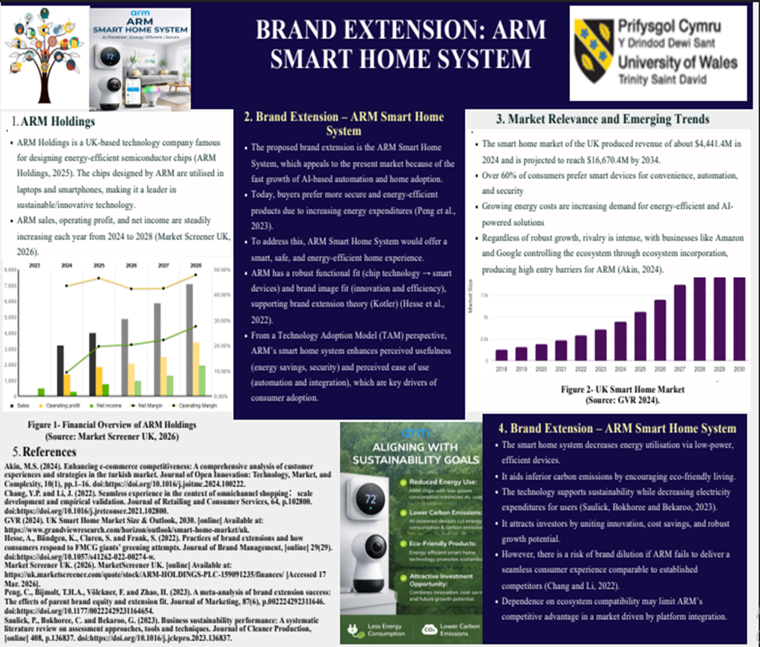

Element 2: STDP Analysis for ARM Smart Home System

1. Segmentation
Geographic Segmentation: ARM primarily serves customers in the UK, Europe and North America; all three regions generally provide good digital coverage, enabling customer access via the Internet. About 68M internet users in the UK directly support smart home adoption in the country (Thuy, 2025).
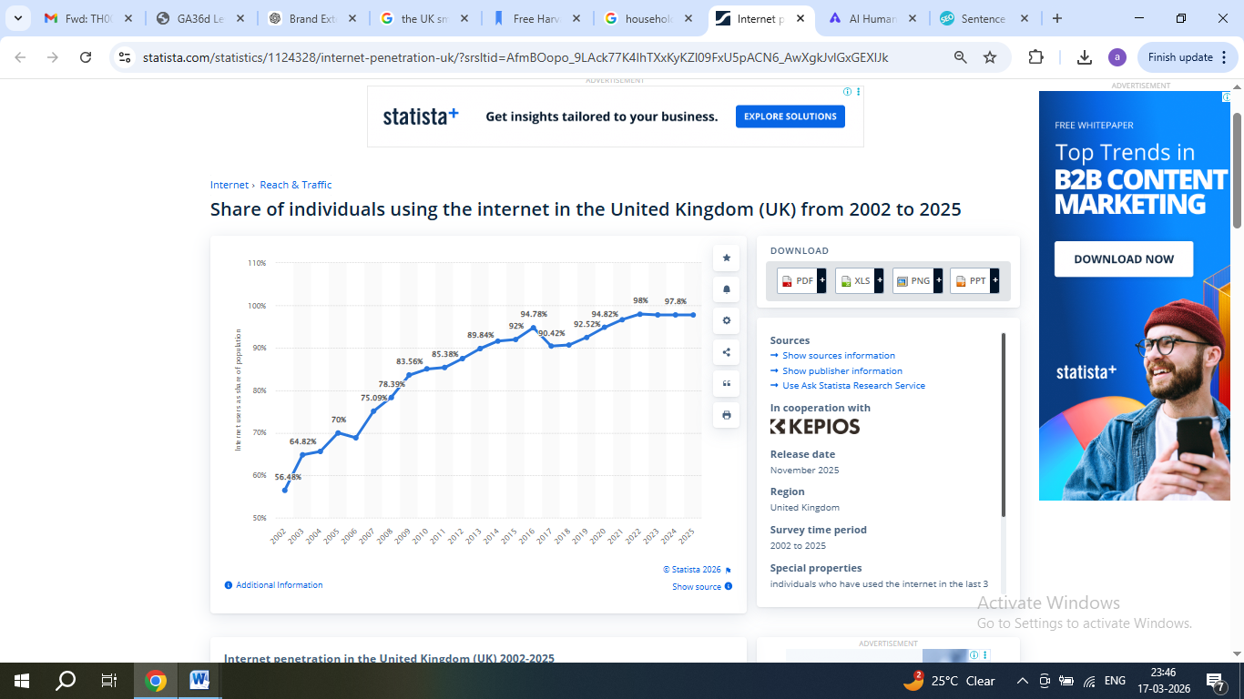
Figure 1- Internet Users in the UK
(Source: Thuy, 2025)

Demographic Segmentation- ARM targets adult-aged consumers, aged 25-55; generally, this group has a tendency to embrace new products earlier. ARM targets consumers within affluent families (middle-upper income) because smart home technology requires a financial commitment when buying first device. The categories of customers include people who have the financial means to invest in smart technology (Clarke, Freytag and Cortez, 2024).
Psychographic Segmentation- ARM targets consumers who are tech-comfortable and contemporary. They also show concern about the sustainability of environment, are more cognizant of climate change and are choosing to purchase brands that promote sustainable living. About 78% of UK consumers are willing to pay more for sustainable products which aligns with ARM’s low-energy technology (Ruiz, 2025).

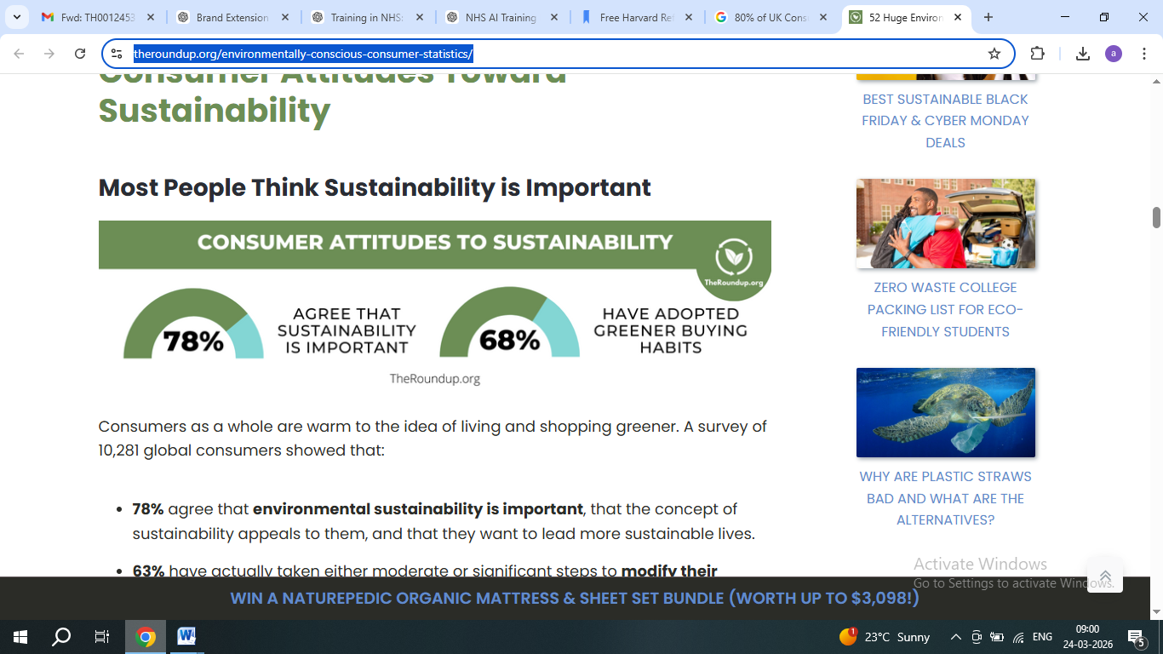
Figure 2- Sustainability
(Source: Ruiz, 2025)
Behavioural Segmentation- Today, consumers want benefits such as energy savings, security at home, home automation and comfort. Many of them already use technology regularly (smart speakers), which reinforces consumer loyalty towards brands that provide reliable and innovative solutions (Borg, Lindsay and Curtis, 2021).

Table 1-Segment Attractiveness Evaluation
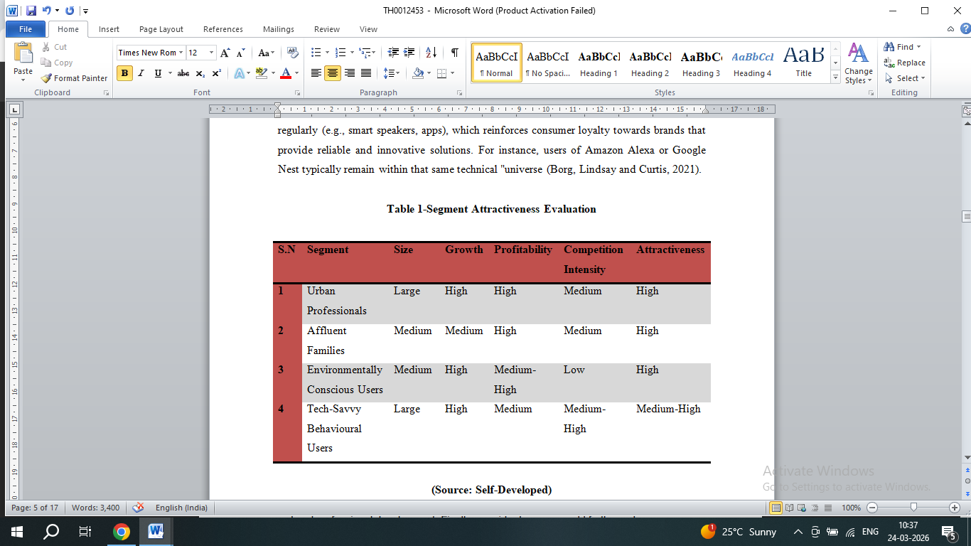
(Source: Self-Developed)

2. Targeting
ARM plans to utilize a differentiated targeting strategy. This approach is chosen over concentrated or mass targeting because of ARM’s resource capabilities, competitive strategy, brand positioning, and market heterogeneity. ARM will target urban professionals/families/environmentally conscious consumers who have the highest propensity to adopt smart home technology. Urban professionals tend to be attracted to the convenience of using automated products due to their busy lifestyles. Families tend to be more concerned about security and safety in the home with AI-based monitoring systems (Lemmens et al., 2025).Environmentally conscious consumers have an emphasis on reducing energy consumption and their carbon footprint.
- Resource Capability: ARM has both the expertise in terms of technology and a sufficient range of products that meet the needs of many customer segments at once.
- Competitive Strategy: Differentiated targeting links with ARM’s differentiation approach, permitting it to provide unique value propositions to distinct segments.
- Brand Positioning: By serving multiple segments, the company can position itself as a high-performance, energy-efficient, and secure smart home brand for a diverse audience (Arm Ltd, 2024).
- Market Heterogeneity: Consumer needs in smart home technology vary, requiring tailored marketing.
UK household electricity prices increased from about 14–15 euro cents/kWh in 2010 to nearly 24–25 euro cents/kWh by 2019–2020, showing an important overall rise (Won, 2025). The introduction of the Smart Home System has potential energy savings in excess of 10 to 15%, providing consumers with a compelling value proposition.
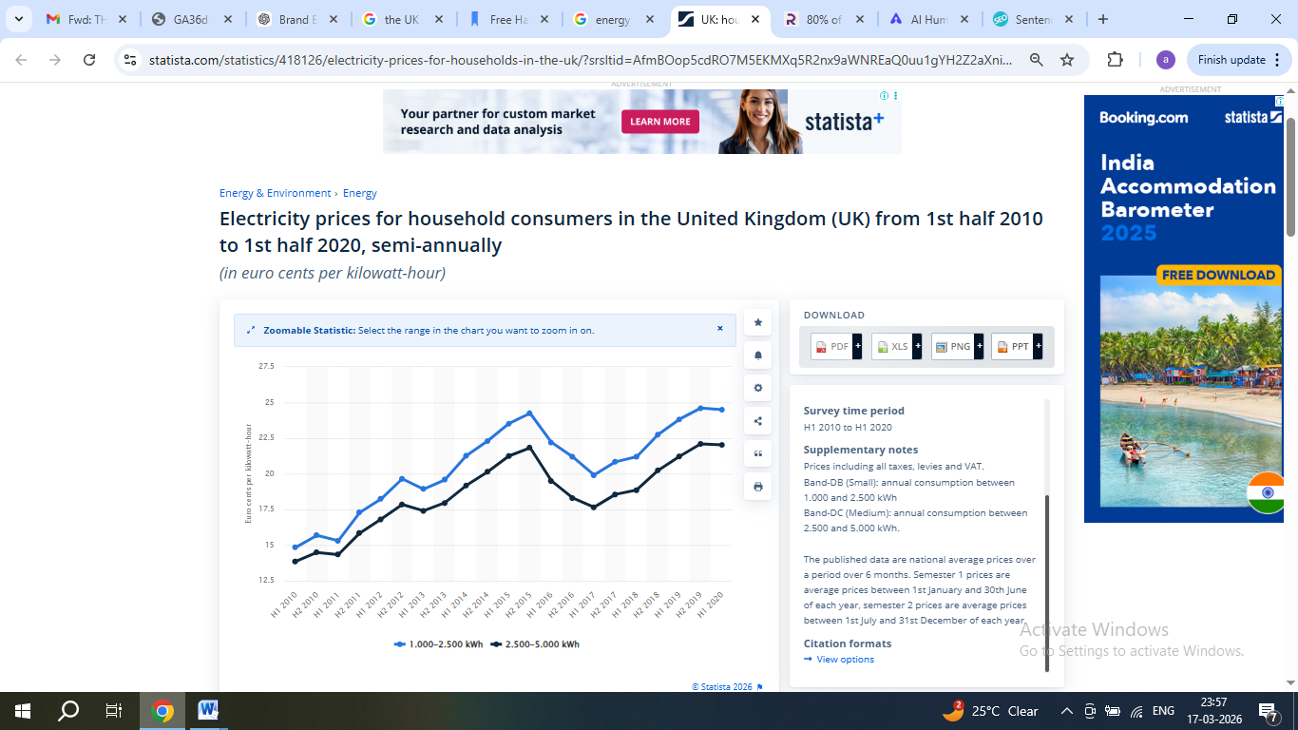
Figure 3- Increasing Electricity Prices in the UK
(Source: Won, 2025)

3. Differentiation
- Energy Efficient: As power costs increase globally, using ARM chips which consume very little power will help consumers find ways to save money on their energy usage (Navaia, Moreira and Ribau, 2023).
- High Performance: By using ARM technology, user can expect faster processing speeds and seamless operations of your devices, resulting in an enhanced user experience.
- Security: ARM has designed their chips with security features embedded in order to help protect consumer's data while using connected home devices (Wei, Chang and Zhao, 2023).
Value Proposition: ARM provide a single, high-performance, energy-efficient, and secures smart home platform, uniting sustainability, convenience, and data defence (Rintamäki and Saarijärvi, 2021).
Competitive Advantage / USP:
- Versus Amazon: Focus on energy efficiency and performance
- Versus Google: Prioritises chip-level security over AI-driven personalisation.
- Versus Apple: Delivers premium-level performance
Strategic Approach: ARM uses a differentiation approach (Porter’s Generic Strategy), producing unique value that defends premium pricing and targets ecologically and tech-conscious customers.
Market Positioning: ARM occupies a blue ocean quadrant, offering high performance and energy efficiency, while rivals such as Amazon and Google compete principally on ecosystem integration and convenience (red ocean) (Rua and Santos, 2022).
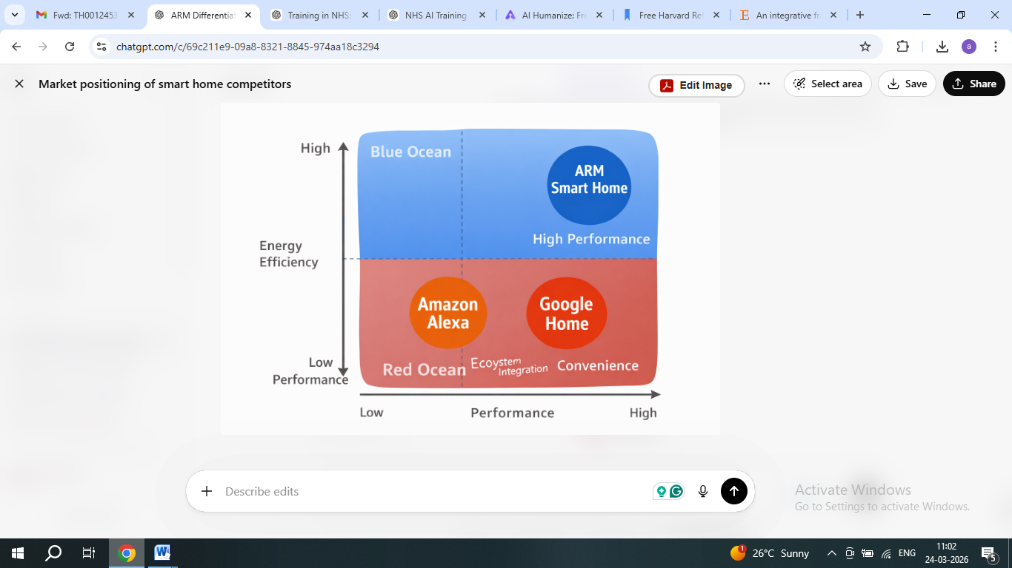
Figure 4- Market Positioning
(Source: Self-Developed)

4. Positioning
The ARM Smart Home System will be positioned as: “A smart, secure and energy-efficient option, fuelled by advanced technology”. Because of that positioning, ARM will demonstrate three core values within its brand: performance, security, and sustainability. In addition to having premium-level prices, ARM will create the perception of being a responsible company (Agyei, Manu and Coffie, 2022). ARM will clearly communicate its brand attributes around trust and innovation. The clear positioning statement for the Smart Home System is: “For the modern household, ARM Smart Home delivers the ultimate solutions that are intelligent and energy saving products that enhance comfort, security and sustainability.” Positioning supported via perceptual maps: Price vs Performance and Energy Efficiency vs Convenience. The ARM Smart Home System’s positioning statement is perfectly aligned with current consumer trends towards smart products and the desire for cost savings through energy efficiency (Kalafatis et al., 2024).
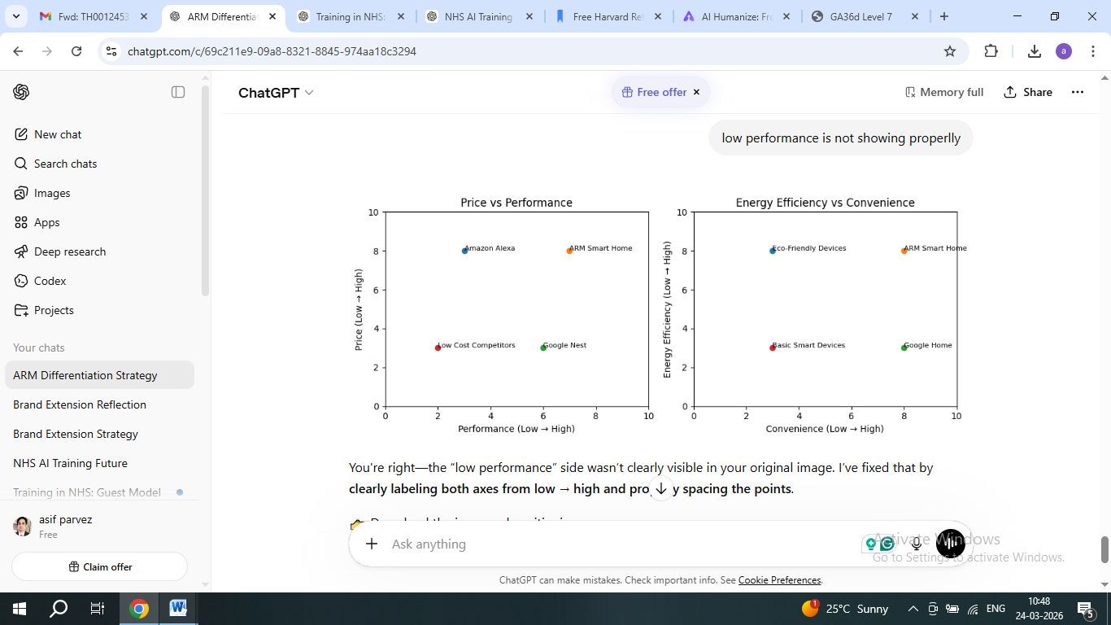
Figure 5- Competitive Positioning Map of ARM
(Source: Self-Developed)

Element 3: Marketing Mix for ARM Smart Home System

1. Product
ARM has created an innovative smart home solution that comprises a range of smart technology-enabled devices such as thermostats, security cameras and an overall automation hub for the home. Utilising ARM’s unique chip technology allows for the creation of products that have the highest performance in terms of speed and the least amount of power consumption compared to products developed using any other type of chip technology available today. In addition to allowing a consumer to control all their devices with one mobile application, this offering promotes the trend of connecting multiple products into a single integrated system and demonstrates that most consumers today prefer to manage their smart home in one easy-to-use application (Norberg, 2026). This product strategically aligns with STDP, platform ecosystem, and product lifecycle considerations. The ARM smart home product aligns with the principles of the core product, actual product, and augmented product: the core product provides convenience and energy savings; the actual product is made up of the various types of smart technology available; and the augmented product includes on-going technical support and software upgrades for each of the smart products within the ARM smart home product line (Ruiz, 2025).

2. Price
The ARM plans to implement a premium pricing structure that accurately represents the high quality and superior technology associated with their products. Premium pricing is typically utilised by technology companies to convey that their product provides a high level of performance and reliability. ARM has established itself as a trusted brand in many different industries, including smartphones, where ARM chips are currently used in more than 90% of the world's smartphones. Pricing considers elasticity, skimming, and competitive positioning strategically. Because of this solid reputation, ARM will be able to command much higher prices than new or lesser-known competitor brands (Trebicka, Tartaraj and Harizi, 2023). However, to help increase their market share, ARM could implement a bundling pricing strategy, whereby they offer a complete smart home package at a discounted price. Amazon has been able to sell smart home devices that have been bundled together to encourage consumers to purchase the device. The combination of premium pricing and bundling will assist ARM in balancing their brand positioning with their access to consumers; they will be able to successfully appeal to both higher-income consumers and lower-income consumers (Makienko and Rixom, 2022).

3. Place
To ensure that the company has a broad range of distribution methods available to its customers, the company's distribution strategy utilises various methods both online and offline. There will be several ways in which consumers can buy their products - through the company's official website; through other e-commerce sites and definitive electronics stores. Online sales will be very important to the company's overall sales strategy because over 80% of UK customers do their product research online prior to making any purchases (Wichmann et al., 2022). Distribution uses omnichannel strategy, direct/indirect channel integration, and platform partnerships. ARM will also enter into partnerships with builders of homes and companies that provide smart home install solutions so that the product can be installed into new homes providing consumers with an easy path for adopting the product. All of these distribution methods will provide consumers with convenience and easy access to the products (Jedin and Balachandran, 2021).

4. Promotion
As part of promoting energy-efficient products, the promotional strategy will primarily use social media advertising, influencer collaborations and product demonstrations. Influencer marketing can be a very powerful tool within the technology industry. For instance, when technology influencers post reviews on YouTube, they can have a significant impact on consumer purchase choices. According to Pangarkar (2024), about 94% of Gen Z and 70% Millennials strongly trust influencer marketing. IMC, digital funnel, and customer journey mapping support strategic promotion.
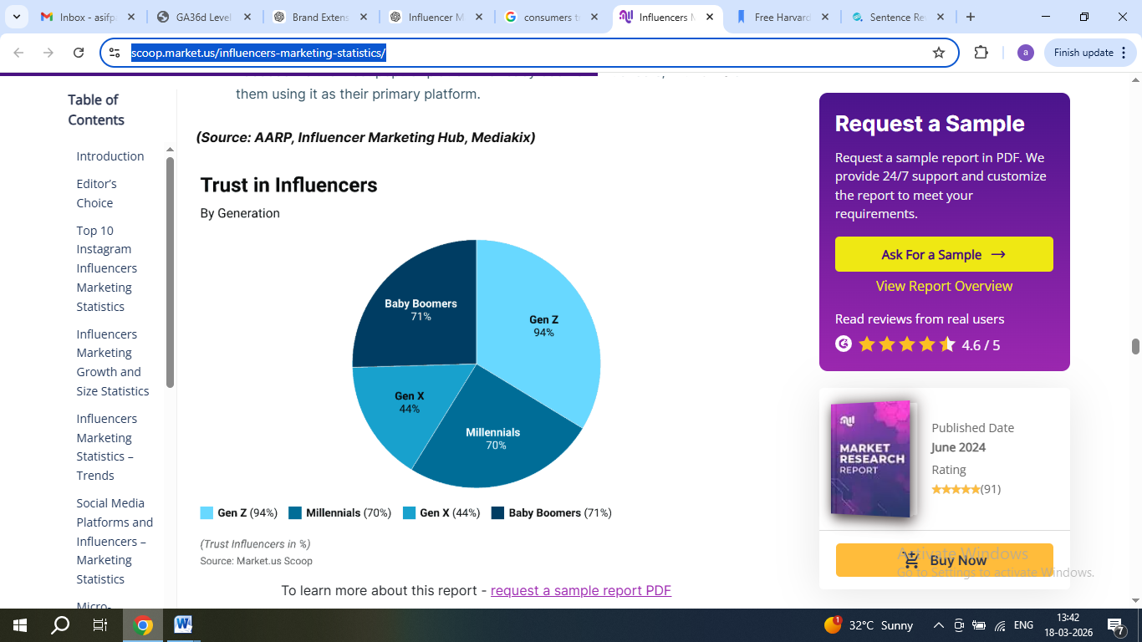
Figure 6- Trust in influencer marketing
(Source: Pangarkar, 2024)
Three primary benefits of promoting these unique energy-efficient products include: energy savings, smart living and security. These benefits address the growing needs of consumers today, most specifically high energy prices. ARM will be planning to run sustainability campaigns that promote how ARM products are saving consumer’s energy and reducing their carbon footprints (Ruiz, 2025).

5. People
A customer's experience will be greatly impacted by the people who deliver it, such as the customer service, technical support and sales teams. ARM plans to train their employees to have excellent technical knowledge and support ability, because the products they are selling for smart homes are complex and customers will need assistance understanding how to use them (Badi, 2018). Employee focus aligns with service blueprint and brand experience strategy. If ARM offers excellent service, they will create loyal customers who return for repeat business. It has been shown that 58% of consumers are willing to pay more for better service (Hyken, 2022). By concentrating on the development of skilled, supportive staff; ARM can create strong relationships with customers and improve their overall satisfaction.

6. Process
ARM intends to develop the processes used by customers to have an easy and smooth user experience; a user-friendly installation, mobile apps which are easy to navigate, and fast response to customer questions and concerns. A complicated process may have a negative effect on customer satisfaction. Companies like Apple are successful in large part because they have created simple and intuitive user experiences for their customers. Thus, ARM can improve the usability of their products. A well-designed process will reduce customer frustration and ultimately increase customer satisfaction. Processes guarantee smooth customer journey and improve experience strategy (Ahmed et al., 2024).

7. Physical Evidence
All visible physical aspects that affect how customers feel about a company and the things it sells, including packaging, product and service design, web presence, and customer reviews. The ARM will provide eco-friendly packaging as part of its commitment to sustainability. The redesign of the website and mobile applications will be completed to portray a modern and professional appearance similar to ARM's cutting-edge nature. Overall, physical evidence supports brand experience, sustainability, and trust (Rohit, Ranjan and Shainesh, 2025).

Element 4: Reflection
Description- As part of this project, I developed an ARM brand extension in the form of the ARM Smart Home System (ASHS). The project involved creating a poster, as well as a verbal presentation, describing my concept, and conducting STDP analysis and marketing strategies for the brand extension. This experience enhanced my strategic thinking, assisting me understand how businesses can utilise existing strengths to enter new markets successfully (Deng and Messinger, 2021).
Feelings- Initially, I had difficulty determining the appropriate brand extension; it needed to be both feasible and original. However, throughout the project, I grew increasingly more comfortable and convinced in my proposed extension. I also experienced a bit of apprehension when preparing my poster since I needed to make sure that I presented the material clearly, but it also motivated me to improve my communication and presentation skills, which are indispensable for effective marketing decision-making (Ahmadpour, Shariati and Moghadam, 2025).
Evaluation- One key aspect of this project that was a positive is the fact that I was able to successfully integrate one of ARM’s core competencies (energy savings) with the Smart Home market, signifying strategic positioning. I also prepared a well-defined STDP strategy, which provided strong foundations for this project and created a solid project. I found the poster allowed me to provide information in a concise, easy-to-follow manner. However, one difficult aspect of the project was working within the word limits – selecting the most relevant points to present (Kaur et al., 2022).
Analysis- During this project, I gained valuable insight into brand development and marketing strategy. I found out that a successful brand extension should fit with the company’s overall identity and will also match what is being demanded in the market, which improved my strategic decision-making. The STDP analysis gave me a clearer understanding of customers’ needs as well as how businesses target specific groups of consumers. I learned that differentiation and positioning are critical to success in a competitive marketplace, and using energy efficiency to differentiate themselves from their competitors was a way for ARM to uniquely position them. Preparing the poster also refined my ability to communicate complex ideas clearly, a skill that would support my career grwoth in marketing and business management. (Theoharakis, Zheng and Zhang, 2024).
Conclusion- This project has improved my analytical thinking, strategic planning, and marketing decision-making skills. The project has also increased my confidence to use marketing theory to support decision-making in the real world. Finally, this experience has improved my understanding of how companies develop and implement new products and services (Kaur et al., 2022).
Action Plan- In the future, I will focus on performing all tasks with very clear market research and using a variety of academic resources that will aid my performance as a marketing/ business management professional. I plan improve my presentation skills so I can be more comfortable and confident when speaking in front of large groups. These improvements will improve my performance in similar projects and directly support my career progress in marketing and business management (Saylor et al., 2023).
.

References
Agyei, P.M., Manu, F. and Coffie, S. (2022). Positioning strategies for B2B service markets. Industrial Marketing Management, 106, pp.405–419. doi:https://doi.org/10.1016/j.indmarman.2022.09.010.
Ahmadpour, N., Shariati, A. and Moghadam, M.P. (2025). Effect of Narrative Writing Based on Gibbs’ Reflective Model on the Empathy and Communication Skills of Nursing Students. BMC Medical Education, 25(1), pp.1–9. doi:https://doi.org/10.1186/s12909-024-06593-7.
Ahmed, S., Saad, A.T., Chowdhury, S.R., Sobhani, F.A., Hassan, Md.S. and Islam, M.A. (2024). Impact of marketing mix elements on the brand equity of online food delivery services: an emerging economy perspective. Cogent Business & Management, 11(1). doi:https://doi.org/10.1080/23311975.2024.2380018.
Arm Ltd (2024). Architecting a Smarter World – Arm. [online] Arm | The Architecture for the Digital World. Available at: https://www.arm.com/.
Badi, K.S.A. (2018). The Impact of Marketing Mix on the Competitive Advantage of the SME Sector in the Al Buraimi Governorate in Oman. SAGE Open, 8(3). doi:https://doi.org/10.1177/2158244018800838.
Borg, K., Lindsay, J. and Curtis, J. (2021). Targeted Change: Using Behavioral Segmentation to Identify and Understand Plastic Consumers and How They Respond to Media Communications. Environmental Communication, [online] 15(8), pp.1–18. doi:https://doi.org/10.1080/17524032.2021.1956558.
Clarke, A.H., Freytag, P.V. and Cortez, R.M. (2024). Revisiting the Strategic Role of Market segmentation: Five Themes for Future Research. Industrial Marketing Management, 121, pp.A7–A10. doi:https://doi.org/10.1016/j.indmarman.2024.07.012.
Deng, Q.C. and Messinger, P.R. (2021). Dimensions of brand-extension fit. International Journal of Research in Marketing, [online] 39(3). doi:https://doi.org/10.1016/j.ijresmar.2021.09.013.
GVR (2024). UK Smart Home Market Size & Outlook, 2030. [online] Available at: https://www.grandviewresearch.com/horizon/outlook/smart-home-market/uk.
Hyken, S. (2022). 58% Of Customers Will Pay More For Better Customer Service. [online] Forbes. Available at: https://www.forbes.com/sites/shephyken/2022/04/24/fifty-eight-percent-of-customers-will-pay-more-for-better-customer-service/.
Jedin, M.H. bin and Balachandran, I. a/p (2021). Marketing Mix Elements and Customer Service Satisfaction: Empirical Evidence in the Malaysia Edutainment Theme Park Industry. Services Marketing Quarterly, 42(1-2), pp.93–107. doi: https://doi.org/10.1080/15332969.2021.1947087.
Kalafatis, S.P., Blankson, C., Boatswain, M.L. and Tsogas, M.H. (2024). Positioning Strategies in B2B Marketing: The Regulatory Focus Orientation. Journal of Business-to-Business Marketing, pp.1–37. doi: https://doi.org/10.1080/1051712x.2024.2411455.
Kaur, R., Singh, R., Gehlot, A., Priyadarshi, N. and Twala, B. (2022). Marketing Strategies 4.0: Recent Trends and Technologies in Marketing. Sustainability, 14(24), p.16356. doi: https://doi.org/10.3390/su142416356.
Lemmens, A., Roos, J., Gabel, S., Ascarza, E., Bruno, H., Gordon, B., Israeli, A., McDonnell Feit, E., Mela, C. and Netzer, O. (2025). Personalization and Targeting: How to Experiment, Learn & Optimize. International Journal of Research in Marketing. [online] doi: https://doi.org/10.1016/j.ijresmar.2025.07.004.
Makienko, I. and Rixom, J. (2022). Using Marketing Mix Elasticities to Demonstrate Consumer and Producer Perspectives in Marketing Management Class. The International Journal of Management Education, 20(3), p.100689. doi: https://doi.org/10.1016/j.ijme.2022.100689.
Market Screener UK. (2026). MarketScreener UK. [online] Available at: https://uk.marketscreener.com/quote/stock/ARM-HOLDINGS-PLC-159091235/finances/ [Accessed 17 Mar. 2026].
Navaia, E., Moreira, A. and Ribau, C. (2023). Differentiation Strategy and Export Performance in Emerging Countries: Mediating Effects of Positional Advantage among Mozambican Firms. Economies, 11(2), p.44. doi: https://doi.org/10.3390/economies11020044.
Norberg, S. (2026). Smart Home Statistics. [online] Gitnux. Available at: https://gitnux.org/smart-home-statistics/?utm_source=chatgpt.com [Accessed 17 Mar. 2026].
Pangarkar, T. (2024). Influencers marketing statistics 2024 by growth, strategy. [online] Market.us Scoop. Available at: https://scoop.market.us/influencers-marketing-statistics/.
Rintamäki, T. and Saarijärvi, H. (2021) An integrative framework for managing customer value propositions. Journal of Business Research, [online] 134(134), pp.754–764. doi: https://doi.org/10.1016/j.jbusres.2021.05.030.
Rohit, S., Ranjan, K.R. and Shainesh, G. (2025). Service marketing mix and customer engagement: A meta-analysis. Journal of Business Research, [online] 194, p.115363. doi: https://doi.org/10.1016/j.jbusres.2025.115363.
Rua, O.L. and Santos, C. (2022). Linking brand and competitive advantage: The mediating effect of positioning and market orientation. European Research on Management and Business Economics, [online] 28(2), p.100194. Available at: https://www.sciencedirect.com/science/article/pii/S244488342100053X.
Rua, O.L. and Santos, C. (2022). Linking brand and competitive advantage: The mediating effect of positioning and market orientation. European Research on Management and Business Economics, [online] 28(2), p.100194. Available at: https://www.sciencedirect.com/science/article/pii/S244488342100053X.
Ruiz, A. (2025). 51 huge environmentally conscious consumer statistics 2023. [online] The Roundup. Available at: https://theroundup.org/environmentally-conscious-consumer-statistics/.
Ruiz, A. (2025). 51 huge environmentally conscious consumer statistics 2023. [online] The Roundup. Available at: https://theroundup.org/environmentally-conscious-consumer-statistics/.
Saulick, P., Bokhoree, C. and Bekaroo, G. (2023). Business sustainability performance: A systematic literature review on assessment approaches, tools and techniques. Journal of Cleaner Production, [online] 408, p.136837. doi: https://doi.org/10.1016/j.jclepro.2023.136837.
Saylor, M., Clair, C.A., Curriero, S., DeGroot, L., Nelson, K., Pavlovic, N., Taylor, J., Gallo, J.J. and Szanton, S. (2023). Analysis of action planning, achievement and life purpose statements in an intervention to support caregivers of persons with heart failure. Heart & Lung, [online] 61, pp.8–15. doi: https://doi.org/10.1016/j.hrtlng.2023.04.002.
Theoharis, V., Zheng, Y. and Zhang, L. (2024). Dynamic strategic marketing planning: The paradox of concurrently reconfiguring and implementing strategic marketing planning. Journal of Business Research, [online] 174(1), p.114525. doi: https://doi.org/10.1016/j.jbusres.2024.114525.
Thuy D., (2025). Internet penetration in the UK 2025| Statista. [online] Available at: https://www.statista.com/statistics/1124328/internet-penetration-uk/?srsltid=AfmBOopo_9LAck77K4IhTXxKyKZl09FxU5pACN6_AwXgkJvlGxGEXIJk [Accessed 17 Mar. 2026].
Trebicka, B., Tartaraj, A. and Harizi, A. (2023). Analysing the relationship between pricing strategy and customer retention in hotels: A study in Albania. F1000Research, 12(1), pp.690–690. doi: https://doi.org/10.12688/f1000research.132723.1.
Wei, J., Chang, M. and Zhao, J. (2023). Price matching and product differentiation strategies considering showrooming. Journal of Retailing and Consumer Services, 75, pp.103473–103473. doi: https://doi.org/10.1016/j.jretconser.2023.103473.
Wichmann, J.R.K., Uppal, A., Sharma, A. and Dekimpe, M.G. (2022). A Global Perspective on the Marketing Mix across Time and Space. International Journal of Research in Marketing, 39(2), pp.502–521. doi: https://doi.org/10.1016/j.ijresmar.2021.09.001.
Won, S. (2025). UK: household electricity prices| Statista. [online] Available at: https://www.statista.com/statistics/418126/electricity-prices-for-households-in-the-uk/?srsltid=AfmBOop5cdRO7M5EKMXq5R2nx9aWNREaQ0uu1gYH2Z2aXniGRkqjTusO [Accessed 17 Mar. 2026].

