Postgraduate/Distance Learning
Assignment coversheet & feedback form


THIS SHEET MUST BE THE FIRST PAGE OF THE ASSIGNMENT YOU ARE SUBMITTING (DO NOT SEND AS A SEPARATE FILE)

For completion by the student:
Student Name: Tina Jensen Friis Auster

Student University Email: 2024510@student.uwtsd.ac.uk
Module code: HPCA7014  Module title: Foundations in Cultural Astronomy and Astrology | Student ID number:  2024510 |  |  | Educational support needs:  No
Assignment title: Are sacred waters natural or created by humans?

Assignment due date: 13th January 2022
This assignment is for the 2nd module of the degree
I confirm that this is my original work and that I have adhered to the University policy on plagiarism.
Signed ……Tina Jensen Friis Auster………………………………………………………
Email submission:if you are submitting this form via email, please tick this box x
(as a substitute for your signature) to confirm that you agree to the above declaration.
Assignment Mark

1st Marker’s Provisional mark

2nd Marker’s/Moderator’s provisional mark

External Examiner’s mark (if relevant)

Final Mark

NB. All marks are provisional until confirmed by the Final Examination Board.

ALL COMMENTS ARE ON THE PDF OF YOUR PAPER IN TURNITIN

For completion by Marker 1 :

Comments:

Marker’s signature: |  |  | Date:
For completion by Marker 2/Moderator:

Comments:

Marker’s Signature: |  | Date:
External Examiner’s comments (if relevant)
External Examiner’s Signature: |  | Date:

Is Sacred Spaces A Human Construct Or A Natural Phenomena?
Water As Sacred Space
(5360 words)

Tina Jensen Friis Auster
Sophia Centre for the Study of Cosmology in Culture
University of Wales Trinity Saint David, Institute of Education and Humanities

Introduction
This essay is based on a field work study of three types of waters, which will be explored in relation to the question: ‘Is Sacred Space A Human Construct Or A Natural Phenomena?’, exploring: ‘Water As Sacred Space’. The essay will examine and analyse a connection to water as sacred through a possible source of meaning , functionality , wonder , remembrance , sacredness , and personal experience .
The geographical area chosen for the purpose of the essay was Cornwall, the most south western part of England, UK. Cornwall has over 200 holy wells, and the most coastline in the UK. Furthermore, Cornwall has many springs, rivers and streams, water basins at stone circles and fonts in churches. As everywhere else, it also rains in Cornwall. From the above list of potential sacred waters, is was evident that the exploration of "sacred waters" would be very broad, and this essay has thus been structurally limited to examine: 1) Rain; 2) The St. Euny’s Holy Well, Redruth; and 3) Portreath Sea.
Methodology
This essay will explore whether rain, and the two geographical places, were experienced as sacred space through a phenomenological approach. This approach was discussed by Kim Etherington, as using yourself in the research. Tilley further discussed how the purpose of a phenomenological approach would be to contemplate the world in the way of human experience:
[…] the attempt to describe objects of consciousness in the manner in which they are presented to the consciousness. It attempts to reveal the world as it is actually experienced directly by a subject as opposed to how we might theoretically assume it to be.
I am female, in my early fifties. I spend a lot of time outdoors, however my favourite place would not be a place of water. Rain is my favourite weather, thus, the rain-study is biased. Bias was described by Judith Bell and Stephen Waters when conducting a reflexive study. This study challenged my observation and research abilities to remain open and neutral. The field work was conducted from 10/12/21 to 10/01/22, and will explore three different waters, as per the "Literature Review".
Firstly, the field work explored "Rain" in relation to the aspects of waters significance , the significance of rain itself , and rain/water as deified and a life force . The exploration of rain was geographically limited to Cornwall, England, UK, including The St. Euny’s Holy Well and Portreath Sea, with the "place" or "space" being in the rain. St. Euny’s Holy Well, Redruth,
Cornwall, England, UK is located below the Neolithic settlement at Carn Brea at Redruth, Cornwall, England, UK (Fig. 1, Fig 2, Fig 3 and Fig 4).

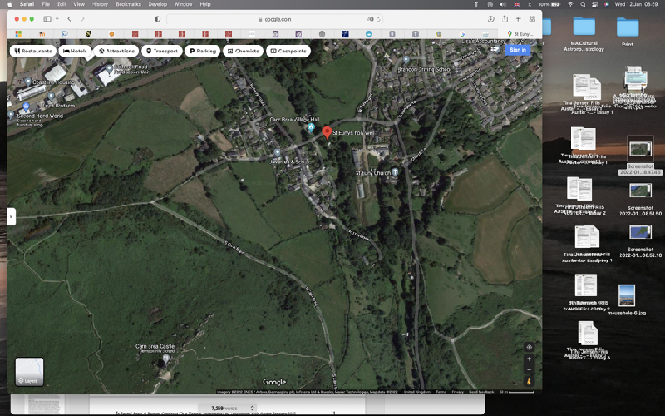
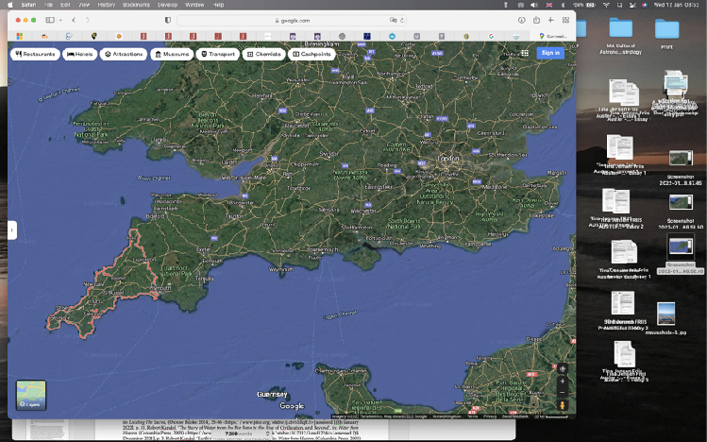
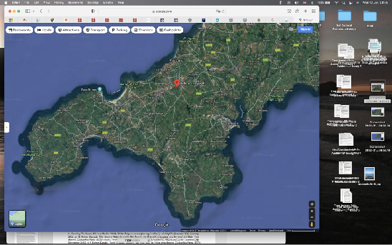
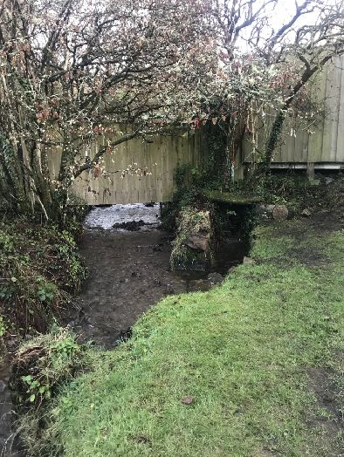
The British Listed Buildings website stated that the well has been a Grade II Listed Building since 2005 as a holy well of Medieval origin. The Cornwall Archaeological Unit noted:

Figure 3. Map of St. Euny’s Well at the Village of Carn Brea and below Carn Brea, Redruth, Cornwall, England, UK.St. Euny’s Holy Well marked with red dot. Source: Google Maps https://www.google.com/maps> [assessed 12th January 2022].

Figure 1. Map of England, UK. Cornwall circled in orange. Source: Google Maps https://www.google.com/maps> [assessed 12th January 2022].

Figure 2. Map of Cornwall, England, UK.St. Euny’s Holy Well marked with red dot. Source: Google Maps https://www.google.com/maps> [assessed 12th January 2022].

Figure 4. St. Euny’s Holy Well. Sunday 26.12.21, 15.29, Photo: Tina Jensen Friis Auster.
[…] the little well-house has no evident decorative worked stones or other datable features, but these may have been robbed or lie beneath present ground level. It lies beside a stream forming the parish boundary, around 130m from the church further east.
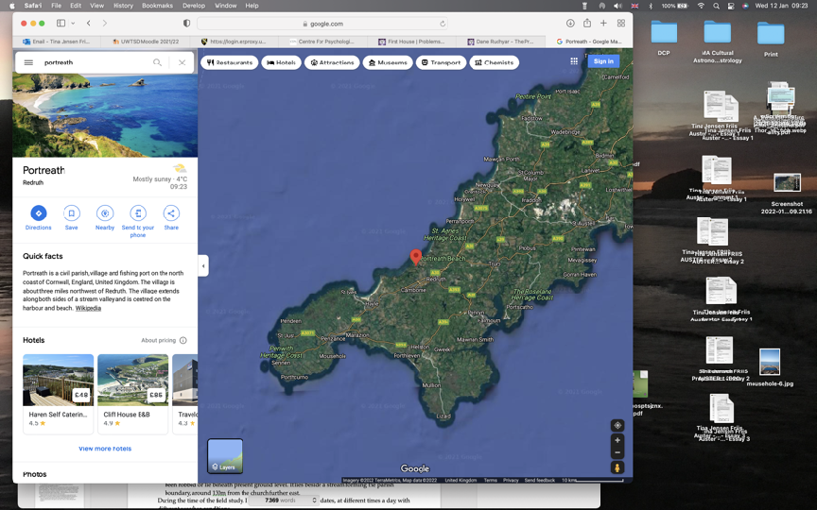
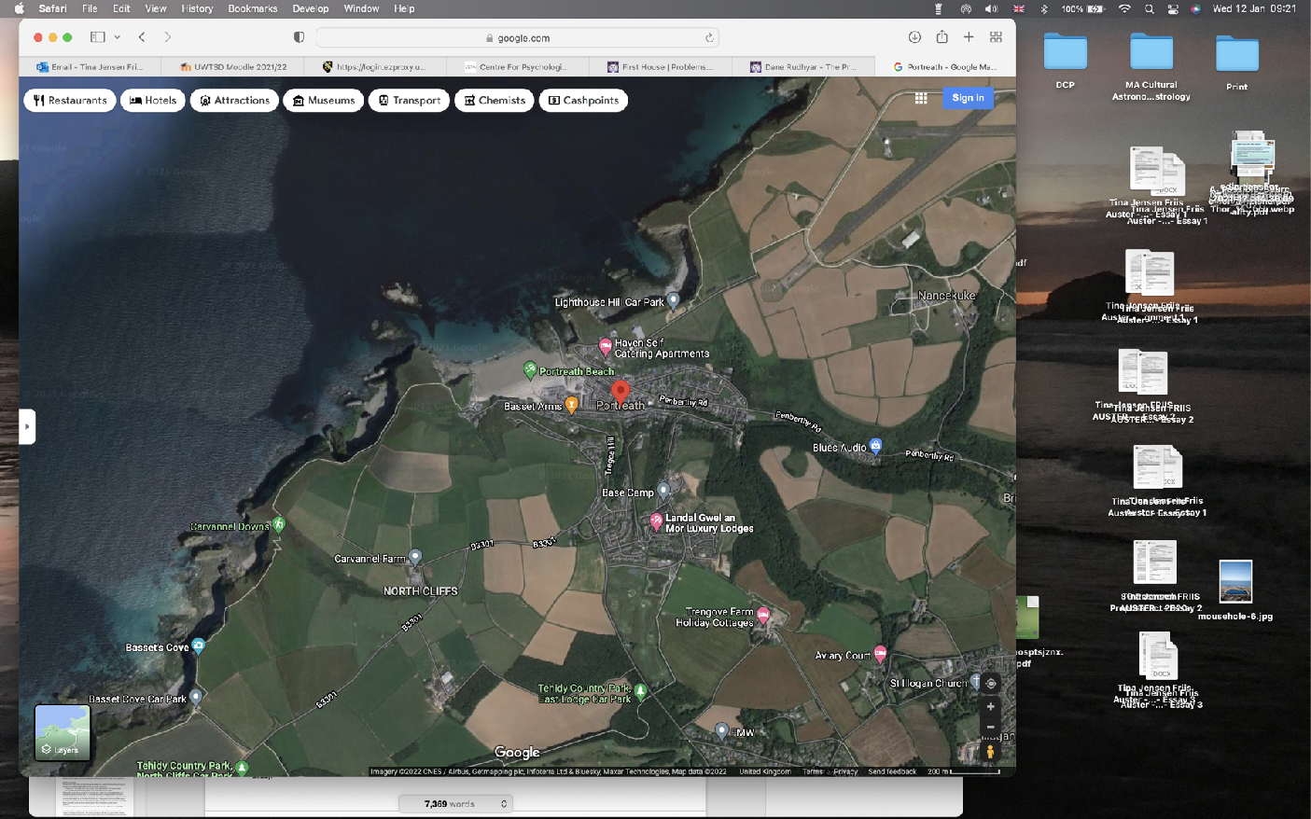
Portreath sea, Cornwall, England, UK consists of the harbour and the beach. Portreath is a mining village, with the harbour dating back to 1713. Portreath is located 5 miles west of Redruth, at the North Coast of Cornwall, England, UK (Fig. 5, Fig 6, Fig 7, Fig. 8, Fig 9).

Figure 5. Map of England, UK. Cornwall circled in orange. Source: Google Maps https://www.google.com/maps> [assessed 12th January 2022].

Figure 6. Map of Cornwall, England, UK.Portreath marked with red dot. Source: Google Maps https://www.google.com/maps> [assessed 12th January 2022].

Figure 7. Map of Portreath, Portreath Seafront and Harbour, Cornwall, England, UK.Portreath marked with red dot. Source: Google Maps https://www.google.com/maps> [assessed 12th January 2022].

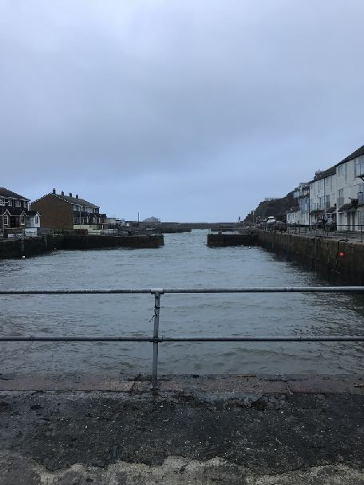
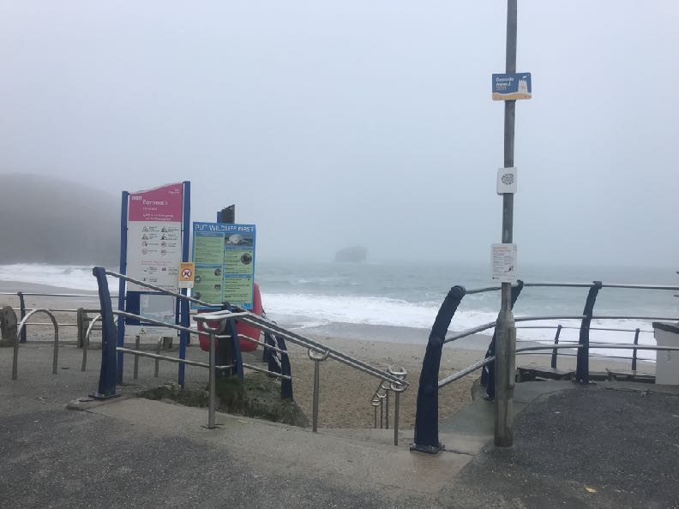

Figure 8. Portreath Harbour. Wednesday 29.12.22, 12.05, Photo: Tina Jensen Friis Auster.

Figure 9. Portreath Beach. Monday 10.01.22, 10.27, Photo: Tina Jensen Friis Auster.

The harbour was constructed to allow large ships to deliver coal and collect copper and tin. By the 1840s Portreath managed 700 shiploads per year, loading 100,000 tons of ore. Today, the harbour is owned by Cornwall Council. The beach at Portreath is a short beach in between natural rock formations.

Literature Review
The primary source of the essay is the field work study journal which consisted of 217 photos, 9 videos, 34-page full notebook along with electronically recorded notes; from hereon referenced as ‘my journal’. The findings in my journal will be analysed with the use of existing sources. In the paper ‘Thinking across the Divide’, Barbara Bender argued that a phenomenological approach involved sense of place. Edward Casey similarly described experiencing place through utilising our body, which he defined as: […] "the geographical self". Through the field work, my journal recorded phenomenological aspects from experiencing the rain, the holy well and the sea, which will be analysed in the "Discussion".
Rain will be the first to be analysed. Tilley discussed rain as divine: ‘the purest of all water is that which comes from the Heaven’. This is supported in the holy text of The Rig Veda, where rain is deified and the source of all life , and similarly described in many other cultures. The Earth needs water for survival, and the Danish author John V. Jensen discussed the stone-age humans’ perception of the natural wells as being alive, as well as being functional. The functional use of water was supported by Tilley and Feldman respectively, who described the collection of rain water into basins and sanctuaries for healing and practical purposes in two different cultures.
Bryan described the function of the sea as being made sacred for pleasure and fishing boats. This study explored the aspects of three potential sacred waters, along with how such sacredness arose. Was it natural or a human construct?
The Rig Veda described the sacredness of water , as similarly described in Alan Ereira’s book "The Elder Brothers’ Warning":
This was a spiritual centre, home to many of the Mothers, which acted as a focus of thought for the protection of the species, and a place of shrines, at which offerings had to be given.
The key theorist used in relation to the concept of sacred was Mircea Eliade, who discussed the sacred in the two books used in this essay. In relation to water Eliade argued:
[…] water fills the same function in whatever type of cultural pattern we find it; it precedes all forms and upholds all creation.
Eliade continued: ‘The sacred always manifests itself as a reality of wholly different order from ‘natural’ realities.’ Emilie Durkheim argued that everything was sacred, including a spring, and thus including water , however further argued that nature was divinised later than animals. Belden C. Lane argued that: ‘[…] the sacred place is not chosen, it chooses’ , and further that: ‘[…] the places themselves participate in the perception that is made of them’. This communication, or connection, will be explored and analysed in relation to all the visited spaces/places. ‘Water was sacred before it was material’, Greely argued. This study focused on three waters in Cornwall. As Tilley et.al. described Cornwall as: ‘[…] different landscapes within Cornwall, like a series of Chinese boxes, one inside the other.’

Discussion
Rain
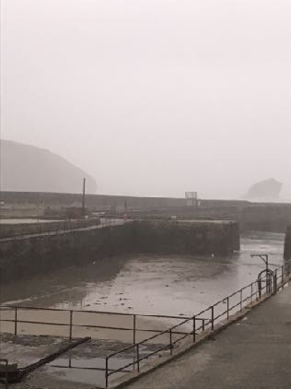
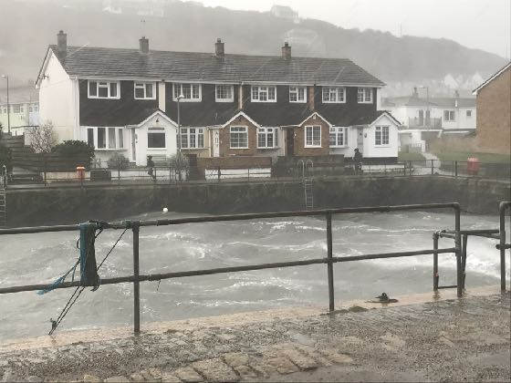
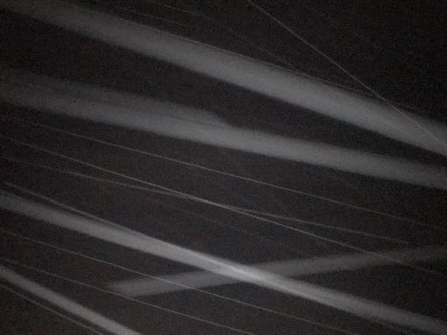
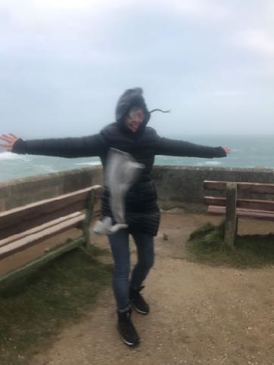
The rain took various forms during the study, from misty, gentle falling, to windy/horizontal, pouring and nighttime-rain (Fig, 9, Fig. 10, Fig. 11 and Fig 12).

Figure 9. A misty rainy day. Tuesday 11.01.22, 08.09, Photo: Tina Jensen Friis Auster.

Figure 10. Gentle, but steady rain falling while at Portreath harbour with people running to get to shelter. Tuesday 09.02.20, 15.48, Photo: Tina Jensen Friis Auster.

Figure 12. Rain at night taken with flash to catch the streaks of rain passing the camera. Sunday 09.11.22, 17.54, Photo: Tina Jensen Friis Auster.

Figure 11. A Portreath day of high winds and horizontal rain. Sunday 28.12.22, 11.56, Photo: Tina Jensen Friis Auster.

The first note of my journal said:
I want to say: "I am at the rain"; like I say: "I am at the seafront" or "I am at the holy well". The rain feels like I am at a place, but it also feels like I am in a space.
Casey argued how ‘place’ was unable to be ‘space’ as place had a horizon. This is opposed by Durkheim arguing that a sacred space can be anywhere. My journal reflected finding sacred space in the landscape, and finding place and space at the same time: ‘I am at The Holy Well in the rain’. The rain felt like a physical location, as a confined space, though a confined space that kept moving with me, myself being the centre of that space. Eliade described sacred spaces as confined spaces with a centre space, an ‘axis mundi’:
[…] represents a cosmos axis, for it is around the sacred pole that territory becomes habitable […] The sacred pole consequently plays an important role ritually. […] always carry it with them […] to be always in “their world” and, at the same time, in communication with the sky […] ,
as opposed to Lane who discussed that the sacred was often not at the centre:
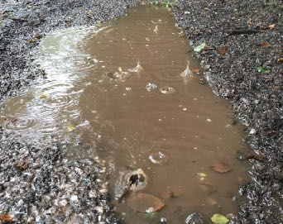
[…] the axis mundi, located at the centre and separated from all profane attachments, is simply not possible’.

Figure 13. Raindrops in a puddle as it starts raining. Monday 20.12.22, 16.39, Photo: Tina Jensen Friis Auster.
My journal reflected further expressed:
When I am in the rain, I can take it with me, the experience can happen anywhere it rains. I am not bound to a specific geographical place as a sacred space. The sacred space arises as soon as it starts to rain.
As such, this study explored and found, that both a physical location (place) and being present (space) could be sacred. However, the space could be argued to be a personal experience, as discussed by Durkheim: ‘[…[ the space I know by my senses of which I am the centre and where everything is disposed in relation to me, could not be space in general’.
My journal continued to contemplate on my personal space at the rain: ‘[…] makes me feel alive and revived’; ‘[…] feel a close connection to the skies as if part of them/in them’; ‘The clouds that share the rain seem to have added a lid on all stress and worries’; and further (Fig 13):
It has just started to rain now, I feel blessed and instantly calm. The sense of the raindrops on my skin creates the first rush of sensation. I look at the rain drops on my pen as my

paper gets wet. Somehow it is magical. The rain represents something free, something uncontrolled. The air suddenly smells fresher, I can breathe more freely. Simply magnificent.
This record reminded me of the Waters of Tao, as discussed by Chamberlain , and further a common story told by C.G. Jung: ‘The Rainmaker Story’ : Rain would fall when equilibrium (Tao) was present: ‘[…] back in Tao, and then naturally the rain came’. Rain was deified in The Rig Veda: ‘It was the upholder of all lives and the saviour of everything […]’. The 9 verses of ‘The Waters Of Life’ in the Rig Veda, described water as a life force, a giver of well-being and cure. Eliade contributed to the wonders of rain:
Water nourishes life, rain fertilizes as does the semen virile. In the erotic symbolism of the creation, the sky embraces and fertilizes the earth with rain. The same symbolism is found universally.
Annemarie Schimmel described rain as life-giving with the ‘quality of Mercy’. Rain was argued by Feldman to be collected in ancient Egypt for the sanctuaries, in favour of water from the river. Feldmam argued: […] an appreciation for the variety of ways in which the power of the gods was made manifest through water. Finally, Eliade described water:
The waters symbolize the universal sum of virtualities; they are fons et origo, "spring and origin”, the reservoir of all possibilities of existence; they precede every form and support every creation.
The analysis showed that sources agreed on the aspect of divinity and sacredness of rain and water. It could be argued that the sensations evoked within me, were a natural human admiration for rain.
Irrespective of which type of rain (gentle, mist, windy or pouring), my journal expressed one common aspect: a sense of connection. On a stormy day, I wrote:
The rain is horizontal today. Being out is a challenge, very cold, so this will be brief. The wind disrupts my sense of rain, as my mind is occupied with battling the wind, and the rain hitting my skin hurts today. But if I put my back to the wind, I connect to its wonder. I look at the rain. The rain, which I thought was free and uncontrolled, has become controlled.
This resembled Bernadette Brady’s discussion on Kosmos and Chaos: ‘Cosmos touched the earth through heavenly order and Chaos by heavenly disorder’. For moments, in that windy rain, the Earth seemed touched by Chaos. Even so, I was still able to connect with the rain, to speak to it, to sense it. As discussed by Lane: ‘[…] form a dancelike exchange that is essential to the holistic perception of the way any manifestation of the holy is perceived in space’. The space held in the rain, could be argued to be my personal sacred space of connection and, as such, a human construct, though the sacred waters falling from above was a natural phenomena and found to be sacred it itself. Sacred waters can also come from the depth of the Earth, for example from the wells. Though, as discussed by Robert Kandel, without rainwater, there would be no wells.

St. Euny’s Holy Well
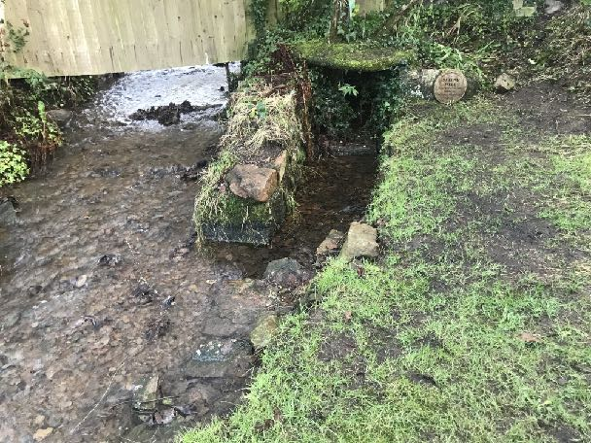
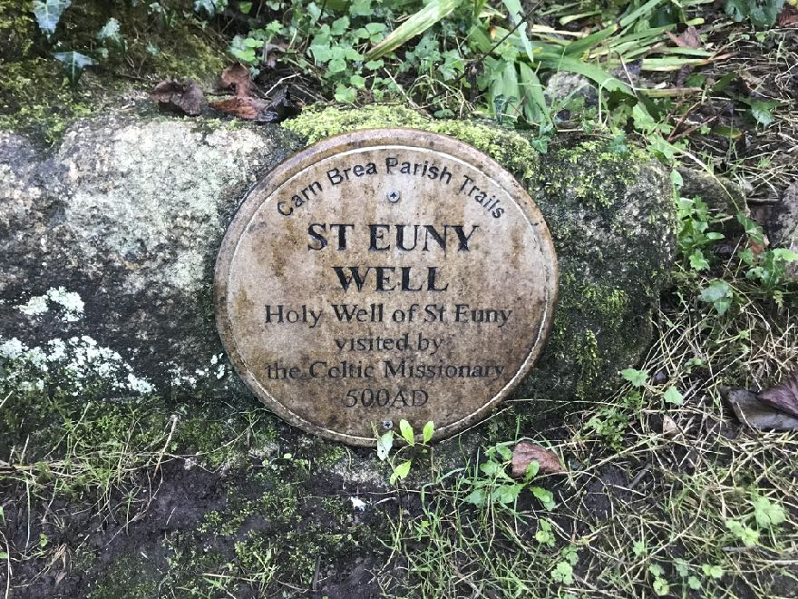
A plaque mounted on a rock next to the well read: ‘Carn Brea Parish Trails. St Euny Well. Holy well of St. Euny visited by the Celtic Missionary 500AD’ (Fig, 14 and Fig 15.).

Figure 14 and Figure 15. The plaque at The St. Euny’s Holy Well. Sunday 26.12.22, both taken at 15.26, Photos: Tina Jensen Friis Auster.
According to Chamberlain, 129 wells in England had relation to saints. There was little information about the St. Euny’s Well, and only one sentence relating to its qualities: ‘Baptism with water from the holy well was believed to safeguard against hanging’ . Matthew Franklin Cooper wrote about Saint Euny:
It is supposed based on local lore that Saint Euny visited Carn Brea when it was still ruled as a heathen holy site by a Romano-British chieftain, and performed a wonder of God that resulted in or was commemorated by the holy well there.
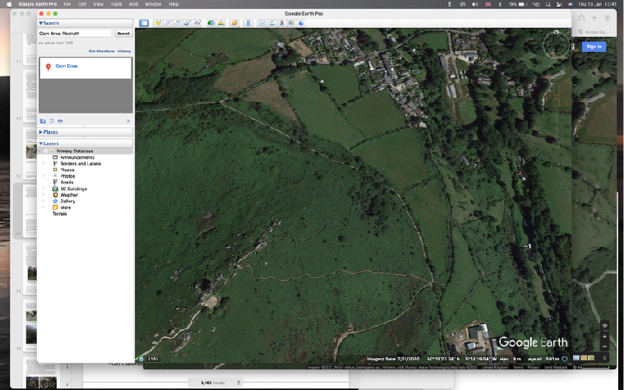
This ‘wonder of God’ could indicate that the well and its waters were perceived as sacred. Furthermore, the wells’ location below the earliest know village in Britain , the Neolithic settlement at Carn Brea, could suggest a connection to an area of sacredness (Fig. 16). Eliade argued: ‘[…] all water comes to be considered powerful for fertility or healing’. Coltelli

Figure 16. The area of Carn Brea settlement (large star) and The St. Euny’s Holy Well (small star). Google Earth Pro, version 7.3.4.8248 (64-bit). Friday, July 16, 2021, 9:22:26.

supported this, arguing that: ‘[…] springs endowed with powers of purification or magic casting spells’. Chamberlain quoted the Tao: ‘[…] the highest good is like water’. Furthermore, Kandal discussed another reason for the sacredness of the water in wells: ‘[…] it has been “processed” by more or less chemically active soil and rocks. Water emerging from the ground and its filtering
action naturally contains minerals […]’. In my journal, I wondered, whether Saint Euny, and the Romano-British before him, knew of this well and were attracted to the well for a reason. Lane argued: ‘[…] sacred places inherently possess an intentionality and power drawn form within or beyond themselves.’ My journal reflected:
It is lovely visiting this sacred place without knowing its wonders or its story. In this way, my mind has not been allowed to form a preset idea. For once, I have not spent hours researching, but am simply learning about this well through experience! It feels nice, but also strange, to be here with an empty mind instead of a mind filled with researched information. Loving it!
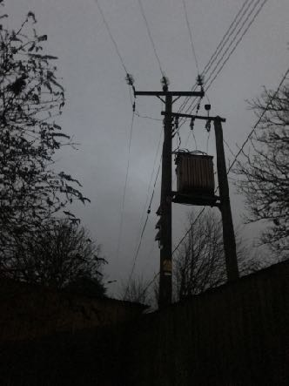
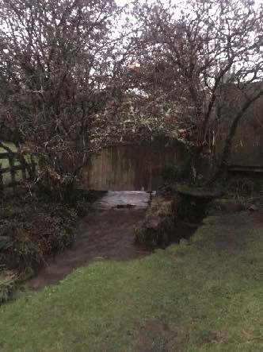
Tilley et.al. discussed how research often is prepared using: ‘[…] writings, maps, photographs, paintings, drawings, and entire apparatus […]’ , and further quoted Tim Ingold: ‘we owe our very being to the world we seek to know. In a nutshell participant observation is a way of knowing from the inside’. . My journal records from the well could be argued to be the most neutral and non-biased of this study. I was able to communicate with the site without preconceived ideas. As discussed by Lane: […] to listen to the place itself, to recognise its own topography and material character as suggesting affordances of their own’.

Figure 18. The electrical pole at The St. Euny’s Holy Well. Sunday 10.01.22, 17.20, Photo: Tina Jensen Friis Auster.

Figure 17. The enclosed area of The St. Euny’s Holy Well. To the back the 2-2.5 metre tall fence, which also stands on the right along the 20 metre path when walking towards the well; and to the left the metal fencing. Sunday 10.01.22, 17.20, Photo: Tina Jensen Friis Auster.
The well was surrounded by human construction. Just behind the well and all the way on the right next to the path leading to the well, was a 2-2.5 metre tall wooden fence; to the left next to the stream was another metal fence, making the whole area of the well an enclosed space (Fig. 17). Furthermore, there was a large electricity pole to the right of the well (Fig. 18). Richard Sosis
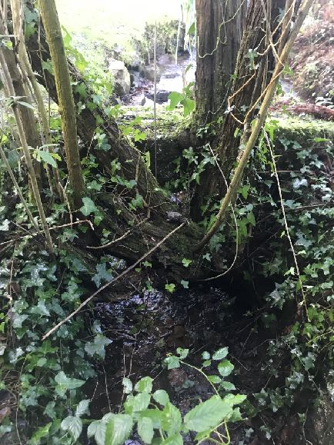
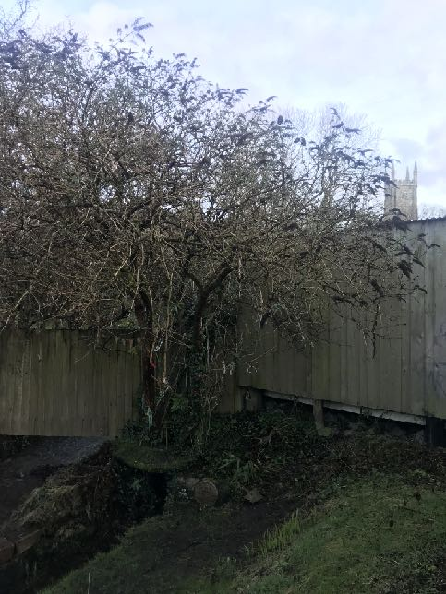
argued: ‘Sacred spaces consist of humanly defined areas in which particular behaviours, typically ritual, are expected’. In the case of the well, the area had been defined by the plaque, but also by the fences; the latter did not aid in my experience of sacred space, which at times felt disrupted. The sense of sacredness increased being closer to the well. The wonderful flow of the stream and the clearness of the water, the magical natural fauna, and the sight to the distant church tower increased the sense of sacredness (Fig. 19, Fig. 20, Fig 21).

Figure 19. The flow and clearness of the water at The St. Euny’s Holy Well. Sunday 26.12.21, 15.26, Photo: Tina Jensen Friis Auster.

Figure 20. The magical natural fauna in and at The St. Euny’s Holy Well. Sunday 26.12.21, 15.27, Photo: Tina Jensen Friis Auster.

Figure 21. The view to the church from The St. Euny’s Holy Well. Sunday 26.12.21, 15.27, Photo: Tina Jensen Friis Auster.

Chamberlain argued: ‘The quiet waters, also found in wells, symbolise wisdom, clarity and good judgment’. Particularly the tree, which had been planted, or self-planted, directly in the well, endowed such sacredness. One Monday evening visit offered a very special experience. This was recorded in my journal:
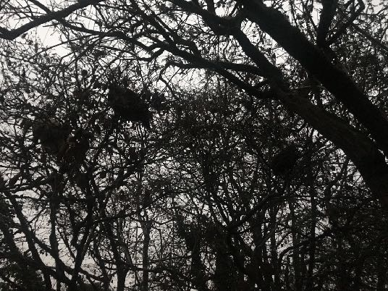
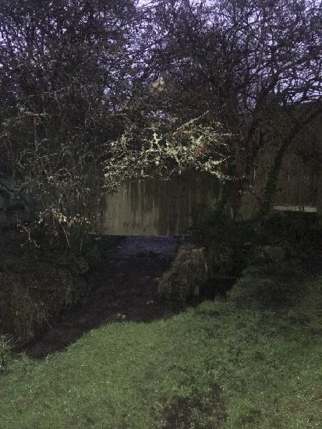
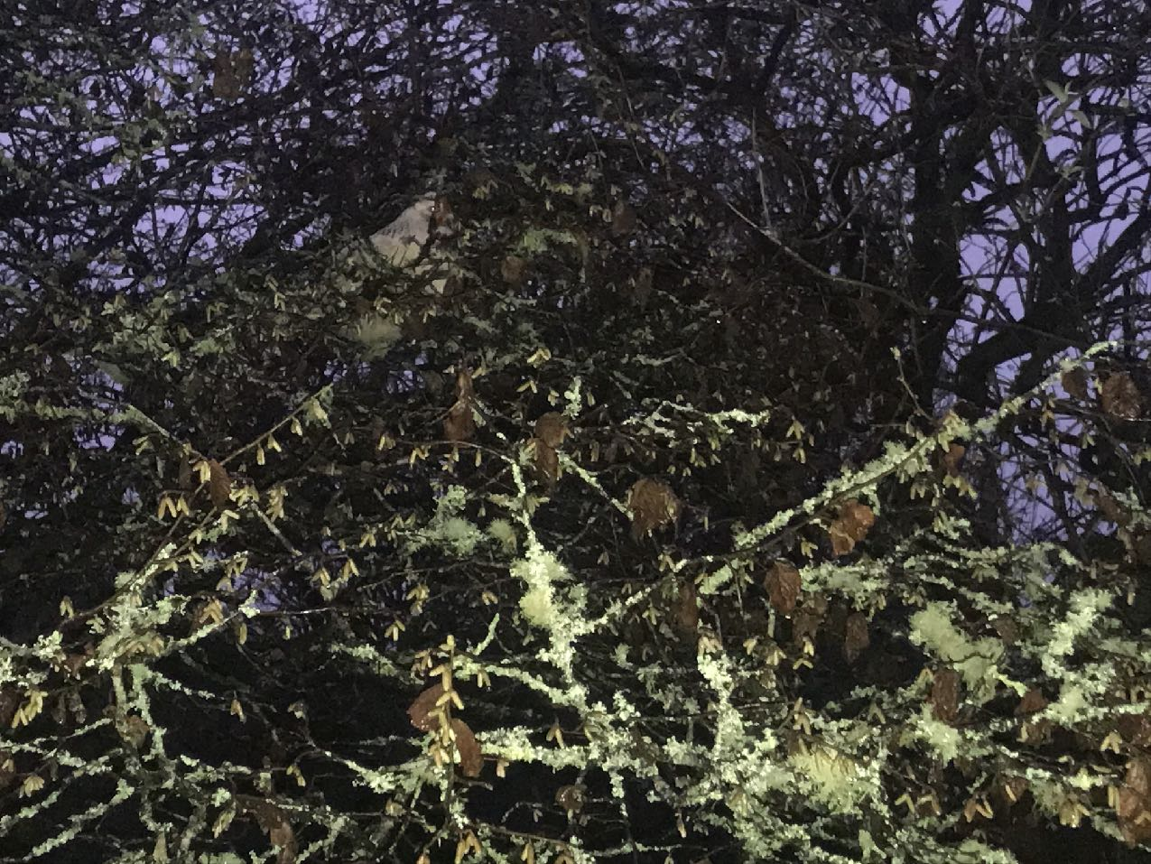
I am visiting the well after dark today. As I approach the well, I see something white in the beautiful tree rooted in the well. I think, being annoyed: ‘Argh, rubbish has blown into the tree’, but then had a lovely surprise. The white was not rubbish, it was a chicken! And to my wonder, the white chicken was not alone. There were 3 chickens in the tree, sat safe, ready to tuck in for the night. My presence did not worry them, they carried on with the evening cleaning of feathers. Lovely. I was there for a while, me and the chickens.

Figure 24. The 3 chickens in the well tree at The St. Euny’s Holy Well. Monday 10.01.22, 17.09, Photo: Tina Jensen Friis Auster.

Figure 22/23. The white chicken in the well tree (which looked like rubbish blown into the tree) at The St. Euny’s Holy Well. Monday 10.01.22, 17.06, Photos: Tina Jensen Friis Auster.
Maybe the chickens (Fig. 22/23, Fig, 24), Saint Euny, myself, and anyone else, animal or human embodiment, who have been attracted to this well, were attracted for a reason. As Tilley et.al. argued: ‘In fact human reason is a from of animal reason.’ Or, as medicine people told Barbara Reimensnyder Duncan: ‘Our brothers the animals know these places and come to these places’.
The holy well did have a sense of sacredness, but it was a little chaotic with the disturbances from the modern human constructions around it. The sensation of sacredness was experienced by the sacred well tree, rooted in the well (Fig. 25, Fig. 26 and Fig. 27), by the peaceful chickens who

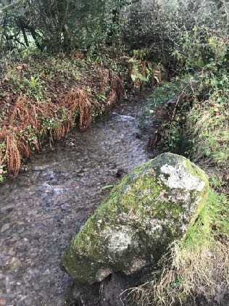
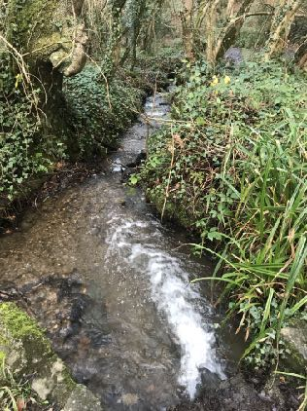
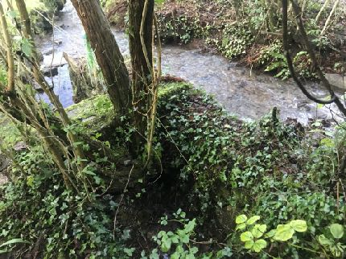
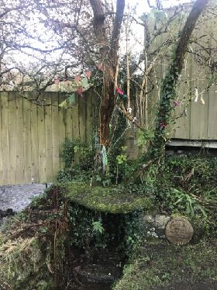
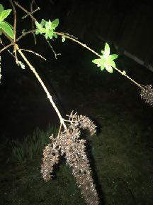
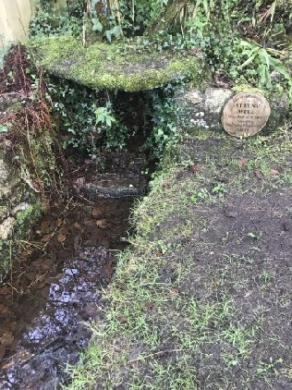
had chosen to be there, by the water gently arising from the well, and by the knowledge that the waters had been made holy through a 'wonder of God’. Finally, the flow of the stream seemed sacred. The stream next to the well would flow into the little well-house, mix with the water from below and then flow back out to the stream. My journal reflected: ‘Does this make the stream holy as well?’. Lane described: […] the flow of water finds a path of least resistance along the steepest slope, forming an intricate network of gullies’. I followed the possibly holy stream, which flowed through the landscape all the way to Portreath where the stream met the sea. (Fig. 28, Fig. 29, Fig. 30, Fig. 31, Fig. 32, Fig 33).

Figure 29. Flowing past the standing stones near The St. Euny’s Holy Well. Sunday 26.12.21, 15.37, Photo: Tina Jensen Friis Auster.

Figure 30. Flowing through the Illogan woods on its way to Portreath. Sunday 02.01.22, 15.15, Photo: Tina Jensen Friis Auster.

Figure 25 and Figure 26. The sacred well tree, growing directly from within the well at The St. Euny’s Holy Well. Sunday 26.12.21, 15.27 (Fig. 24) and 15.28 (Fig. 25), Photos: Tina Jensen Friis Auster.

Figure 27. A branch from the sacred well tree, not removed, only photographed! at The St. Euny’s Holy Well. Monday 10.01.22, 17.14, Photo: Tina Jensen Friis Auster.

Figure 28. The journey of a stream, starting at The St. Euny’s Holy Well. Sunday 26.12.21, 15.26, Photo: Tina Jensen Friis Auster.

My journal further reflected: ‘Does this make the waters of the sea holy as well’?

Portreath Sea
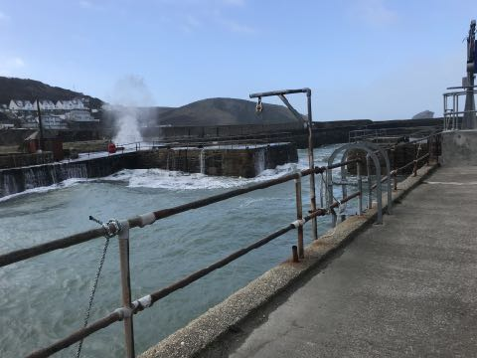
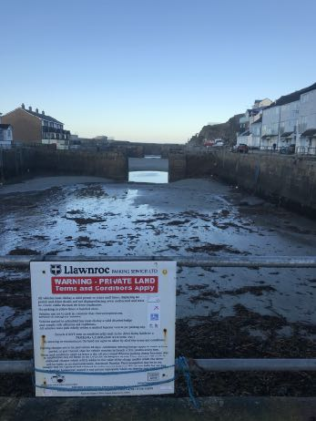
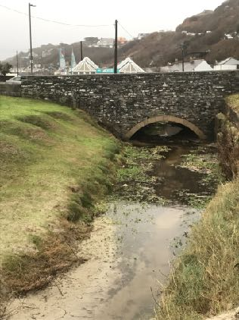
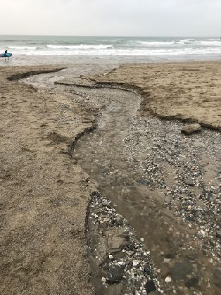
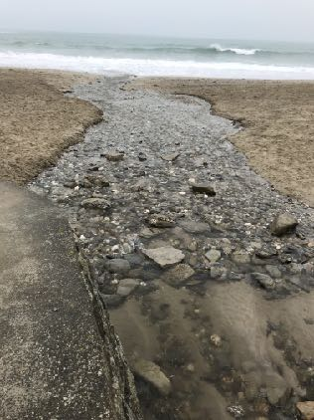
The sea-waters at Portreath presented two very different experiences of: the water in the harbour versus the water at the beach. Bryan discussed how cultures seem better at acknowledging the social use of water for recreation and fishing as opposed to ensuring preservation of sacred waters. Now a pleasure and fishing harbour, Portreath harbour was an industrial harbour into the 19th century, and the harbour still had a sense of industry. The question was, would the human construction disrupt the sensation of the harbour as a sacred space? Tilley et. al. discussed: ‘we consider landscape as being a set of relationships between places in which meaning is grounded in existential consciousness, event, history and association […]’. My journal described (Fig. 34, Fig. 35):

Figure 34. The harbour at high tide. Tuesday 28.12.21, 11.38, Photo: Tina Jensen Friis Auster.

Figure 35. The harbour at low tide. Thursday 13.01.22, 09.27. Photo: Tina Jensen Friis Auster.

Figure 31. Arrived in Portreath. Monday 27.12.21, 15.51, Photo: Tina Jensen Friis Auster.

Figure 32. Flowing towards the sea at Portreath beach. Monday 27.12.21, 15.54, Photo: Tina Jensen Friis Auster.

Figure 33. Meeting at the waves at Portreath beach. Monday 10.01.22, 11.17, Photo: Tina Jensen Friis Auster.

This harbour is not the prettiest, and it gives a sensation of what it is - industrial. There is a huge difference between the harbour being full or water at high tide and empty of water at low tide. At low tide, the space seems abandoned and isolated, at high tide, the space seems alive, but also chaotic.
The water was disrupted in the harbour, controlled by the walls, which the water battled at high tide. The waters have often won and destroyed parts of the walls. High tides have been the inspiration to many poets, for example, Mallika Sengupta, who wrote:
‘High tide, it's high tide now,
The thrill within me in the high tide now.’
This sensation of “thrill” was reflected in my journal (Fig. 36, Fig. 37):
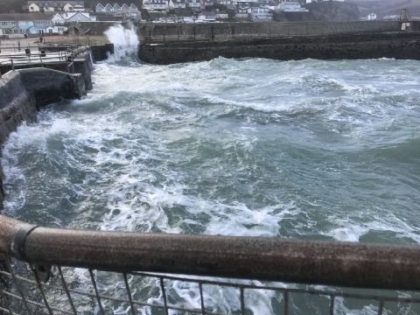
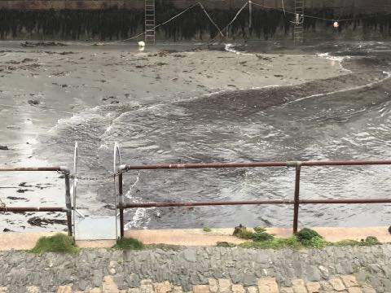
The wonder is the rushing in of the water, the strong currents that appear. I can watch this ‘rushing in’ of waters again and again. They thrill me, make me feel elevated. A similar flow occurs when the water is receding for low tide, but somehow it does not offer the same sensation. The waters arrive with force, but disappear peacefully and slowly.

Figure 36. The thrill of the high tide, the waves are rushing in. Tuesday 28.12.21, 11.41, Photo: Tina Jensen Friis Auster.

Figure 37. The low tide approaching, the waters disappear peacefully and slowly. Thursday 30.12.21, 10:38, Photo: Tina Jensen Friis Auster.

During the harbour’s busiest times, it may have been sacred to the mine owners, being able to ship their ores. Today, the pleasure boats and fishing boats may experience the harbour as a sacred space, along with the youths of Portreath who enjoy tombstoning from the harbour walls, creating happy childhood memories. In the case of The Harbour, the experience of sacredness and sacred space could be argued as being defined by personal experience. As Casey argued: ‘Landscape and the body are the effective epicentres of the geographical self.’ In comparison to the connection felt in the rain and at the well, the waters of the harbour did not offer a significant sense of

sacredness to me, apart from when a seal visits (Fig. 38). This could be due to the human construction of the harbour walls, since the water is the same as the water on the beach.
Portreath beach is most often very busy, but at the time of this study, the beach was mainly used by locals and a lot quieter. My journal reflected on my walk to the beach:
I am walking towards the beach through the village of Portreath, between houses, cars on the road driving by, people out walking, saying ‘hi’ to a friend and then …. the scene suddenly changes, the open space appears in front of me, the view is now eternal, an open space of the sea and sky, mixed with the sounds of the high tide waves roaring loudly. this is a true wilderness.
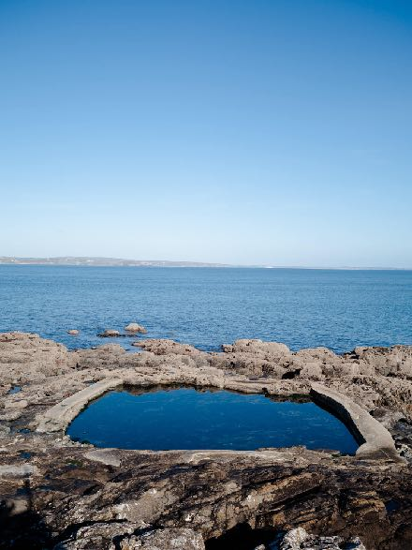
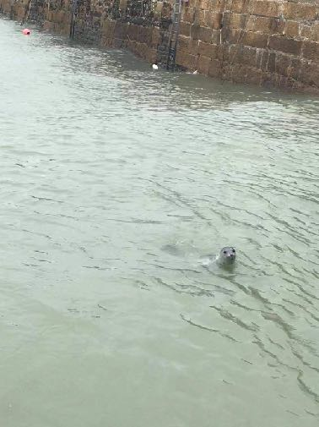
This experience of open space and wilderness related to Casey’s argument: ‘Without landscape, we would be altogether confined to the peculiarities of a particular place, its consistent idiolocalism.’ My body and my perception had arrived at this beach consisting of wilderness of sand and rock formations, and the island in the sea, known locally as "Gull Rock". The natural rock formations have natural tidal basins or pools, large enough for several people to bathe within them (Fig. 39).

Figure 39. One of the natural tidal basis at Portreath Beach. Source: <https://thecornishlife.co.uk/outdoor-tidal-pools-cornwall/> [assessed 12th January 2022].

Figure 38. The wonder of a seal in the harbour. Thursday 26.12.21, 16:45, Photo: Tina Jensen Friis Auster.

Ereira narrated that: ‘Both the shells of the beach and the stars of the sky referred to as traces left by Serankua’s original act of fertilising the world […] , and further: ’[…] are aspects of the original ocean’. Durkheim described the fascination of wilderness:
[…] there is a certain impression which men cannot help feeling in the presence of nature. He cannot come in contact with it, without realizing that it is greater than he. […] awaken within him the idea that outside of him there exists an infinite power upon which he depends’.
As discussed by Bruce Martin: ‘Wilderness, consequently also serves as an ideal medium in which to explore and experience the divine’. The Rig Veda described the beginning of times from the ocean: ‘The creation of the universe out of water […] and rescuing of the sun from the ocean […]’, such creation of the universe from the ocean water could signify the ocean perceived as a sacred space. As I arrived on the beach, I found a rock to sit on to observe. My journal reflected:
The water hits the natural rocks and splashes up high. It fills me with the same sense of divinity to see the splashes from the natural formations as from the harbour wall. The sensations of wonder remain. The rock formations of the beach and the sight of Gull Rock are enchanting.
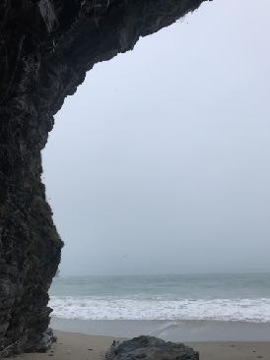
The splashing of water on the natural rocks and the harbour wall seemed equally sacred, however the natural "Gull Rock" had a wider sense of sacredness. This perception was supported by Eliade, who argued:

Figure 40. The framed ocean, in a beautiful frame offered by the rock formations. Monday 10.01.22, 11:04, Photo: Tina Jensen Friis Auster.
One of the paradigmatic images of creation is the island that suddenly manifests itself in the midst of the waves.
As described by Eliade, the rock formations were like beings from ancient times, so I decided to get closer (Fig. 40) which was reflected in my journal:
I have now found a new viewpoint inside a small cave. Oh such wonder. The ocean waves are trying to catch me, whilst raindrops are dropping from the cave wall.

Inside the cave, the ocean became a defined area, defined by the walls of the cave. I wrote: ‘Like the centre of the Universe’. This centre aspect was discussed in the section about rain, and here at the beach it occurred again. Eliade’s ‘axis mundi’. The Rig Veda reads:
He, whose destination is the ocean, who purifies the world, is always flowing, such water lives in the middle of the Universe.
The sea was experienced with the same sense of sacredness and wonder, whether it was high tide or low tide, whereas the tidal waters in the harbour showed a clear difference.
As discussed by Greely: ‘[…] all first peoples identified both the miraculous life-giving but also the concomitant life-ending power of water’. At several places by the sea, sacredness was evident as a space of ritual and remembrance of a loved one. As expressed in my journal (Fig. 41/42/43, Fig. 44, Fig. 45):
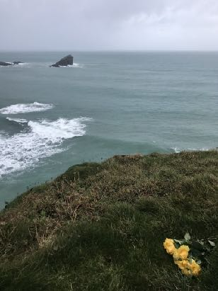
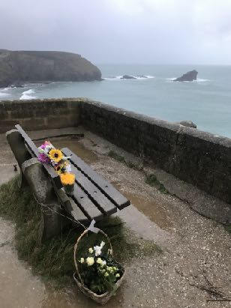
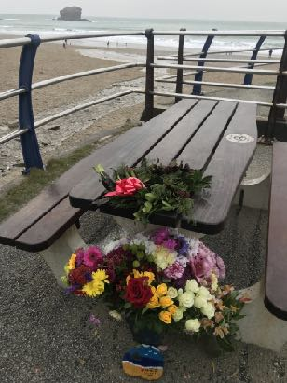
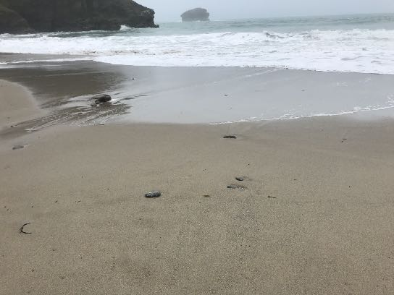
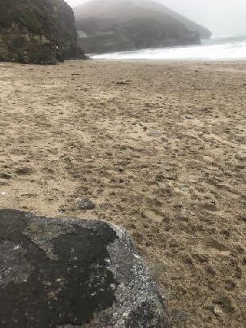
I am filled with a sadness, but also a heightened sacredness, seeing the ceremonial remembrance plaques and flowers. It is Christmas and family members are paying tribute to loved ones lost to the sea. As I walk onto the sands, the waves have washed away the footsteps made since the last high tide. Those steps are gone now, like the loved ones on the remembrance plaques. The sand feels sacred now, cleansed by the sea, and I almost do not want to break this sacredness with my footsteps, but instead leave it untouched and sacred.

Figure 41/412/43. Flowers laid in remembrance. Monday 27/12/21, 15:58 (Fig. 39), 16:19 (Fig 40), 16:16 (Fig 41). Photos: Tina Jensen Friis Auster.

Figure 45. The sacred, untouched sand Monday 10.01.22, 11:09, Photo: Tina Jensen Friis Auster.

Figure 44. The footsteps since the last high tide. Thursday 30.12.21, 10:38, Photo: Tina Jensen Friis Auster.
Bernadette Brady descried how ritual can be re-used if found useful: ‘If a particular bifurcation (event) yields pleasing results, then the person could consciously set up the pattern and run it again and again’. In the chaos of grief, it could be argued that ritual could be useful as a coping mechanism. Barbara Bender discussed how landscape can be used to create a sacred space: ‘[…] through movement, through attachment, through wrapping stories and memories around places […]. As mentioned previously, Casey argued:
‘The intrinsic difference between place and space is nowhere more evident than in the role of a primary feature of landscape, its horizon. Every landscape has a horizon, yet space never does.’
The places of sacred remembrance did have horizon, though could be argued to be a space.
On the last day of my study, I was fortunate enough to have an amazing experience of all the chosen waters being united in one place:
The sacred stream from The Holy Wall is running fast today, very filled with water. The sound of the stream flowing, which was sacred at The Holy Well, is now mixed with the loud noise of the sea, and with the misty air of rain, there is a union of the waters.
The cycle of water from the sky falling to the ground, feeding wells, streams and the sea, to then return back to the skies to once again become rain, was described by Kandel , and by Ereira . Schimmel argued: ‘But not only raindrops return to the ocean. Running waters, the streams that hurry back to reach the ocean […]’. All waters are one and the same, from the same source, eventually united to then again split into rain, wells, streams and seas. This is beautifully expressed by Walt Whitman:
[…] Eternal I rise impalpable out of the land and the bottomless sea,
Upward to heaven, whence, vaguely form'd, altogether changed,
and yet the same,
I descend to lave the drouths, atomies, dust-layers of the globe,
And all that in them without me were seeds only, latent, unborn;
And forever, by day and night, I give back life to my own
origin, and make pure and beautify it […]
As such, it could be argued that all waters were sacred, irrespective of their physical place. Overall, experiencing these three sacred waters was a study of wonder, meaning, remembrance and personal connection. A wonder of sacred waters occurred on the last day of the study. On the Portreath beach all three waters explored in this study became united (Fig. 46). My journal

reflected:
The misty rain is falling from the sky, making sea and air become one, the stream from the holy well is flowing full of water, down onto the beach, into the sea, sacred waters uniting, the waves of the high tide are embracing the beach, welcoming the well, while the waves crash agains the harbour wall. All the sacred waters of my study have united.

Conclusion
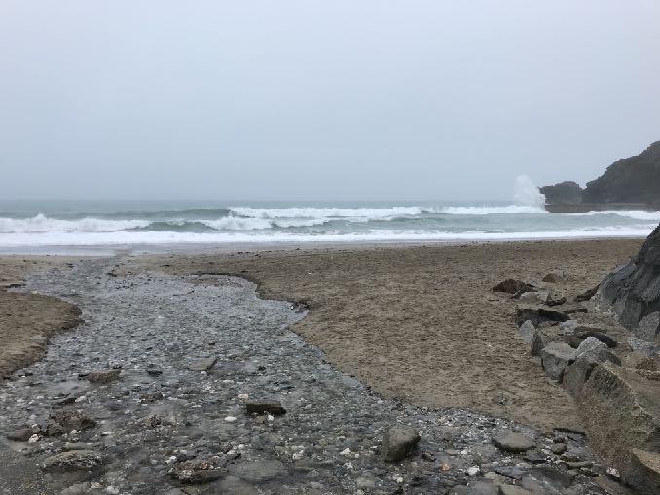
This essay has reflected on the question: ‘Is Sacred Space A Human Construct Or A Natural Phenomena?’ exploring: ‘Water As Sacred Space’. The essay examined and analysed a connection to water as a possible sacred source through meaning , functionality , wonder , remembrance , sacredness , and personal experience . The essay explored three sacred waters in Cornwall, England, UK, structurally limited to: 1) Rain; 2) The St. Euny’s Holy Well, Redruth; and 3) Portreath Sea.

Figure 46. All the waters. Sacred and United. And the very last photo of my journal. Monday 10.01.22, 11:18, Photos: Tina Jensen Friis Auster.

It was found that waters, in personal experience, could be argued to be a sacred space through meaning, wonder, remembrance and personal experience. The possibility of sacredness while ‘being at the rain’, in the sense of rain experienced as a space in a physical location with the self at the centre, was, in this study, found to phenomenologically occur. Rain and waters were, as discussed, perceived as deified, and sacred life-giving since ancient times, a sacredness that would feed the wells, the stream and the sea.
The personal exploration of The St. Euny’s Holy Well was found to be sacred, though with some disruption from the human constructions. It was found that apart from Saint Euny and myself, a tree had chosen to root directly in the well and chickens were also attracted to the well, sleeping in the sacred well tree; and the well offered its holiness to the steam and the sea, the waters then to return as rain falling to the ground.
Whereas both the rain and the well were found, through the phenomenological approach of exploration from within, to be sacred, the sea of Portreath was found to be different. The harbour, with its human construction, was perceived less sacred, unless visited by seals. It was however found that it could be sacred from a functional aspect. The sea offered sacredness of natural origin through the waves, rocks, caves and untouched, sacred sand.
The main observation was that sacred spaces can be either, both, or a combination of, a natural phenomena and a human construct. The rain, the well and the sea were all sacred natural spaces, though it was also found that the experience of sacred space could be a human construct, arising from personal experience and definition , and from the space or place, we find ourselves in .
Casey argued that space could not have a horizon. Is it however possible that we in the wilderness, in the landscape, can have a ‘sacred space’ even with the view to the horizon? As Durkheim, finding sacred space everywhere , this study agreed as shown in the narratives of the phenomenological experiences of the rain, the well, the sea and in the aspect of remembrance. In these ‘places’, our embodiment seem able to create a ‘sacred space’, surrounding us, created invisibly by the mind, present in a natural landscape, connecting to a natural phenomena.

Bibliography

Bell, Judith and Stephen Waters, Doing Your Research Project, 7th edn. (London: Open University Press, McGraw-Hill Education, 2018).

Brady, Bernadette, Cosmos, Chasms And Astrology: Rethinking The Nature Of Astrology (Wales: Sophia Centre Press, 2014).

Bryan, Michelle, ‘Valuing Sacred Tribal Waters Within Prior Appropriation’, Natural Resources Journal, 57:1 (2017), 139-182 <ttps://www.jstor.org/stable/26202190> [assessed 6th December 2021].

Casey, Edward S., ‘Between Geography and Philosophy: What Does It Mean to Be in the Place-World?’, Annals of the Association of American Geographers, 91:4 (2001), 683-693 <https://www.jstor.org/stable/3651229> [assessed 7th January 2022].

Chamberlain, Gary, ‘From Holy Water To Holy Water’, Religion, Culture, and Water, 14:2 (2012), 6-9 <https://www.jstor.org/stable/wateresoimpa.14.2.0006> [assessed 6th December 2021].

Chamberlain, Gary, ‘The Waters of Tao’ Water Resources IMPACT: Spirituality and Water Management ,11:6, (2009), 13-14 <https://www.jstor.org/stable/wateresoimpa.11.6.0013> [ assessed 6th December 2021].

Coltelli, Laura, ‘Leslie Marmon Silko's Sacred Water’, Studies in American Indian Literatures : European Writings on Native American Literatures, 2:8, 4, (1996), 21-29 <https://www.jstor.org/stable/20739368> [assessed 6th December 2021].

Cornwall Trails, ‘Carn Brea Triaol 6 - Illogan Highway trail’, <https://www.cornwalltrails.net/trails/carn-brea/carn-brea-trail-6/?doing_wp_cron=1642080111.7107241153717041015625>. [assessed 13th January 2022].

Duncan, Barbara Reimensnyder, ‘Going to Water: A Cherokee Ritual in Its Contemporary Context’, Journal Of The Appalachian Studies Association: DIVERSITY IN APPALACHIA: IMAGES AND REALITIES, 5 (1993), 94-99 <https://www.jstor.org/stable/41445648> [assessed 6th December 2021].
Durkheim, Emile, The Elementary Forms Of The Religious Life, Dover edn. (Mineola, New York: Dover Publications Inc.).

Eliade, Mircia, The Sacred And The Profane, translated from the French by Willard R.Trask (USA and London: A Harvest Book, Harcourt Inc., 1987).
Eliade, Mircia, Patterns In Comparative Religion, translated by Rosemary Sheed (London & New York: Sheed and Ward Inc.: 1958).
Ereira, Alan, The Elder Brother’s Warning, The Tairona Heritage Trust edn. (UK: The Tairona Heritage Trust, 2008).
Etherington, Kim, Becoming A Reflexive Researcher (London: Jessica Kingsley Publishers, 2004).

Feldman, Cecelia A., ‘Re-Placing the Nile: Water and Mimesis in the Roman Practice of Egyptian Religion at Pergamon’, in: Locating The Sacred, (Oxbow Books: 2014), 35-56 <https://www.jstor.org/stable/j.ctvh1dqff.5> [assessed 10th January 2022].

Greeley, June-Ann, ‘Water in Native American spirituality: Liquid life—blood of the earth and life of the community’, Green Humanities, 2, (2017), 156-179 <https://digitalcommons.sacredheart.edu/rel_fac/125/> [assessed 7th December 2021].

Hamblyn, Richard, Clouds: Nature and Culture (London: Reaktion Book, Ltd, 2017).

Harrison, Stephan, Doreen Massey, Keith Richards, Francis J. Magilligan, Nigel Thrift and Barbara Bender, ‘Thinking across the Divide: Perspectives on the Conversations between Physical and Human Geography’, Area, 36:4 (2004), 435-442 <https://www.jstor.org/stable/20004417> [assessed 7th January 2022].

Heritage Gateway, <https://www.heritagegateway.org.uk/gateway/Results_Single.aspx?uid=MCO37&resourceID=1020> [assessed 13th January 2022].

Ingold, Tim, as quoted in Tilley, Christopher and Kate Cameron-Daum, 'The anthropology of landscape: materiality, embodiment, contestation and emotion’, In: Anthropology of Landscape: The Extraordinary in the Ordinary, (UCL Press, 2017), 1-22 <https://www.jstor.org/stable/j.ctt1mtz542.7> [assessed 7th January 2022].

Jensen, John V., ‘Hellige Kilder - Kilder Til Undren’, Translates to: ‘Holy Wells - Wells For Wonder’, Ribe Amt, (1), 3–16 (2007) <https://tidsskrift.dk/fraribeamt/article/view/76639> [assessed 11th January 2022].

Jung, C.G. as quoted in Sabini, Meredith, The Earth Has A Soul: C.G. Jung On Nature, Technology & Modern Life, edited by Meredith Sabini (California: North Atlantic books, 2002).

Kandel, Robert, ‘The Story of Water from the Big Bang to the Rise of Civilization, and Beyond’, in: Water from Heaven, (Columbia Press, 2003) <https://www-jstor-org.ezproxy.uwtsd.ac.uk/stable/10.7312/kand12244> [assessed 7th December 2021].

Kandel, Robert, ‘Earth’s Water, Between Sky And Sea’, in: Water from Heaven, (Columbia Press, 2003) <https://www-jstor-org.ezproxy.uwtsd.ac.uk/stable/10.7312/kand12244> [assessed 7th December 2021].

Lane, Belden C., ‘Giving Voice to Place: Three Models for Understanding American Sacred Space’, Religion and American Culture: A Journal of Interpretation, 11:1 (2001), 53-81, <https://www.jstor.org/stable/10.1525/rac.2001.11.1.53> [assessed 7th January 2022].

Lane, Belden C., Landscapes Of The Sacred, Maryland, USA: The Johns Hopkins University Press, 2002).

Martin, Bruce, ‘Wilderness and the Sacred: The Meeting of Spirit and Nature in Human Experience’, Environmental Philosophy, 1:1 (2004), 79-83 <https://www.jstor.org/stable/26167889> [assessed 7th December 2021].

Parkes, Catherine, ‘No.1, Shopside, Carn Brea Village, Redruth, Cornwall’ Heritage Impact Assessment, Cornwall Archaeological Unit, CAU Report No: 2019R068 <https://docs.planning.org.uk/20210421/5/QQDHOQFGI1W00/1ci2dqoosptsjznx.pdf> [assessed 13th January 2022].

Portreath Harbour Association Website. <https://portreath-harbour.org/harbour-history/> [assessed 11th January 2022].

Sabini, Meredith, The Earth Has A Soul: C.G. Jung On Nature, Technology & Modern Life, edited by Meredith Sabini (California: North Atlantic books, 2002).

Saxena, Chandni, ‘The Concept Of Water In Rig Veda’, International Journal of Social Science & Interdisciplinary Research, 1:8 (2012), 131-138 <http://www.indianresearchjournals.com/pdf/IJSSIR/2012/August/11.pdf> [assessed 7th December 2021].

Schimmel, Annemarie, ‘The Sky, the Wind, and the Sea’, in: A Two-Colored Brocade: The Imagery of Persian Poetry, (University of North Carolina Press: 1992), 201-216 <https://www.jstor.org/stable/10.5149/9781469616377_schimmel.21> [assessed 7th December 2021].

Sengupta, Mallika, ‘High Tide’, Indian Literature 35:5, 151, (1992), 12-13 <ttps://www.jstor.org/stable/23337124> [assessed 11th January 2022].

Sosis, Richard, ‘Why Sacred Lands Are Not Indivisible: The Cognitive Foundations of Sacralising Land’, Journal of Terrorism Research, 2(1). <http://doi.org/10.15664/jtr.172> [assessed 7th December 2021].

The Rig Veda, The Rig Veda: Anthology: One Hundred And Eight Hymns, selected, translated and annotated by Wendy Doninger (London: Penguin Books).

Tilley, Christopher, The Materiality Of Stone: Explorations In Landscape Phenomenology, 2nd edn. (New York: Routledge, 2020).

Tilley, Christopher and Kate Cameron-Daum, 'The anthropology of landscape: materiality, embodiment, contestation and emotion’, In: Anthropology of Landscape: The Extraordinary in the Ordinary, (UCL Press, 2017), 1-22 <https://www.jstor.org/stable/j.ctt1mtz542.7> [assessed 7th January 2022].

Tilley, Christopher and Wayne Bennett, ‘An Archaeology of Supernatural Places: The Case of West Penwith’, The Journal of the Royal Anthropological Institute, 7:2 (2001), 335-362 <https://www.jstor.org/stable/2661226> [assessed 7th January 2022].

Whitman, Walter, ‘The Voice Of The Rain’, The Walter Whitmen Archive <https://whitmanarchive.org/published/LG/1891/poems/349> [assessed 13th January 2022].

Michelle Bryan, ‘Valuing Sacred Tribal Waters Within Prior Appropriation’, Natural Resources Journal, 57:1 (2017), 139-182 <ttps://www.jstor.org/stable/26202190> [assessed 6th December 2021], p. 174.
Gary Chamberlain, ‘The Waters of Tao’ Water Resources IMPACT: Spirituality and Water Management ,11:6, (2009), 13-14 <https://www.jstor.org/stable/wateresoimpa.11.6.0013> [ assessed 6th December 2021], p. 13
Mircea Eliade, The Sacred And The Profane, translated from the French by Willard R.Trask (USA and London: A Harvest Book, Harcourt Inc., 1987), p. 130.
Harrison, Stephan, Doreen Massey, Keith Richards, Francis J. Magilligan, Nigel Thrift and Barbara Bender, ‘Thinking across the Divide: Perspectives on the Conversations between Physical and Human Geography’, Area, 36:4 (2004), 435-442 <https://www.jstor.org/stable/20004417> [assessed 7th January 2022], p. 440.
Christopher Tilley and Wayne Bennett, ‘An Archaeology of Supernatural Places: The Case of West Penwith’, The Journal of the Royal Anthropological Institute, 7:2 (2001), 335-362 <https://www.jstor.org/stable/2661226> [assessed 7th January 2022], pp. 344-345. Michelle Bryan, Valuing Sacred Tribal, pp. 140, 145-150. June-Ann Greeley, ‘Water in Native American spirituality: Liquid life—blood of the earth and life of the community’, Green Humanities, 2, (2017), 156-179 <https://digitalcommons.sacredheart.edu/rel_fac/125/> [assessed 7th December 2021], pp. 156, 158-159.
Kim Etherington, Becoming A Reflexive Researcher (London: Jessica Kingsley Publishers, 2004), p. 25 and p. 32.
Kim Etherington, Becoming A Reflexive Researcher, pp. 9-11.
Christopher Tilley, The Materiality Of Stone: Explorations In Landscape Phenomenology, 2nd edn. (New York: Routledge, 2020), p. 1.
Judith Bell and Stephen Waters, Doing Your Research Project, 7th edn. (London: Open University Press, McGraw-Hill Education, 2018).
Richard Hamblyn, Clouds: Nature and Culture (London: Reaktion Book, Ltd, 2017), p. 202.
Cecelia A. Feldman, ‘Re-Placing the Nile: Water and Mimesis in the Roman Practice of Egyptian Religion at Pergamon’, in: Locating The Sacred, (Oxbow Books: 2014), 35-56 <https://www.jstor.org/stable/j.ctvh1dqff.5> [assessed 10th January 2022], p. 51. Robert Kandel, ‘The Story of Water from the Big Bang to the Rise of Civilization, and Beyond’, in: Water from Heaven, (Columbia Press, 2003) <https://www-jstor-org.ezproxy.uwtsd.ac.uk/stable/10.7312/kand12244> [assessed 7th December 2021], p. 3. Robert Kandel, ‘Earth’s Water, Between Sky And Sea’, in: Water from Heaven, (Columbia Press, 2003) <https://www-jstor-org.ezproxy.uwtsd.ac.uk/stable/10.7312/kand12244> [assessed 7th December 2021], p. 155.
Dr. Chandni Saxena, ‘The Concept Of Water In Rig Veda’, International Journal Of Social Science and Interdisciplinary Research, 1:8 (2012), pp. 131-138, p. 135.
British Listed Buildings, St Eunys Well: A Grade II Listed Building in Carn Brea, Cornwall<https://britishlistedbuildings.co.uk/101392501-st-eunys-well-carn-brea#.YdtQYi-l3T-> [ assessed 9th January 2022].
Catherine Parkes, ‘No.1, Shopside, Carn Brea Village, Redruth, Cornwall’ Heritage Impact Assessment, Cornwall Archaeological Unit, CAU Report No: 2019R068 <https://docs.planning.org.uk/20210421/5/QQDHOQFGI1W00/1ci2dqoosptsjznx.pdf> [assessed 13th January 2022].
Portreath Harbour Association Website. <https://portreath-harbour.org/harbour-history/> [assessed 11th January 2022].
Portreath Harbour Association Website. <https://portreath-harbour.org/harbour-history/> [assessed 11th January 2022].
Ibid.
Harrison et.al., Thinking across the Divide, p. 440.
Edward S. Casey, ‘Between Geography and Philosophy: What Does It Mean to Be in the Place-World?’, Annals of the Association of American Geographers, 91:4 (2001), 683-693 <https://www.jstor.org/stable/3651229> [assessed 7th January 2022].
Christopher Tilley and Wayne Bennett, An Archaeology of Supernatural Places, pp. 344-345.
Dr. Chandni Saxena, The Concept Of Water, p. 135.
Laura Coltelli, ‘Leslie Marmon Silko’s Sacred Water’, Studies In American Indian Literatures, 2:8:4 (1996), 21-29 <https://www.jstor.org/stable/20739368> [assessed 6th December 2021], p. 21. June-Ann Greeley, Water in Native American spirituality, p. 156. Michelle Bryan, Valuing Sacred Tribal Waters, p. 139. Alan Ereira, The Elder Brother’s Warning, The Tairona Heritage Trust edn. (UK: The Tairona Heritage Trust, 2008), p. 169.
John V. Jensen, ‘Hellige Kilder - Kilder Til Undren’, Translates to: ‘Holy Wells - Wells For Wonder’, Ribe Amt, (1), 3–16 (2007) <https://tidsskrift.dk/fraribeamt/article/view/76639> [assessed 11th January 2022], p. 5.
Christopher Tilley and Wayne Bennett, An Archaeology of Supernatural Places, pp. 340, 343, 344. Cecelia A. Feldman, Re-Placing the Nile, p. 51.
Michelle Bryan, Valuing Sacred Tribal Waters, p. 142.
Dr. Chandni Saxena, The Concept Of Water, p. 133.
Alan Ereira, The Elder Brother’s Warning, p. 201.
Mircea Eliade Patterns In Comparative Religion, translated by Rosemary Sheed (London & New York: Sheed and Ward Inc.: 1958), p. 188.
Mircea Eliade, The Sacred And The Profane, p. 11.
Emile Durkheim, The Elementary Forms Of The Religious Life, Dover edn. (Mineola, New York: Dover Publications Inc.), p. 37.
Ibid, p. 86.
Belden C. Lane, Landscapes Of The Sacred, Maryland, USA: The Johns Hopkins University Press, 2002), p. 19.
Belden C. Lane, ‘Giving Voice to Place: Three Models for Understanding American Sacred Space’, Religion and American Culture: A Journal of Interpretation, 11:1 (2001), 53-81, <https://www.jstor.org/stable/10.1525/rac.2001.11.1.53> [assessed 7th January 2022], p. 58.
June-Ann Greeley, Water in Native American Spirituality, p. 156.
Christopher Tilley and Kate Cameron-Daum, 'The anthropology of landscape: materiality, embodiment, contestation and emotion’, In: Anthropology of Landscape: The Extraordinary in the Ordinary, (UCL Press, 2017), 1-22 <https://www.jstor.org/stable/j.ctt1mtz542.7> [assessed 7th January 2022], p. 2.
Edward S. Casey, Between Geography And Philosophy, p. 690.
Emile Durkheim, The Elementary Forms Of The Religious Life, p. 37.
Mircea Eliade, The Sacred And The Profane, p. 33.
Belden C. Lane, Giving Voice To A Place, p. 63.
Emile Durkheim, The Elementary Forms Of The Religious Life, p. 440.
Gary Chamberlain, The Waters Of Tao, pp. 13-14.
C.G. Jung, as quoted in Meredith Sabini, The Earth Has A Soul: C.G. Jung On Nature, Technology & Modern Life, edited by Meredith Sabini (California: North Atlantic books, 2002), pp. 211-214.
Dr. Chandni Saxena, The Concept Of Water, p. 132.
The Rig Veda, The Rig Veda: Anthology: One Hundred And Eight Hymns, selected, translated and annotated by Wendy Doninger (London: Penguin Books), p. 231.
Mircea Eliade, Patterns In Comparative Religion, p. 192.
Annemarie Schimmel, ‘The Sky, the Wind, and the Sea’, in: A Two-Colored Brocade: The Imagery of Persian Poetry, (University of North Carolina Press: 1992), 201-216 <https://www.jstor.org/stable/10.5149/9781469616377_schimmel.21 > [assessed 7th December 2021], p. 202.
Cecelia A. Feldman, Re-Placing the Nile, p. 51.
Mircea Eliade, The Sacred And The Profane, p. 130.
Brady, Bernadette, Cosmos, Chasms And Astrology: Rethinking The Nature Of Astrology (Wales: Sophia Centre Press, 2014), p. 4.
Belden C. Lane, Giving Voice To A Place, p. 60.
Robert Kandel, The Story of Water, p. 3.
Gary Chamberlain, ‘From Holy Water To Holy Water’, Religion, Culture, and Water, 14:2 (2012), 6-9 <https://www.jstor.org/stable/wateresoimpa.14.2.0006> [assessed 6th December 2021], p. 6.
Cornwall Trails, ‘Carn Brea Triaol 6 - Illogan Highway trail’, <https://www.cornwalltrails.net/trails/carn-brea/carn-brea-trail-6/?doing_wp_cron=1642080111.7107241153717041015625>. [assessed 13th January 2022].
Matthew Franklin Cooper, ‘Venerable Euny, Hermit of Lelant’ <http://heavyangloorthodox.blogspot.com/2020/02/venerable-euny-hermit-of-lelant.html> [assessed 9th February 2022].
Heritage Gateway, <https://www.heritagegateway.org.uk/gateway/Results_Single.aspx?uid=MCO37&resourceID=1020> [assessed 13th January 2022].
Eliade, Mircea, Patterns In Comparative Religion, p. 193.
Laura Coltelli, Leslie Marino Silko’s Sacred Water, p. 57,.
Gary Chamberlain, The Waters Of Tao, p. 14.
Robert Kandel, Earth’s Water, p. 170.
Belden C. Lane, Giving Voice To A Place, p. 57.
Christopher Tilley and Kate Cameron-Daum, The anthropology of landscape, p. 4.
Tim Ingold as quoted in Christopher Tilley and Kate Cameron-Daum, The anthropology of landscape, p. 4.
Belden C. Lane, Giving Voice To A Place, p. 58.
Richard Sosis, ‘Why Sacred Lands Are Not Indivisible: The Cognitive Foundations of Sacralising Land’, Journal of Terrorism Research, 2(1). <http://doi.org/10.15664/jtr.172> [assessed 7th December 2021], p. 24.
Gary Chamberlain, From Holy Water To Holy Water, p. 13.
Christopher Tilley and Kate Cameron-Daum, The anthropology of landscape, p. 4.
Barbara Reimensnyder Duncan, ‘Going to Water: A Cherokee Ritual in Its Contemporary Context’, Journal Of The Appalachian Studies Association: Diversity In Appalachia: Images And Realities, 5 (1993), 94-99 <https://www.jstor.org/stable/41445648> [assessed 6th December 2021], p. 97.
Robert Kandel, Earth’s Water, p. 170.
Michelle Bryan, Valuing Sacred Tribal Waters, p. 142.
Christopher Tilley and Kate Cameron-Daum, The anthropology of landscape, p. 2.
Mallika Sengupta, ‘High Tide’, Indian Literature 35:5, 151, (1992), 12-13 <ttps://www.jstor.org/stable/23337124> [assessed 11th January 2022].
Edward S. Casey, Between Geography And Philosophy, p. 690.
Edward S. Casey, Between Geography And Philosophy, p. 690.
The Cornish Life, Outdoor Tidal Pools in Cornwall <https://thecornishlife.co.uk/outdoor-tidal-pools-cornwall/> [assessed 11th January 2022].
Alan Ereira, The Elder Brother’s Warning, p. 199.
Ibid, 199.
Emile Durkheim, The Elementary Forms Of The Religious Life, p. 85.
Bruce Martin, ‘Wilderness and the Sacred: The Meeting of Spirit and Nature in Human Experience’, Environmental Philosophy, 1:1 (2004), 79-83 <https://www.jstor.org/stable/26167889> [assessed 11th January 2022], p. 82.
Mircea Eliade, The Sacred And The Profane, p. 130.
Ibid, p. 33.
Dr. Chandni Saxena, The Concept Of Water, p. 133.
June-Ann Greeley, Water in Native American spirituality, p. 156.
Bernadette Brady, Cosmos, Chaosmos And Astrology, p. 94.
Stephan Harrison et.al., Thinking Across The Divide, p. 440.
Edward S. Casey, Between Geography And Philosophy, p. 690.
Robert Kandel, The Story Of Water, pp. 6-7.
Ereira, Alan, The Elder Brother’s Warning, p. 200.
Annemarie Schimmel, The Sky, the Wind, and the Sea, p. 202.
Walter Whitman, ‘The Voice Of The Rain’, The Walter Whitmen Archive <https://whitmanarchive.org/published/LG/1891/poems/349> [assessed 13th January 2022].
Michelle Bryan, Valuing Sacred Tribal Waters, p. 174.
Gary Chamberlain, The Waters of Tao, p. 13
Mircea Eliade, The Sacred And The Profane, p. 130.
Stephan Harrison et.al., Thinking across the Divide, p. 440.
Christopher Tilley and Wayne Bennett, An Archaeology of Supernatural Places, pp. 344-345. Michelle Bryan, Valuing Sacred Tribal, pp. 140, 145-150. June-Ann Greeley, Water in Native American spirituality, pp. 156, 158-159.
Kim Etherington, Becoming A Reflexive Researcher, p. 25 and p. 32.
Robert Kandel, The Story Of Water, pp. 6-7. Ereira, Alan, The Elder Brother’s Warning, p. 200. Annemarie Schimmel, The Sky, the Wind, and the Sea, p. 202.
Christopher Tilley, The Materiality Of Stone, p. 1.
Belden C. Lane, Giving Voice To A Place, pp. 57-58.
Edward S. Casey, Between Geography And Philosophy, p. 690.
Emile Durkheim, The Elementary Forms Of The Religious Life, p. 37.

