DEVELOPING RELATIONSHIPS AND WORKPLACE ACHIEVEMENT

SAUDI ARAMCO [SAUDI ARABIA] ACQUISITION OF VALVOLINE [US]

Student Name: David Marian Beltic
Student ID: 2020289
Lecturer’s Name: Zahra Mohammadnazari
Module Code: BMSW5102

Abstract

Saudi Aramco’s acquisition of Valvoline Inc. will be completed in 2023. The process will involve strategic and human resource management teams from both organisations to factor in the new entity's growth opportunities. The study recommends the acquisition process use an absorption process, which is slow but effective as it will ensure that all operations in Valvoline Inc. have been fully incorporated into Aramco's business strategy. By actively involving the HRM, staff will be professionally guided on how to conduct themselves while supporting the process during the transition process. Some staff may have to be laid off, which the HRM will ensure they understand, and necessary benefit packages are extended to them.



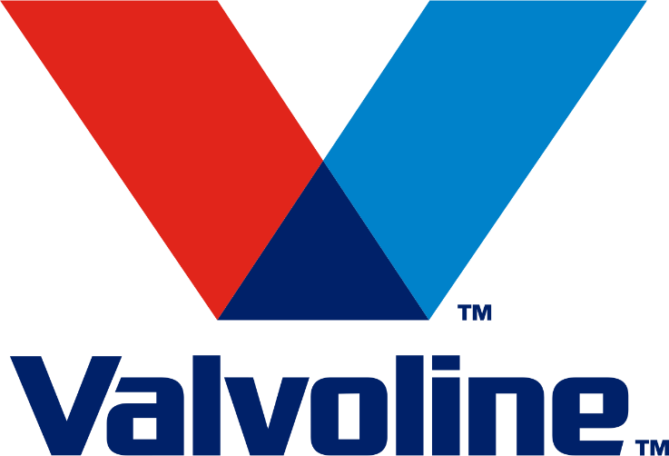

Table of Contents
Abstract 2
Introduction 3
Section 1: Part 1 Cultural Analysis of Saudi Arabia and the US 5
Hofstede module. 6
Section 1: Part 2 Institutional analysis of Saudi Arabia and the US 7
Section 2: M & A Rationale and Integration Strategy 8
Section 2, Part 2 – Role of IHRM in implementing effective M&A 9
Conclusion and Recommendations 10
Reference List 11

Introduction

Saudi Aramco, also known as Aramco, operates in Saudi Arabia and is internationally recognized as a publicly traded organisation, with its petroleum and gas commodities distributed worldwide (Saudi Aramco, 2023). As the second-largest oil producer, Aramco boasts of being established and stable in the industry, which has directly contributed to its growth and expansion across the world. The organisation began operating in 1933 and has a $1.933 trillion market cap as of February 2023, as stipulated by CompaniesMarketCap.com (2023). The firm has managed to have more than 66,000 employees since its inception. Aramco's main competitors are Shell, TotalEnergies, BP, Retrobras and Roneft, all internationally recognized brands (JPT, 2022). Aramco serves individual customers across all ages, with those between 36 and 40 years being more based on the fact that they are comprised of actively employed personnel, companies and wholesalers of oil products.

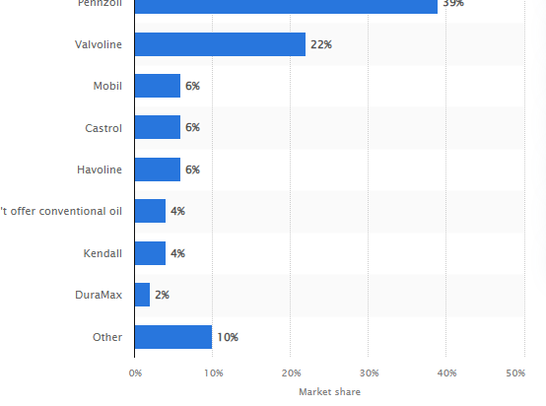
On the other hand, Valvoline Inc., located in the United States, with its headquarters in Kentucky, credits itself for having a 22% market share in the US as of 2018 (Statista, 2018). The firm was founded in 1866, making it among the oldest organisations in the oil and gas industry. Valvoline Inc. has almost 9,000 employees, and its customers mainly comprise organisations and individuals (Valvoline Inc., 2023). With both organisations operating for more than five decades, a merger and acquisition decision has been deliberated to ensure that it's the most appropriate choice that will be of economic and financial benefit, both in the short-term and in the long-term.
Figure 1: Valvoline Inc. market share in the US
Source: Statista (2018)

Section 1: Part 1 Cultural Analysis of Saudi Arabia and the US

Culture is an acceptable way of doing business within a geographical area or within an organisational setup where staffs relate with each other based on the accepted norms and practices (Tarba et al., 2020). Culture directly affects organisational behaviour based on the policies formulated by the human resource manager HRM and perceived as a normal practice within a workplace. The HRM is directly involved in decisions that affect employees, and their active participation is supported through the hiring process. The Saudi Arabian cultural practices are religious based, with a patriarchal model followed. Alkhoraif and McLaughlin (2018) argued that the country is highly traditional and considers men superior to women to some extent, taking the lead in the political, social, and legal structures. However, as suggested by Alkhoraif and McLaughlin (2018), there have been many changes and evolutions in Saudi Arabia to accommodate women in the corporate environment. Drawing inspiration from Hosftede’s cultural dimensions theory that emphasizes the need to understand the diverse national cultures that affect how businesses are conducted, then it would enhance the appreciation of the differences that exist between the US and Saudi Arabia from a femininity and masculinity perspective (Rojo et al., 2020). In the Saudi Arabian context, the traditional perspective of femininity and masculinity has been largely based on the different characteristics between the two genders. For instance, masculine tendencies are perceived as tougher and focused on building wealth, while feminine tendencies are mainly concerned with the quality of relationships by nurturing (Minkov and Kaasa, 2021). This justifies why males mostly head most organisations in Saudi Arabia, which may impact organisational behaviour in the sense that masculinity tendencies are considered when selecting leaders.

On the other hand, the US cultural environment is more lenient and casual. However, formal business practices are incorporated into the relationships and decisions amongst relevant industry and economic stakeholders (Sampson and Wilson, 2020). Smircich (2017) argued that the US business cultural environment is more of a collectivist as opposed to an individualism ideology from the Hofstede dimension. People tend to believe in and uphold teamwork, encouraging individuals to work towards similar objectives, especially within organisations (Rojo et al., 2020). Comparatively, the Saudi Arabian workplace environment also considers the need for employees to join their resources, knowledge and expertise towards a single goal (Alsanoosy et al., 2018). However, the US cultural environment is accommodative of both males and females. In the corporate environment, securing employment opportunities is merit-based, with minimal consideration of gender.

Hofstede module.

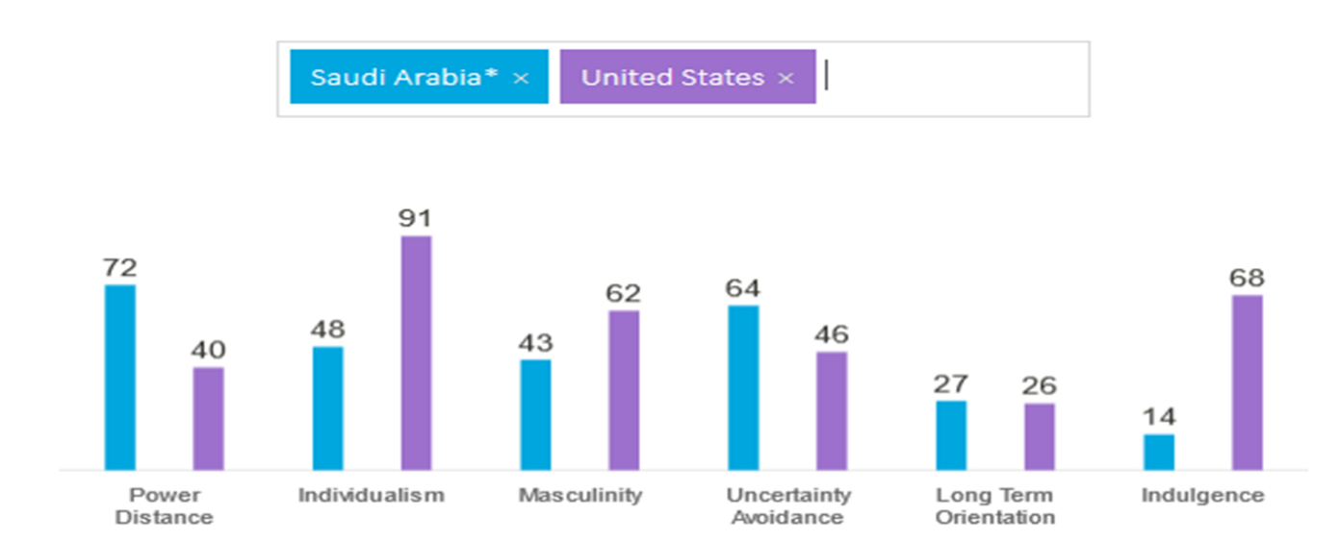

Power Distance: Saudi Arabia scored high 72 compared with US 40 means that Saudi Arabia's culture is formed around hierarchical order where everyone knows and has a place in society and does not need other explanation.

Individualism: with a score of 91 US is the most Individualist culture in the world. If in Saudi Arabia, loyalty plays a fundamental part in a collectivist culture, in the US, individuals are expected to look after themself and close family members. In the business environment, Americans are looking for an individual to be able to be self-reliant and have initiative.

Masculinity: Saudi Arabia is considered a Feminine country, meaning the quality of life is a success metric, and caring for others is a must. On the other hand, the US is a Masculine country that promotes competition, assuring that achievement and success are part of a lifestyle.

Uncertainty Avoidance: US culture tends to be more open-minded for new idea or opinions and allow freedom of expression. However, after 9/11, fear became part of American society, forcing the government to start to monitor everyone through different security measures. On the other hand, Saudi Arabia's culture is based on very strict rules based on belief and behaviour, and not open to new ideas that are not following tradition and beliefs.

Long Term Orientation: On this pillar, both countries score low, which means their culture may have many similarities with small differences. A country with a low score on this dimension has a lot of focus and respect for tradition, focusing on achieving quick results and measuring that by short-term performance.

Indulgence: This dimension is the biggest score difference between the US and Saudi Arabia cultures. If in US culture (Indulgent) is to have a good balance between work and leisure time, in Saudi Arabia, culture (Restrained) is only working hard and does not consider leisure time as a priority in society. People in a Restrained country tend to control their wishes and impulses best on the social norm.

Section 1: Part 2 Institutional analysis of Saudi Arabia and the US

An institutional approach to IHRM is a concept that describes and defines the extent to which the practice of human resources has been based on theoretical foundations (Haak-Saheem et al., 2017). It takes into consideration the actual implementation of ideas into practical measures while appreciating the organisations as social structures that allow the human resource to interact with each other (Farndale et al., 2023). The Embassy of the Kingdom of Saudi Arabia (2023) claimed that the Saudi Arabian political, economic and social institutions are a culmination of religious beliefs and are intertwined in a manner that allows them to collectively influence IHRM practices. This is because all institutions in the country are geared towards economic development. The main focus is maintaining relations between men and women, even in the corporate environment. For instance, from a religious perspective, females are expected to be submissive. In economic institutions, women may hold junior and supportive positions, thus influencing IHRMs to hire them for such positions as opposed to those the strategic positions (Nadworny, 2021).

From a neo-institutional theoretical perspective, the institutional practices in Saudi Arabia could be considered from a formal and informal perspective based on the fact that social beliefs and practices largely influence the decisions made by HRMs (Alvesson and Spicer, 2019; The Embassy of the Kingdom of Saudi Arabia, 2023). The justification for this is that only recent changes have been made in the country to ensure women join the workforce easily, meaning that economic pressures that required the contribution of both male and female employees were largely ignored. For instance, when taken in this context, the neo-institutional theory creates the impression that modern labour laws now recognize women after the elimination of strict guardianship laws by allowing them to earn incomes (Alvesson and Spicer, 2019).

From the isomorphism theory, the political, economic and social institutions directly impact IHRM practices in the sense that such are independent pressures, which to some extent, are morally governed (Glynn and Abzug, 2002). They are normative, regulative and cognitive, and their existence in society is to enhance the relationships that exist among human beings. For instance, political institutions may formulate laws from a legal perspective, while social institutions are supported by culture. In the US, industrial guidelines tend to die different practices that each line of work is expected to perform and fulfil. Employees in each industry, irrespective of their gender, are expected to follow the stipulated rules while taking into consideration each other respect (D'Aunno et al., 1991). For instance, in the medical industry, accreditation ad certification is needed and followed when admitting new staff in a healthcare facility, which is normative in nature.

Section 2: M & A Rationale and Integration Strategy

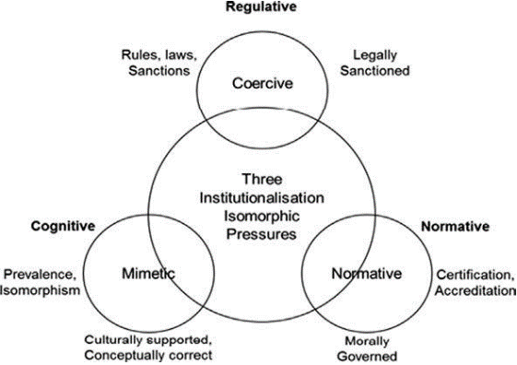
Aramco also considers the global efficiency objective of the merger process (Ermolovskaya, 2018; Zuhri et al., 2020). Arab News (2022) claimed that Aramco, a Saudi Arabian-based organisation, has been at the forefront of extending its coverage to other regions of the world and reaching its international status. While taking over the American-based organisation, Aramco will have the commodities from this new entity complement its branded products. The Valvoline Inc. iconic brand's financial weaknesses and problems will be prevented through a consistent strategy that will transform the marketing approach and management as necessary (Christofi et al., 2019). This will allow Valvoline Inc. to align with Aramco’s strategy. The existing team at Valvoline Inc. understands and values the stable distribution network and chain it has already created for itself (Al-Monitor, 2022). This does not eliminate the possibility of having adjustments incorporated in the firm immediately or in the long term once the acquisition process has been completed.
Figure 2: Theory of isomorphism
Source: Satirah Wan Mohd Saman and Haider (2013)

Saudi Aramco is acquiring Valvoline Inc. as an expansion strategy. According to JPT (2022), Aramco has been at the forefront of increasing its capacity and has formulated different and unique strategies to ensure it fulfils its objectives. The management team at Aramco has been in active search of opportunities in an attempt to expand and grow. Al-Monitor (2022) claimed that Valvoline is a perfect match for its expansion portfolio, and the acquisition process, which is expected to be completed by 2023, will allow the management team at Aramco an opportunity to venture into an American-based organisation (Arab News, 2022). Aramco gains the already existing clientele base that Valvoline Inc. has established for itself over the century as well as branded commodities that could be retained or rebranded to fit in the new venture. The strategy for growth will also be supported by the implementation of extensive research and development ideas discovered recently (Brueller et al., 2018).

By taking advantage of the synergy theory, where the combined value of the acquisition should exceed that of Aramco operating on its own, the acquisition strategy that could potentially be incorporated into this process is the absorption typology (Feldman and Hernandez, 2022). Through a synergy theoretical approach, the strategists from Aramco will ensure that the business process has been completed, with the advantages from Valvoline Inc. being fully integrated into the organisation. Additionally, the absorption process, though slow and time-consuming, will allow both companies enough time to adjust to the changes (Rani et al., 2020). This process will factor in the geographical and cultural differences between the firms.

Section 2, Part 2 – Role of IHRM in implementing effective M&A

The HRM department plays a pivotal role in an M & A process as they provide their professional knowledge and input through the structural changes that may affect the human resource asset. Brueller et al. (2018) claimed that by guiding and engaging employees through the transition process and allowing them to understand, through extensive training on, how they should conduct themselves and the impending changes that may affect their work, the staff's attitude and participation in the process becomes easy. Teams from both organisations, coming from different geographical and cultural backgrounds, will need to work towards a common goal. As such, their skills, competence, and capabilities are evaluated to ensure they form a synergetic force (Cooke et al., 2021). Additionally, the M & A may necessitate some staffs to be retained. In contrast, others may be laid off, and the HRM becomes a guiding force to ensure employees negatively affected by this transition understand and has a smooth exit plan (Degbey et al., 2021).

The HRM will also ensure that relevant labour laws from Saudi Arabia and the US are followed. (Li et al., 2018) claimed that the HRM factors all employees' related issues. For instance, competitive packages for compensation will also be incorporated in the active discussions, allowing retained staff to continue performing their duties while receiving their salaries and wages.

Conclusion and Recommendations

Aramco's absorption strategy to acquire Valvoline Inc. is highly dependent on the discussions at the organisation before the process is implemented. Factoring in the human resource impact and ensuring that they are actively and directly involved in the transition will prevent employees from failing to support the process.
- Actively involve employees in all discussions: Staff from both sides should be informed and trained on the potential changes that may affect their jobs. The HRM should be approachable to ensure the transition process has been completed and employees understand the role they have to play.
- Formulate training and development plans for both countries: Employees will need to interact and equipping them with cultural skills will ensure they fit within the new acquisition.
- Merge the organisational culture to a single approach and practice that is favorable to all persons: No cultural practice or attitude should be considered superior to the others after the transition process has been completed.
- Maintain open and functional communication before, during and after the transition process: This will always support the flow of information between the management team and staff.

Reference List
Al Monitor. (2022, August 2). Saudi Aramco acquires lubricant giant Valvoline. Al-Monitor: Independent, trusted coverage of the Middle East. Retrieved February 14, 2023, from https://www.al-monitor.com/originals/2022/08/saudi-aramco-acquires-lubricant-giant-valvoline
Alkhoraif, A. and McLaughlin, P., 2018. Lean implementation within manufacturing SMEs in Saudi Arabia: Organisational culture aspects. Journal of King Saud University-Engineering Sciences, 30(3), pp.232-242.
Alsanoosy, T., Spichkova, M. and Harland, J., 2018. Cultural influences on requirements engineering process in the context of Saudi Arabia. arXiv preprint arXiv:1807.01930.
Alvesson, M. and Spicer, A., 2019. Neo-institutional theory and organisation studies: a mid-life crisis?. Organisation Studies, 40(2), pp.199-218.
Arab News. (2022, August 21). Retrieved February 14, 2023, from https://www.arabnews.com/node/2146811/business-economy
Brueller, N.N., Carmeli, A. and Markman, G.D., 2018. Linking merger and acquisition strategies to postmerger integration: A configurational perspective of human resource management. Journal of Management, 44(5), pp.1793-1818.
Christofi, M., Vrontis, D., Thrassou, A. and Shams, S.R., 2019. Triggering technological innovation through cross-border mergers and acquisitions: A micro-foundational perspective. Technological Forecasting and Social Change, 146, pp.148-166.
CompaniesMarketCap.com. (2023). Saudi Aramco (2222. SR) - Market capitalization. Companies ranked by Market Cap - CompaniesMarketCap.com. Retrieved February 14, 2023, from https://companiesmarketcap.com/saudi-aramco/marketcap/
Compare countries (2021) Hofstede Insights. Available at: https://www.hofstede-Insights.com/fi/product/compare-countries/ (Accessed: March 14, 2023).
Cooke, F.L., Wood, G., Wang, M. and Li, AS, 2021. Riding the tides of mergers and acquisitions by building a resilient workforce: A framework for studying the role of human resource management. Human Resource Management Review, 31(3), p.100747.
D'Aunno, T., Sutton, R.I. and Price, R.H., 1991. Isomorphism and external support in conflicting institutional environments: A study of drug abuse treatment units. Academy of management journal, 34(3), pp.636-661.
Degbey, W.Y., Rodgers, P., Kromah, M.D. and Weber, Y., 2021. The impact of psychological ownership on employee retention in mergers and acquisitions. Human Resource Management Review, 31(3), p.100745.
Ermolovskaya, O.Y., 2018. Problems of the Russian market of merger and absorption transactions. Journal of Reviews on Global Economics, 7(85), p.825.
Farndale, E., Bonache, J., McDonnell, A. and Kwon, B., 2023. Positioning context front and center in international human resource management research. Human Resource Management Journal, 33(1), pp.1-16.
Feldman, E.R. and Hernandez, E., 2022. Synergy in Mergers and Acquisitions: Typology, Life Cycles, and Value. Academy of Management Review, 47(4), pp.549-578.
Glynn, M.A. and Abzug, R., 2002. Institutionalizing identity: Symbolic isomorphism and organisational names. Academy of Management journal, 45(1), pp.267-280.
Haak-Saheem, W., Festing, M. and Darwish, T.K., 2017. International human resource management in the Arab Gulf States–an institutional perspective. The International Journal of Human Resource Management, 28(18), pp.2684-2712.
JPT. (2022, May 16). Saudi Aramco claims world’s biggest market cap, aims to boost capacity beyond 13 million B/D. Retrieved February 14, 2023, from https://jpt.spe.org/saudi-aramco-claims-worlds-biggest-market-cap-aims-to-boost-capacity-beyond-13-million-b-d
Li, K., Qiu, B. and Shen, R., 2018. Organisation capital and mergers and acquisitions. Journal of Financial and Quantitative Analysis, 53(4), pp.1871-1909.
Minkov, M. and Kaasa, A., 2021. A test of Hofstede's model of culture following his own approach. Cross Cultural & Strategic Management, 28(2), pp.384-406.
Nadworny, K. (2021, July 7). Saudi Arabia’s legal reforms help women in the workforce. SHRM. Retrieved February 14, 2023, from https://www.shrm.org/resourcesandtools/legal-and-compliance/employment-law/pages/global-saudi-arabia-legal-reforms-women-workforce.aspx
Rani, P., Shauki, E.R., Darminto, D. and Prijadi, R., 2020. Motives, governance, and long-term performance of mergers and acquisitions in Asia. Cogent Business & Management, 7(1), p.1791445.
Rojo, J., Everett, B., Ramjan, L.M., Hunt, L. and Salamonson, Y., 2020. Hofstede's cultural dimensions as the explanatory framework for performance issues during clinical placement: A mixed methods study. Nurse education today, 94, p.104581.
Sampson, R.J. and Wilson, W.J., 2020. Toward a theory of race, crime, and urban inequality. In Crime, inequality and the state (pp. 312-325). Routledge.
Satirah Wan Mohd Saman, W. and Haider, A., 2013. E‐Shariah in Malaysia: technology adoption within justice system. Transforming Government: People, Process and Policy, 7(2), pp.256-276.
Saudi Aramco. (2023). Capturing carbon on the move. Retrieved February 14, 2023, from https://www.aramco.com/
Smircich, L., 2017. Concepts of culture and organisational analysis. The Anthropology of Organisations, pp.255-274.
Statista. (2018, November 14). Motor oils market share by company US 2018. Retrieved February 14, 2023, from https://www.statista.com/statistics/445231/market-share-of-us-motor-oils-in-fast-lubes-by-company/
Tarba, S.Y., Cooke, F.L., Weber, Y., Ahlstrom, D., Cooper, C.L. and Collings, D.G., 2020. Mergers and acquisitions in the global context: The role of human resource management. Journal of World Business, 55(2), p.101048.
The Embassy of the Kingdom of Saudi Arabia. (2023). Labor and workmen law. Retrieved February 14, 2023, from https://www.saudiembassy.net/labor-and-workmen-law
Valvoline Inc. (2023). Valvoline. Valvoline. Retrieved February 14, 2023, from https://www.valvoline.com/en/
Zuhri, S., Fahlevi, M., Abdi, M.N., Irma, D. and Maemunah, S., 2020. The impact of merger and acquisition on financial performance in Indonesia. Journal of Research in Business, Economics, and Education, 2(1).

