Accounting Fundamentals
Iulia Andreea Flita
ID.no. 2027759

Table of Contents
Introduction 3
Question one 3
a) 3
1. Income statement 3
2. Statement of Financial performance 4
b) Why does the statement of financial position balance? 4
Question Two 6
a. Ratio calculation 6
1. ROCE 6
2. ROE 6
3. Earnings per share 7
4. Net profit margin 7
5. Asset turnover 7
6. Stock holding days 8
7. Debtor collection period 8
8. Current ratio 9
9. Gearing Ratio 9
b. Comment on findings 9
Conclusion 10
References 11

Introduction
Accounting play’s crucial role to run a business as it assists to them to track expenditure and income, make sure statutory compliance as well as management, government and investors with quantitative financial information that use in making effective business decision. Income statement gives information regarding whether a firm can earn profit by raising revenue, decreasing expenses or both. The report will prepare income statement and financial statement of Kedison PLC. It will also calculate financial ratios of Chocco plc such as earnings per share, ROCE, stock holding days, net profit margin, ROE, asset turnover and debtors’ collection period.

Question one

a)

1. Income statement
Income Statement of Kedison PLC
For the year ended 31st December 2020
Particular |  | Amt | Particular | Amt
Cost of sales |  | 578650 | Sales | 826650
 |  |  | Credit Sales | 980
Gross Profit |  | 248980
Preference Dividend |  | 30000 | Gross Profit | 248980
Administration |  | 30000
Interest Paid |  | 2000
Directors’ remuneration |  | 5000
Costs |  | 28000
Accrued Commission |  | 3000
Corporation tax |  | 68000
Net profit |  | 82980
Total |  | 248980 |  | 248980

2. Statement of Financial performance
Statement of Financial Position
Liability
Equity and Shares
£1 ordinary Shares |  | 310,000
10% £1 preferences Shares |  | 300,000
4% Debentures |  | 100,000
Retained Profit 1st January 2020 |  | 112,000
Net Profit |  | 82980
Trade Creditors |  | 171355
Suspense A/c |  | 69,040
Total |  | 1,145,375
Assets
Cash and Bank |  | 12900
Plant Equipment |  | 632,730
Closing Stock | 330,600
Good sold | -980
Closing Stock |  | 329,620
Debtors |  | 170,125
Total |  | 1145375

b) Why does the statement of financial position balance?
The balance sheet is also known as a financial statement of a firm that involves equity capital, assets, total debt, liabilities, etc. The main function of the balance sheet is to summarize all business assets and represent how much money would have left and how many assets are sold (Obeki, 2018). The balance sheet aims to give interested stakeholders ideas of the financial position of a business. It is important that both sides of the balance sheet always balance (Jeenas, 2019). Double entry is one of the main reasons behind the balance of the balance sheet. Cash flow statements affect the balance sheet and if one or more entries and movements are missing between the balance sheet and cash flow, the balance sheet would not match. The balance sheet is essential to compare total liability against total assets (Campos, Sanchis and Talavera, 2021). The balance sheet of Kedison PLC is balanced which shows that all entries are entered in cash flow and balance sheet and there are no mistakes in the balance sheet and cash flow (Liu and Blanchett, 2021).

Question Two

Ratio calculation

1. ROCE
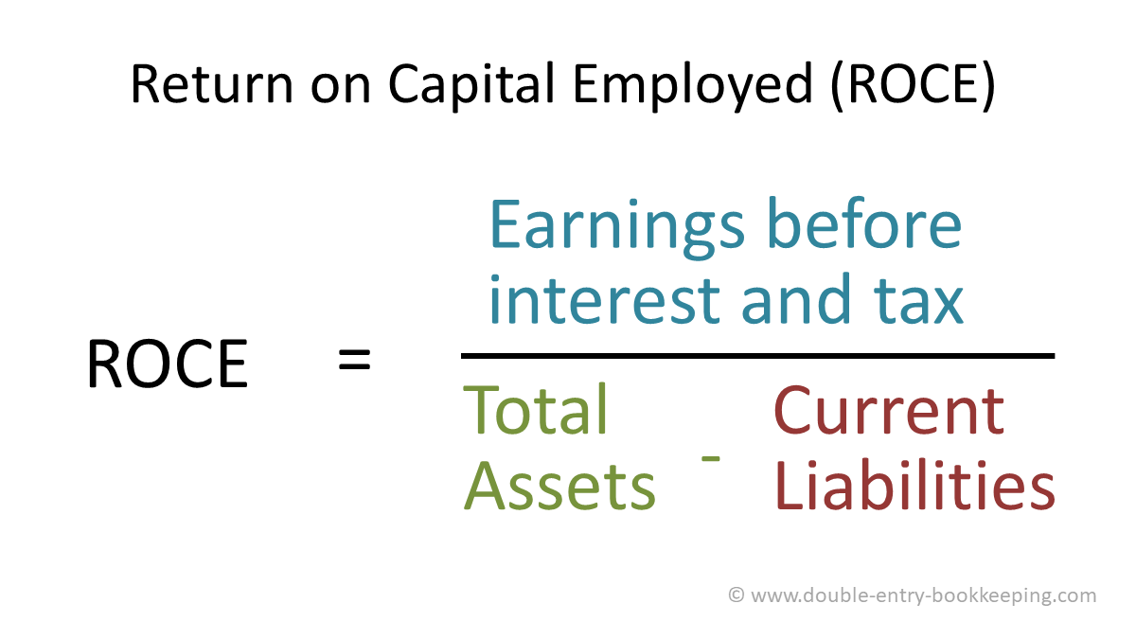

ROCE | 2020 | 2021
 | ROCE  = 620 / 9,736- 2,511  =620/7225  = 0.08 | ROCE  = 539 / 10,087- 3,046  =539 /7041  = 0.08

2. ROE

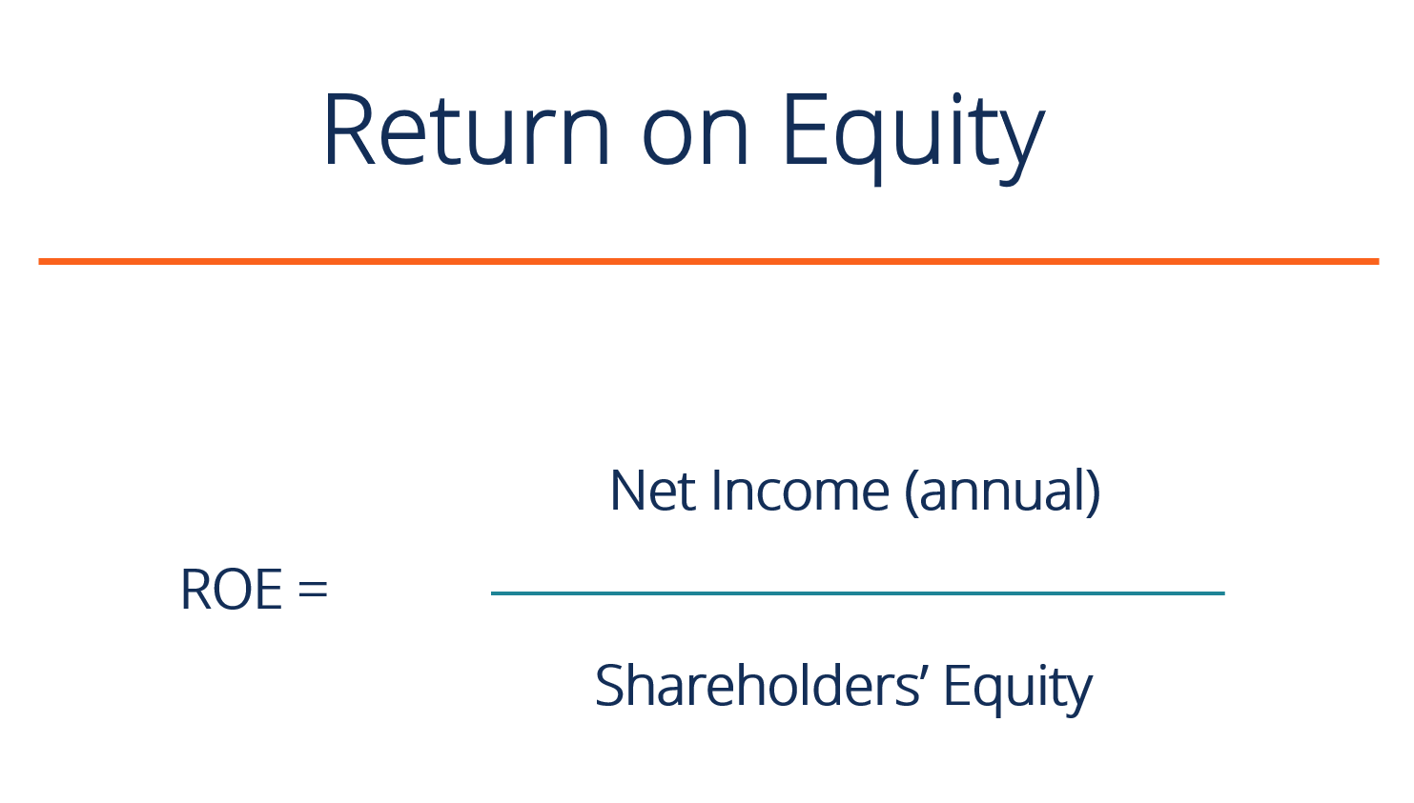
ROE | 2020 | 2021
 | ROE = 431 / 3,088  = 0.14 | ROE = 366 / 2,912  = 0.12

3. Earnings per share
- Net income =£ 431
- The average share price during 2020 was £5.12
Average outstanding common share = 50*5.12 = 256
- Earnings per share = Net Income/ average share price
- Earnings per share = 431/256 = $1.683

4. Net profit margin
Net profit margin | 2020 | 2021
 | Net profit margin = 431 / 6,738  = 0.06 | Net profit margin = 366 / 6,441  = 0.06

5. Asset turnover
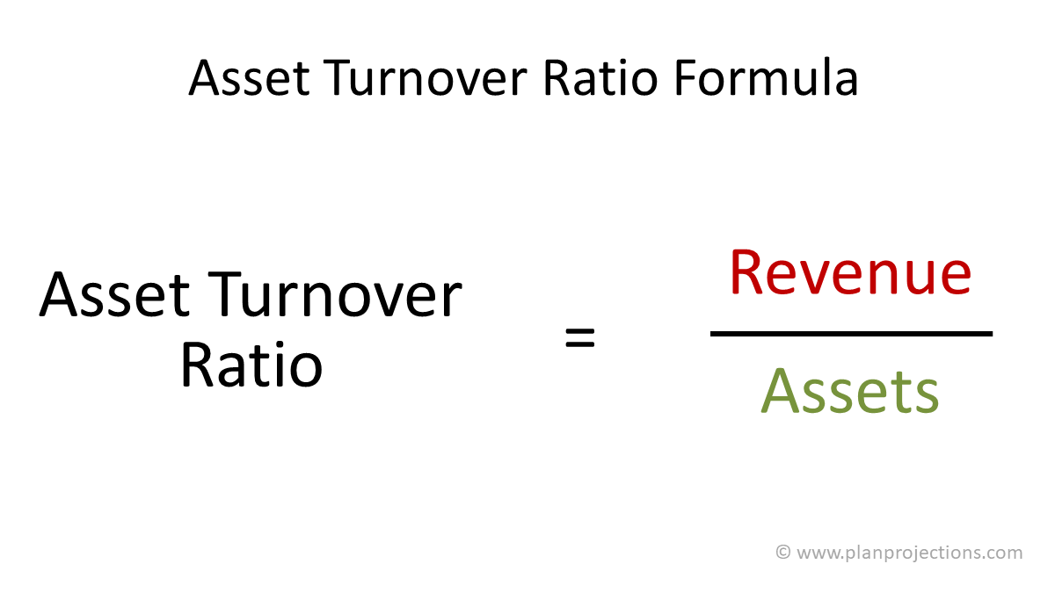
Asset turnover | 2020 | 2021
 | Asset turnover = 6,738 / 3,088  = 2.18 | Asset turnover = 6,441 / 2,912  = 2.21

6. Stock holding days
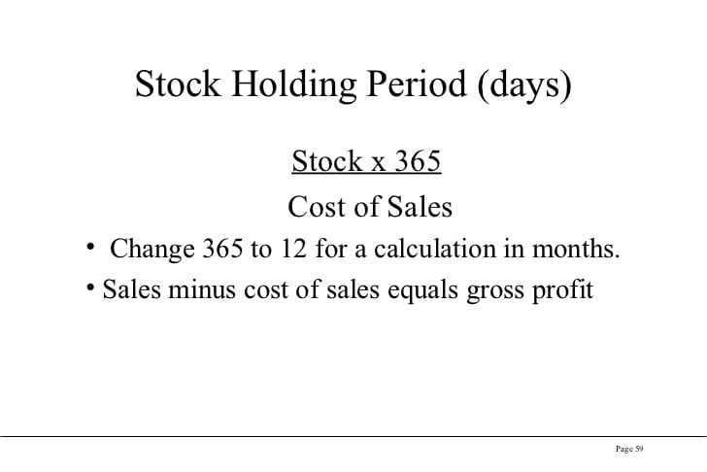
Stock holding days | 2020 | 2021
 | Stock holding days = 708 / 3,235  = 0.22 | Stock holding days = 659 / 3,096  = 0.21

7. Debtor collection period
Debtor collection period | 2020 | 2021
 | Debtor collection period  = 1,249/ 6,738  = 0.18 | Debtor collection period  = 1,287/ 6,441  = 0.20

8. Current ratio
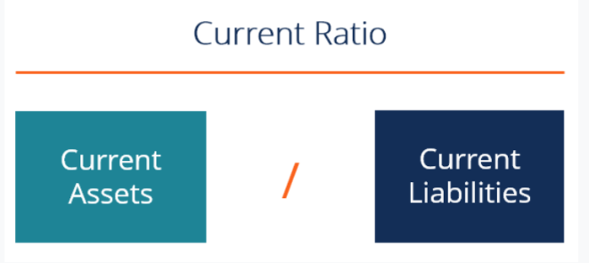

Current ratio | 2020 | 2021
 | Current ratio= 2,303/ 2,511  = 0.918 | Current ratio= 2,355/ 3,046  = 0.77

9. Gearing Ratio

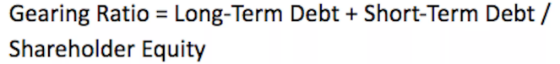
- Gearing ratio = 4137 + 583/ 3088
- Gearing ratio = 4720/ 3088
Gearing ratio = 1.528

Comment on findings
From the above calculation, it is found that Chocco plc has a good financial position and just needs to work on its current ratio and retained profit for future investments and meeting day-to-day expenses (Jeenas, 2019). The company has good liquidity in terms of financial position and strategy to allocate capital. The profit and loss statement of the company is showing a profit for the shareholders which are good for the company’s financial reputation in the market (Obeki, 2018). Asset’s turnover of the company is good with both the year which is good for financial sustainability (Liu and Blanchett, 2021). The current ratio of Chocco plc is decreasing in 2021 which is not better for this company, and they need to work to improve their assets and decrease liabilities (Campos, Sanchis and Talavera, 2021).

Conclusion
Income statements and balance sheets both are vital for a business because they provide essential information about the financial performance of a business. The income statement of Kedison PLC helps to measure income and revenue. Kedison PLC has earned a net profit of £82,980. The income statement, as well as the financial statement of this company, will help investors to take decisions regarding investment. The financial ratios of Chocco plc are good and indicate the better financial position of this company.

References
Barker, R. and Penman, S., 2019. Balance Sheet Approach in Retreat. (Barker and Penman, 2019)
Campos, V., Sanchis, J.R. and Talavera, C., 2021. Adjusting the Common Good Balance Sheet to Improve Their Sustainable Management. Sustainability 2021, 13, 1184.
Jeenas, P., 2019. Firm balance sheet liquidity, monetary policy shocks, and investment dynamics. Work.
Liu, Z. and Blanchett, D.M., 2021. Focusing on both sides of the balance sheet: the potential benefit of liability management. Financial Services Review, 29(2).
Obeki, O.S., 2018. Income statement preparation by small and medium enterprises.

